Supplementary Material

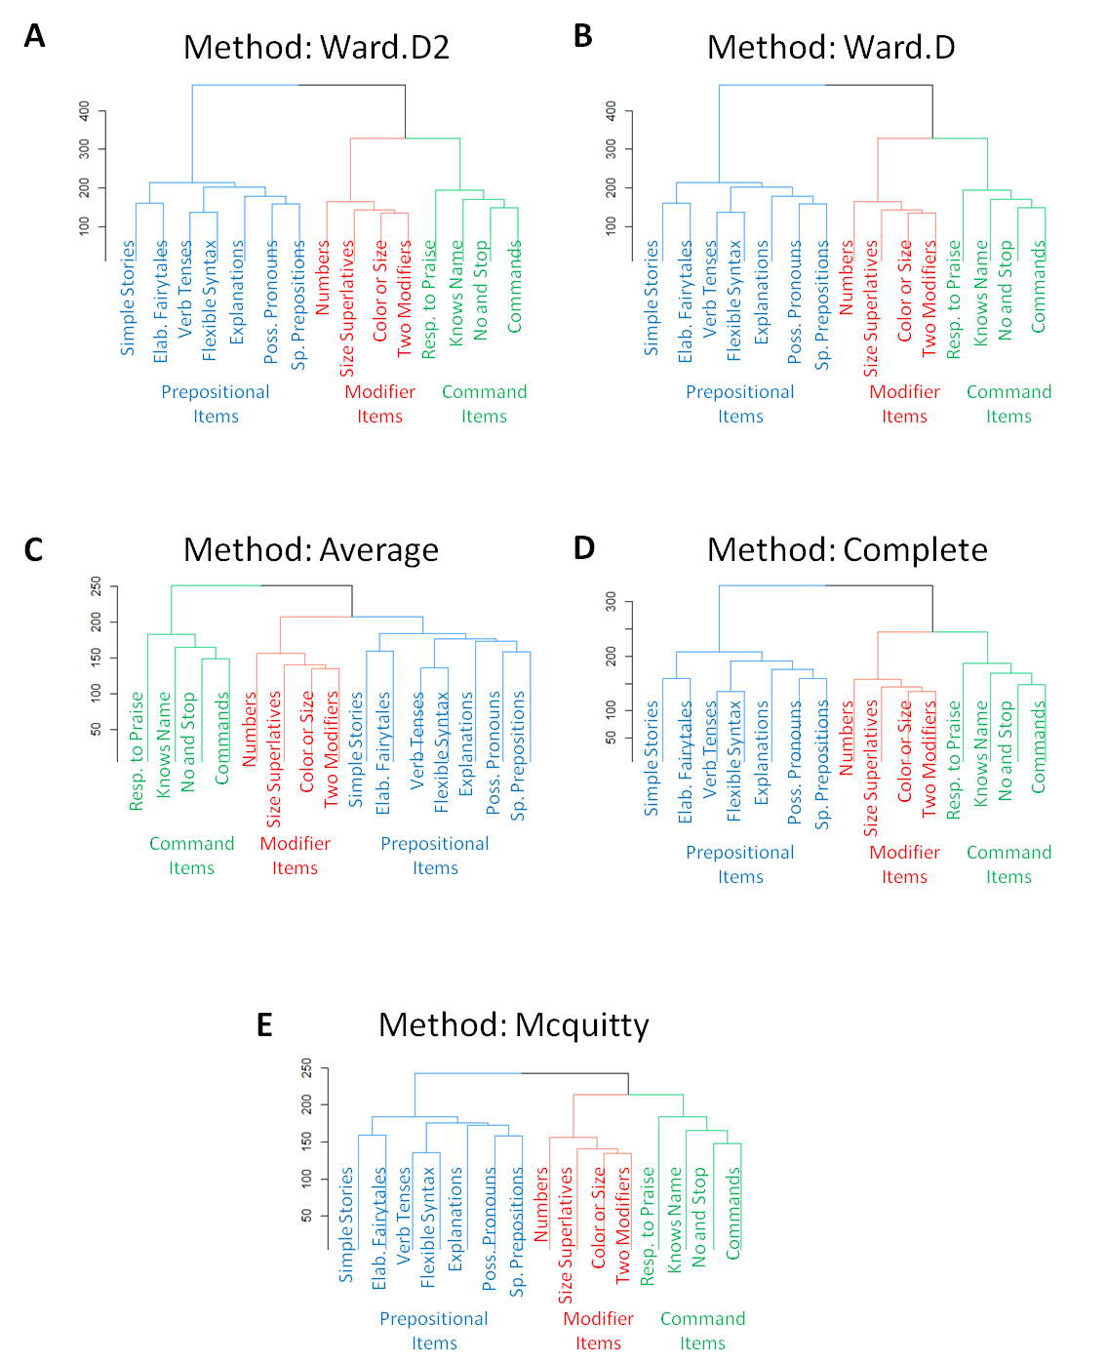
Figure S1. The three-cluster solution of the 15 language comprehension abilities was stable across different evaluation methods. A: Ward.D2. B: Ward.D. C: Average. D: Complete. E: Mcquitty.

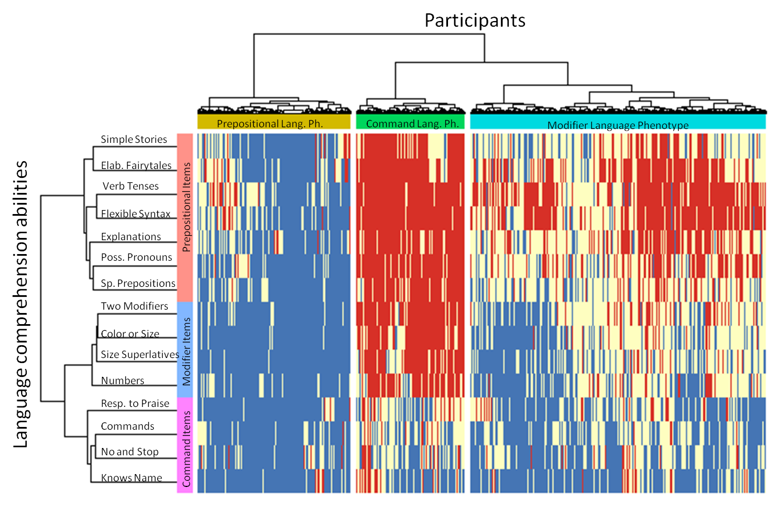

Figure S2. Two dimensional heatmap relating 31,988 participants (of 4 to 6 years of age) to their language comprehension abilities. The 15 language comprehension abilities are shown as rows. The dendrogram representing language comprehension abilities is shown on the left. Participants are shown as 31,988 columns. The dendrogram representing participants is shown on the top. Blue color indicates the presence of a skill (the “very true” answer), red indicates the lack of skill (the “not true” answer), and white indicates the “somewhat true” answer.

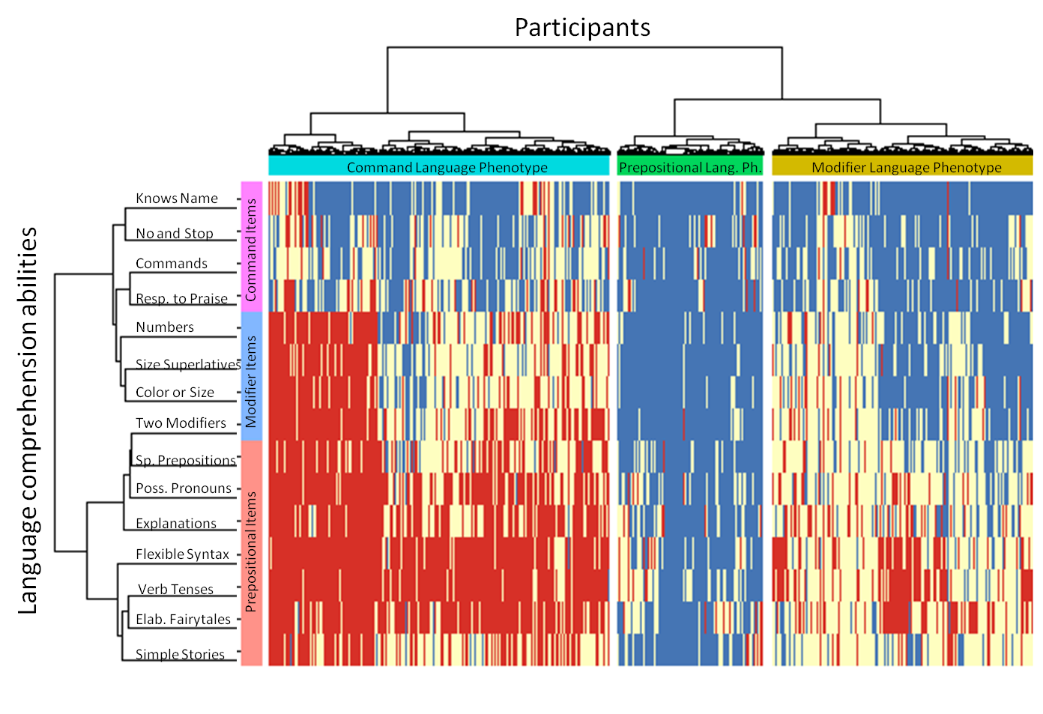
Figure S3. Two dimensional heatmap relating 23,570 participants (of 6 to 21 years of age) to their language comprehension abilities. The 15 language comprehension abilities are shown as rows. The dendrogram representing language comprehension abilities is shown on the left. Participants are shown as 23,570 columns. The dendrogram representing participants is shown on the top. Blue color indicates the presence of a skill (the “very true” answer), red indicates the lack of skill (the “not true” answer), and white indicates the “somewhat true” answer.

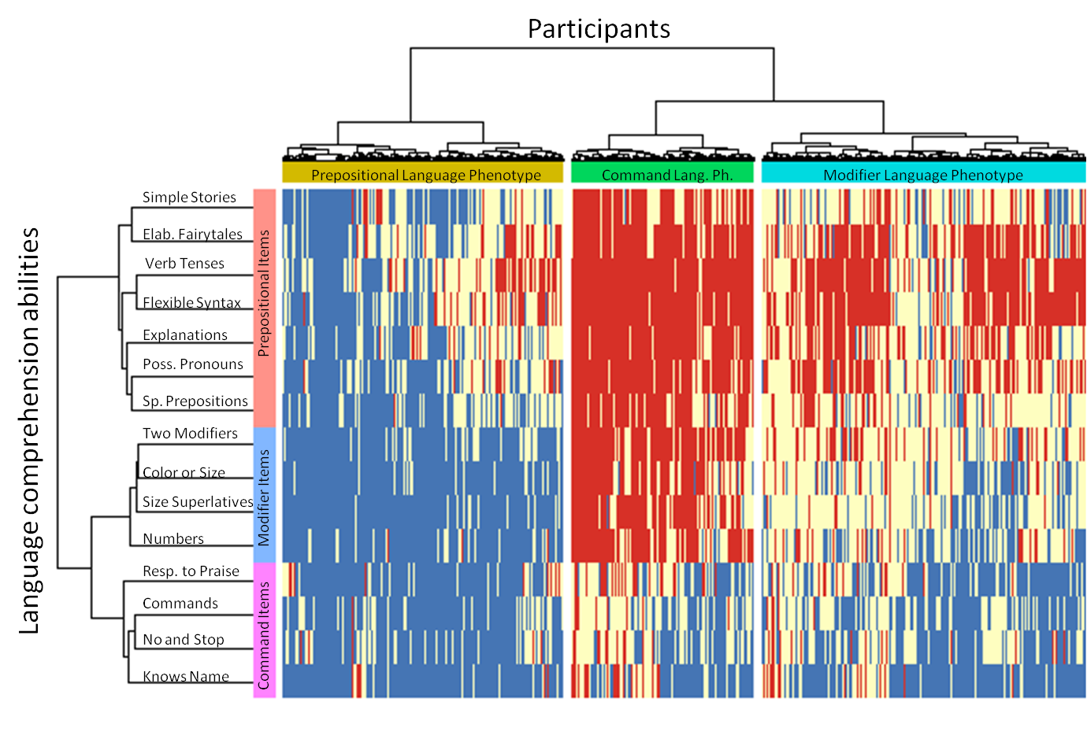
Figure S4. Two dimensional heatmap relating 55,558 participants (of 4 to 21 years of age, first evaluation) to their language comprehension abilities. The 15 language comprehension abilities are shown as rows. The dendrogram representing language comprehension abilities is shown on the left. Participants are shown as 55,558 columns. The dendrogram representing participants is shown on the top. Blue color indicates the presence of a skill (the “very true” answer), red indicates the lack of skill (the “not true” answer), and white indicates the “somewhat true” answer.

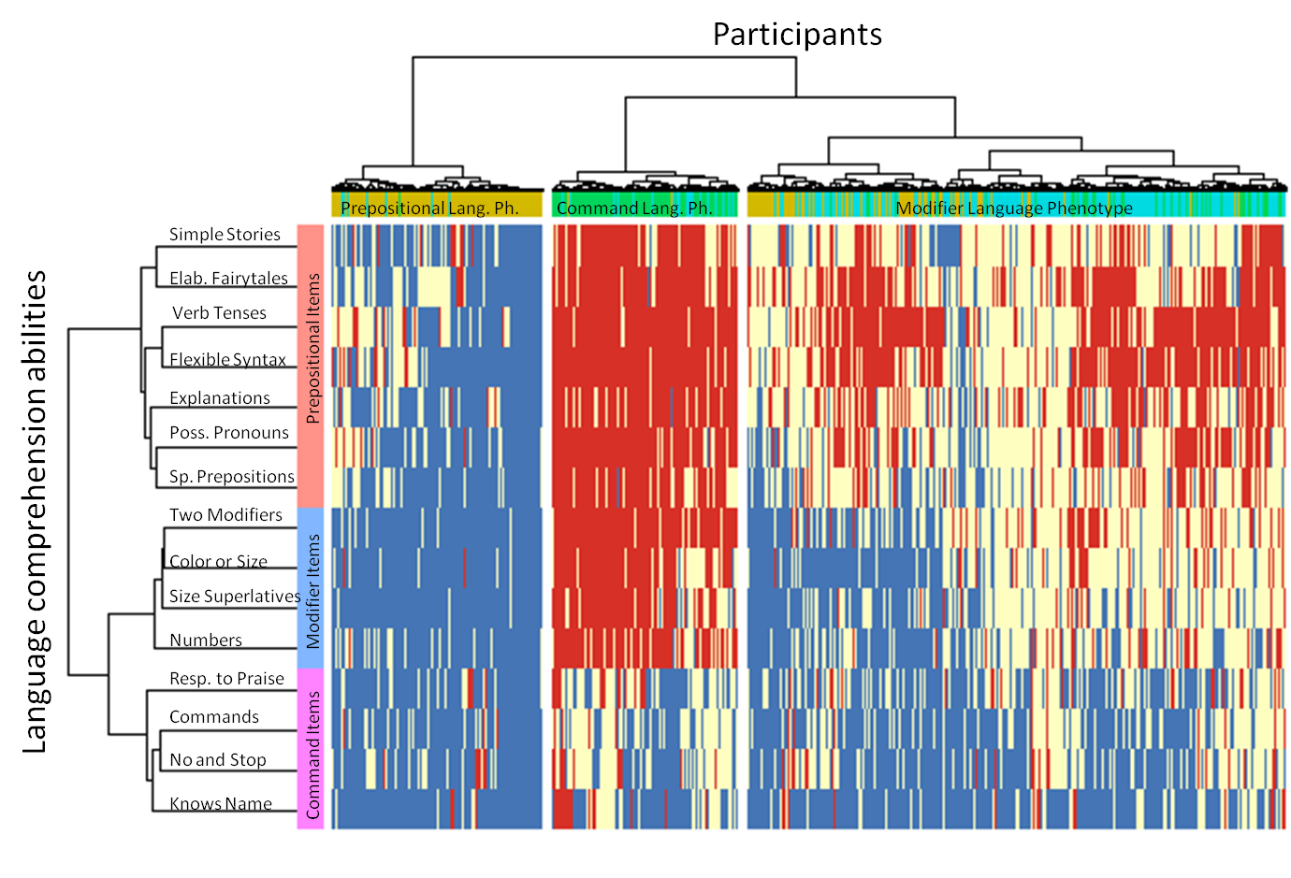
Figure S5. Two dimensional heatmap relating 55,558 participants (of 4 to 21 years of age, last evaluation) to their language comprehension abilities. This heatmap uses Manhattan distance metric unlike heatmaps above that use Euclidean distance metric. The 15 language comprehension abilities are shown as rows. The dendrogram representing language comprehension abilities is shown on the left. Participants are shown as 55,558 columns. The dendrogram representing participants is shown on the top. Blue color indicates the presence of a skill (the “very true” answer), red indicates the lack of skill (the “not true” answer), and white indicates the “somewhat true” answer.

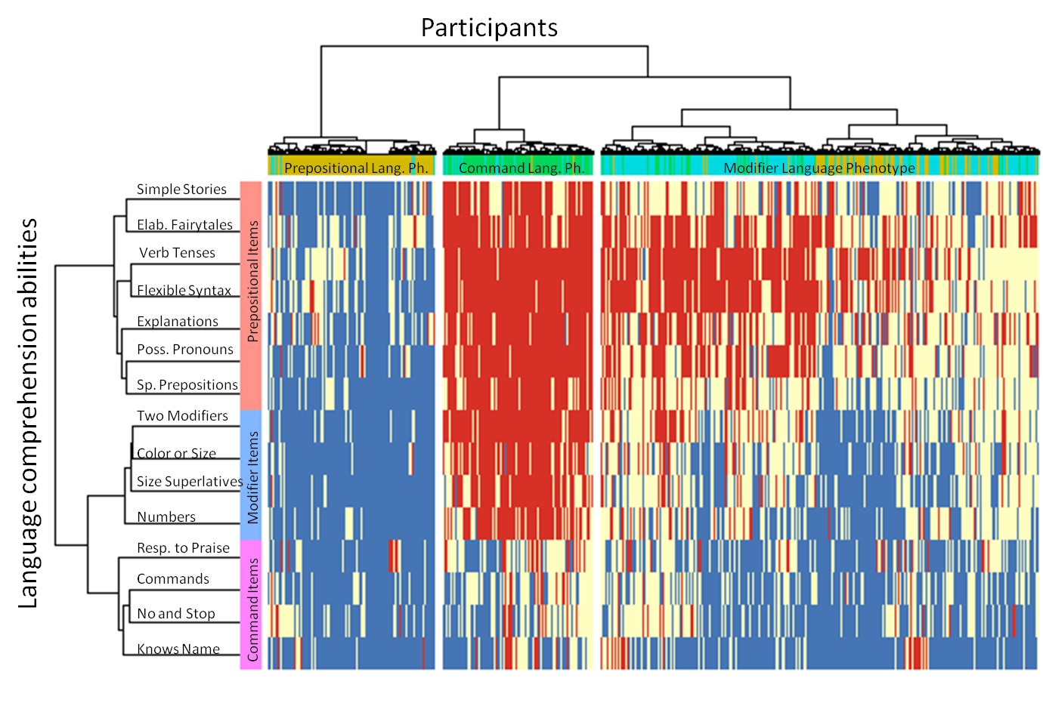
Figure S6. Two dimensional heatmap relating 55,558 participants (of 4 to 21 years of age, last evaluation) to their language comprehension abilities. This heatmap uses Minkowski distance metric. The 15 language comprehension abilities are shown as rows. The dendrogram representing language comprehension abilities is shown on the left. Participants are shown as 55,558 columns. The dendrogram representing participants is shown on the top. Blue color indicates the presence of a skill (the “very true” answer), red indicates the lack of skill (the “not true” answer), and white indicates the “somewhat true” answer.

