Supplementary Materials
Description of Social Adversity Measures
Below is a description of each of the social risk and support measures included in analyses with EGAA.

Adverse Childhood Experiences. Mothers reported on their adverse childhood experiences (ACEs) using the 10-item measure developed by Felitti et al. that assesses childhood physical, emotional, and sexual abuse and emotional and physical neglect. Scores were summed to create a total ACE score (range: 0-10). For mothers with responses to at least 1 ACE items, missing responses were coded as 0 (no) [1].

Financial Stress (FIN). Financial stress was measured using the 6-item Financial Stress Index, which assesses the frequency of financial stressors in the last three months (e.g., difficulty paying bills, fears of losing home/job). Items are Likert scaled from 0 (never) to 4 (always) and summed (range: 0-24) with higher scores indicating more financial stress. Missing responses were imputed with the mean value across all other available items if data on at least one item was present [2].

Discrimination. Mother’s experience of discrimination was assessed using the 9-item Everyday Discrimination Scale. Mothers were asked about experiences of racial discrimination in their day-to-day life (e.g., “People act as if they are afraid of you"). Response options range on a scale from 0 (never) to 6 (almost every day). Scores were summed (range: 0-54) with higher scores indicating more discrimination [3].

Perceived Stress (PSS). Mother’s perceived stress was assessed using the 10-item Perceived Stress Scale. Mothers were asked about their feelings in the past month (e.g., “How often have you felt nervous or stressed?”). Response options range on a scale from 0 (never) to 4 (very often). Scores were summed (range: 0-40) with higher scores indicating more perceived stress.

Prenatal Distress (PDS). Mother’s prenatal distress was assessed using the 12-item Prenatal Distress Questionnaire. Mothers were asked about their feelings during pregnancy (e.g., “I worry about having an unhealthy infant.”). Response options range on a scale from 0 (not at all worried) to 4 (extremely). Scores were summed (range: 0-48) with higher scores indicating more prenatal distress [4].

Functional Social Support (SS). Mother’s social isolation was assessed using the 8-item Duke/UNC Functional Social Support Questionnaire. Mothers are asked about the amount of functional support in their lives, relative to their ideal (e.g., “Changes to talk about money matters;” “Help when I’m sick in bed”). Response options ranged on a scale from 0 (much less than I would like) to 5 (as much as I would like). Scores are summed (range: 0-40) with higher scores indicating more functional support.

Anxiety (ANX). Anxiety symptoms were measured using the PROMIS Emotional Distress-Anxiety-6a [5]. This 6-item validated measure includes items such as “My worries overwhelmed me” and “I felt like I needed help for my anxiety.” Items are scored on a 5-point Likert scale from “Never” [1] to “Always” [5] (range: 6 to 30). Higher scores indicate more anxiety.

Depression. Mother’s depression was assessed using the 20-item Center for Epidemiological Studies-Depression (CES-D). Mothers are asked about their feelings in the past week (e.g., “My sleep was restless.”). Response options range from 0 (Rarely or None of the Time) to 3 (Most or All of the Time). Scores are summed (range: 0-60) with higher scores indicating greater depressive symptoms.

Time of social adversity information collection. The information of ACEs, FIN, and Discrimination was collected during 2nd trimester. All other social adversity information was collected during 3rd trimester.

Supplementary Tables
Supplementary Table 1. CpGs and coefficient used in our epigenetic gestational age clock.
CpGs | Coefficient
(Intercept) | 30.2945279
cg26339484 | 1.11335003
cg08529574 | -0.270825
cg16312002 | 0.05549891
cg15650580 | 0.04152318
cg14817702 | 2.74787284
cg09476154 | 0.04563963
cg25758134 | -2.6423574
cg00969087 | 0.25925717
cg21861340 | 0.17754927
cg20682146 | 1.68681919
cg01896605 | -7.6260784
cg00697486 | 0.41601688
cg14706297 | 0.09379941
cg12928619 | -4.1016324
cg04679040 | -0.2502734
cg14684141 | 0.63697486
cg15140246 | 0.05804666
cg09772299 | 0.89199064
cg00331740 | 2.20299184
cg16814023 | 0.06712198
cg14986890 | -0.476181
cg12034765 | -0.972691
cg14760020 | 0.52115997
cg20132545 | 0.96290186
cg13810873 | -0.1438248
cg13735704 | 5.26005266
cg12682529 | 0.08972318
cg14451382 | -0.6589154
cg22052847 | -0.7591501
cg17454247 | -0.4091106
cg10030303 | 1.53236123
cg08179037 | 0.95601615
cg19108542 | -7.1081431
cg23143796 | 1.34397355
cg06634471 | -2.6376978
cg01208296 | 0.58218683
cg15367041 | -0.1831088
cg13400248 | 2.07081313
cg16581075 | -0.4375756
cg12451926 | 0.24632867
cg17805581 | 0.55793965
cg09934789 | -2.6136541
cg16070605 | -0.480864
cg09147401 | -0.0331472
cg05413282 | 0.33095858
cg08623856 | 3.50781957
cg24874025 | 0.06135568
cg11061422 | 0.39229759
cg15012692 | -1.682864
cg18089519 | 0.07650968
cg07283152 | -1.2779541
cg24607755 | -0.7946555
cg16150798 | -0.0273311
cg07710883 | 0.78499402
cg23019886 | -0.7757526
cg06352218 | -3.8220995
cg25405684 | -1.1492763
cg08855729 | -0.9417619
cg07697828 | -0.986094
cg12026015 | 5.7260591
cg01203563 | -0.4118485
cg23543263 | 2.42463937
cg26842121 | -0.7749576
cg00502575 | 0.87876214
cg20650823 | -1.1443676
cg05868942 | -0.0495887
cg06496630 | 0.04249048
cg26270066 | 0.19278073
cg12638476 | 0.09624678
cg02016903 | -1.6767636
cg25414799 | 1.13965667
cg05212282 | -3.8759749
cg05288475 | 0.06084625
cg08326019 | 0.11532871
cg08384112 | 0.92803837
cg22410544 | 0.34508237
cg15867944 | 1.03876654
cg23966593 | -0.2587385
cg04398610 | -1.121961
cg14239488 | 0.26547173
cg19414598 | 2.80997468
cg02852651 | -1.0273513
cg22780000 | 6.16408107

Supplementary Table 2. Correlation coefficient between epigenetic gestational age estimated from five clocks and clinical gestational age for Black and Non-Black newborns. Difference is calculated as the difference of correlation coefficient between Black and Non-Black divided by the correlation coefficient of Black.
Clock | Black | Non-Black | Difference
PedBE | 0.209 | 0.206 | 1.51%
Knight | 0.171 | 0.202 | -18.21%
Bohlin | 0.212 | 0.257 | -21.28%
EPIC | 0.136 | 0.189 | -39.07%
Our | 0.855 | 0.842 | 1.52%

Supplementary Table 3. Coefficients and p-value of linear regression between EGAA and social adversity scores.
Score | Coefficient | p-value
ACEs | 7.48E-03 | 0.52
HASSLES | 1.02E-04 | 0.99
FIN | -3.78E-03 | 0.34
CES-D | -2.04E-03 | 0.44
PSS | -9.25E-04 | 0.79
PDS | 7.31E-04 | 0.81
SS | -1.68E-03 | 0.62
ANX | -3.31E-03 | 0.45

Supplementary Table 4. Coefficients and p-value of multi-variable linear regression between EGAA and 6 significant covariates found in un-adjusted correlation analysis.
Covariate | Coefficient | p-value
Cohort SHIP | -0.14 | 0.024
Hispanic | -0.16 | 0.016
Non-Hispanic Black | -0.11 | 0.063
NICU | -0.17 | 0.013
Birth Weight (kg) | 0.10 | 0.012
Complication | -0.05 | 0.331

Supplementary Figures
Supplementary Figure 1. Overlaps of CpG sites used in 6 clocks.
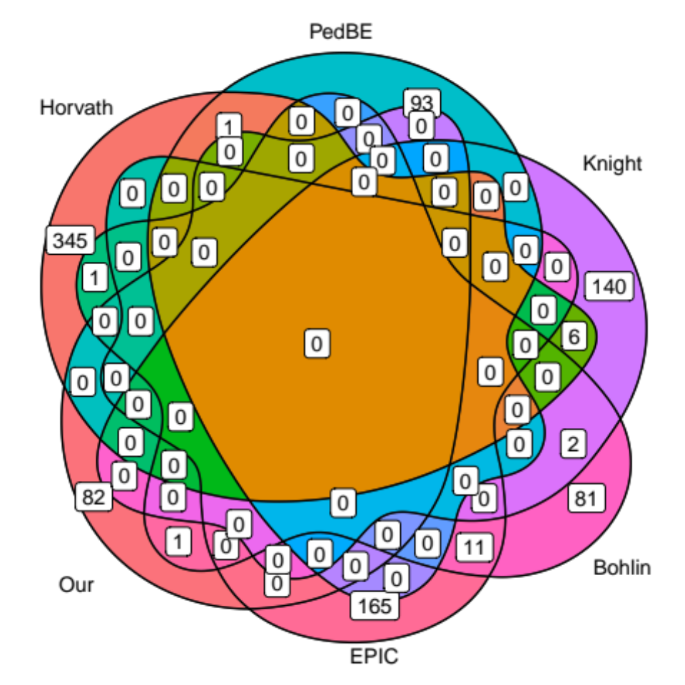

Supplementary Figure 2. Scatter plot of PC1 and PC3 of top 500 CpGs with the largest variation. The race/ethnicity of newborns is derived from their mothers. The newborns at the border of the two clusters might be multi-racial.
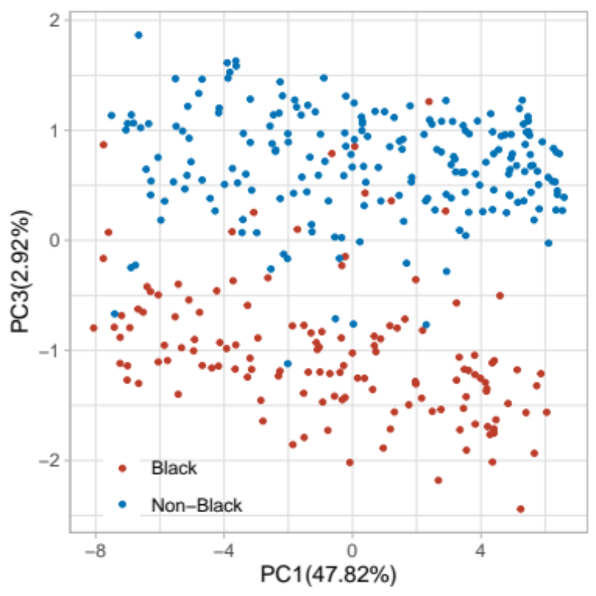

Supplementary Figure 3. Social adversity scores associated with cohort and race/ethnicity. P-value is calculated from Wilcoxon test.
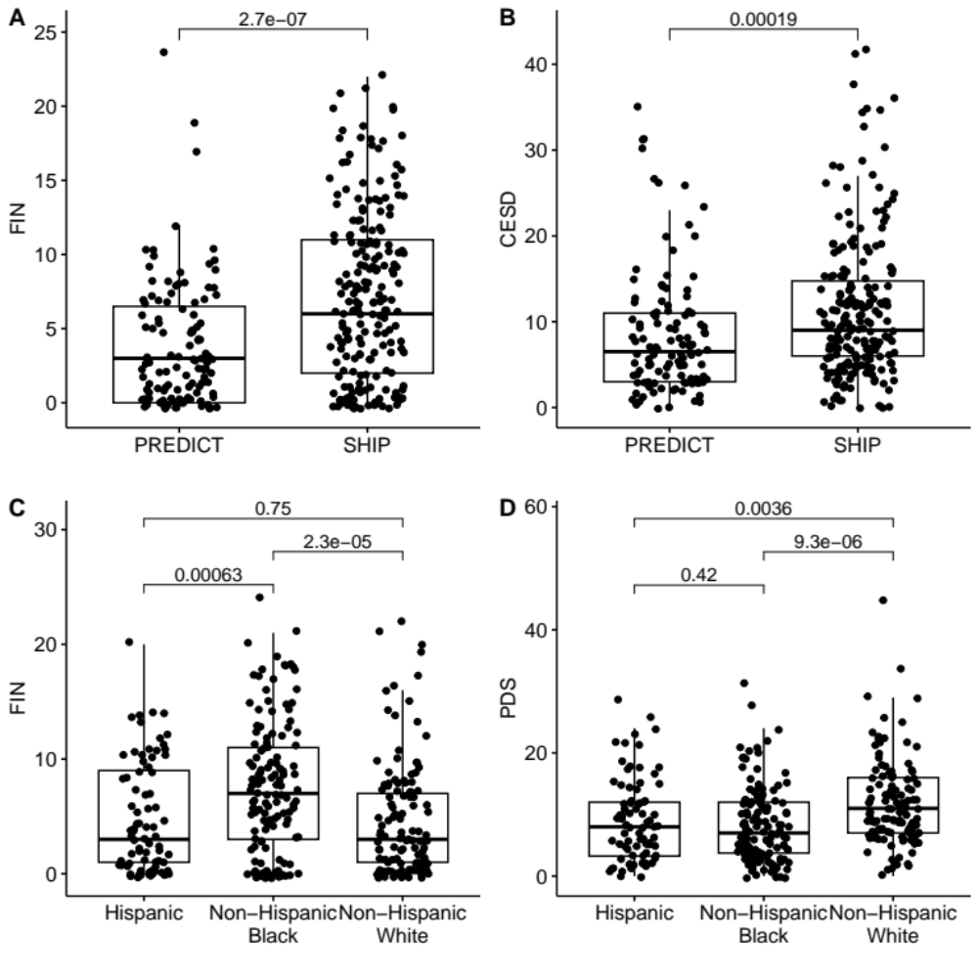

Supplementary Figure 4. Birth weight difference between Hispanic, Non-Hispanic Black, and Non-Hispanic White. Non-Hispanic Black has lower birth weight than Hispanic and Non-Hispanic White.
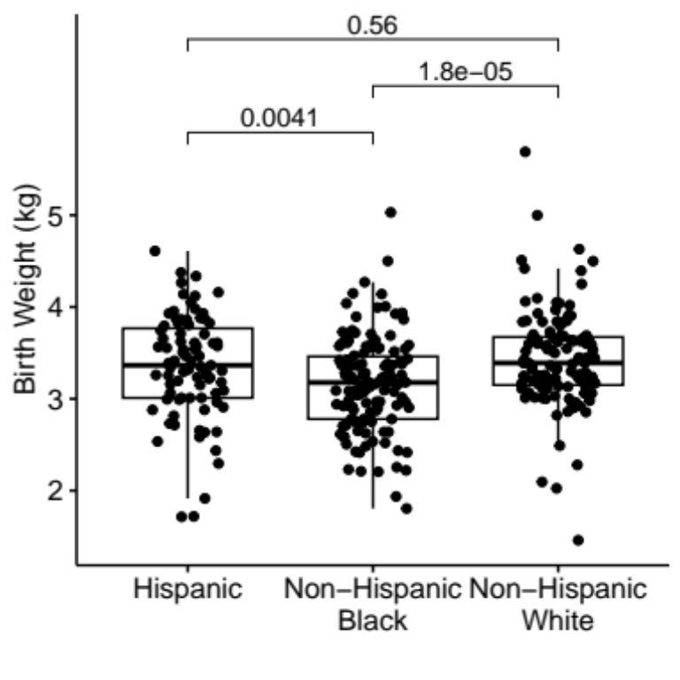

Supplementary Figure 5. Birth weight difference between newborns with and without transfer to neonatal intensive care unit (NICU).
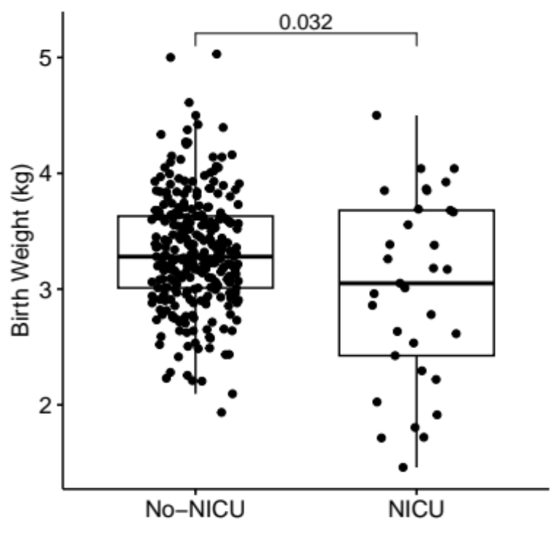

Supplementary Figure 6. Endothelial cells in nondigested umbilical vein (left, insert is close up) as compared to enzyme-digested vein (right).
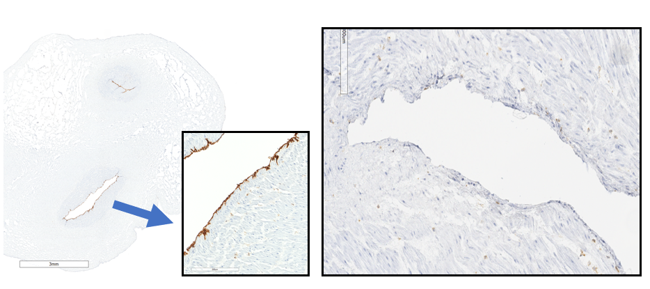

Supplementary Figure 7. Venn diagram of samples filtered during quality control.
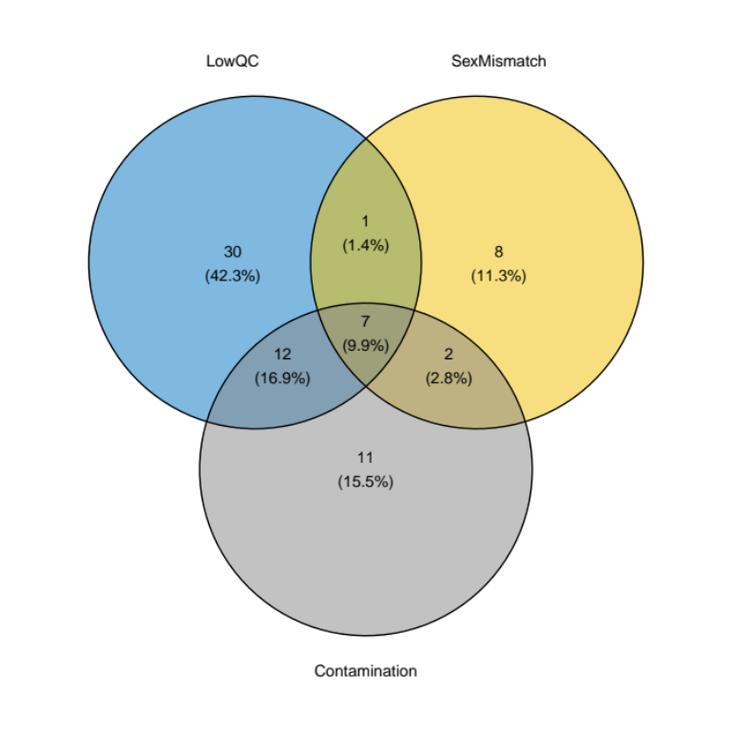

References

1. Felitti VJ, Anda RF, Nordenberg D, Williamson DF, Spitz AM, Edwards V, Koss MP, Marks JS: Relationship of childhood abuse and household dysfunction to many of the leading causes of death in adults. The Adverse Childhood Experiences (ACE) Study. Am J Prev Med 1998, 14:245-258.
2. Riis JL, Granger DA, Minkovitz CS, Bandeen-Roche K, DiPietro JA, Johnson SB: Maternal distress and child neuroendocrine and immune regulation. Soc Sci Med 2016, 151:206-214.
3. Williams DR: Stress and the Mental Health of Populations of Color: Advancing Our Understanding of Race-related Stressors. J Health Soc Behav 2018, 59:466-485.
4. Yali AM, Lobel M: Coping and distress in pregnancy: an investigation of medically high risk women. J Psychosom Obstet Gynaecol 1999, 20:39-52.
5. Pilkonis PA, Choi SW, Reise SP, Stover AM, Riley WT, Cella D: Item banks for measuring emotional distress from the Patient-Reported Outcomes Measurement Information System (PROMIS®): depression, anxiety, and anger. Assessment 2011, 18:263-283.

