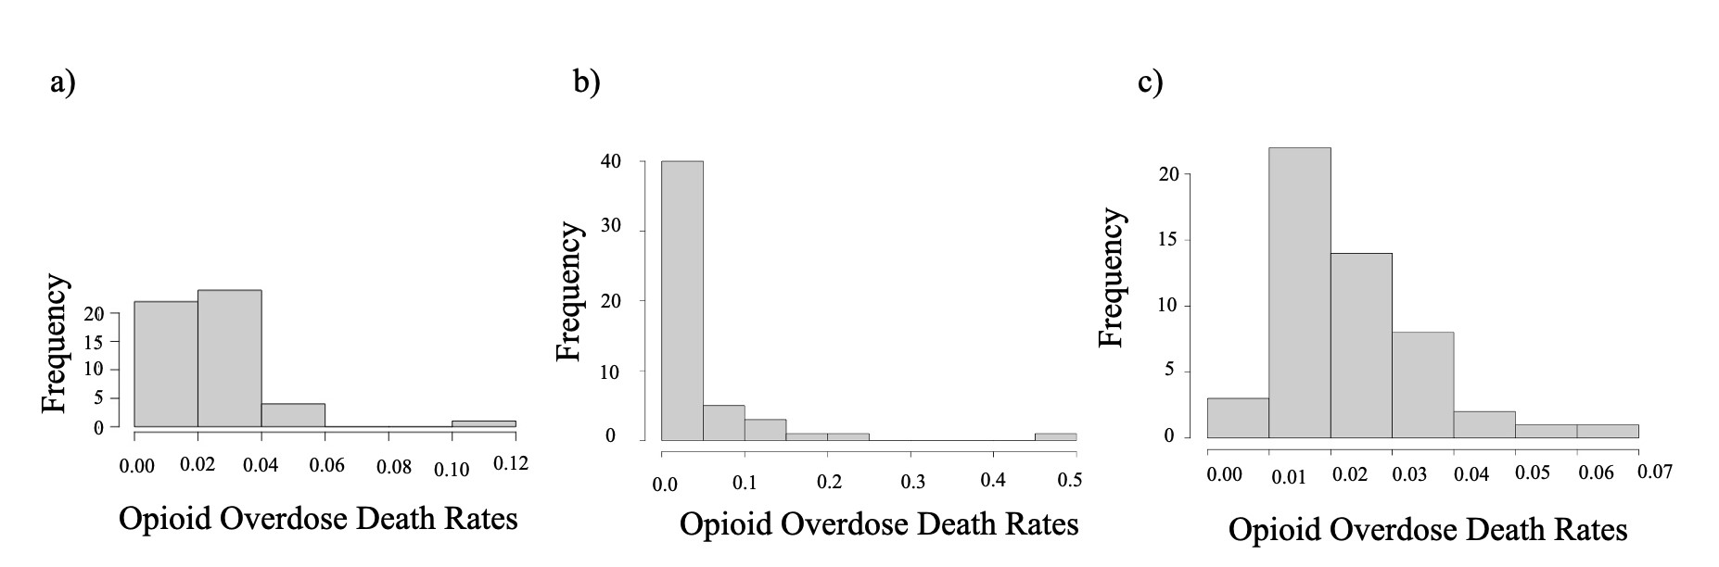

Appendix 1: Histogram of opioid overdose death rates in a) 2017, b) 2018 and c) 2019. Opioid overdose death rates represented as percents (%) and frequency as number of values corresponding to a rate.

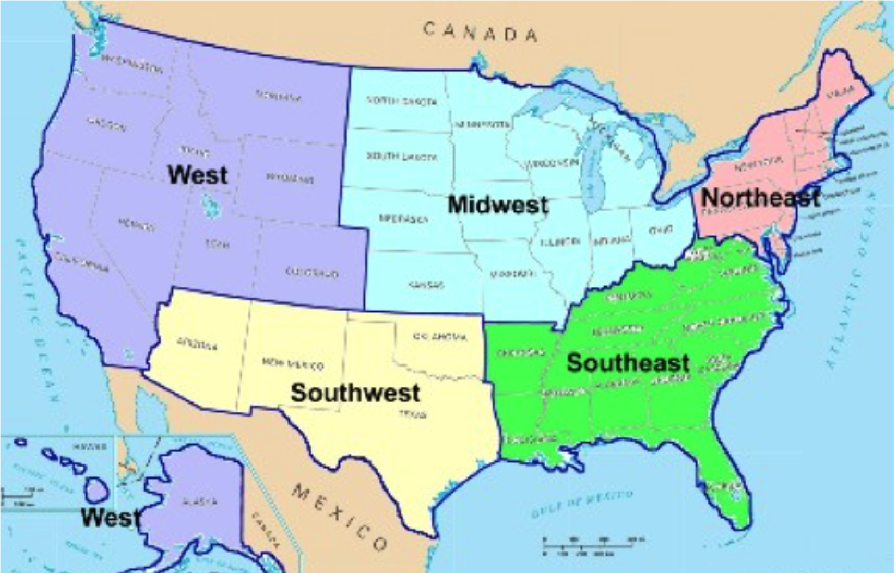
Appendix 2: Divisions of the United States (obtained with permission from https://www.ducksters.com/geography/us_states/us_geographical_regions.php)

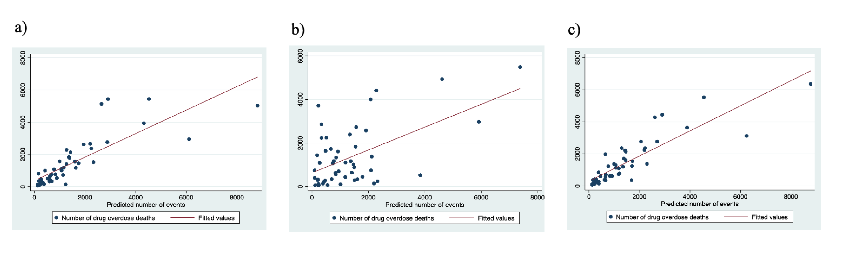
Appendix 3: Density plot of the Monte Carlo permutations to assess Moran’s global I in a) 2017, b) 2018 and c) 2019

Appendix 4: Observed versus fitted values for Poisson regression models of the association between unemployment and opioid overdose deaths in a) 2017, b) 2018 and c) 2019
