Supporting Information
Prominent role of sulfate reduction in robust sulfur retention in subtropical soil
Qian Yu¹, Jan Mulder², Gaoyue Si¹, Longfei Yu³, Ronghua Kang⁴, Kaiyi Liu¹, Jiming Hao^{1,5*}, Lei Duan^{1,5*}
¹State Key Laboratory of Environmental Simulation and Pollution Control, School of Environment, Tsinghua University, Beijing 100084, China.
²Faculty of Environmental Sciences and Natural Resource Management, Norwegian University of Life Sciences, Box 5003, NO-1432 Ås, Norway
³Institute of Groundwater and Earth Sciences, Jinan University, Guangzhou, 510632, China
⁴CAS Key Laboratory of Forest Ecology and Management, Institute of Applied Ecology, Chinese Academy of Sciences, Shenyang, 110016, China
⁵Collaborative Innovation Centre for Regional Environmental Quality, Tsinghua University, Beijing 100084, China
*Corresponding Author. e-mail: lduan@tsinghua.edu.cn (LD); hjm-den@mail.tsinghua.edu.cn (JMH)
Supplementary Information file includes:
Supplementary text 1-5
Supplementary Figures 1-4
Supplementary Table 1
References

Supplementary text 1| The calculation of S fluxes along the hydrological continuum
The S fluxes along the hydrological continuum were determined by multiplying SO₄²⁻ concentrations by water fluxes. The SO₄²⁻ concentrations in throughfall (TF), soil water in 0 and 40 cm (S1 and S2), and stream water (SW) were water flux-weighted concentrations from 2001 to 2017. The SO₄²⁻ concentrations of soil water in 60 cm depth at H3, G1, G2, and G3 (S_{H3}, S_{G1}, S_{G2}, and S_{G3}) was the water flux-weighted value in May, August, and October 2017. The water flux of the soil water in 60 cm depth was assumed as that in stream water due to limited evapotranspiration in the groundwater discharge zone. Then, the S fluxes along the hydrological continuum were calculated and showed in Fig. 2c.

Supplementary text 2| The calculation of S store in the soil
The store (kg S ha⁻¹, Supplementary Fig. 1a) of different S species in the soil layer were determined by the equation (S1):
S store = C × m / 3A /100 (S1)
Where C is the S content in the soil (mg S kg⁻¹), showed in Supplementary Fig. 1b, m is the dry weight of bulk soil in each layer (kg), A is the area of the soil sampling drill (m²). We are dividing by 3 because the bulk soil is consisted of 3 parallel samples in each plot.
The total S store in the soil is the sum of S store in all the soil layers (13,400, 16,000, 13,800, 11,900, 12,700, and 11,500 kg S ha⁻¹ for the 0-215 cm soil in H1, H2, H3, G1, G2, and G3, respectively), is approximately 14,400 kg S ha⁻¹ and 12,000 kg S ha⁻¹ for the 0−215 cm soil at hillslope and groundwater discharge zone, respectively. Thus, the S store for the entire catchment was ~14,300 kg S ha⁻¹ (14,400 × 96% + 12,000 × 4%), of which ~18% and ~25% stored in the upper 40 cm and 50 cm soil as 2,570 and 3,600 kg S ha⁻¹.

Supplementary text 3| Trends of δ¹⁸O and δ³⁴S during sulfate reduction
Linear and non-linear trends of δ¹⁸O and δ³⁴S can provide insight into the relative rates of sulfate reduction and the extent of back reaction that occurs during intracellular cycling of sulfur intermediates. There are three reversible steps coupled S and O isotope (kinetic and equilibrium) fractionations during the sulfate reduction defined by Antler et al., (2013)¹, including uptake into the cell (³⁴ε = -3‰; ¹⁸ε = -0.75‰), the reduction of adenosine 5-phosphosulfate (APS) to sulfite (³⁴ε = 25‰; ¹⁸ε = 6.25‰), and the reduction of sulfite to sulfide (³⁴ε = 25‰; ¹⁸ε = 6.25‰) ¹. During rapid and unidirectional sulfate reduction, the relationship of δ¹⁸O and δ³⁴S of residual sulfate (δ¹⁸O_{t} and δ³⁴S_{t}) is linear (Trend A) with a slope of the ratio of the total fractionation factors for oxygen and sulphur isotopes (¹⁸ε_{total}/ ³⁴ε_{total}, 11.75‰/47‰ = 0.25), and a start point of initial isotopic compositions (δ¹⁸O₀ and δ³⁴S₀) as equation (S2):
δ¹⁸O_{t} = ¹⁸ε_{total}/³⁴ε_{total} × (δ³⁴S_{t} – δ³⁴S_{o}) + δ¹⁸O_{o} (S2)
However, new oxygen atoms are acquired during the re-oxidation of sulfide, and the oxygen isotopes of sulfate are influenced by an additional equilibrium isotope effect with or incorporation of water when intracellular recycling (back reaction) occurs during sulfate reduction²⁻⁴. The ¹⁸O is tend to concentrate in the sulfur species and this ¹⁸O-enriched sulfate can be returned to the residual sulfate pool upon oxidation of that intermediate. Therefore, the δ¹⁸O-SO₄ of the residual sulfate is non-linear (Trend B), having steep slopes with lower rates of sulfate reduction and enhanced recycling of intracellular sulfur (equation S3). The oxygen isotope composition of sulfate at apparent equilibrium (δ¹⁸O_{(A.E.)}) and the relationship (θ₀) between oxygen isotope exchange and the rate of sulfate reduction become critical parameters in non-linear datasets：
δ¹⁸O_{t} = δ¹⁸O_{(A.E.)} – exp(-θ₀ ×(δ³⁴S_{t} – δ³⁴S_{o})/ ³⁴ε_{total}) × (δ¹⁸O_{(A.E.)} – δ¹⁸O₀) (S3)
The δ¹⁸O-SO₄ increases initially until it reaches a constant value and does not increase further, while the δ³⁴S-SO₄ may continue to increase^{5,6}. This ‘oxygen isotope equilibrium’ value (usually between 22‰ and 30‰ in most natural environments) has been shown to depend on the δ¹⁸O of the ambient water².

Supplementary text 4| Study sites, sampling, and laboratory analysis.
Having a typical subtropical monsoonal climate, TSP catchment receives a mean annual precipitation of 1105 mm and has a mean air temperature of 18.2°C. More than 75% of the annual rainfall occurs in the wet season from April to September. TSP site is a secondary Pinus massoniana forest with stand age of about 60 years, which is a typical forest type of subtropical China.The soil type in hillslope is Ferralosols (Haplic Acrisols⁷), which is widely distributed in subtropical China. The hillslope soils are well drained, with a relatively thin organic surface layer (O horizon; < 2 cm) and low pH value (3.7 – 4.1 from the O horizon to the lower B horizon), having considerable interflow over the B horizon. The soils in groundwater discharge zone develop from colluvium (Cambisols⁷) derived from the surrounding hillslope, and tends to water logging. A density rock layer in ~2 m depth impedes the exchange between the soil water and groundwater.
Samples of soil core (0-215 cm) were collected in triplicate in October, 2017 at plots H1, H2, and H3 in hillslope, and G1, G2, and G3 in groundwater discharge zone, and W at the weir (only 135 cm of the soil was sampled due to the thin soil layer), using hand-held high frequency vibrating soil sampling drill (Φ = 34 mm), and divided to 13 intervals from top to deep as show in Fig. 3a, then mixed the intervals of the parallel samples. Samples of throughfall (TF), soil water (S₁ and S₂ at about 5 and 40 cm soil depth, respectively), and stream water (SW) were collected weekly from 2001 to 2017. The soil waters in 60 cm at plot H3, G1, G2, and G3 (S_{H3}, S_{G1}, S_{G2}, and S_{G3}) was sampled in May and August, October 2017. Throughfall was sampled in quintuplicate in self-made collectors consisted of an 8.6-cm-diameter funnel with nylon gauze to exclude canopy litter and an opaque 3 L bottle to store water. Soil water was sampled in quadruplicate by Rhizon lysimeters (Eijkelkamp, Wageningen, the Netherlands) in a vacuum through 50 ml syringe for 12 h in each week. Every four weeks, the samples from all throughfall collectors or the same lysimeters were pooled into monthly bulk samples prior to analysis, and the total volumes of throughfall were recorded. Stream water was sampled at the weir located at the outlet of the catchment.
Sulfur chemical analysis was conducted for interval soils and water samples at each plots. Splits of the soil samples were dried at 60℃, ball crushed, sieved and analyzed for total S content by Element Analyser (EA, Flash Smart, Thermo fisher, USA). And another subsamples were extracted by 1:5 CH₂Cl, subsequently concentrated by N₂ flow, and analyzed for organic S by EA. For water soluble sulfate and adsorbed sulfate, subsamples were extracted by 1:10 deionized water and 0.01 M Ca(H₂PO₄), shaking 24 h, centrifuging for 10 min at 10000 r min⁻¹. All the soil extracts supernatants and water samples were filtered (0.45 μm syringe filters, Millex, Millipore Corporation, Billerica, MA, USA), and split 2 mL subsets for anion concentrations analysis by ion chromatography (ICS-2000, Dionex Corp., Sunnyvale, CA, USA).
For isotopic speciation analysis, residual filtered extracts supernatants and water samples were entirely precipitated as barium sulfate (BaSO₄) with a 1M barium chloride (BaCl₂) solution in excess, and acidified with 4M HCl to remove carbonates after 24 h standing. The BaSO₄ precipitates were recovered by centrifugation, and re-suspended with deionized water in twice, then re-dissolved with a strong chelator (DTPA) to liberate potentially trapped water (effect the ¹⁸O), subsequently, re-precipitated by addition of acidified BaCl₂ solution, washed with deionized water and dried at 50℃. Sulfur isotope measurements of solid samples (BaSO₄ precipitates and soils) were performed with a gas sources stable isotope ratio mass spectrometer (GS-IRMS, model MAT 253 plus, Thermo Scientific, Germany) coupled with Flash EA 2000. For oxygen isotope of sulfate, the BaSO₄ was pyrolyzed to carbon monoxide at 1450℃ in a temperature conversion element analyzer (TC/EA), subsequently measured by GS-IRMS. The oxygen isotope of H₂O was measured by a Continuous Flow GS-IRMS coupled with Gas Bench II. The S and O isotopic composition are normalized to the reference standards of Vienna Canyon Diablo Troilite (VCDT) and Vienna Standard Mean Ocean Water (VSMOW), respectively, expressed as δ according to equation (S4):
δ = (R_{sample}/R_{standard} -1) × 1000‰ (S4)
Where R_{sample} and R_{standard} are the molar ratios of the heavier to the lighter isotope for sample and reference standard. NBS-127 (δ³⁴S = 20.32‰, δ¹⁸O = 9.34‰), IAEA-SO5 (δ³⁴S = 0.49‰, δ¹⁸O = 12.20‰), and IAEA-SO6 (δ³⁴S = -34.05‰, δ¹⁸O = -10.43‰) were used as the internal standards. The precision was 0.2‰ (2σ, n = 12) during the run period reproducibility test. The isotope effect (ε, ε = ^{light}k/^{heavy}k –1, reported in ‰, with k being the rate constant, ε = R_{substrate}/R_{product}－1 ≈ δ_{substrate} – δ_{product}) was used to indicate the isotope fractionation.

Supplementary text 5| Model parameterization and uncertainty
The hydrologic S fluxes
According to the water fluxes records from 2001 to 2017, the mean water fluxes for soil water in 40 cm and stream water attributed to 68% and 30% of the total water input in throughfall, respectively. Thus, the total evapotranspiration contributed about 70% of the total water input. When normalized by the total area of the catchment, the throughfall input accounted to 96% and 4%, and the evapotranspiration was calculated as 67% and 3% of the total water input in hillslope and groundwater discharge zone, respectively (Supplementary Fig. 2). In the upper 40 cm soil in hillslope, the evapotranspiration (e.g. the evaporation from the soil surface and the transpiration of aboveground vegetation) was calculated as 28% of total water input using the throughfall input minus the leaching, thus the evapotranspiration was 39% (total evapotranspiration in hillslope of 67% minus the evapotranspiration in the upper layer of 28%, e.g. the transpiration of masson pine, its roots are mainly distributed in the deeper soil layer) in the deeper soil. The water flux of leachate into deeper soil was equal to the evapotranspiration (39%) since there is no lateral interflow⁸, and then the residual 29% (68% minus 39%) would leach into groundwater discharge zone as subsurface flow (interflow) in the upper soil. All the S transport fluxes, including S inputs and leaching losses were determined by multiplying SO₄²⁻ concentrations by water fluxes.
According to the hydrology in groundwater discharge zone, surface water is derived from the leachate from both upper and deeper layers. The S fluxes of lateral interflow from upper and deeper layers were calculated according to ³⁴S balance (Eq S5 and S6),
F_{O1} + F_{O2} = F_{SW} (S5)
F_{O1} × δ³⁴S₁ + F_{O2} × δ³⁴S₂ = F_{SW} × δ³⁴S_{SW} (S6)
where δ³⁴S₁ and δ³⁴S₂ were the SO₄²⁻-concentration-weighted δ³⁴S of water soluble SO₄²⁻ in 0-40 cm and 40-215 cm soil at plot G3, respectively, δ³⁴S_{SW} was the SO₄²⁻-concentration-weighted δ³⁴S of SO₄²⁻ for stream water in different month (Fig. 2c). F_{O1}, F_{O2}, and F_{SW} were the S fluxes leached from upper, deeper, and into stream water, respectively. Then the water fluxes were calculated as 14% and 16% in upper and deeper leachate, using the SO₄²⁻ concentrations in the corresponding depth, and the total water flux for stream water (30%). The evapotranspiration (3%) would mainly happen in the upper soil since that there is only herbaceous plants with shallow roots in the groundwater discharge zone. And the water flux leachate into the deeper soil was equal to the lateral interflow as 16%. Consequently, the water balance and S fluxes was established as Supplementary Fig. 2.
³⁴S and ¹⁸O effects during S cycling processes
The S isotope effects were compiled from previous studies for sulfate adsorption/desorption, plant uptake, assimilation, mineralization, and reduction in Supplementary Fig. 3a. Numerous studies conducted in laboratory and field, as well as by model focused on the isotope effects of dissimilatory sulfate reduction, and have documented the magnitude of ³⁴ε varies with the sulfate concentration⁹, temperate¹⁰ and bacteria and carbon source types¹¹⁻¹⁵. In the environmental studies in groundwater, wetland, lake, and marine, the ³⁴ε had a widely range of 0‰-75‰, and more than 75% of the total 272 field results actually lied within the range of 30‰-60‰ ^{12,15,16}. The values of ³⁴ε were usually smaller than 47‰ (theoretical value according to the kinetic equilibrium fractionation) in the lab studies, but was proved to achieve 66‰ in the growing culture of a marine sulfate-reducing bacterium¹⁵. In addition, the magnitude of ³⁴ε ranged from 47-72‰ based on the model^{1,17}. There is general agreement that the other processes, including deposition/adsorption, mineralization, assimilation and plant uptake, were served as no or litter isotope effects (Supplementary Fig. 3a). Consequently, sulfate reduction is the only relevant isotopic fractionation process in the ecosystem.
In the absence of studies in forest ecosystems, the ³⁴ε_{r} was estimated by Rayleigh distillation equation in this study (equation S7)¹⁸.
³⁴ε_{r} = – (δ_{s} – δ₀) / ln f (S7)
where δ_{S} and δ_{o} are the δ³⁴S of initial and residual SO₄²⁻, respectively, and f is the fraction remaining of the initial SO₄²⁻. Assuming that the catchment behaves as a quasi‐closed system during the S store period, we could then calculate ³⁴ε_{r} based on the gradual decrease of the quantity of S (total quantity of S input minus the reduced S store in the soil layer) and gradual increase in δ³⁴S of water dissolved SO₄²⁻ along the soil profile (Fig. 3a). The ³⁴ε_{r} determined with our field data was ~16‰ (Supplementary Fig. 3b), which is in the global reported range in the natural environment (0‰-75‰), but much lower than the normal. The liner relationship of δ¹⁸O and δ³⁴S indicated that the reduction rate was fast in our catchment, and faster reduction rates lead to smaller fractionation factors.
The δ¹⁸O-SO₄²⁻ has also shown fractionations during sulfate reduction. In this study, the δ¹⁸O-SO₄²⁻ exhibits a linear relationship with δ³⁴S-SO₄²⁻, suggesting the magnitude of the oxygen isotope fractionation during this distillation was suggested to be 38% of the magnitude for sulfur isotopes fractionation (Fig. 3b).
S fluxes of net mineralization, reduction, and adsorption
The S fluxes of net mineralization, reduction, and adsorption were calculated according to the equation (S8), (S9), and (S10), based on the equation (1), (2), and (3) in method section.
F_{n} = F_{i} × [(δ³⁴S_{o}– δ³⁴S_{i}) – 4 (δ¹⁸O_{o} – δ¹⁸O_{i})] / [4 (δ¹⁸O_{o} – δ¹⁸O₁) – (δ³⁴S_{o}–δ³⁴S₁)] (S8)
F_{r} = [F_{i} × (δ³⁴S_{o} – δ³⁴S_{i}) + F_{n}×(δ³⁴S_{o} – δ³⁴S₁)]/ ³⁴ε_{r} (S9)
F_{a} = F_{i} + F_{n} – F_{r} – F_{o} (S10)
At hillslope, for the first layer (0-40 cm), the F_{i} and F_{o} are 170 and 134 kg S ha⁻¹ yr⁻¹ (Supplementary Fig. 2). For the second layer (40-200 cm), the F_{i} and F_{o} are 77.1 and 0 kg S ha⁻¹ yr⁻¹. At groundwater discharge zone, the F_{i} and F_{o} are 64.4 (including atmospheric deposition and the lateral interflow from the hillslope) and 60.4 kg S ha⁻¹ yr⁻¹ (including the leaching into next layer and stream) in the first layer, and 32.2 and 8.00 kg S ha⁻¹ yr⁻¹ in the second layer.
Uncertainty of model
The uncertainty of S fluxes in throughfall and leachate was derived from the error of SO₄²⁻ concentration analysis (~2% according to the precision of ion chromatography for fresh water) and the temporal variation. The temporal variation was defined as ± relative standard deviation (RSD, %) of volume-weighted annual fluxes in during 2001-2017. Based on the uncertainties propagation, the uncertainties of S fluxes in throughfall, soil water in 40 cm and stream water were 23%, 20%, and 19%, respectively. Thus, the uncertainty of the hydrologic S fluxes in the model was assumed to 20%. The uncertainty associated with δ³⁴S and δ¹⁸O in the model was defined as the detection precision as 0.2%. The uncertainty of ³⁴ε_{r} was 20% according to the estimated by Rayleigh distillation equation. The impact of the uncertainty of ³⁴ε_{r} on our estimation are demonstrated as Supplementary Fig. 4. Overall, the uncertainties of S fluxes for incorporation, adsorption, and reduction were 20%, 49% and 35%, respectively, according to the uncertainty propagation.

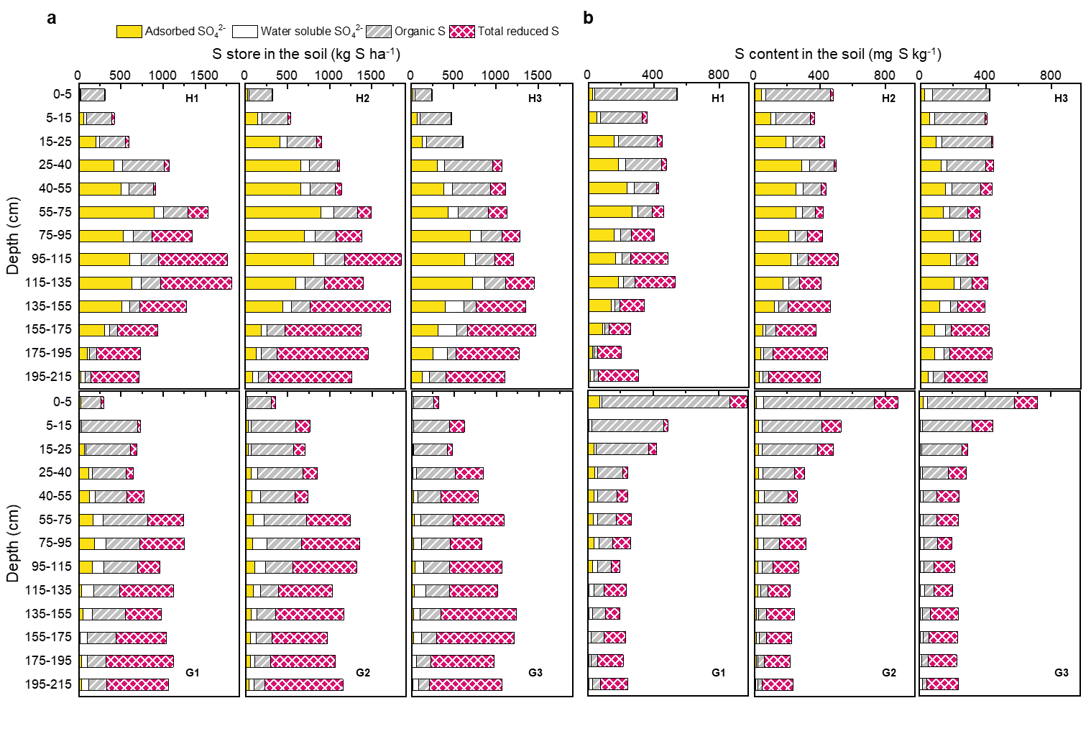
Supplementary Fig. 1| S species composition within entire soil profile. a, S store in kg ha⁻¹, b, S content in mg kg⁻¹. Plots H1, H2, and H3 located at hillslope, and G1, G2, and G3 located at groundwater discharge zone.

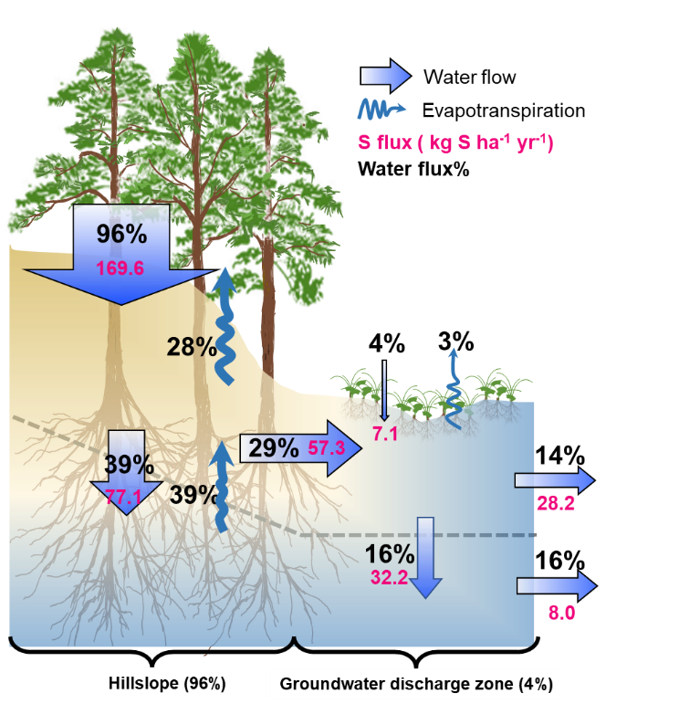
Supplementary Fig. 2| The water flow and hydrologic S fluxes in TSP catchment.
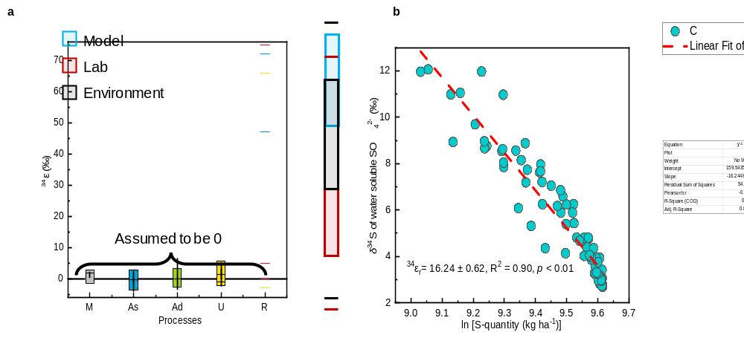
Supplementary Fig. 3| The isotope fractionation effects. a, for mineralization (M)^{19,20}, assimilation (As)²⁰⁻²², adsorption (Ad)²³⁻²⁶, plant uptake (U)²⁷⁻³³, and reduction (R)^{15,17} in previous studies. b, for sulfate reduction determined by the slope of a Rayleigh model in this study.
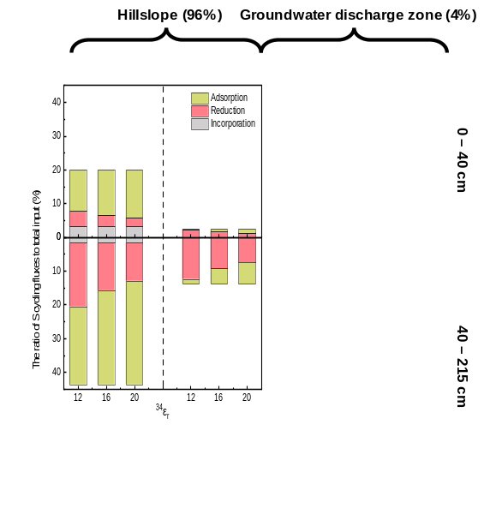
Supplementary Fig. 4| The impact of ³⁴ε_{r} on the fluxes of S-retention processes in TSP catchment.
Supplementary Table. 1| Sulfur budgets in forested catchments in temperate and subtropical forests. The unit of S fluxes is kg S ha⁻¹ yr⁻¹.

Location^{period} | S deposition | S export | Reference
Temperate forested catchments
Sogndal, Norway | 7.36 | 7.36 | ³⁴
Gårdsjön, Sweden | 37.8 | 46.7 | ³⁴
Aber,Wales | 58.9 | 41.6 | ³⁴
Alptal, Switzerland | 16.6 | 21.4 | ³⁴
Klosterhede, Denmark | 56.0 | 52.2 | ³⁴
Solling, Germany | 84.8 | 129 | ³⁴
Speuld, Netherlands | 66.9 | 117 | ³⁴
Ysselsteyn, Netherlands | 75.8 | 117 | ³⁴
Experimental Lakes Area, Canada | 7.32 | 6.20 | ³⁵
Experimental Lakes Area, Canada | 7.32 | 9.24 | ³⁵
Experimental Lakes Area, Canada | 7.32 | 8.25 | ³⁵
Lac Tirasse, Canada | 9.11 | 12.8 | ³⁵
Bear Brook, USA | 15.8 | 14.3 | ³⁵
Langtjern, Norway | 18.4 | 13.0 | ³⁵
Moose Pit Brook, Canada | 18.9 | 21.1 | ³⁵
Lac Laflamme, Canada | 16.0 | 29.4 | ³⁵
Villingen, Germany | 18.9 | 30.2 | ³⁵
MUS-HAL, Canada | 21.7 | 29.9 | ³⁵
MUS-HAL, Canada | 21.7 | 32.6 | ³⁵
Lac Clair, Canada | 23.9 | 35.1 | ³⁵
Cone Pond, USA | 20.7 | 36.0 | ³⁵
MUS-HAL, Canada | 21.7 | 35.1 | ³⁵
Turkey Lakes, Canada | 20.7 | 39.7 | ³⁵
Hubbard Brook, USA | 28.4 | 44.5 | ³⁵
Birkenes, Norway | 26.7 | 51.1 | ³⁵
Schluchsee, Germany | 20.9 | 50.9 | ³⁵
Arbutus, USA | 17.0 | 47.9 | ³⁵
Lehstenbach, Germany | 24.1 | 105 | ³⁵
Whiteface, USA | 55.1 | 58.0 | ³⁵
Zöbelboden, Austria | 6.08 | 3.52 | ³⁶
Anenske Povodi, Czech Republic | 13.3 | 9.60 | ³⁶
Lysina, Czech Republic | 14.2 | 19.0 | ³⁶
Forellenbach, Germany | 6.40 | 10.7 | ³⁶
Saarejärve, Estonia | 5.76 | 6.72 | ³⁶
Valkea-Kotinen, Finland | 4.16 | 4.00 | ³⁶
Hietajärvi, Finland | 2.72 | 1.60 | ³⁶
Renon-Ritten, Italy | 3.84 | 1.38 | ³⁶
Aukstaitija, Lithuania | 3.36 | 22.1 | ³⁶
Zemaitija, Lithuania | 9.92 | 17.3 | ³⁶
Birkenes, Norway | 8.00 | 10.7 | ³⁶
Kårvatn, Norway | 1.26 | 2.08 | ³⁶
Langtjern, Norway | 2.56 | 2.88 | ³⁶
Storkowo, Poland | 6.40 | 28.5 | ³⁶
Szymbark, Poland | 13.6 | 50.6 | ³⁶
Gårdsjön, Sweden | 7.04 | 9.76 | ³⁶
Aneboda, Sweden | 2.56 | 6.24 | ³⁶
Kindla, Sweden | 3.20 | 7.68 | ³⁶
Gammtratten, Sweden | 1.18 | 2.40 | ³⁶
Zöbelboden, Austria | 5.60 | 3.84 | ³⁷
Anenske Povodi, Czech Republic | 13.6 | 9.60 | ³⁷
Lysina, Czech Republic | 16.0 | 20.5 | ³⁷
Forellenbach, Germany | 6.40 | 11.4 | ³⁷
Saarejärve, Estonia | 5.28 | 7.04 | ³⁷
Valkea-Kotinen, Finland | 4.32 | 4.16 | ³⁷
Hietajärvi, Finland | 2.56 | 1.76 | ³⁷
Aukstaitija, Lithuania | 4.32 | 7.68 | ³⁷
Zemaitija, Lithuania | 11.8 | 19.5 | ³⁷
Rucava, Latvia | 6.40 | 14.2 | ³⁷
Zoseni, Latvia | 4.64 | 16.5 | ³⁷
Birkenes, Norway | 10.6 | 13.6 | ³⁷
Kårvatn, Norway | 2.88 | 3.68 | ³⁷
Gårdsjön, Sweden | 11.2 | 14.7 | ³⁷
Aneboda, Sweden | 3.36 | 7.68 | ³⁷
Kindla, Sweden | 3.84 | 8.32 | ³⁷
Gammtratten, Sweden | 1.34 | 2.56 | ³⁷
Navasfrias, Western Spain | 5.00 | 4.90 | ³⁸
Jezeří, Czech Republic | 40.0 | 56.0 | ³⁹
Jezeří, Czech Republic | 33.0 | 58.0 | ³⁹
Načetín, Czech Republic | 29.0 | 85.0 | ³⁹
Schluchsee, Germany | 11.3 | 10.0 | ²⁴
Villingen, Germany | 11.0 | 17.1 | ²⁴
Lehstenbach, Germany | 45.4 | 28.5 | ²⁴
Cervik, Czech Republic | 30.5 | 59.7 | ⁴⁰
Anensky potok, Czech Republic, | 18.5 | 9.90 | ⁴⁰
Jezeri, Czech Republic, | 60.9 | 56.5 | ⁴⁰
Lesni potok, Czech Republic, | 20.7 | 43.3 | ⁴⁰
Na Lizu, Czech Republic, | 11.9 | 14.9 | ⁴⁰
Lysina, Czech Republic | 22.7 | 19.8 | ⁴⁰
Modry potok, Czech Republic, | 26.0 | 22.6 | ⁴⁰
Pluhuv Bo, Czech Republic, | 15.6 | 25.3 | ⁴⁰
Polomka, Czech Republic, | 37.8 | 52.5 | ⁴⁰
Salacova, Czech Republic, | 20.4 | 8.60 | ⁴⁰
Spalenec, Czech Republic, | 22.3 | 14.1 | ⁴⁰
U dvou loucek, Czech Republic, | 40.9 | 37.8 | ⁴⁰
Uhlirska, Czech Republic, | 71.5 | 49.7 | ⁴⁰
Plastic Lake, Ontario, Canada¹⁹⁸⁸ | 27.4 | 44.8 | ⁴¹
Plastic Lake, Ontario, Canada¹⁹⁸⁹ | 24.5 | 45.6 | ⁴¹
Plastic Lake, Ontario, Canada¹⁹⁹⁰ | 22.2 | 43.7 | ⁴¹
Plastic Lake, Ontario, Canada¹⁹⁹¹ | 25.6 | 53.0 | ⁴¹
Plastic Lake, Ontario, Canada¹⁹⁹² | 25.6 | 38.7 | ⁴¹
Plastic Lake, Ontario, Canada¹⁹⁹³ | 23.8 | 47.4 | ⁴¹
Plastic Lake, Ontario, Canada¹⁹⁹⁴ | 20.9 | 28.6 | ⁴¹
Plastic Lake, Ontario, Canada¹⁹⁹⁵ | 21.4 | 36.4 | ⁴¹
Plastic Lake, Ontario, Canada²⁰⁰⁰ | 23.3 | 43.2 | ⁴¹
Plastic Lake, Ontario, Canada²⁰⁰¹ | 15.1 | 25.2 | ⁴¹
Archer Creek, New York, USA | 9.10 | 15.2 | ⁴²
Mississippi, USA | 3.64 | 2.98 | ⁴³
Thompson site, Washington, USA | 5.81 | 5.62 | ⁴³
Central Sweden | 12.8 | 1.18 | ⁴³
Pack Forest, Washington, USA | 16.7 | 6.79 | ⁴³
Mediterranean, France | 21.7 | 22.2 | ⁴³
Hubbard Brook, New Hampshire, USA | 21.2 | 18.1 | ⁴³
Beech stands, Solling, West Germany | 48.2 | 38.5 | ⁴³
Spruce stands, Solling, West Germany | 62.6 | 54.4 | ⁴³
Thompson Site, Washington, USA | 25.7 | 18.7 | ⁴⁴
Thompson Site, Washington, USA | 23.0 | 43.5 | ⁴⁴
Andrews, Loch Vale, Colorado, USA | 12.6 | 23.0 | ⁴⁵
Sleepers River, Vermont, USA | 45.8 | 104 | ⁴⁵
Allequash, Trout Lake, Wisconsin, USA | 14.6 | 21.7 | ⁴⁵
Arbutus, New York, USA | 6.70 | 11.5 | ⁴⁶
Black, New York, USA | 5.76 | 9.74 | ⁴⁶
Windfall, New York, USA | 9.22 | 12.4 | ⁴⁶
Constable, New York, USA | 8.92 | 11.9 | ⁴⁶
Cascade, New York, USA | 8.69 | 11.4 | ⁴⁶
Moss, New York, USA | 8.69 | 11.3 | ⁴⁶
Otter, New York, USA | 9.33 | 11.9 | ⁴⁶
Big Moose, New York, USA | 8.69 | 10.9 | ⁴⁶
Dart, New York, USA | 8.63 | 10.8 | ⁴⁶
Rondaxe, New York, USA | 8.80 | 10.7 | ⁴⁶
Bubb, New York, USA | 8.80 | 10.2 | ⁴⁶
Heart, New York, USA | 6.87 | 8.10 | ⁴⁶
West, New York, USA | 8.98 | 9.45 | ⁴⁶
Squash, New York, USA | 9.86 | 10.1 | ⁴⁶
Thompson, Washington, USA | 4.10 | 6.10 | ⁴⁷
Eatonville, Washington, USA | 8.90 | 6.70 | ⁴⁷
Hubbard Brook, New Hampshire, USA | 12.7 | 17.6 | ⁴⁷
Chesuncook, Maine, USA | 6.30 | 7.50 | ⁴⁷
Narraguagus, Maine, USA | 7.00 | 12.9 | ⁴⁷
White River, Vermont, USA | 5.30 | 17.0 | ⁴⁷
Huntington Forest, New York, USA | 8.00 | 14.0 | ⁴⁷
Panther Lake, New York, USA | 15.6 | 16.9 | ⁴⁷
Sagamore Lake, New York, USA | 13.7 | 19.3 | ⁴⁷
Woods Lake, New York, USA | 13.8 | 14.3 | ⁴⁷
Silver Creek, Idaho, USA | 3.60 | 2.20 | ⁴⁷
Vilas County, Wisconsin, USA | 4.60 | 2.60 | ⁴⁷
Haney, British Columbia, Canada | 7.90 | 9.45 | ⁴⁷
Rawson Lake, Ontario, Canada | 3.70 | 3.93 | ⁴⁷
Harp Lake, Ontario, Canada | 12.6 | 17.8 | ⁴⁷
Turkey Lakes, Ontario, Canada | 10.2 | 13.3 | ⁴⁷
Kananaskis Valley, Alberta, Canada | 6.30 | 17.4 | ⁴⁷
Jamieson Creek, British Columbia, Canada | 6.70 | 9.00 | ⁴⁷
Vancouver Island, British Columbia, Canada | 8.70 | 28.2 | ⁴⁷
Kejimkujik, Nova Scotia, Canada | 7.40 | 11.6 | ⁴⁷
Langtjern, Norway | 6.11 | 5.42 | ⁴⁸
Storgama, Norway | 9.41 | 9.17 | ⁴⁸
Villingen, Germany | 9.45 | 9.88 | ⁴⁸
Schluchsee, Germany | 9.45 | 9.88 | ⁴⁸
Vysne Wahlenbergovo, Slovakia | 15.0 | 12.4 | ⁴⁸
Risdalsheia ROLF Reference, Norway | 14.2 | 14.0 | ⁴⁸
Schluchsee, Germany | 9.01 | 16.9 | ⁴⁸
Gårdsjön F1 Control, Sweden | 15.9 | 19.6 | ⁴⁸
Markungsgraben, Germany | 19.2 | 17.3 | ⁴⁸
Birkenes, Norway | 19.6 | 21.9 | ⁴⁸
Allt a Mharcaidh, United Kingdom | 22.7 | 20.7 | ⁴⁸
Cannobino, Italy | 21.2 | 24.4 | ⁴⁸
Pellesino, Italy | 25.2 | 20.5 | ⁴⁸
Pellino, Italy | 23.9 | 28.2 | ⁴⁸
Pescone, Italy | 23.3 | 40.4 | ⁴⁸
Černé, Czech Republic | 31.6 | 23.6 | ⁴⁸
Lange Bramke, Germany | 37.0 | 24.6 | ⁴⁸
Lehstenbach, Germany | 31.7 | 27.8 | ⁴⁸
Čertovo, Czech Republic | 31.6 | 28.9 | ⁴⁸
Plešné, Czech Republic | 31.6 | 29.5 | ⁴⁸
Subtropical forested catchments in USA
Walker Branch Watershed, Tennessee, USA | 28.4 | 10.2 | ⁴³
Walker Branch Watershed, Tennessee, USA | 62.6 | 11.4 | ⁴³
Camp Branch Watershed, Tennessee, USA | 8.40 | 5.70 | ⁴⁴
Walker Branch Watershed, Tennessee, USA | 8.90 | 12.2 | ⁴⁴
Walker Branch Watershed, Tennessee, USA | 13.4 | 7.00 | ⁴⁴
Panola Mountain, Georgia, USA | 34.7 | 18.4 | ⁴⁵
Panola Mountain Research Watershed, Georgia | 13.5 | 1.80 | ⁴⁹
Noland Divide Watershed, Tennessee1991 | 30.8 | 12.9 | ⁵⁰
Noland Divide Watershed, Tennessee1992 | 34.8 | 12.4 | ⁵⁰
Noland Divide Watershed, Tennessee1993 | 39.7 | 15.4 | ⁵⁰
Walker Branch, Tennessee, USA | 14.9 | 11.5 | ⁴⁷
Cross Creek, Tennessee, USA | 14.6 | 10.3 | ⁴⁷
Camp Branch, Tennessee, USA | 11.2 | 9.20 | ⁴⁷
Coweeta, North Carolina, USA | 12.0 | 1.68 | ⁴⁷
White Oak Run, Virginia, USA | 10.0 | 6.40 | ⁴⁷
Deep Run, Virginia, USA | 10.0 | 3.30 | ⁴⁷
Clemson, South Carolina, USA | 12.3 | 3.40 | ⁴⁷
Subtropical forested catchments in China
TSP, Chongqing, China²⁰⁰¹ | 139 | 28.9 | ⁵¹
TSP, Chongqing, China²⁰⁰² | 167 | 79.5 | ⁵¹
TSP, Chongqing, China²⁰⁰³ | 169 | 43.8 | ⁵¹
TSP, Chongqing, China²⁰⁰⁴ | 234 | 75.1 | ⁵¹
TSP, Chongqing, China²⁰⁰⁵ | 231 | - | ⁵¹
TSP, Chongqing, China²⁰⁰⁶ | 163 | - | ⁵¹
TSP, Chongqing, China²⁰⁰⁷ | 206 | - | ⁵¹
TSP, Chongqing, China²⁰⁰⁸ | 214 | - | ⁵¹
TSP, Chongqing, China²⁰⁰⁹ | 169 | 31.7 | ⁵¹
TSP, Chongqing, China²⁰¹⁰ | 191 | 33.0 | ⁵¹
TSP, Chongqing, China²⁰¹¹ | 179 | 31.0 | ⁵¹
TSP, Chongqing, China²⁰¹² | 184 | 43.9 | ⁵¹
TSP, Chongqing, China²⁰¹³ | 123 | 36.0 | ⁵¹
TSP, Chongqing, China²⁰¹⁷ | 83.1 | 47.3 | This study
TSP, Chongqing, China²⁰⁰⁴ | 160 | 60.0 | ⁵²
CJT, Hunan, China²⁰⁰⁴ | 68.0 | 24.0 | ⁵²
LGS, Guizhou, China²⁰⁰⁴ | 25.6 | 4.80 | ⁵²
LXH, Guangdong, China²⁰⁰⁴ | 28.0 | 4.80 | ⁵²
LCG, Guizhou, China²⁰⁰¹ | 43.0 | 2.57 | ⁵³
LGS, Guizhou, China²⁰⁰¹ | 7.97 | 3.67 | ⁵³
LGS, Guizhou, China²⁰⁰² | 18.7 | 5.23 | ⁵³
CJT, Hunan, China²⁰⁰¹ | 37.3 | 12.1 | ⁵³
CJT, Hunan, China²⁰⁰² | 65.4 | 7.36 | ⁵³
CJT, Hunan, China²⁰⁰³ | 70.8 | 2.51 | ⁵³
Fengxingzhuang, Anhui, China | 37.0 | 16.0 | ⁵⁴
Jiulianshan, Jiangxi, China | 10.9 | 1.90 | ⁵⁵
Jiulianshan, Jiangxi, China | 20.6 | 3.00 | ⁵⁵
Mt. Simian, Chongqing, China | 21.1 | 4.20 | ⁵⁶
Mt. Jinyun, Chongqing, China | 104 | 7.10 | ⁵⁷
Mt. Jinyun, Chongqing, China | 71.5 | 8.40 | ⁵⁷
Mt. Baiyun, Guangdong, China | 95.6 | 20.0 | ⁵⁸
Mt. Baiyun, Guangdong, China | 193 | 48.4 | ⁵⁸
Longdong, Guangdong, China | 96.9 | 5.20 | ⁵⁸
Liuchongguan, Guizhou, China¹⁹⁹² | 59.0 | 31.5 | ⁵⁹
Liuchongguan, Guizhou, China¹⁹⁹³ | 91.7 | 26.7 | ⁵⁹
Liuchongguan, Guizhou, China¹⁹⁹⁴ | 89.7 | 26.9 | ⁵⁹
Liuchongguan, Guizhou, China²⁰⁰¹ | 85.2 | 34.6 | ⁵⁹
Liuchongguan, Guizhou, China²⁰⁰² | 64.2 | 28.0 | ⁵⁹
Liuchongguan, Guizhou, China²⁰⁰³ | 59.7 | 27.6 | ⁵⁹
Liuchongguan, Guizhou, China²⁰⁰⁴ | 61.5 | 32.5 | ⁵⁹
Liuchongguan, Guizhou, China²⁰⁰⁵ | 147 | 49.2 | ⁵⁹
Kaiyang, Guizhou, China | 180 | 1.60 | ⁵⁷
Kaiyang, Guizhou, China | 112 | 3.50 | ⁵⁷
Hongya, Sichuan, China | 97.7 | 4.30 | ⁶⁰
Lushan, Jiangxi, China | 110 | 3.20 | ⁶¹
Lushan, Jiangxi, China | 62.2 | 5.70 | ⁶¹

Reference
1 Antler, G., Turchyn, A. V., Rennie, V., Herut, B. & Sivan, O. Coupled sulfur and oxygen isotope insight into bacterial sulfate reduction in the natural environment. Geochimica Et Cosmochimica Acta 118, 98-117, doi:10.1016/j.gca.2013.05.005 (2013).
2 Brunner, B., Bernasconi, S. M., Kleikemper, J. & Schroth, M. H. A model for oxygen and sulfur isotope fractionation in sulfate during bacterial sulfate reduction processes. Geochimica Et Cosmochimica Acta 69, 4773-4785, doi:10.1016/j.gca.2005.04.017 (2005).
3 Brunner, B. et al. The reversibility of dissimilatory sulphate reduction and the cell-internal multi-step reduction of sulphite to sulphide: insights from the oxygen isotope composition of sulphate. Isotopes in Environmental and Health Studies 48, 33-54, doi:10.1080/10256016.2011.608128 (2012).
4 Fritz, P., Basharmal, G. M., Drimmie, R. J., Ibsen, J. & Qureshi, R. M. Oxygen isotope exchange between sulfate and water during bacterial reduction of sulfate. Chemical Geology 79, 99-105, doi:10.1016/0168-9622(89)90012-2 (1989).
5 Antler, G., Turchyn, A. V., Ono, S., Sivan, O. & Bosak, T. Combined S-34, S-33 and O-18 isotope fractionations record different intracellular steps of microbial sulfate reduction. Geochimica Et Cosmochimica Acta 203, 364-380, doi:10.1016/j.gca.2017.01.015 (2017).
6 Turchyn, A. V. et al. Kinetic oxygen isotope effects during dissimilatory sulfate reduction: A combined theoretical and experimental approach. Geochimica Et Cosmochimica Acta 74, 2011-2024, doi:10.1016/j.gca.2010.01.004 (2010).
7 Schad, P. & Dondeyne, S. World Reference Base for Soil Resources. (2017).
8 Sorbotten, L.-E., Stolte, J., Wang, Y. & Mulder, J. Hydrological Responses and Flow Pathways in an Acrisol on a Forested Hillslope with a Monsoonal Subtropical Climate. Pedosphere 27, 1037-1048, doi:10.1016/s1002-0160(17)60447-8 (2017).
9 Bradley, A. S. et al. Patterns of sulfur isotope fractionation during microbial sulfate reduction. Geobiology 14, 91-101, doi:10.1111/gbi.12149 (2016).
10 Canfield, D. E., Olesen, C. A. & Cox, R. P. Temperature and its control of isotope fractionation by a sulfate-reducing bacterium. Geochimica Et Cosmochimica Acta 70, 548-561, doi:10.1016/j.gca.2005.10.028 (2006).
11 Canfield, D. E. & Thamdrup, B. The production of s-34-depleted sulfide during bacterial disproportionation of elemental sulfur. Science 266, 1973-1975, doi:10.1126/science.11540246 (1994).
12 Leavitt, W. D., Halevy, I., Bradley, A. S. & Johnston, D. T. Influence of sulfate reduction rates on the Phanerozoic sulfur isotope record. Proceedings of the National Academy of Sciences of the United States of America 110, 11244-11249, doi:10.1073/pnas.1218874110 (2013).
13 Ono, S., Sim, M. S. & Bosak, T. Predictive isotope model connects microbes in culture and nature. Proceedings of the National Academy of Sciences of the United States of America 111, 18102-18103, doi:10.1073/pnas.1420670111 (2014).
14 Shen, Y. A., Buick, R. & Canfield, D. E. Isotopic evidence for microbial sulphate reduction in the early Archaean era. Nature 410, 77-81, doi:10.1038/35065071 (2001).
15 Sim, M. S., Bosak, T. & Ono, S. Large Sulfur Isotope Fractionation Does Not Require Disproportionation. Science 333, 74-77, doi:10.1126/science.1205103 (2011).
16 Gilhooly, W. P., III, Reinhard, C. T. & Lyons, T. W. A comprehensive sulfur and oxygen isotope study of sulfur cycling in a shallow, hyper-euxinic meromictic lake. Geochimica Et Cosmochimica Acta 189, 1-23, doi:10.1016/j.gca.2016.05.044 (2016).
17 Brunner, B. & Bernasconi, S. M. A revised isotope fractionation model for dissimilatory sulfate reduction in sulfate reducing bacteria. Geochimica Et Cosmochimica Acta 69, 4759-4771, doi:10.1016/j.gca.2005.04.015 (2005).
18 Mariotti, A. et al. Experimental determination of nitrogen kinetic isotope fractionation: some principles; illustration for the denitrification and nitrification processes. Plant Soil 62, 413-430, doi:10.1007/bf02374138 (1981).
19 Mayer, B., Fritz, P., Prietzel, J. & Krouse, H. R. The use of stable sulfur and oxygen-isotope ratios for interpreting the mobility of sulfate in aerobic forest soils. Appl. Geochem. 10, 161-173, doi:10.1016/0883-2927(94)00054-a (1995).
20 Norman, A. L., Giesemann, A., Krouse, H. R. & Jager, H. J. Sulphur isotope fractionation during sulphur mineralization: Results of an incubation-extraction experiment with a Black Forest soil. Soil Biol. Biochem. 34, 1425-1438, doi:10.1016/s0038-0717(02)00086-x (2002).
21 Novak, M. et al. Similarity between C, N and S stable isotope profiles in European spruce forest soils: implications for the use of delta S-34 as a tracer. Appl. Geochem. 18, 765-779, doi:10.1016/s0883-2927(02)00162-2 (2003).
22 Zhang, W., Liu, C.Q., Wang, Z.L., Zhang, L.L. & Luo, X.Q. Speciation and Isotopic Composition of Sulfur in Limestone Soil and Yellow Soil in Karst Areas of Southwest China: Implications of Different Responses to Acid Deposition. Journal of Environmental Quality 43, 809-819, doi:10.2134/jeq2013.09.0359 (2014).
23 Fuller, R. D., Mitchell, M. J., Krouse, H. R., Wyskowski, B. J. & Driscoll, C. T. Stable sulfur isotope ratios as a tool for interpreting ecosystem sulfur dynamics. Water Air Soil Pollut. 28, 163-171 (1986).
24 Mayer, B., Feger, K. H., Giesemann, A. & Jager, H. J. Interpretation of sulfur cycling in 2 catchments in the black-forest (germany) using stable sulfur and oxygen-isotope data. Biogeochemistry 30, 31-58, doi:10.1007/bf02181039 (1995).
25 Vanstempvoort, D. R., Reardon, E. J. & Fritz, P. Fractionation of sulfur and oxygen isotopes in sulfate by soil sorption. Geochimica Et Cosmochimica Acta 54, 2817-2826, doi:10.1016/0016-7037(90)90016-e (1990).
26 Xiao, H.-Y., Li, N. & Liu, C.-Q. Source Identification of Sulfur in Uncultivated Surface Soils from Four Chinese Provinces. Pedosphere 25, 140-149, doi:10.1016/s1002-0160(14)60084-9 (2015).
27 Bern, C. R. & Townsend, A. R. Accumulation of atmospheric sulfur in some Costa Rican soils. J. Geophys. Res.-Biogeosci. 113, doi:10.1029/2008jg000692 (2008).
28 Novak, M., Bottrell, S. H. & Prechova, E. Sulfur isotope inventories of atmospheric deposition, spruce forest floor and living Sphagnum along a NW-SE transect across Europe. Biogeochemistry 53, 23-50, doi:10.1023/a:1010792205756 (2001).
29 Tcherkez, G. & Tea, I. S-32/S-34 isotope fractionation in plant sulphur metabolism. New Phytologist 200, 44-53, doi:10.1111/nph.12314 (2013).
30 Trust, B. A. & Fry, B. Stable sulfur isotopes in plants - a review. Plant Cell and Environment 15, 1105-1110, doi:10.1111/j.1365-3040.1992.tb01661.x (1992).
31 Vanstempvoort, D. R., Wills, J. J. & Fritz, P. Aboveground vegetation effects on the deposition and cycling of atmospheric sulfur - chemical and stable isotope evidence. Water Air Soil Pollut. 60, 55-82, doi:10.1007/bf00293966 (1991).
32 Xiao, H.-Y., Zhu, R.-G., Lin, B.-N. & Liu, C.-Q. Sulfur isotopic signatures in rainwater and moss Haplocladium microphyllum indicating atmospheric sulfur sources in Nanchang City (SE China). Sci. Total Environ. 409, 2127-2132, doi:10.1016/j.scitotenv.2011.02.011 (2011).
33 Yi-Balan, S. A., Amundson, R. & Buss, H. L. Decoupling of sulfur and nitrogen cycling due to biotic processes in a tropical rainforest. Geochimica Et Cosmochimica Acta 142, 411-428, doi:10.1016/j.gca.2014.05.049 (2014).
34 Bredemeier, M. et al. Input-output budgets at the NITREX sites. For. Ecol. Manage. 101, 57-64, doi:10.1016/s0378-1127(97)00125-4 (1998).
35 Watmough, S. A. et al. Sulphate, nitrogen and base cation budgets at 21 forested catchments in Canada, the United States and Europe. Environ. Monit. Assess. 109, 1-36, doi:10.1007/s10661-005-4336-z (2005).
36 Vuorenmaa, J. et al. Long-term changes (1990-2015) in the atmospheric deposition and runoff water chemistry of sulphate, inorganic nitrogen and acidity for forested catchments in Europe in relation to changes in emissions and hydrometeorological conditions. Sci. Total Environ. 625, 1129-1145, doi:10.1016/j.scitotenv.2017.12.245 (2018).
37 Vuorenmaa, J. et al. Long-term sulphate and inorganic nitrogen mass balance budgets in European ICP Integrated Monitoring catchments (1990-2012). Ecological Indicators 76, 15-29, doi:10.1016/j.ecolind.2016.12.040 (2017).
38 Quilchano, C., Haneklaus, S., Gallardo, J. F., Schnug, E. & Moreno, G. Sulphur balance in a broadleaf, non-polluted, forest ecosystem (central-western Spain). For. Ecol. Manage. 161, 205-214, doi:10.1016/s0378-1127(01)00483-2 (2002).
39 Novak, M. et al. Sulfur isotope dynamics in two Central European watersheds affected by high atmospheric deposition of SOx. Geochimica Et Cosmochimica Acta 64, 367-383, doi:10.1016/s0016-7037(99)00298-7 (2000).
40 Novak, M. et al. Isotopic evidence for processes of sulfur retention/release in 13 forested catchments spanning a strong pollution gradient (Czech Republic, central Europe). Global Biogeochemical Cycles 19, doi:10.1029/2004gb002396 (2005).
41 Eimers, M. C., Dillon, P. J. & Schiff, S. L. Sulphate flux from an upland forested catchment in South-Central Ontario, Canada. Water Air Soil Pollut. 152, 3-21, doi:10.1023/b:wate.0000015334.03973.65 (2004).
42 Park, J. H., Mitchell, M. J., McHale, P. J., Christopher, S. F. & Meyers, T. P. Impacts of changing climate and atmospheric deposition on N and S drainage losses from a forested watershed of the Adirondack Mountains, New York State. Glob. Change Biol. 9, 1602-1619, doi:10.1046/j.1529-8817.2003.00686.x (2003).
43 Johnson, D. W. Sulfur cycling in forests. Biogeochemistry 1, 29-43, doi:10.1007/bf02181119 (1984).
44 Johnson, D. W., Richter, D. D., Vanmiegroet, H. & Kelly, J. M. Sulfur cycling in 5 forest ecosystems. Water Air Soil Pollut. 30, 965-979, doi:10.1007/bf00303360 (1986).
45 Peters, N. E. et al. Water and solute mass balance of five small, relatively undisturbed watersheds in the US. Sci. Total Environ. 358, 221-242, doi:10.1016/j.scitotenv.2005.04.044 (2006).
46 Mitchell, M. J., Driscoll, C. T., McHale, P. J., Roy, K. M. & Dong, Z. Lake/watershed sulfur budgets and their response to decreases in atmospheric sulfur deposition: watershed and climate controls. Hydrological Processes 27, 710-720, doi:10.1002/hyp.9670 (2013).
47 Rochelle, B. P., Church, M. R. & David, M. B. Sulfur retention at intensively studied sites in the United States and Canada. Water Air Soil Pollut. 33, 73-83, doi:10.1007/bf00191379 (1987).
48 Prechtel, A. et al. Response of sulphur dynamics in European catchments to decreasing sulphate deposition. Hydrol. Earth Syst. Sci. 5, 311-325, doi:10.5194/hess-5-311-2001 (2001).
49 Cappellato, R., Peters, N. E. & Meyers, T. P. Above-ground sulfur cycling in adjacent coniferous and deciduous forests and watershed sulfur retention in the Georgia Piedmont, USA. Water Air Soil Pollut. 103, 151-171, doi:10.1023/a:1004902816609 (1998).
50 Nodvin, S. C., VanMiegroet, H., Lindberg, S. E., Nicholas, N. S. & Johnson, D. W. Acidic deposition, ecosystem processes, and nitrogen saturation in a high elevation Southern Appalachian watershed. Water Air Soil Pollut. 85, 1647-1652, doi:10.1007/bf00477216 (1995).
51 Yu, Q. et al. Monitoring Effect of SO2 Emission Abatement on Recovery of Acidified Soil and Streamwater in Southwest China. Environ. Sci. Technol. 51, 9498-9506, doi:10.1021/acs.est.7b01147 (2017).
52 Larssen, T., Duan, L. & Mulder, J. Deposition and leaching of sulfur, nitrogen and calcium in four forested catchments in China: implications for acidification. Environ. Sci. Technol. 45, 1192-1198, doi:10.1021/es103426p (2011).
53 Larssen, T., Tang, D. & He, Y. Integrated Monitoring Program on Acidification of Chinese Terrestrial Systems - IMPACTS. Annual Report;Results 2003. (2004).
54 Huang, L.M., Zhang, G.l. & Yang, J.L. Weathering and soil formation rates based on geochemical mass balances in a small forested watershed under acid precipitation in subtropical China. Catena 105, 11-20, doi:10.1016/j.catena.2013.01.002 (2013).
55 Nakagawa, Y., Li, C. & Iwatsubo, G. Inputs and Outputs of Major Chemicals in a Subtropical Forested Watershed in Southern China. Resources Scinece 8, 93-103 (2001).
56 Sun, T., Ma, M., Wang, D.Y. & Huang, L.X. Dynamics of Nitrogen and Sulfur Wet Deposition in Typical Forest Stand at Different Spatial Levels in Simian Mountain, Mid-subtropical Region. Huanjing Kexue 35, 4475-4481, doi:10.13227/j.hjkx.2014.12.008 (2014).
57 Tang, X.F. et al. Canopy Leaching Characteristics of Typical Forests during Acid Rain at Jinyun Mountains, Chongqing. Forest Research 26, 548-553 (2013).
58 Xu, Y. G., Zhou, G. Y., Luo, T. S., Wu, Z. M. & He, Z. C. Soil solution chemistry and element budget in the forest ecosystem in Guangzhou. Acta Ecologica Sinica 21 (2001).
59 Xiao, J., Wu, X. & Xia, Y. Chemical Characteristics of Atmospheric Deposition and Surface Water in Liuchongguan Catchment, Guizhou Province. Research of Environmental Sciences 23, 539-542 (2010).
60 Huang, L. Precipiation redistribution and hydro-chemical characteristics of water of Pleioblastus Amarus forest ecosystem rainy area of West China, Sichuan Agricultural University, (2010).
61 Cao, L., Shi, S. & Pan, G. Distribution and Transport of Sulfur in the Surface Water System of Forest Ecosystem with Different Vegetative Covers. Earth and Environment 43, 8-13 (2015).

