Further Results:

Additional Tables
Table 1 Percentage of BGPs in cluster REF BGP 1 (n=206) limited by constraints for each variant
Constraint | NoRestrict | M1-GHG-Q NoRev | M1-GHG-Q | M1,5 | M2-EEG NoRev | M2-EEG | M1-2 | M1-2 150d | M1-3 | M1-4 | M1-5
Methane production* | 100% | 100% | 0% | 49% | 100% | 31% | 0% | 0% | 0% | 0% | 49%
Digestate storage capacity | 42% | 100% | 100% | 100% | 56% | 38% | 100% | 69% | 100% | 100% | 100%
GHG Emissions (M1) | 0% | 0% | 0% | 0% | 0% | 0% | 0% | 0% | 0% | 0% | 0%
GHG Emissions (M2) | 0% | 0% | 0% | 0% | 67% | 79% | 0% | 50% | 0% | 0% | 0%
TSIn, digester | 0% | 0% | 0% | 0% | 0% | 0% | 0% | 0% | 0% | 0% | 0%
TSOut, digester | 100% | 0% | 95% | 100% | 34% | 99% | 95% | 97% | 95% | 95% | 100%
OLR | 0% | 0% | 95% | 3% | 0% | 25% | 95% | 63% | 95% | 95% | 4%
HRT digester | 22% | 0% | 35% | 83% | 0% | 30% | 35% | 33% | 35% | 37% | 83%
HRT gastight system (M1) | 0% | 0% | 0% | 0% | 0% | 0% | 0% | 66% | 0% | 0% | 0%
HRT gastight system (M2) | 0% | 0% | 0% | 0% | 44% | 64% | 0% | 31% | 0% | 0% | 0%
Maize cap (M2) | 0% | 0% | 0% | 0% | 1% | 4% | 0% | 3% | 0% | 0% | 0%
* For variants with revenues the percentage of BGPs with production below the REF variants is shown.
Table 2 Percentage of BGPs in cluster REF BGP 3 (n=195) limited by constraints for each variant
Constraint | NoRestrict | M1-GHG-Q NoRev | M1-GHG-Q | M1,5 | M2-EEG NoRev | M2-EEG | M1-2 | M1-2 150d | M1-3 | M1-4 | M1-5
Methane production* | 100% | 100% | 18% | 83% | 100% | 59% | 18% | 22% | 18% | 18% | 83%
Digestate storage capacity | 100% | 100% | 100% | 100% | 92% | 92% | 100% | 95% | 100% | 100% | 100%
GHG Emissions (M1) | 0% | 0% | 0% | 0% | 0% | 0% | 0% | 0% | 0% | 0% | 0%
GHG Emissions (M2) | 0% | 0% | 0% | 0% | 85% | 85% | 0% | 7% | 0% | 0% | 0%
TSIn, digester | 2% | 2% | 2% | 0% | 0% | 0% | 2% | 2% | 2% | 2% | 0%
TSOut, digester | 98% | 50% | 90% | 100% | 73% | 92% | 90% | 90% | 90% | 90% | 100%
OLR | 8% | 5% | 24% | 2% | 12% | 13% | 24% | 23% | 24% | 24% | 2%
HRT digester | 88% | 31% | 80% | 88% | 38% | 73% | 80% | 80% | 80% | 80% | 88%
HRT gastight system (M1) | 0% | 0% | 0% | 0% | 0% | 0% | 0% | 8% | 0% | 0% | 0%
HRT gastight system (M2) | 0% | 0% | 0% | 0% | 8% | 8% | 0% | 6% | 0% | 0% | 0%
Maize cap (M2) | 0% | 0% | 0% | 0% | 23% | 39% | 0% | 5% | 0% | 0% | 0%
* For variants with revenues the percentage of BGPs with production below the REF variants is shown.
Table 3 Percentage of BGPs in cluster REF BGP 4 (n=338) limited by constraints for each variant
Constraint | NoRestrict | M1-GHG-Q NoRev | M1-GHG-Q | M1,5 | M2-EEG NoRev | M2-EEG | M1-2 | M1-2 150d | M1-3 | M1-4 | M1-5
Methane production* | 100% | 100% | 100% | 100% | 100% | 100% | 100% | 100% | 100% | 100% | 100%
Digestate storage capacity | 100% | 96% | 96% | 96% | 90% | 91% | 96% | 96% | 100% | 100% | 100%
GHG Emissions (M1) | 0% | 0% | 0% | 0% | 0% | 0% | 0% | 0% | 0% | 0% | 0%
GHG Emissions (M2) | 0% | 0% | 0% | 0% | 81% | 81% | 0% | 4% | 0% | 0% | 0%
TSIn, digester | 64% | 45% | 38% | 12% | 39% | 14% | 38% | 38% | 38% | 37% | 12%
TSOut, digester | 43% | 55% | 63% | 88% | 61% | 86% | 63% | 63% | 63% | 63% | 88%
OLR | 0% | 0% | 0% | 0% | 0% | 0% | 0% | 0% | 0% | 0% | 0%
HRT digester | 51% | 26% | 32% | 32% | 26% | 32% | 32% | 32% | 32% | 32% | 32%
HRT gastight system (M1) | 0% | 0% | 0% | 0% | 0% | 0% | 0% | 4% | 0% | 0% | 0%
HRT gastight system (M2) | 0% | 0% | 0% | 0% | 4% | 4% | 0% | 0% | 0% | 0% | 0%
Maize cap (M2) | 0% | 0% | 0% | 0% | 15% | 28% | 0% | 0% | 0% | 0% | 0%
* For variants with revenues the percentage of BGPs with production below the REF variants is shown.
Table 4 Percentage of BGPs in cluster REF BGP 5 (n=202) limited by constraints for each variant
Constraint | NoRestrict | M1-GHG-Q NoRev | M1-GHG-Q | M1,5 | M2-EEG NoRev | M2-EEG | M1-2 | M1-2 150d | M1-3 | M1-4 | M1-5
Methane production* | 100% | 100% | 98% | 99% | 100% | 100% | 98% | 98% | 98% | 99% | 99%
Digestate storage capacity | 100% | 95% | 97% | 95% | 85% | 86% | 97% | 96% | 100% | 100% | 99%
GHG Emissions (M1) | 0% | 0% | 0% | 0% | 0% | 0% | 0% | 0% | 0% | 0% | 0%
GHG Emissions (M2) | 0% | 0% | 0% | 0% | 81% | 81% | 0% | 4% | 0% | 0% | 0%
TSIn, digester | 60% | 37% | 31% | 8% | 29% | 11% | 31% | 31% | 31% | 30% | 8%
TSOut, digester | 46% | 62% | 70% | 92% | 71% | 88% | 70% | 70% | 70% | 70% | 92%
OLR | 0% | 2% | 2% | 2% | 3% | 2% | 2% | 2% | 2% | 2% | 2%
HRT digester | 60% | 28% | 38% | 38% | 25% | 38% | 38% | 38% | 38% | 38% | 38%
HRT gastight system (M1) | 0% | 0% | 0% | 0% | 0% | 0% | 0% | 4% | 0% | 0% | 0%
HRT gastight system (M2) | 0% | 0% | 0% | 0% | 4% | 4% | 0% | 0% | 0% | 0% | 0%
Maize cap (M2) | 0% | 0% | 0% | 0% | 19% | 31% | 0% | 0% | 0% | 0% | 0%
* For variants with revenues the percentage of BGPs with production below the REF variants is shown.
Table 5 REF BGP cluster specific gains (compared to a benchmark) for different variants with revenues
Cluster | REF BGP 1 | REF BGP 2 | REF BGP 3 | REF BGP 4 | REF BGP 5
 | Mean increase of BGPs with a gain
M1 (M1 NoRev) | 43% | 82% | 11% | 1% | 1%
M1,5 (M1) | 67% | 59% | 50% | 50% | 49%
M2 (M2 NoRev) | 18% | 64% | 5% | 3% | 2%
M1-3 (M1) | - | - | - | 140% | 133%
M1-4(M1) | 5% | 4% | 1% | 64% | 68%
M1-5 (M1,5) | 1% | 1% | - | 109% | 89%
 | Total gains in contribution margin across all BGPs
M1 (M1 NoRev) | 43% | 73% | 12% | 1% | 1%
M1,5 (M1) | 68% | 59% | 47% | 49% | 48%
M2 (M2 NoRev) | 19% | 57% | 5% | 3% | 2%
M1-3 (M1) | 0% | 0% | 0% | 1% | 1%
M1-4(M1) | 0% | 0% | 0% | 1% | 1%
M1-5 (M1,5) | 0% | 0% | 0% | 1% | 1%

Additional Figures
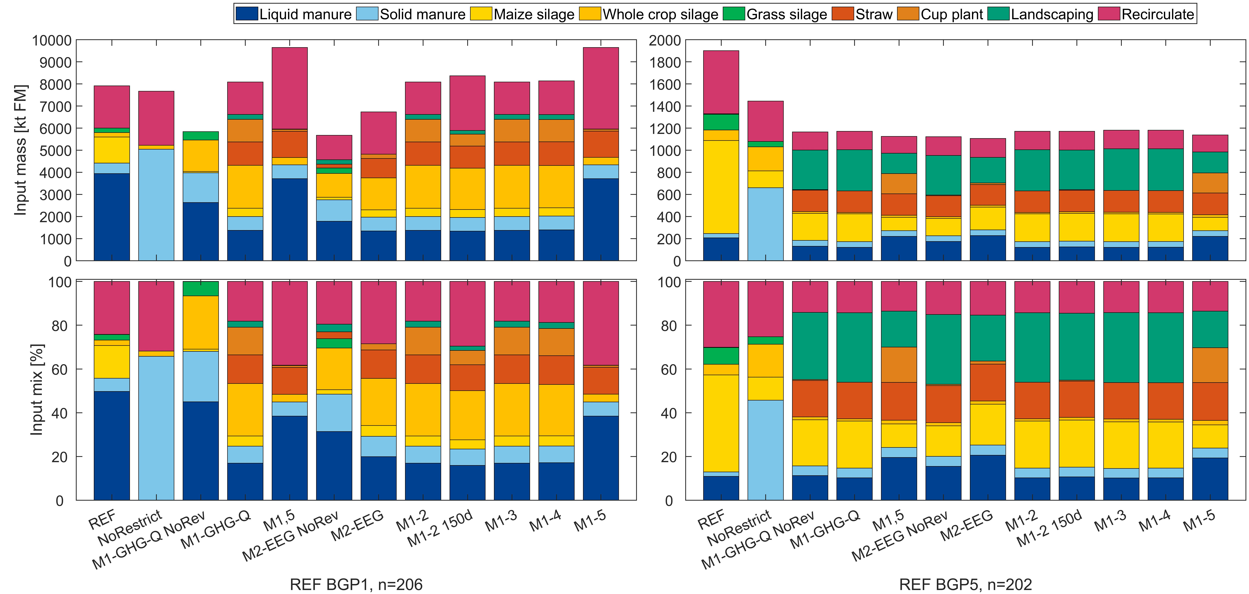
Figure 1 Comparison of the absolute and relative optimized substrate mix of the assessed variants for REF BGP1 & 5
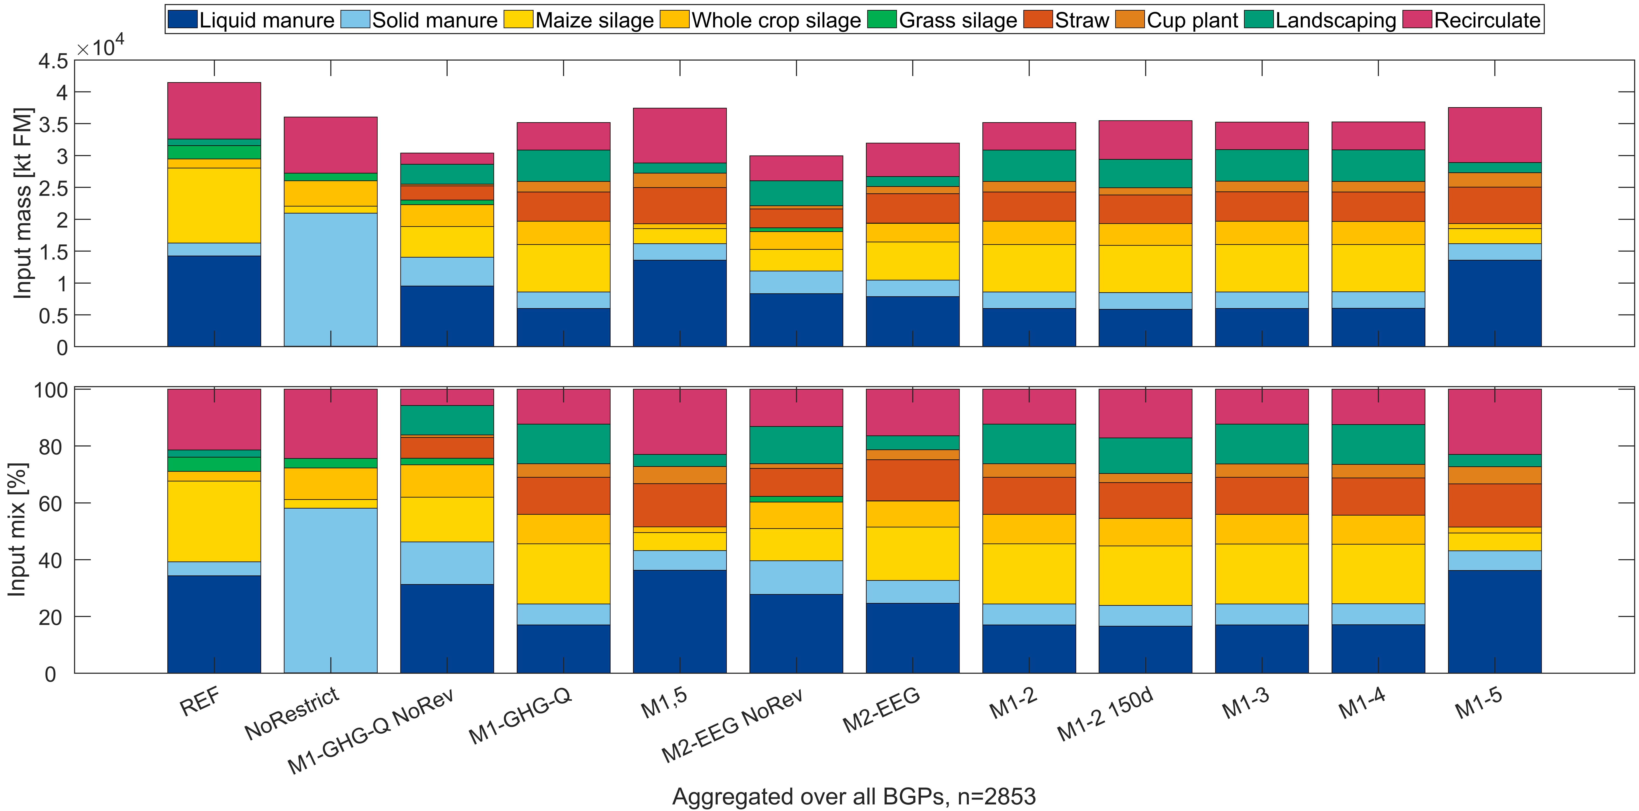
Figure 2 Comparison of the absolute and relative optimized substrate mix of the assessed variants summed across all BGPs in the database
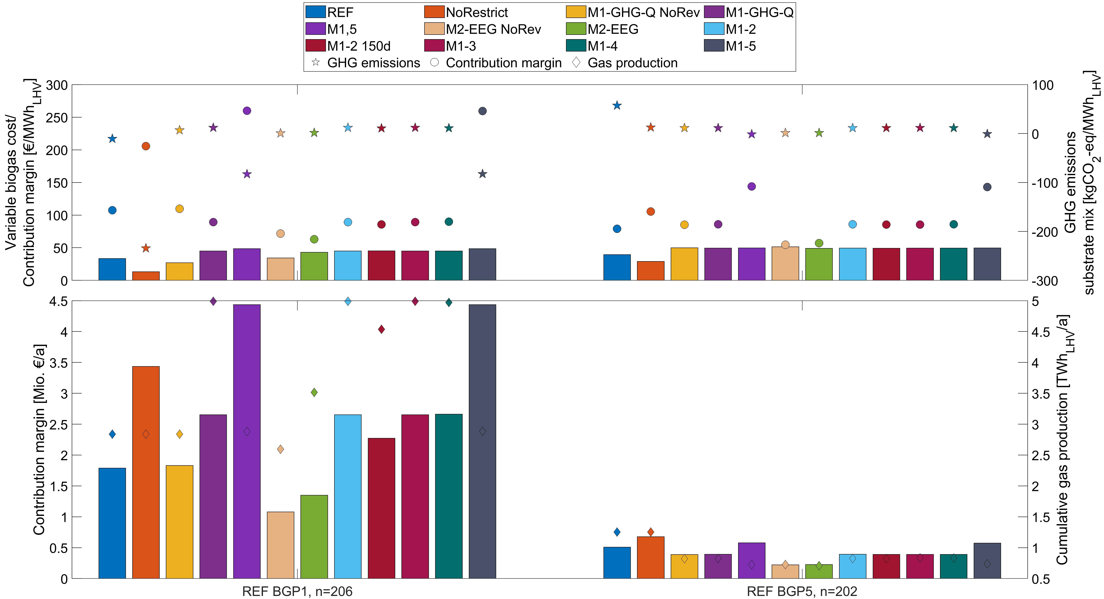
Figure 3 Impact of the assessed variants for clusters REF BGP1&5 on variable gas costs, contribution margin (spec. & abs.), GHG emissions and gas production (abs.), Specific values shown as weighted means (weighted by gas production).

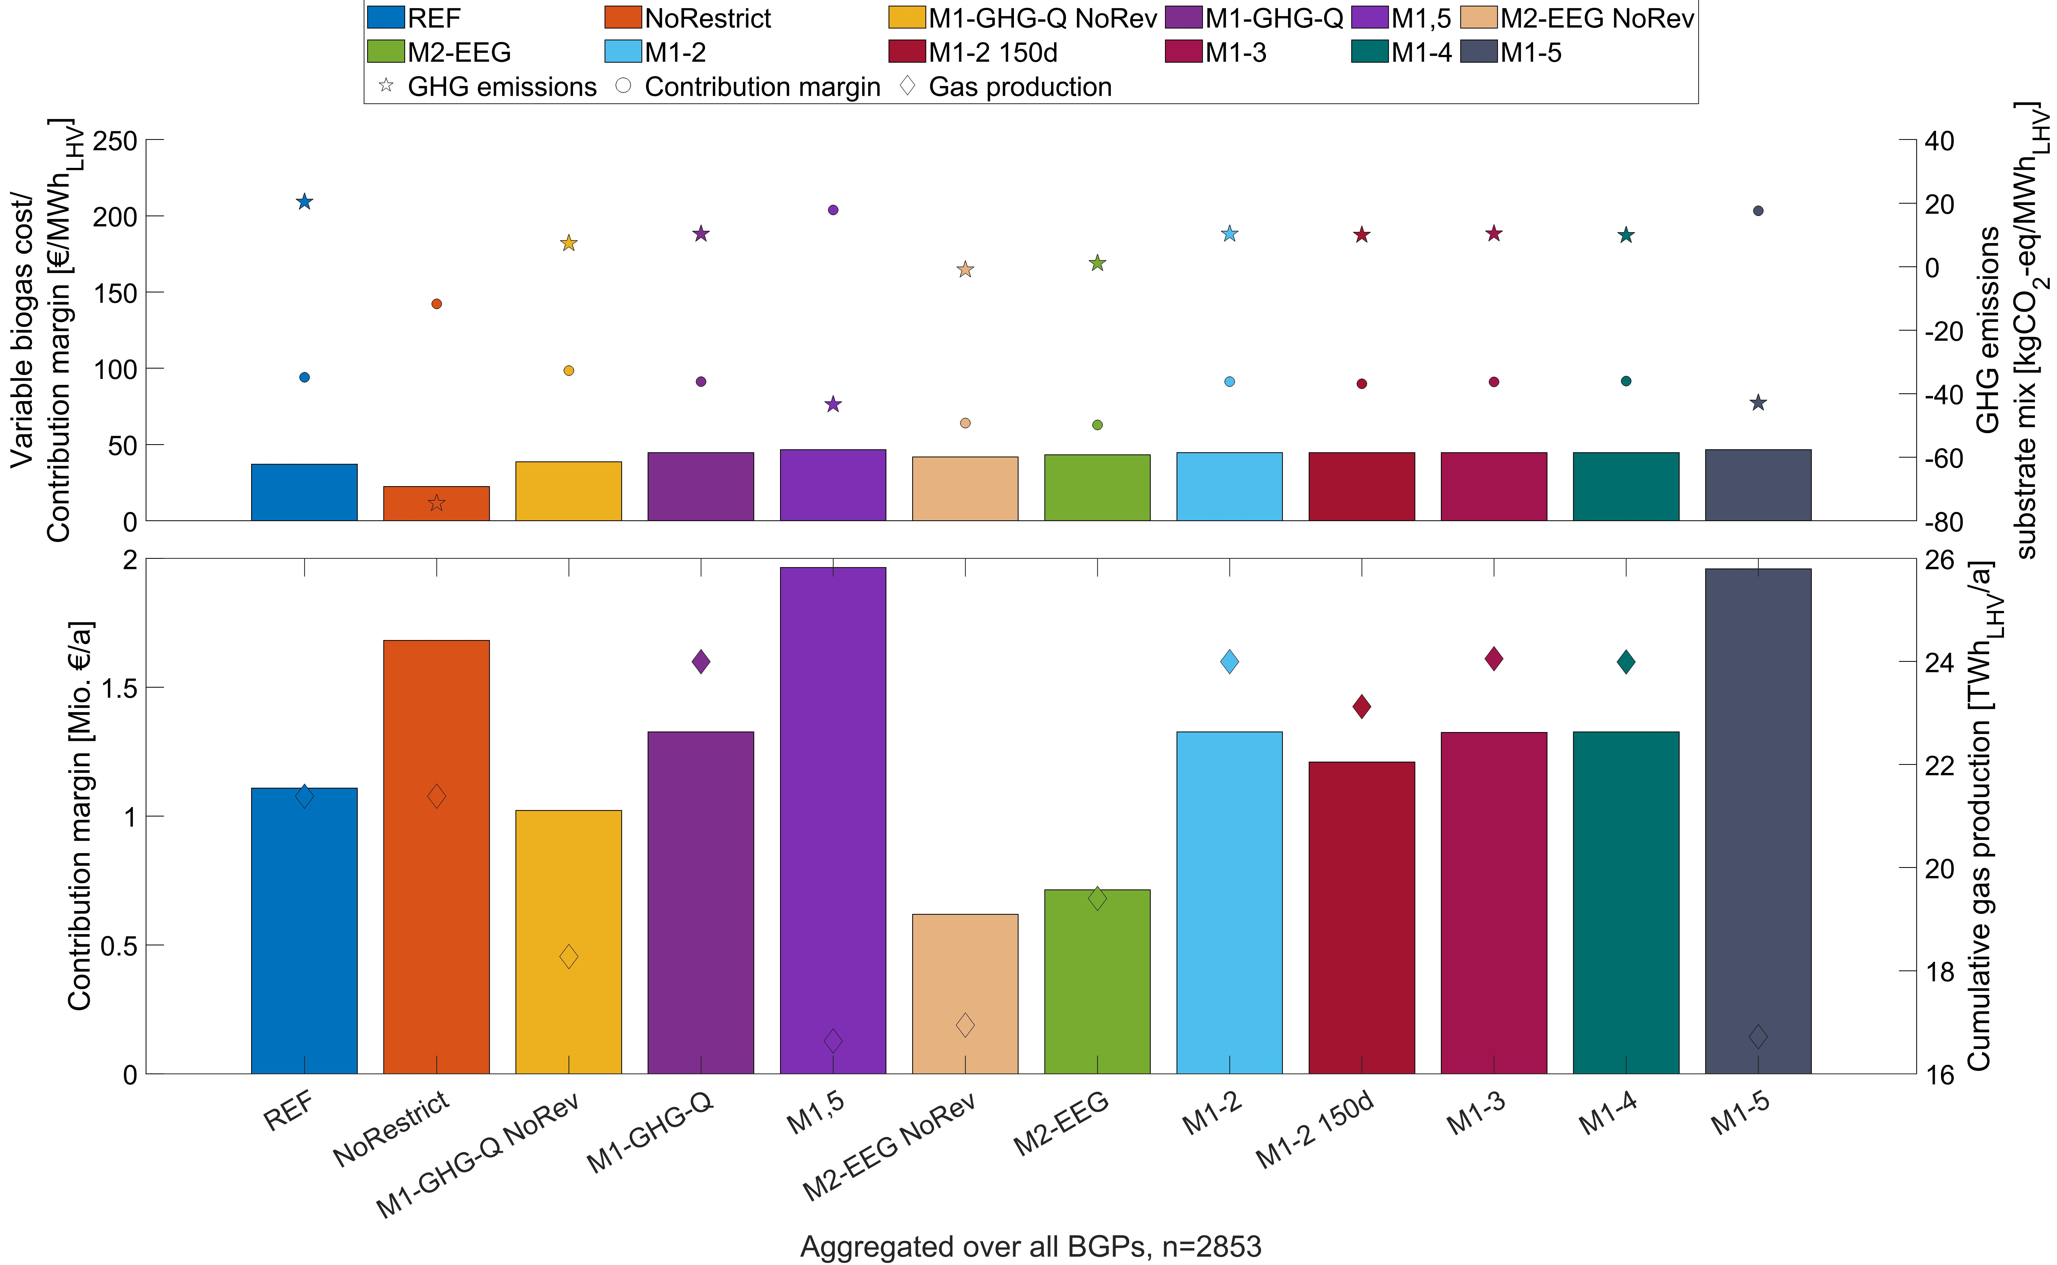
Figure 4 Impact of the assessed variants for all BGPs in the database on variable gas costs, contribution margin (spec. & abs.), GHG emissions and gas production (abs.), Specific values shown as weighted means (weighted by gas production).
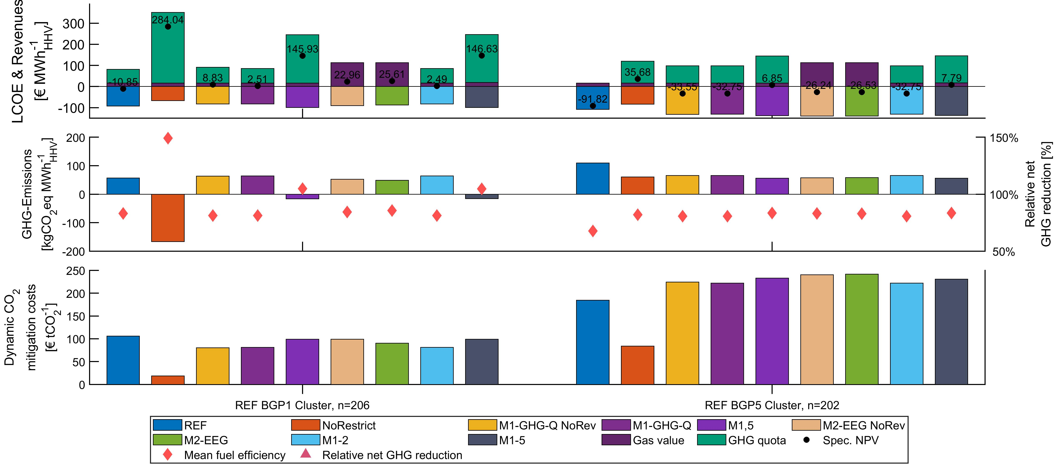
Figure 5 Comparison of selected key performance indicators of different variants for REF BGP clusters 1 & 5. Shown as weighted means (weighted by gas production).
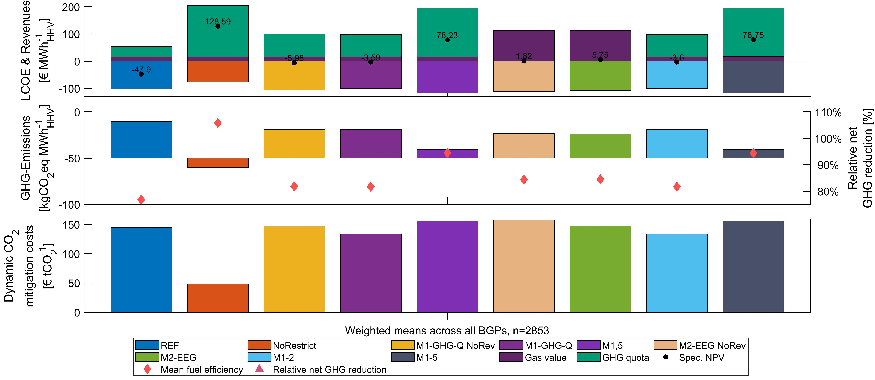
Figure 6 Comparison of selected key performance indicators of different variants for all BGPs in the database. Shown as weighted means (by gas production).
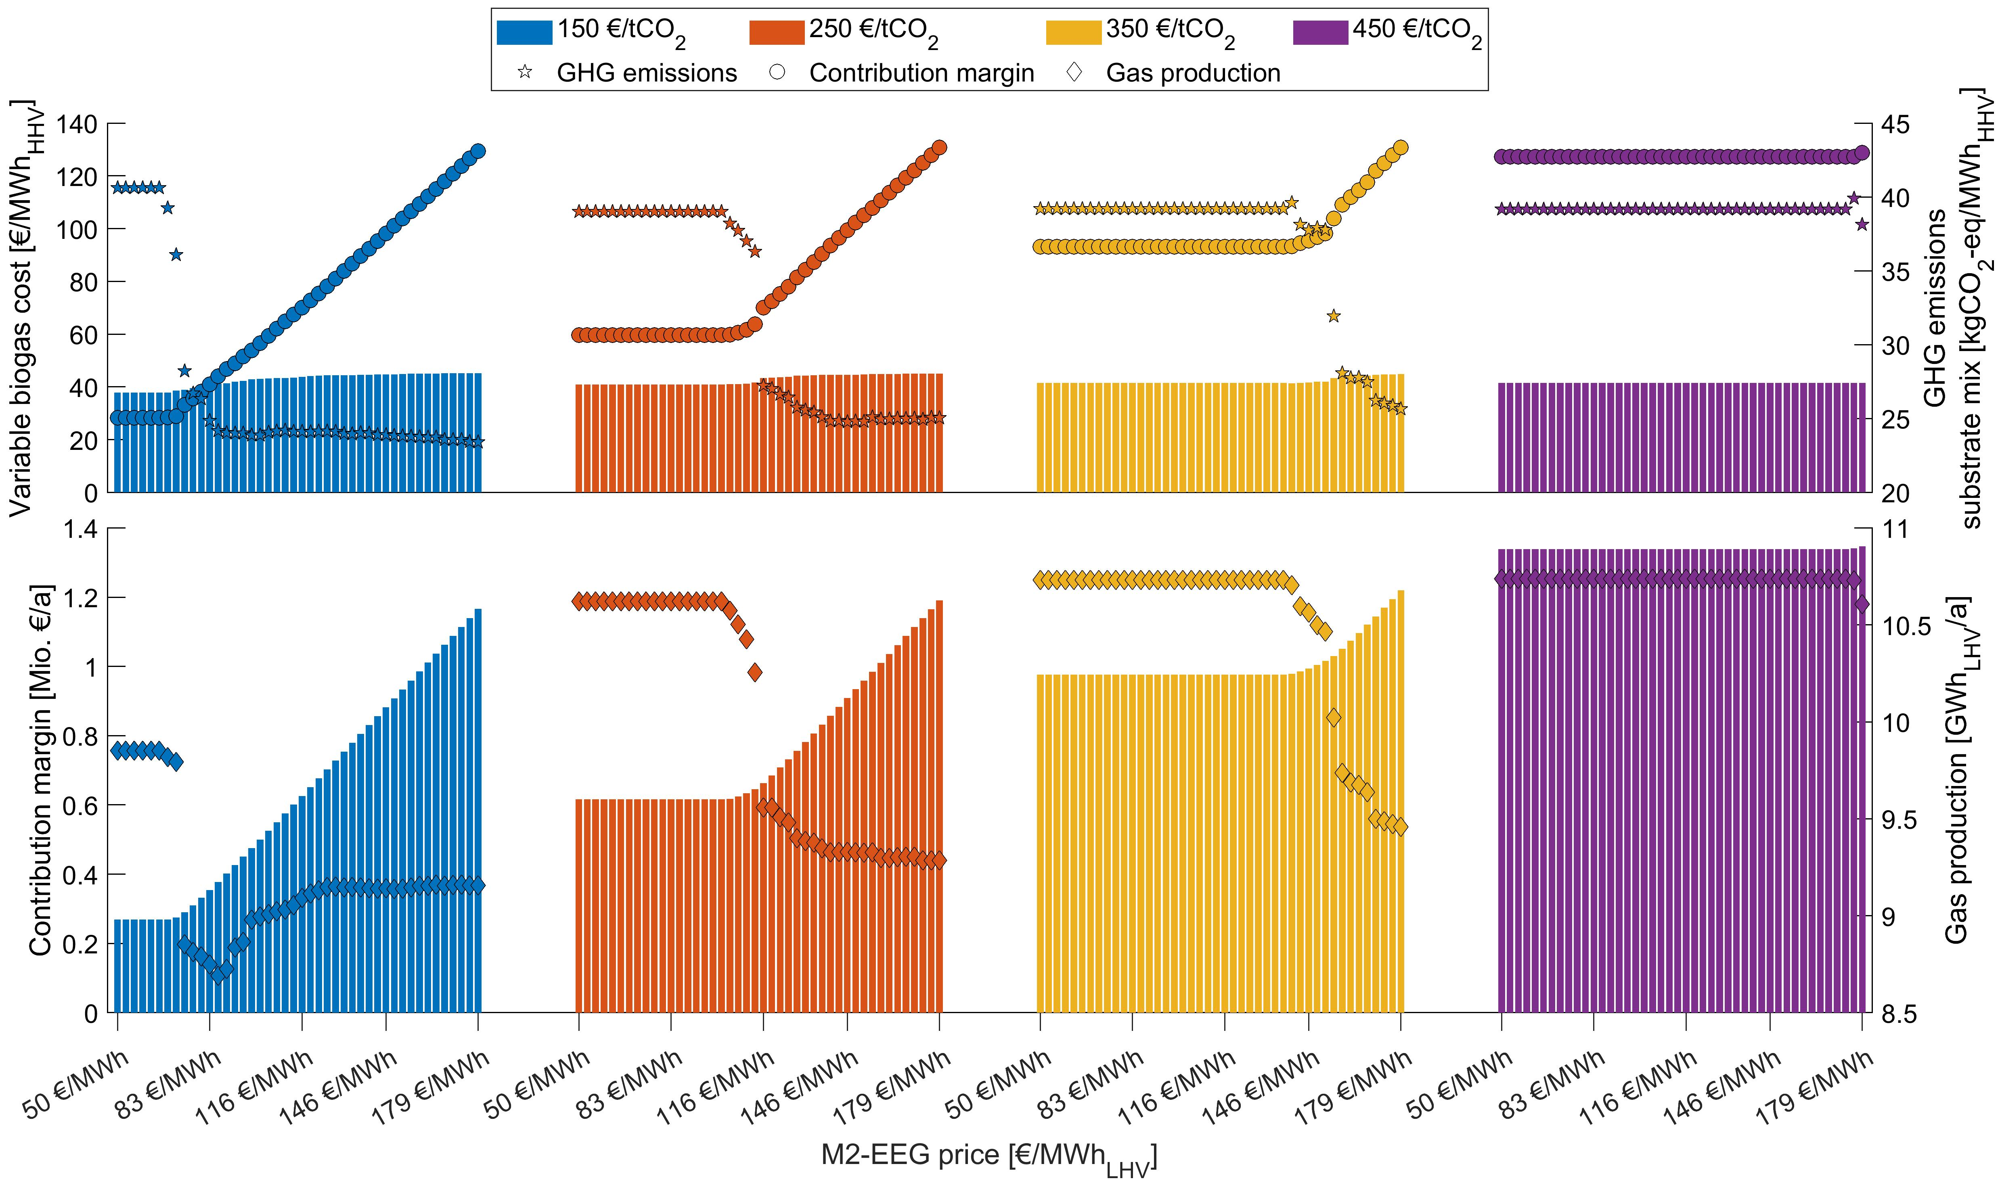
Figure 7 Changes in variable gas costs, contribution margin (spec. & abs.), GHG emissions and gas production (abs.) for changing market prices in M2 and different GHG quota prices levels in M1 (variant M12)
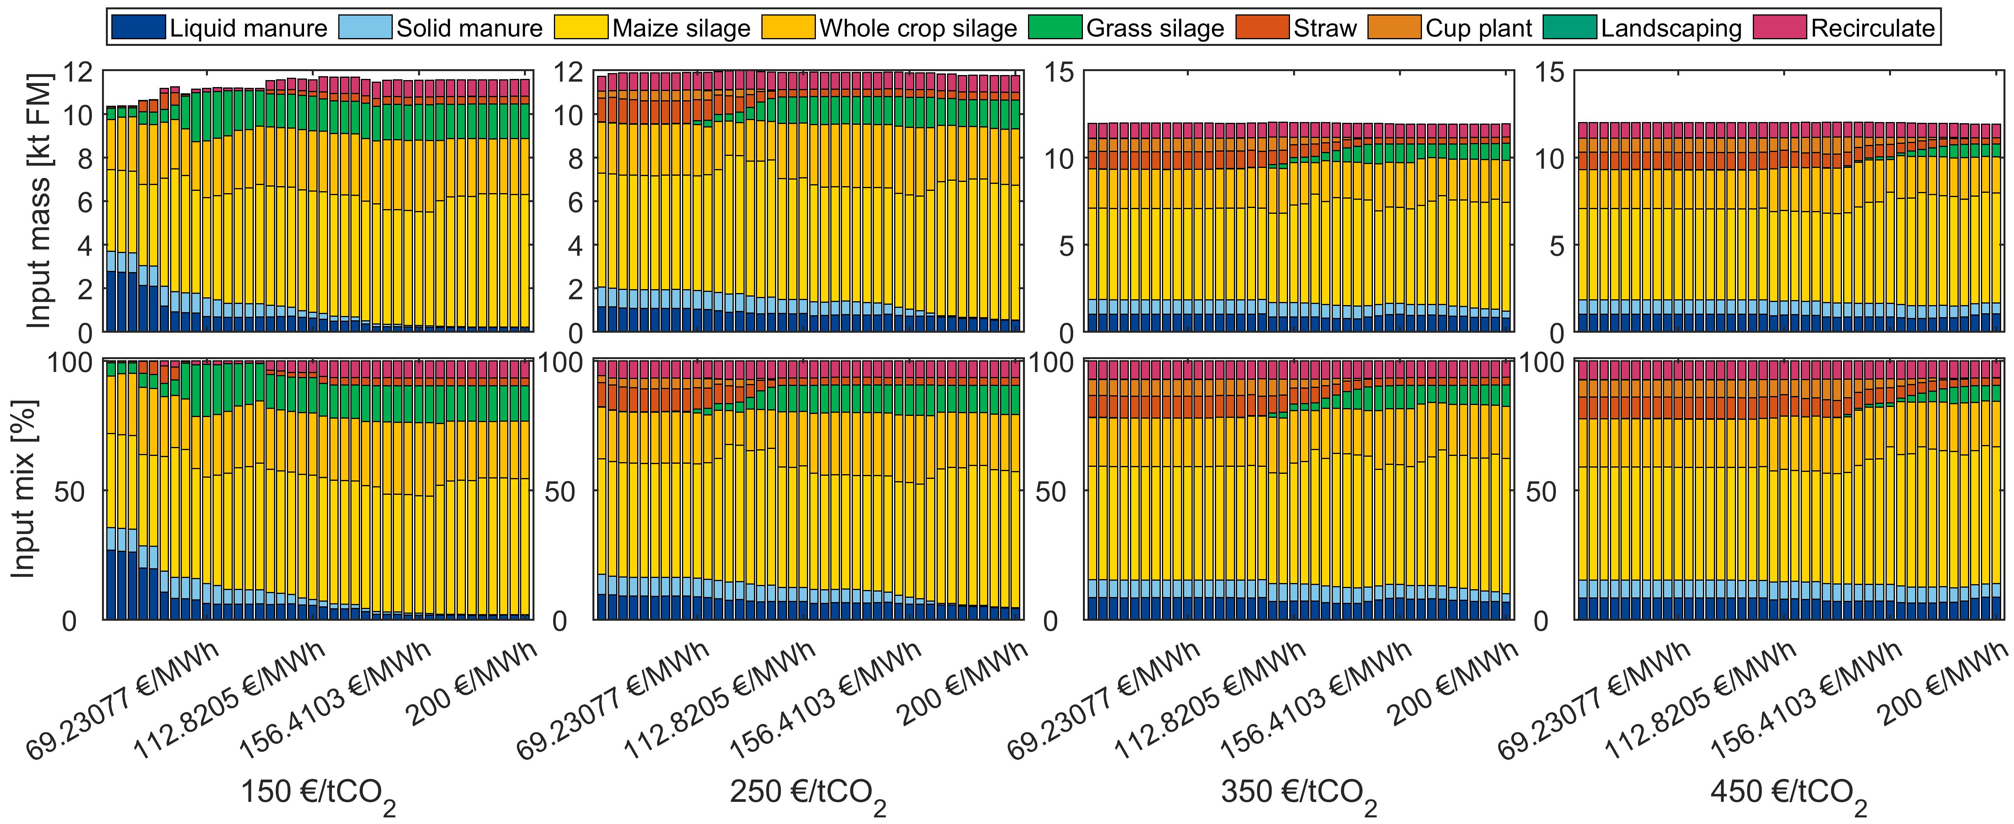
Figure 8 Changes in substrate mix for changing market prices in M3 and different GHG quota prices levels in M1 (variant M1,3)
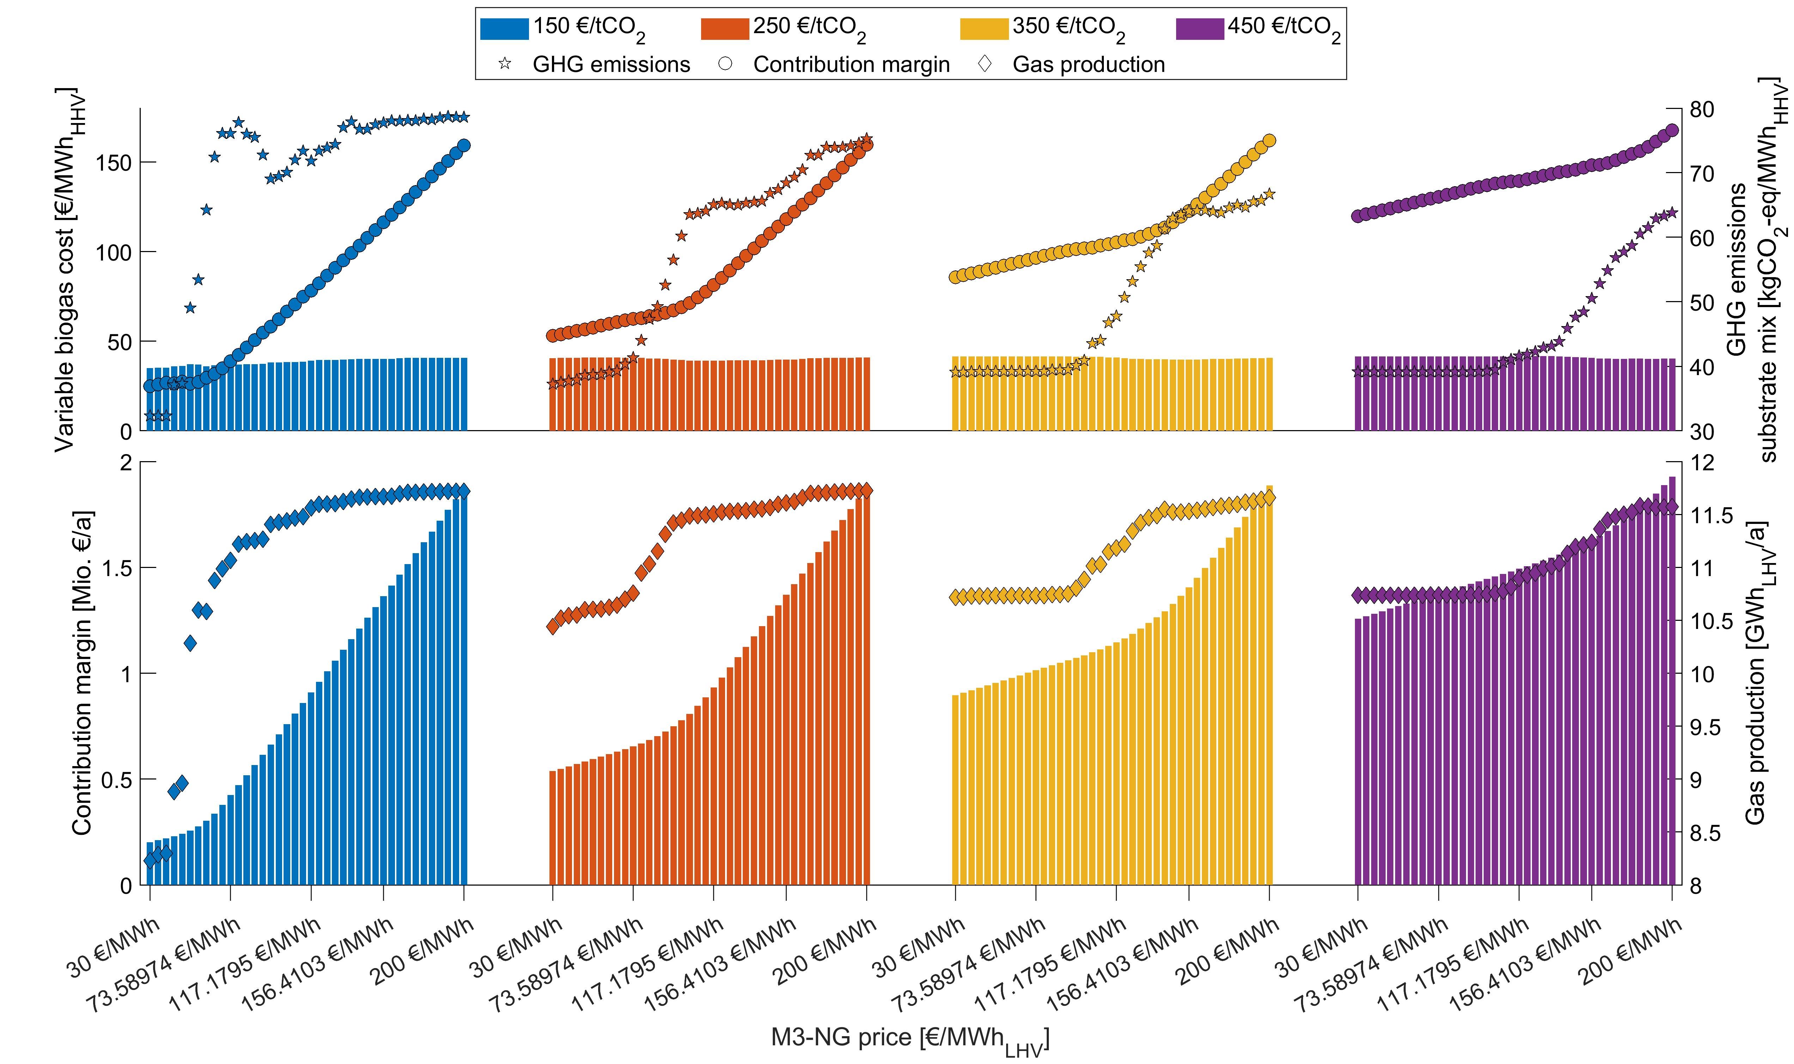
Figure 9 Changes in variable gas costs, contribution margin (spec. & abs.), GHG emissions and gas production (abs.) for changing market prices in M3 and different GHG quota prices levels in M1 (variant M1,3)
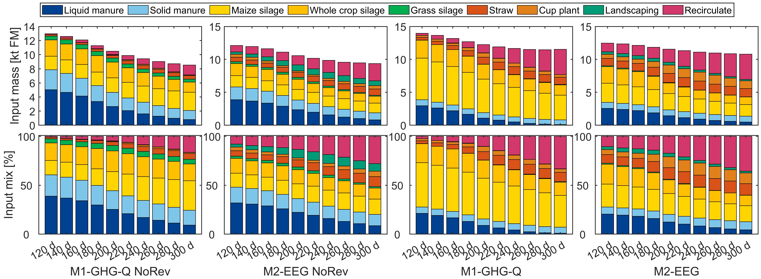
Figure 10 Changes in substrate mix for changes in the required DSC and different market variants
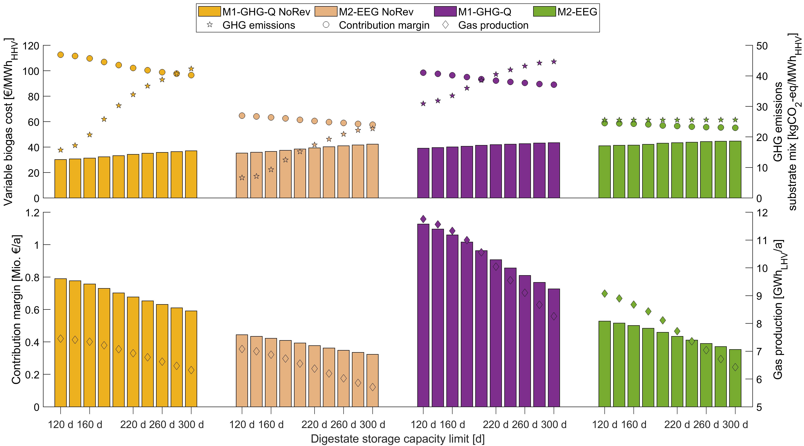
Figure 11 Changes in variable gas costs, contribution margin (spec. & abs.), GHG emissions and gas production (abs.) for changes in the required DSC and market variants
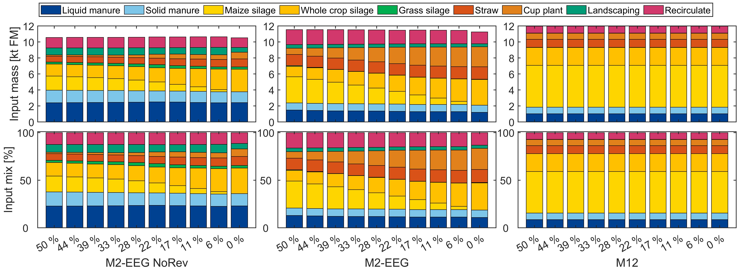
Figure 12 Changes in substrate mix for changes in the required maize cap and different market variants
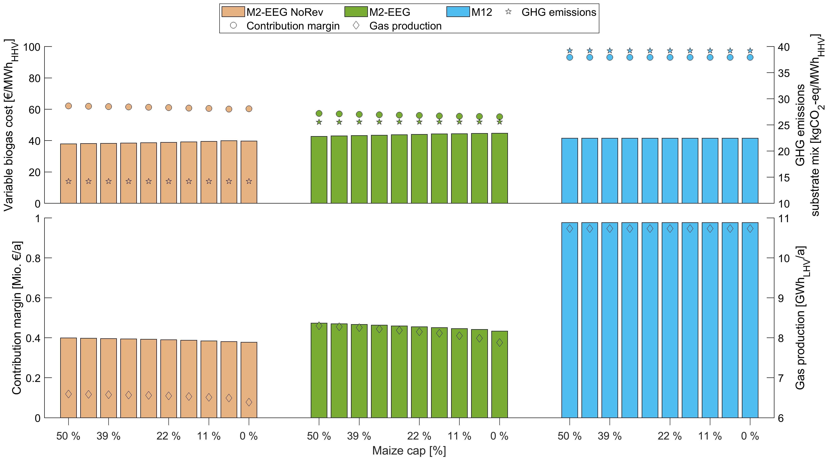
Figure 13 Changes in variable gas costs, contribution margin (spec. & abs.), GHG emissions and gas production (abs.) for changes in the required maize cap and market variants
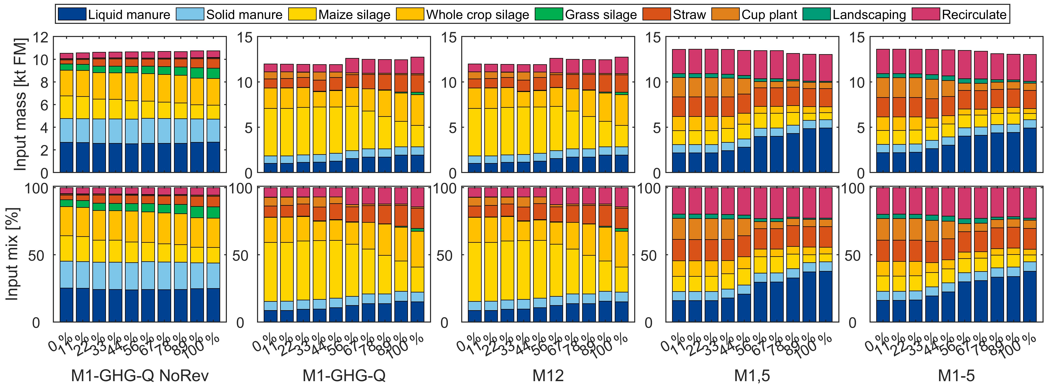
Figure 14 Changes in substrate mix for changes in the energy crops prices and different market variants
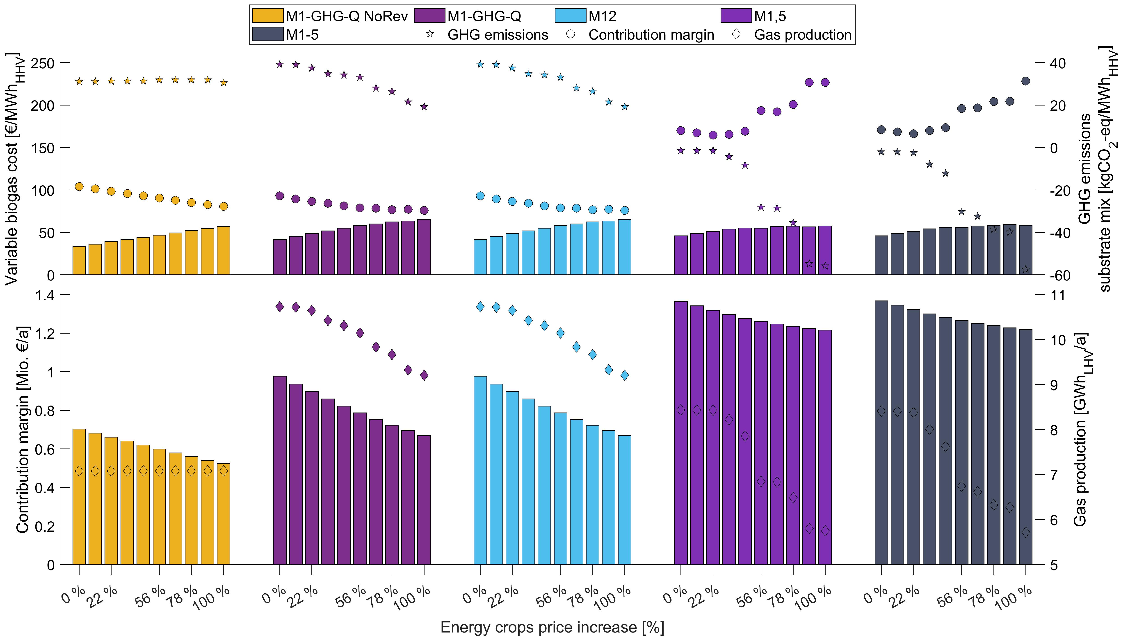
Figure 15 Changes in variable gas costs, contribution margin (spec. & abs.), GHG emissions and gas production (abs.) for changes in the energy crop prices and market variants
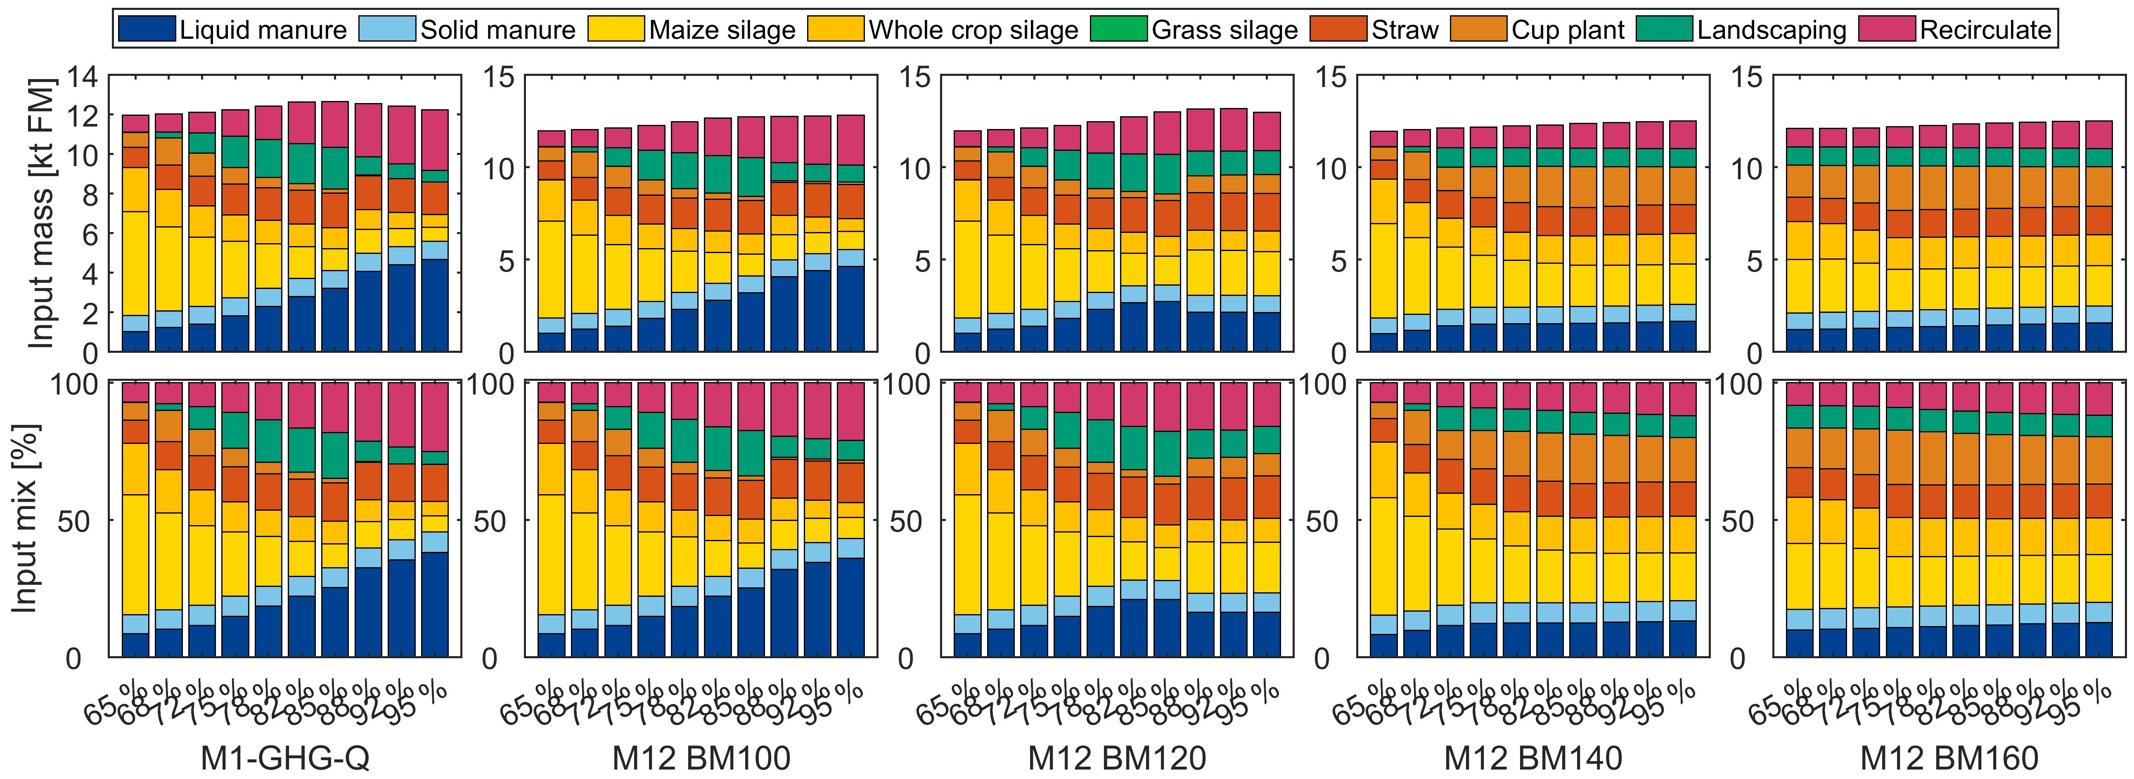
Figure 16 Changes in substrate mix for changes in the GRT of M1 and different price levels of M2 (BM100 – BM160)
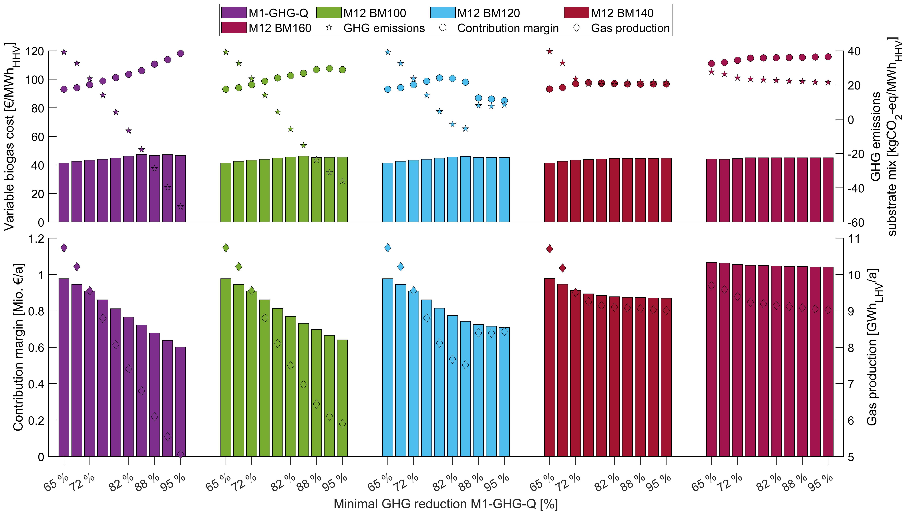
Figure 17 Changes in variable gas costs, contribution margin (spec. & abs.), GHG emissions and gas production (abs.) for changes in the GRT of M1 vs. different price levels of M2 (BM100 – BM160)
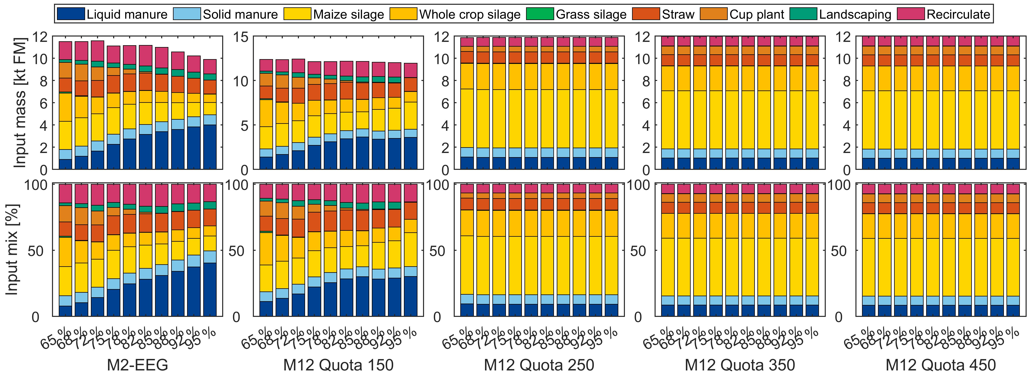
Figure 18 Changes in substrate mix for changes in the GRT of M2 and different GHG quota price levels of M1 (Quota 150 – BM450)
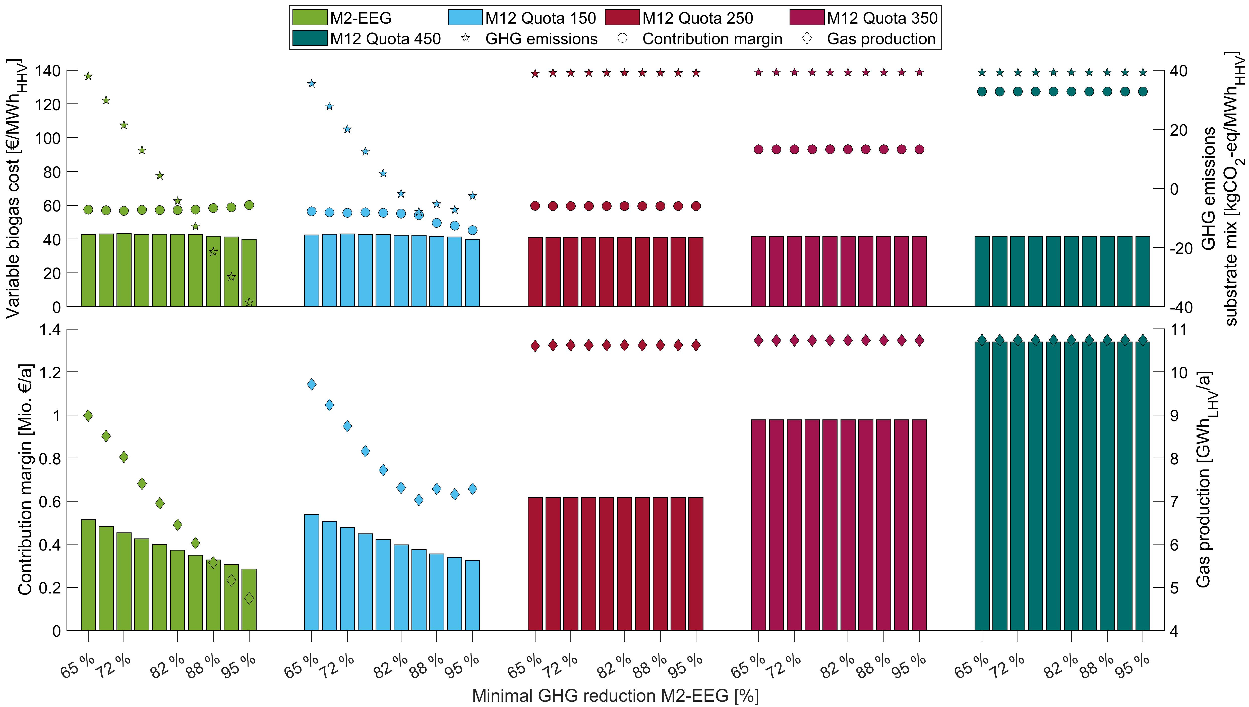
Figure 19 Changes in variable gas costs, contribution margin (spec. & abs.), GHG emissions and gas production (abs.) for changes in the GRT of M2 vs. different GHG quota price levels of M1 (Quota 150 – BM450)

