Pricing model for biomethane in the EEG – M2 Revenues
The price of biomethane as a fuel for biomethane-CHP units was calculated through the following relation:
$$Net Profit Margin=\frac{Revenue-Cost}{Revenue}$$
Where the cost comprises OPEX and CAPEX of the CHP unit and the revenue comes from selling electricity and heat. Considering the biomethane CHP unit working under the EEG system (EEG 2023) and participating in the tender system, they generate revenue from two options available in the electricity market, market premium and direct marketing.
Figure 1 shows a boxplot created by the calculation of the biomethane price for 7056 variants. Each variant stands for a certain condition regarding CHP unit installed capacity, assumed average electricity and heat price, risk factor assigned to the revenues and desired net profit margin. Based on the boxplot, the median price of 97 €/MWh was considered for the biomethane price in M2.
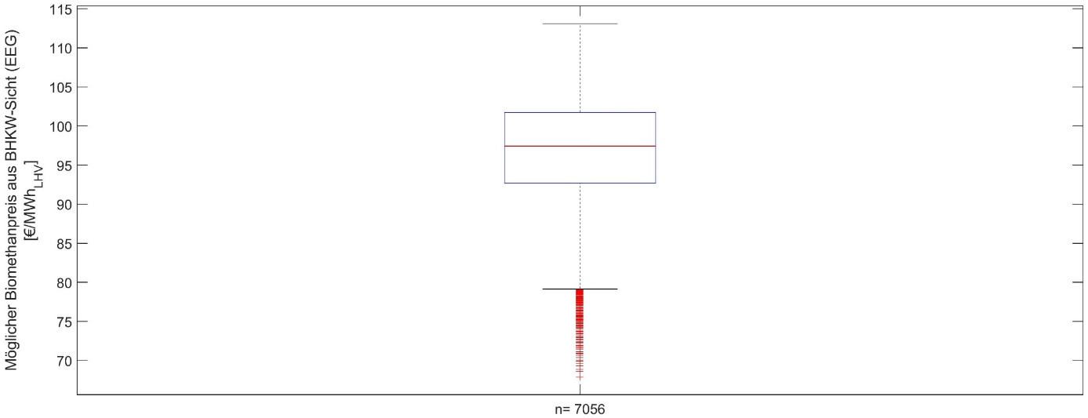
Figure 1 Evaluation of BM pricing model

