Supplementary table 1 | Light-extinction coefficient (k) values derived from remotely-sensed products and from site measurements

Major biome | Satellite (MODIS) | In situ⁷³
Grassland | 0.49 | 0.50
Shrubland | 0.48 (closed shrubland);  0.62 (open shrubland) | 0.56
Broadleaf Forest | 0.48 | 0.59
Needleleaf Forest | 0.37 | 0.45
Mixed Forest | 0.43 | –
Savanna | 0.45 | –

Supplementary table 2 | Fitted values for z and f₀ under different scenarios for k.

Scenario | z | f₀
- Constant k | 13.86 | 0.62
- MODIS-derived k | 14.50 | 0.64
- MODIS vegetation type-specific k | 13.59 | 0.63
- In situ vegetation type-specific k | 14.06 | 0.63

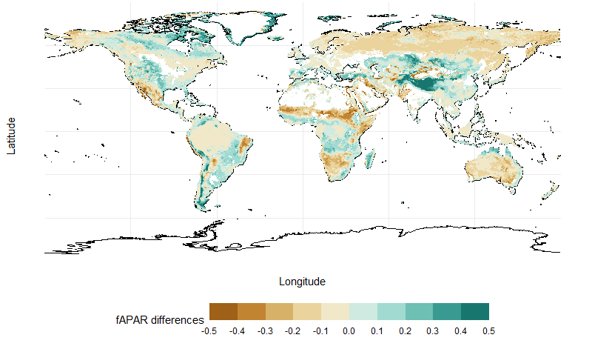
Supplementary figure 1 | Spatial distribution of differences between modelled and observed multi-year average seasonal maximum fAPAR.

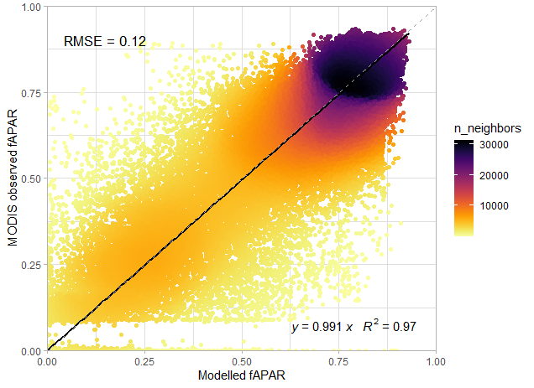
Supplementary figure 2 | Performance of modelled fAPAR prediction using temperature-dependent z and f0. Solid line is the ordinary least-squares regression line; grey dashed line is the 1:1 line. RMSE, root-mean-squared error; y, regression slope; R², coefficient of determination.

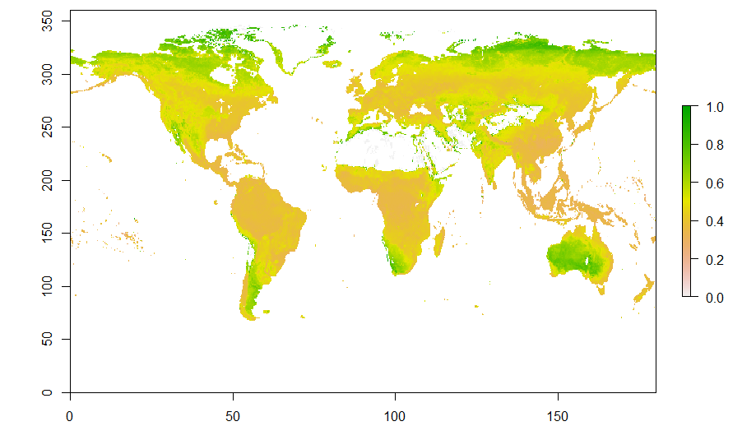
Supplementary figure 3 | Spatial distribution of the apparent light-extinction coefficient (k) inferred from the MODIS fAPAR and LAI products.

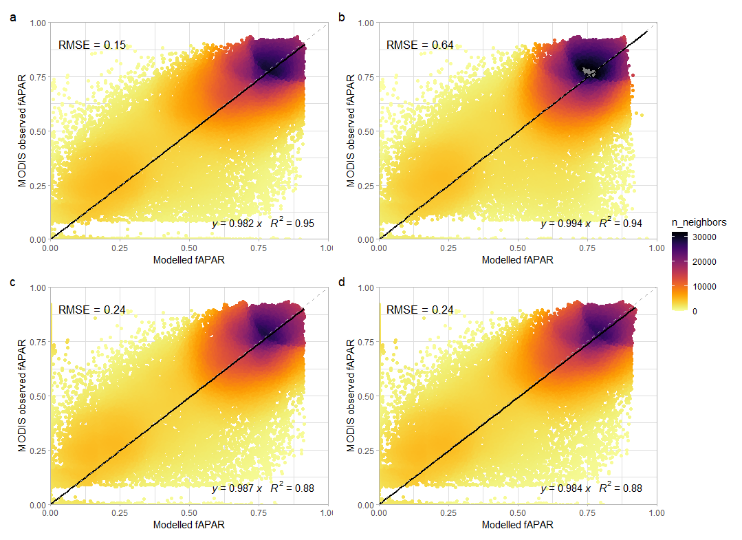
Supplementary figure 4 | Performance of modelled fAPAR prediction under different scenarios for k. Solid line is the ordinary least-squares regression line; grey dashed line is the 1:1 line. RMSE, root-mean-squared error; y, regression slope; R², coefficient of determination.

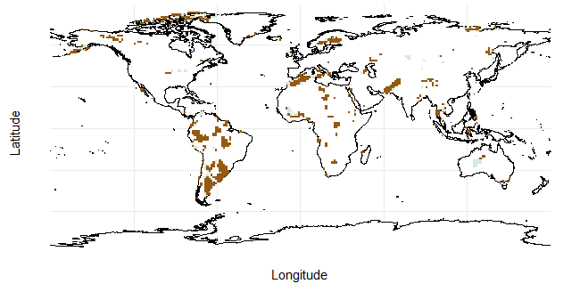

Supplementary figure 5 | Spatial distribution of ANOVA test comparing quadratic polynomials regression and simple linear regression. Brown area indicates area where quadratic regression is significantly better than linear regression.

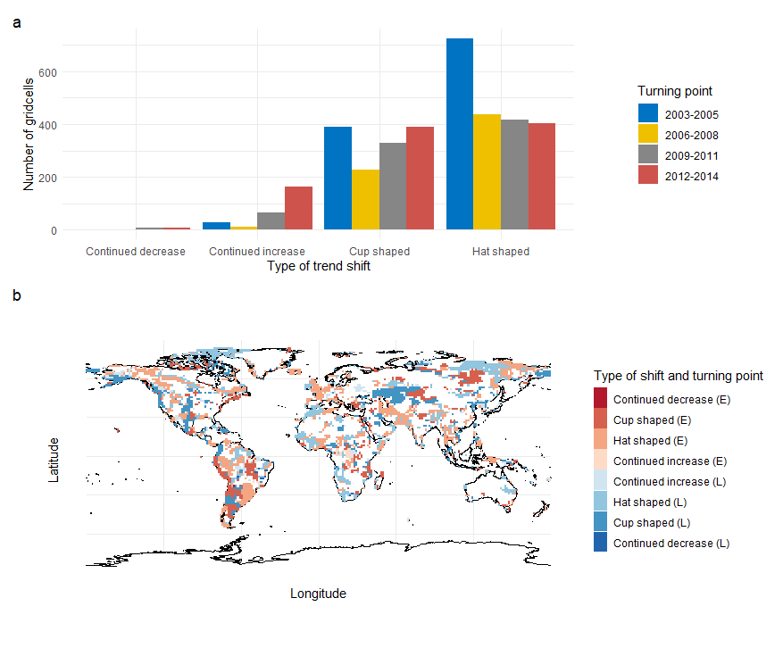

Supplementary figure 6 | Bent-cable piecewise regression of fAPAR trend for each grid cell. a, The frequency of continued increase, cup-shaped, hat-shaped and continued decrease fAPAR trend; b, spatial distribution of trend shift and turning point; E and L stands for earlier period (2003-2008) and later period (2009-2014) respectively.

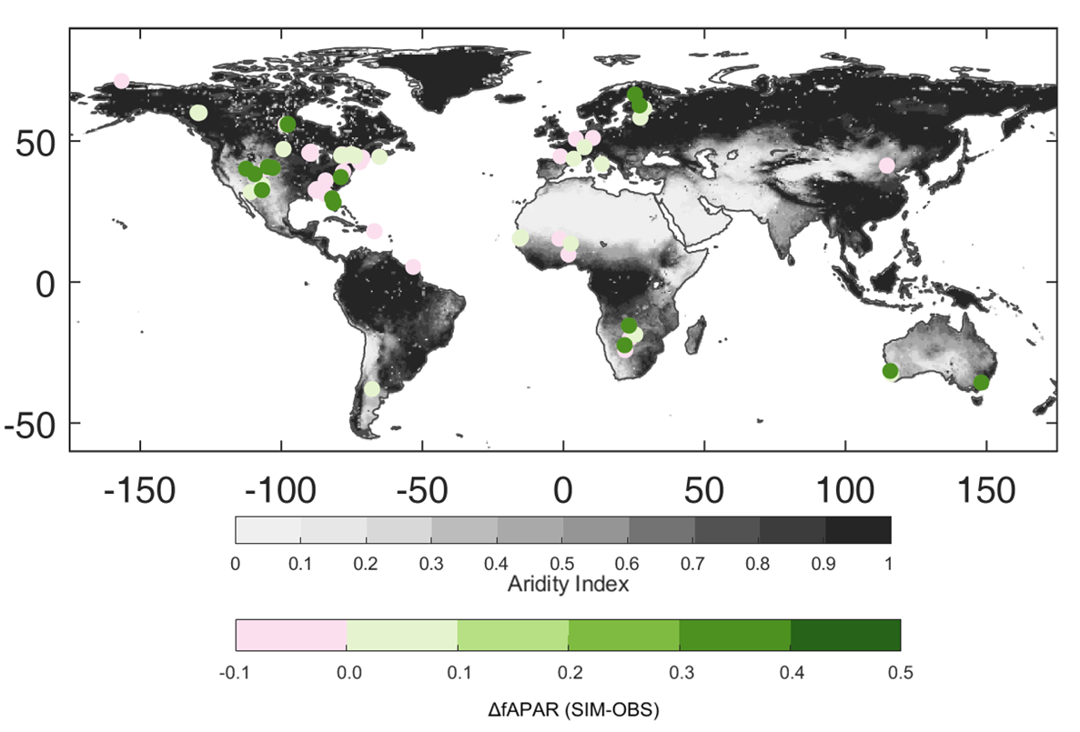
Supplementary figure 7 | Differences between predicted and observed seasonal maximum fAPAR compared against aridity index (actual evapotranspiration divided by potential evapotranspiration). Differences between prediction and observation are shown in points, and aridity index is shown as base map, with white representing the most arid regions and dark gray indicating the least arid areas.

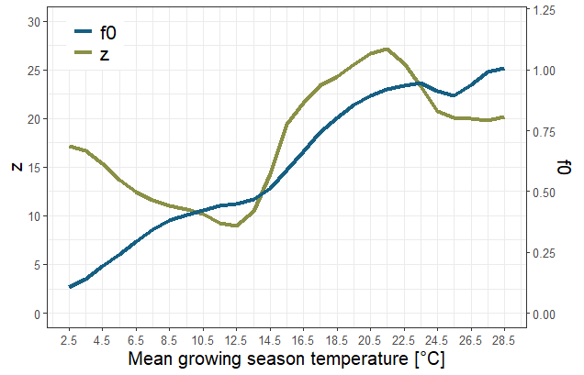

Supplementary figure 8 | Variation of fitted parameter values with temperature. The blue line indicates f₀ (ratio of vegetation water uptake to precipitation) and the green line indicates z (leaf construction and maintenance costs).

