Additional information

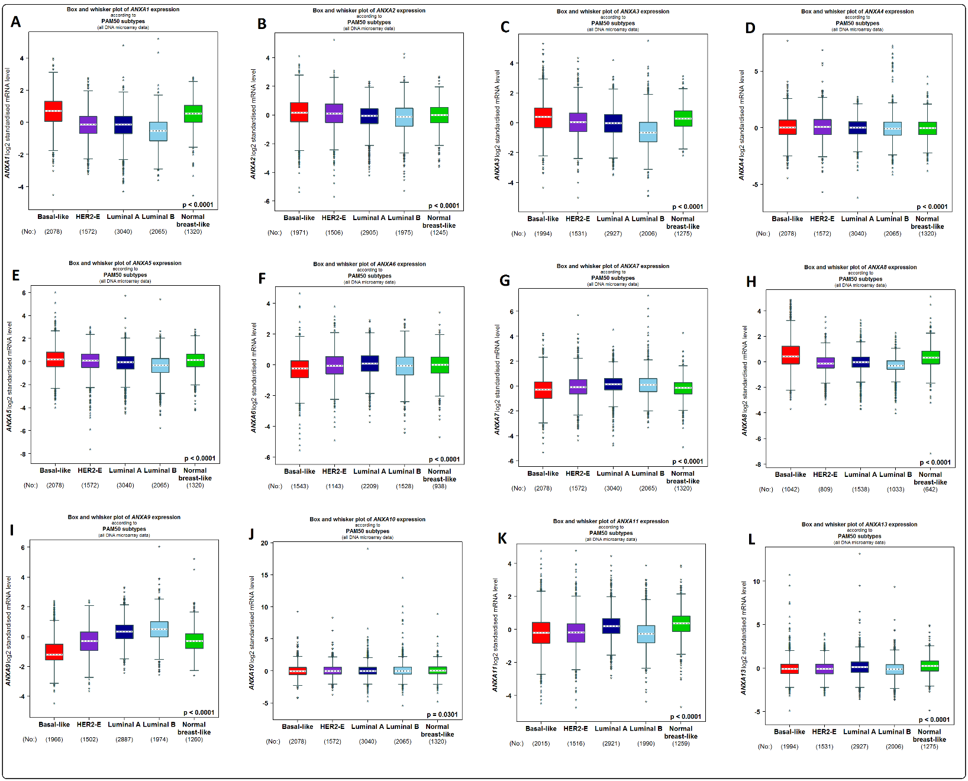
Supplementary Fig. S1. The distribution of ANXAs expression according to the PAM50 subtype of breast cancer (bc-GenExMiner v4.7). Using Welch’s tests and Dunnett–Tukey–Kramer’s test, the difference in mRNA expression between groups was assessed. Box plot of ANXAs expression goes from the lower quartile (Q1) to the upper quartile (Q3), and the median is marked with a horizontal dotted line. Whiskers are lines at the bottom and the top of the box representing the distance between the quartiles and 1.5 times the interquartile range. The number of patients is represented in brackets. *P < 0.05, **P < 0.01, ***P < 0.001, ****P < 0.0001.

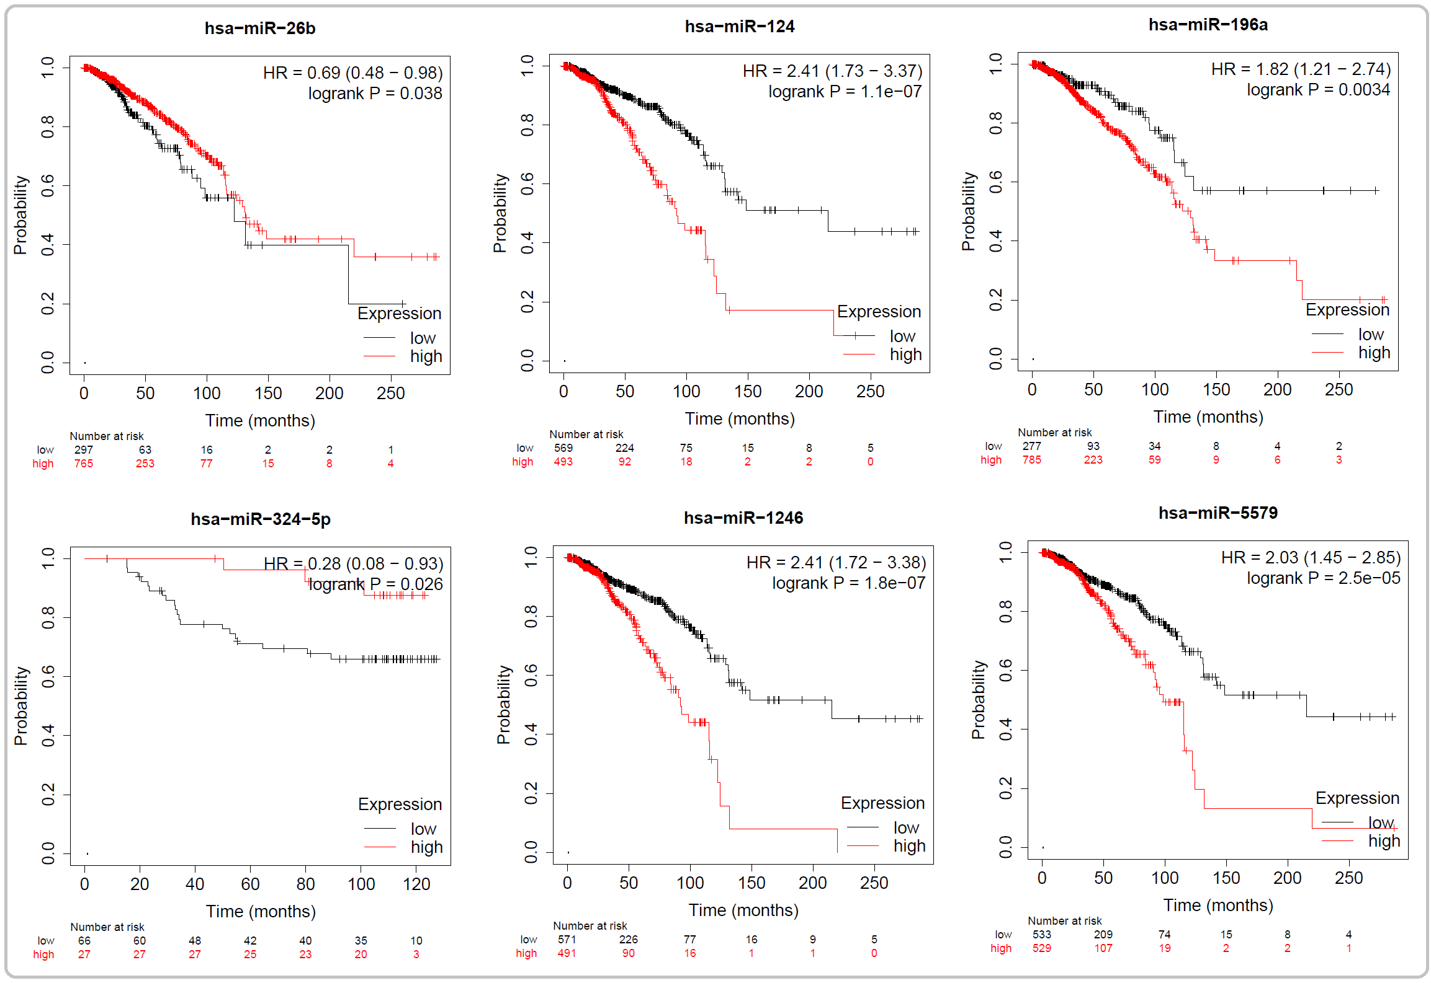
Supplementary Fig. S2. The prognostic value of the miRNAs regulating ANXAs. (Kaplan-Meier plotter). The association of miR-26b, miR-124, miR-196a, miR-324-5p, miR-1246 and miR-5579 expression with OS in BC patients. A value of P < 0.05 was defined as significant. The confidence intervals are represented in brackets. Red line represents higher expression and black line represents lower expression. HR, hazard ratio.

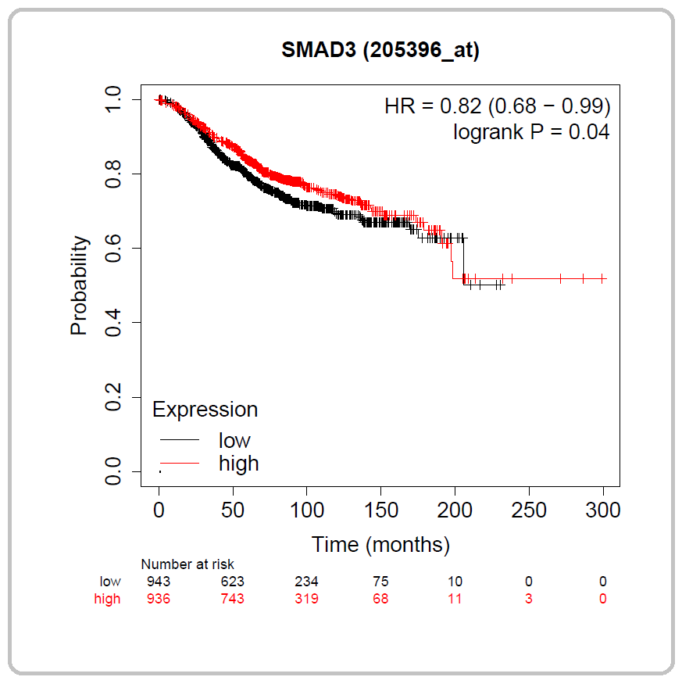
Supplementary Fig. S3. The prognostic value of the Transcription Factor regulating ANXAs. (Kaplan-Meier plotter). The association of mRNA expression of SMAD3 with OS in BC patients. A value of P < 0.05 was defined as significant. The confidence intervals are represented in brackets. Red line represents higher expression and black line represents lower expression. HR, hazard ratio.

Table s1. The top 50 frequently altered neighbor genes co-expressed with ANXAs members in BC.
FLNA | PARVG | IL10RA | EGFR | S100A11
THPO | GP2 | FBLIM1 | HCLS1 | C4BPA
GRP | LAMP1 | MDM2 | CD244 | ALOX5
DNM1 | GMFG | AGGF1 | EFNA4 | PIK3CD
PSTPIP1 | LCAT | S100A6 | CYTH4 | CCNE1
CYTH3 | MPRIP | CDK6 | EVL | CCND2
HSH2D | EFNB1 | ENO1 | HSPB2 | VIM
PLCB2 | NMB | CD40 | MAP4K4 | TAGLN2
CD276 | FGF11 | MNDA | WAS | MYH9
MYO1F | PROM1 | CORO1A | LMNA | DIAPH1

