Supplementary information
Optical emissions associated with narrow bipolar events in radio signals from thunderstorm clouds penetrating into the stratosphere

Feifan Liu¹, Gaopeng Lu¹, Torsten Neubert², Jiuhou Lei^{1*}, Oliver Chanrion², Nikolai Østgaard³, Dongshuai Li⁴, Alejandro. Luque⁴, Francisco J. Gordillo-Vázquez⁴, Victor Reglero⁵, Weitao Lyu⁶ , and Baoyou Zhu^{1*}

1. CAS Key Laboratory of Geospace Environment, School of Earth and Space Sciences, University of Science and Technology of China, Hefei, China.
2. National Space Institute, Technical University of Denmark (DTU Space), Kongens Lyngby, Denmark.
3. Birkeland Centre for Space Science, Department of Physics and Technology, University of Bergen, Norway.
4.Instituto de Astrofísica de Andalucía, CSIC, Glorieta de la Astronomia s/n, Granada, Spain.
5. Image Processing Laboratory, University of Valencia, Valencia, Spain.
6. State Key Laboratory of Severe Weather, Chinese Academy of Meteorological Sciences, Beijing, China.
1. Rise-time (T_{AB}): Time of rising transition from the zero-reference level moment to the peak amplitude.
2. Duration (T_{AC}): Time difference between the zero-reference level moments to the final transition of pulse (overshoot);
3. Signal-to-noise ratio (SNR): In order to eliminate the influence of subsequent waveform, we use the quantity Pre_SNR, which is defined by equation (1) (Hamlin et al., 2007; Smith et al., 2002)
Pre_SNR=10×$\log_{10}{\frac{\sum_{peak-0.3ms}^{peak+4ms}{ {Flux}^{2}}}{\sum_{peak-30ms}^{peak-0.3ms}{{ Flux}^{2}}}}$ (1)
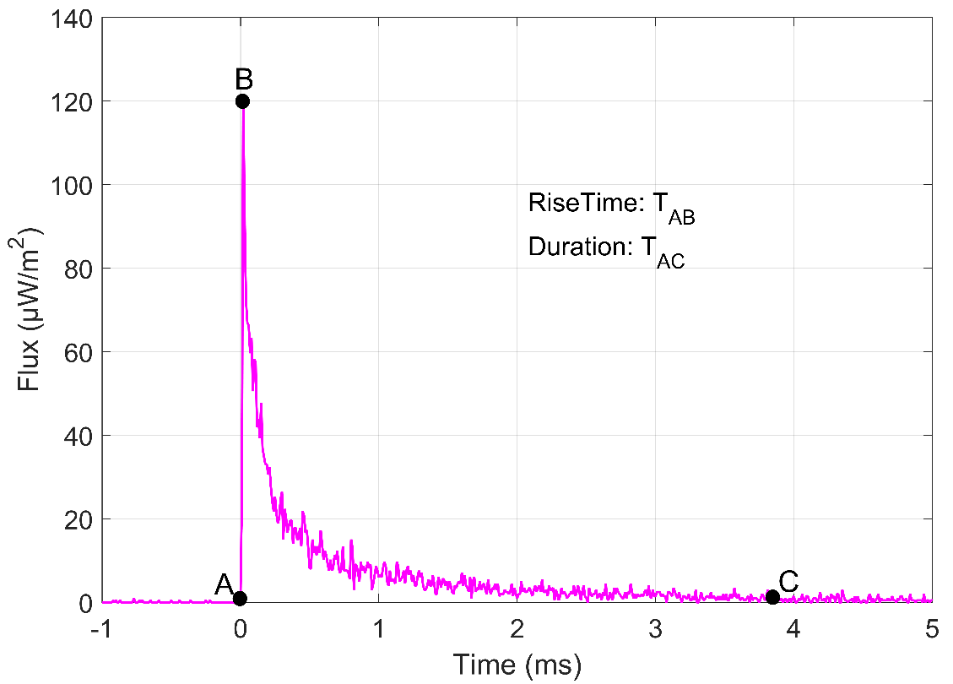
Supplementary Figure 1 | Definition of the waveform parameters for the blue emission events. Point A present the beginning time of the blue emission. Point B represents the peak amplitude. Point C present the ending time.
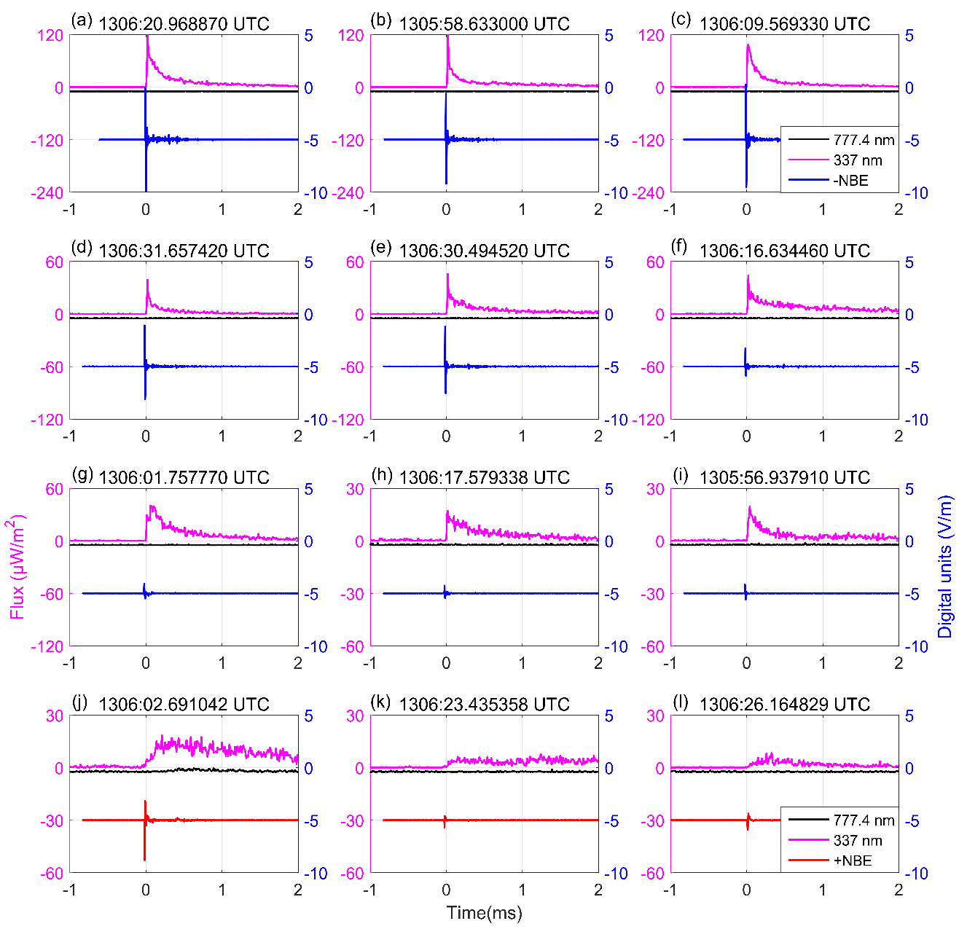
Supplementary Figure 2 | Optical and electrical signature of all NBEs. (a)-(i) present negative NBEs; (j)-(l) presents positive NBEs. E-waveform of negative NBEs is plotted with blue line, and that of positive NBEs is plotted with red line; the 337-nm emission and 777.4-nm emission are plotted with pink and black lines, respectively.
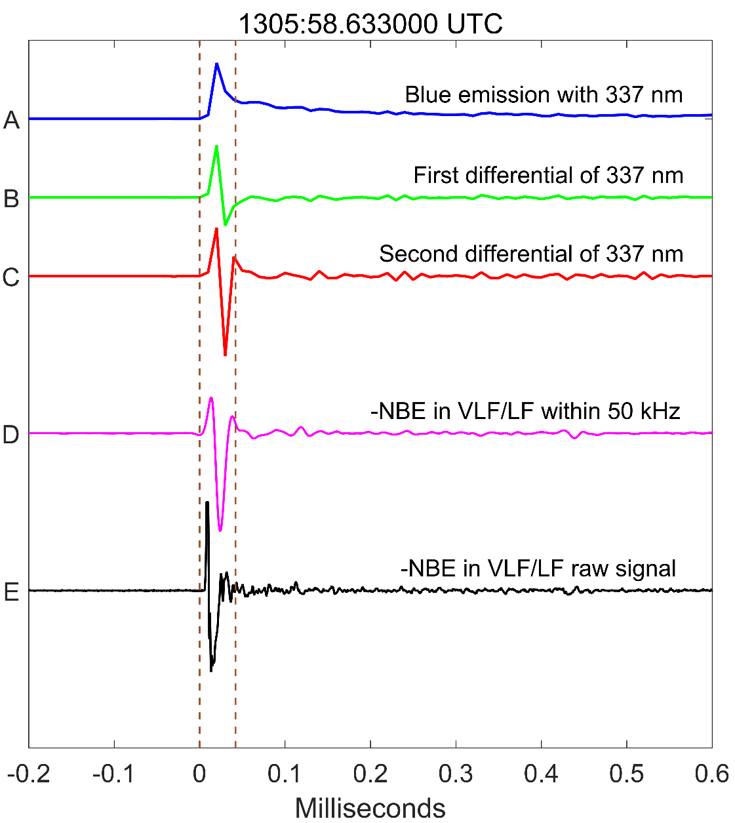
Supplementary Figure 3 | Correlations between VLF/LF signal within 50 kHz of negative NBE and the second differential of blue emission. t = 0 ms corresponds to 07 August 2019 at 1305:58.633000 UTC.
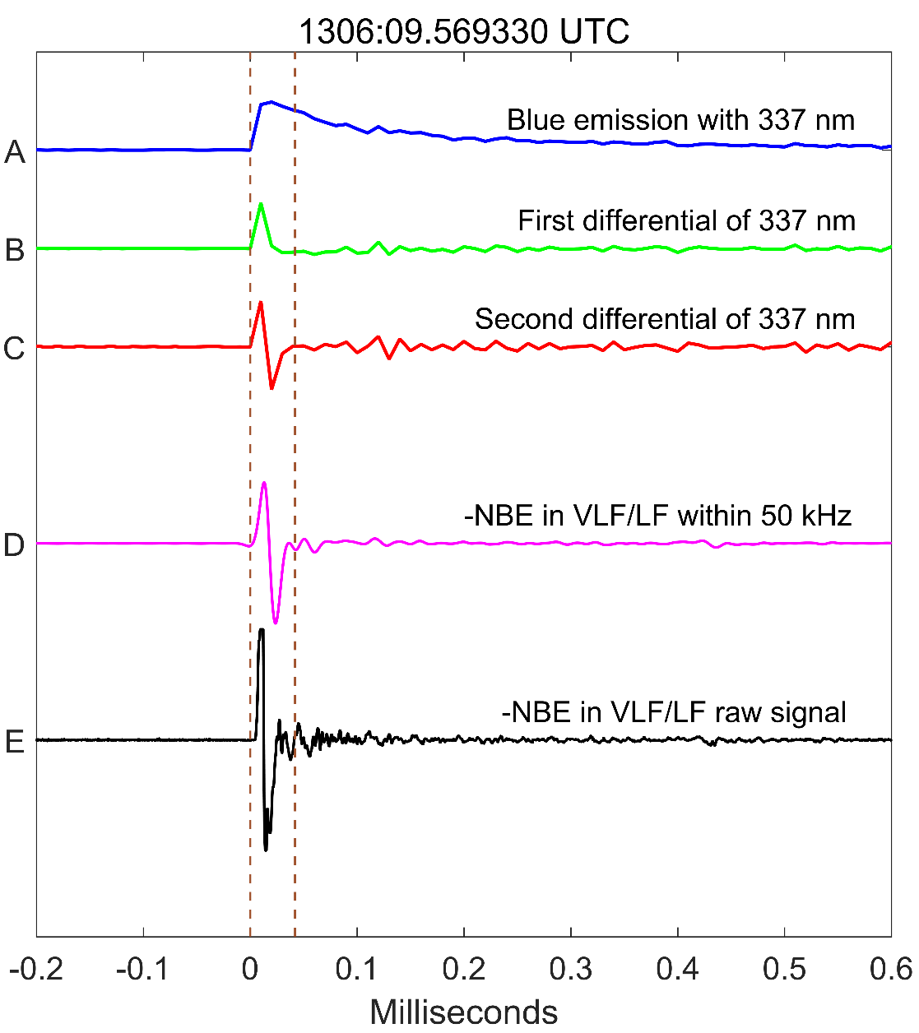
Supplementary Figure 4 | Correlations between VLF/LF signal within 50 kHz of negative NBE and the second differential of blue emission. t = 0 ms corresponds to 07 August 2019 at 1306:09.569330 UTC.
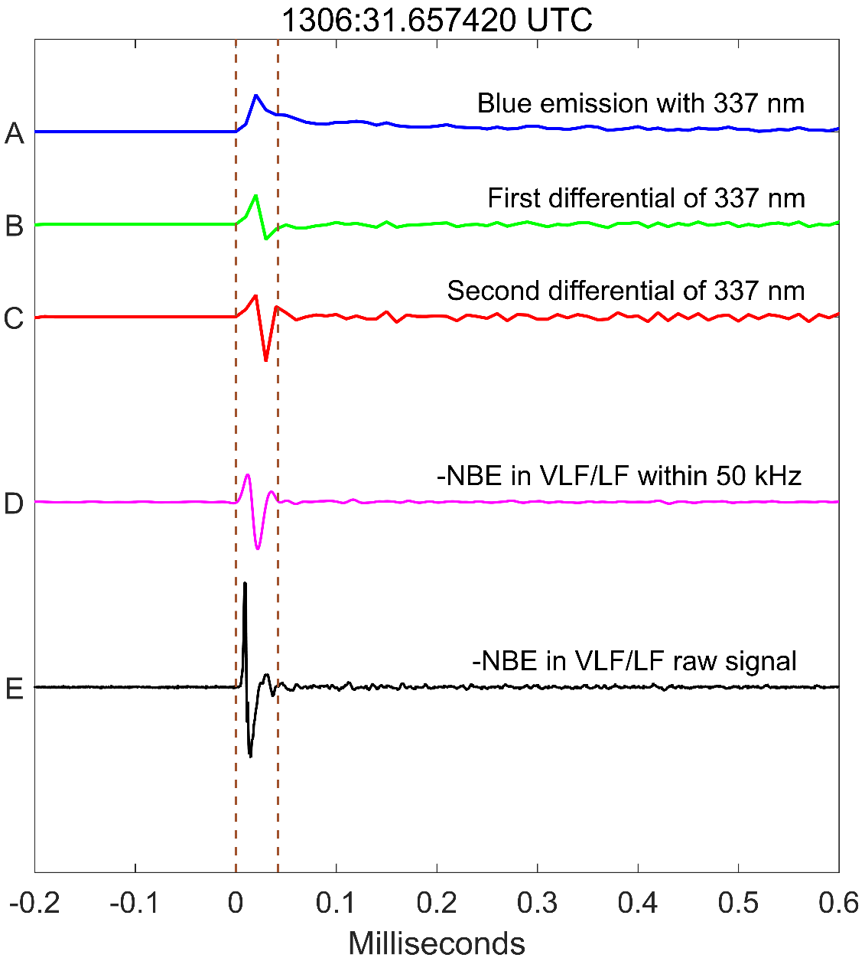
Supplementary Figure 5 | Correlations between VLF/LF signal within 50 kHz of negative NBE and the second differential of blue emission. t = 0 ms corresponds to 07 August 2019 at 1306:31.657420 UTC.
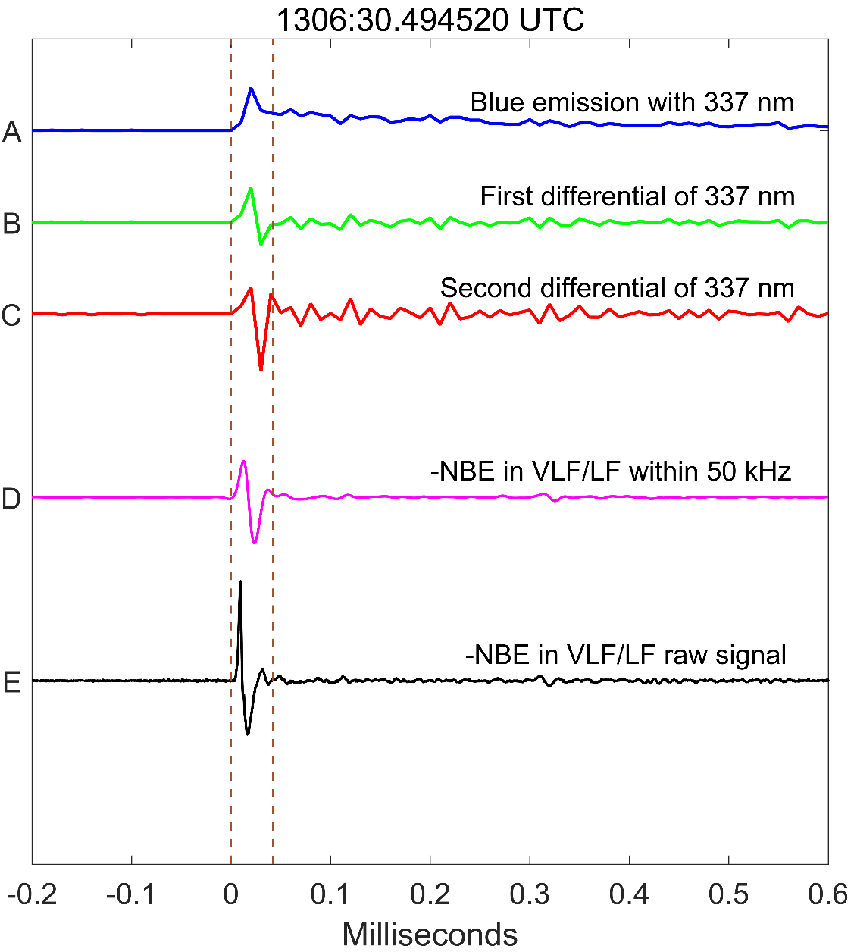
Supplementary Figure 6 | Correlations between VLF/LF signal within 50 kHz of negative NBE and the second differential of blue emission. t = 0 ms corresponds to 07 August 2019 at 1306:30.494520 UTC.
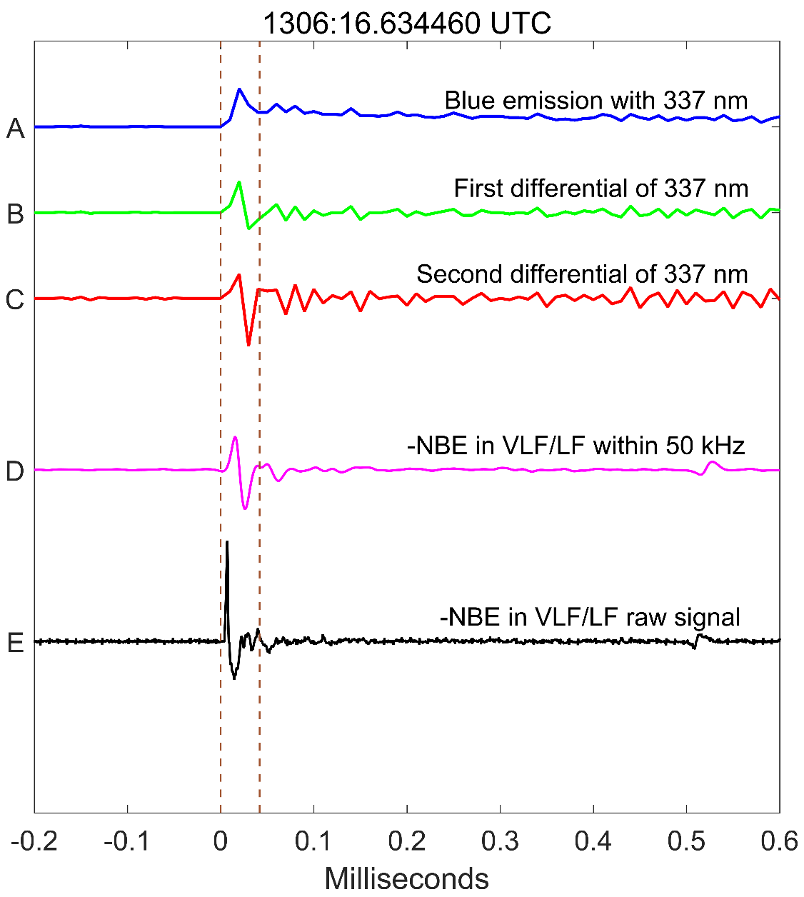
Supplementary Figure 7 | Correlations between VLF/LF signal within 50 kHz of negative NBE and the second differential of blue emission. t = 0 ms corresponds to 07 August 2019 at 1306:16.634460 UTC.

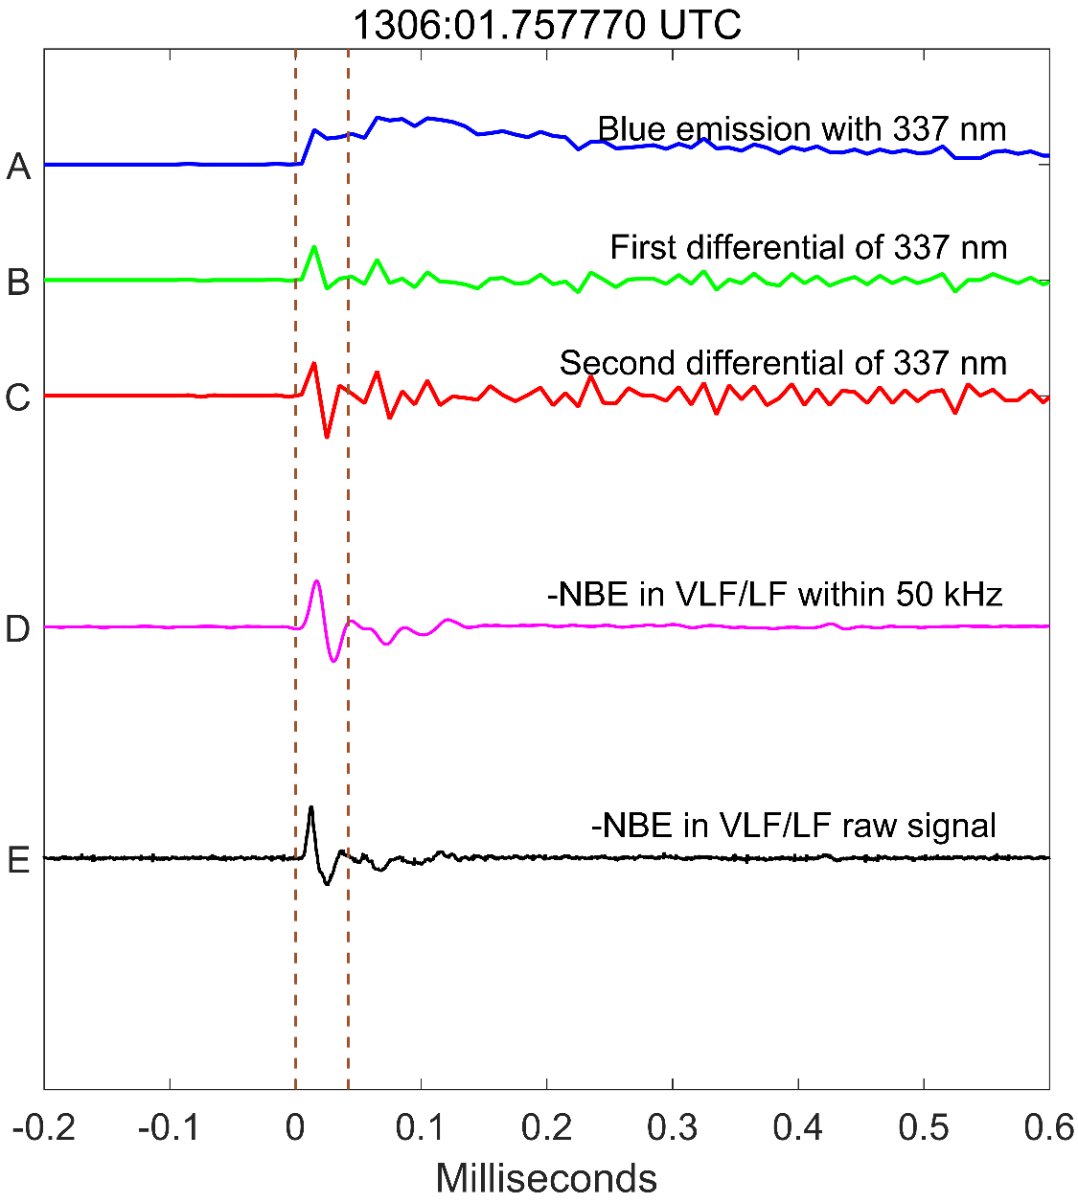
Supplementary Figure 8 | Correlations between VLF/LF signal within 50 kHz of negative NBE and the second differential of blue emission. t = 0 ms corresponds to 07 August 2019 at 1306:01.757770 UTC.

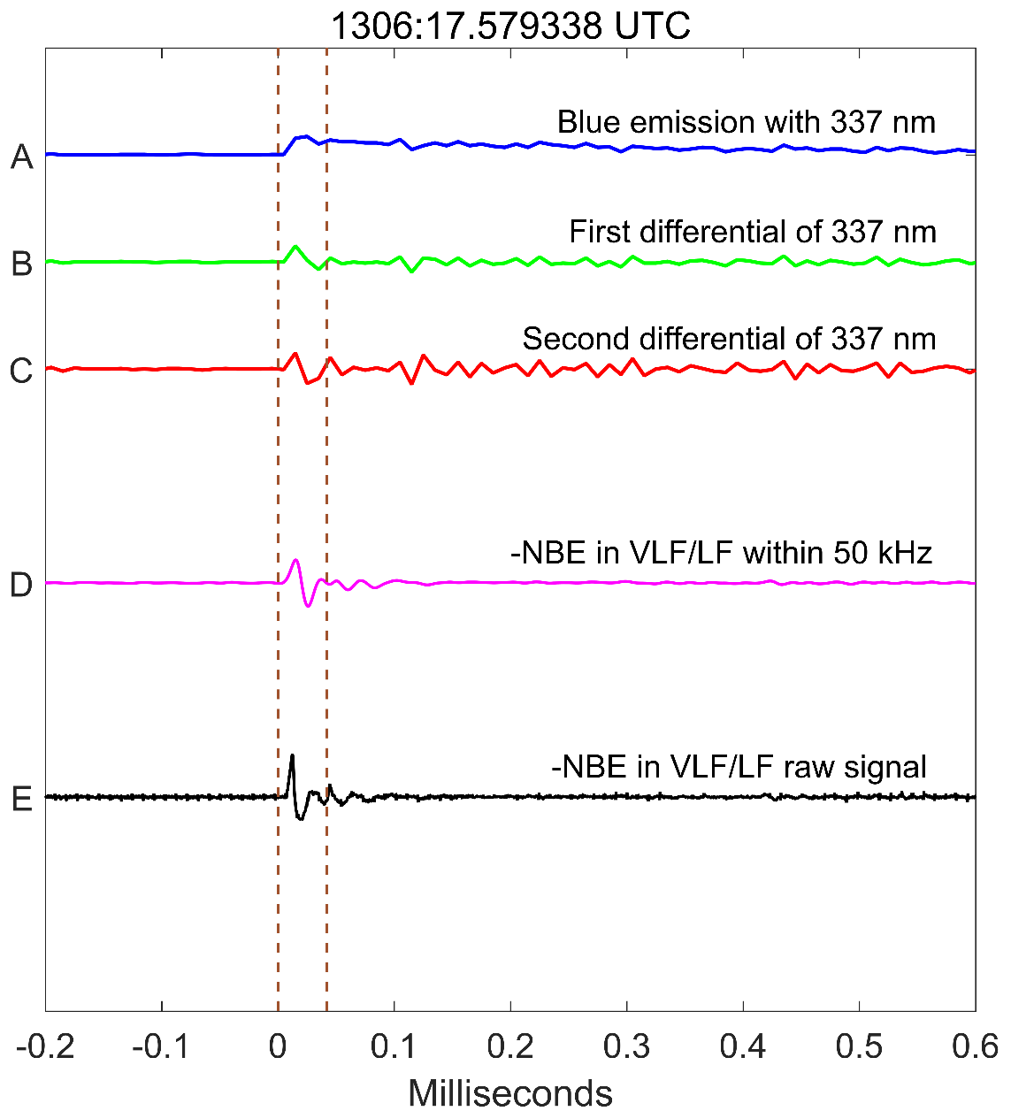
Supplementary Figure 9 | Correlations between VLF/LF signal within 50 kHz of negative NBE and the second differential of blue emission. t = 0 ms corresponds to 07 August 2019 at 1306:17.579338 UTC.
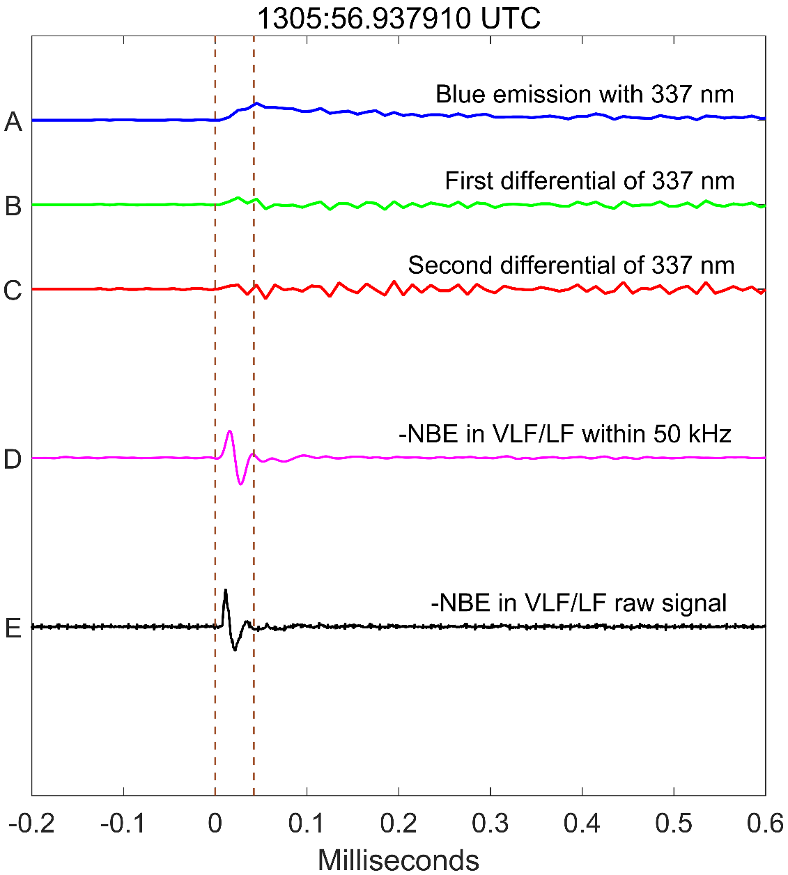
Supplementary Figure 10 | Correlations between VLF/LF signal within 50 kHz of negative NBE and the second differential of blue emission. t = 0 ms corresponds to 07 August 2019 at 1305:56.937910 UTC.
Supplementary Table 1 | Time match information of blue events with ground-based VLF receiver.
Date | ASIM Optical Trigger Time  （UTC） | Time Shift  (ms) | VLF Trigger Time  (UTC) | Type
2019/8/7 | 1306:31.657420 | +5 ms | 1306:31.6619366 | -NBE
2019/8/7 | 1306:30.494520 | +5 ms | 1306:30.4996518 | -NBE
2019/8/7 | 1306:20.968870 | +4 ms | 1306:20.9729968 | -NBE
2019/8/7 | 1306:17.579338 | +4 ms | 1306:17.5838553 | -NBE
2019/8/7 | 1306:16.634460 | +4 ms | 1306:16.6388164 | -NBE
2019/8/7 | 1306:09.569330 | +3 ms | 1306:09.5725785 | -NBE
2019/8/7 | 1306:01.757770 | +22 ms | 1306:01.7803276 | -NBE
2019/8/7 | 1305:58.633000 | +22 ms | 1305:58.6551992 | -NBE
2019/8/7 | 1305:56.937910 | +22 ms | 1305:56.9597594 | -NBE
2019/8/7 | 1306:26.164829 | +4 ms | 1306:26.1689388 | +NBE
2019/8/7 | 1306:23.451358 | +4 ms | 1306:23.4563116 | +NBE
2019/8/7 | 1306:02.691042 | +21 ms | 1306:02.7128139 | +NBE

Reference
Hamlin T., T. E. Light, X. M. Shao, K. B. Eack, and J. D. Harlin, 2007. Estimating lightning channel characteristics of positive narrow bipolar events using intrachannel current reflection signatures, Journal of Geophysical Research: Atmospheres., 112, D14108, doi:10.1029/2007JD008471.
Smith, D. A., Eack, K. B., Harlin, J., Heavner, M. J., Jacobson, A. R., Massey, R. S., Shao, X. M., and Wiens, K. C., 2002. The Los Alamos Sferic Array: A research tool for lightning investigations, Journal of Geophysical Research: Atmospheres. 107, D13, doi:10.1029/2001JD000502.

