Appendices
Appendix 1: Screenshot of the Original Table Representing Items in English
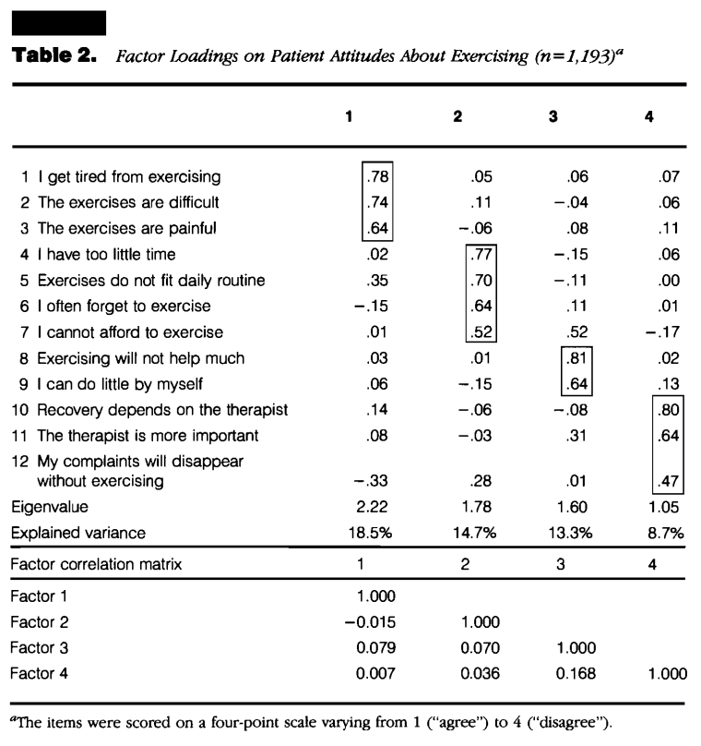

Appendix 2: Table Representing the Forward Translation T1 and T2
Translation T1 | Translation T2
1 Ich werde vom üben müde | 1 Ich werde vom üben müde
2 Die Übungen sind schwierig | 2 Die Übungen sind schwierig
3 Die Übungen sind schmerzhaft | 3 Die Übungen sind schmerzhaft
4 Ich habe zu wenig Zeit | 4 Ich habe zu wenig Zeit um zu Üben
5 Die Übungen passen nicht in meine Routine | 5 Die Übungen passen nicht in die tägliche Routine
6 Ich vergesse es oft zu üben | 6 Ich vergesse oft zu üben
7 Ich kann es mir nicht leisten zu üben | 7 Ich kann es mir nicht leisten zu üben
8 Üben wird mir nicht helfen | 8 Die Übungen werden nicht viel helfen
9 Ich kann wenig alleine machen | 9 Ich kann wenig alleine machen
10 Die Genesung hängt vom Physiotherapeuten a | 10 Die Genesung hängt vom Physiotherapeuten ab
11 Der Physiotherapeut ist am wichtigsten. | 11 Der Physiotherapeut ist wichtiger
12 Meine Beschwerden werden sich auch ohne Übungen lösen | 12 Meine Beschwerden werden sich auch vermindern ohne zu üben.

Appendix 3: Table Representing the Backward Translations BT1 and BT2
Back-Translation BT1 | Back-Translation BT2
1 I get tired from exercising | 1 I get tired from practicing
2 The exercises are difficult | 2 The exercises are difficult
3 The exercises are painful | 3 The exercises are painful
4 I don’t have enough time (to exercise) | 4 I don’t have enough time
5 The exercises don’t fit into my daily routine | 5 The exercises don’t fit into my daily schedule
6 I often forget to do the exercises | 6 I often forget to practise
7 I cannot afford to do the exercises | 7 I cannot afford to practise
8 The exercises will not help much | 8 The exercises will not help much
9 I cannot do much on my own | 9 The recovery depends on my physiotherapist
10 Recovery depends on the physiotherapist | 10 The recovery depends on my physiotherapist
11 The physiotherapist is more important (than the exercises) | 11 The physiotherapist is more important
12 My health problems will resolve without exercise | 12 The physiotherapist is more important

Appendix 4: Comments Provided by Patients in the Corresponding Section of the Questionnaire
Patient 1: “The main factor influencing healing is the attitude of the patients themselves. A physiotherapist can only do as much as instructing us on how to do the exercises properly. Executing the exercises on a regular basis is our responsibility”.
Patient 2: “Simple yes or no questions would be better, although I found no difficulties in answering the items”
Patient 3: “I do not consider the physiotherapist to be essential in the daily execution of exercises. However, exercising with someone, maybe like a group of people, would be much more motivating than doing so alone”.
Patient 4: “I think we need a paper-based program than details the correct way of performing an exercise since I am afraid to do it in a wrong manner and hurt myself”.
Patient 5: “I try to do my exercises routinely but Pain presents rapidly and inhibits further repetitions”
Patient 6: “I think these questions are subjective and answering them might depend on my mood. Yesterday I was feeling pain so I would have answered them differently”
Additional Files
Additional files include figure 1 referenced in the main Manuscript text. It will be supplemented as a word file named Figure 1.
The included in Figure 1 describes the steps of Cross-Cultural adaption used for this document.

