Supplemental Information for

PD-L1-expressing cancer-associated fibroblasts induce tumor immunosuppression and contribute to poor clinical outcome

Authors: Kento Kawasaki¹, Kazuhiro Noma¹, Takuya Kato¹, Toshiaki Ohara^{1,2}, Shunsuke Tanabe¹, Yasushige Takeda¹, Hijiri Matsumoto¹, Seitaro Nishimura¹, Tomoyoshi Kunitomo¹,
Masaaki Akai¹, Teruki Kobayashi¹, Noriyuki Nishiwaki¹, Hajime Kashima¹, Naoaki Maeda¹, Satoru Kikuchi¹, Hiroshi Tazawa^{1,3}, Yasuhiro Shirakawa^{1,4}, and Toshiyoshi Fujiwara¹

Affiliations:
¹ Department of Gastroenterological Surgery, Okayama University Graduate School of Medicine, Dentistry and Pharmaceutical Sciences, Okayama, Japan.
² Department of Pathology & Experimental Medicine, Okayama University Graduate School of Medicine, Dentistry and Pharmaceutical Sciences, Okayama, Japan.
³ Center for Gene and Cell Therapy, Okayama University Hospital, Okayama, Japan.
⁴ Department of Surgery, Hiroshima City Hiroshima Citizens Hospital
*Corresponding author. Kazuhiro Noma, Department of Gastroenterological Surgery, Okayama University Graduate School of Medicine, Dentistry, and Pharmaceutical Sciences, 2-5-1 Shikata-cho, Kita-ku, Okayama 700-8558, Japan Phone: +81-86-235-7255; Fax: +81-86-221-8775; E-mail: knoma@md.okayama-u.ac.jp
List of Supplemental Information
Supplemental Figure S1. Representative pictures of PD-L1 expression in the stromal area
Supplemental Figure S2. Survival curves for the variance of PD-L1 expression
Supplemental Figure S3. PD-L1 expression in fibroblasts and OE33 cells stimulated by the cancer-conditioned medium of esophageal adenocarcinoma cell lines
Supplemental Figure S4. PD-L1 expression in FEF3 stimulated by TGF-β or conditioned medium of ESCCs.
Supplemental Figure S5. Dot plots of co-culture models using Cytotell UltraGreen
Supplemental Figure S6. Representative pictures of immunohistochemical staining for CD8, FoxP3, and αSMA in tumor tissues
Supplemental Figure S7. Digoxigenin-labeled anti-PD-L1 antibody administration for murine subcutaneous tumors
Supplemental Table S1. Clinicopathological features for PD-L1 in cancer cells
Supplemental Table S2. Univariate and multivariate analysis for overall survival
Supplemental Table S3. Univariate and multivariate analysis for relapse-free survival
Supplemental Table S4. Univariate and multivariate analysis for PD-L1 expression in cancer cells

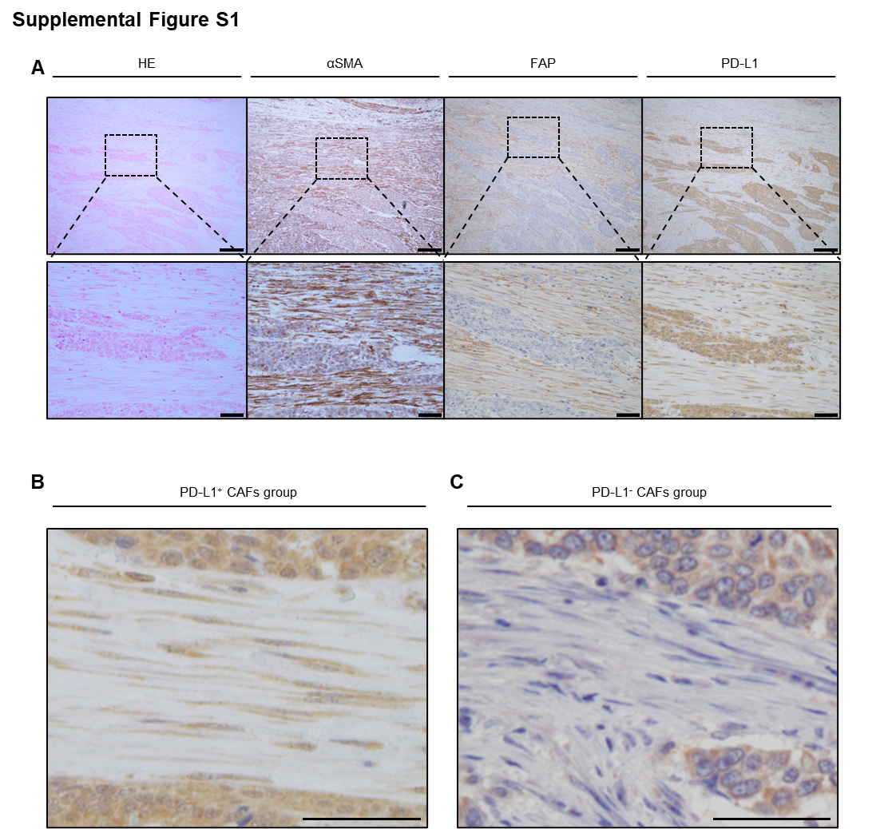
Supplemental Figure S1. Representative pictures of PD-L1 expression in the stromal area
(A) Representative images of hematoxylin and eosin staining, α-SMA, FAP, and PD-L1 immunostaining. Scale bars = 100 µm. The lower figures are enlarged images. Scare bars = 50 µm. (B) Representative picture of PD-L1⁺ CAFs group. Scale bars = 50 µm. (C) Representative picture of the PD-L1⁻ CAFs group. Scale bars = 50 µm.

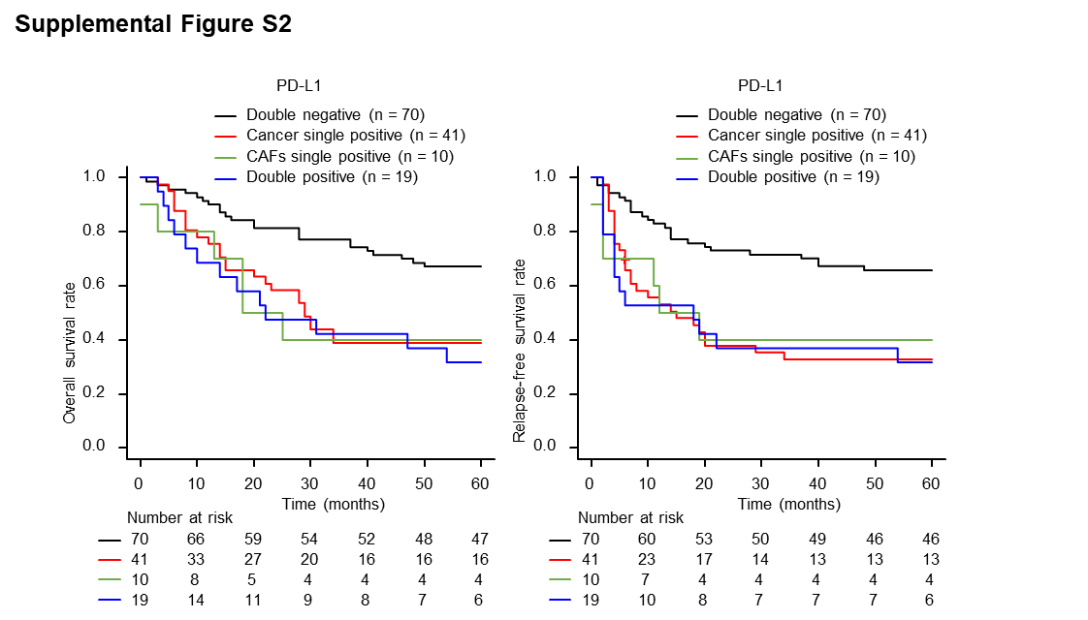
Supplemental Figure S2. Survival curves for the variance of PD-L1 expression
Survival curve according to the variance of PD-L1 expression analyzed using the Kaplan–Meier method (n = 140).
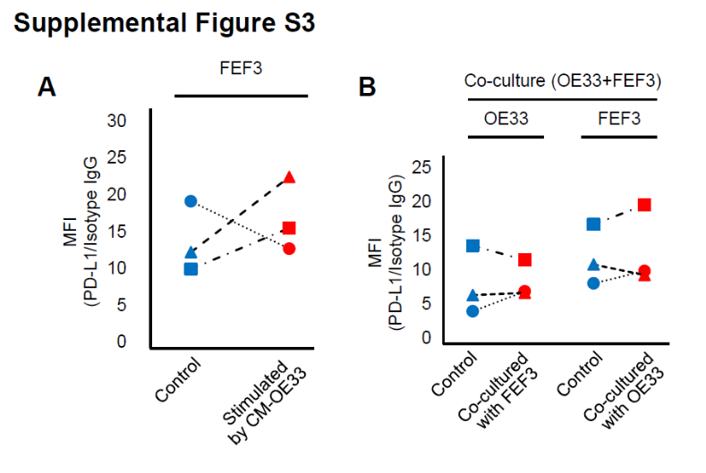
Supplemental Figure S3. PD-L1 expression in fibroblasts and OE33 cells stimulated by the cancer-conditioned medium of esophageal adenocarcinoma cell lines
(A) Flow cytometry analysis of cell surface PD-L1 expression in fibroblasts with or without activation by conditioned medium from OE33 cells. (B) Flow cytometry analysis of cell surface PD-L1 expression in OE33 cells and FEF3 in a co-culture model. n = 3, comparative analysis of mean fluorescence intensities using paired t-test, *P < 0.05.
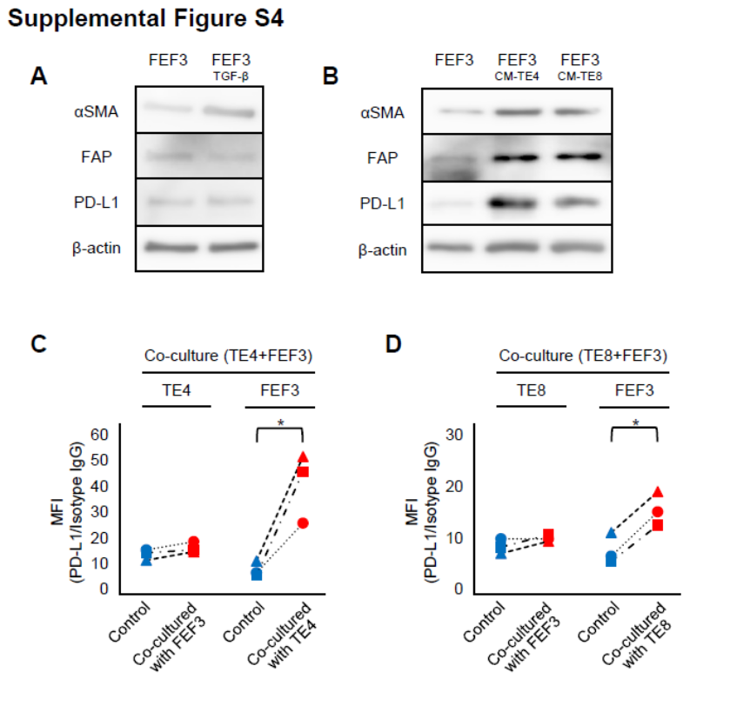
Supplemental Figure S4. PD-L1 expression in FEF3 stimulated by TGF-β or conditioned medium of ESCCs.
Western blotting was performed as described preveously. The following antibodies were used; monoclonal anti-E-cadherin (#3195 clone, 24E10, Cell Signaling Technology), monoclonal anti-vimentin (#5741, clone D21H3, Cell Signaling Technology), monoclonal anti-αSMA (#19245, clone D4K9N, Cell Signaling Technology), polyclonal anti-FAP (ab53066, Abcam), monoclonal anti-PD-L1 (#13684, clone E1L3N, Cell Signaling Technology), and monoclonal anti-β-actin (A5441, clone AC-15, Sigma-Aldrich). The membranes were visualized using an Amersham Imager 600 (GE Healthcare, Little Chalfont/ UK). (A, B) FEF3 activated by (A) TGF-β and (B) conditioned medium of TE4 and TE8 subjected to western blotting of αSMA, FAP, PD-L1, and β-actin expression. (C, D) Flow cytometry analysis of cell surface PD-L1 expression in human cancer cells and fibroblasts in a co-culture model. (C) TE4 and FEF3, (D) TE8 and FEF3 (n = 3, comparative analysis of mean fluorescence intensities by ratio paired t-test, *P < 0.05; **P < 0.01).

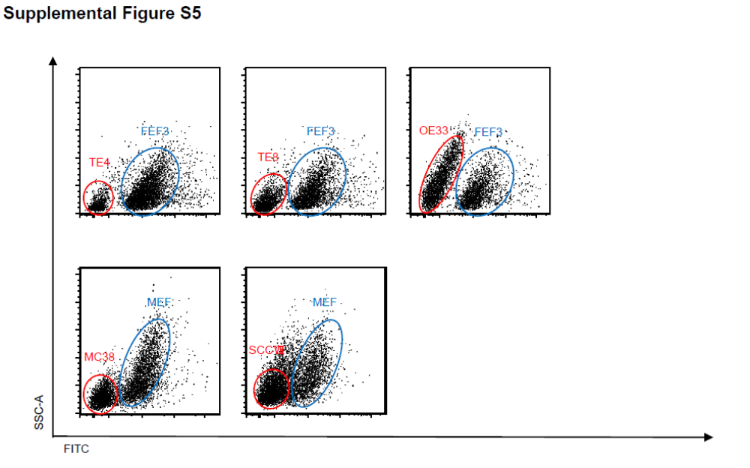
Supplemental Figure S5. Dot plots of co-culture models using Cytotell UltraGreen
Representative dot plots by flow cytometric analysis. Fibroblasts were detected using FITC and distinguished from cancer cells by pre-staining with ultra-green.
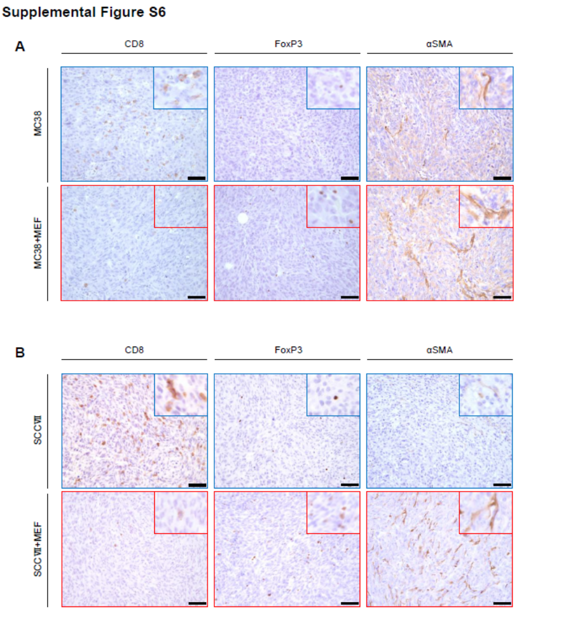

Supplemental Figure S6. Representative pictures of immunohistochemical staining for CD8, FoxP3, and αSMA in tumor tissues
(A) MC38 cells with and without MEF tumors. (B) SCCⅦ with or without MEF tumors. Scale bars = 50 µm.
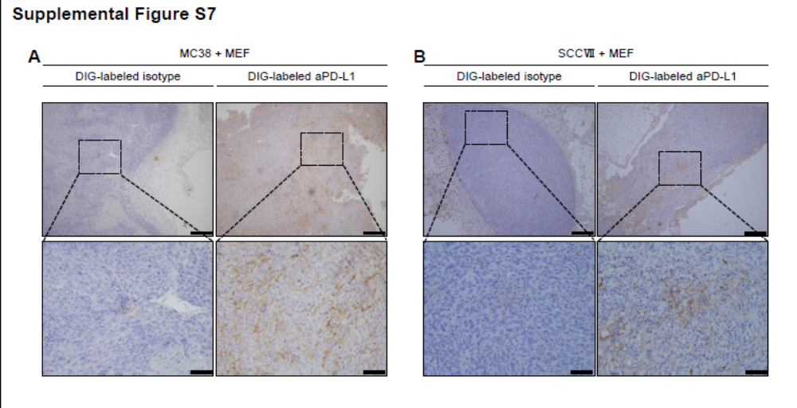
Supplementary Figure S7. Digoxigenin-labeled anti-PD-L1 antibody administration for murine subcutaneous tumors
(A, B) Representative pictures of immunohistochemical staining for Digoxigenin (DIG)-labeled anti-PD-L1 antibody (aPD-L1) and DIG-labeled isotype rat IgG2b. (A) MC38+MEF. (B) SCCⅦ+MEF. Scale bars = 200 µm. Lower figures are enlarged images. Scare bars = 50 µm.

Supplemental Table S1. Clinicopathological features for PD-L1 in cancer cells
 | Total | PD-L1(+) | PD-L1(-) | P value
Variable | n = 140 | n = 60 (42.9%) | n = 80 (57.1%)
Age (years) | 67 (40–85) | 67 (44–85) | 67 (40–84) | 0.644§
Sex (male/female) |  |  |  | 0.626†
Male | 121 (86.4%) | 53 (88.3%) | 68 (85.0%)
Female | 19 (13.6%) | 7 (11.7%) | 12 (15.0%)
Neo-adjuvant chemotherapy | 35 (25.0%) | 18 (30.0%) | 17 (21.2%) | 0.245†
Tumor location |  |  |  | 0.089†
Cervical | 12 (8.6%) | 4 (6.7%) | 8 (10.0%)
Upper | 24 (17.1%) | 5 (8.3%) | 19 (23.8%)
Middle | 60 (42.9%) | 30 (50.0%) | 30 (37.5%)
Lower | 28 (20.0%) | 15 (25.0%) | 13 (16.2%)
Abdominal | 16 (11.4%) | 6 (10.0%) | 10 (12.5%)
Pathological T stage |  |  |  | < 0.001*
T1 | 62 (44.3%) | 14 (23.3%) | 48 (60.0%)
T2 | 15 (10.7%) | 7 (11.7%) | 8 (10.0%)
T3 | 59 (42.1%) | 38 (63.3%) | 21 (26.2%)
T4 | 4 (2.9%) | 1 (1.7%) | 3 (3.8%)
Pathological N stage |  |  |  | 0.054†
N0 | 68 (48.6%) | 23 (38.3%) | 45 (56.2%)
N1 | 38 (27.1%) | 16 (26.7%) | 22 (27.5%)
N2 | 21 (15.0%) | 12 (20.0%) | 9 (11.2%)
N3 | 13 (9.3%) | 9 (15.0%) | 4 (5.0%)
Histological type |  |  |  | 0.422†
Squamous cell carcinoma | 123 (87.9%) | 55 (91.7%) | 68 (85.0%)
Adenocarcinoma | 12 (8.6%) | 3 (5.0%) | 9 (11.2%)
Other | 5 (3.6%) | 2 (3.3%) | 3 (3.8%)
αSMA Area Index | 7.76 (0.49–40.30) | 12.83 (1.39–33.25) | 4.73 (0.49–40.30) | < 0.001§*
FAP Area Index | 6.04 (0.01–39.91) | 8.54 (0.5–37.0) | 3.97 (0.01–39.91) | < 0.001§*
CD8 | 40.13 (0.25–215.75) | 43.38 (0.25–185.25) | 38.13 (0.50–215.75) | 0.931§
FoxP3 | 15.13 (0.5–138) | 20.75 (2.0–138) | 11.86 (0.50–52.5) | 0.001§*
Values are presented as median or n (%)
Mann–Whitney U test: §, Fisher’s exact test: †, *P < 0.05 (statistical significance)
SMA, smooth muscle actin; FAP, fibroblast activation protein; FoxP3, forkhead box p3; PD-L1, programmed cell death ligand 1
Supplemental Table S2. Univariate and multivariate analysis for overall survival
 |  | Univariate analysis |  |  |  | Multivariate analysis
Variable | Unfavorable/favorable | HR | 95% CI | P value |  | HR | 95% CI | P value
Age (years) | ≥70/＜70 | 1.09 | 0.67–1.79 | 0.720
Sex | Male/Female | 2.91 | 1.06–8.00 | 0.039* |  | 2.88 | 1.04–7.97 | 0.041*
Neo-adjuvant chemotherapy | Yes/No | 2.20 | 1.33–3.63 | 0.002* |  | 1.50 | 0.88–2.54 | 0.132
Pathological T stage | T2, T3, T4/T1 | 2.55 | 1.51–4.31 | < 0.001* |  | 1.46 | 0.79–2.69 | 0.226
Pathological N stage | N1, N2, N3/N0 | 2.71 | 1.61–4.54 | < 0.001* |  | 2.01 | 1.15–3.55 | 0.015*
PD-L1 in cancer cells | Positive/Negative | 2.22 | 1.37–3.61 | 0.001* |  | 1.72 | 1.03–2.87 | 0.039*
Cox proportional hazard model, *P < 0.05 (statistical significance)
HR, hazard ratio; CI, confidence interval; PD-L1, programmed cell death 1.
Multivariate analysis was performed on statistically significant parameters obtained from the univariate.
Supplemental Table S3. Univariate and multivariate analysis for relapse-free survival
 |  | Univariate analysis |  |  |  | Multivariate analysis
Variable | Unfavorable/favorable | HR | 95% CI | P value |  | HR | 95% CI | P value
Age (years) | ≥70/＜70 | 0.97 | 0.60–1.57 | 0.892
Sex | Male/Female | 3.06 | 1.11–8.40 | 0.030* |  | 2.79 | 1.01–7.74 | 0.048*
Neo-adjuvant chemotherapy | Yes/No | 2.76 | 1.68–4.53 | < 0.001* |  | 1.58 | 0.88–2.81 | 0.122
Pathological T stage | T2, T3, T4/T1 | 2.84 | 1.70–4.76 | < 0.001* |  | 2.05 | 1.21–3.49 | 0.008*
Pathological N stage | N1, N2, N3/N0 | 2.72 | 1.64–4.49 | < 0.001* |  | 2.14 | 1.27–3.60 | 0.004*
PD-L1 in cancer cells | Positive/Negative | 2.41 | 1.50–3.88 | < 0.001* |  | 2.02 | 1.22–3.34 | 0.006*
Cox proportional hazard model, *P < 0.05 (statistical significance)
HR, hazard ratio; CI, confidence interval; PD-L1, programmed cell death 1.
Multivariate analysis was performed on statistically significant parameters obtained from the univariate.
Supplemental Table S4. Univariate and multivariate analysis for PD-L1 expression in cancer cells
 |  | Univariate analysis |  |  |  | Multivariate analysis
Variable | Unfavorable/favorable | OR | 95% CI | P-value |  | OR | 95% CI | P-value
Age (years) | ≥70/＜70 | 1.04 | 0.52–2.07 | 0.920
Sex | Male/Female | 1.34 | 0.49–3.63 | 0.570
Neo-adjuvant chemotherapy | Yes/No | 1.59 | 0.74–3.43 | 0.239
Pathological T stage | T2, T3, T4/T1 | 4.93 | 2.34–10.40 | < 0.001* |  | 2.29 | 0.87–6.02 | 0.093
Pathological N stage | N1, N2, N3/N0 | 2.07 | 1.05–4.09 | 0.037* |  | 0.73 | 0.30–1.78 | 0.489
Area index of αSMA | Positive/Negative | 1.83 | 1.08–3.10 | 0.024* |  | 4.72 | 1.81–12.30 | 0.001*
Logistic regression analysis, *P < 0.05 (statistical significance)
OR, odds ratio; CI, confidence interval; SMA, smooth muscle actin.
Multivariate analysis was performed on statistically significant parameters obtained from the univariate.

