Supplementary materials
Species composition determines bioplastics production in photosynthetic microbiomes: strategy to enrich cyanobacteria PHB-producers
Beatriz Altamira-Algarraª, Artai Lageª, Joan García^{b}, Eva Gonzalez-Flo^{a*}
ª GEMMA-Group of Environmental Engineering and Microbiology. Department of Civil and Environmental Engineering. Escola d’Enginyeria de Barcelona Est (EEBE). Universitat Politècnica de Catalunya-BarcelonaTech. Av. Eduard Maristany 16. Building C5.1. E-08019 Barcelona. Spain
^{b} GEMMA-Group of Environmental Engineering and Microbiology. Department of Civil and Environmental Engineering. Universitat Politècnica de Catalunya-BarcelonaTech. c/ Jordi Girona 1-3. Building D1. E-08034 Barcelona. Spain
* corresponding author

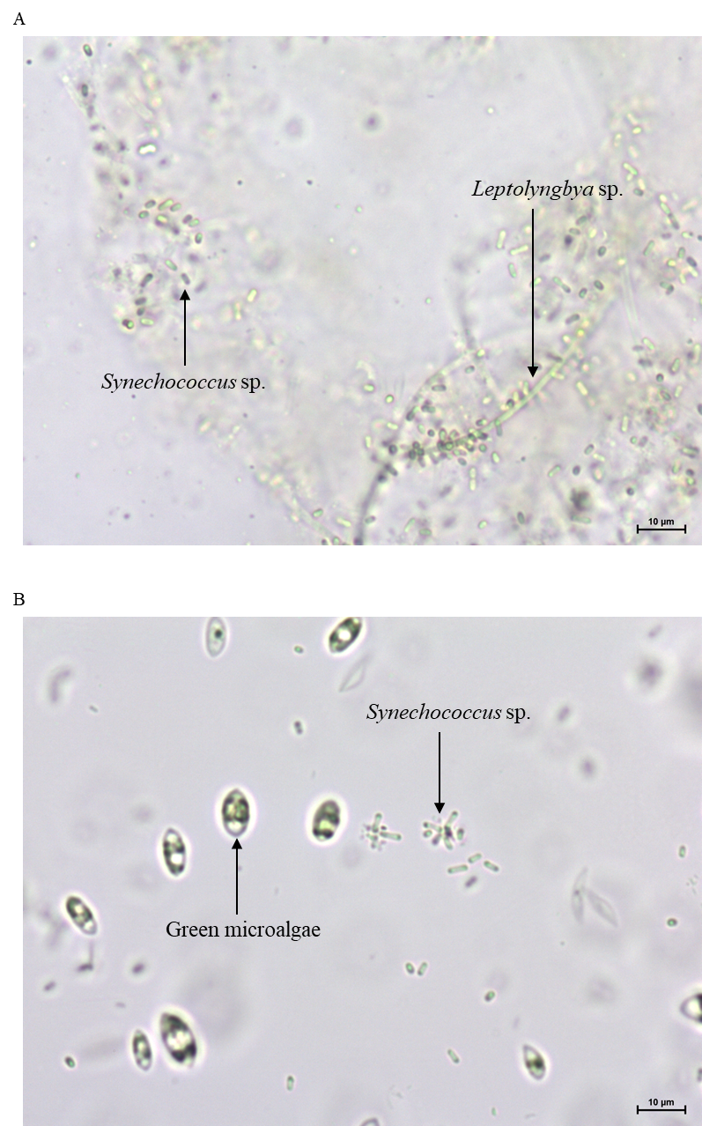
Figure S1. Microscope images under bright light microscopy at 40X of (A) inoculum and (B) culture at the end of conditioning period. In (A) unicellular cyanobacteria Synechococcus sp. and filamentous cyanobacteria Leptolyngbya sp. can be seen. In (B) the presence of green algae and Synechococcus sp. is observed.
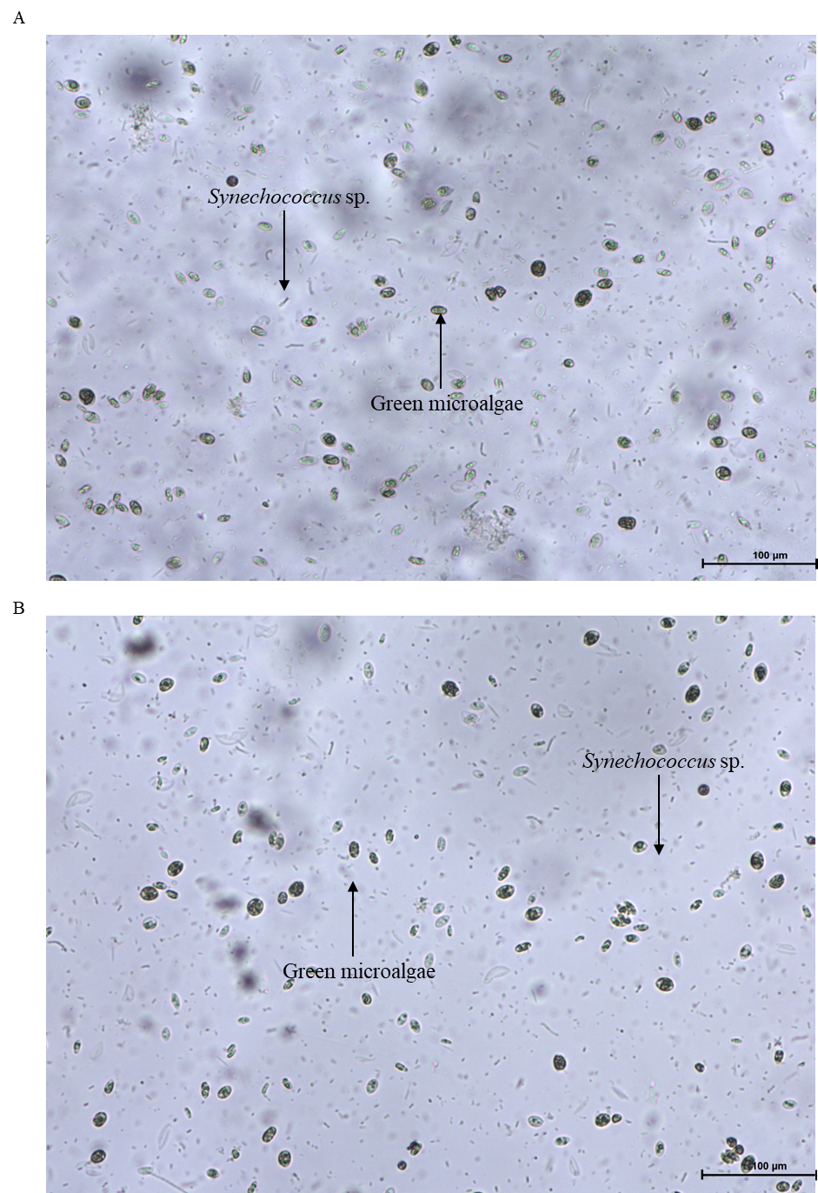
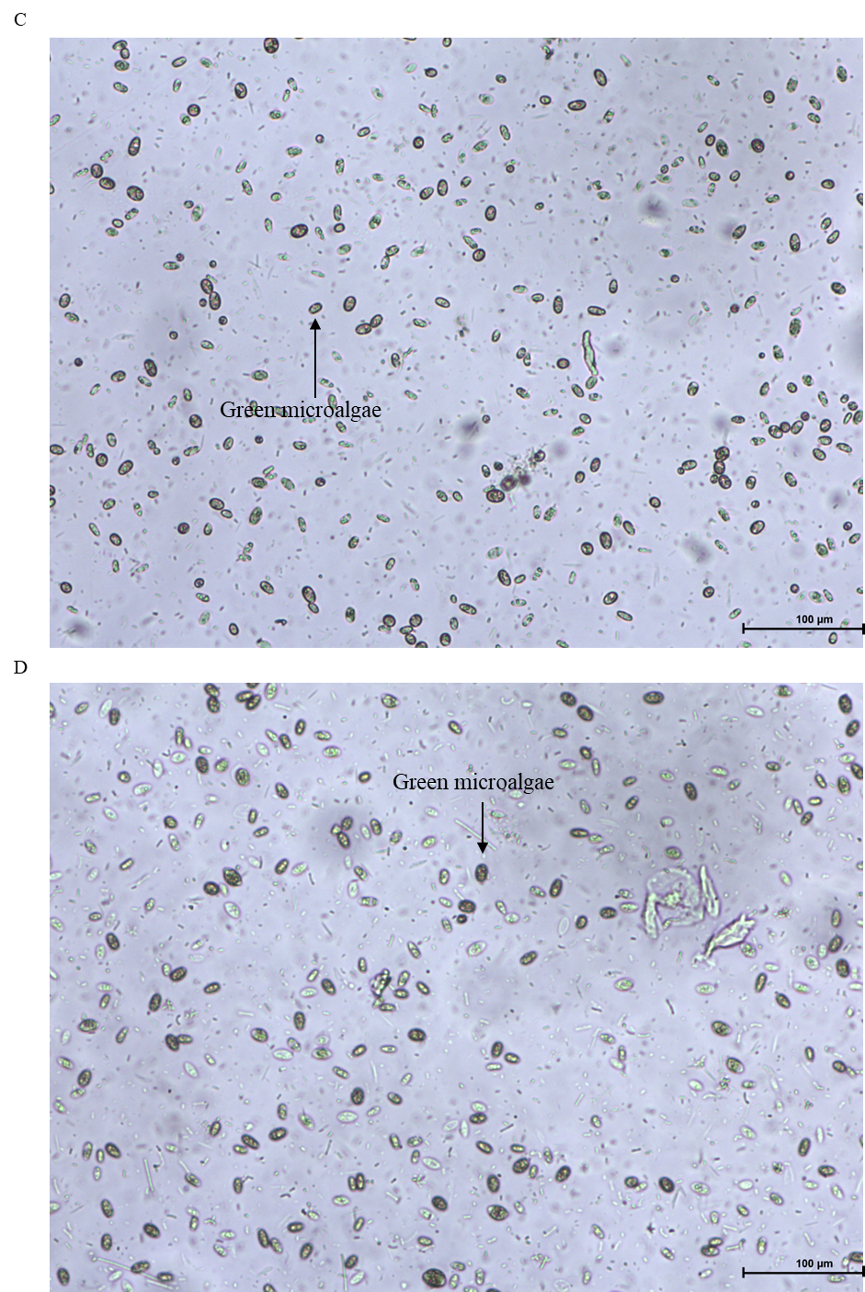
Figure S2. Microscope images under bright light microscopy at 10X of (A) PBR1, (B) PBR2, (C) PBR3 and (D) PBR4 at the end of cycle period. Differences in presence of unicellular cyanobacteria Synechococcus sp. and green algae between PBR 1 & 2 and PBR 3& 4 can be detected. In PBR 1 & 2 it can be clearly observed the lower abundance of green algae.
Table S1. Consumed acetate during the iterated period. Values were calculated by subtracting the amount of Ac remaining in the PBRs to the initial Ac concentration (600 mg·L⁻¹).
Repetition | Consumed Ac (mgAc·L⁻¹)
Repetition | PBR1 | PBR2
1 | 277.62 | 292.079
2 | 424.71 | 454.46
3 | n.d. | n.d.
4 | 596.94 | 523.824
5 | 600 | 342.06
6 | n.d. | n.d.
7 | n.d. | n.d.
8 | 218.169 | 449.3
9 | 296.73 | 444.58

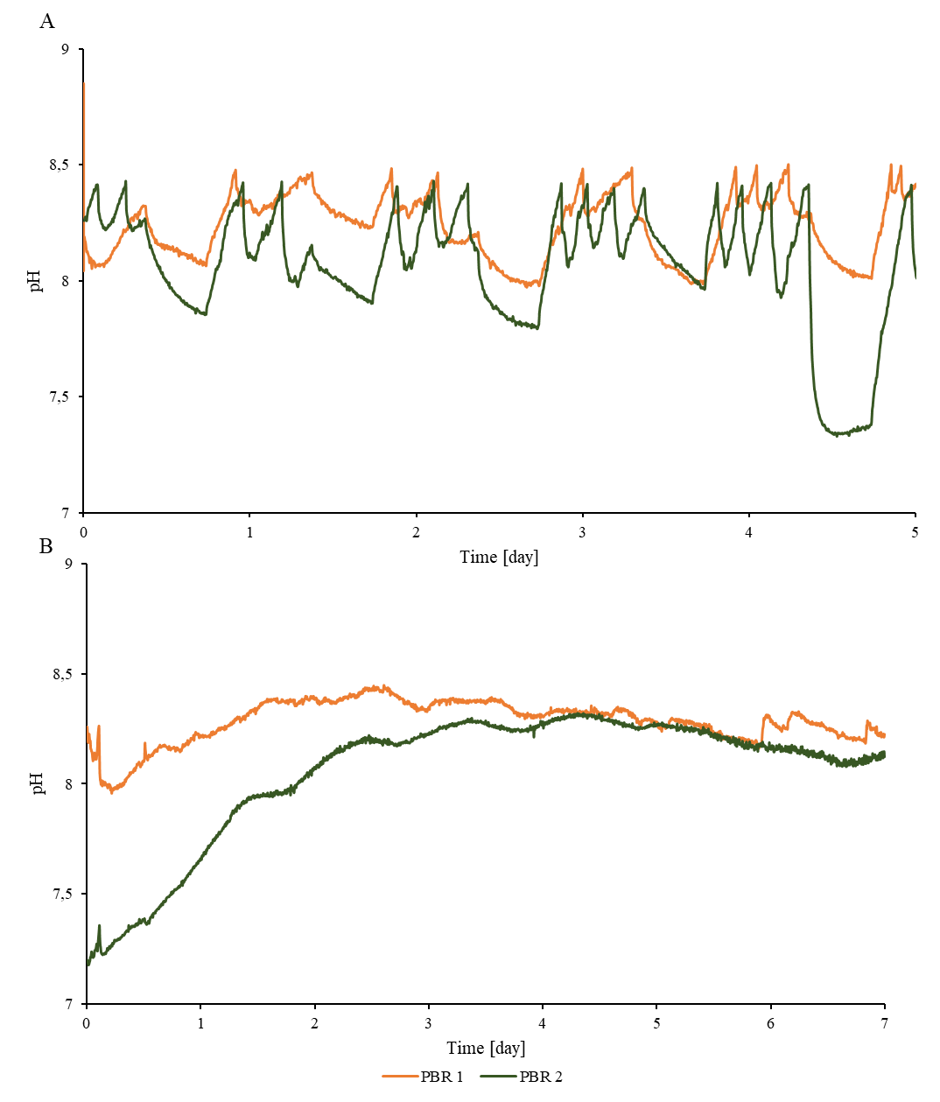
Figure S3. Example of pH evolution through on cycle. (A) Profile during growth phase in repetition 5 and (B) during accumulation phase in repetition 4.

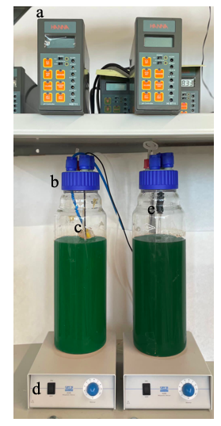
Figure S4. Image of the experimental set-up. a) pH controller; b) photobioreactor; c) CO₂ diffusor; d) magnetic stirrer; e) pH probe.

Figure S5. Calibration curve VSS-Turbidity for microbiome CC.

Table S2. Data used to calculate biovolumes.
Cell type | Average width (µm) | Average lenght (µm) | Cell shape | Count (n) | Average volume (µm³) | Volume equation*
Synechococcus sp. | 1.64 | 4.29 | Cylinder | 20 | 22.72 | $v=\frac{1}{4}π$l$w^{2}$
Green microalgae | 8.06 | 10.63 | Ellipsoid | 20 | 521.90 | $v=\frac{1}{6}π$l$w^{2}$
*In volume equation, l stands for average length and w for average width.

