Supplementary materials
From embryo to adult: Unravelling the temporal and spatial variations in fungal phylotypes of Atlantic salmon

Jep Lokesh1#*, Prabhugouda Siriyappagouder1, Jorge M.O. Fernandes1*

1Faculty of Biosciences and Aquaculture, Nord University, Bodø, Norway
#Current address: Université de Pau et des Pays de l'Adour, E2S UPPA. INRAE, NUMEA, Saint-Pée-sur-Nivelle, France

Running title: Fungal communities of Atlantic salmon

Keywords: Aquaculture, Atlantic salmon (Salmo salar), fungal community, microbiota, intestine, amplicon sequencing.

* Corresponding authors: lokesh.jep@inrae.fr; jorge.m.fernandes@nord.no
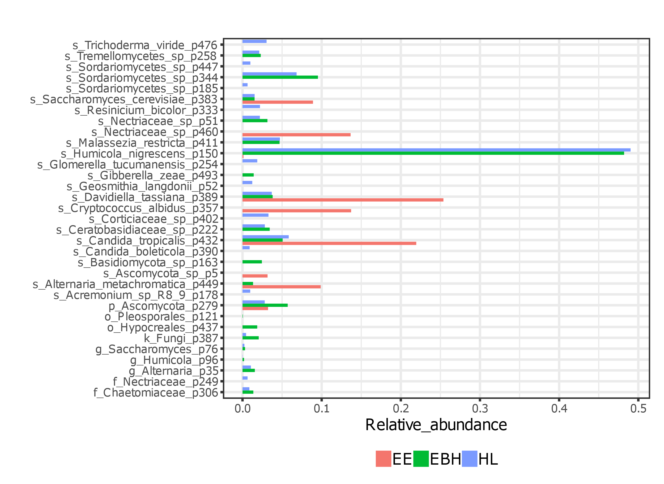
Supplementary figure 1: Composition of the core phylotypes during the early stages of ontogeny (EE, EBH, and HL) with a minimum relative abundance greater than 0.01.

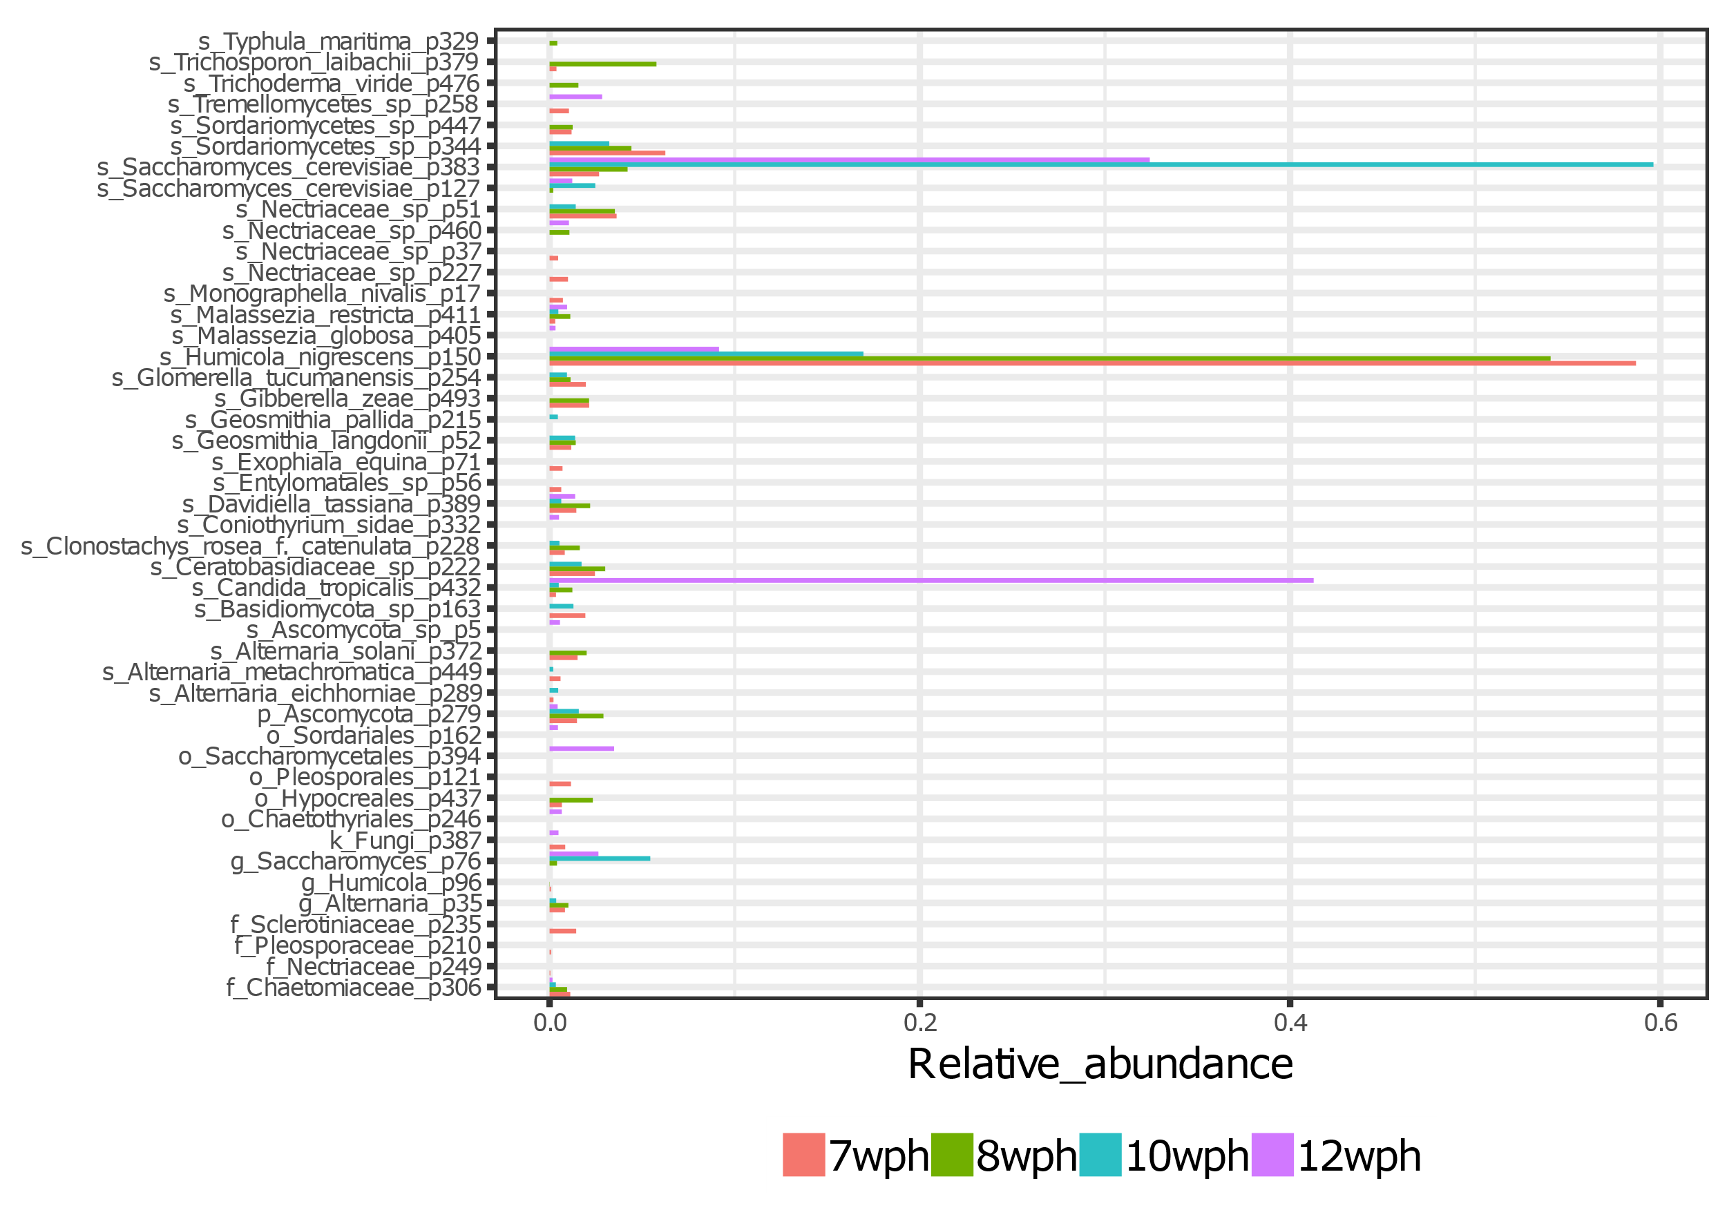
Supplementary figure 2: Composition of the core phylotypes in the intestine of the early stages of ontogeny (7 wph, 8 wph, 10 wph and 12 wph) with a minimum relative abundance greater than 0.01.
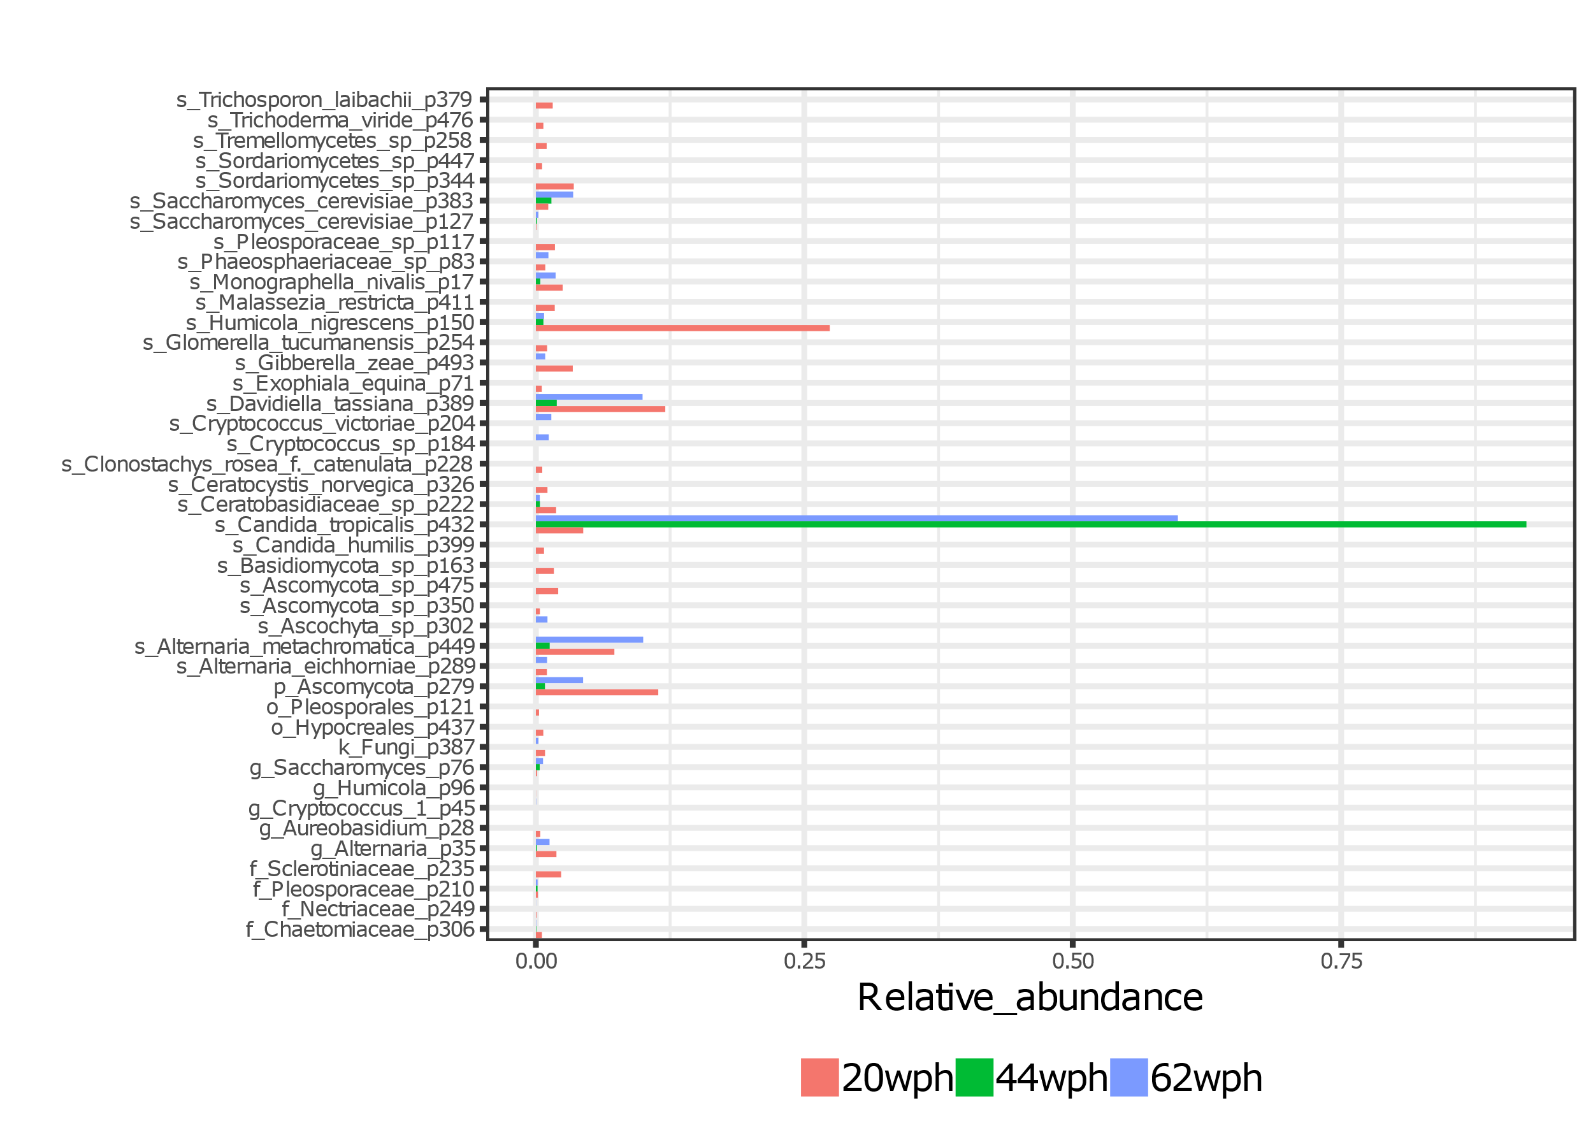
Supplementary figure 3: Composition of the core phylotypes in the intestine of the late freshwater stages of Atlantic salmon (20 wph, 44 wph, and 62 wph) with a minimum relative abundance greater than 0.01.

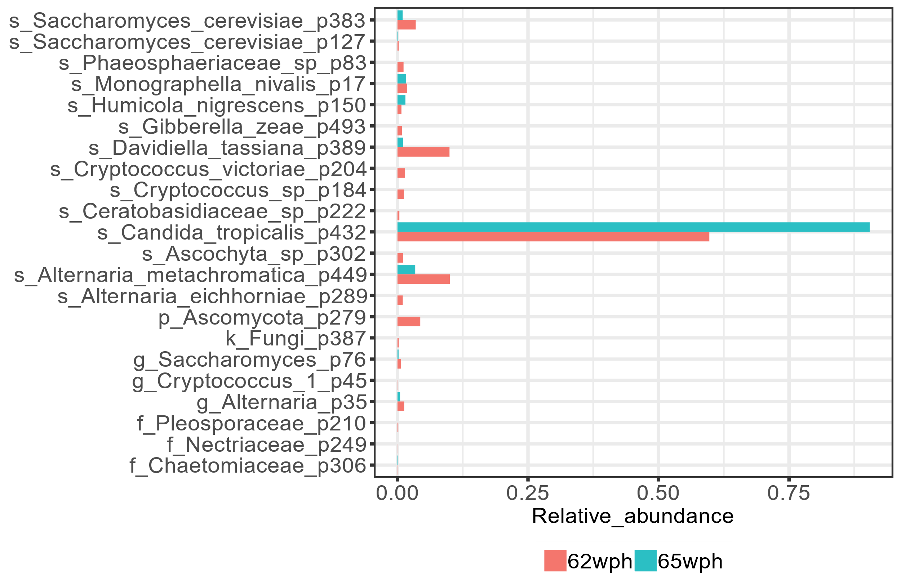
Supplementary figure 4: Composition of the core phylotypes (minimum relative abundance greater than 0.01) in the intestine of Atlantic salmon during the transition from freshwater (62 wph) to seawater (65 wph).

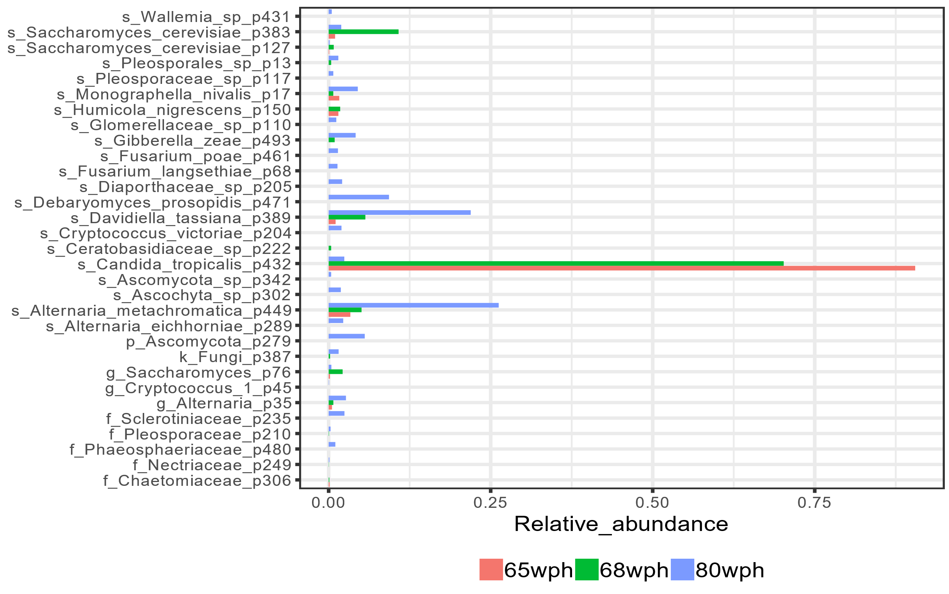
Supplementary figure 5: Composition of the core phylotypes during the stages of ontogeny sampled from the seawater phase (65 wph, 68 wph, and 80 wph) with a minimum relative abundance greater than 0.01.

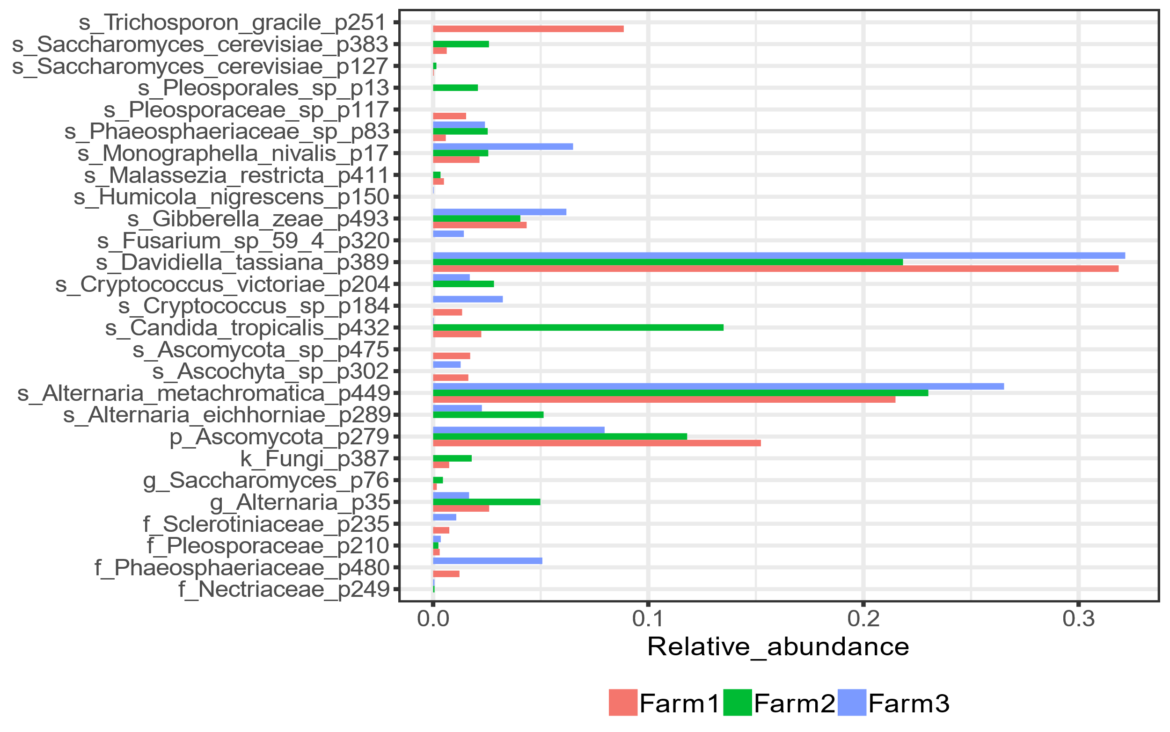
Supplementary figure 6: Composition of the core phylotypes of the Atlantic salmon originating from three different with a minimum relative abundance greater than 0.01.

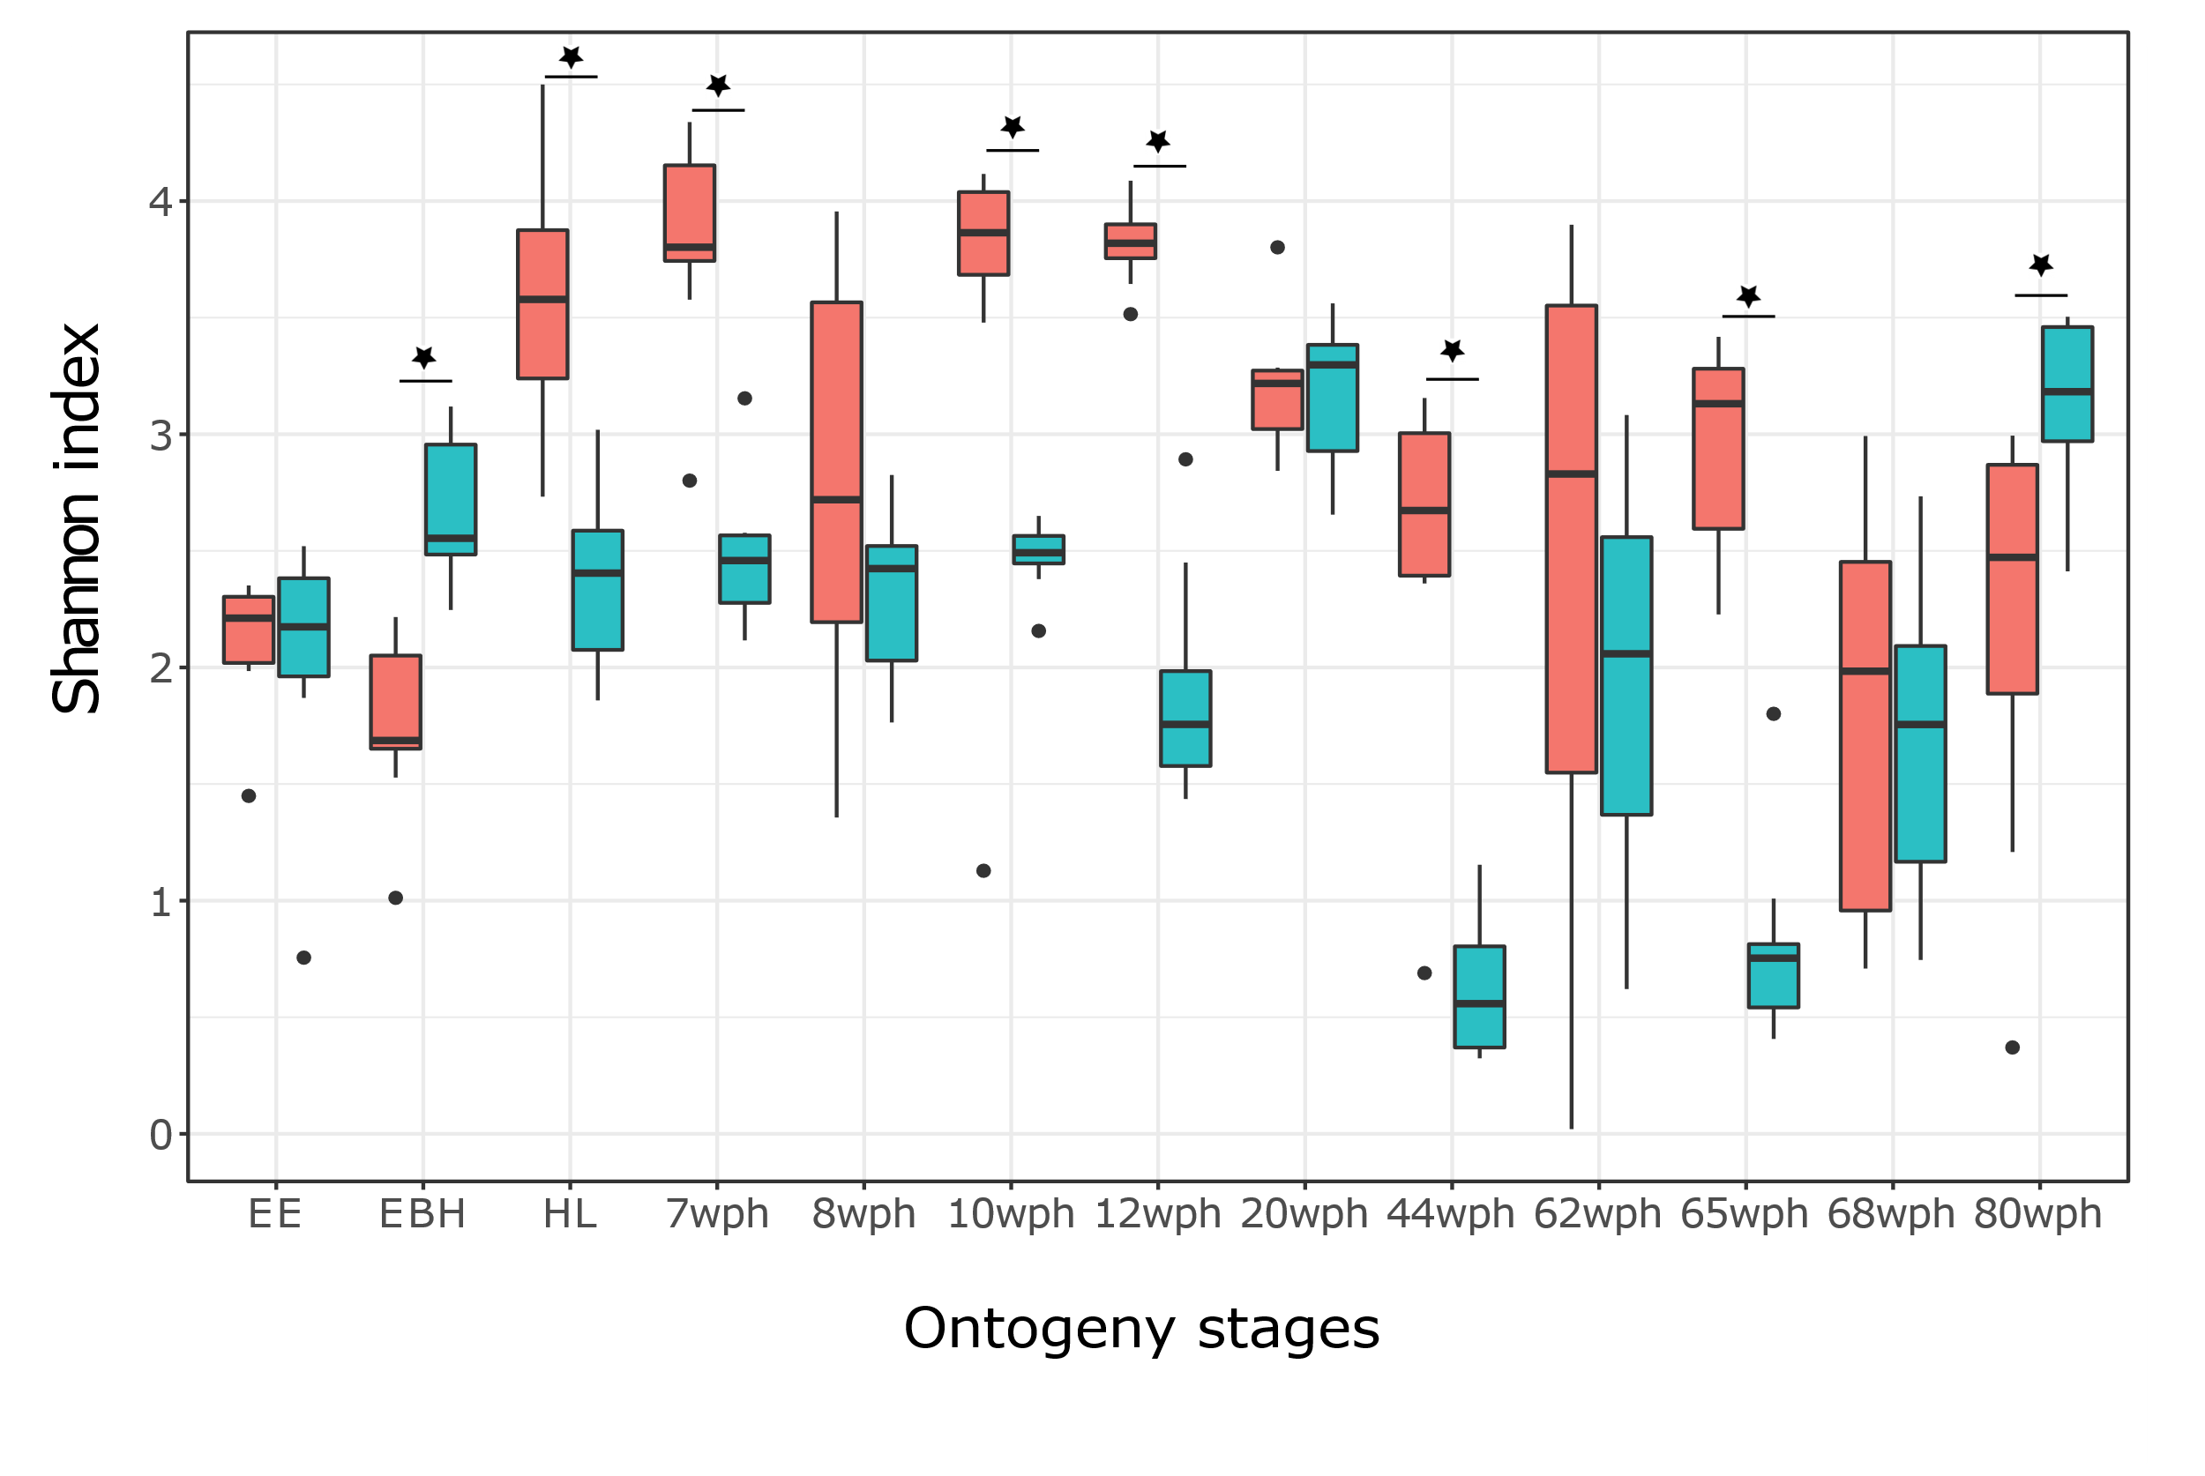
Supplementary figure 7: Comparison of the bacterial and fungal alpha diversities at different stages of ontogeny of Atlantic salmon.

