·Supplementary Information (SI) for
Remediation of As(Ⅴ) and Cd(II) contamination by a ZVI-biochar: experimental and DFT calculation
Bangwei Liu¹, Yan Zhou¹,Yiwei Zhang¹, Dandan Chen¹*, Wenhui Liu¹, Ping Lu¹, Xiaoyu Su¹, and Tian Xia¹
1.School of Energy and Mechanical Engineering, Nanjing Normal University, Nanjing 210023, China;
*Corresponding Author: Tel/Fax: +86–25–85481085; E-mail: dandanchen@njnu.edu.cn

The Supporting Information includes:
2 Texts
1 Table
3 Figures

Text S1 Kinetic model and Intra-particle diffusion model
(1) To investigate the adsorption equilibrium time and the possible mechanism, the kinetic equations of Pseudo-first-order model (Equation 1) and pseudo-second-order model (Equation 2) were used to describe the adsorption kinetics of biochar on As(Ⅴ) and Cd(Ⅱ), respectively.
$\text{ln}\left({\text{Q}}_{\text{e}}\text{-}{\text{Q}}_{\text{t}}\right)\text{=}\text{ln}{{\text{Q}}_{\text{e}}}\text{-}{\text{k}}_{\text{1}}\text{t}$ (1)
$\frac{\text{t}}{{\text{Q}}_{\text{t}}}\text{=}\frac{\text{1}}{{\text{K}}_{\text{2}}{\text{Q}}_{\text{e}}^{\text{2}}}\text{+}\frac{\text{t}}{{\text{Q}}_{\text{e}}}$ (2)
Q_{e} ………… Adsorption capacity at equilibrium，
Q_{t}…………Adsorption capacity at time t，
k₁、k₂……… Rate constants for two adsorption models.
(2) Intra-particle diffusion model
${\text{Q}}_{\text{t}}\text{=A}{\text{t}}^{\text{0.5}}\text{+B}$ (3)
Q_{t}………… Adsorption capacity at time t，
A…………Internal diffusion rate constant (g/kg)
B…………dimensionless constants

Text S2 Calculation formula for soil leaching experiments
（1）Single release of heavy metals in soil
The single release of heavy metals in the experimental soil column reflects the influence of leaching processes on the leaching characteristics of heavy metals in soil. The higher the single release of heavy metals, the more easily they migrate and the worse their bioavailability.
${\text{R}}_{\text{i}}\text{=}\frac{{\text{C}}_{\text{i}}\text{×v}}{\text{m}}$(4)
$R_{i}$…………Single release of heavy metals in soil samples for leaching experiments，mg/kg
$C_{i}$…………Concentration of heavy metals in the filtrate collected in the i-th leaching，mg/kg
$ν$…………Volume of filtrate during each leaching process，ml
$m$…………Experimental soil quality，kg
In the experiment, six leaching processes were carried out. The filtration volume of each leaching was 350 ml. the mass of the experimental soil was 120 g.
(2) Cumulative release of heavy metals in soils
$\text{R=}{\text{R}}_{\text{1}}{\text{+R}}_{\text{2}}\text{+…}{\text{+R}}_{\text{6}}$(5)
R…………Cumulative release of heavy metals from soil samples under leaching experiments，mg/kg；
(3) Single release rate and cumulative release rate of heavy metals in soils
${\text{k}}_{\text{i}}\text{=}\frac{{\text{R}}_{\text{i}}}{{\text{M}}_{\text{hm}}}$(6)
$\text{k=}\frac{\text{R}}{{\text{M}}_{\text{hm}}}$(7)
K_{i}…………Single release rate of heavy metals from soil in the i-th leaching%；
K…………Cumulative release rate of heavy metals in soils， %；
M_{hm}…………Total heavy metals in soils，mg/kg；
As and Cd concentrations in soil was 47 and 3 mg/kg, respectively.

Table S1 Fitting parameters of the kinetic models for CSC and ZVI-CSC
(a) As(Ⅴ) adsorption kinetics
Types | Pseudo-first-order |  |  | Pseudo-second-order
Types | K₁  (min⁻¹) | Q_{e}  (g.kg⁻¹) | R² | K₁  (min⁻¹) | Q_{e}  (g.kg⁻¹) | R²
CSC (pH=6) | 0.00443 | 6.29935 | 0.8997 | 0.00068 | 7.44654 | 0.9345
ZVI-CSC (pH=6) | 0.0521 | 3.86243 | 0.8530 | 0.01897 | 4.10306 | 0.9689
CSC (pH=3) | 0.12396 | 6.63473 | 0.8537 | 0.02741 | 6.91569 | 0.9824
ZVI-CSC (pH=3) | 0.09689 | 13.74731 | 0.8179 | 0.00995 | 14.42402 | 0.9585
(b) Cd(II) adsorption kinetics
Types | Pseudo-first-order |  |  | Pseudo-second-order
Types | K₁  (min⁻¹) | Q_{e}  (g.kg⁻¹) | R² | K₁  (min⁻¹) | Q_{e}  (g.kg-1) | R²
CSC (pH=3) | 0.08282 | 2.44023 | 0.9451 | 0.04678 | 2.56761 | 0.99037
ZVI-CSC (pH=3) | 0.0548 | 3.12059 | 0.8211 | 0.02146 | 3.34594 | 0.85231
CSC (pH=6) | 0.09797 | 4.39713 | 0.8167 | 0.02847 | 4.64723 | 0.95227
ZVI-CSC (pH=6) | 0.08974 | 2.09247 | 0.9398 | 0.05951 | 2.19771 | 0.99158

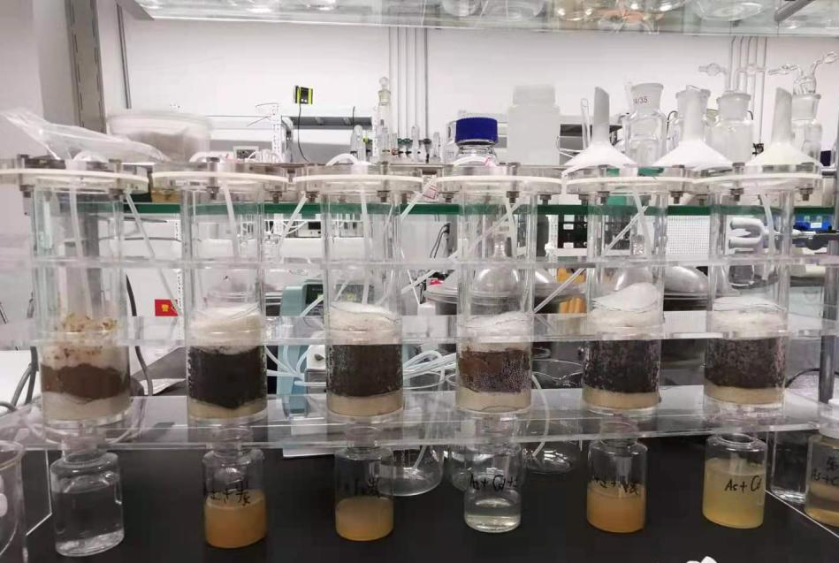
Fig.S1 Soil leaching experimental setup
Fig.S2 Pore size distribution curves of CS, CSC, and ZVI-CSC

Fig.S3 XPS spectra of C 1s, O 1s and As 3d of CSC and ZVI-CSC

