Supplementary data

Fluorescence multi-staining and image analysis
From the lymph node tissue samples fixed in formalin and embedded in paraffin, 2-3µm thick tissue sections were prepared, which were drawn onto coated slides and dried overnight. Each slide was manually stained with the Opal 6-Plex Manual Detection Kit - for Whole Slide Imaging (Akoya Biosciences) for CD30 (HRSC), CD68 (macrophages), CD8 (cytotoxic T-cells), FoxP3 (regulatory T-cells), LAG3 (exhaustion marker) and DAPI (nucleus detection) following the manufacturer's instructions.
To remove the paraffin, the slides were incubated in 100% xylene for 20 minutes subsequently rehydrated in a descending alcohol series and washed with distilled water and PBS. The following cycle (step 1-5) was repeated four times for CD8/Opal690, CD30/Opal570, CD68/Opal520 and FoxP3/Opal620 at room temperature. After each step, except after incubation of the Antibody Diluent, the slides were washed three times for 2 minutes with PBS. (1) Antigen retrieval in AR6 buffer (pH6) for 45 seconds at 1000 watts and for 15 minutes at 200 watts in the microwave. Cooling down to room temperature for at least 15 minutes. (2) 2-3 drops of Antibody Diluent were applied for 10 minutes to block non-specific binding sites. (3) 150µl of the primary antibody (dilution in Antibody Diluent) incubated for 30 minutes. (4) 2-3 drops of Opal Polymer HRP were applied, containing the HRP-conjugated secondary antibody. (5) The opal fluorophore (1:100 in Amplification Diluent) was incubated for 10 minutes.
The fifth cycle (step 6-12) for LAG3/Opal780 was different because Opal780 is heat labile. (6) The cycle also started with a microwave treatment and the slides then cooled down to room temperature for at least 15 minutes. (7) The Antibody Diluent incubated for 10 minutes, before (8) LAG3 (1:100 in Antibody Diluent) incubated for 30 minutes. (9) Next, the HRP-conjugated secondary antibody was applied for 10 minutes. (10) TSA-DIG (1:100 in Amplification Diluent) was then applied for 10 minutes, followed by (11) a second microwave treatment and cooldown to room temperature. The last step was (12) 1 hour incubation of Opal780 (1:50 in Antibody Diluent).
For nucleus staining Dapi (1 drop in 500µl PBS) was incubated for 5 minutes. Finally, the slides were sealed with 35µl mounting medium and the coverslips were fixed with nail polish. The slides then dried overnight at 4° Celsius before scanning. Supplementary table 3 gives information on the staining order, antibody and fluorophore concentrations and corresponding buffers.

Scanning
The slides were scanned with the NanoZoomer S60 (Hamamatsu). To avoid shifts in the z-axis, each channel was scanned individually, with a DAPI image as the focal plane. Five marker images with corresponding DAPI images were created for each case, which were then opened as .ndpi files in the NDPI viewer (Hamamatsu).

Digital image analysis for coexpression phenotypes
For digital image analysis we used the open-source software QuPath v. 0.3.2 .[1] The following steps were performed on each case: (1) Image import. (2) Creation of an overlay based on the Dapi image using the image combiner extension. (3) Definition of the regions of interest (ROI): Three squared areas of 150x150µm each were placed within a HRSC node (nTME) and minimum 75µm distant (dTME). In dTME ROI did not include an intact B-cell follicle. (4) Cell detection using the script StarDist.[2] The average cell count per case was 1,230 (Standard deviation (SD) ±255) in the nTME areas and 1,522 (SD ±300) in the dTME areas, respectively. Cell classification was performed in eight evenly placed squared training areas of 500x500µm and mean values were calculated to best cover the heterogeneity of the whole slide. In the non-auto fluorescent channels, the function "create single measurement classifier" was used; intensity thresholds for the nuclear marker FoxP3 were set at "Nucleus: mean", for CD8 and LAG3 at "Cell: mean". To avoid false positive detections in the auto fluorescent channels (520nm, 570nm), the "train object classifier" function was used. Here, the number of labeled objects varied between 30-50 per case. (6) The cell classifications were finally applied to the analysis areas.

Digital image analysis for protein quantification of TARC/CCL17
For the TARC analysis we used the same software and settings as for the TME analyses. Two squared areas of 250x250µm were placed in HRSC dense areas as ROI. The average cell count was 2490 per case (SD ± 409). For cell classification of CD30+ and TARC+ cells we used the function “train object classifier”. TARC fluorescence intensity was determined for each case per CD30+ cell area (sum of “TARC: Cell: Mean” / sum of “Cell: Area ¬µm^2”). To create comparability, we had a reference slide per run (R1-4), which was analyzed in similarly positioned ROI. Here, the TARC fluorescence intensities differed only marginally (R1=0.42, R2=0.49, R3=0.34, R4= 0.39). A correction factor was calculated from the mean value (mean=0.41) for each case (F1=0.98, F2=0.84, F3=1.21, F4=1.05) to minimize staining-related differences.

 | Project Cohort |  | HD 14 Cohort°
 | N=198 | 100% | N=1889 | 100%
 | n | % | n | %
 | N=198 | 100% | N=1889 | 100%
Treatment group
4xABVD | 109 | 55.1 | 777 | 44.1
2xBesc+2xABVD | 89 | 44.9 | 1112 | 58.9
Progression or Relapse
 | 40 | 20.2 | 117 | 6.2
Survival status
Alive, without Progression/Relapse | 156 | 78.8 | 1715 | 90.8
Alive, after Progression or Relapse | 25 | 12.6 | 79 | 4.3
Dead, after previous progression or relapse | 15 | 7.6 | 38 | 2.0
Dead, not HL-related | 2 | 1.0 | 57 | 3.0
female | 110 | 55.6 | 991 | 52.5
male | 88 | 44.4 | 898 | 47.5
Age
Median - IQR | 33 | 25-41 | 31 | 24-41
Clinical Stage (CS)
I | 8 | 4.0 | 82 | 4.3
II | 190 | 96.0 | 1807 | 96.7
B-Symptoms
present | 62 | 31.3 | 559 | 29.6
WHO activity index
0 | 153 | 77.3 | 1469 | 77.9
I-II | 45 | 22.7 | 417 | 22.1
GHSG-Risk Factors
Large mediastinal mass | 34 | 17.2 | 360 | 19.1
Extra-nodal involvement | 18 | 9.1 | 148 | 7.9
3 or more involved lymph node areas | 137 | 69.2 | 1330 | 70.6
Elevated ESR | 114 | 58.2 | 989 | 53.1
Intra-diaphragmatic disease | 13 | 6.6 | 113 | 6.0
Histological Subtype*
Nodular lymphocyte predominant HL | 2 | 1.0 | 23 | 1.4
Lymphocyte rich classical HL | 4 | 2.0 | 38 | 2.3
Lymphocyte depleted classical HL | 1 | 0.5 | 4 | 0.2
Nodular sclerosis classical HL | 134 | 68.0 | 1167 | 71.2
Mixed cellularity classical HL | 41 | 20.8 | 288 | 17.6
Classical HL, not specified | 15 | 7.6 | 120 | 7.3

Supplementary Table 1: Study Cohort compared to complete cohort of GHSG-HD14. As part of the statistical plan, the project cohort was enriched for patients suffering from a progression or relapse (20.2%) compared to the whole HD14 cohort (6.3%). ABVD= doxorubicin, bleomycin, vinblastine, and dacarbazine, Besc= bleomycin, etoposide, doxorubicin, cyclophosphamide, vincristine, procarbazine, and prednisone, HL=Hodgkin Lymphoma, ° qualified patients cohort; *No information available for 14% of patients in HD14 cohort; $No information available for 7% of patients in HD14 cohort.

Running number | subtype | EBV Status of HRSC | ß-2-M  (HLA-I) | HLA-DR  (HLA-II)
24 | lymphocyte rich | + | neg | neg
10 | nodular sclerosis | - | neg | neg
9 | nodular sclerosis | - | pos | neg
22 | nodular sclerosis | - | neg | pos
23 | nodular sclerosis | - | neg | pos
12 | nodular sclerosis | - | neg | neg
19 | mixed cellularity | - | neg | pos
25 | mixed cellularity | - | neg | pos
11 | mixed cellularity | + | pos | neg
14 | mixed cellularity | - | neg | pos
15 | nodular sclerosis | - | pos | neg
16 | mixed cellularity | - | neg | neg
20 | nodular sclerosis | - | neg | pos
21 | mixed cellularity | - | pos | neg
17 | nodular sclerosis | - | neg | neg
18 | nodular sclerosis | - | pos | neg
13 | lymphocyte rich | + | neg | neg
26 | nodular sclerosis | + | pos | neg
27 | nodular sclerosis | - | pos | neg
28 | mixed cellularity | + | pos | neg

Supplementary table 2: Characteristics of cohort analyzed by fluorescence multi-staining. EBV=Epstein Barr Virus, pos= positive, neg= negative

Multiplex staining
Antibody | Company | Clone | Host | Clonality | Dilution  Antibody | Opal  Fluorophore |  | Dilution  Fluorophore |  | Buffer
CD30 | UKSH intern | BerH2 | mouse | mono | 1:10 | Opal 570 |  | 1:100 |  | AR6
FoxP3 | abcam | SP97 | rabbit | mono | 1:25 | Opal 620 |  | 1:100 |  | AR6
LAG3 | abcam | EPR20261 | rabbit | mono | 1:100 | Opal 780 |  | 1:50 |  | AR6
CD68 | Dako | PG-M1 | mouse | mono | 1:50 | Opal 520 |  | 1:100 |  | AR6
CD8 | Dako | C8/144B | mouse | mono | 1:100 | Opal 690 |  | 1:100 |  | AR6
Fluorescent staining
Antibody | Company | Clone | Host | Clonality | Dilution  Antibody | Buffer
TARC | R&D BioTechne |  | goat | poly | 1:100 | pH9
CD30 | UKSH intern | BerH2 | mouse | mono | 1:10 | pH9
Secondary antibodies
Alexa 488 | ThermoScientific |  | donkey  anti mouse |  | 1:100
Alexa 555 | ThermoScientific |  | donkey  anti goat |  | 1:100
Conventional staining
Antibody | Company | Clone | Host | Clonality | Dilution  Antibody | Buffer | StainiStaining Device
HLA-DP/DQ/DR | Dako | CR3/43 | mouse | mono | 1:100 | pH6 | manual
ß-2-Microglobulin | Dako |  | rabbit | poly | 1:2000 | pH6 | manual
CD30 | UKSH intern | BerH2 | mouse | mono | 1:5 | ER1 | Bond Stainer
CD20 | Dako | L26 | mouse | mono | 1:400 | ER1 | Bond Stainer
CD8 | Dako | C8/144B | mouse | mono | 1:200 | ER1 | Bond Stainer
Supplementary table 3: Antibodies used in the study

Genes | p | 95CI_low | 95CI_high | HLA+_mean | HLA-_mean | Fold-Change(HLA-_to_HLA+) | p.adjust
CCR4 | 4,47E-12 | -1,87654 | -1,17095 | -1,35325 | 0,170495 | 1,523745 | 3,26E-09
SELPLG | 5,12E-08 | -1,14952 | -0,62297 | 0,711966 | 1,598209 | 0,886243 | 1,87E-05
CD200 | 1,09E-07 | -0,98629 | -0,51141 | -0,00165 | 0,747202 | 0,748852 | 2,66E-05
IL17RA | 1,51E-07 | -0,83732 | -0,43546 | 1,035268 | 1,671658 | 0,636389 | 2,71E-05
PRM1 | 2,23E-07 | 0,521454 | 1,051023 | -3,96391 | -4,75014 | -0,78624 | 2,71E-05
MAP2K1 | 2,48E-07 | -0,71749 | -0,3606 | 1,205011 | 1,744057 | 0,539045 | 2,71E-05
RUNX1 | 2,6E-07 | -1,2392 | -0,61503 | 0,286438 | 1,213557 | 0,927118 | 2,71E-05
CCL22 | 4,32E-07 | -2,90951 | -1,43164 | 0,845149 | 3,015727 | 2,170578 | 3,94E-05
IL22RA1 | 5,21E-07 | 0,828958 | 1,710608 | -3,86521 | -5,13499 | -1,26978 | 4,22E-05
C8A | 6,7E-07 | 0,608692 | 1,258431 | -3,81627 | -4,74983 | -0,93356 | 4,88E-05
CD19 | 9,62E-07 | 0,969533 | 2,060142 | 2,135664 | 0,620827 | -1,51484 | 6,38E-05
CX3CL1 | 2,13E-06 | -1,08737 | -0,48907 | -1,20174 | -0,41352 | 0,78822 | 0,000129
C1R | 3,66E-06 | -1,60989 | -0,72277 | 2,991081 | 4,15741 | 1,166329 | 0,000205
IL22RA2 | 4,76E-06 | -1,94655 | -0,83466 | -1,2494 | 0,141206 | 1,390603 | 0,000248
HMGB1 | 5,71E-06 | -1,06448 | -0,47431 | 0,495026 | 1,264418 | 0,769392 | 0,000272
DDX43 | 6,4E-06 | 0,504497 | 1,18571 | -3,36145 | -4,20655 | -0,8451 | 0,000272
TMEFF2 | 6,4E-06 | 0,461231 | 1,065006 | -3,73257 | -4,49569 | -0,76312 | 0,000272
PIN1 | 6,72E-06 | -0,43864 | -0,19102 | 0,886429 | 1,201259 | 0,31483 | 0,000272
CAMP | 7,96E-06 | 0,450908 | 1,07752 | -4,0259 | -4,79011 | -0,76421 | 0,000305
TNFSF8 | 8,91E-06 | -1,31629 | -0,55203 | -0,89117 | 0,042988 | 0,934159 | 0,000325
GTF3C1 | 1,11E-05 | -0,56789 | -0,24314 | 1,216568 | 1,622081 | 0,405513 | 0,000376
KLRF1 | 1,15E-05 | 0,381386 | 0,932527 | -2,55018 | -3,20713 | -0,65696 | 0,000376
ANP32B | 1,19E-05 | -0,89324 | -0,38323 | 2,69536 | 3,333599 | 0,638239 | 0,000376
IFNL2 | 1,53E-05 | 0,537676 | 1,297237 | -3,52511 | -4,44257 | -0,91746 | 0,000449
IFNA2 | 1,56E-05 | 0,456651 | 1,105084 | -3,80179 | -4,58266 | -0,78087 | 0,000449
CASP3 | 1,6E-05 | -1,08708 | -0,45154 | 0,227865 | 0,997173 | 0,769307 | 0,000449
BCL10 | 1,67E-05 | -0,90838 | -0,38435 | 1,458053 | 2,104418 | 0,646365 | 0,00045
CCL17 | 1,81E-05 | -3,54049 | -1,45011 | 2,77523 | 5,270528 | 2,495299 | 0,000472
CD22 | 2,02E-05 | 0,627713 | 1,578867 | 3,099307 | 1,996017 | -1,10329 | 0,000501
MAPK14 | 2,06E-05 | -0,32629 | -0,13072 | 2,223635 | 2,452136 | 0,228502 | 0,000501
BST1 | 2,73E-05 | -1,03339 | -0,41799 | -0,72689 | -0,0012 | 0,72569 | 0,000641
CCL25 | 2,95E-05 | 0,4087 | 1,047457 | -3,47394 | -4,20202 | -0,72808 | 0,000673
CHUK | 4,49E-05 | 0,29611 | 0,760866 | 0,872517 | 0,344029 | -0,52849 | 0,000992
RAG1 | 5,39E-05 | 0,38119 | 1,022664 | -3,3129 | -4,01482 | -0,70193 | 0,001133
PTPRC | 5,57E-05 | -0,77223 | -0,29126 | 3,711824 | 4,243572 | 0,531748 | 0,001133
C3 | 5,59E-05 | -1,45166 | -0,54809 | 2,557461 | 3,557339 | 0,999879 | 0,001133
PSMB7 | 6,42E-05 | -0,65829 | -0,24943 | 1,651884 | 2,105746 | 0,453862 | 0,001264
AIRE | 6,74E-05 | 0,499365 | 1,368154 | -2,11287 | -3,04663 | -0,93376 | 0,001283
TFEB | 6,86E-05 | 0,312758 | 0,83765 | 0,80206 | 0,226856 | -0,5752 | 0,001283
MAPK11 | 7,54E-05 | -0,63274 | -0,23533 | -1,6841 | -1,25007 | 0,434035 | 0,001366
AICDA | 7,83E-05 | 0,449949 | 1,220626 | -2,84788 | -3,68317 | -0,83529 | 0,001366
BCL2 | 7,87E-05 | 0,476527 | 1,280895 | 1,790888 | 0,912177 | -0,87871 | 0,001366
IL12RB2 | 9,06E-05 | -1,31083 | -0,47323 | -1,11258 | -0,22056 | 0,892027 | 0,001536
ITGA5 | 0,000105 | -1,12102 | -0,40442 | 0,861907 | 1,624629 | 0,762721 | 0,001744
TIRAP | 0,000123 | 0,246627 | 0,704081 | -0,83699 | -1,31234 | -0,47535 | 0,001994
IL5 | 0,000129 | 0,45074 | 1,290602 | -4,49542 | -5,36609 | -0,87067 | 0,002047
CEACAM6 | 0,00014 | 0,664383 | 1,871118 | -3,41122 | -4,67897 | -1,26775 | 0,002128
ROPN1 | 0,000143 | 0,392252 | 1,117915 | -3,55335 | -4,30843 | -0,75508 | 0,002128
ATG7 | 0,000143 | -0,61788 | -0,21738 | 0,804991 | 1,222623 | 0,417632 | 0,002128
CEACAM1 | 0,000147 | 0,362301 | 1,037871 | -1,9614 | -2,66148 | -0,70009 | 0,002137
CDH5 | 0,00015 | -1,14376 | -0,3995 | -0,82532 | -0,05369 | 0,77163 | 0,002137
NEFL | 0,000154 | 0,405229 | 1,19523 | -3,89435 | -4,69458 | -0,80023 | 0,002137
HLA-G | 0,000155 | -1,10219 | -0,38124 | 1,75291 | 2,494627 | 0,741716 | 0,002137
SH2B2 | 0,000163 | 0,229052 | 0,670133 | -0,54323 | -0,99282 | -0,44959 | 0,002197
CT45A1 | 0,000185 | -2,30208 | -0,75332 | -2,24015 | -0,71245 | 1,5277 | 0,00243
CRP | 0,000187 | 0,348831 | 1,047039 | -4,67657 | -5,37451 | -0,69794 | 0,00243
NFKB1 | 0,00024 | -0,65941 | -0,2124 | -0,37892 | 0,056981 | 0,435906 | 0,00307
TAB1 | 0,00025 | -0,65089 | -0,21703 | 0,051972 | 0,485931 | 0,433959 | 0,003147
SEMG1 | 0,000257 | 0,339225 | 1,033717 | -3,70371 | -4,39019 | -0,68647 | 0,003173
FEZ1 | 0,000269 | -0,65564 | -0,21226 | -0,90942 | -0,47546 | 0,433952 | 0,003264
JAK2 | 0,000292 | -0,50346 | -0,16382 | 2,546578 | 2,880217 | 0,333639 | 0,003439
HLA-E | 0,000292 | 0,168775 | 0,517518 | 5,444337 | 5,101191 | -0,34315 | 0,003439
PSMD7 | 0,000298 | -0,31778 | -0,09985 | 2,443658 | 2,652471 | 0,208813 | 0,00344
KIR3DL1 | 0,000302 | 0,265495 | 0,852456 | -3,84963 | -4,40861 | -0,55898 | 0,00344
IL21R | 0,000313 | -0,93452 | -0,29886 | 1,865572 | 2,482261 | 0,616689 | 0,003514
FN1 | 0,000337 | -2,14355 | -0,67727 | 2,445478 | 3,855885 | 1,410407 | 0,003726
IL6R | 0,000351 | 0,232661 | 0,737045 | 0,761802 | 0,276949 | -0,48485 | 0,003818
CD86 | 0,00036 | -1,06891 | -0,33241 | -0,81437 | -0,11371 | 0,700657 | 0,003854
IL32 | 0,000369 | -0,88185 | -0,27873 | 3,411718 | 3,992011 | 0,580293 | 0,003894
FOXP3 | 0,000425 | -1,18637 | -0,3603 | -0,05014 | 0,723189 | 0,773334 | 0,004426
MPPED1 | 0,000466 | 0,288679 | 0,948414 | -3,8228 | -4,44135 | -0,61855 | 0,00478
TNFRSF13B | 0,000474 | 0,430328 | 1,419525 | -0,17237 | -1,0973 | -0,92493 | 0,004803
IFNG | 0,000501 | 0,432041 | 1,427599 | -1,34863 | -2,27845 | -0,92982 | 0,005008
CD5 | 0,000526 | -0,88879 | -0,26349 | 1,71304 | 2,289184 | 0,576143 | 0,005181
ULBP2 | 0,000548 | 0,369654 | 1,229824 | -3,52578 | -4,32552 | -0,79974 | 0,005331
SH2D1B | 0,000572 | 0,260602 | 0,883917 | -2,41156 | -2,98382 | -0,57226 | 0,005488
TP53 | 0,000619 | -0,52301 | -0,15448 | 1,621757 | 1,960503 | 0,338746 | 0,005859
FUT7 | 0,00066 | 0,262356 | 0,902264 | -0,433 | -1,01531 | -0,58231 | 0,006158
KIR_Activating_Subgroup_1 | 0,000667 | 0,425759 | 1,491295 | -5,1826 | -6,14112 | -0,95853 | 0,006158
HLA-A | 0,000707 | -0,68385 | -0,19866 | 6,111918 | 6,553169 | 0,441251 | 0,006447
TICAM1 | 0,000724 | 0,127626 | 0,438303 | -0,04319 | -0,32615 | -0,28296 | 0,006512
MAGEA4 | 0,000796 | -1,10343 | -0,2976 | -4,26965 | -3,56914 | 0,700511 | 0,007072
EPCAM | 0,000806 | 0,297966 | 1,05752 | -3,45776 | -4,1355 | -0,67774 | 0,00708
CASP1 | 0,00086 | 0,216782 | 0,776125 | 0,784292 | 0,287838 | -0,49645 | 0,007461
THY1 | 0,00089 | -0,96702 | -0,26947 | 2,240035 | 2,858282 | 0,618247 | 0,007571
GPI | 0,000893 | -0,51642 | -0,14322 | 2,01528 | 2,3451 | 0,32982 | 0,007571
CD79B | 0,000961 | 0,335504 | 1,23612 | 3,603836 | 2,818024 | -0,78581 | 0,008049
KIR3DL3 | 0,00099 | 0,298987 | 1,09076 | -3,87537 | -4,57024 | -0,69487 | 0,0082
MAPK8 | 0,001002 | -0,45448 | -0,12546 | -0,15692 | 0,133054 | 0,289971 | 0,008207
CD160 | 0,001082 | 0,350978 | 1,301925 | -2,45348 | -3,27993 | -0,82645 | 0,008767
COL3A1 | 0,001123 | -2,3513 | -0,62736 | 5,491097 | 6,980424 | 1,489327 | 0,008995
USP9Y | 0,001195 | 0,691437 | 2,656876 | -1,72317 | -3,39733 | -1,67416 | 0,009466
C4BPA | 0,001214 | 0,260659 | 1,00651 | -4,36476 | -4,99835 | -0,63358 | 0,009517
IKBKG | 0,001365 | 0,117696 | 0,454073 | 0,755578 | 0,469694 | -0,28588 | 0,010587
CD37 | 0,001434 | 0,244877 | 0,948101 | 2,222207 | 1,625718 | -0,59649 | 0,011006
FCGR1A | 0,001485 | 0,291506 | 1,154989 | -1,85873 | -2,58198 | -0,72325 | 0,011273
TNFRSF10B | 0,001516 | -0,3915 | -0,09815 | 0,167941 | 0,412769 | 0,244828 | 0,01139
C3AR1 | 0,001564 | -1,03317 | -0,26119 | -0,21679 | 0,430384 | 0,647178 | 0,011601
IFI35 | 0,001583 | -0,73192 | -0,18595 | 0,122523 | 0,581458 | 0,458935 | 0,011601
IFI16 | 0,001591 | 0,089652 | 0,358268 | 3,104822 | 2,880862 | -0,22396 | 0,011601
NOD1 | 0,001648 | 0,136327 | 0,550815 | -0,39108 | -0,73465 | -0,34357 | 0,011898
BCL2L1 | 0,001675 | -0,40151 | -0,0999 | 2,303657 | 2,55436 | 0,250703 | 0,011972
C1S | 0,001743 | -0,89895 | -0,22153 | 2,508234 | 3,068472 | 0,560237 | 0,012335
IL2 | 0,001764 | 0,20465 | 0,838636 | -4,09197 | -4,61361 | -0,52164 | 0,012363
PRKCD | 0,001782 | -0,52709 | -0,13063 | 1,806869 | 2,135727 | 0,328858 | 0,012371
SMPD3 | 0,001859 | 0,149874 | 0,626787 | -1,90483 | -2,29316 | -0,38833 | 0,012784
BCL6 | 0,001916 | -0,65158 | -0,15741 | 1,330232 | 1,734727 | 0,404495 | 0,013054
IRF3 | 0,001942 | 0,149034 | 0,61156 | 0,862772 | 0,482475 | -0,3803 | 0,013106
TIGIT | 0,002029 | 0,23011 | 0,96334 | 1,165356 | 0,568631 | -0,59672 | 0,013567
PTGDR2 | 0,002083 | 0,18107 | 0,770955 | -3,45279 | -3,9288 | -0,47601 | 0,013806
BIRC5 | 0,002149 | -0,79059 | -0,18368 | -0,41463 | 0,072504 | 0,487135 | 0,014112
TLR9 | 0,002172 | 0,22618 | 0,958021 | -0,73051 | -1,32261 | -0,5921 | 0,014136
TAPBP | 0,002193 | -0,69136 | -0,16334 | 3,950022 | 4,377373 | 0,427351 | 0,014146
IFNA17 | 0,002233 | 0,308461 | 1,307952 | -4,17289 | -4,9811 | -0,80821 | 0,014277
CYLD | 0,002274 | -0,52992 | -0,12238 | 3,017087 | 3,343236 | 0,326149 | 0,014296
UBC | 0,002277 | -0,49222 | -0,115 | 6,00541 | 6,30902 | 0,303611 | 0,014296
SSX1 | 0,002314 | 0,149905 | 0,64532 | -3,67203 | -4,06964 | -0,39761 | 0,014296
IL9 | 0,002314 | -2,62675 | -0,59983 | -3,48416 | -1,87087 | 1,613291 | 0,014296
EP300 | 0,002397 | -0,6114 | -0,14205 | 1,955783 | 2,33251 | 0,376726 | 0,014686
IFNA7 | 0,002419 | 0,276718 | 1,196184 | -2,69201 | -3,42846 | -0,73645 | 0,014696
MAPK1 | 0,002507 | -0,83043 | -0,19179 | 1,313868 | 1,824979 | 0,511111 | 0,014945
PRAME | 0,002517 | -1,81863 | -0,4128 | -1,5035 | -0,38778 | 1,115718 | 0,014945
DUSP4 | 0,00256 | -1,04193 | -0,23521 | 0,101386 | 0,739956 | 0,63857 | 0,014945
CD8B | 0,002563 | 0,268815 | 1,170493 | 0,504527 | -0,21513 | -0,71965 | 0,014945
FUT5 | 0,002563 | 0,231272 | 1,02137 | -4,26822 | -4,89454 | -0,62632 | 0,014945
CTLA4 | 0,002741 | -0,9657 | -0,21401 | 2,349508 | 2,939363 | 0,589855 | 0,015816
STAT5B | 0,002755 | -0,67883 | -0,15067 | 1,15751 | 1,572259 | 0,414749 | 0,015816
ELANE | 0,002827 | 0,159141 | 0,715904 | -3,40857 | -3,84609 | -0,43752 | 0,016103
CD99 | 0,002896 | -0,65889 | -0,14375 | 3,239267 | 3,640585 | 0,401318 | 0,016228
CDKN1A | 0,002902 | -0,85098 | -0,18978 | 0,915332 | 1,435712 | 0,52038 | 0,016228
MASP2 | 0,002916 | 0,20087 | 0,91669 | -4,36868 | -4,92746 | -0,55878 | 0,016228
CCL26 | 0,002939 | -2,11162 | -0,45961 | -0,26605 | 1,019561 | 1,285614 | 0,016231
MAGEA12 | 0,003029 | 0,194223 | 0,902579 | -4,38455 | -4,93295 | -0,5484 | 0,016601
APP | 0,003227 | -0,61215 | -0,13046 | 2,26884 | 2,640144 | 0,371305 | 0,017549
IL7R | 0,00325 | -0,80487 | -0,17209 | 3,30668 | 3,795157 | 0,488477 | 0,017549
CD276 | 0,003314 | -0,97605 | -0,20807 | 0,848104 | 1,440164 | 0,59206 | 0,017765
TNFRSF9 | 0,003508 | -0,81027 | -0,16795 | -0,26941 | 0,219697 | 0,489111 | 0,018664
MASP1 | 0,003577 | 0,208584 | 0,99567 | -3,58194 | -4,18407 | -0,60213 | 0,018895
IL25 | 0,003829 | 0,207389 | 1,006964 | -4,33849 | -4,94566 | -0,60718 | 0,019968
PLAUR | 0,003835 | -1,12313 | -0,2308 | -0,87195 | -0,19498 | 0,676965 | 0,019968
REPS1 | 0,004024 | -0,80089 | -0,16235 | 1,158199 | 1,63982 | 0,481621 | 0,020756
IL12B | 0,004043 | 0,178415 | 0,893644 | -3,78456 | -4,32059 | -0,53603 | 0,020756
ICOSLG | 0,004091 | 0,139306 | 0,704973 | -0,05703 | -0,47917 | -0,42214 | 0,020853
CD81 | 0,004272 | -0,58464 | -0,11752 | 4,933616 | 5,284697 | 0,351081 | 0,021627
MIF | 0,004378 | -0,44355 | -0,08762 | 2,95613 | 3,221714 | 0,265585 | 0,022011
ARG1 | 0,004417 | 0,200293 | 1,024917 | -4,20519 | -4,8178 | -0,61261 | 0,022057
CKLF | 0,004482 | -0,53732 | -0,10399 | 2,33823 | 2,658886 | 0,320656 | 0,022101
CD244 | 0,004487 | 0,192506 | 0,978914 | -2,07159 | -2,6573 | -0,58571 | 0,022101
MAGEC2 | 0,004581 | 0,204665 | 1,04506 | -4,12547 | -4,75033 | -0,62486 | 0,022415
IL13 | 0,004672 | -1,66058 | -0,31939 | -1,74655 | -0,75657 | 0,989983 | 0,022707
ENG | 0,004799 | -0,67077 | -0,12785 | 1,771797 | 2,171106 | 0,39931 | 0,023169
PLA2G6 | 0,004856 | -0,54291 | -0,10318 | 0,133101 | 0,456147 | 0,323045 | 0,02329
CCL27 | 0,00521 | 0,1743 | 0,940199 | -4,42445 | -4,9817 | -0,55725 | 0,024822
MS4A1 | 0,005347 | 0,276982 | 1,520907 | 3,064434 | 2,16549 | -0,89894 | 0,025314
STAT1 | 0,005472 | -0,88589 | -0,16378 | 4,022675 | 4,54751 | 0,524835 | 0,025613
C9 | 0,005481 | 0,111119 | 0,603697 | -2,9345 | -3,2919 | -0,35741 | 0,025613
HLA-DPA1 | 0,005538 | -0,91002 | -0,16853 | 4,358668 | 4,897942 | 0,539274 | 0,025714
DEFB1 | 0,005939 | 0,168913 | 0,949714 | -4,30138 | -4,86069 | -0,55931 | 0,027404
TNFRSF17 | 0,006047 | 0,167325 | 0,953192 | 0,254471 | -0,30579 | -0,56026 | 0,027504
MAGEB2 | 0,006052 | -1,50765 | -0,26485 | -3,20852 | -2,32228 | 0,886248 | 0,027504
MBL2 | 0,006074 | 0,249586 | 1,404189 | -3,91241 | -4,7393 | -0,82689 | 0,027504
ITCH | 0,006229 | -0,44665 | -0,07927 | 1,903404 | 2,166367 | 0,262963 | 0,02801
PAX5 | 0,00628 | 0,192602 | 1,104334 | 1,184867 | 0,536399 | -0,64847 | 0,02801
CXCR6 | 0,006301 | -0,80986 | -0,14011 | 0,528991 | 1,003976 | 0,474985 | 0,02801
NRP1 | 0,006492 | -1,11688 | -0,19347 | 1,686753 | 2,341928 | 0,655175 | 0,028685
CLU | 0,006988 | 0,122395 | 0,734088 | -3,08113 | -3,50938 | -0,42824 | 0,030688
IL1R1 | 0,007126 | -1,05528 | -0,17694 | 0,566842 | 1,182952 | 0,616111 | 0,031106
CD53 | 0,007478 | -0,89537 | -0,14763 | 3,609282 | 4,130781 | 0,521499 | 0,032449
IL6 | 0,007585 | -1,0732 | -0,17628 | -0,81268 | -0,18794 | 0,62474 | 0,03272
TNFRSF12A | 0,007745 | -0,97155 | -0,15459 | -2,89058 | -2,32751 | 0,563073 | 0,033213
LTA | 0,008153 | -1,03752 | -0,1633 | 1,406046 | 2,006457 | 0,600412 | 0,034757
LAMP3 | 0,008211 | -1,00748 | -0,15853 | 0,266059 | 0,849066 | 0,583007 | 0,034802
CFP | 0,008489 | -0,62634 | -0,09668 | 0,146432 | 0,507938 | 0,361506 | 0,035697
SYCP1 | 0,008564 | 0,111142 | 0,721755 | -3,88805 | -4,3045 | -0,41645 | 0,035697
CD1B | 0,008613 | -1,27817 | -0,19489 | -3,62799 | -2,89146 | 0,736529 | 0,035697
TNFRSF4 | 0,008637 | -0,86022 | -0,13298 | 0,731283 | 1,227883 | 0,496599 | 0,035697
SH2D1A | 0,008667 | -0,95682 | -0,1477 | 1,342709 | 1,894969 | 0,55226 | 0,035697
IFITM1 | 0,008781 | -0,96699 | -0,14726 | 3,151236 | 3,708361 | 0,557125 | 0,035964
IL22 | 0,008928 | 0,182327 | 1,211584 | -4,4904 | -5,18735 | -0,69696 | 0,036361
IL1RAPL2 | 0,009063 | 0,109274 | 0,724253 | -3,27319 | -3,68995 | -0,41676 | 0,036401
CTCFL | 0,009124 | 0,128558 | 0,854478 | -3,78981 | -4,28133 | -0,49152 | 0,036401
PYCARD | 0,009134 | 0,066162 | 0,443342 | 0,502848 | 0,248096 | -0,25475 | 0,036401
HLA-DOB | 0,009138 | 0,123604 | 0,828725 | 1,242334 | 0,766169 | -0,47616 | 0,036401
LRP1 | 0,009254 | -1,07963 | -0,15957 | 1,574332 | 2,193932 | 0,619601 | 0,036663
MYD88 | 0,009479 | 0,070764 | 0,48104 | 2,919371 | 2,643468 | -0,2759 | 0,037352
CD33 | 0,009643 | 0,129884 | 0,884049 | -1,74247 | -2,24943 | -0,50697 | 0,037795
SBNO2 | 0,00981 | 0,068439 | 0,467475 | 2,67809 | 2,410133 | -0,26796 | 0,038244
IGF2R | 0,010189 | -0,56115 | -0,08102 | 1,018965 | 1,340054 | 0,321088 | 0,03951
PDGFRB | 0,010353 | -0,88188 | -0,12432 | 1,649386 | 2,15249 | 0,503104 | 0,039932
SMAD2 | 0,010561 | -0,79896 | -0,11209 | 0,689957 | 1,145484 | 0,455527 | 0,040523
IFNAR2 | 0,011002 | 0,043646 | 0,317783 | 2,784379 | 2,603664 | -0,18071 | 0,041991
ILF3 | 0,011122 | -0,33113 | -0,04495 | 3,120342 | 3,308384 | 0,188042 | 0,042229
TNFRSF1B | 0,011234 | 0,060343 | 0,451578 | 2,112383 | 1,856423 | -0,25596 | 0,042433
CD70 | 0,011449 | -0,8653 | -0,11441 | -1,14289 | -0,65303 | 0,489855 | 0,043024
IL3RA | 0,01153 | -0,68769 | -0,09154 | -0,31115 | 0,078469 | 0,389615 | 0,043106
SLAMF1 | 0,011673 | 0,073505 | 0,552762 | -0,1807 | -0,49383 | -0,31313 | 0,043417
CFI | 0,011768 | -0,79381 | -0,10347 | -0,01198 | 0,436662 | 0,448643 | 0,043546
TNFSF15 | 0,012064 | 0,09314 | 0,71272 | -1,00568 | -1,40861 | -0,40293 | 0,044417
MEFV | 0,01214 | 0,133586 | 1,022403 | -2,14379 | -2,72179 | -0,57799 | 0,044474
ATM | 0,012717 | 0,10329 | 0,812843 | -0,99857 | -1,45663 | -0,45807 | 0,046137
TNFRSF11A | 0,012721 | -0,95049 | -0,1209 | -2,23863 | -1,70293 | 0,535694 | 0,046137
CTAGE1 | 0,012859 | 0,138886 | 1,095738 | -4,21212 | -4,82943 | -0,61731 | 0,046406
RORC | 0,013035 | -0,63354 | -0,07845 | -2,99607 | -2,64007 | 0,355996 | 0,046812
TLR10 | 0,013151 | 0,117822 | 0,958142 | 0,757596 | 0,219614 | -0,53798 | 0,046994
DPP4 | 0,013332 | 0,075718 | 0,623881 | -1,74142 | -2,09122 | -0,3498 | 0,047411
CD38 | 0,013474 | -0,80418 | -0,09856 | 1,164407 | 1,615777 | 0,45137 | 0,047682
IKBKE | 0,013687 | -0,43473 | -0,05243 | 2,053078 | 2,296659 | 0,243581 | 0,048202
CEBPB | 0,013843 | -0,87181 | -0,10485 | 1,336492 | 1,824821 | 0,488329 | 0,048491
CCR9 | 0,013902 | 0,122585 | 1,019754 | -4,21109 | -4,78226 | -0,57117 | 0,048491
ECSIT | 0,014384 | 0,045647 | 0,388343 | -0,11423 | -0,33122 | -0,217 | 0,049932
Supplementary table 4: Differentially expressed genes according to HLA-I expression of HRSC

Supplementary Figure 1: Cohorts of patient/material and methods used in the current manuscript

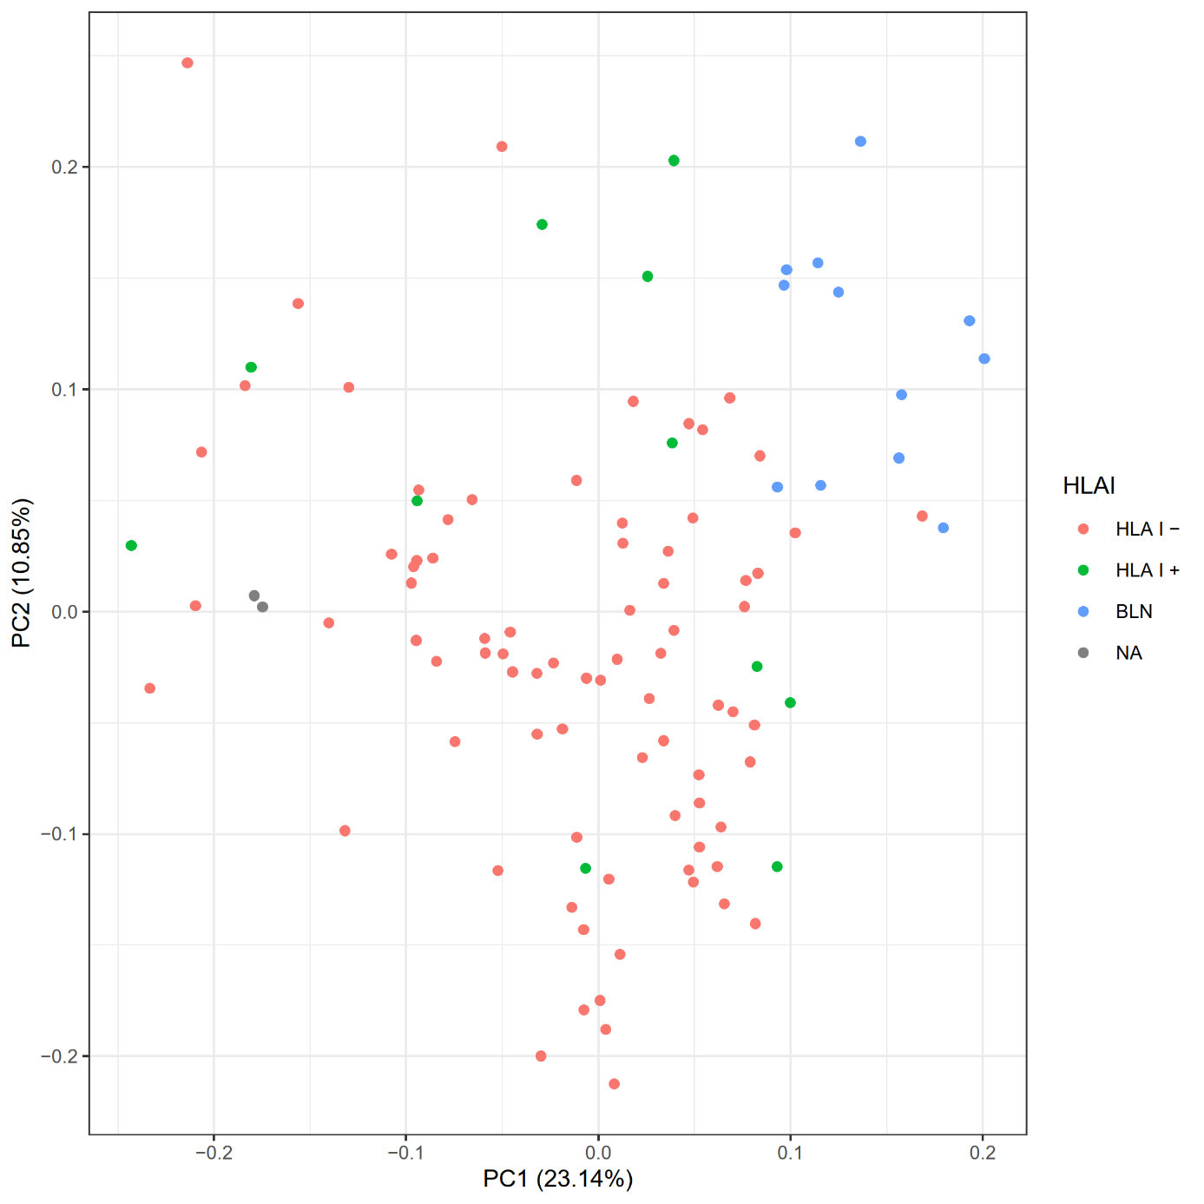
Supplementary Figure 2: Principle component analysis of log2-transformed and mean-centered gene expressions in respect to HLA-I expression in NIVAHL cases. blue: benign lymph nodes, red: HLA-I-, green HLA-I+ treatment-naïve classic Hodgkin Lymphoma (Nivahl study cohort). grey: classical Hodgkin lymphoma not evaluable for HLA-I expression.
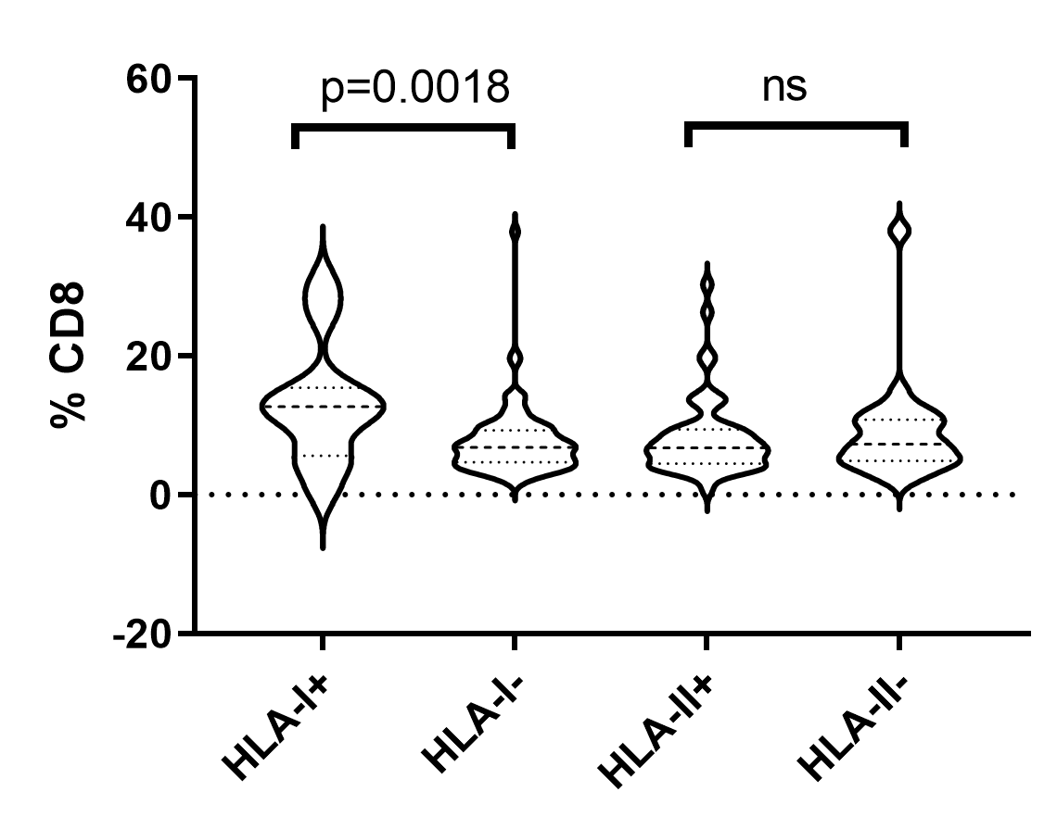
Supplementary figure 3: Content of CD8 cells assessed by whole slide image analysis as previously described.[3] ns= not significant.

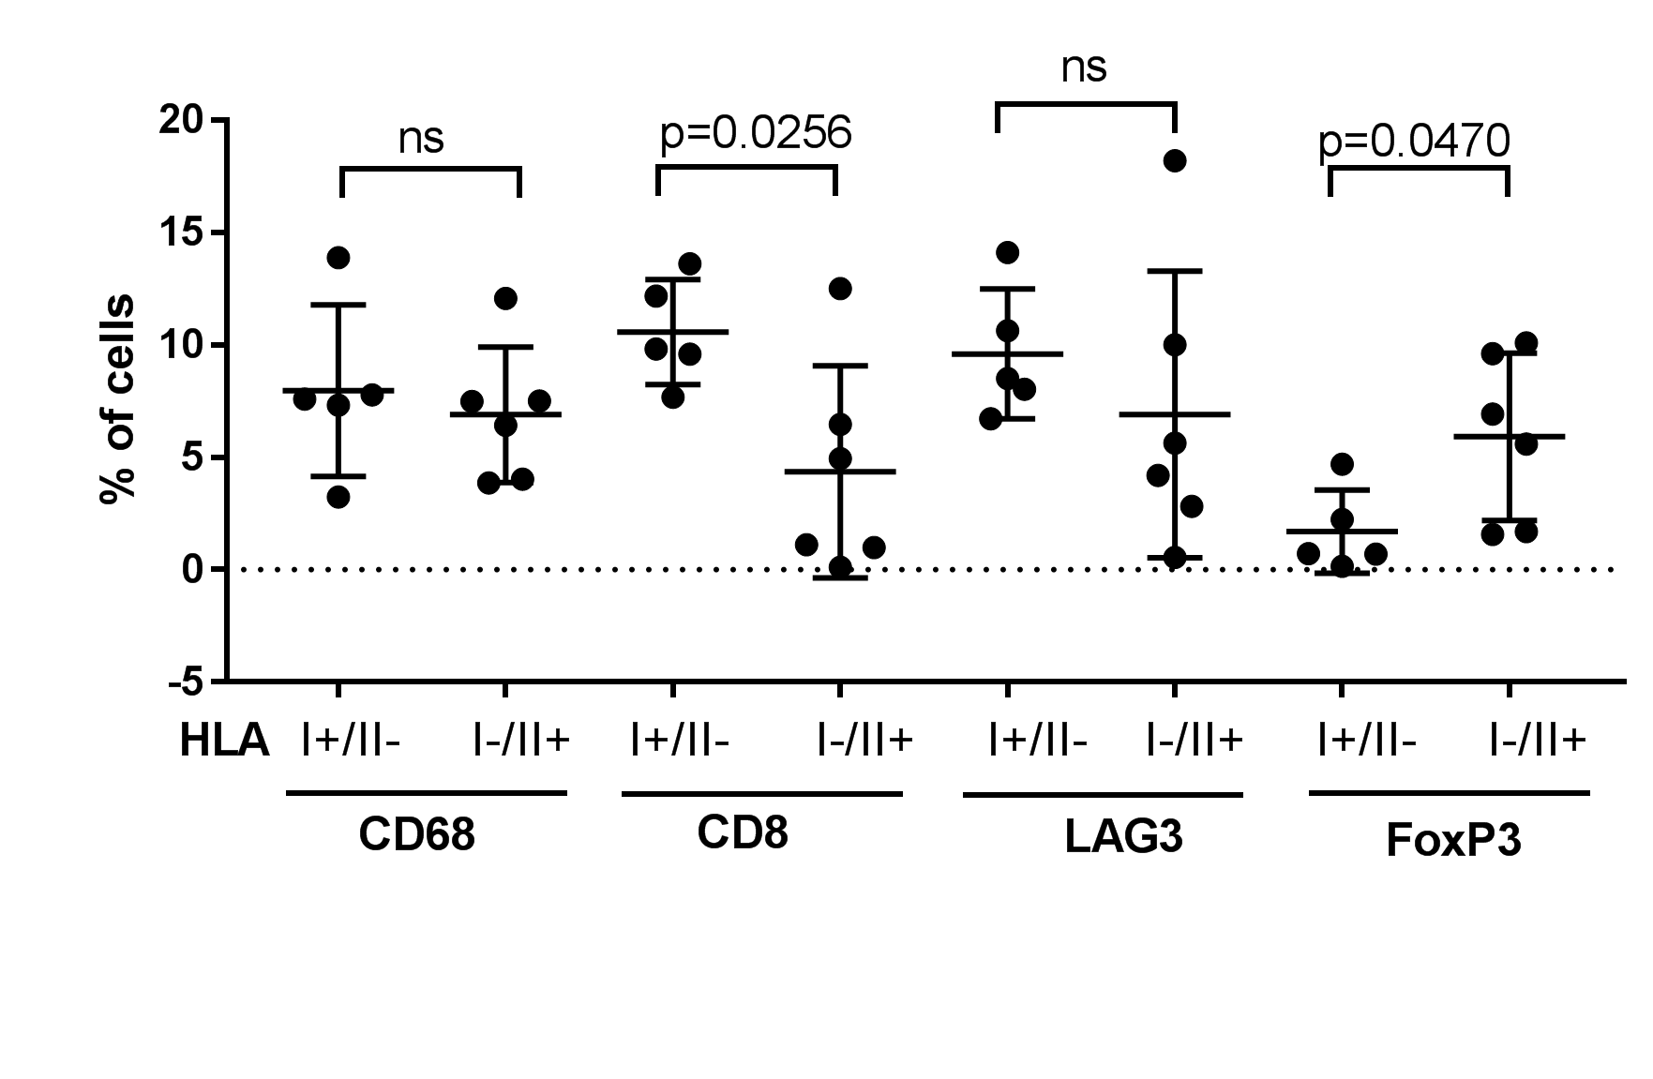Supplementary figure 4: Analysis of areas in close proximity to HRSC in EBV-negative HL. Analysis restricted to cases expressing HLA-I but not HLA-II (HLA-I+) or HLA-II but not HLA-I (HLA-II+). Percent of cells in the respective areas indicated. P-values according to unpaired t-test. ns= not significant.

1. Bankhead, P., et al., QuPath: Open source software for digital pathology image analysis. Sci Rep, 2017. 7(1): p. 16878.
2. Schmidt, U., et al. Cell Detection with Star-Convex Polygons. 2018. Cham: Springer International Publishing.
3. Jachimowicz, R.D., et al., Whole-slide image analysis of the tumor microenvironment identifies low B-cell content as a predictor of adverse outcome in patients with advanced-stage classical Hodgkin lymphoma treated with BEACOPP. Haematologica, 2021. 106(6): p. 1684-1692.

