Supporting Information for

Insights into the biochar-respiratory growth of a model methanogen
-Microbial Ecology-
Rui Huang· Chuyan Tang· Yameng Zhao· Lina Liu· Jiazhe Chen· Zhirui Shi· Zhen Yan*

*Corresponding author: Zhen Yan
Affiliation: ¹Shandong Key Laboratory of Water Pollution Control and Resource Reuse, School of Environmental Science and Engineering, Shandong University, Qingdao, Shandong 266237, China; ²Suzhou Research Institute, Shandong University, Suzhou, Jiangsu 215123, China
E-mail: yanzhen@email.sdu.edu.cn
ORCID iD:0000-0002-6213-9054

This PDF file includes:
Supporting text
Figures S1 to S4
Table S1

Supporting text
Extraction of Extracellular polymeric substances (EPS)
10 mL of culture grown at day 4 was centrifuged at 6,500 rpm for 10 min. The cell pellet was washed twice with phosphate buffered saline (PBS, pH 7.4), and then suspended into 10-mL PBS. Afterwards, the suspension was sonicated at 20 kHz for 2 min, shaken horizontally at 150 rpm for 10 min and sonicated again for 2 min. The solution was centrifuged at 8,000 rpm for 10 min, and the supernatant was collected as loosely bound EPS. The pellet was resuspended in PBS solution, sonicated for 3 min, then heated in a water bath at 70 °C for 30 min, and finally centrifuged at 10,000 rpm for 20 min to collect the supernatant as tightly bound EPS.
Biochemical and physicochemical analysis
A fourier transform infrared spectrometer (FTIR) (Nicolettis 10, Thermo) was used to characterize the surface groups of biochar and the EPS of M. acetivorans with the spectrum collected in 4000–500 cm⁻¹. X-ray photoelectron spectroscopy (XPS) (K-Alpha, Thermo) was used to analyze the chemical phase distribution of the elements on the surface of biochar.
Anthrone method
A volume of 5 mL of chromogenic agent (anthrone: concentrated sulfuric acid = 1:500), and 2 mL of EPS solution was added to a tube, mixed well, and then cooled it to room temperature in ice water. The tube was heated in a 100 °C water bath for 10 min, then cooled to room temperature and measured at a wavelength of 625 nm. A polysaccharide standard curve was used to obtain the polysaccharide content in EPS.
Electrochemical analysis
Cyclic voltammetry (CV) was used to measure the electrochemical capacitance of biochar, where the biochar electrode was used as the working electrode. The capacitance was calculated as follows:
$$C=\frac{A}{2SvΔV}$$
Where C is the capacitance of biochar in mF cm⁻², and A is the area enclosed by the CV curve. S is the geometric surface area of the pyrogenic carbon working electrode (0.196 cm²), and v is the scan rate (0.05 V s⁻¹), and ΔV is the potential range for charge / discharge.
The electron accepting capacity (EAC) was determined via chronoamperometry in an anaerobic chamber, where the glassy carbon electrode was used as working electrode and the constant potential was −0.49 V. 6 mL of PBS buffer deoxidized by N₂ was added into the system. When the current was stable, 100 μL of mediator (10 mM flavin mononucleotide) was added from the feeding port and a current response curve was generated. Biochar suspension (100 μL of 0.1 g/L) was added to regenerate the response current after the mediator was reduced. The time-current curve of biochar-accepting electrons could then be obtained. The following equation was used to integrate the curve to obtain the EAC of biochar:
$$EAC=\frac{\int{\frac{I_{red}}{F}dt}}{m_{biochar}}$$
Where I_{red} (A) is the baseline-corrected reductive current, F = 96485 s A/mole⁻ is the Faraday constant, t is the time (s), and m_{biochar} (g) is the mass of added biochar.
Morphology analysis
The morphology of M. acetivorans and biochar was analyzed using a field emission scanning electron microscope (SEM) (Quanta 250 FEG, FEI). The cells were collected from the culture of M. acetivorans grew with biochar (pyrolyzed at 300 °C) or not at day 6 by centrifuging at 6,500 rpm for 15 min. The supernatant was removed and cleaned once with 1 × PBS. Glutaraldehyde (2.5%, prepared with 1 × PBS) was added, fixed at 4 °C for 3 h to remove the supernatant, and then washed with 1 × PBS three times. Afterwards, samples were sequentially dehydrated with 30%, 50%, 70%, 80%, and 90% ethanol for 15 min at each step. The supernatant was discarded and dehydrated twice in 100% ethanol for 15 min. Cell samples and biochar were dried via critical point drying and sprayed with platinum for observation.

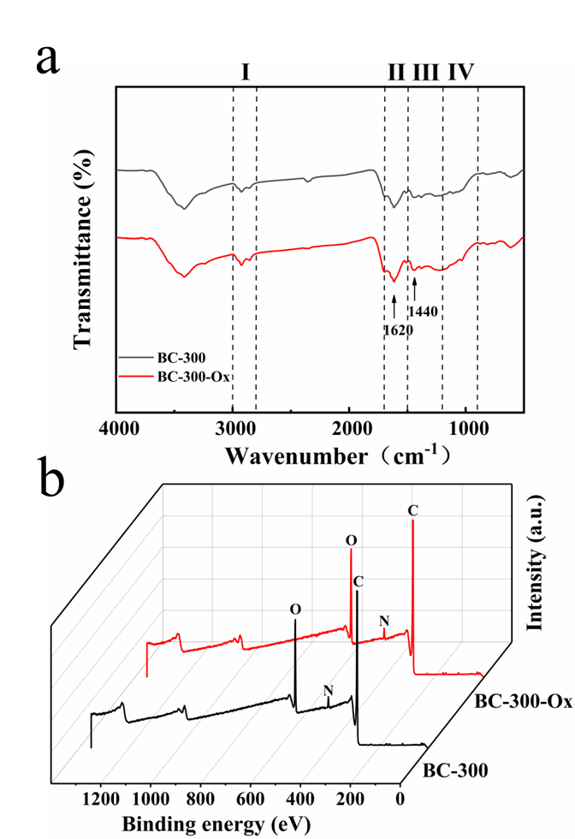
Fig. S1 FTIR and XPS analysis for BC-300 and BC-300-Ox. (a) FTIR spectra. (I) indicates the fatty acid region. (II) indicates the protein and amide region. (III) indicates the mixed region. (IV) indicates the polysaccharide region. The vibration of C−O at 1440 cm⁻¹ and C=O at 1620 cm⁻¹ are indicative of the presence of oxygenic moieties in terms of carboxylic acid groups and quinone moiety. (b) XPS spectra

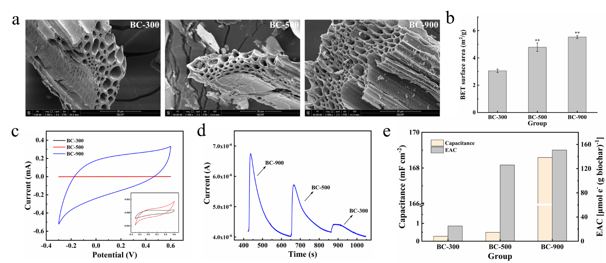
Fig. S2 Morphology, physicochemical and electrochemistry properties of biochar. (a) SEM images of BC-300, BC-500, and BC-900. (b) BET surface area of BC-300, BC-500, and BC-900. ** indicates significant differences between the BC-300 group and other groups at p < 0.01 (c) Cyclic voltammograms of BC-300, BC-500 and BC-900. (d) Chronoamperogram by successive additions of BC-900, BC-500 and BC-300 suspensions. (e) The capacitance and EAC of BC-300, BC-500, and BC-900 are calculated from the cyclic voltammograms and chronoamperogram shown in Fig. S2c and S2d, respectively. The calculated equations were described in the section of Methods&Materials. This is representative of the results of three independent replicates.

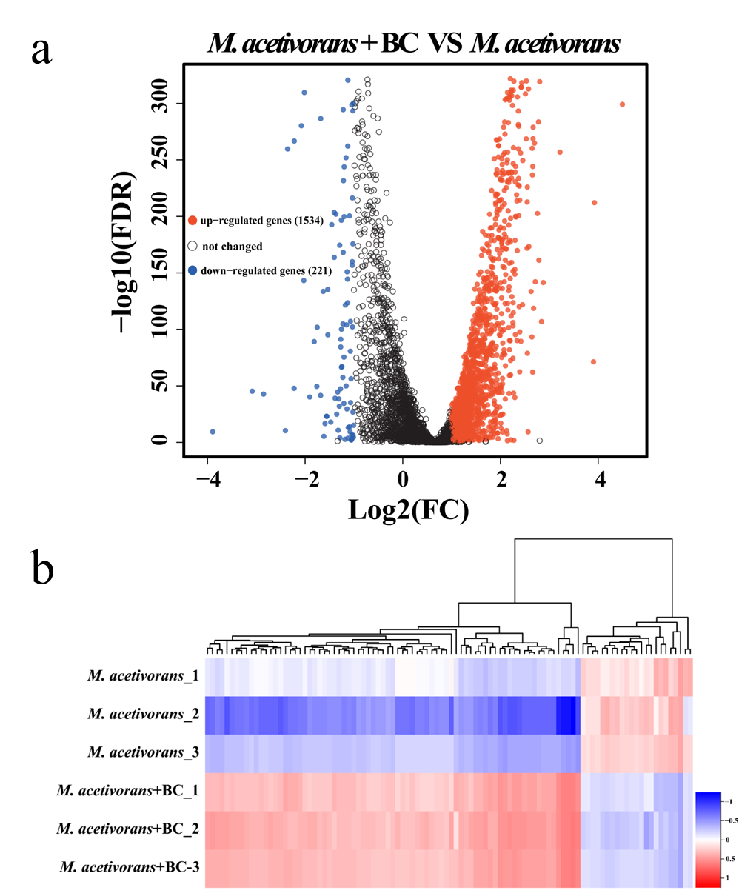

Fig. S3 Transcriptome analysis of M. acetivorans. (a) Volcano plot of differentially expressed genes (DEGs) in M. acetivorans + BC-300 vs. M. acetivorans. (b) Cluster map in all groups.

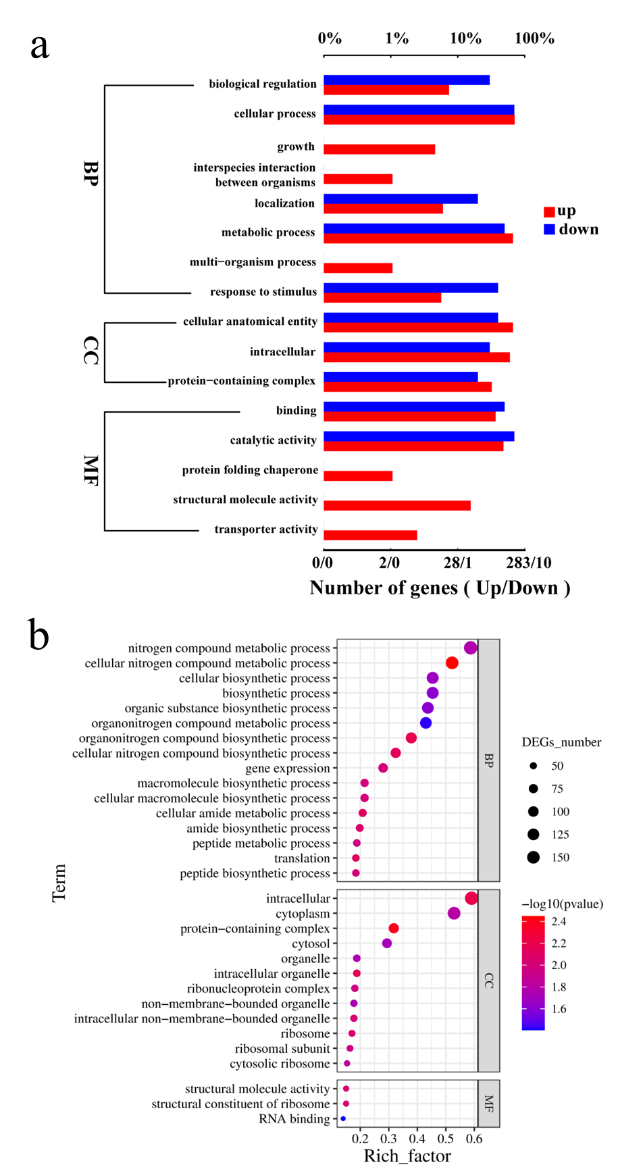

Fig. S4 Transcriptome analysis of M. acetivorans. Upregulated and downregulated DEGs of (a) Gene ontology (GO) annotation and (b) GO enrichment diagram.
Table S1 DEGs in genetic processing information
Genetic processing | GeneID | function | Log₂FC | p-value
Transcription | MA_RS03140 | DNA-directed RNA polymerase subunit N | 3.218642483 | 1.13E-258
Transcription | MA_RS03150 | DNA-directed RNA polymerase subunit K | 2.805257594 | 0
Transcription | MA_RS03775 | DNA-directed RNA polymerase subunit L | 2.036523041 | 8.12E-138
Transcription | MA_RS06545 | rpoA2; DNA-directed RNA polymerase subunit A'' | 1.819655468 | 1.27E-224
Transcription | MA_RS06550 | DNA-directed RNA polymerase subunit A' | 1.688591444 | 2.61E-185
Transcription | MA_RS06555 | rpoB; DNA-directed RNA polymerase subunit B | 1.956843299 | 2.70E-254
Transcription | MA_RS06560 | DNA-directed RNA polymerase subunit B'' | 2.064461221 | 7.51E-281
Transcription | MA_RS06565 | DNA-directed RNA polymerase subunit H | 2.458573116 | 0
Transcription | MA_RS19235 | DNA-directed RNA polymerase | 2.084630805 | 3.33E-258
Transcription | MA_RS19240 | DNA-directed RNA polymerase subunit E'' | 2.199661883 | 1.56E-146
Transcription | MA_RS25375 | DNA-directed RNA polymerase subunit P | 2.648858981 | 4.57E-262
Transcription | MA_RS00110 | metal-dependent transcriptional regulator | 2.216739136 | 0
Transcription | MA_RS00585 | transcription factor S | 2.068825278 | 3.47E-191
Transcription | MA_RS00970 | TATA-box-binding protein | 2.294229621 | 6.93E-41
Transcription | MA_RS00975 | MarR family transcriptional regulator | 1.301305404 | 8.00E-07
Transcription | MA_RS01480 | TATA-box-binding protein | 2.099613852 | 1.49E-39
Transcription | MA_RS01505 | molybdenum-dependent transcriptional regulator | 1.378123733 | 1.53E-28
Transcription | MA_RS01525 | TrmB family transcriptional regulator | 1.509535178 | 2.07E-53
Transcription | MA_RS01935 | TetR/AcrR family transcriptional regulator | 1.207444212 | 8.12E-40
Transcription | MA_RS03205 | transcription initiation factor IIB | 1.735905714 | 1.66E-126
Transcription | MA_RS06535 | NusA-like transcription termination signal-binding factor | 2.925975306 | 0
Transcription | MA_RS07335 | Lrp/AsnC family transcriptional regulator | 2.3411584 | 0
Transcription | MA_RS07555 | MarR family winged helix-turn-helix transcriptional regulator | 1.357646293 | 2.64E-63
Transcription | MA_RS07565 | ArsR family transcriptional regulator | 1.005414367 | 1.19E-28
Transcription | MA_RS13390 | winged helix-turn-helix transcriptional regulator | 1.821057028 | 1.56E-141
Transcription | MA_RS20190 | transcription factor | 1.380721038 | 1.68E-56
Transcription | MA_RS22620 | TATA-box-binding protein | 1.50153066 | 5.69E-79
Transcription | MA_RS24315 | winged helix-turn-helix transcriptional regulator | 1.547157098 | 1.56E-29
Translation | MA_RS00220 | argS; arginine--tRNA ligase | 2.034422933 | 9.65E-248
Translation | MA_RS00460 | sepS; O-phosphoserine--tRNA ligase | 1.408074 | 2.22E-81
Translation | MA_RS00500 | glyS; glycine--tRNA ligase | 2.246520424 | 4.67E-300
Translation | MA_RS00930 | phenylalanine--tRNA ligase subunit alpha | 1.434961381 | 4.35E-74
Translation | MA_RS00935 | tryptophan--tRNA ligase | 1.291737257 | 1.61E-35
Translation | MA_RS01045 | alaS; alanine--tRNA ligase | 2.096508702 | 4.47E-305
Translation | MA_RS02805 | lysS; lysine--tRNA ligase | 1.689443653 | 1.97E-80
Translation | MA_RS03780 | pscS; O-phospho-L-seryl-tRNA:Cys-tRNA synthase | 1.085746823 | 5.99E-26
Translation | MA_RS03975 | lysS; lysine--tRNA ligase | 1.736461853 | 5.25E-64
Translation | MA_RS04250 | tyrosine--tRNA ligase | 1.605241667 | 4.27E-114
Translation | MA_RS04900 | hisS; histidine--tRNA ligase | 1.657851766 | 3.77E-62
Translation | MA_RS06825 | gatD; Glu-tRNA(Gln) amidotransferase subunit GatD | 1.712459657 | 7.10E-147
Translation | MA_RS08370 | leuS; leucine--tRNA ligase | 1.822358793 | 1.29E-191
Translation | MA_RS08730 | aspS; aspartate--tRNA(Asn) ligase | 2.525404823 | 0
Translation | MA_RS10195 | pheT; phenylalanine--tRNA ligase subunit beta | 2.086136103 | 1.99E-285
Translation | MA_RS12625 | ileS; isoleucine--tRNA ligase | 1.513786311 | 8.06E-111
Translation | MA_RS15190 | threonine--tRNA ligase | 1.325016345 | 5.34E-72
Translation | MA_RS15970 | valine--tRNA ligase | 2.309302569 | 0
Translation | MA_RS20265 | proS; proline--tRNA ligase | 1.762244491 | 4.80E-171
Translation | MA_RS21120 | metG; methionine--tRNA ligase | 1.064153594 | 3.61E-20
Translation | MA_RS21130 | serS; serine--tRNA ligase | 1.755134978 | 7.69E-176
Translation | MA_RS23585 | gatC; Asp-tRNA(Asn)/Glu-tRNA(Gln) amidotransferase subunit GatC | 1.892647578 | 4.35E-138
Translation | MA_RS23590 | gatA; Asp-tRNA(Asn)/Glu-tRNA(Gln) amidotransferase subunit GatA | 1.387876434 | 8.77E-63
Translation | MA_RS00990 | 50S ribosomal protein L16 | 3.028079701 | 0
Translation | MA_RS03125 | 50S ribosomal protein L18e | 2.935203241 | 0
Translation | MA_RS03130 | 50S ribosomal protein L13 | 2.982147766 | 0
Translation | MA_RS03135 | 30S ribosomal protein S9 | 2.991612927 | 0
Translation | MA_RS03395 | 30S ribosomal protein S27e | 2.660596898 | 0
Translation | MA_RS03400 | 50S ribosomal protein L44e | 2.669930376 | 0
Translation | MA_RS04785 | 30S ribosomal protein S8e | 2.739863479 | 0
Translation | MA_RS04935 | 30S ribosomal protein S15 | 3.004246653 | 0
Translation | MA_RS05595 | rpl3p; 50S ribosomal protein L3 | 1.793540464 | 1.91E-191
Translation | MA_RS05600 | rpl4p; 50S ribosomal protein L4 | 1.454332062 | 2.23E-99
Translation | MA_RS05605 | 50S ribosomal protein L23 | 1.604544852 | 9.82E-92
Translation | MA_RS05610 | 50S ribosomal protein L2 | 1.431804804 | 2.20E-86
Translation | MA_RS05615 | 30S ribosomal protein S19 | 1.491119545 | 7.52E-94
Translation | MA_RS05620 | 50S ribosomal protein L22 | 1.292729818 | 1.68E-58
Translation | MA_RS05625 | 30S ribosomal protein S3 | 1.074289062 | 2.82E-31
Translation | MA_RS05640 | 30S ribosomal protein S17 | 1.200994161 | 5.98E-29
Translation | MA_RS05650 | rplX; 50S ribosomal protein L24 | 1.268141028 | 1.78E-70
Translation | MA_RS05655 | 30S ribosomal protein S4e | 1.149912899 | 4.19E-44
Translation | MA_RS05660 | 50S ribosomal protein L5 | 1.240404888 | 1.83E-62
Translation | MA_RS05665 | 30S ribosomal protein S14 | 1.232623498 | 2.31E-54
Translation | MA_RS05670 | 30S ribosomal protein S8 | 1.586908093 | 2.08E-109
Translation | MA_RS05675 | rpl6p; 50S ribosomal protein L6 | 1.723161987 | 3.05E-177
Translation | MA_RS05680 | 50S ribosomal protein L32e | 1.595317897 | 1.02E-118
Translation | MA_RS05685 | 50S ribosomal protein L19e | 1.479129166 | 1.15E-113
Translation | MA_RS05690 | 50S ribosomal protein L18 | 1.456640128 | 8.20E-102
Translation | MA_RS05695 | 30S ribosomal protein S5 | 1.209140179 | 2.08E-57
Translation | MA_RS05700 | 50S ribosomal protein L30 | 1.22993716 | 8.02E-57
Translation | MA_RS05705 | 50S ribosomal protein L15 | 1.300284866 | 6.34E-53
Translation | MA_RS05775 | 30S ribosomal protein S13 | 2.746036205 | 0
Translation | MA_RS05780 | 30S ribosomal protein S4 | 2.577178994 | 0
Translation | MA_RS05785 | 30S ribosomal protein S11 | 2.576913043 | 0
Translation | MA_RS06510 | rpsJ; 30S ribosomal protein S10 | 2.260424343 | 1.95E-248
Translation | MA_RS06525 | 30S ribosomal protein S7 | 2.661360776 | 0
Translation | MA_RS06530 | 30S ribosomal protein S12 | 2.820213783 | 0
Translation | MA_RS06540 | 50S ribosomal protein L30e | 2.667377842 | 0
Translation | MA_RS07505 | 50S ribosomal protein L21e | 3.482323872 | 0
Translation | MA_RS07905 | 30S ribosomal protein S28e | 3.935210825 | 0
Translation | MA_RS07910 | 50S ribosomal protein L24e | 3.414138469 | 0
Translation | MA_RS07925 | 30S ribosomal protein S6e | 3.731898476 | 0
Translation | MA_RS09225 | 50S ribosomal protein L37ae | 2.925146647 | 0
Translation | MA_RS09270 | 50S ribosomal protein L15e | 1.546459394 | 1.56E-129
Translation | MA_RS17840 | 30S ribosomal protein S3ae | 3.152908447 | 0
Translation | MA_RS19250 | 30S ribosomal protein S24e | 3.229342519 | 0
Translation | MA_RS19255 | 30S ribosomal protein S27ae | 3.075081506 | 0
Translation | MA_RS21450 | rpl18a; 50S ribosomal protein L18Ae | 2.931054758 | 0
Translation | MA_RS21460 | 50S ribosomal protein L31e | 2.844499393 | 0
Translation | MA_RS21475 | 30S ribosomal protein S19e | 3.406029293 | 0
Translation | MA_RS22315 | 50S ribosomal protein L11 | 2.148011336 | 0
Translation | MA_RS22320 | 50S ribosomal protein L1 | 2.278751326 | 0
Translation | MA_RS22325 | 50S ribosomal protein L10 | 2.291918935 | 0
Translation | MA_RS22330 | rpl12p; 50S ribosomal protein P1 | 1.578440039 | 9.04E-88
Translation | MA_RS23340 | 30S ribosomal protein S17e | 3.310014262 | 0
Translation | MA_RS25780 | 50S ribosomal protein L37e | 2.927859573 | 0
Translation | MA_RS26070 | 50S ribosomal protein L39e | 2.980277906 | 0
Translation | MA_RS00985 | translation initiation factor IF-2 subunit beta | 3.287493861 | 0
Translation | MA_RS01050 | methyltransferase domain-containing protein | 1.884183949 | 3.66E-123
Translation | MA_RS01540 | ribonuclease P | 1.120044699 | 4.39E-05
Translation | MA_RS03390 | translation initiation factor IF-2 subunit alpha | 2.593120547 | 0
Translation | MA_RS06515 | tuf; translation elongation factor EF-1 subunit alpha | 2.115184632 | 0
Translation | MA_RS07010 | eif1A; translation initiation factor eIF-1A | 2.870991696 | 0
Translation | MA_RS07030 | eif1A; translation initiation factor eIF-1A | 2.071773961 | 2.93E-80
Translation | MA_RS07635 | elongation factor 1-beta | 3.966814228 | 0
Translation | MA_RS07920 | infB; translation initiation factor IF-2 | 3.145842545 | 0
Translation | MA_RS09255 | ribonuclease P | 1.875858863 | 1.24E-101
Translation | MA_RS09260 | ribonuclease P protein component 3 | 2.872853471 | 0
Translation | MA_RS15875 | rnz; ribonuclease Z | 1.376858495 | 6.69E-24
Translation | MA_RS19225 | translation initiation factor IF-2 subunit gamma | 2.217165279 | 0
Translation | MA_RS20180 | NMD3-related protein | 2.133086811 | 3.93E-249
Translation | MA_RS20800 | translation initiation factor IF-5A | 2.85004635 | 0
Translation | MA_RS21455 | translation initiation factor IF-6 | 2.770923599 | 0
Translation | MA_RS24275 | translation elongation factor | 1.224146236 | 5.35E-22
Translation | MA_RS25400 | eif1A; translation initiation factor eIF-1A | 4.389319986 | 0
Translation | MA_RS00215 | prf1; peptide chain release factor aRF-1 | 2.376654647 | 0
Translation | MA_RS05270 | prf1; peptide chain release factor aRF-1 | 1.924242112 | 2.54E-141

