Supplement
Supplementary materials for
Compost as green adsorbent for the azo dyes - structural characterization and dye removal mechanism

Joanna Kyziol-Komosinskaª, Agnieszka Dzieniszewska^{*a}, Sylwia Pasieczna-Patkowska^{b}, Anna Kołbus^{c}, Justyna Czupiołª

ª Institute of Environmental Engineering, Polish Academy of Sciences, 34 M. Skłodowska-Curie St., 41-819 Zabrze, Poland
^{b} Department of Chemical, Faculty of Chemistry, University of Maria Curie-Sklodowska, Technology, 3 Maria Curie-Sklodowska Square, 20-031 Lublin, Poland
^{c} Institute of Chemistry, Jan Kochanowski University , 7 Uniwersytecka, 25-406 Kielce, Poland
* corresponding author: agnieszka.dzieniszewska@ipispan.edu.pl

Submitted to Environmental Management

METHODS
FT-IR/ATR analysis
Spectra were recorded in the range 3800-400 cm^{–1} range, resolution 4 cm^{–1}, at room temperature using a Nicolet 6700 spectrometer and Meridian Diamond ATR accessory (Harrick). Samples were applied directly to the diamond crystal, and close contact was made with the surface by a pressure tower. Interferograms of 512 scans were averaged for each spectrum, providing good signal-to-noise (S/N) ratio. Dry potassium bromide (48h, 105°C) was used as reference material to collect ATR spectra. All ATR spectra were corrected for water vapor and carbon dioxide, and ATR correction was applied. No smoothing functions were used. All spectral measurements were performed at least in triplicate.

Isotherms and kinetics models
Table S1. Isotherms equations.
Isotherm model | Equation | Parameters | Eq.
Freundlich | $$q=K_{F}∙{C_{eq}}^{1/n}$$ | K_{F} – Freundlich isotherm constant ((mg/g)·(L/mg)^{1/n}) and it is an approximate indicator of adsorption capacity  1/n – a function of the strength of adsorption in the adsorption process | S1
Langmuir | $$q=\frac{q_{L}K_{L}C_{eq}}{1+K_{L}C_{eq}}$$ | q_{L} – maximum monolayer coverage capacity (mg/g)  K_{L} – Langmuir isotherm constant related to the affinity of binding sited (L/mg) | S2
Dubinin-Radushkevich | $$q=q_{D}∙exp⁡\left(–βε^{2}\right)$$ | q_{D} – the adsorption capacity of studied minerals for dyes (mol/g)  β – the constant (mol²/J²)  ε – the Polanyi potential (J/mol) which is equal to  $ε=\text{RTln}(1+\frac{1}{C_{\text{eq}}})$.  R – the gas constant (8.314 J/mol K)  T – absolute temperature (K)  $E=\frac{1}{(2β)^{1/2}}$ – free energy (E) of the adsorption (kJ/mol) | S3  S4
Sips | $$q=\frac{q_{S}K_{S}{C_{eq}}^{m_{S}}}{1+K_{S}{C_{eq}}^{m_{S}}}$$ | q_{S} – Sips maximum adsorption capacity (mg/g)  K_{S} – the Sips equilibrium constant (L/mg)^{m}  m_{S} – the Sips model exponent | S5

Table S2. Kinetics equations.
Name of equation | Equation | Non-linear form | Description of kinetic parameters | Eq.
Pseudo–first order (PFO) | $$\frac{dq_{t}}{dt}=k_{1}(q_{e}-q_{t})$$ | $$q_{t}=q_{e}(1-e^{-k_{1}t})$$ | q_{t} (mg/g) - the dye adsorption at any given time t (min)  q_{e} (mg/g) - the dye adsorption at equilibrium  k₁ (1/min) - adsorption rate constant for PFO  k₂ (g/mg min) - adsorption rate constant for PSO  $h=k_{2}q_{e2}^{2}$- initial adsorption rate (mg/g min) | S6
Pseudo–second order (PSO) | $$\frac{dq_{t}}{dt}=k_{2}(q_{e}-q_{t})^{2}$$ | $$q_{t}=\frac{k_{2}q_{e}^{2}t}{1+k_{2}q_{e}t}$$ |  | S7  S8
Weber–Morris mass transfer model | $$q_{t}=K_{p}t^{0.5}+C$$ | – | K_{p} (mg/g min^{1/2}) - rate constant  C (mg/g) - initial adsorbed concentration of the step in the process | S9

Table S3. List of error functions.
Error function | Abbreviation | Expression | Eq.
Sum of squares error | SSE | $$\sum_{i=1}^{n}{(q_{calc}-q_{meas})_{i}^{2}}$$ | S10
Nonlinear chi-square test | χ² | $$\sum_{i=1}^{n}{\frac{(q_{meas}-q_{calc})^{2}}{q_{calc}}}$$ | S11
‘‘meas’’ and ‘‘calc’’ show the measured and calculated values; n is the number of observations in the experimental data.

RESULTS AND DISCUSSION
Point of charge (pH_{PZC}) value for compost
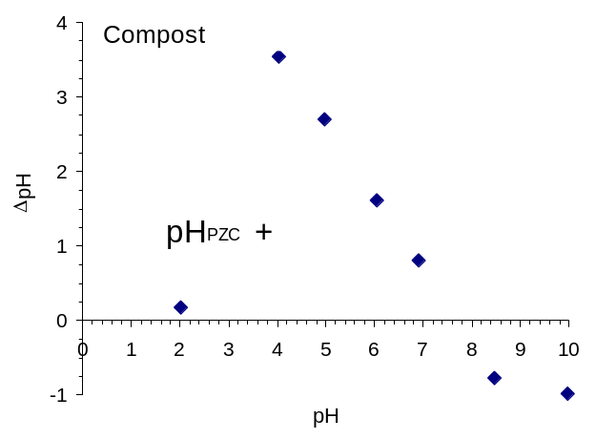

Fig. S1. Point of zero charge for compost

Buffer capacity of the compost
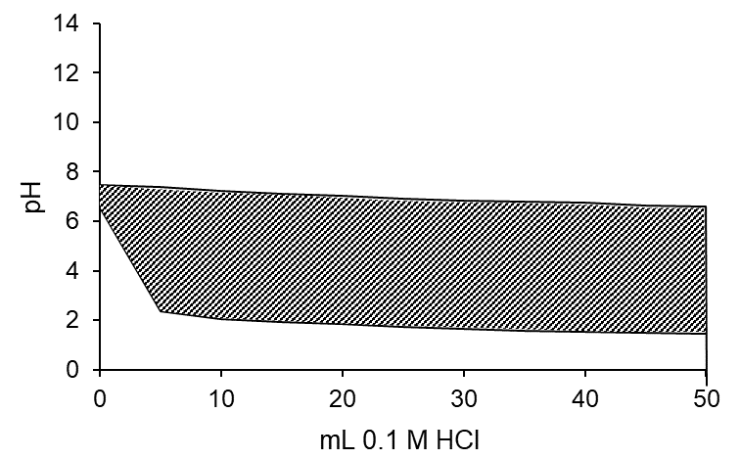
Fig. S2. Buffer capacity of the compost.

FT-IR/ATR analysis
For a better visibility, the FT-IR/ATR spectra of compost, dye, and compost with adsorbed dye are compared in the individual figures. Interpretation of the IR spectra of dyes is complicated because each functional group visible on the IR spectrum may be responsible for the appearance of multiple bands over a wide range of wavenumbers, so that each band may have a contribution of many functional groups present in the dye structure. Some functional groups are present in all dyes structures and are visible in the FT-IR spectra at similar wavenumbers. The peaks at 2956, 2926, and 2856 cm⁻¹ are the result of asymmetric and symmetric C-H stretching vibrations. The sulfonate –SO₃– bands are also present in all dyes spectra in the 1385-1345 cm⁻¹ range (asymmetric SO₂ stretching) and at ~1180 cm⁻¹, ~1125 cm⁻¹ and ~1035 cm⁻¹ (asymmetric and symmetric –SO₃ stretching) (Socrates, 2001). The band at ~1125 cm⁻¹ may also be the result of C–H deformation in substituted benzenes. The vibrations of the aromatic ring are visible in the 900-650 cm⁻¹ range (C-H out-of-plane vibrations). Ring C-C stretching occurs in the 3100-3050 cm⁻¹ and 1625-1430 cm⁻¹ range. While the ring is conjugated, as in the case of all presented dyes, a strong band occurs at ~1580 cm⁻¹ (Socrates, 2001). The –N=N– groups give bands within ~1500-1400 cm⁻¹ (Zimmermann et al., 1993), so the bands may overlap with ring or C-H stretching. The bands at ~1400 cm⁻¹ in DR-81, RB-81, RR-198, and ABk-194 are the result of O–H deformation in phenols. N-H stretching is visible as a wide band with a maximum at ~3431 cm⁻¹, –NH₂ stretching (in the case of DB-74) is visible at 3356 and 3235 cm⁻¹ (Fig. S3) (Socrates, 2001). This region overlaps with phenolic –OH groups stretching. In the case of the spectra of RB-81 and RR-198 dyes, the band for C=N stretching vibrations in pyridines at ~1535 cm ⁻¹ (RB-81, Fig. S3-C) and 1555 cm⁻¹ (RR-198, Fig. S3-D) is visible. In the case of ABk-194 (Fig. S3-E), bands at 1555 cm⁻¹ and 1317 cm⁻¹ are due to the asymmetric and symmetric stretching vibrations of the –NO₂ group, respectively (Socrates, 2001). –NO₂ in-plane deformation band is visible at 741 cm⁻¹. A similar position (~750 cm⁻¹) is observed for the C-Cl stretching in halogenated compounds in RB-81 and RR-198 dyes spectra (Fig. S3-C,D) (Kurade et al., 2015). The band at ~1215 cm⁻¹ is the result of C–O stretching in phenols and also for N–H deformation in bonded N–H. The band of rather low intensity at ~1725 cm⁻¹ comes from carbonyl C=O stretching in the amide I band (DR-81) and aromatic ketone group (DB-74). The band at 1753 cm⁻¹ in the RR-198 spectrum (Fig. S3-D) was also observed by other researchers (Kurade et al., 2015), probably coming from the carbonyl group.

A
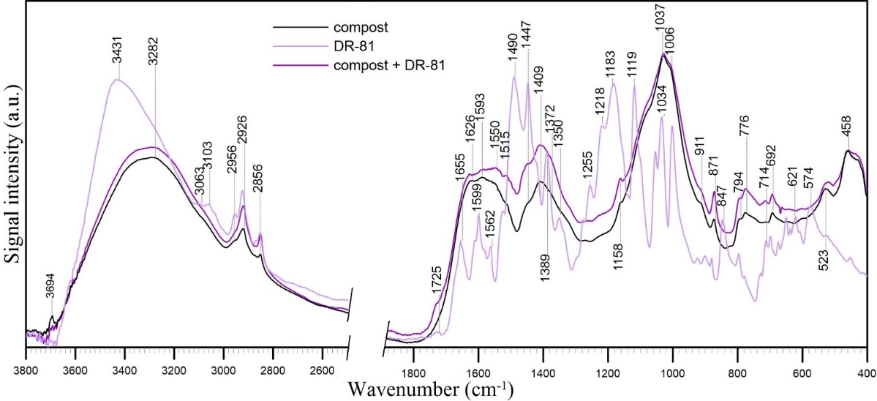
B
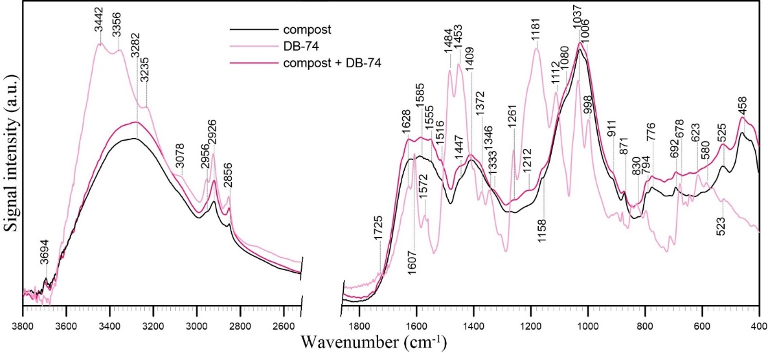
C
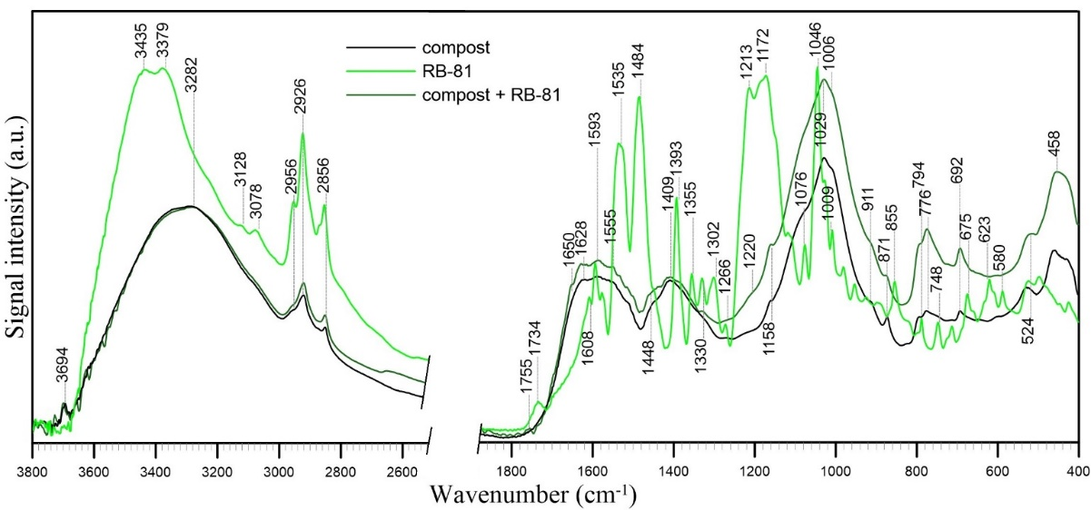

D
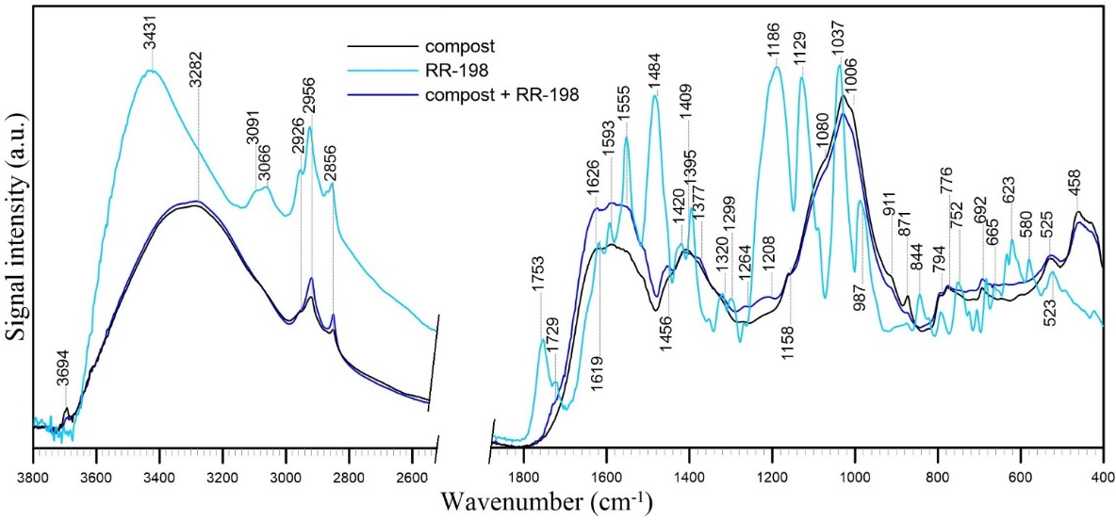
E
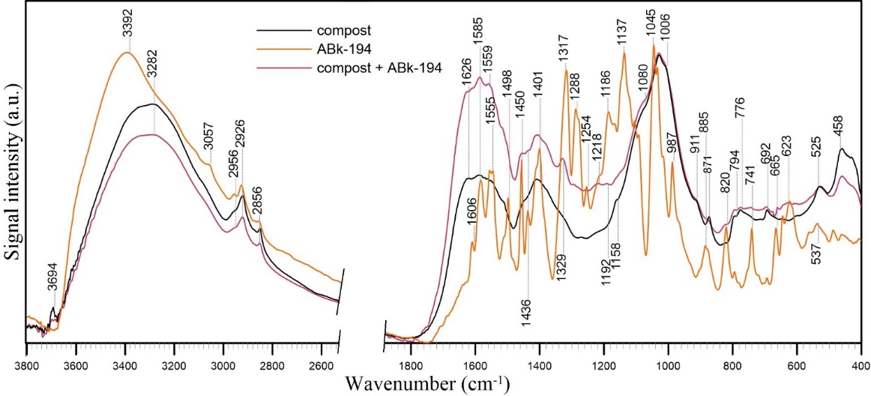
Fig. S3. FT-IR/ATR spectra of dyes, compost, and compost with adsorbed dye.

The IR spectrum of the compost has a series of peaks, which signifies the complex nature of the examined sample (Fig. S3). The spectrum in the 3800–2400 cm^{–1} range has a broad absorbance band with a maximum at ~3282 cm^{–1}, which may have contributed from multiple functional groups: O–H stretching of hydroxyl groups from hydrogen bonding in COOH groups and/or N–H asymmetric stretching of peptide groups involved in intermolecular H-bonded interaction and adsorbed water (Socrates, 2001). The band at 3694 cm⁻¹ has been assigned to the surface hydroxyl groups of inorganic compounds (Socrates, 2001). Absorbance bands within 2960–2850 cm^{–1} indicate the presence of aliphatic C–H stretching, representing the skeleton of many biomolecules. In the 2000-400 cm⁻¹ range, multiple bands indicate the presence of different groups. The band at 1626 cm⁻¹ is due to the overlapping of aromatic C=C vibrations, functional group vibrations such as C=O (carboxylates and amides), C=C (alkenes), and O–H from water, all contributing to this strong band (Meissl et al., 2008). The weak band at ~1593 cm⁻¹ can be attributed to aromatic vibrations (Smidt and Meissl, 2006) as well as the band at ~1515 cm⁻¹ (aromatic skeleton of lignin), but probably also nitrile type compounds alkynes (≡C–C, –C≡N, and –N=N–) or isocyanates (–N=C=O). The shoulder at about 1540 cm⁻¹, may be assigned to amide II. The band at 1409 cm^{–1} may indicate the presence of alkyl groups and/or carbonate species and/or O–H deformation in phenolic groups. The bands within 1160-1080 cm^{–1} may be the result of the S–O stretching vibration (Smidt and Meissl, 2006). The weak shoulder at 1080 cm^{–1} can also be assigned to C–O stretching (Coates, 2000). The band at 1037 cm^{–1} may be assigned to C–O, C-O-C, C-OH stretching of polysaccharides or polysaccharide-like substances, Si–O of silicate impurities, and clay minerals probably in complex with humic acids (Ahmad, et al., 2017; Grube et al., 2006). The bands at 871 and 692 cm^{–1} can be assigned to the aromatic ring and –C=S=C–, respectively. The band at 871 cm^{–1} may also be assigned to carbonate species in compost. The bands within 850-750 cm^{–1} can be the result of NH₂ out-of-plane vibrations of primary amine groups (Smidt and Meissl, 2006). All these groups can participate in the dye adsorption process.
Interpretation of FT-IR/ATR spectra of compost with adsorbed dyes allowed us to determine how individual dyes adsorb on the compost and which functional groups of the compost are involved in binding the dyes.
After the adsorption of the dyes, the FT-IR spectra of the compost show no loss or reduction of the bands of individual functional groups. The exception may be the disappearance of the surface hydroxyl functional groups band at 3694 cm⁻¹ in the case of DR-81 dye adsorption (Fig. S3-A) and the decrease in the intensity of this band for RR-198 and ABk-194 dyes adsorption (Fig. S3-D,E, respectively). It may indicate the involvement of these groups in dye binding. However, the spectra after adsorption show the presence of some bands characteristic of individual dyes.
The intensity and position of peaks assigned to the characteristic functional groups of dyes were either minimized or slightly shifted after the adsorption of the reactive dye on compost. In the case of DR-81, additional bands are visible in the spectrum after dye adsorption. The changes are subtle, but bands of very low intensity appear at 1725 cm⁻¹ (C=O), 1593, 1550, 1515 cm⁻¹ (aromatic ring), 1447 cm⁻¹ (N-H in amide), and 714 cm⁻¹ (N-H). In the case of DB-74, RB-81, and RR-198, the spectra after adsorption show an increase in the intensity of the bands at ~1628, 1555, 1516, 1447, 1333 cm⁻¹, and 1261 and 1212 cm⁻¹ (phenyl-carbon stretching vibration) (Socrates, 2001). In the case of DB-74, the C=O group band (~1725 cm⁻¹), one of the strongest bands in the IR spectra, is not visible, which may indicate its participation in the binding of the dye to the compost. The changes in the compost spectra after adsorption are most visible in the case of ABk-194 dye. The position of the bands is similar to the previous cases, but their intensity is greater. The –NO₂ bands (1559 and 1329 cm⁻¹) are visible. However, those bands are slightly shifted compared to the pure dye spectrum, which confirms the physical adsorption or electrostatic interaction between the dye and the compost. The lack of other bands in the spectrum of adsorbed dyes may indicate that these groups are chemically involved in dye binding.

Comparison of the adsorption capacities of various organogenic adsorbents
Table S4. Experimental and estimated adsorption capacities of various organogenic adsorbents for studied anionic azo dyes.
Anionic azo dye | Adsorbent | q (mg/g) | Conditions | References
Direct Red 81 | Argemone mexicana seeds | 8.78 | C₀=10·10⁻⁵ M, SD=4 g/L, pH=7, T=30⁰C | Khamparia and Jaspal, 2016
Direct Red 81 | potato peel | 58.8 | C₀=50 mg/L, SD=2.5 g/L, T=25⁰C | Sharma et al., 2014
Direct Red 81 | Neem bark | 8.4 | C₀=50 mg/L, SD=2.5 g/L, T=25⁰C | Sharma et al., 2014
Direct Red 81 | bamboo sawdust | 6.43* | C₀=60 mg/L, SD=6 g/L, pH=7, T=30⁰C | Khan et al., 2012
Direct Red 81 | soy meal hull | 120.48* | C₀=150 mg/L, SD=0.6 g/L, pH=2, T=20⁰C | Arami et al., 2006
Direct Red 81 | activated carbon from Hibiscus Sabdariffa stem | 18.66 | C₀=98 mg/L, SD=1.5 g/L, T=25⁰C | Sohrabi et al., 2016
Direct Red 81 | powdered activated carbon | 15.89 | C₀=50 mg/L, SD=0.3 g/L, pH=7, T=25⁰C | Bhatt et al., 2013
Direct Red 81 | compost from the green wastes | 13.28  18.19* | C₀=1 g/L, SD=20 g/L, pH=8.22, T=25⁰C | this study
Direct Blue 74 | compost from the green wastes | 15.97  23.49* | C₀=1 g/L, SD=20 g/L, pH=8.03, T=25⁰C | this study
Reactive Blue 81 | modified rye straw | 14.00  19.87* | C₀=800 mg/L, 25 g/L, pH=5-6, T=25⁰C | Tomczak and Tosik, 2014
Reactive Blue 81 | alder peat | 11.60* | C₀=1 g/L, SD=50 g/L pH=4.97, T=25⁰C | Kyziol-Komosinska et al., 2018b
Reactive Blue 81 | sedge peat | 14.60* | C₀=1 g/L, SD=50 g/L, pH=4.97, T=25⁰C | Kyziol-Komosinska et al., 2018b
Reactive Blue 81 | soya bean meal | 44.45* | C₀=120 mg/L, 2 g/L, pH=2, T=30⁰C | Sahadevan et al., 2009
Reactive Blue 81 | activated carbon from Euphorbia tirucalli L wood | 181.81* | C₀=100 mg/L, SD=0.5 g/L, T=30⁰C | Palanisamy et al., 2013
Reactive Blue 81 | compost from the green wastes | 18.55  23.26* | C₀=1 g/L, SD=20 g/L, pH=4.97, T=25⁰C | this study
Reactive Red 198 | alder peat | 10.99* | C₀=1 g/L, SD=50 g/L, pH=4.99, T=25⁰C | Kyziol-Komosinska et al., 2018b
Reactive Red 198 | sedge peat | 16.90* | C₀=1 g/L, SD=50 g/L, pH=4.99, T=25⁰C | Kyziol-Komosinska et al., 2018b
Reactive Red 198 | activated carbon from walnut shells | 79.15* | C₀=500 mg/L, SD=2 g/L, pH=3, T=25⁰C | Alimohammadi et al., 2016
Reactive Red 198 | waste coagulation sludge of the WTP | 34.4 | C₀=100 mg/L, SD=2 g/L, pH=7-8 | Asilian et al., 2010
Reactive Red 198 | cuttlefish bone powder | 1.817 | C₀=50 mg/L, SD=20 g/L, T=20⁰C | Mahboobeh et al., 2017
Reactive Red 198 | untreated olive pomace | 60.49 | C₀=500 mg/L, 3 g/L, pH=2, T=20⁰C | Tunali Akar et al., 2009
Reactive Red 198 | compost from the green wastes | 9.73  12.57* | C₀=1 g/L, SD=20 g/L, pH=4.99, T=25⁰C | this study
Acid Black 194 | alder forest peat | 59.18  60.23* | C₀=5 g/L, SD=50 g/L, T=25⁰C | Kyziol-Komosinska et al., 2010
Acid Black 194 | sedge peat | 78.62  80.9* | C₀=5 g/L, SD=50 g/L, T=25⁰C | Kyziol-Komosinska et al., 2010
Acid Black 194 | brown coal | 13.9  16.67* | C₀=1 g/L, SD=50 g/L, T=25⁰C | Kyziol-Komosinska et al., 2010
Acid Black 194 | compost | 12.39  15.87* | C₀=1 g/L, SD=50 g/L, T=25⁰C | Kyziol-Komosinska et al., 2010
Acid Black 194 | compost from the green wastes | 20.76  25.43* | C₀=1 g/L, SD=20 g/L, pH=5.11, T=25⁰C | this study
* estimated adsorption capacity

Computational calculations
Including the electronic description of the dyes molecules facilitates explaining its interaction with the adsorbent surface. The B88-LYP GGA method does not completely cover long-range-type electrostatic effects (Rizvi et al., 2022). However, when assuming that van der Walls forces will work on all molecules, the absolute values of molecular partial charges allow to compare their electron distributions and show general trends.
The optimized structures with the most stable conformation and the electrostatic potential energy maps for the ABk-194, RB-81, and DR-81 dye molecules are presented in Fig. S4. It can be seen that dihedral angles of the ABk-194 and DR-81 dyes are slightly greater than those of RB-81. The dihedral angles indicate the molecule planarity for ABk-194, DR-81 dyes with a slight deviation from planarity in the case of the RB-81 dye.
The molecular electrostatic potential energy map represents electronic density distribution in the molecule and shows the most probable region for electrophilic and nucleophilic attacks as well as hydrogen-bonding interactions. Moreover, the maps reflect the relationship between the total charge distribution, the dipole moment, electronegativity, and the site of chemical reactivity of molecules. The color on the electrostatic potential energy map points out to electrostatic potential values on the surface (Fig. S4). The red color shows the electron-rich region, whereas blue an electron-deficient region. Intermediate colors: yellow, green, and light blue represent slightly electron-rich, neutral, and slightly electron-deficient regions respectively.
Table S5 contains the theoretical values of electronic descriptors as regards all the studied molecules: dipole moments, HOMO, LUMO energy (DFT method), polarizability (PM6 method), electron affinity (EA), ionization potential (IP), electronegativity (EN), and chemical hardness.
The highest occupied molecular orbital (HOMO) can act as an electron donor and the lowest unoccupied orbital (LUMO) as an electron acceptor. Compound stability, including dyes, can be estimated by the energy difference between the HOMO and LUMO. The HOMO-LUMO gap (ΔE) is correlated to the reactivity of the molecules in the statistical sense. Chemical hardness is a measure of the resistance of molecules to changes in its electronic configuration. It is also an indicator together with the electronegativity of the chemical reactivity and stability (Makov, 1995).
The obtained values of ΔE are comparable for all dyes, but the values of electronegativity and chemical hardness were greater for the ABk-194 and RB-81 dyes than for DR-81, indicating higher reactivity of the monoazo dyes.

Table S5. The values of electronic descriptors of dyes: dipole moments, HOMO, LUMO energy (DFT method), log P, polarizability (PM6 method), electron affinity (EA), ionization potential (IP), electronegativity (EN), and chemical hardness ($η).$
Compound | Dipole moment [D] | HOMO energy [eV] | LUMO energy [eV] | Energy gap, $ΔE$ | log P | Polariza-  bility [A³] | EA  [eV] | IP  [eV] | EN  $χ$ | $η$
ABk-194 | 5.158 | -5.232 | -3.629 | 1.603 | 3.496 | 43.403 | 3.629 | 5.232 | 4.430 | 0.802
RB-81 | 14.086 | -4.978 | -3.370 | 1.608 | 3.533 | 69.281 | 3.370 | 4.978 | 4.174 | 0.804
DR-81 | 3.205 | -4.834 | -3.330 | 1.504 | 3.647 | 68.511 | 3.330 | 4.834 | 4.082 | 0.752

ABk-194
- Optimized structure of molecule and atom-numbering:
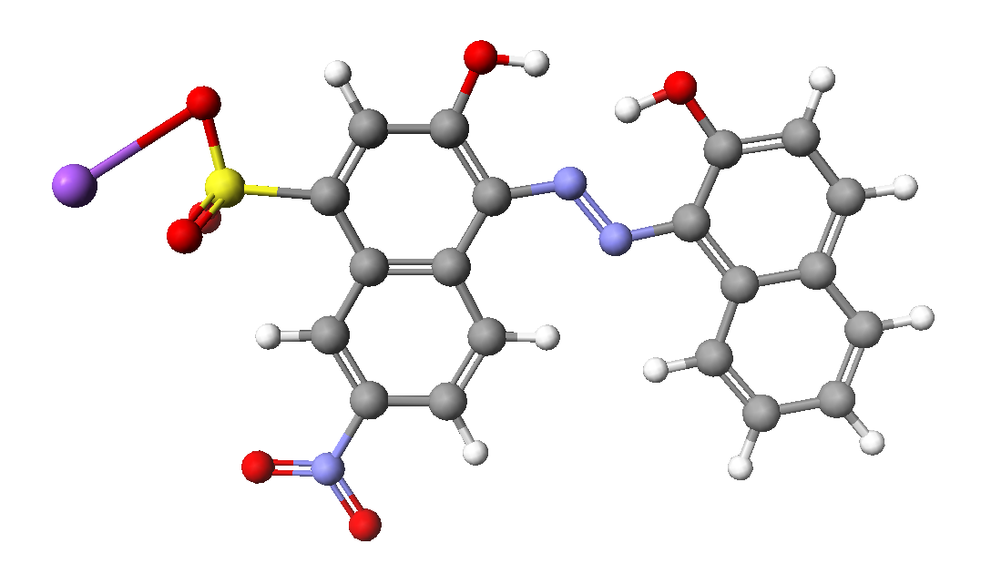
- Dihedral angles:
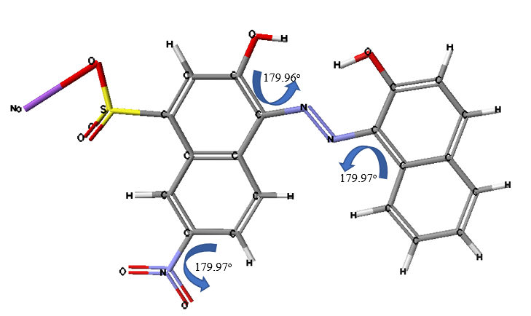
- Electrostatic potential distribution of molecule (view from different sides):

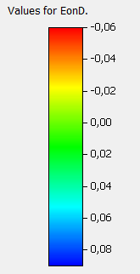
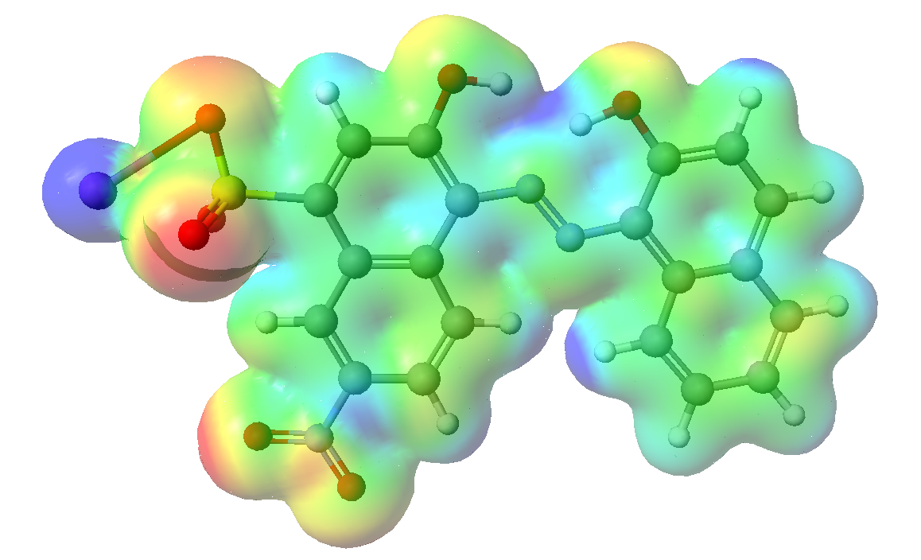
RB-81
- Optimized structure of molecule and atom-numbering:
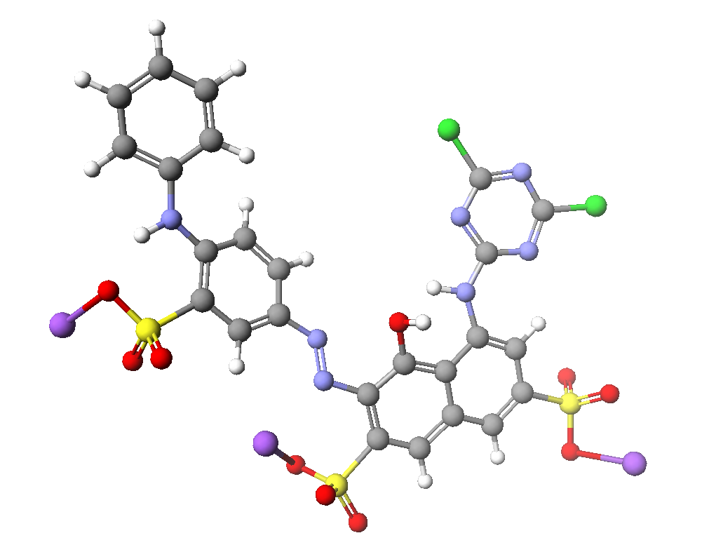
- Dihedral angles:
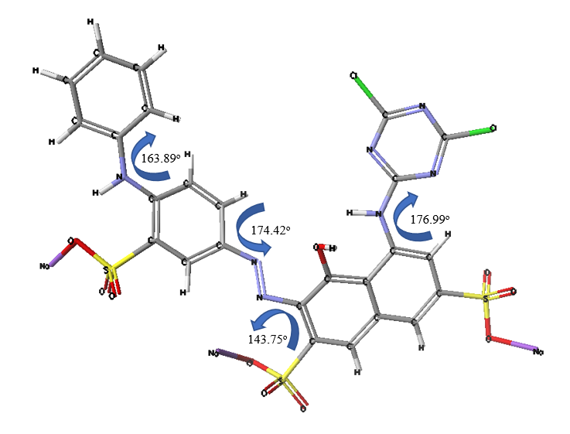

- Electrostatic potential distribution of molecule (view from different sides):
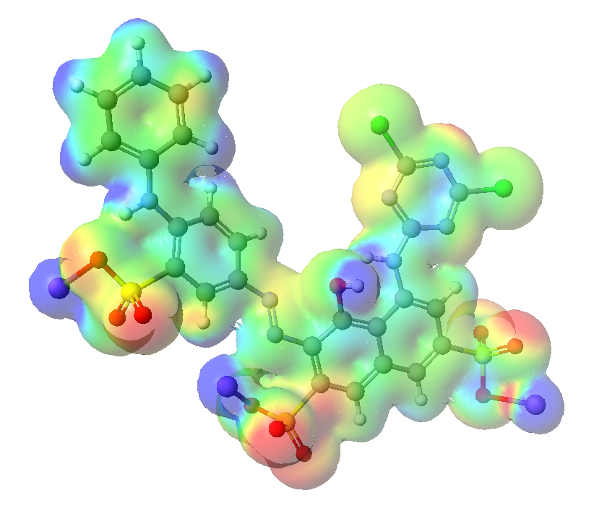

DR-81
- Optimized structure of molecule and atom-numbering:
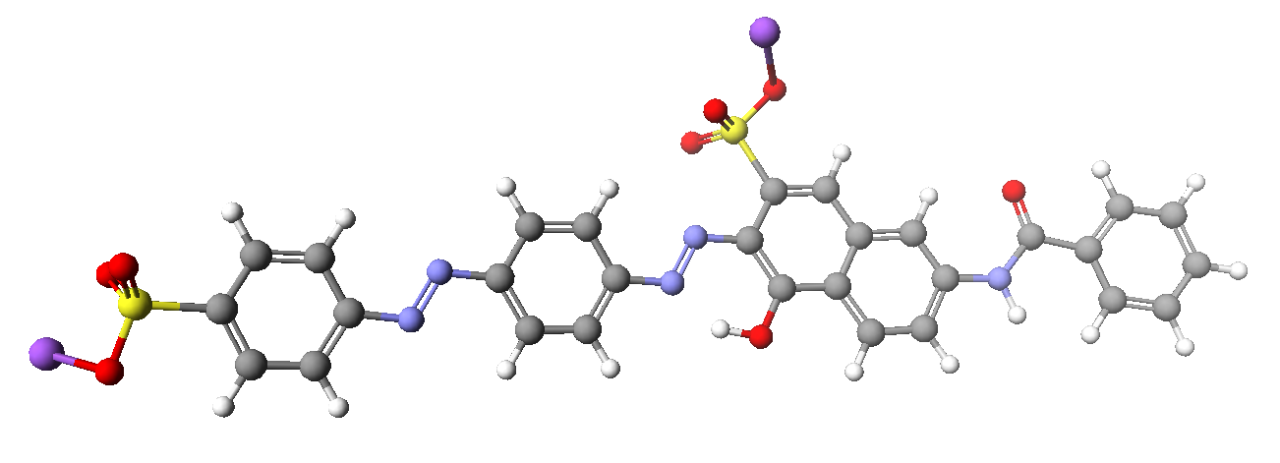

- Dihedral angles:
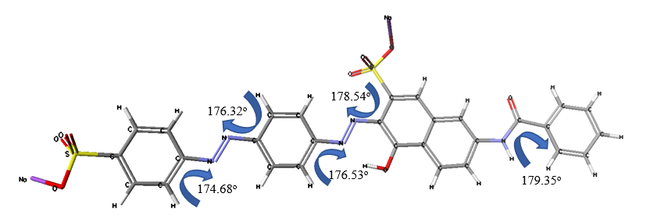

- Electrostatic potential distribution of molecule (view from different sides):

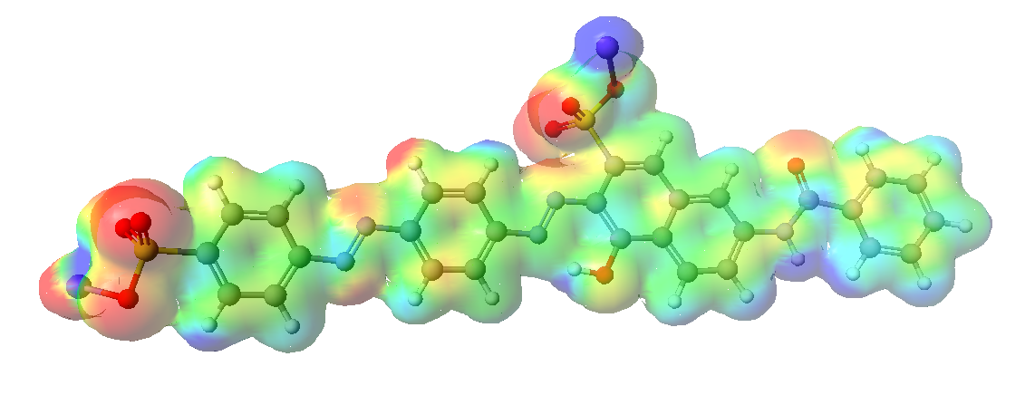

Fig. S4. Optimized geometry (a), dihedral angles of most reactive regions (b), and the electrostatic potential distribution (c) of the molecules for the ABk-194, RB-81, and DR-81 dyes.

References

Ahmad, I., Akhtar, M.J., Jadoon, I.B.K., Imran, M., Imran, M., Ali, S., 2017. Equilibrium modelling of cadmium biosorption from aqueous solution of compost. Environ. Sci. Pollut. Res. 24, 5277–5284. https://doi.org/10.1007/s11356-016-8280-y.
Alimohammadi, Z., Younesi, H., Nader Bahramifar, N., 2016. Batch and column adsorption of Reactive Red 198 from textile industry effluent by microporous activated carbon developed from walnut shells. Waste Biomass Valori. 7, 1255–1270. https://doi.org/10.1007/s12649-016-9506-4.
Arami, M., Limaee, N.Y., Mahmoodi, N.M., Tabrizi, N.S., 2006. Equilibrium and kinetics studies for the adsorption of direct and acid dyes from aqueous solution by soy meal hull. J. Hazard. Mater. 135, 171–179. https://doi.org/10.1016/j.jhazmat.2005.11.044.
Asilian, H., Mousavi, G., Mahmoodi, M., 2010. Adsorption of Reactive Red 198 azo dye from aqueous solution onto the waste coagulation sludge of the water treatment plants. J. Health Sci. 3, 93–102. https://doi.org/10.18869/acadpub.jhs.1.1.36.
Bhatt, P., Vyas, R.K., Pandit, P., Sharma, M., 2013. Adsorption of reactive blue and direct red dyes on powdered activated carbon (PAC) - equilibrium, kinetics and thermodynamic studies. Nat. Environ. Pollut. Technol. 12(3), 397–405.

Coates, J., 2000. Interpretation of infrared spectra, a practical approach. In: Meyers, R.A. (Ed.), Encyclopedia of Analytical Chemistry. John Wiley & Sons Ltd, Chichester, pp. 10815–10837.

Grube, M., Lin, J.G., Lee, P.H., Kokorevicha, S., 2006. Evaluation of sewage sludge-based compost by FT-IR spectroscopy. Geoderma. 130, 324–333. https://doi.org/10.1016/j.geoderma.2005.02.005.
Khamparia, S., Jaspal, D., 2016. Adsorptive removal of Direct Red 81 dye from aqueous solution onto Argemone Mexicana. Sustain. Environ. Res. 26, 117–123. https://doi.org/10.1016/j.serj.2016.04.002.
Khan, T.A., Dahiya, S., Imran, A., 2012. Removal of Direct Red 81 dye from aqueous solution by native and citric acid modified bamboo sawdust—Kinetic study and equilibrium isotherm analyses. Gazi Univ. J. Sci. 25, 59–87.
Klamt A., Schuurmann, G.J.A., 1993. New Approach to Dielectric Screening in Solvents with Explicit Expressions for the Screening Energy and its Gradient. Chem. Soc. Perkin Trans. 2. 5, 799–805. https://doi.org/10.1039/P29930000799.

Kurade, M.B., Waghmode, T.R., Jadhav, M.U., Jeon, B.H., Govindwar, S.P., 2015. Bacterial–yeast consortium as an effective biocatalyst for biodegradation of sulphonated azo dye Reactive Red 198. RSC Adv. 5, 23046–23056. https://doi.org/10.1039/C4RA15834B.
Kyziol-Komosinska, J., Rosik-Dulewska, Cz., Pająk, M., 2010. The potential of metal-complex dyes removal from wastewater using the sorption method onto organic matter-rich substances. In: Pawłowski, L., Dudzińska, M.R., Pawłowski, R. (Eds.), Environmental Engineering. Taylor & Francis Group CRC Press, Boca Raton, New York, pp.197–202.
Kyziol-Komosinska, J., Rosik-Dulewska, Cz., Dzieniszewska, A., Pajak, M., 2018b. Low-moor peats as biosorbents for removal of anionic dyes from water. Fresenius Environ. Bull. 27, 6–20.
Mahboobeh, D., Hassan, E.M., Taghi, G.M., Behzad, J., Masoumeh, T., 2017. Adsorption kinetics and equilibrium studies of Reactive Red 198 dye by cuttlefish bone powder. Iran. J. Chem. Chem. Eng. 36, 143–151. https://doi.org/10.30492/ijcce.2017.26703.
Makov G., 1995. Chemical Hardness in Density Functional Theory. J. Phys. Chem. 99(23), 9337–9339. https://doi.org/10.1021/j100023a006.
Meissl, K., Smidt, E., Tintner, J., 2008. Reproducibility of FTIR spectra of compost, municipal solid waste and landfill material. Appl. Spectrosc. 62, 190–196. https://doi.org/10.1366/000370208783575537.

Palanisamy, P.N., Agalya, A., Sivakumar, P., 2013. Equilibrium uptake and sorption dynamics for the removal of reactive dyes from aqueous solution using activated carbon prepared from Euphorbia tirucalli L wood. Indian J. Chem. Technol. 20, 245–251.
Rizvi M., Tiwari N., Mishra A., Gupta R., 2022. Kinetic and Computational Study of Degradation of Two Azo Dyes, Metanil Yellow and Orange II, by Iron Oxide Nanoparticles Synthesized Using Hylocereus undatus. ACS Omega 7(36), 31667–31681. https://doi.org/10.1021/acsomega.2c00966.
Sahadevan, R., Mahendradas, D.K., Shanmugasundaram, V., Shanmugam, K., Velan, M., 2009. Sorption kinetics and equilibrium analysis for the removal of Reactive Red 2 and Reactive Blue 81 dyes from synthetic effluents using dried soya bean meal. Int. J. Chem. React. 7, A33. https://doi.org/10.2202/1542-6580.1909.
Sharma, N., Tiwari, D.P., Singh, S.K., 2014. Efficiency of chemically treated potato peel and neem bark for sorption of Direct Red-81 dye from aqueous solution. Rasayan. J. Chem. 7, 399–409. https://doi.org/10.31788/Rjc.2020.1325405.

Smidt, E., Meissl, K., 2006. The applicability of Fourier Transform Infrared (FT-IR) Spectroscopy in waste management. Waste Manage. 27, 268–276. https://doi.org/10.1016/j.wasman.2006.01.016.
Socrates, G., 2001. Infrared and Raman Characteristic Group Frequencies. Tables and Charts, John Wiley & Sons Ltd., Chichester.
Sohrabi, N., Rasouli, N., Karimi, M., 2016. Influence of ultrasound on adsorption of Direct Red 81 dye onto low cost activated carbon: Kinetic and thermodynamic studies. J. Sci. Eng. Res. 3, 46–55.
Tamijani, A.A., Salam, A., de Lara-Castells, M.P., 2016. Adsorption of Noble-Gas Atoms on the TiO2(110) Surface: An Ab Initio-Assisted Study with van der Waals-Corrected DFT. J. Phys. Chem. C 120, 18126–18139. https://doi.org/10.1021/acs.jpcc.6b05949.

Tomczak, E., Tosik, P., 2014. Sorption equilibrium of azo dyes Direct Orange 26 and Reactive Blue 81 onto a cheap plant sorbent. Ecol. Chem. Eng. 21, 435–445 https://doi.org/10.2478/eces-2014-0032.

Tunali Akar, S., Akar T., Cabuk., A, 2009. Decolorization of a textile dye, Reactive Red 198 (RR198), by Aspergillus parasiticus fungal biosorbent. Braz. J. Chem. Eng. 26, 399–405. https://doi.org/10.1590/S0104-66322009000200018.

Zimmermann, F., Lippert, T.H., Beyen, C.H., Stebani, J., 1993. N=N vibrational frequencies and fragmentation patterns of substituted 1-aryl-3,3-dialkyl-triazenes: comparison with other high-nitrogen compounds. Appl. Spectrosc. 47, 986–993. https://doi.org/10.1366/0003702934415165.

