Precision cooking for printed foods via multi-wavelength lasers
Jonathan Blutinger,*, Alissa Tsai1, Erika Storvick1, Gabriel Seymour1,

Elise Liu1, Noà Samarelli1, Shravan Karthik1, Yoran Meijers1,, Hod Lipson1
Contents:
S1. Measuring spatial resolution of laser cooking……………………………………………………….. 3
S2. Organoleptic evaluation………………………………………………………………………………... 4
S3. Food prep and printing…………………………………………………………………………………. 6
S4. Cooking with laser diodes……………………………………………………………………………… 7
S5. Controlling the mirror galvanometers………………………………………………………………… 8
S6. Amplifier circuit design…………………………………………………………………………………. 9
S7. Food printer design and mechanism…………………………………………………………………. 10
S8. Laser cooking pattern design………………………………………………………………………….. 11
S9. Creating surface temperature plots…………………………………………………………………… 12
S10. Measuring color change……………………………………………………………………………… 13
S11. Measuring shrinkage and weight loss………………………………………………………………. 14
S12. Measuring depth of heat penetration……………………………………………………………….. 15
Figures S1 – S17
Table S1

File name: Supplementary Materials
Description: Supplementary Figures and Supplementary Discussion

File name: Video 1
Description: Precision laser cooking overview. This video provides a summary of the paper. We introduce laser cooking as a new digital processing method, describe the experimental method, provide an overview of the cooking apparatus, and illustrate the main results.

File name: Video 2
Description: Temperature surface plots during laser cooking. This video shows surface temperature surface plots of various cooking trials. Maximum surface temperature and maximum internal temperature can be compared for various cooking trials that vary in exposure time and number of passes.

S1. Measuring spatial resolution of the lasers
We used the change in color of the heated chicken to determine the extents of the heat-affected zone (HAZ). A custom Matlab script was written to calculate the depth and width of the heat penetration based on the selection of a few points on the chicken samples (Fig. S8). This process was executed three times for 30 different pictures. Five tests were performed at three different speeds for each of the lasers, and measurements were repeated three times to minimize the error associated with the measuring technique. Blutinger et al. (2019)¹ utilized a similar method to measure the HAZ of laser-cooked salmon.

S2. Organoleptic evaluation
The transcript that follows was from two separate blind taste-testers. They were given two plates: (Sample 1) printed chicken cooked using a blue laser, and (Sample 2) printed chicken cooked on an electric range. Each tester was instructed to sample each cooked sample as they choose and describe all sensory reactions. Their responses are reproduced verbatim in italics with occasional follow-up questions from the overseer of the experiment in bold.
Taste-tester 1
[Responses from eating Sample 2]
It’s got a few brown spots on the top so it looks like it’s pretty cooked. It smells pretty precisely liked cooked chicken, it smells like it’s cooked. You can’t smell any like machine, straight chicken. It tastes fully cooked, the texture is conventionally like a dryer chicken. A little dry but cooked throughout. Durable, solid, no soft spots, pretty hard throughout. It’s good, if I liked cooked chicken I would eat that regularly with no seasoning.
[Responses from eating Sample 1]
Looks a little different. Looks a little whiter in the middle and more on the outside for browning. This one smells a little more metallic I guess. Let’s try it.. Cooked throughout, a little bit smoother on eating. A little bit less dry than the other one, surprisingly. More moist. Certainly not rubbery, it was good. The stringiness from the first one wasn’t there. Traditional raw chicken kind of breaks up in your mouth, this one didn’t break up as much, it’s more solid throughout. More uniform structure, tastes more uniform.
[Could identify which sample was laser-cooked]
What do you mean by metallic?
Ever go to the dentist and get fillings done? They have a laser they use to seal the fillings and you get that smell.. a little bit of an industry odor a sharpness you get to it that you don’t get with normal chicken. You smell the heating of the laser and you can smell it a little bit with the chicken, it leaves a little bit left on it. Sample 1 you can smell a traditional cook. Normally with cooked foods you can taste what it has been cooked in oil if or if it’s been baked. It was very slight but I like consistency more of the laser-cooked.
The texture is better?
Yes, it didn’t have as many different parts to it. The outsides of Sample 1 were a little bit crispier than the insides of the cooked chicken, and this one (Sample 2) was more uniform, there were no breakups in the consistency of the chicken.
Taste-tester 2
[Responses from eating Sample 1]
The taste is chicken. It tastes like chicken. The first bite is a little squishy but then as it tears apart in your mouth it feels right. It evens out pretty well. It’s not really dry. I’d eat it, it’s good chicken. My mouth didn’t dry out eating it.
[Responses from eating Sample 2]
This is definitely a little bit more dry. The first bite wasn’t quite as chewy as the other one (Sample 1), but it is definitely more dry. The taste, I think is pretty much equivalent. The texture is similar but this one being dryer you have to chew it a bit more so it’s harder to get through.
Which one did you prefer in terms of texture?
This one (pointing to Sample 1), it was easier to chew. Seemed more moist.
And that’s important?
Yes, especially with meat.

S3. Food prep and printing
We acquired raw chicken breast and other ingredients for printing from a local convenience store (Appletree Market, New York City, USA). Prior to mincing the meat, we removed the white tendons from the breast to keep the material more uniform and easier to extrude. We ran the raw food through an FP-8GMFR Food Processor (Cuisinart, Stamford, USA) on high for 5 – 10 min, which provided enough time for the consistency to become uniform and consistent. Occasionally during the mincing process, the chicken would clump into a larger mass and we would have to pause the blender and break up the material.
Once pureed, the chicken was packed into syringe barrels (PN: 7012134), which were outfitted with a 14 gauge tapered nozzle tip (PN: 7018052) (Nordson EFD, East Providence, USA). The barrels were carefully packed with a spoon and the material was packed from the top of the barrel downward to avoid bubbles or air pockets, which could cause issues during printing.

S4. Cooking with laser diodes
Because our galvo mirrors weren’t reflective at the operating wavelength of our near-infrared (NIR) laser (980 nm), we needed to mount the laser to a movable platform. Hence, we decided to vertically mount the laser to the printer head of our extrusion mechanism. We designed and fabricated an acrylic platform and printed fixture that allowed us to seamlessly mount the laser via the slotted holes in its base (Fig. S2, right). With minor adjustments to the code we used for printing, we could control the movement of the laser via G-code and tailor the cooking pattern accordingly.
Our stationary blue diode laser was positioned at two mirror galvanometers as displayed in Fig. S2 (left). Each of the two setups have different merits. Table S1 lists out the pros and cons for each of these laser setups. While Setup 1 is more compact, integrable to other cooking appliances, and provides more versatile cooking patterns; it’s slightly more limiting in terms of cooking area and software fixes need to be implemented to prevent distortion effects from mirrors. Conversely, Setup 2 provides a much larger cooking area with an easier system to upload cooking patterns, yet it’s inefficient in terms of the mounting of the laser and as a result less compact. Ideally, we would have used galvo mirrors with both lasers but light from the NIR laser gets fully absorbed by the optical mirrors on our galvo setup, hence we needed to mount it to a movable platform.
Laser diode calibrations were conducted with a Newmark thermopile sensor (PN: 919P-150-26) (MKS Instruments, Inc., Irvine, USA). A linear relation was observed between the current and the power output of the blue and NIR lasers and was found to be
P_{blue} = 9.2774 $×$ I_{blue} – 2.9104, R² = 0.9994
P_{nir} = 0.9888 $×$ I_{nir} – 0.2205, R² = 0.9979
, respectively.
S5. Controlling the mirror galvanometers
To control the mirror galvanometers, a Raspberry Pi 2 Model B (Raspberry Pi Foundation, Cambridge, United Kingdom) in tandem with two 12-bit digital-to-analog (DAC) converters (MCP4725, Adafruit Industries, New York, USA) were used to create two analog signals, each with a 5 V range. Each signal was passed to a custom printed circuit board (Fig. S9) consisting of two difference amplifiers to scale the full voltage range from 5 V to 24 V. The scaled signals were then passed to the dual-axis mirror galvanometers (Seeed Studio Electronics, Shenzhen, China) via their microcontroller. The angles of the mirrors are determined by the voltage from the mirror galvanometer microcontroller. Therefore we can control the mirror angles by changing the output voltages from the Raspberry Pi. The flow of the signals controlling each galvo mirror is outlined in Fig. S10.

S6. Amplifier circuit design
To achieve full range of motion of the galvo mirrors, we created a custom PCB consisting of a buffer amplifier, two difference amplifiers, and two lowpass filters. The buffer amplifier used an LM7341 (Texas Instruments, Dallas, USA) to reduce the load on the power supply powering the op amps and supplying the voltage for the difference amplifier. Two difference amplifiers are required so both mirror signals can be amplified. The LT1028 (Linear Technology, Milpatas, USA) is used in the difference amplifiers as it is inexpensive and offers low slew rate, low noise, and has a linear frequency response in our desired frequency range. The two low-pass filters are used to reduce any noise introduced into the system.
After a few benchmarking tests with the galvo mirrors, we concluded that the maximum frequency the motors could handle—to produce some desired visual output—was 2 kHz. Values for the resistors and capacitors in the low-pass filters were chosen based on the maximum frequency we found (refer to Fig. S9).

S7. Food printer design and mechanism
Our custom food printer was designed around an off-the-shelf X-Carve Cartesian gantry system (Inventables, Inc., Chicago, USA). The X-Carve provides 3-axis motion with belt-driven actuators on the x and y axes and a ball screw on the z axis. We outfitted the x axis with a custom tool change rack (Fig. S11d) that allows for easy swapping of materials. More importantly, we designed and fabricated an extrusion mechanism from laser cut acrylic and 3D-printed plastic components (Fig. S11a). This system accommodates a removable acrylic tray (Fig. S11b), which allows for the transfer of printed food from the printer to our laser cooking apparatus for heating. For the purposes of the experiments, we printed simple geometric shapes (Fig. S11c), but more complex shapes and designs can be printed as well.
For ease of assembly and serviceability, the main support structure of the extrusion mechanism was laser cut from a 0.25 in sheet of acrylic and was fastened using screws (most visible in Fig. S12). Components that were printed out of PLA include the tapered end piece of the lead screw, motion-restriction clamp for the lead screw, gear that transfers motion from motor to lead screw, and fastening panels for cartridge supporting arms.
All axes—including the extrusion axis—are driven by ClearPath brushless servomotors (CPM-SDSK-2311S-RQN). A timing belt couples the motion from the motor to the lead screw on the e axis (most visible in Fig. S12b). The lead screw’s downward motion is what provides the force on the stopper in the food syringe to deposit food as the x and y axes are moving the extruder head.

S8. Laser cooking pattern design
To define the desired cooking path, we first defined the four outer corners of our cooking path which corresponded to the food size. Cooking paths were then scaled to fit this quadrilateral region, which was positioned towards the middle of the mirrors’ range of motion. The basic design of the cooking path propagated a spiraling ring—or “trochoid”—along a series of shells, which followed the shape of the printed sample (Fig. S13a). Variables such as circle diameter, distance between circles (circle density), and randomness can be varied to alter the laser cooking behavior.
Speed of the laser can be altered by changing the time delay in software or by increasing the number of point per circle. We approximated each rotating ring with ten points, but the total exposure time is directly related to the points per circle, which gives us the flexibility to change the laser speed via more or less points. Another way to vary the cycle time of the traced path is by using a time delay, which we can manually adjust and get different cooking speeds.
To further compensate for the galvo mirrors’ slight imperfections, the pattern was stretched in the x direction by a factor of 1.35 and rectilinear distortion was added (Fig. S13c). Galvo mirrors often times suffer from pincushion distortion, which is a type of optical distortion where straight lines closer to the edges of the mirrors’ range of motion bulge towards the center. To counter this, we applied a slight barrel distortion (Fig. S13b) which allowed us to trace more true-to-shape geometries.
Once all x and y motor values were adjusted, they were uploaded to the Raspberry Pi via a simple text file. We connected to our Raspberry Pi via Apple File Protocol (AFP), which allows for wireless sharing of files on a local network. This made it very easy to upload new cooking files and run them remotely. Once a new text file was generated and uploaded via AFP, the file could be run and terminated via Mac Terminal.

S9. Creating surface temperature plots
During a few of the cooking trials, surface temperature of the samples was recorded using a FLIR C2 thermal camera (FLIR Systems, Wilsonville, USA). We positioned the camera at a downward oblique angle to capture the heat form the surface of the sample. The camera has 4800 px to capture temperature data (80px by 60px) at a rate of 2.5 fps. The software that comes with the camera module allowed us to export the 80px by 60px of temperature data to a .csv file to open in Microsoft Excel (Microsoft, Redmond, USA). From there, we imported the file to MATLAB (MathWorks, Natick, USA) and created a custom script that created a surface plot of the temperature data during heating.
Due to the size of the beam and the fact that it would heat up the surrounding plate and skew the temperature data, we needed to filter the pixel data so that we only captured data on areas of interest, which was done using two methods. First, we got rid of any pixels that registered a temperature greater than the maximum temperature recorded on the sample; this eliminated pixels along the edge of the sample that were registering temperature peaks on the surrounding acrylic piece. Second, any pixels that logged a temperature above the starting temperature of the food sample would be eliminated. This second method worked due to the fact that the food sample was naturally colder than the ambient.

S10. Measuring color change
Using a similar method to how we calculated sample shrinkage (Section S13), regions of raw and cooked printed samples were selected for color sampling (Fig. S14). Sampling regions were selected manually with the intent that regions would be selected based on low—to no—specular reflectance from the light source. Since the printing process left slight bumps along the surface of the food along the path of the deposition path, specular reflectance along the surface of the food was inevitable. To avoid white-shifting the color data by averaging color across the entire surface, we chose this method of manual selection and averaging to achieve more accurate color information.

S11. Measuring shrinkage and weight loss
All printed samples were imaged before and after cooking with the same environmental lighting and focus distance from the camera (EOS 80D, Canon, Tokyo, Japan). We developed a MATLAB script that allowed the user to manually select two points (black dots in Figure. S15a) to trace out a region on the food sample. The script grabbed the lowest and highest RGB color values within this selected region (red-dotted square in Fig. S15a) and kept any pixels that fell within this color range (yellow region in Fig. S15b). By performing this analysis on raw and cooked samples, we could then determine the shrinkage with the following equation:
$$\% shrinkage=\frac{raw pixels-cooked pixels}{raw pixels}×100$$
A similar equation was used to calculate weight loss:
$$\% weight loss=\frac{weight of raw sample-weight of cooked sample}{weight of raw sample}×100$$
Each sample was weighed with acrylic tray it was supported on. Since the weight of the tray didn’t change between trials, we could just subtract this value from the total weight of the raw and cooked samples that were recorded. An analytical balance (Denver Instrument, Arvada, USA) accurate to four decimal places was used to capture the weight of the samples. The acrylic tray weighed roughly 44 g, while samples were ≤1 g.

S12. Measuring depth of heat penetration
A few cooking trials involved heating thinly cut slices of chicken with a blue laser and a CO₂ to assess penetrative heating abilities of different light wavelengths. A MATLAB script was generated to help the user determine the depth of heat penetration based on color change. The code used the following structure:
Algorithm 1: Determining depth of heat penetration
Display cross-section image of laser-heated sample
Prompt user to manually select 3 points on image
P1: Sample surface of heat-affected zone (HAZ)
P2: Some point below the HAZ
P3: Raw portion of the sample (used as color threshold)
For i = P1 : P2
If L of pixel ≤ 10% of P3
Set depth of heat penetration = i
End if
End for
End

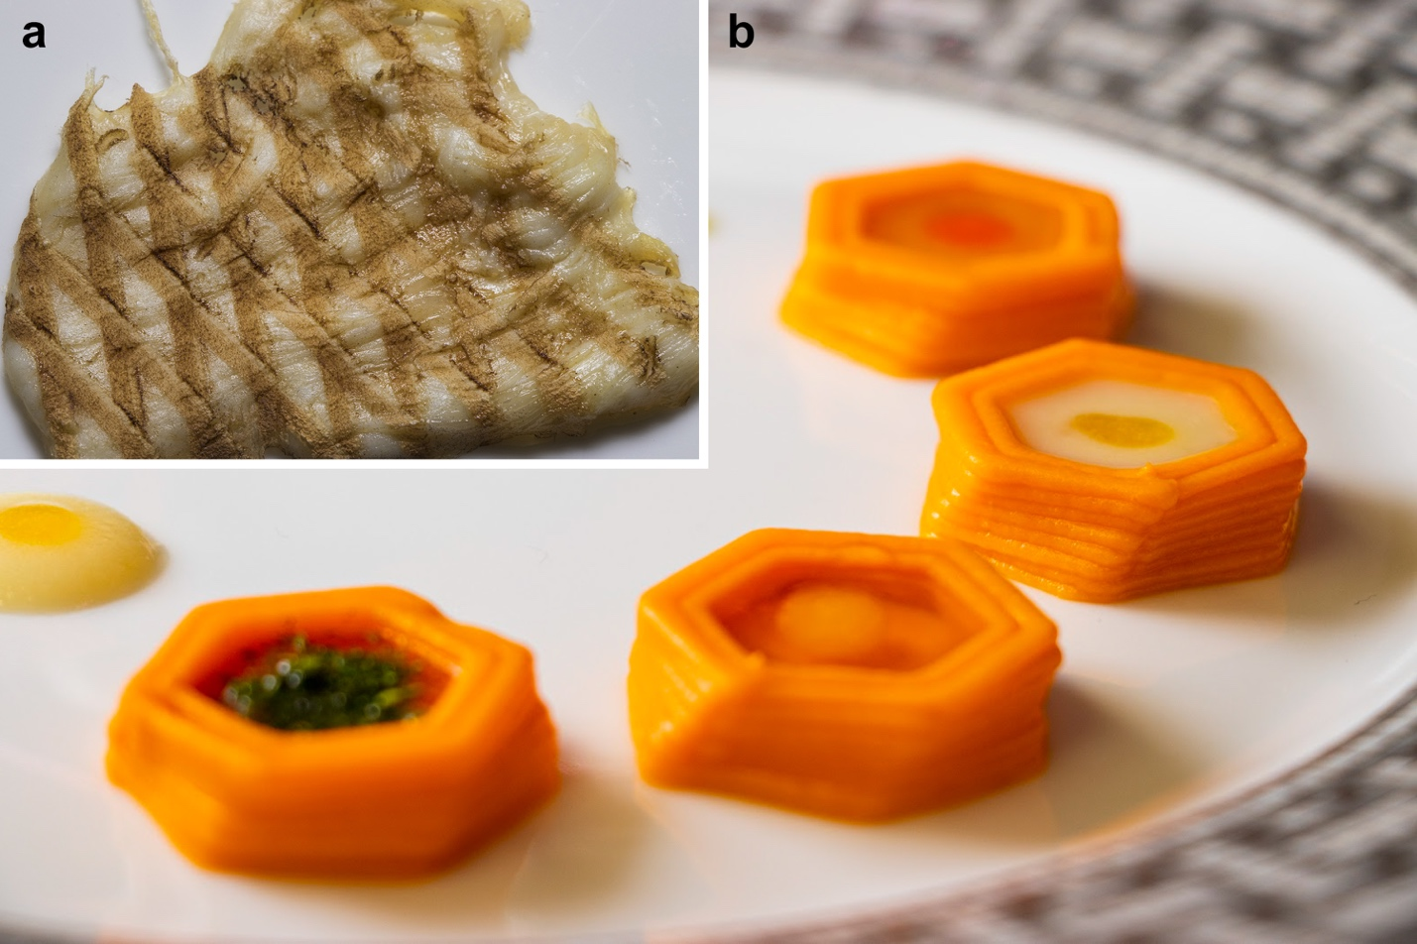
Fig. S1: a Chicken breast slice that has been cooked using a blue laser and browned using a CO₂ infrared laser. b Printed hexagonal structures made from a carrot purée with various fillings.

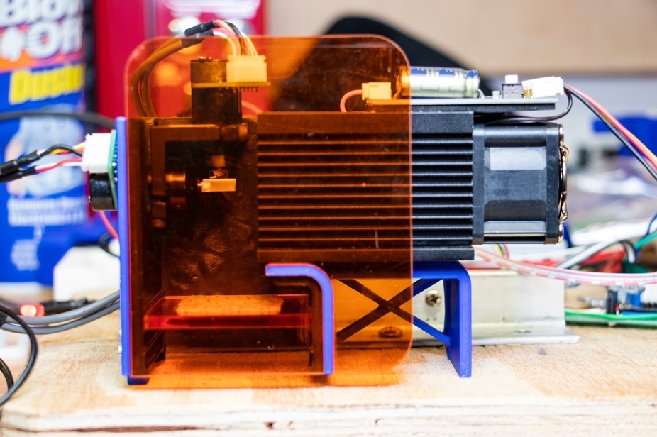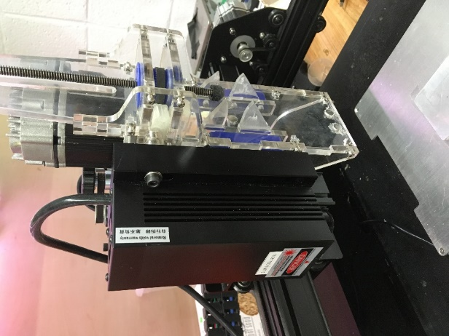
Fig. S2: Laser systems used in cooking trials. Left: Stationary blue diode laser with energy being redirected by dual axis mirror galvanometers. Right: Near-infrared diode laser mounted to a 3-axis gantry.

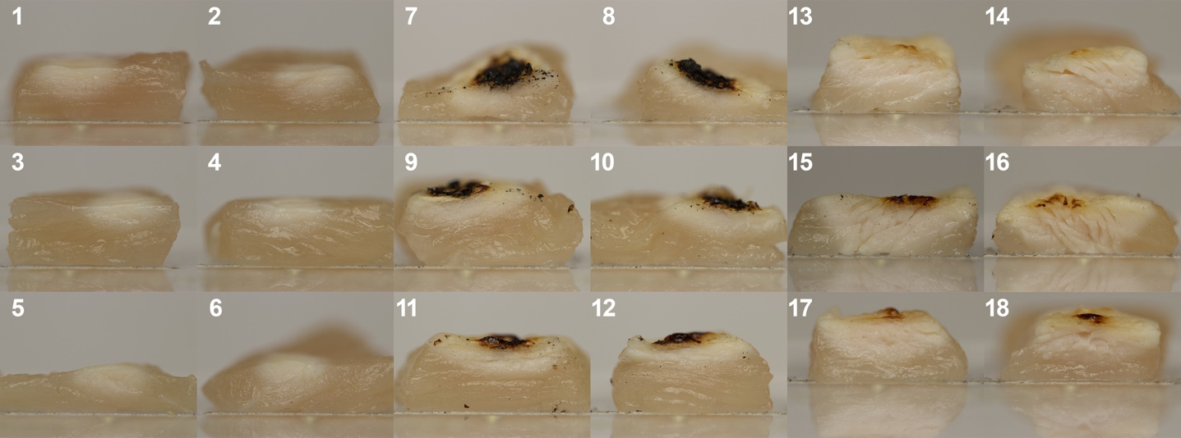
Fig. S3: Cross-sectional views of testing samples used to assess cooking depth. Samples 1 – 6 were heated with a 5 W blue laser. Samples 7 – 18 were heated with an 8 W CO₂ IR laser.

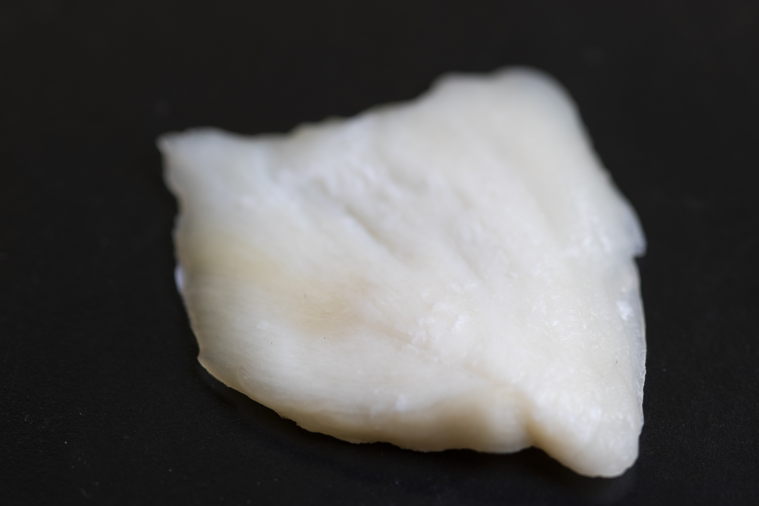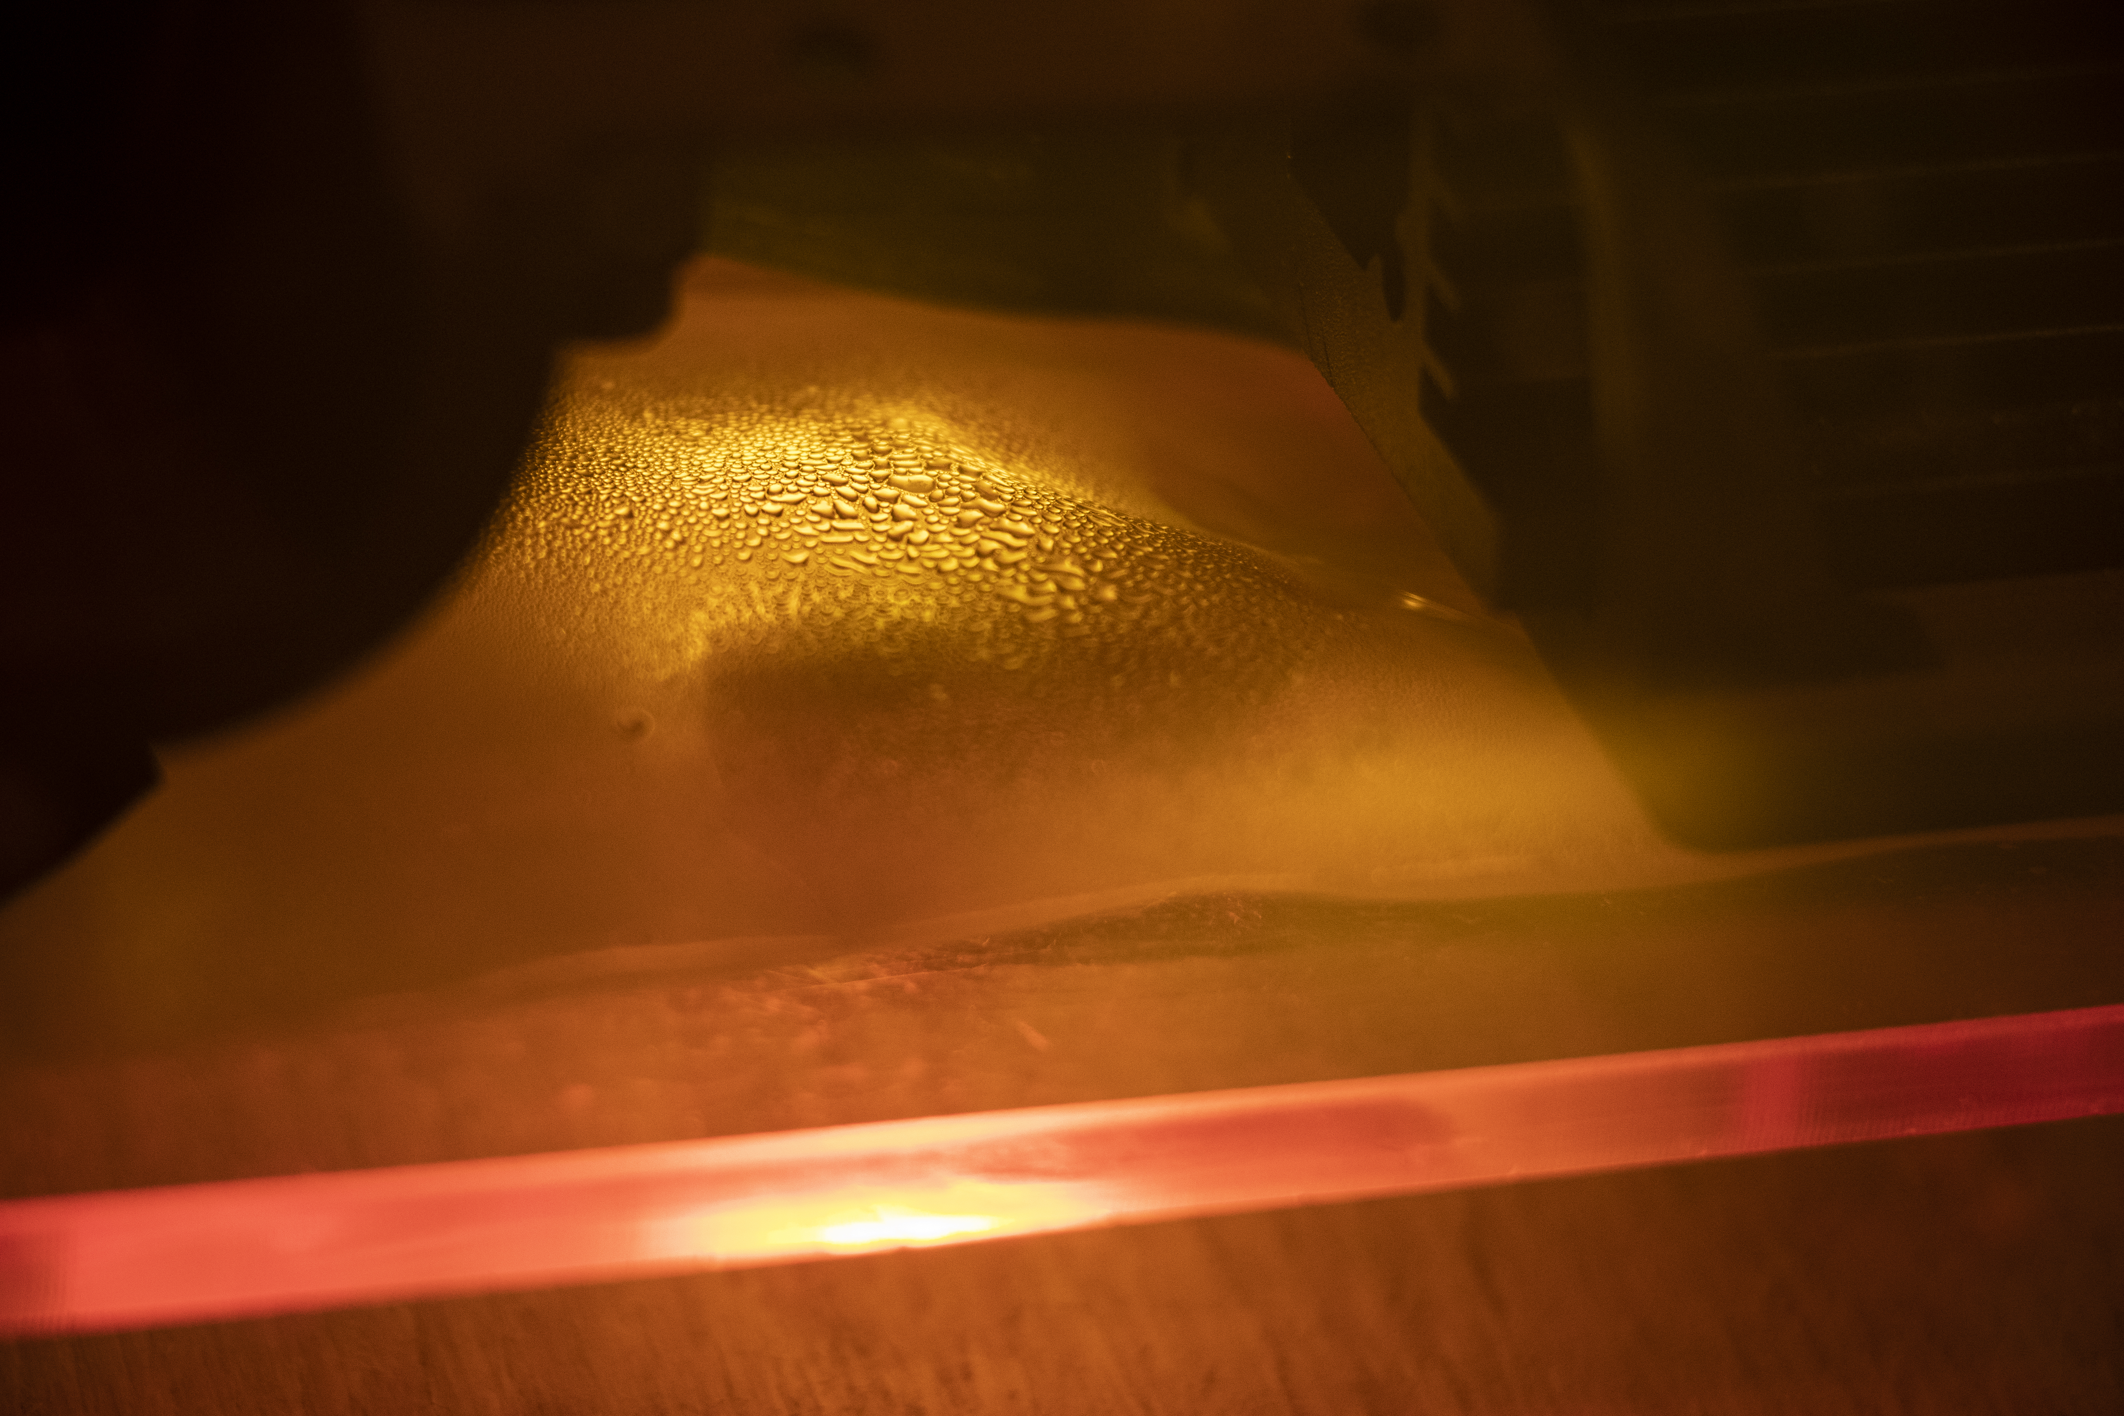
Fig. S4: Cooking chicken with a blue laser through packaging. Left: Chicken that’s been laser-cooked via blue laser showing protein denaturation with little to no indication of surface browning. Right: Chicken sealed in a plastic package being cooked by a blue laser with visible condensation on the interior of the package.

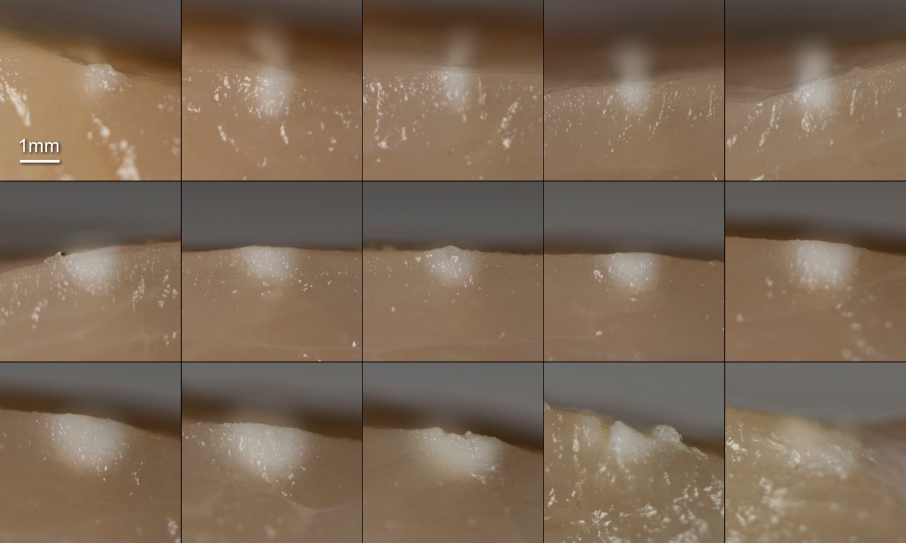
Fig. S5: Samples used to calculate horizontal and vertical heat-affected zone for chicken cooked via blue laser. Laser power was held constant at 10 W for all tests. Each row corresponds to a different cooking speed (top: 200mm/min, middle: 170 mm/min, bottom: 140 mm/min). All images are cross-sectional cuts showing a side view.

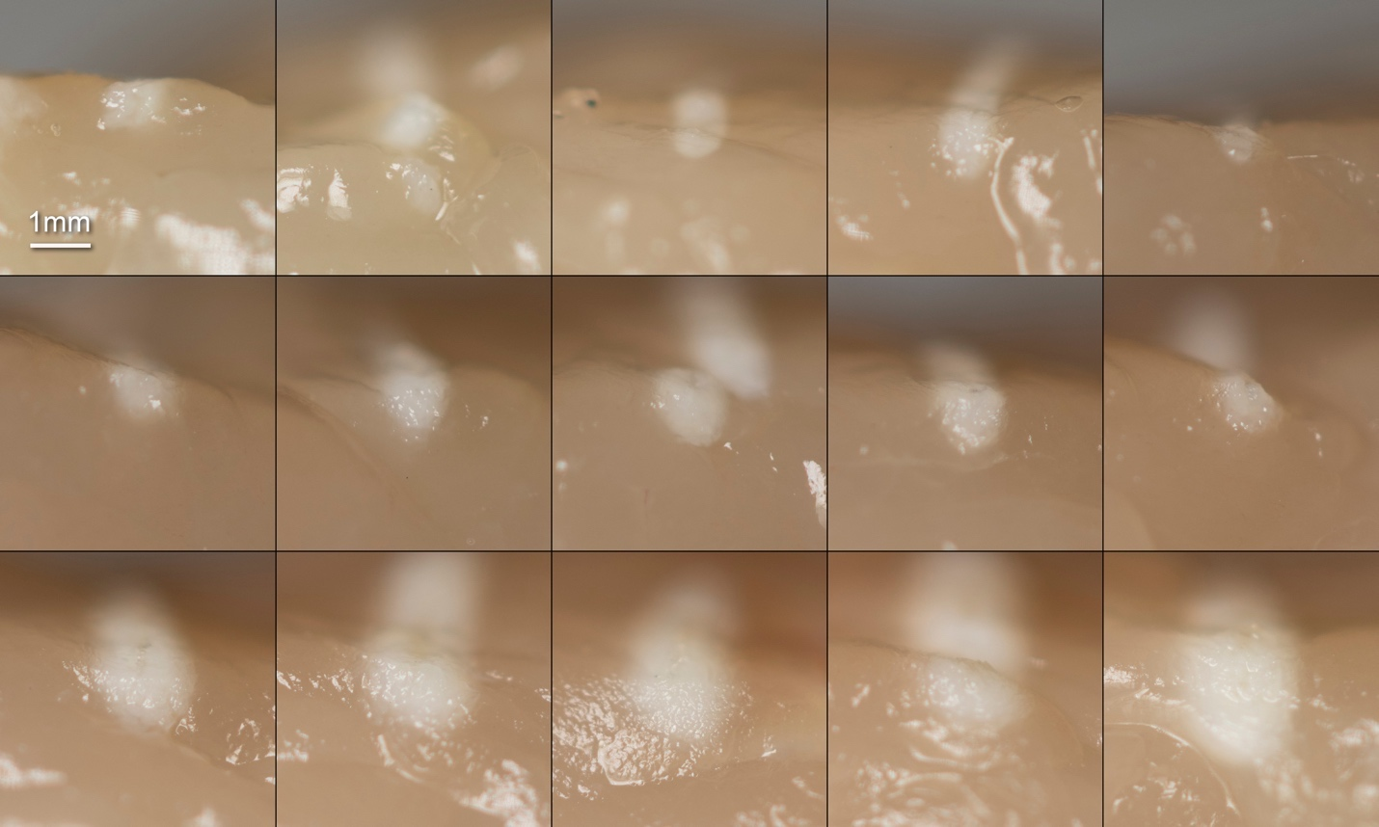
Fig. S6: Samples used to calculate horizontal and vertical heat-affected zone for chicken cooked via NIR laser. Laser power was held constant at 10 W for all tests. Each row corresponds to a different cooking speed (top: 100mm/min, middle: 80 mm/min, bottom: 60 mm/min). All images are cross-sectional cuts showing a side view.

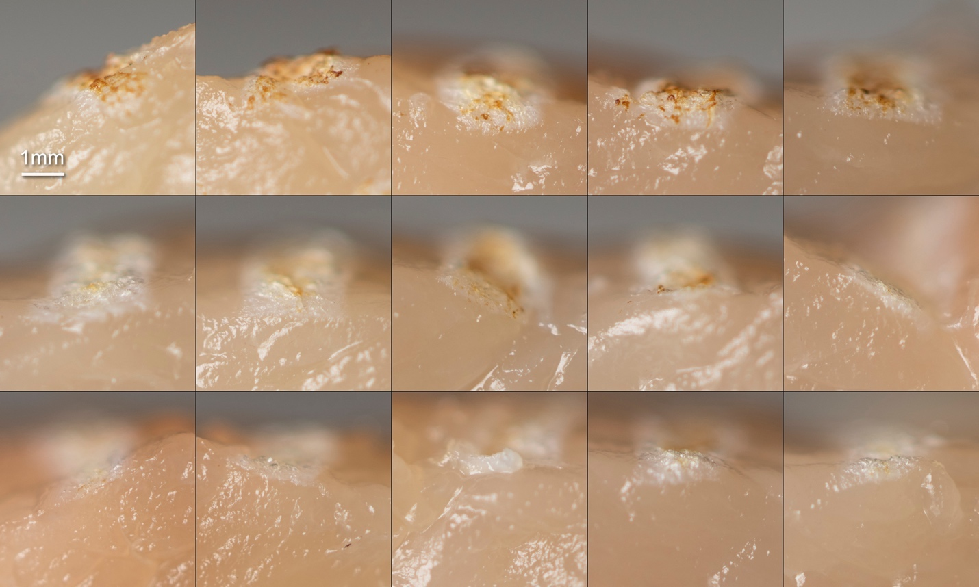Fig. S7: Samples used to calculate horizontal and vertical heat-affected zone for chicken cooked via MIR laser. Laser power was held constant at 10 W for all tests. Each row corresponds to a different cooking speed (top: 20mm/s, middle: 30 mm/s, bottom: 40 mm/s). All images are cross-sectional cuts showing a side view.

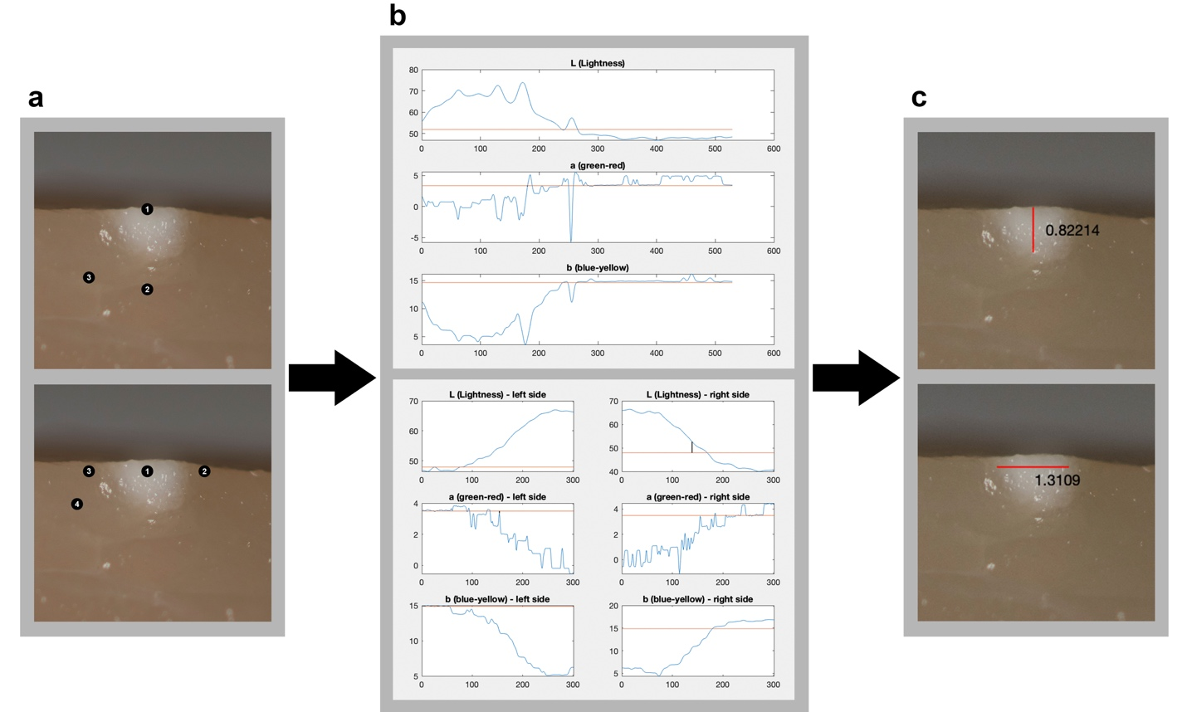
Fig. S8: Tabulating vertical and horizontal heat-affected zone (HAZ) from laser-cooking trials. a: To assess vertical HAZ a user needs to select (1) a point at the surface of the sample, (2) a point below the HAZ, and (3) a threshold value to compare “cooked” pixels to. Similarly, to assess horizontal HAZ a user needs to select (1) a point somewhere in the middle of the HAZ, (2) a point to the right of the HAZ, (3) a point to the left of the HAZ, and (4) a threshold value to compare “cooked” pixels to. b: The shift in color is then plotted and the resulting horizontal and vertical size of the HAZ is calculated. c: The HAZ is then displayed on the original picture to visually validate each measurement. This process was executed in triplicate for each sample.

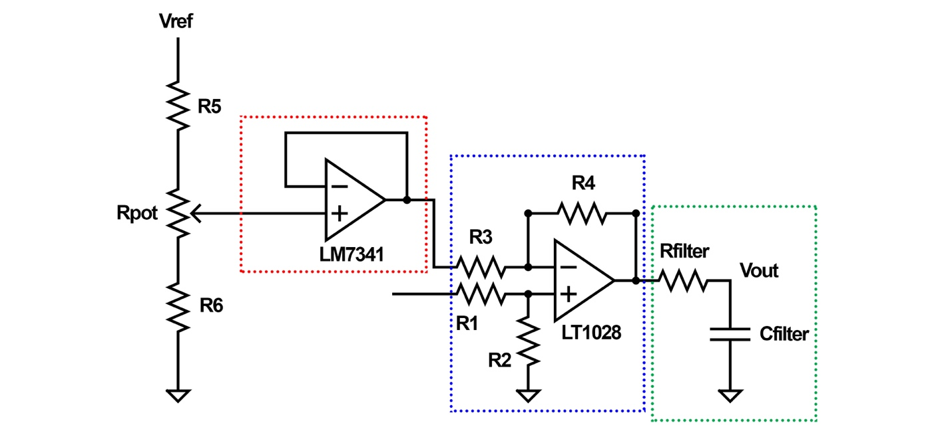
Fig. S9: Custom amplifier circuit designed with buffer circuit to reduce noise (red-dotted region), a difference amplifier (blue-dotted region), and an RC low-pass filter (green-dotted region). Rfilter = 7.5 kΩ, Cfilter = 100 pF, R1 = 10 kΩ, R2 = 48 kΩ, R3 = 2.1 kΩ, R4 = 10 kΩ, R5 = 47 kΩ, R6 = 4.7 kΩ, Rpot = 10 kΩ.

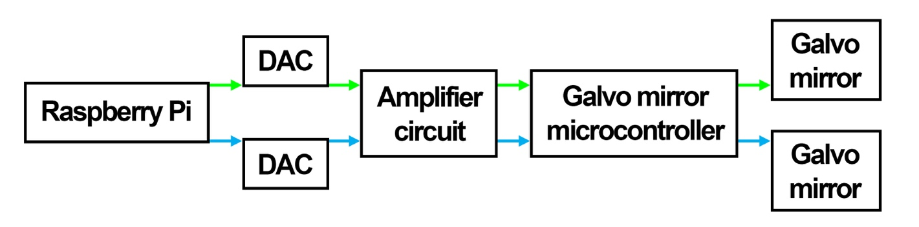
Fig. S10: Block diagram showing the flow of the signals controlling the x (green arrow) and y (blue arrow) position of the laser via the galvo mirrors.

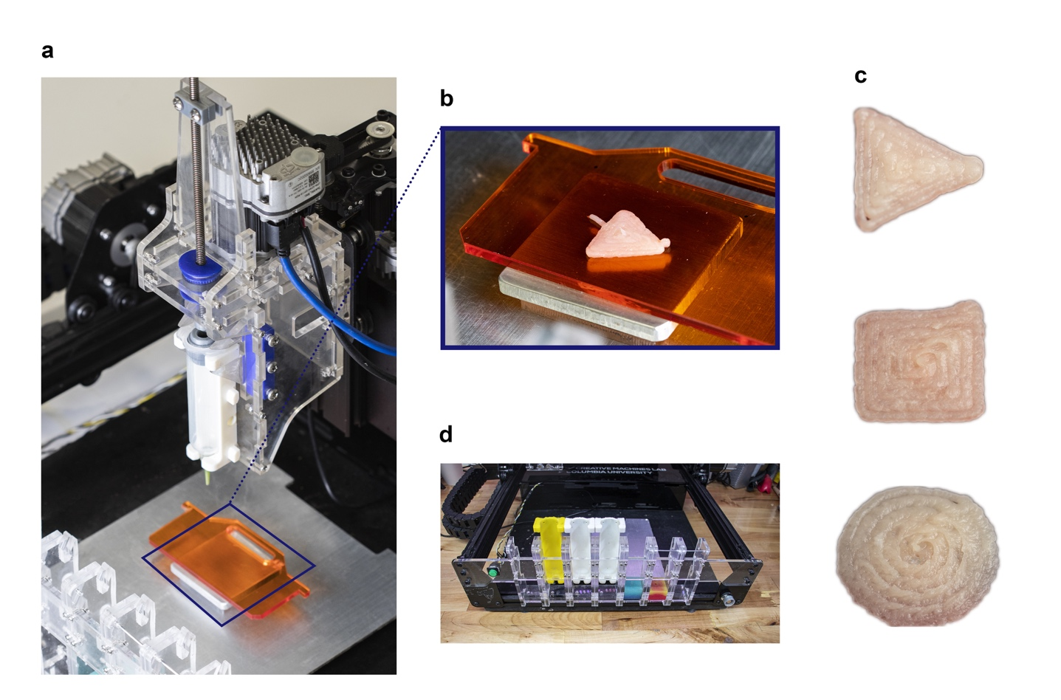
Fig. S11: Mechanism for printing chicken. a Custom fabricated extrusion mechanism that can pick and place material-filled syringes and print them onto a removable platform (orange-tinted tray) for laser cooking. b Close-up shot of printed chicken sample on removable platform (orange-tinted tray). c Examples of single-layer prints (triangle, square, and circle) that were used in the study. d Custom fabricated tool change rack for swapping food cartridges.

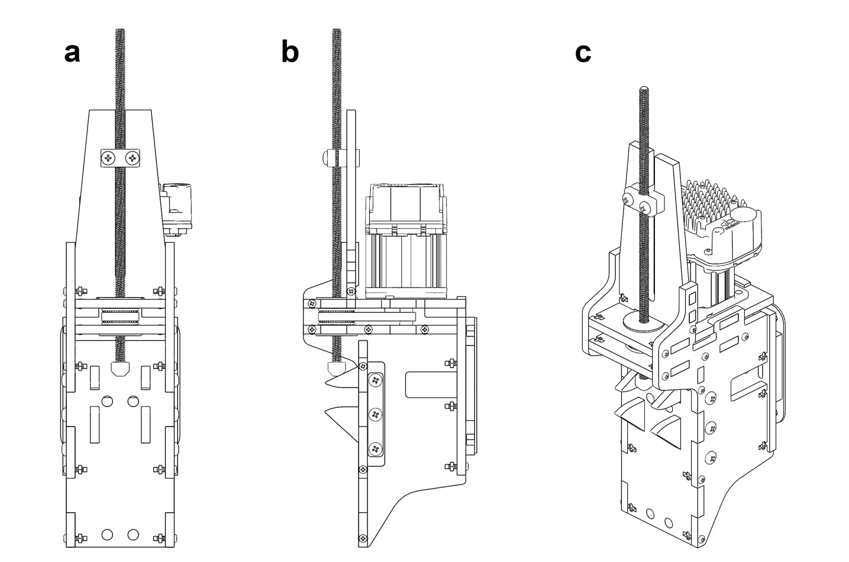
Fig. S12: Custom designed and fabricated extrusion mechanism. All wall components were laser cut and a few components were 3D-printed. a front view, b side view with side panel removed, and c isometric view.

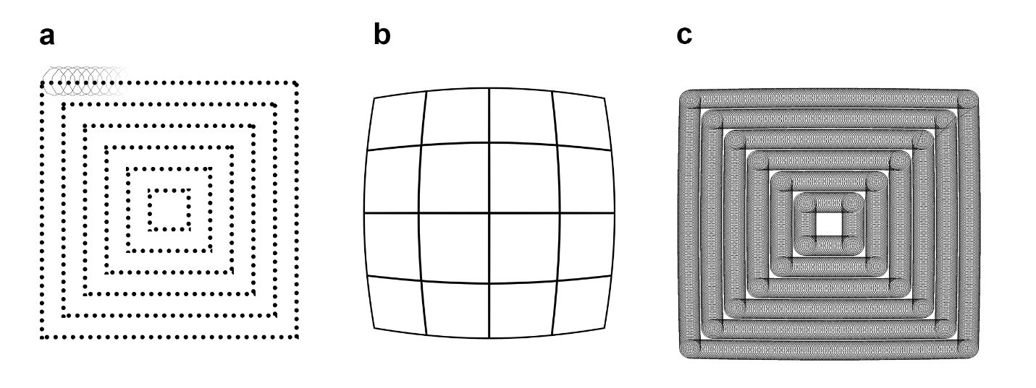
Fig. S13: Design of the laser cooking patterns. a Trochoidal path that follows a series of six square shells (dotted lines) as it propagates along the path. b Barrel distortion was added to the cooking paths to counter the pincushion distortion that resulted from the galvo mirrors. c An example of a cooking pattern used in the trials.

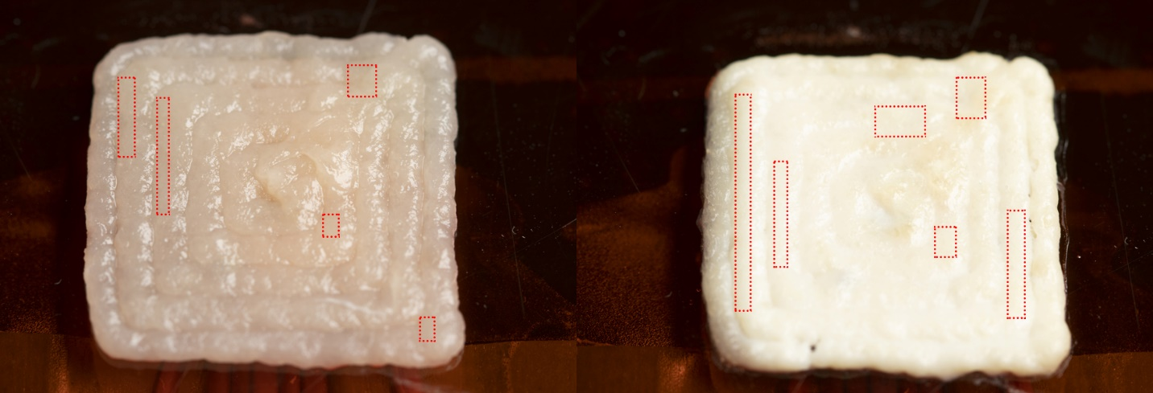
Fig. S14: Calculating sample color via image analysis. Regions for sampling color on raw (left) and cooked (right) samples are shown with red-dotted regions. Sampling regions were selected based on lowest amount of specular reflectance from the light source. Three regions on each sample were selected and averaged.

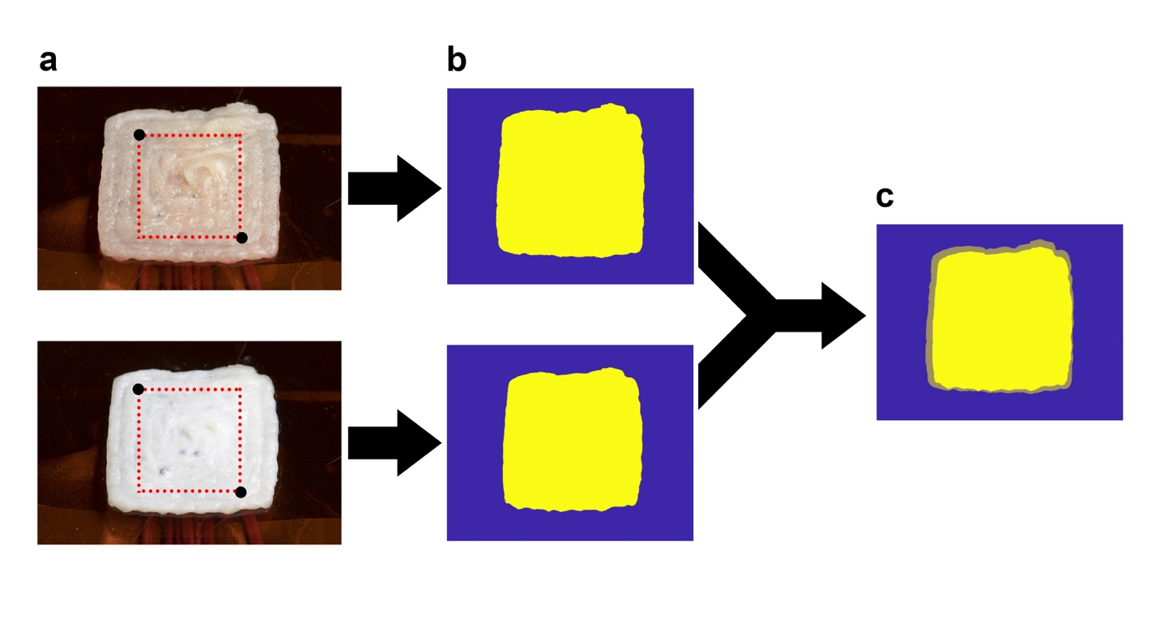
Fig. S15: Calculating sample shrinkage via image analysis. a Input images are before and after pictures of the raw and cooked chicken, respectively. Area to sample color from is manually selected by the user (denoted by red-dotted square). b Software analyzes image based on selected region and stores all food-containing pixels (yellow). c Shrinkage is calculated by comparing total number of pixels before and after heating.

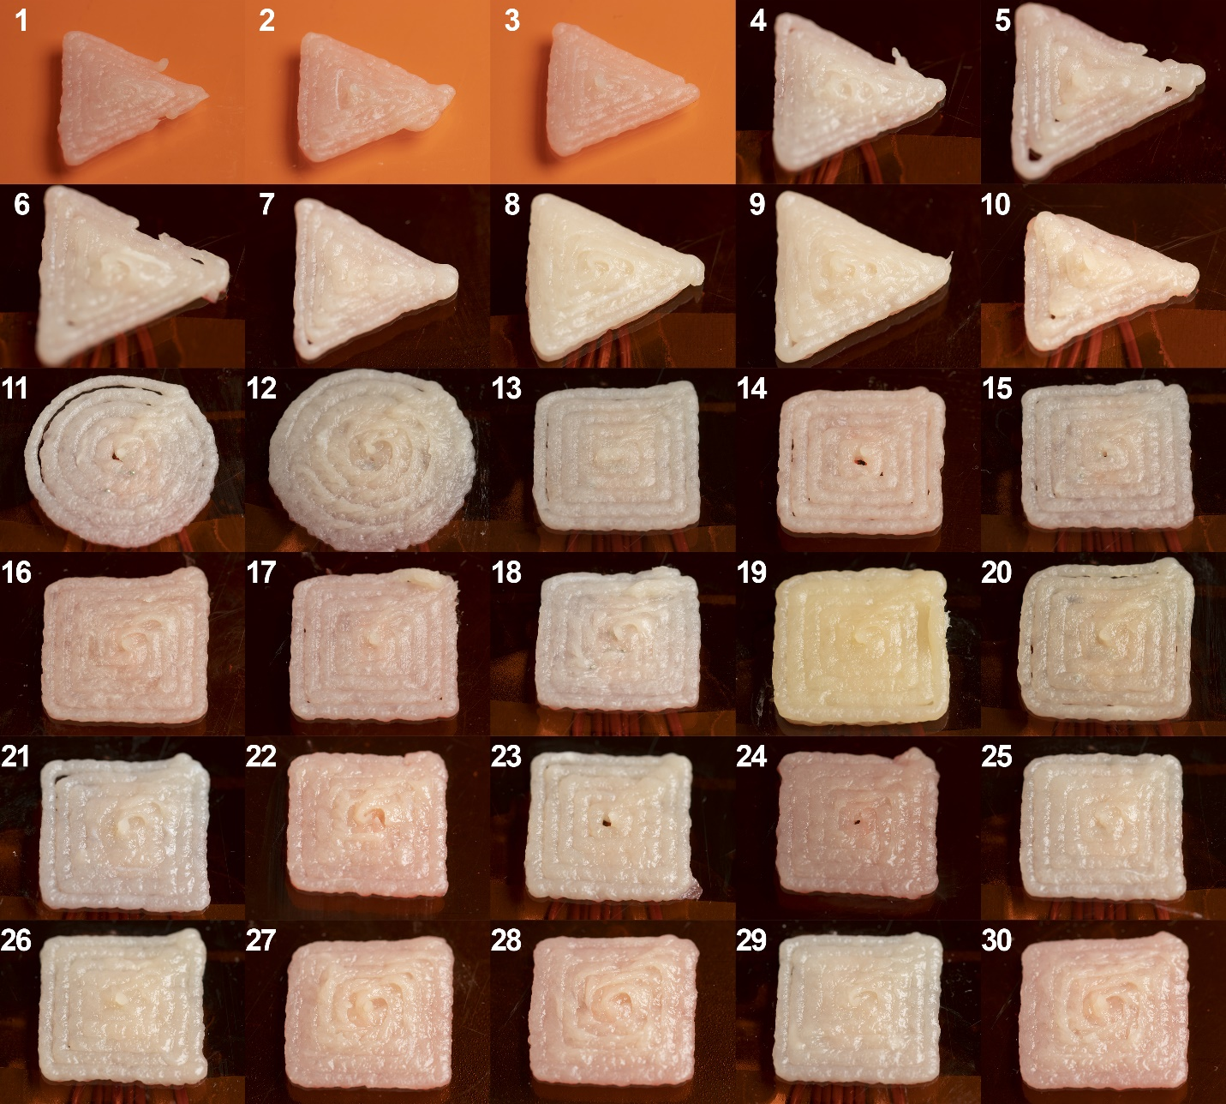
Fig. S16: Data set of raw printed samples. All samples were used to measure shrinkage and color change. Samples that were used for internal temperature data include 4, 6, 8, 10, 11, 12, 13, 15, 18, 19, 20, 21, 23, 25, 26, 29.

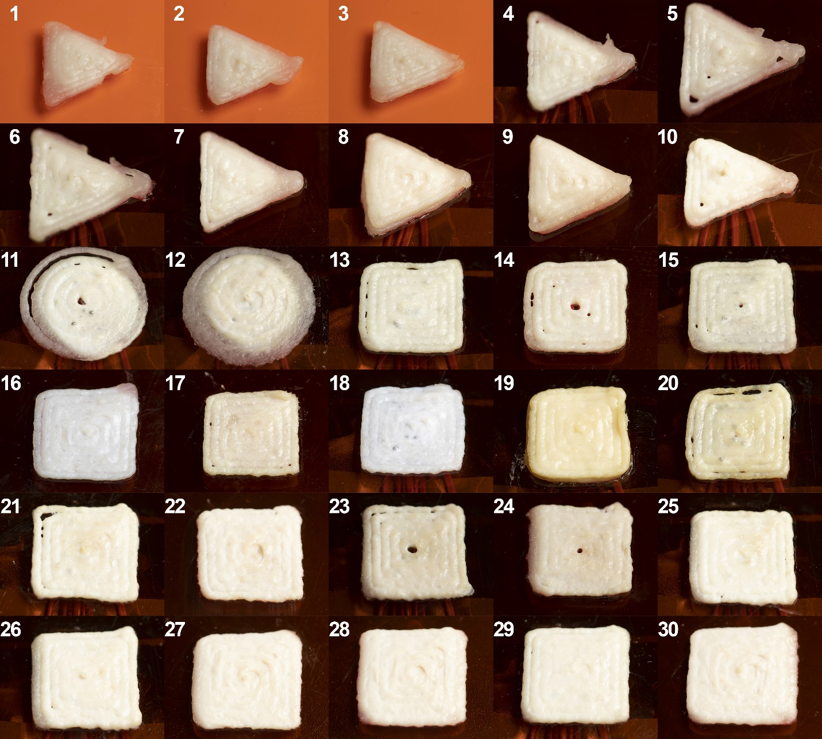
Fig. S17: Data set of cooked printed samples. All samples were used to measure shrinkage and color change. Samples that were used for internal temperature data include 4, 6, 8, 10, 11, 12, 13, 15, 18, 19, 20, 21, 23, 25, 26, 29.

Setup 1: Blue laser |  | Setup 2: NIR laser
Advantages | Disadvantages | Advantages | Disadvantages
- More compact  - Higher laser speeds  - More complex cooking patterns  - More integrable | - Limited cooking area  - Mirror distortion affects  - Inconsistent beam diameter  - Efficiency loss to mirror heating | - Larger cooking area  - Quicker setup time  - More intuitive motion profile | - Large moving mass on end effector  - Less compact  - More safeguarding needed
Table S1: Advantages and disadvantages for both laser heating systems.

Supplementary Reference
1. Blutinger, J. D., Meijers, Y. & Lipson, H. Selective laser broiling of Atlantic salmon. Food Res. Int. 120, 196–208 (2019).

Creative Machines Laboratory, Mechanical Engineering, Columbia University, New York, NY 10027, USA.
Food Technology, Wageningen University, 6708 PB Wageningen, Netherlands

