Supportive information
Annealing Effect on Mechanical and Tribological behaviour with Nanoscale Mechanics of Thin Layer Metallic Glasses for Engineering Material Applications
Adem Ali Muhabie,¹ Wubshet Mekonnen Girma²

¹Department of Chemistry, Woldia University, Woldia, Ethiopia
²Department of Chemistry, Wollo University, Dessie, Ethiopia
Corresponding author
E-mail: alimohabe2003@gmail.com ( Adem Ali Muhabie)

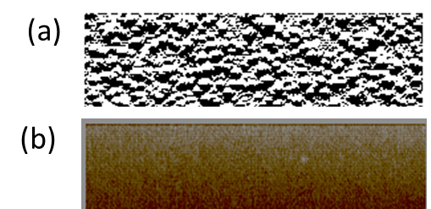
Fig. S1 Topography images recorded by tapping mode AFM on Zr60Cu30Al10 Ag10 metallic glass surface (a) in the as-cast state and (b) after annealing for 60 min. rough surface before annealing and smooth surface after annealing

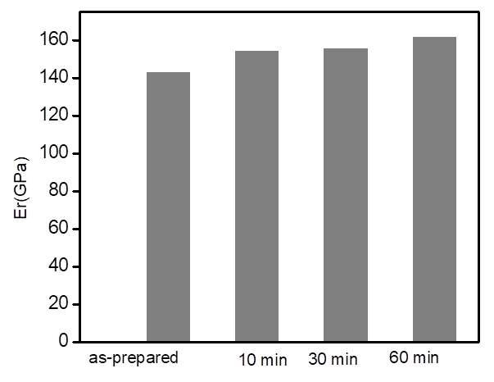
Fig.S2 elastic modulus of metallic glass as function of annealing times of 0, 10, 30 and 60 minutes that determined by Nano indentation tests.
Fig.S3 H/E ratio of metallic glass as function of annealing times of 0, 10, 30 and 60 minutes that determined by Nano indentation tests.
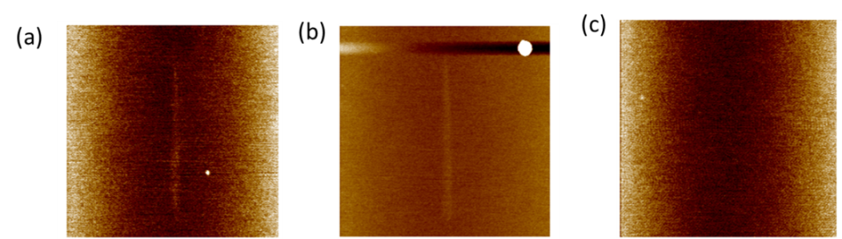
Fig.S4 Topography after scratch tests at the normal forces FN of 0.9 N at different annealing time (a) as-cast, (b) 30, (c) 60 min

