Supplementary information
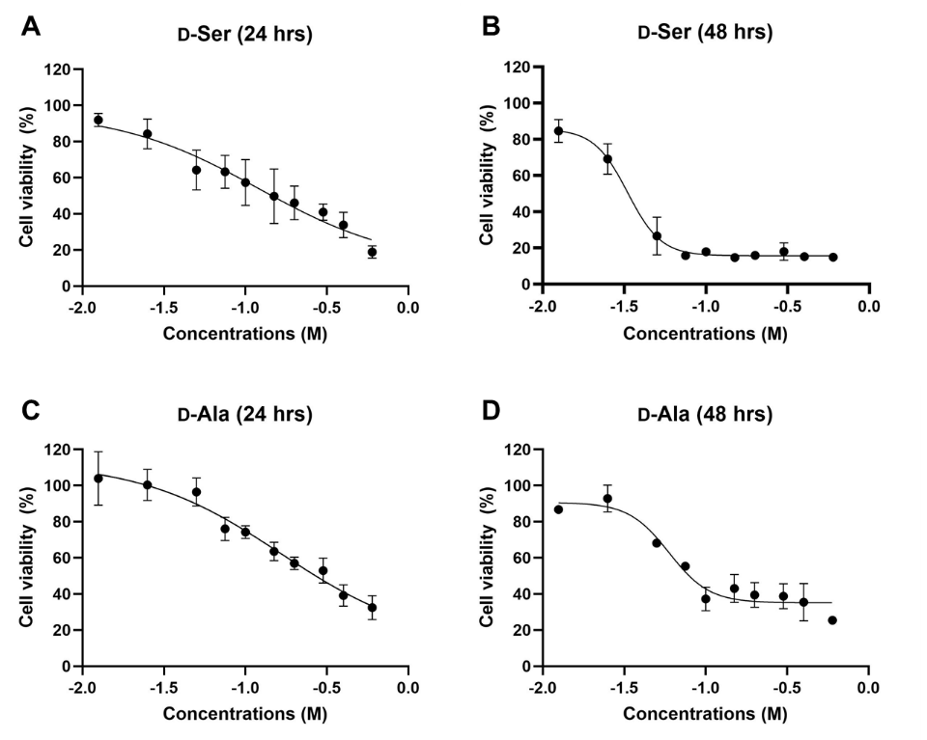
Supplementary Figure 1: Dose-response curve of D-Ser (A, B) and D-Ala (C, D) on HepG2 cells over a 24- and 48-hrs period using the MTT assay. HepG2 were treated with various concentrations (ranging from 12.5 mM to 600 mM) for 24 and 48 hrs. Increasing concentrations of D-Ser and D-Ala reduced the cell viability of HepG2. The data are expressed as the mean ± SEM (n = 3).

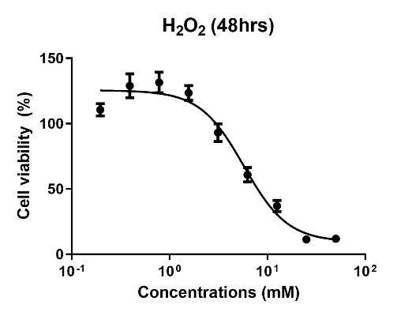
Supplementary Figure 2: Dose-response curve of H₂O₂ on HepG2 cells over a 48-h period using the MTT assay. Increasing concentrations of H₂O₂ reduced the cell viability of HepG2 and the calculated IC₅₀ for H₂O₂ is approximately 5.8 mM. The data are expressed as the mean ± SEM (n = 3).

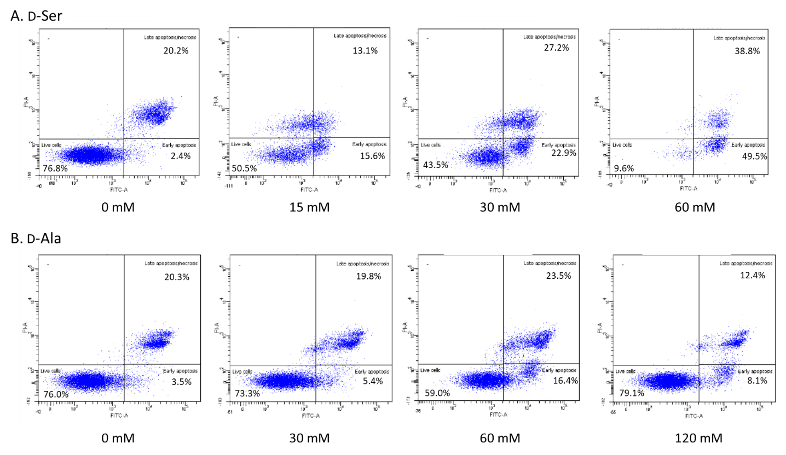
Supplementary Figure 3: Flow cytometry plots for apoptosis using Annexin-V (FITC) binding and propidium iodide (PI) staining in HepG2 cells. The plots shown represent one of the experiment replicates.

