Table 8 represents the Simpson Index and Shannon-Wiener Index of Herb species of Edayar in each season.
Seasons | TERRESTRIAL HABITAT
Seasons | SIMPSON INDEX | SHANNON INDEX
SOUTH-WEST MONSOON | 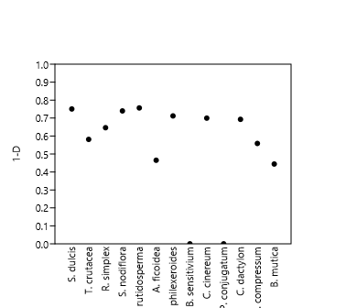 | 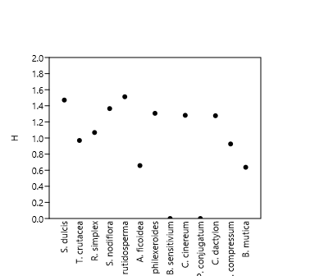
NORTH-EAST MONSOON | 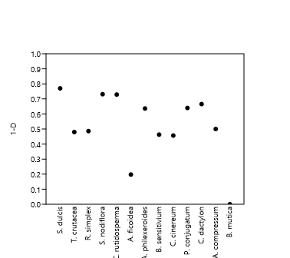 | 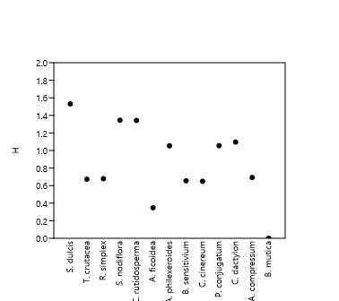
WINTER SEASON | 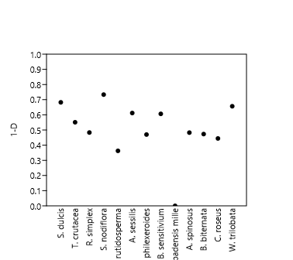 | 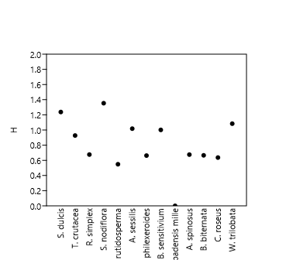
SUMMER SEASON | 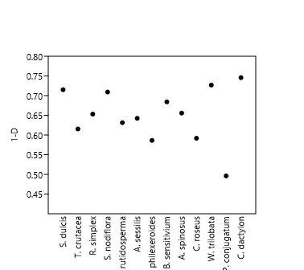 | 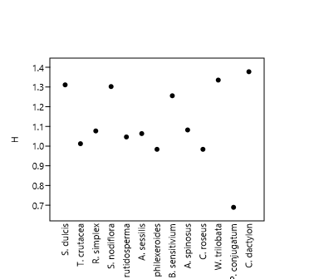

Table 9 represents the Simpson Index and Shannon-Wiener Index of Macrophytes of Edayar in each season.
Seasons | AQUATIC HABITAT
Seasons | SIMPSON INDEX | SHANNON INDEX
SOUTH-WEST MONSOON | 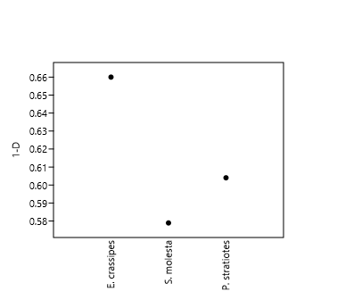 | 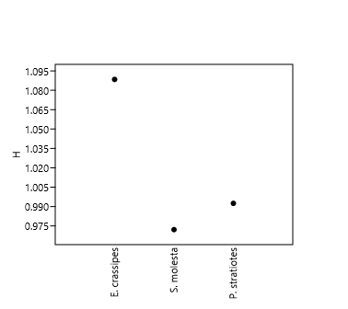
WINTER SEASON | 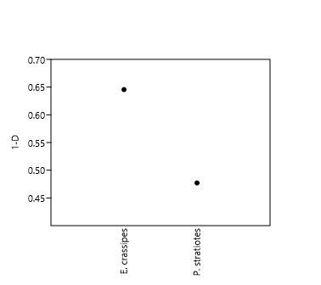 | 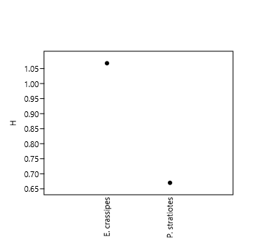
SUMMER SEASON | 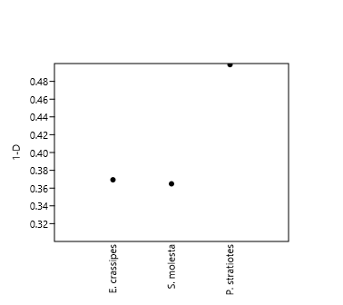 | 