Supporting Information
Activation of Persulfate for the Degradation of Ethyl-parathion in Soil: Combined Effects of Microwave with Biochar

Song Zhao ª, Jinbo Liu ^{b}, Duo Miao ^{c}, Hongwen Sun ^{d}, Peng Zhang ^{d}, Hanzhong Jia ^{b}*
ª College of Ecology and Environment, Xinjiang University, Urumqi 830046, China
^{b} College of Resources and Environment, Northwest A & F University, Yangling 712100, China.
^{c} Xinjiang University, Urumqi 830046, China.
^{d} Tianjin Key Laboratory of Environmental Remediation and Pollution Control, College of Environmental Science and Engineering, Nankai University, Tianjin, 300071, China

*Corresponding author:
E-mails: jiahz@nwafu.edu.cn

Text S1. Materials
Ethyl-parathion (PTH, 99%, brown liquid, melting point: 6.0 ºC, boiling point: 375 ºC), sodium persulfate (PS, analytical grade), humic acid (HA, ≥ 90%), dimethyl sulfoxide (DMSO, 99%), tert-butanol (TBA, ≥ 98.5%) and isopropanol (IPA, 99%), 1,4-benzoquinone (BQ) were obtained from J&K Scientific Co., Ltd. (Beijing, China). Methanol (HPLC-grade) and acetone (AR) were obtained from Sigma-Aldrich Pty Ltd. (Sydney, Australia), and 5, 5-dimethyl-1-pyrroline N-Oxide (DMPO, 98%) was purchased from Sinopharm Chemical Reagent Co., Ltd (Shanghai, China).

Text S2. Preparation of materials
(1) Biochar preparation
Prior to biochar production, wheat straw was dried at 80 ºC for 12 h and then transferred to a tube furnace and subjected to a step-wise heating program. The initial temperature was set to 200 ºC, increased to 250 ºC (maintained for 1.5 h), and then rose to the above target temperature. The target temperature was maintained until there was no further smoke emission from the gas exhaust pipe. Finally, the manufactured biochar was powdered and sieved through a 100-mesh screen. All the biochar samples were sealed inside a dark container before utilization. Furthermore, nano-size of biochar (< 5 nm) was ground by a planetary ball mill.
(2) Preparation of polluted soil with ethyl-parathion
The soil samples with a pH of 7.83 were obtained from an uncontaminated site near the Tianjin Pesticide Chemical Factory in China. The soil was air-dried and ground to pass through 0.25 mm sieve before further use. The PTH contaminated soil was prepared by combining 100 g sampled soil with 100 mg L⁻¹ PTH (60 mL) solution dissolved in acetone. After that, the mixture was oscillated on a shaker at 230 rpm at room temperature (~25 ºC) for 24 h, and then put into a fuming cabinet in the shade to ensure acetone evaporation entirely. The ultimate level of PTH in the soil was 60 mg·kg⁻¹.
(3) Extraction of PTH from soil
At pre-selected time intervals, the reacted samples were transferred into Teflon centrifuge tubes (50 mL), and then we chose 5 mL of methanol, the solvent with the highest extraction rate, to extract the residual PTH in the soil. The suspensions were subjected to ultrasound waves for 5 min to extract the residual PTH and products. After that, the soil suspensions were centrifuged at a 3294 × g speed for 10 min to separate the supernatant from the soil. The methanol extraction, ultrasound treatment, and centrifugation steps were repeated twice to ensure that the organic pollutants were completely extracted. The supernatants from the duplicate extractions were pooled and filtered through a 0.45 μm membrane syringe filter. The filtrates were transferred into amber vials and analyzed by high-performance liquid chromatography (HPLC) and GC-MS.

Text S3. Analysis methods
(1) HPLC: LC-15 HPLC with a Cosmosil C18 column (25 cm × 4.6 mm). In general, 5 μL of sample volume was automatically injected into the analysis module of HPLC. The HPLC conditions were as follows: the mobile phase was V (ultrapure water): V (methyl alcohol) = 80:20; v (flow rate) = 0.8 mL min⁻¹; detection wavelength, 202 nm; oven temperature, 30 °C. The maximum absorption wavelength of the PTH solution was 202 nm according to the scanning curve, which was measured by an Evolution 201 UV-Visible spectrophotometer (Thermo Scientific, USA).
(2) GC-MS: The intermediates and by-products of PTH transformation was determined using Gas Chromatography-Mass Spectrometry (GC-MS, Agilent 7890B-5977A) in which fitted with an HP-5MS capillary column to detected. High-purity helium as the carrier gas and set the column flow and the inject port temperature to 1 mL·min⁻¹ and 280 ºC, respectively. The oven temperature starts at 60 ºC and then at a speed of 10 ºC min⁻¹ increased to 120 ºC (held 1 min), and increased to 220 ºC maintain for 4 min, and finally increased to 280 ºC (held 5 min). The injection volume of the sample was 1 μL.
(3) EPR evaluation
Biochar particles (0.05 g) were enclosed in a quartz capillary and then analysed by Electron Paramagnetic Resonance (EPR) spectroscopy (Germany, Bruker EMXmicro-6/1/P/L spectrometer) with a resonance frequency of 9.8 Hz, a MW power of 2.02 mW, modulation amplitude of 4.00 G. Receiver gain was adjusted to 3.54 × 10⁴, sweep duration time to 80 s, sweep width to 200 G, time constant to 42 ms, and centre field to 3500 G for the instrument. The concentrations of persistent free radicals (PFRs) and the g-factor were obtained by the SpinFit (Bruker’s Xenon program). Meanwhile, EPR was used to identify radical signals with spin-trapping agents to identify the SO₄^{−•}, •OH and O₂^{−•} generated by biochar/MW-activated PS in the soil. EPR experiments were performed at room temperature, and the specific operating conditions were similar to the aforementioned PFRs experiments.
Briefly, 0.1 g of soil was individually mixed with 0.2 mL 0.1 M freshly prepared DMPO or DMSO in water to trap •OH, SO₄^{−•}, and O₂^{−•} radicals, respectively. The suspension was shaken on a vortex mixer (MX-S, DLAB, China) for 1 min, filtered through a 0.45 µm membrane syringe filter, and 10 μL of this extract was immediately (~60 s) transferred to an EPR capillary tube which was sealed at one end with vacuum grease. The capillary tube was put into an EPR tube and fastened in the EPR resonator.
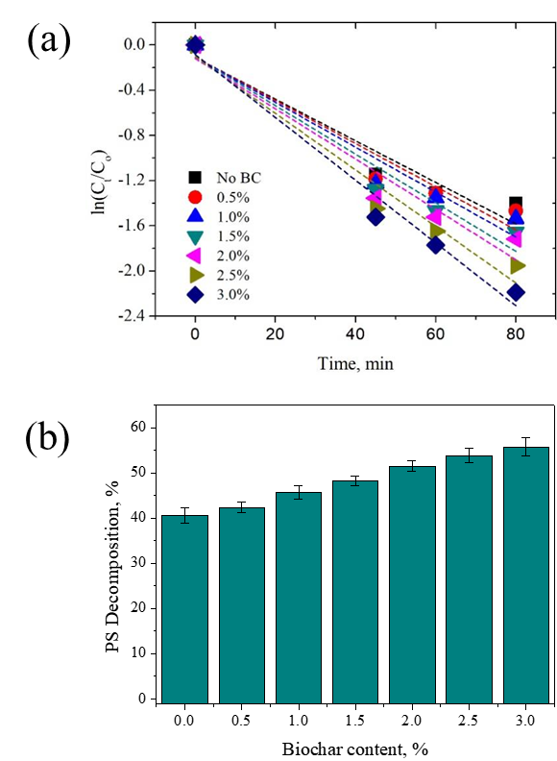
Fig. S1. (a) Kinetics of PTH degradation in the microwave system. (b) Evolution of persulfate decomposition efficiency as a function of different biochar content in a microwave system. The microwave temperature was 60 ºC.

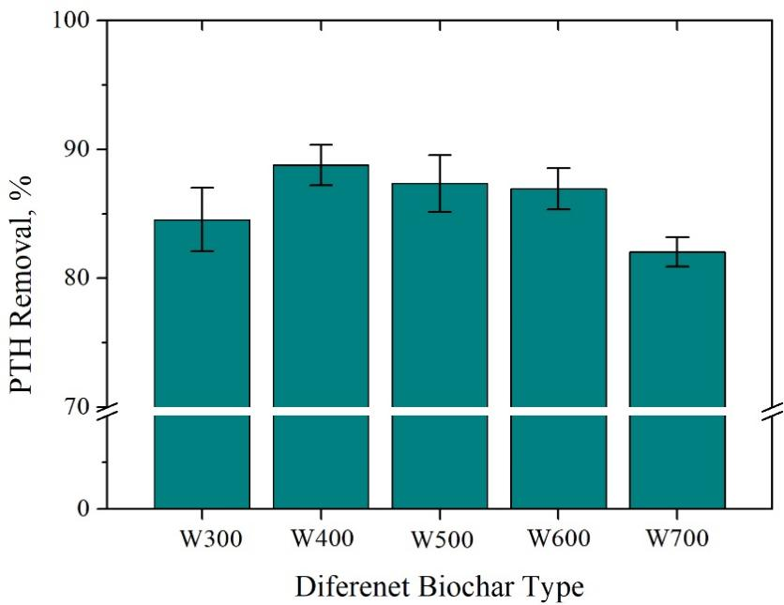
Fig. S2. Effect of different types of biochars (BC) on ethyl-parathion (PTH) degradation at different MW temperatures. The MW temperature was 60 ºC and the initial concentration of persulfate (PS) was 1.0 M.

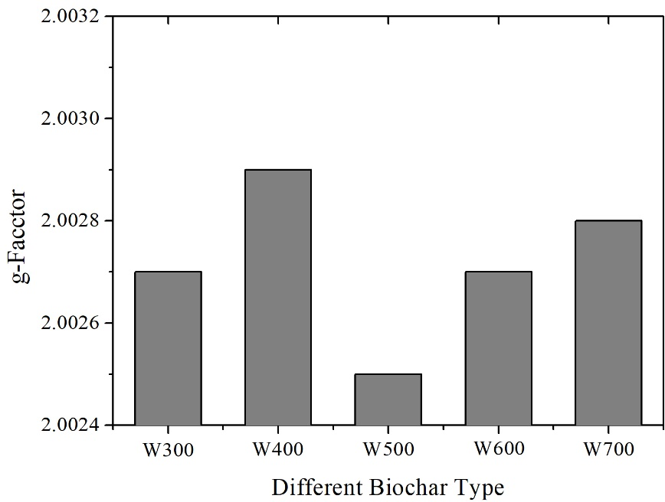
Fig. S3. G-factors of different types of biochar (BC) corresponding to EPR spectra.

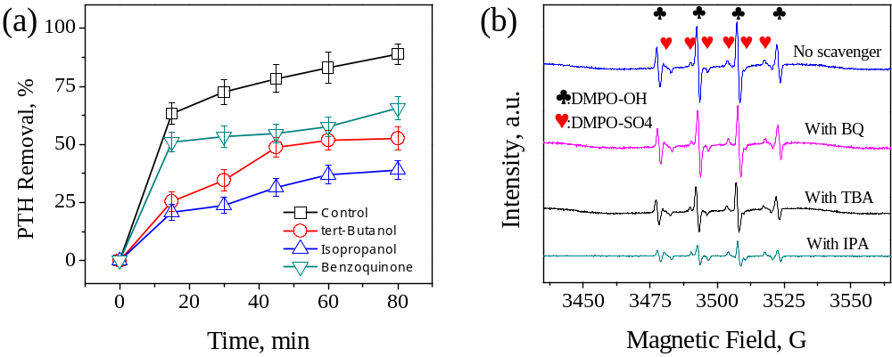Fig. S4. Free radicals quenching experiments: (a) isopropanol (IPA), tert-butanol (TBA), and benzoquinone (BQ), without them is a control experiment on ethyl-parathion degradation in the system and (b) EPR spectra of free radicals. The concentration of DMPO was 0.1 M.

