Supplementary information for
Transesterification with CE15 glucuronoyl esterase from Cerrena Unicolor reveals substrate specificity

Authors: Valentina Perna, Jane Wittrup Agger*

Department of Biotechnology and Biomedicine
Technical University of Denmark
2800 Kgs Lyngby, Denmark
*corresponding; jaag@dtu.dk

Table S1. Results of control experiments of Me-4-O-MeGlcA and MeGlcA hydrolysis by CuGE. Me-4-O-MeGlcA hydrolysis was performed with 5.2 µg/mL of CuGE while MeGlcA hydrolysis was performed with 260 µg/mL of CuGE.
reaction time | Me-4-O-MeGlcA | MeGlcA
 | [mg/mL] | [mg/mL]
0 | 0.146 ± 0.017 | 0.126 ± 0.023
20 | 0.091 ± 0.026 | 0.079 ± 0.023
40 | 0.073 ± 0.021 | 0.065 ± 0.027
60 | 0.065 ± 0.014 | 0.049 ± 0.020
80 | 0.054 ± 0.009 | 0.035 ± 0.013
90 | 0.049 ± 0.002 | 0.020 ± 0.006

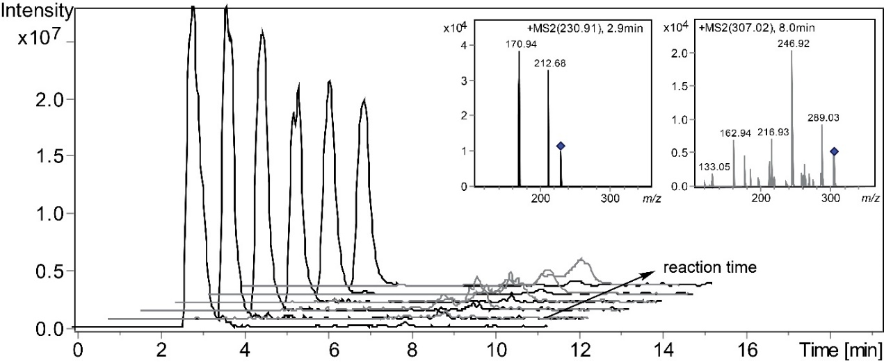
Figure S1. Reaction progression of the transesterification of BnzOH with MeGlcA by 260 µg/mL (4.3 µM) CuGE over 100 min. Extracted Ion Chromatogram (EIC) of MeGlcA (black) at a retention time (RT) 2.9 min and m/z 230.91 decreased intensity over reaction time. EIC of BnzGlcA (grey) at a RT 8.0 min and m/z 307.02 increased intensity over reaction time. All ions are shown as [M+Na]⁺. MS2 spectra of m/z 230.91 and m/z 307.02 are also shown.

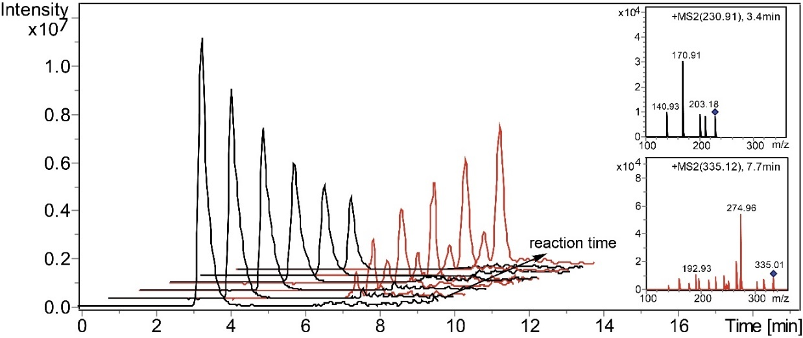
Figure S2. Reaction progression of the transesterification of PhPrOH with MeGlcA by 52 µg/mL (0.87 µM) CuGE over 100 min. EIC of MeGlcA (black) at a retention time (RT) 3.4 min and m/z 230.91 decreased intensity over reaction time. EIC of PhGlcA (red) at a RT 7.7 min and m/z 335.12 increased intensity over reaction time. All ions are shown as [M+Na]⁺. MS2 spectra of m/z 230.91 and m/z 335.12 are also shown.

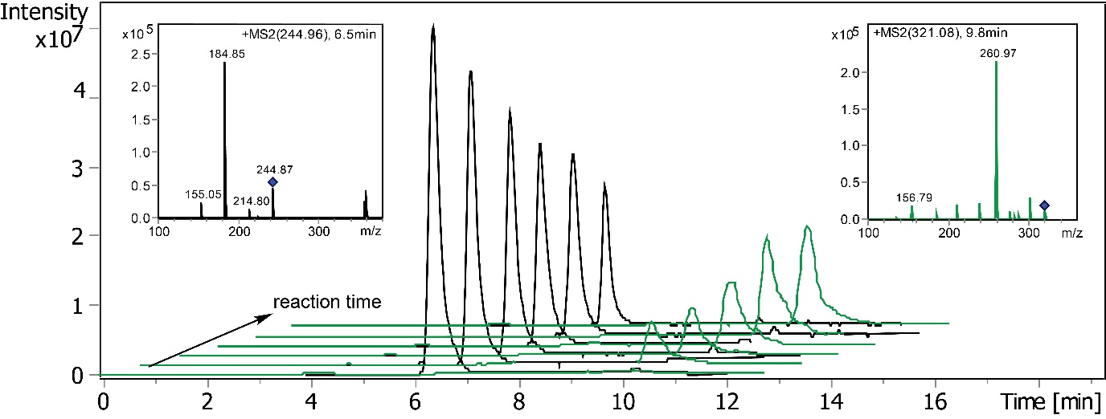
Figure S3. Reaction progression of the transesterification of BnzOH with Me-4-O-MeGlcA by 6.5 µg/mL (0.11 µM) CuGE over 100 min. EIC of Me-4-O-MeGlcA (black) at a retention time (RT) 6.5 min and m/z 244.96 decreased intensity over reaction time. BnzMeGlcA (green) at a RT 9.8 min and m/z 321.08 increased intensity over reaction time. All ions are shown as [M+Na]⁺. MS2 spectra of m/z 244.96 and m/z 321.08 are also shown.

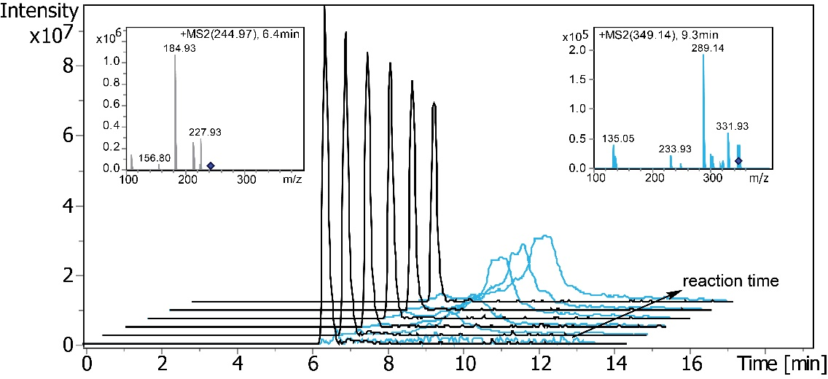
Figure S4. Reaction progression of the transesterification of PhPrOH with Me-4-O-MeGlcA by 1.3 µg/mL (0.02 µM) CuGE over 100 min. EIC of Me-4-O-MeGlcA (black) at a retention time (RT) 6.4 min and m/z 244.97 decreased intensity over reaction time. PhMeGlcA (green) at a RT 9.3 min and m/z 349.14 increased intensity over reaction time. All ions are shown as [M+Na]⁺. MS2 spectra of m/z 244.97 and m/z 349.14 are also shown.
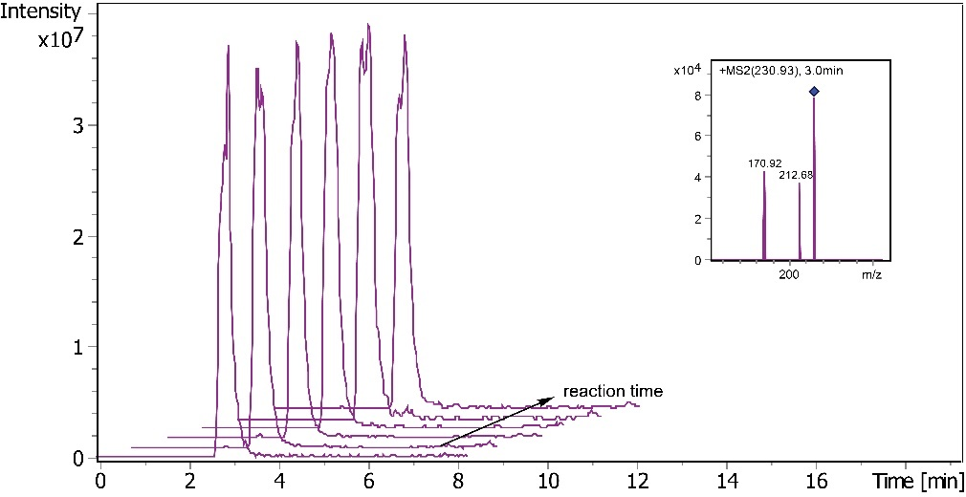
Figure S5. Control reaction with BnzOH and Me-GlcA where CuGE loading was substituted with 10 mM Na acetate buffer pH 6 over 100 min. Extracted Ion Chromatogram (EIC) of MeGlcA (violet) at a retention time (RT) 3.0 min and m/z 230.91 remained constant in intensity over reaction time. Ion is shown as [M+Na]⁺. MS2 spectrum of m/z 230.91 is also shown.

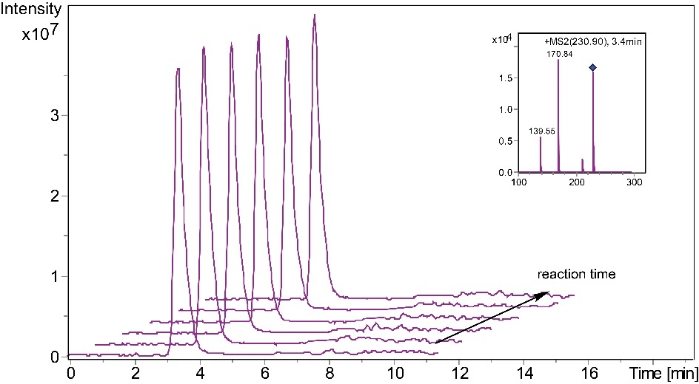
Figure S6. Control reaction with PhPrOH and MeGlcA where CuGE loading was substituted with 10 mM Na acetate buffer pH 6 over 100 min. Extracted Ion Chromatogram (EIC) of MeGlcA (violet) at a retention time (RT) 3.4 min and m/z 230.90 remained constant in intensity over reaction time. Ion is shown as [M+Na]⁺. MS2 spectrum of m/z 230.90 is also shown.
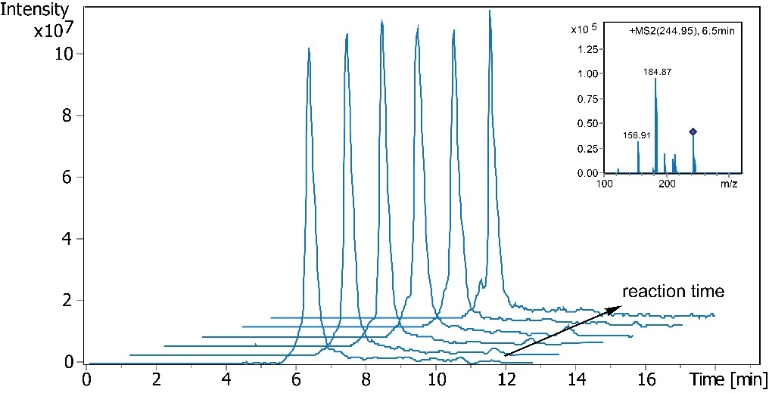
Figure S7. Control reaction with BnzOH and Me-4-O-MeGlcA where CuGE loading was substituted with 10 mM Na acetate buffer pH 6 over 100 min. Extracted Ion Chromatogram (EIC) of Me-4-O-MeGlcA (blue) at a retention time (RT) 6.5 min and m/z 244.95 remained constant in intensity over reaction time. Ion is shown as [M+Na]⁺. MS2 spectrum of m/z 244.95 is also shown.

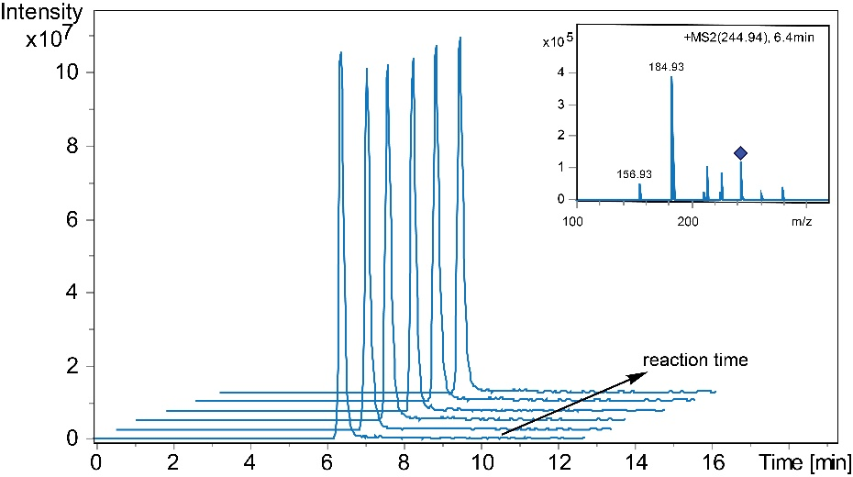
Figure S8. Control reaction with PhPrOH and Me-4-O-MeGlcA where CuGE loading was substituted with 10 mM Na acetate buffer pH 6 over 100 min. Extracted Ion Chromatogram (EIC) of Me-4-O-MeGlcA (blue) at a retention time (RT) 6.4 min and m/z 244.94 remained constant in intensity over reaction time. Ion is shown as [M+Na]⁺. MS2 spectrum of m/z 244.95 is also shown.

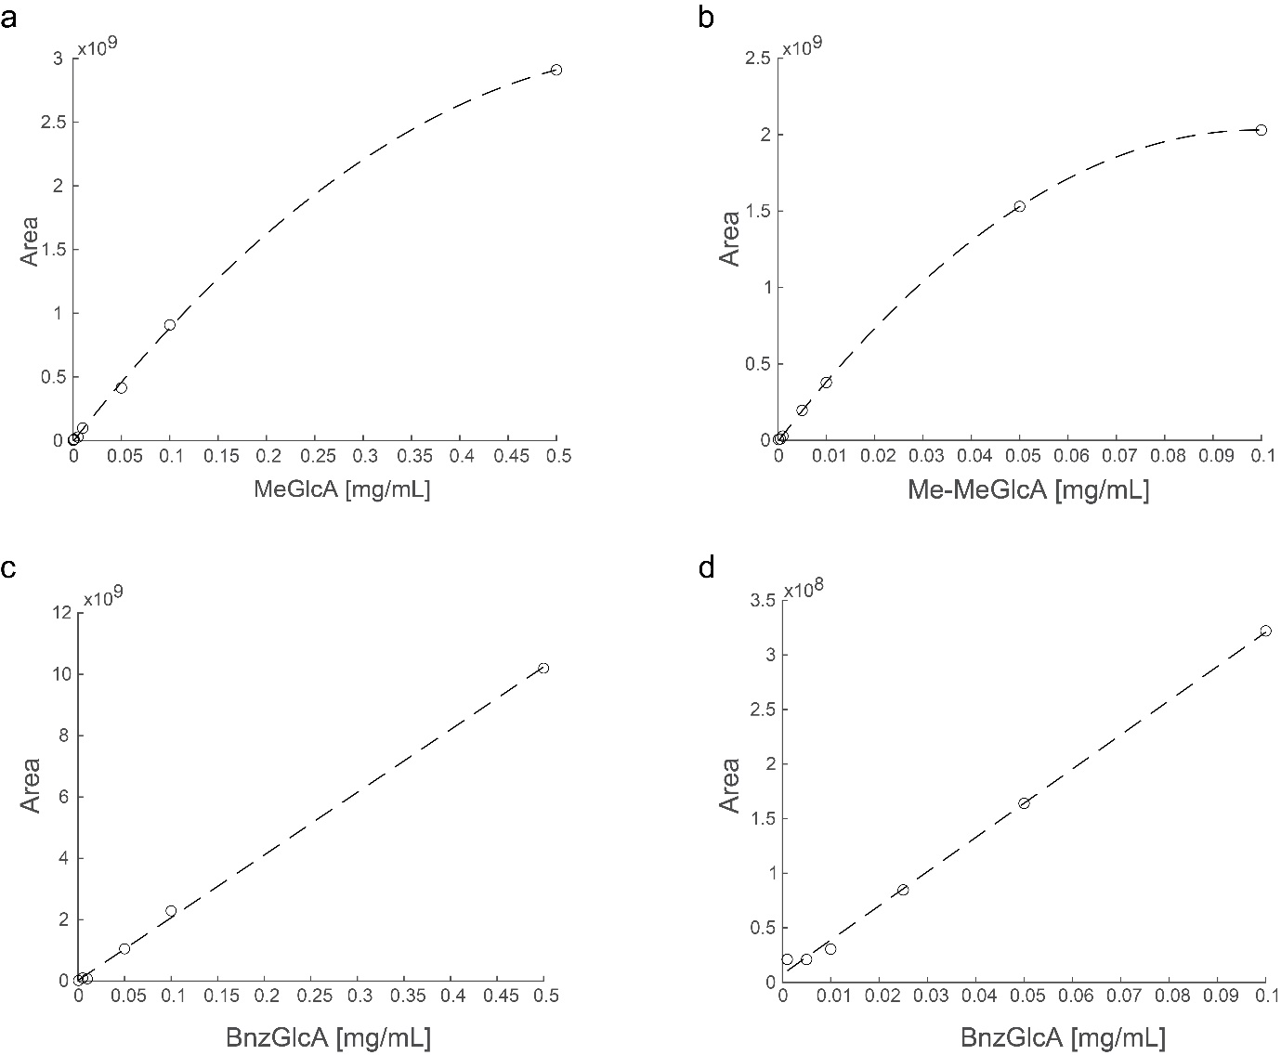
Figure S9. Calibration curves. a) Calibration curve used for MeGlcA hydrolysis by CuGE determined as the area below the EIC of m/z 230.92 and m/z 439.07 at different MeGlcA concentrations. b) Calibration curve used for Me-4-O-MeGlcA hydrolysis by CuGE determined as the area below the EIC of m/z 244.95 and m/z 467.03 at different Me-4-O-MeGlcA concentrations. c) Calibration curve used for transesterification of BnzOH with Me-4-O-MeGlcA and MeGlcA using BnzGlcA by CuGE determined BnzGlcA equivalent (dissolved in BnzOH) as the area below the EIC of m/z 307.04 and m/z 591.01 at different BnzGlcA concentrations. d) Calibration curve used for transesterification of PhPrOH with Me-4-O-MeGlcA and MeGlcA using BnzGlcA by CuGE determined BnzGlcA equivalent (dissolved in PhPrOH) as the area below the EIC of m/z 307.04 and m/z 591.01 at different BnzGlcA concentrations.

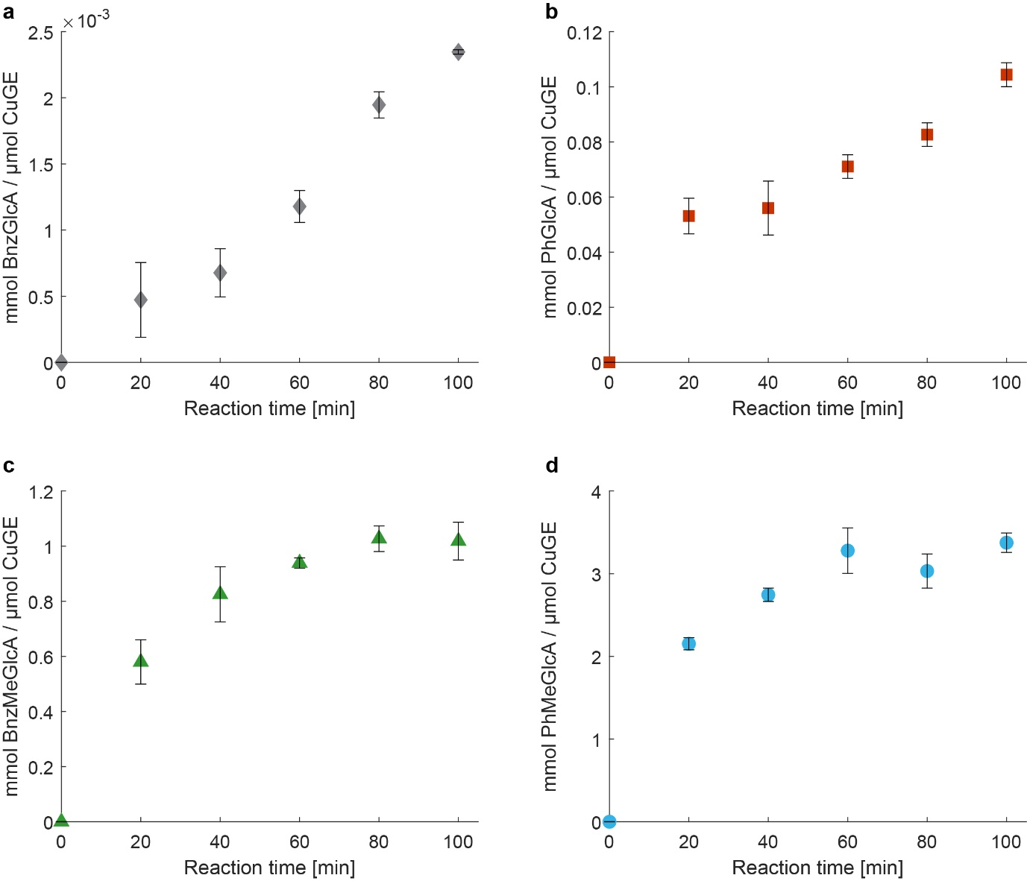
Figure S10. Comparison between the product formations during transesterification reactions by CuGE. a) BnzGlcA (grey diamonds) was the product of the transesterification of BnzOH with MeGlcA using 260 µg/mL (4.3 µM) of CuGE. b) PhPr-GlcA (red squares) was the product of the transesterification of PhPrOH with MeGlcA using 52 µg/mL (0.87 µM) of CuGE. c) Bnz-MeGlcA (grey diamonds) was the product of the transesterification of BnzOH with Me-4-O-MeGlcA using 6.5 µg/mL (0.11 µM) of CuGE. d) PhPr-GlcA (light blue circles) was the product of the transesterification of PhPrOH with Me-4-O-MeGlcA using 1.3 µg/mL (0.02 µM) of CuGE. Standard deviations of triplicate reactions are shown. The reaction evolution cannot be compared directly, they are showed with their specific y-axis.

