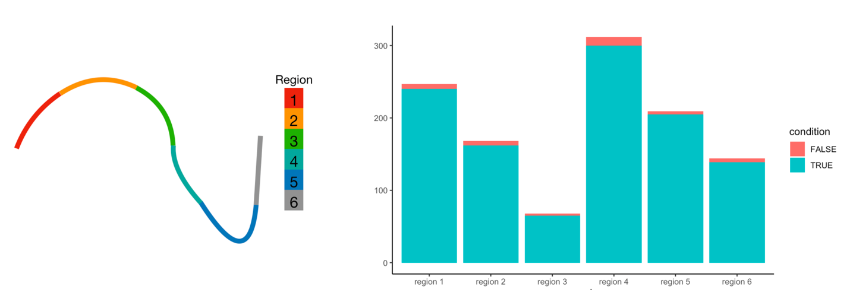
Extended Data Fig. 1 Cell mapping results of ~1,100 single cells in the intestinal villus. ~1,100 cells were mapped back to six predefined regions. Over 99% of the cells can be correctly assigned to the original layers or the layers next to the original layers.

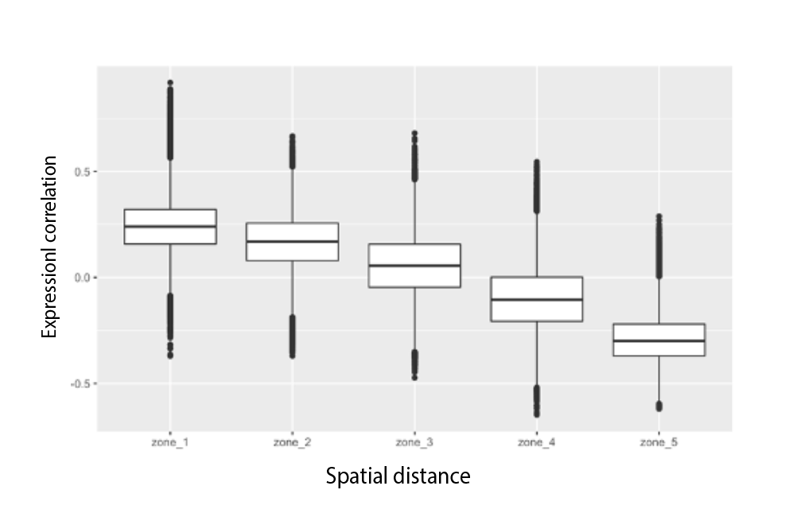 Extended Data Fig. 2 Monotonical relationship between cell-to-cell spatial distance and cell-to-cell expression correlation of marker genes in intestinal villus. Single cells are more correlated when they have closer spatial distance.

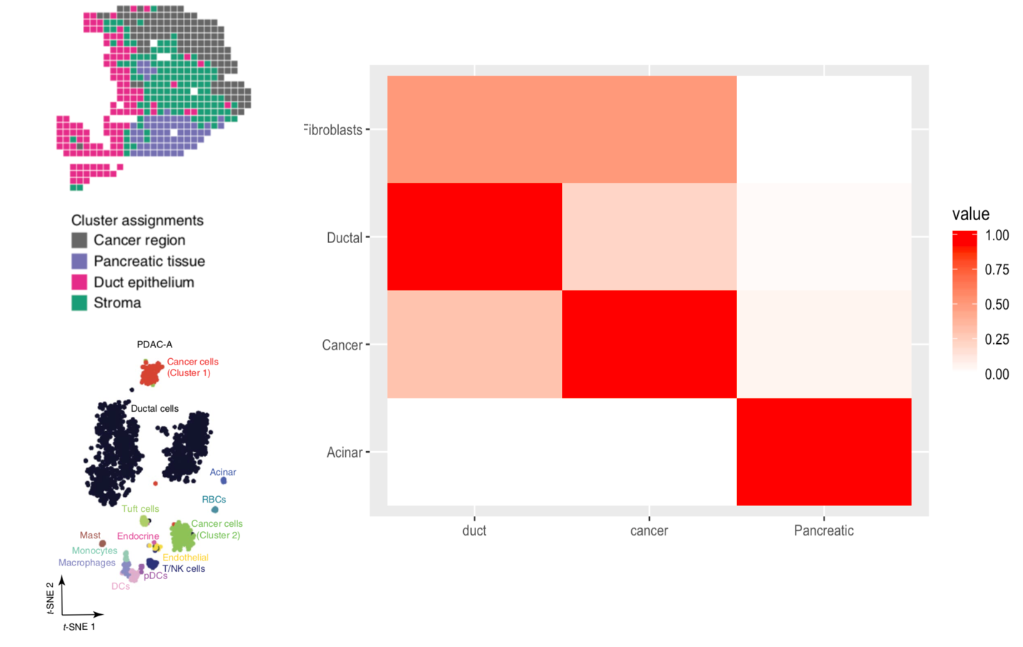
Extended Data Fig. 3 Cell mapping results of 1,926 single cells in the human tumor PDAC-A sample. Single cells can be classified into 11 clusters following the pipeline of Moncada et al. We filtered out the cell clusters where the number of cells was less than 20. Acinar, cancer, and ductal cells remained after filtering. Acinar cells were mainly enriched in the pancreatic regions; cancer cells were mainly enriched in the cancer regions and ductal cells were mainly enriched in the ductal regions. The cell enrichment results were consistent with the literature.

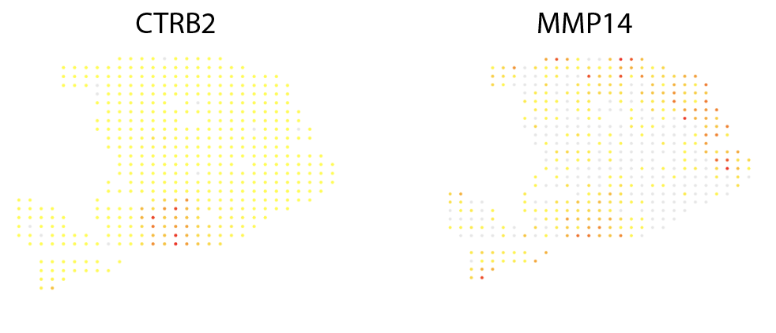
Extended Data Fig. 4 Expression patterns of highly variable genes in the spatial transcriptomics data of PDAC-A sample.
Extended Data Fig. 5 Selected marker genes with specific spatial expression patterns in the drosophila embryo. Twi and sna were well-known ventral genes. Zen and rho were dorsal genes. Trn and run were segment genes. Tll and srp were mostly expressed in the anterior and posterior regions of the embryo. 84 marker genes were selected for predicting the locations of the cells in the simulated data set.

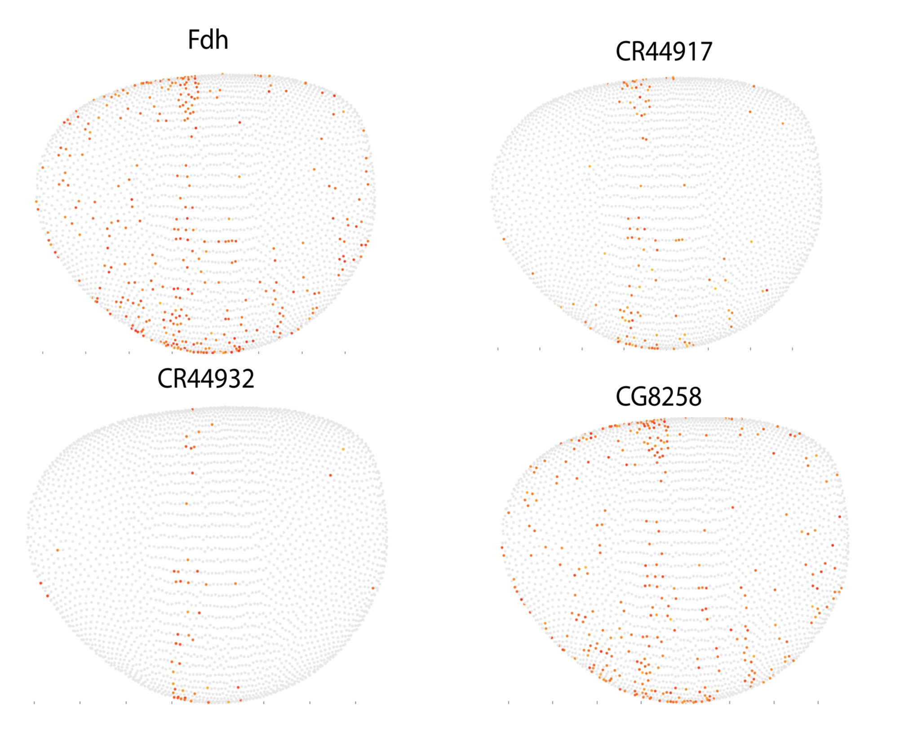
Extended Data Fig. 6 Predicted spatial expression patterns of marker genes. CG4702, bxd, pnr, CG43110, Fdh, CR44917 and CG8258 were reconstructed as segment genes. CG4500, CG14688 and if were reconstructed as ventral genes. CG15236 were reconstructed as dorsal genes.

Extended Data Fig. 7 Spatial expression patterns of Purkinje-specific genes. Car8, Aldoc, Itpr1, Pvalb, Sparcl1, Pcp4, Pcp2, and Gria1 were highly expressed in the Purkinje cells and low expressed in other cells.

Extended Data Fig. 8 Spatial expression patterns of Granule-specific genes. Fth1, Mbp, Mobp, and Plp1 were highly expressed in the Granule cells and low expressed in other cells.

Extended Data Fig. 9 Spatial expression patterns of marker genes that were highly expressed in the other regions. (Ttr, 1500015O10Rik, Enpp2, and Trpm3)
Extended Data Fig. 10 Spatial expression patterns of DG-specific genes. C1ql2, Pnmal2, and Synpr were highly expressed in the DG cells and low expressed in other cells.

Extended Data Fig. 11 Spatial expression patterns of CA-specific genes. Neurod6, Spink8, and Wfs1 were highly expressed in the CA cells and low expressed in other cells.

Extended Data Fig. 12 Spatial expression patterns of hippocampus-specific genes. Malat1, Nrgn, Gria1, and Ppp3ca were highly expressed in the hippocampus regions.

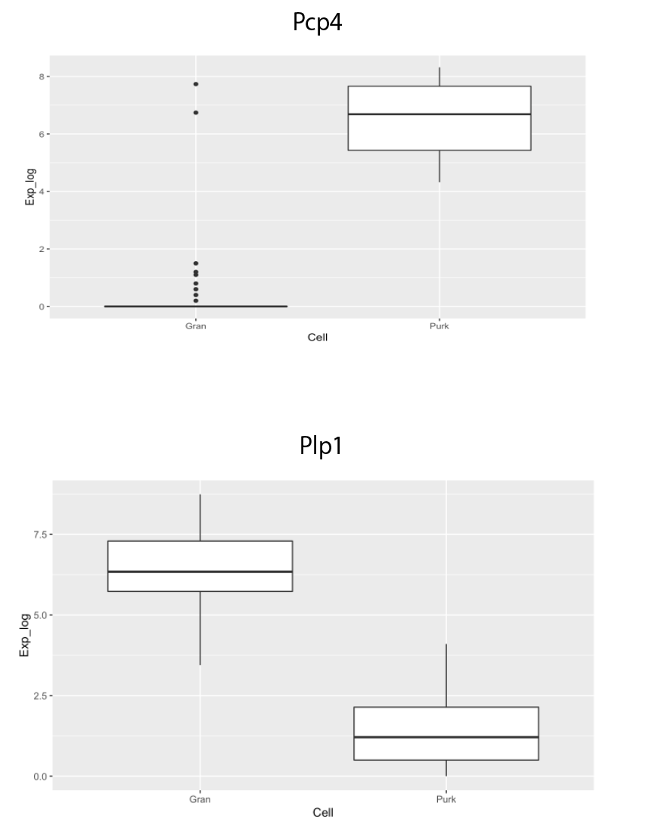 Extended Data Fig. 13 Predicted expression levels of DG-specific and CA-specific genes. Expression profiles of marker genes in the scRNA-seq data were extracted from the predicted DG cells and CA cells. We found that Nptx1 were highly expressed in the DG cells and Plp1 were highly expressed in the CA cells.

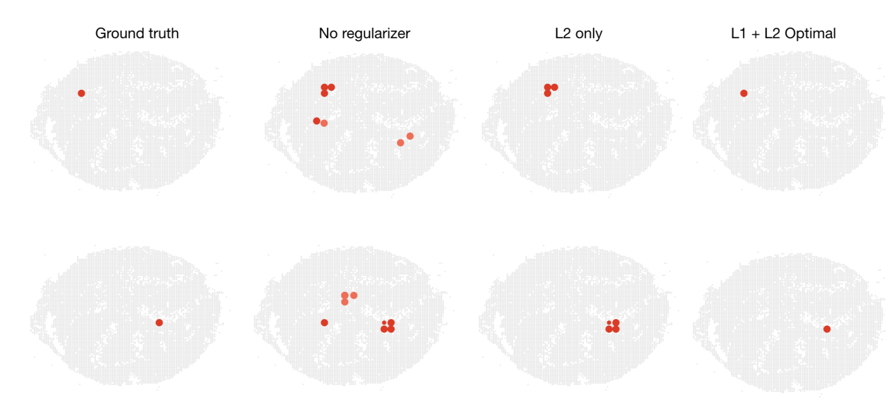 Extended Data Fig. 14 Regularization path in the simulated data of mouse cerebellum. With L1 and generalized L2 regularization, we can achieve the best performance in predicting the cell locations.

Extended Data Fig. 15 Examples of similar spatial expression patterns in the Drosophila embryo. Traf4 and Ilp4 shared highly similar expression profiles in the Virualfly database.

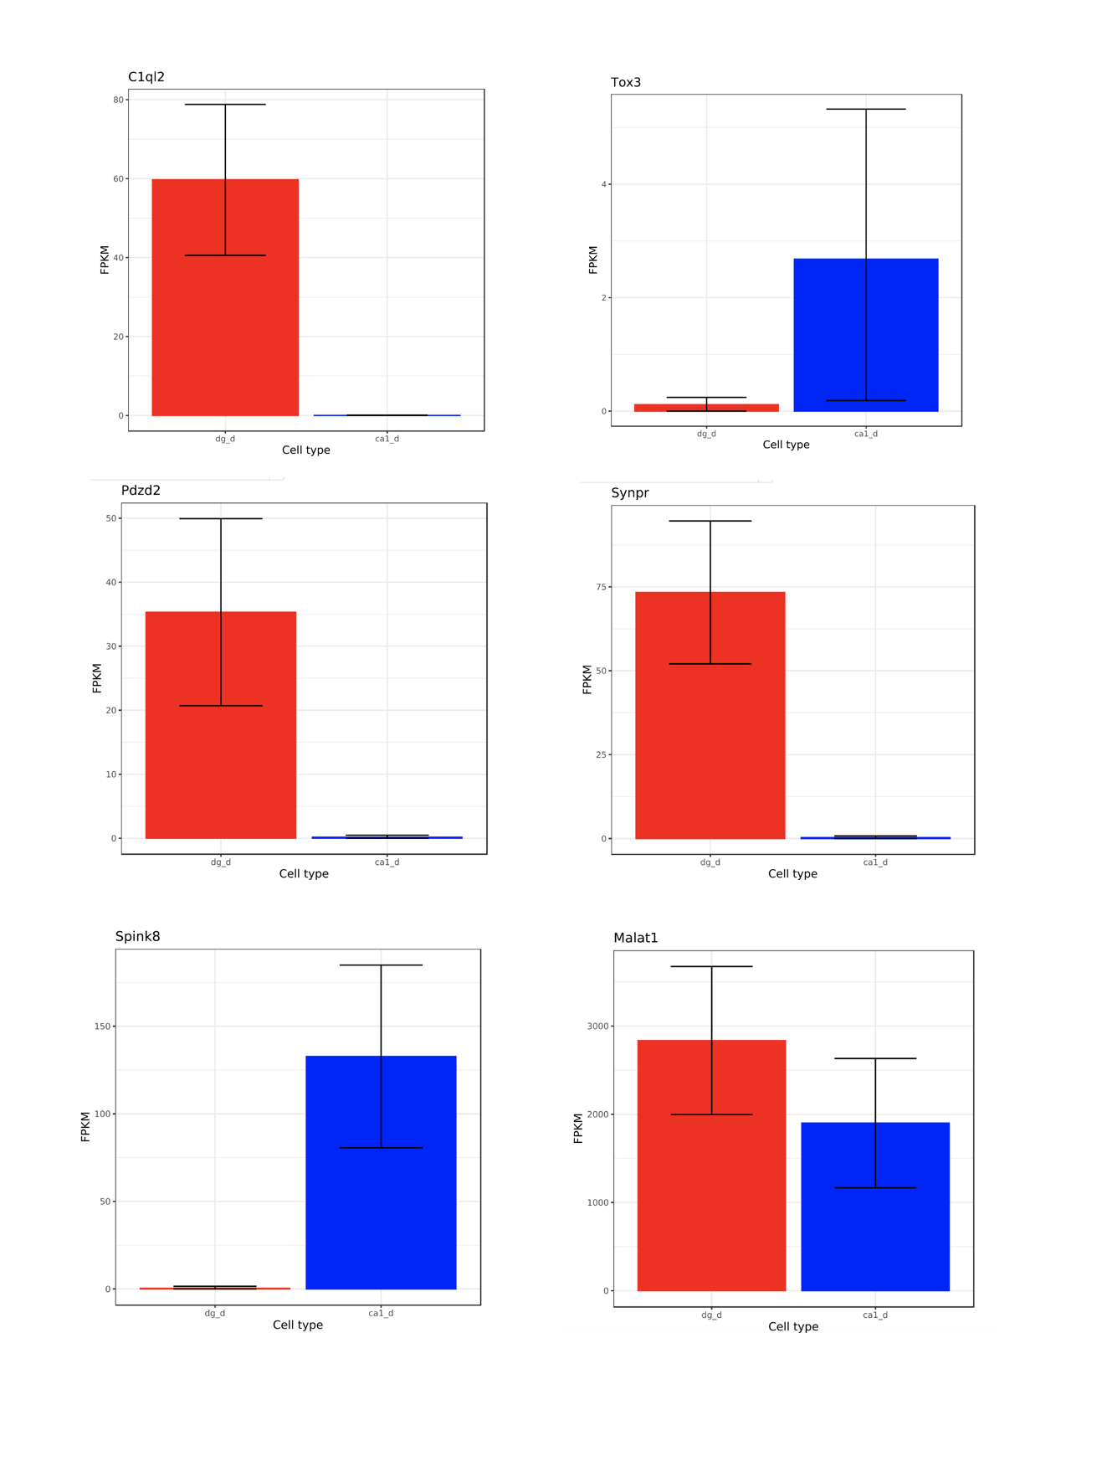
Extended Data Fig. 16 Examples of expression levels of marker genes in the Hipposeq database. Clql2, Pdzd2, and Synpr were highly expressed in the DG region and low expressed in the CA1 region. Spink8 and Tox3 were highly expressed in the CA1 region and low expressed in the DG region.
Extended Data Fig. 17 Examples of ISH images and corresponding expression profiles from Allen Brain Atlas. Prox1 and Kcnc4 were highly expressed in the DG region. Spink8 were highly expressed in the CA1 region.

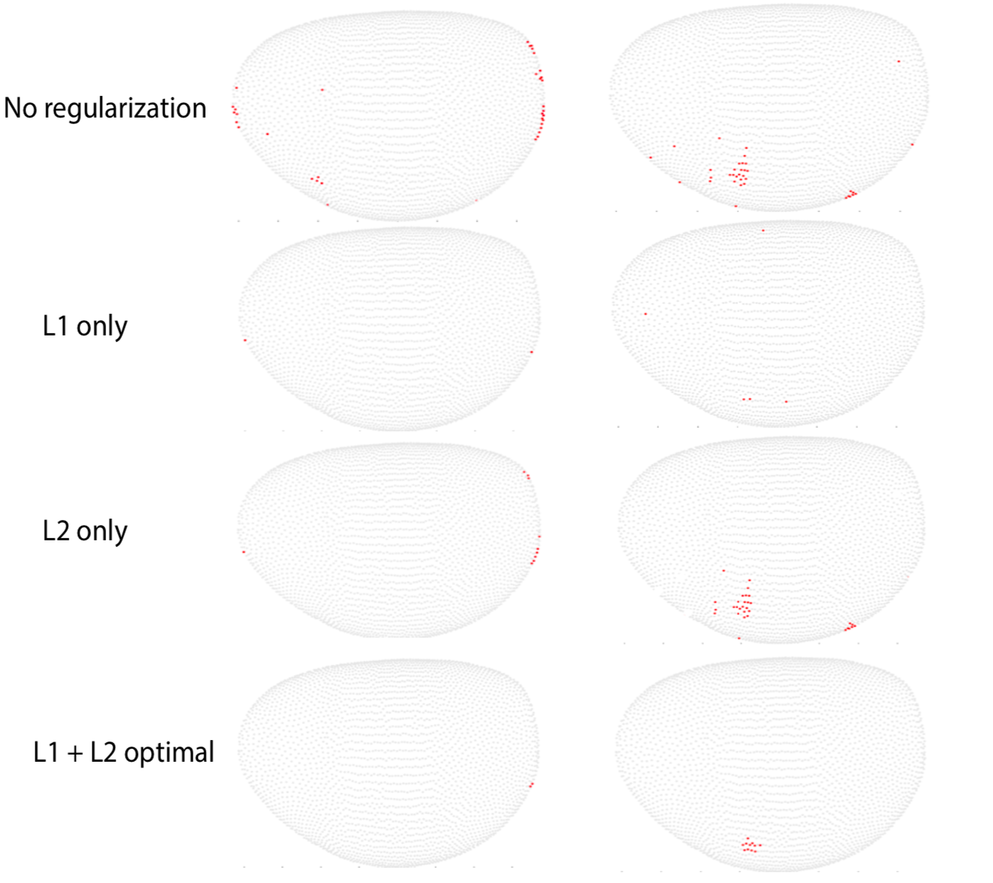 Extended Data Fig. 18 Regularization path for the cell assignments of the real scRNA-seq dataset. By using L1 and generalized L2 regularization, we can locate cells in small patches instead of scattered positions.

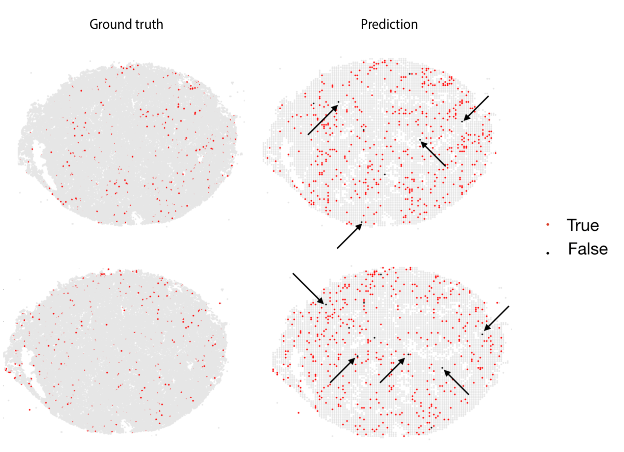 Extended Data Fig. 19 Mapping results for the randomly selected 500 cells using 40 marker genes. Correctly mapped cells were in red and falsely mapped cells were in black. Over 97% of the cells were correctly assigned to their original locations.

Extended Data Fig. 20 Reconstructed patterns of the marker genes in the mouse cerebellum. TSNE-plots from the DropViz database are consistent with our prediction results.

