Appendix
Table 1 – Accuracy of MCM-4 and REC-4 networks on ECG datasets
Dataset | Network | Category | Accuracy of single category |  |  |  |  |  | All
Dataset | Network | Category | NB | V | S, | |  |  |  | All
SVDB | MCM-4 | Train | 95.63 | 95.88 | 98.13 |  |  |  | 96.54
SVDB | MCM-4 | Test | 95.89 | 95.94 | 98.42 |  |  |  | 96.75
SVDB | REC-4 | Train | 97.16 | 96.92 | 98.67 |  |  |  | 97.58
SVDB | REC-4 | Test | 97.25 | 97.24 | 98.55 |  |  |  | 97.68
 |  |  | NB | V | AF,S |  |  |  | All
LTDB | MCM-4 | Train | 99.72 | 99.81 | 95.07 |  |  |  | 99.61
LTDB | MCM-4 | Test | 99.66 | 99.81 | 96.96 |  |  |  | 99.65
LTDB | REC-4 | Train | 99.83 | 99.85 | 96.27 |  |  |  | 99.72
LTDB | REC-4 | Test | 99.75 | 99.86 | 96.70 |  |  |  | 99.72
 |  |  | NB | PAF |  |  |  |  | All
AFPDB | MCM-4 | Train | 99.87 | 99.88 |  |  |  |  | 99.88
AFPDB | MCM-4 | Test | 99.93 | 99.91 |  |  |  |  | 99.92
AFPDB | REC-4 | Train | 99.91 | 99.91 |  |  |  |  | 99.91
AFPDB | REC-4 | Test | 99.91 | 99.91 |  |  |  |  | 99.91
 |  |  | N | L | R | V | / | A,+,AF,~ | All
MITDB | MCM-4 | Train | 98.91 | 99.96 | 99.83 | 99.13 | 100.00 | 98.61 | 99.41
MITDB | MCM-4 | Test | 99.26 | 99.94 | 100.00 | 99.44 | 100.00 | 99.21 | 99.63
MITDB | REC-4 | Train | 99.36 | 99.85 | 99.86 | 99.39 | 100.00 | 98.81 | 99.55
MITDB | REC-4 | Test | 99.13 | 99.94 | 100.00 | 99.16 | 100.00 | 99.30 | 99.56
 |  |  | N | S,V |  |  |  |  | All
STDB | MCM-4 | Train | 99.66 | 98.40 |  |  |  |  | 98.98
STDB | MCM-4 | Test | 99.49 | 98.26 |  |  |  |  | 98.83
STDB | REC-4 | Train | 98.83 | 98.67 |  |  |  |  | 98.75
STDB | REC-4 | Test | 97.51 | 98.23 |  |  |  |  | 97.89
 |  |  | N | ~ | V | +,s,T,S,AF |  |  | All
EDB | MCM-4 | Train | 98.47 | 90.82 | 98.57 | 91.14 |  |  | 94.73
EDB | MCM-4 | Test | 98.80 | 90.74 | 98.62 | 90.50 |  |  | 94.72
EDB | REC-4 | Train | 99.08 | 93.70 | 98.84 | 90.13 |  |  | 95.77
EDB | REC-4 | Test | 99.26 | 93.85 | 98.29 | 89.88 |  |  | 95.75
 |  |  | N | r | S | V | s,+,E |  | All
SDDB | MCM-4 | Train | 97.70 | 93.34 | 92.14 | 90.19 | 93.65 |  | 94.44
SDDB | MCM-4 | Test | 97.53 | 92.37 | 91.94 | 88.37 | 98.21 |  | 94.12
SDDB | REC-4 | Train | 98.70 | 96.11 | 95.24 | 94.15 | 96.32 |  | 96.72
SDDB | REC-4 | Test | 98.68 | 95.61 | 94.49 | 92.84 | 98.54 |  | 96.45

Table 2 – Accuracy of MCM-4 and REC-4 networks on PCG datasets
Dataset | Network | Category | NHS | AHS |  |  |  | All
C2016 | MCM-8 | Train | 98.27 | 93.77 |  |  |  | 97.13
C2016 | MCM-8 | Test | 98.01 | 94.56 |  |  |  | 97.14
C2016 | REC-8 | Train | 96.80 | 93.17 |  |  |  | 95.91
C2016 | REC-8 | Test | 96.89 | 92.91 |  |  |  | 95.92
 |  |  | NHS | AS | MR | MS | MVP | All
Y2018 | MCM-8 | Train | 100.00 | 95.93 | 95.04 | 94.30 | 98.29 | 96.67
Y2018 | MCM-8 | Test | 100.00 | 95.24 | 100.00 | 97.56 | 100.00 | 98.50
Y2018 | REC-8 | Train | 97.52 | 96.75 | 98.28 | 94.31 | 96.58 | 96.67
Y2018 | REC-8 | Test | 97.56 | 97.50 | 94.74 | 95.12 | 97.50 | 96.50
 |  |  | NHS | ECS | CM | FHS |  | All
K2016 | MCM-8 | Train | 89.82 | 85.88 | 93.09 | 94.30 |  | 90.68
K2016 | MCM-8 | Test | 91.59 | 94.55 | 93.22 | 92.75 |  | 92.32
K2016 | REC-8 | Train | 87.94 | 82.56 | 89.57 | 93.88 |  | 88.43
K2016 | REC-8 | Test | 89.65 | 83.33 | 91.16 | 89.86 |  | 89.57
 |  |  | NHS | APA | AA | AMA |  | All
Mfour | MCM-8 | Train | 100.00 | 100.00 | 99.76 | 98.17 |  | 99.55
Mfour | MCM-8 | Test | 100.00 | 100.00 | 99.29 | 96.43 |  | 98.99
Mfour | REC-8 | Train | 94.42 | 100.00 | 99.28 | 95.63 |  | 97.62
Mfour | REC-8 | Test | 94.11 | 100.00 | 99.29 | 96.08 |  | 97.64

Table 3 – Accuracy of all networks in ECGF and PCGF dataset
Dataset | Network | Accuracy of single category |  |  |  |  |  | All
Dataset | Network | NB | PAF | AF | V | S | MA | All
ECGF | MCM-4 | 98.81 | 99.63 | 99.73 | 92.24 | 97.11 | 94.44 | 98.70
ECGF | MCM1-4 | 98.70 | 99.64 | 99.69 | 92.11 | 97.01 | 94.03 | 98.61
ECGF | MCM2-4 | 98.44 | 99.61 | 99.62 | 91.20 | 96.88 | 93.71 | 98.46
ECGF | MCM3-4 | 98.38 | 99.59 | 99.60 | 91.04 | 96.59 | 93.36 | 98.38
ECGF | MCM4-4 | 98.72 | 99.76 | 99.70 | 91.87 | 97.04 | 94.26 | 98.64
ECGF | MCM5-4 | 98.75 | 99.67 | 99.70 | 91.95 | 97.10 | 94.40 | 98.66
ECGF | REC-4 | 98.83 | 99.73 | 99.75 | 91.82 | 97.02 | 94.18 | 98.68
 |  | NHS | AHSS
PCGF | MCM-8 | 94.24 | 89.05 |  |  |  |  | 92.58
PCGF | MCM1-8 | 93.27 | 84.77 |  |  |  |  | 91.08
PCGF | MCM2-8 | 93.51 | 87.27 |  |  |  |  | 91.52
PCGF | MCM3-8 | 89.78 | 80.08 |  |  |  |  | 86.72
PCGF | MCM4-8 | 94.06 | 87.99 |  |  |  |  | 92.15
PCGF | MCM5-8 | 94.08 | 88.43 |  |  |  |  | 92.27
PCGF | REC-8 | 90.11 | 84.04 |  |  |  |  | 88.28

Table 4 – Accuracy of all networks in Synchronized ECG-PCG dataset
Arrange | Network | RS | RL | EP | ESW | EBP | EW | EBS | ALL
1 | MCM-8 | 99.73 | 99.79 | 98.13 | 98.33 | 98.71 | 99.16 | 96.23 | 98.45
1 | MCM1-8 | 100.00 | 99.79 | 98.26 | 98.33 | 98.41 | 98.84 | 96.70 | 98.45
1 | MCM2-8 | 100.00 | 99.79 | 98.57 | 98.07 | 98.78 | 99.23 | 96.30 | 98.58
1 | MCM3-8 | 100.00 | 99.07 | 95.31 | 98.30 | 96.00 | 96.41 | 91.74 | 95.95
1 | MCM4-8 | 100.00 | 99.69 | 98.17 | 97.25 | 98.41 | 98.85 | 95.84 | 98.21
1 | MCM5-8 | 100.00 | 99.90 | 98.10 | 95.66 | 98.48 | 98.98 | 95.35 | 98.10
1 | REC-8 | 100.00 | 99.58 | 95.34 | 98.87 | 96.90 | 97.28 | 92.82 | 96.58
2 | MCM-8 | 100.00 | 99.48 | 98.38 | 97.25 | 98.70 | 98.73 | 96.78 | 98.42
2 | MCM1-8 | 100.00 | 99.79 | 98.13 | 97.53 | 98.93 | 98.91 | 96.77 | 98.50
2 | MCM2-8 | 100.00 | 99.79 | 98.45 | 98.35 | 98.63 | 99.49 | 96.78 | 98.68
2 | MCM3-8 | 100.00 | 99.16 | 95.02 | 96.85 | 95.95 | 97.47 | 93.02 | 96.26
2 | MCM4-8 | 100.00 | 99.38 | 98.18 | 97.27 | 98.48 | 99.10 | 95.82 | 98.24
2 | MCM5-8 | 100.00 | 99.58 | 97.81 | 96.19 | 98.25 | 98.85 | 96.59 | 98.17
2 | REC-8 | 100 .00 | 99.27 | 95.87 | 98.04 | 96.60 | 97.47 | 91.63 | 96.40
3 | MCM-8 | 100.00 | 100.00 | 98.78 | 99.16 | 99.54 | 99.42 | 98.17 | 99.19
3 | MCM1-8 | 100.00 | 100.00 | 98.52 | 99.44 | 99.39 | 99.42 | 97.34 | 98.99
3 | MCM2-8 | 100.00 | 99.90 | 98.53 | 99.16 | 99.68 | 99.42 | 98.09 | 99.13
3 | MCM3-8 | 100.00 | 99.37 | 95.27 | 97.75 | 96.68 | 97.97 | 93.98 | 96.78
3 | MCM4-8 | 100.00 | 99.79 | 98.52 | 98.34 | 99.54 | 99.42 | 97.43 | 98.95
3 | MCM5-8 | 100.00 | 99.69 | 98.77 | 98.32 | 98.94 | 99.30 | 97.60 | 98.88
 | REC-8 | 100.00 | 99.58 | 96.81 | 99.15 | 97.64 | 98.98 | 95.03 | 97.76
4 | MCM-8 | 100.00 | 100.00 | 98.59 | 98.61 | 99.32 | 99.17 | 98.33 | 99.06
4 | MCM1-8 | 100.00 | 100.00 | 98.59 | 98.89 | 99.47 | 99.30 | 97.76 | 99.03
4 | MCM2-8 | 100.00 | 100.00 | 98.28 | 98.62 | 99.02 | 99.68 | 98.07 | 99.00
4 | MCM3-8 | 100.00 | 99.06 | 96.26 | 98.58 | 97.03 | 97.90 | 92.95 | 96.86
4 | MCM4-8 | 100.00 | 100.00 | 98.33 | 98.88 | 99.47 | 99.49 | 97.36 | 98.95
4 | MCM5-8 | 100.00 | 99.90 | 98.14 | 97.53 | 99.24 | 99.30 | 97.27 | 98.73
4 | REC-8 | 100.00 | 100.00 | 96.94 | 98.87 | 97.95 | 98.85 | 95.65 | 97.90
5 | MCM-8 | 100.00 | 99.06 | 94.42 | 98.31 | 97.53 | 98.28 | 91.87 | 96.47
5 | MCM1-8 | 100.00 | 99.16 | 92.60 | 98.59 | 98.56 | 98.97 | 94.06 | 96.78
5 | MCM2-8 | 99.73 | 99.06 | 93.15 | 98.05 | 98.78 | 99.04 | 95.46 | 97.12
5 | MCM3-8 | 100.00 | 97.39 | 91.46 | 93.80 | 96.34 | 96.77 | 89.76 | 94.52
5 | MCM4-8 | 100.00 | 98.85 | 93.00 | 96.94 | 99.08 | 98.66 | 93.77 | 96.73
5 | MCM5-8 | 100.00 | 99.06 | 96.04 | 97.24 | 98.62 | 98.78 | 90.16 | 96.71
5 | REC-8 | 100.00 | 98.74 | 93.13 | 97.48 | 95.20 | 97.66 | 89.69 | 95.23
6 | MCM-8 | 99.73 | 99.58 | 90.77 | 88.35 | 92.86 | 96.21 | 90.77 | 93.80
6 | MCM1-8 | 100.00 | 99.58 | 91.07 | 88.97 | 93.30 | 96.71 | 89.46 | 93.88
6 | MCM2-8 | 100.00 | 99.58 | 91.66 | 88.95 | 92.29 | 97.08 | 89.55 | 93.92
6 | MCM3-8 | 99.45 | 97.70 | 89.92 | 79.24 | 87.18 | 92.77 | 95.02 | 90.14
6 | MCM4-8 | 100.00 | 99.37 | 90.37 | 86.27 | 93.12 | 96.02 | 90.86 | 93.59
6 | MCM5-8 | 100.00 | 99.06 | 89.28 | 88.27 | 93.14 | 95.55 | 89.60 | 93.13
6 | REC-8 | 100.00 | 98.94 | 90.01 | 88.71 | 91.98 | 94.06 | 86.12 | 92.23
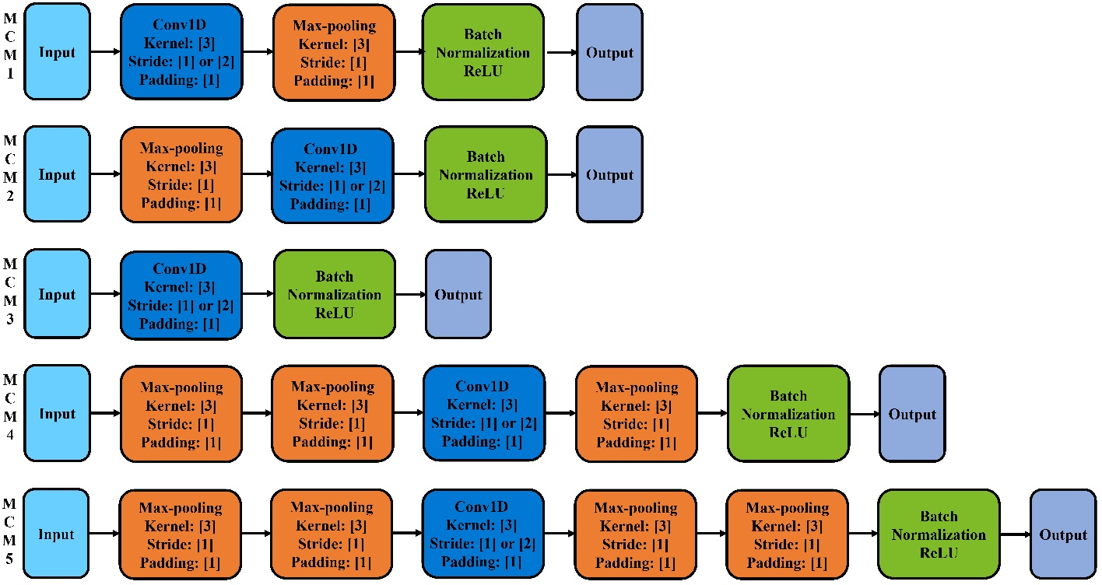
Fig. 1 Multiple variants of MCM structure block

