Appendices
Appendix I: Calculations of the Cohen Kappa statistic
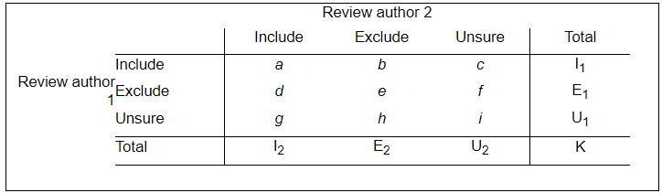
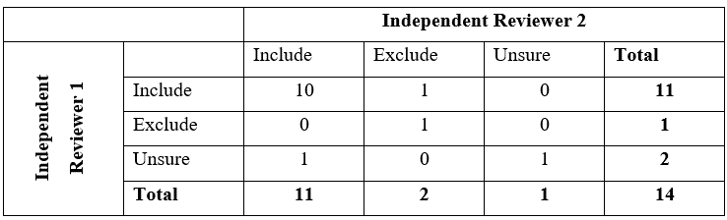
$$Kappa (K)=\frac{P_{0}-P_{e}}{1-P_{e}}$$
$$P_{0}=\frac{a+e+i}{K}= \frac{10+1+1}{14}=0.857$$
$$P_{e}=\frac{I_{1}×I_{2}+E_{1}×E_{2}+U_{1}×U_{2}}{K^{2}}= \frac{11×11+2×1+1×2}{{12}^{2}}= 0.638$$
$Kappa (K)=\frac{P_{0}-P_{e}}{1-P_{e}}$ = $\frac{0.857 -0.638}{1.0-0.638}$ = 0.60

