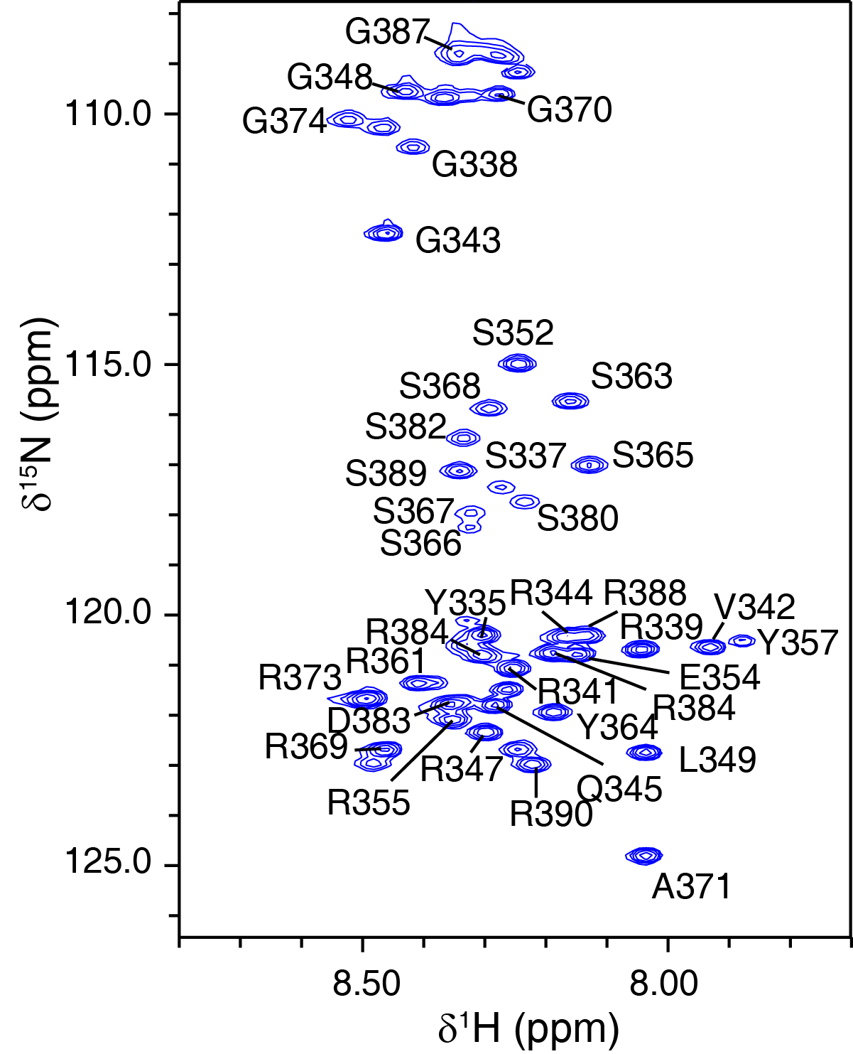

Supplementary Fig. 1 Backbone assignment for HNRNPG-RGG. The assignment was illustrated in ¹H-¹⁵N HSQC spectrum. For the assignment, a series of NMR spectrums were recorded for the backbone assignment, which includes ¹H-¹⁵N HSQC, HNCACB, HNCA, and HNCO.

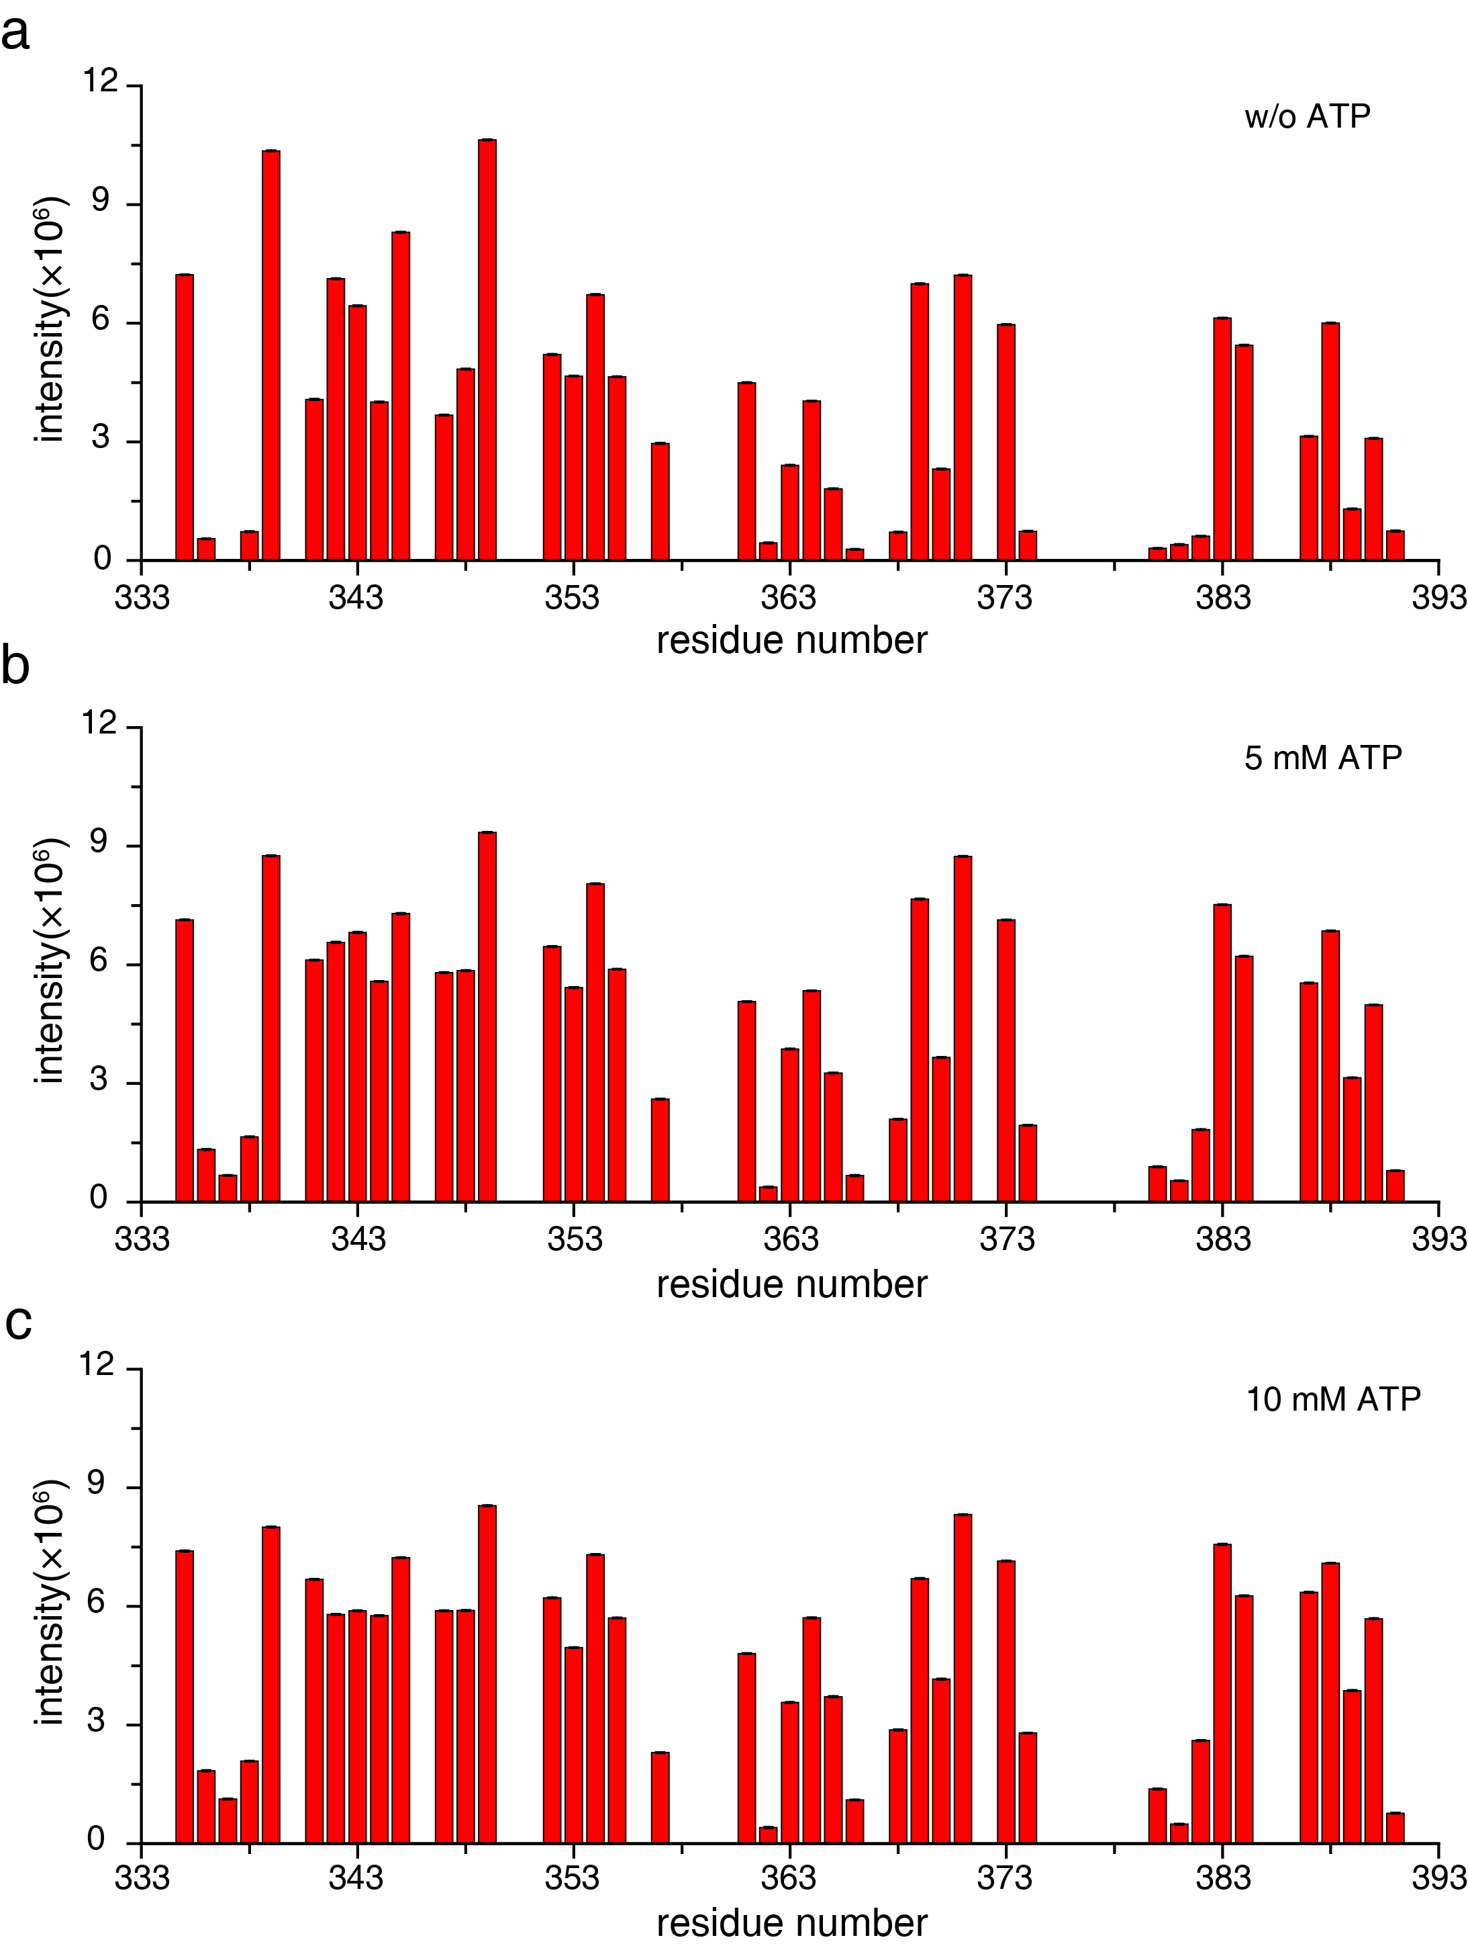
Supplementary Fig. 2 Peak intensities for the backbone amide of HNRNPG-RGG.
The peak intensities were measured in the HSQC spectrum collected for HNRNPG-RGG domain in the absence of ATP (a) and the presence of 5 mM ATP (b) and 10 mM ATP (c), respectively.
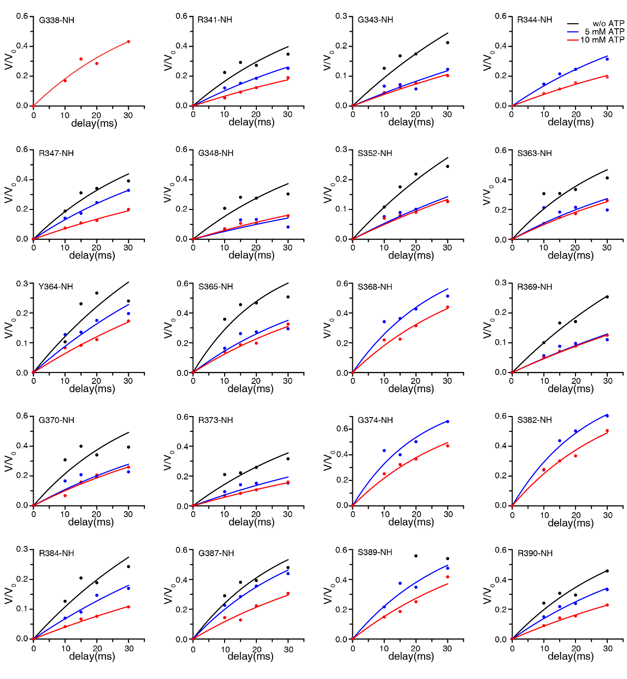
Supplementary Fig. 3 Experimental CLEANEX-PM build-up curves for the backbone amide peaks of HNRNPG-RGG.
The data of experimental CLEANEX-PM of RGG domain in the absence (black) and presence of ATP (red and blue) are shown. Note that some data points were missing due to poor signal, which prevented us from fitting the whole kinetic rate curve.

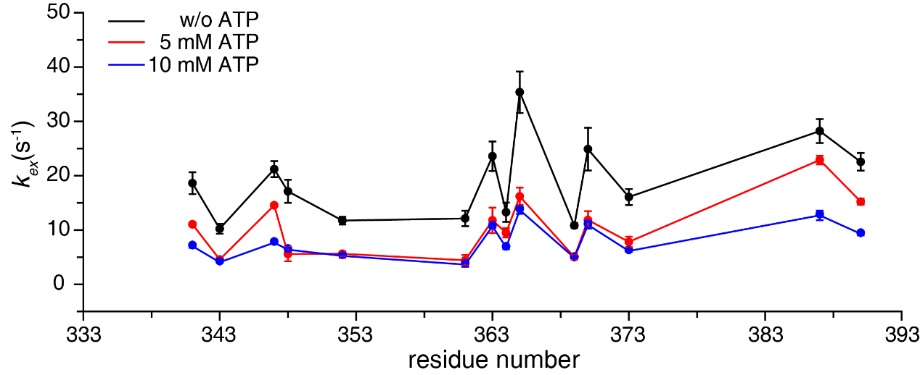

Supplementary Fig. 4 Water-amide hydrogen exchange rates measured for HNRNPG-RGG.
The exchange rates (k_{ex}) of the RGG domain were measured by CLEANEX-PM ¹ in the absence (black) and presence of 5, 10 mM ATP (red and blue).

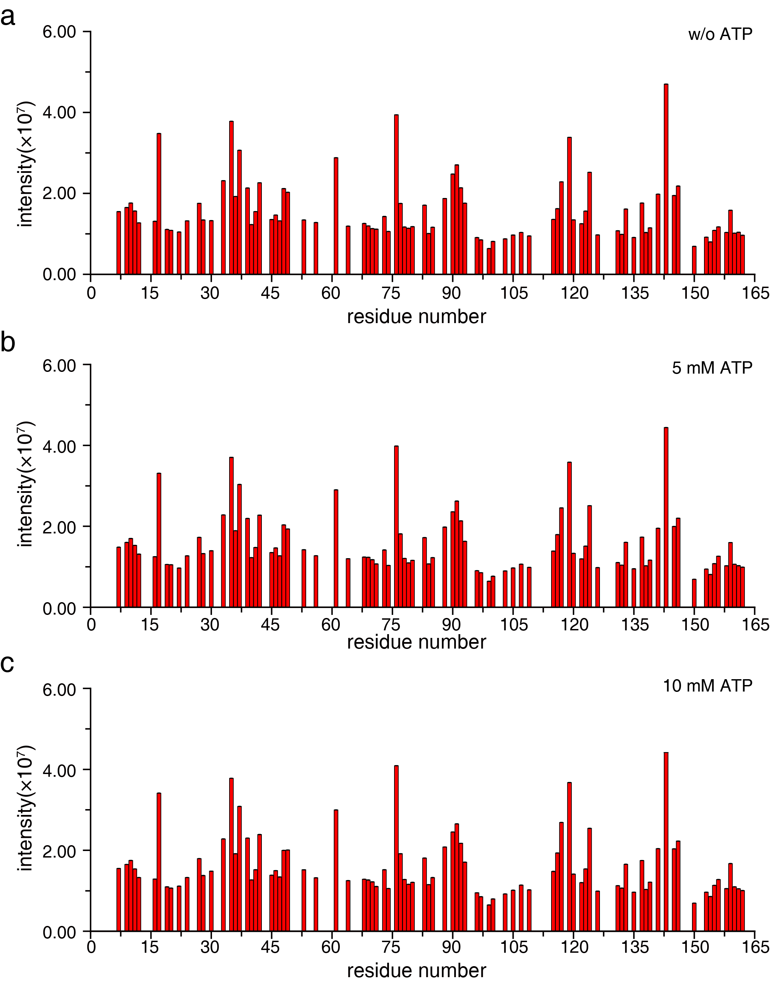
Supplementary Fig. 5 Peak intensity for the backbone amide of FUS PLD domain.
Peak intensities of the PLD domain are plotted in the absence of ATP (a) and the presence of 5 mM ATP (b) and 10 mM ATP (c).

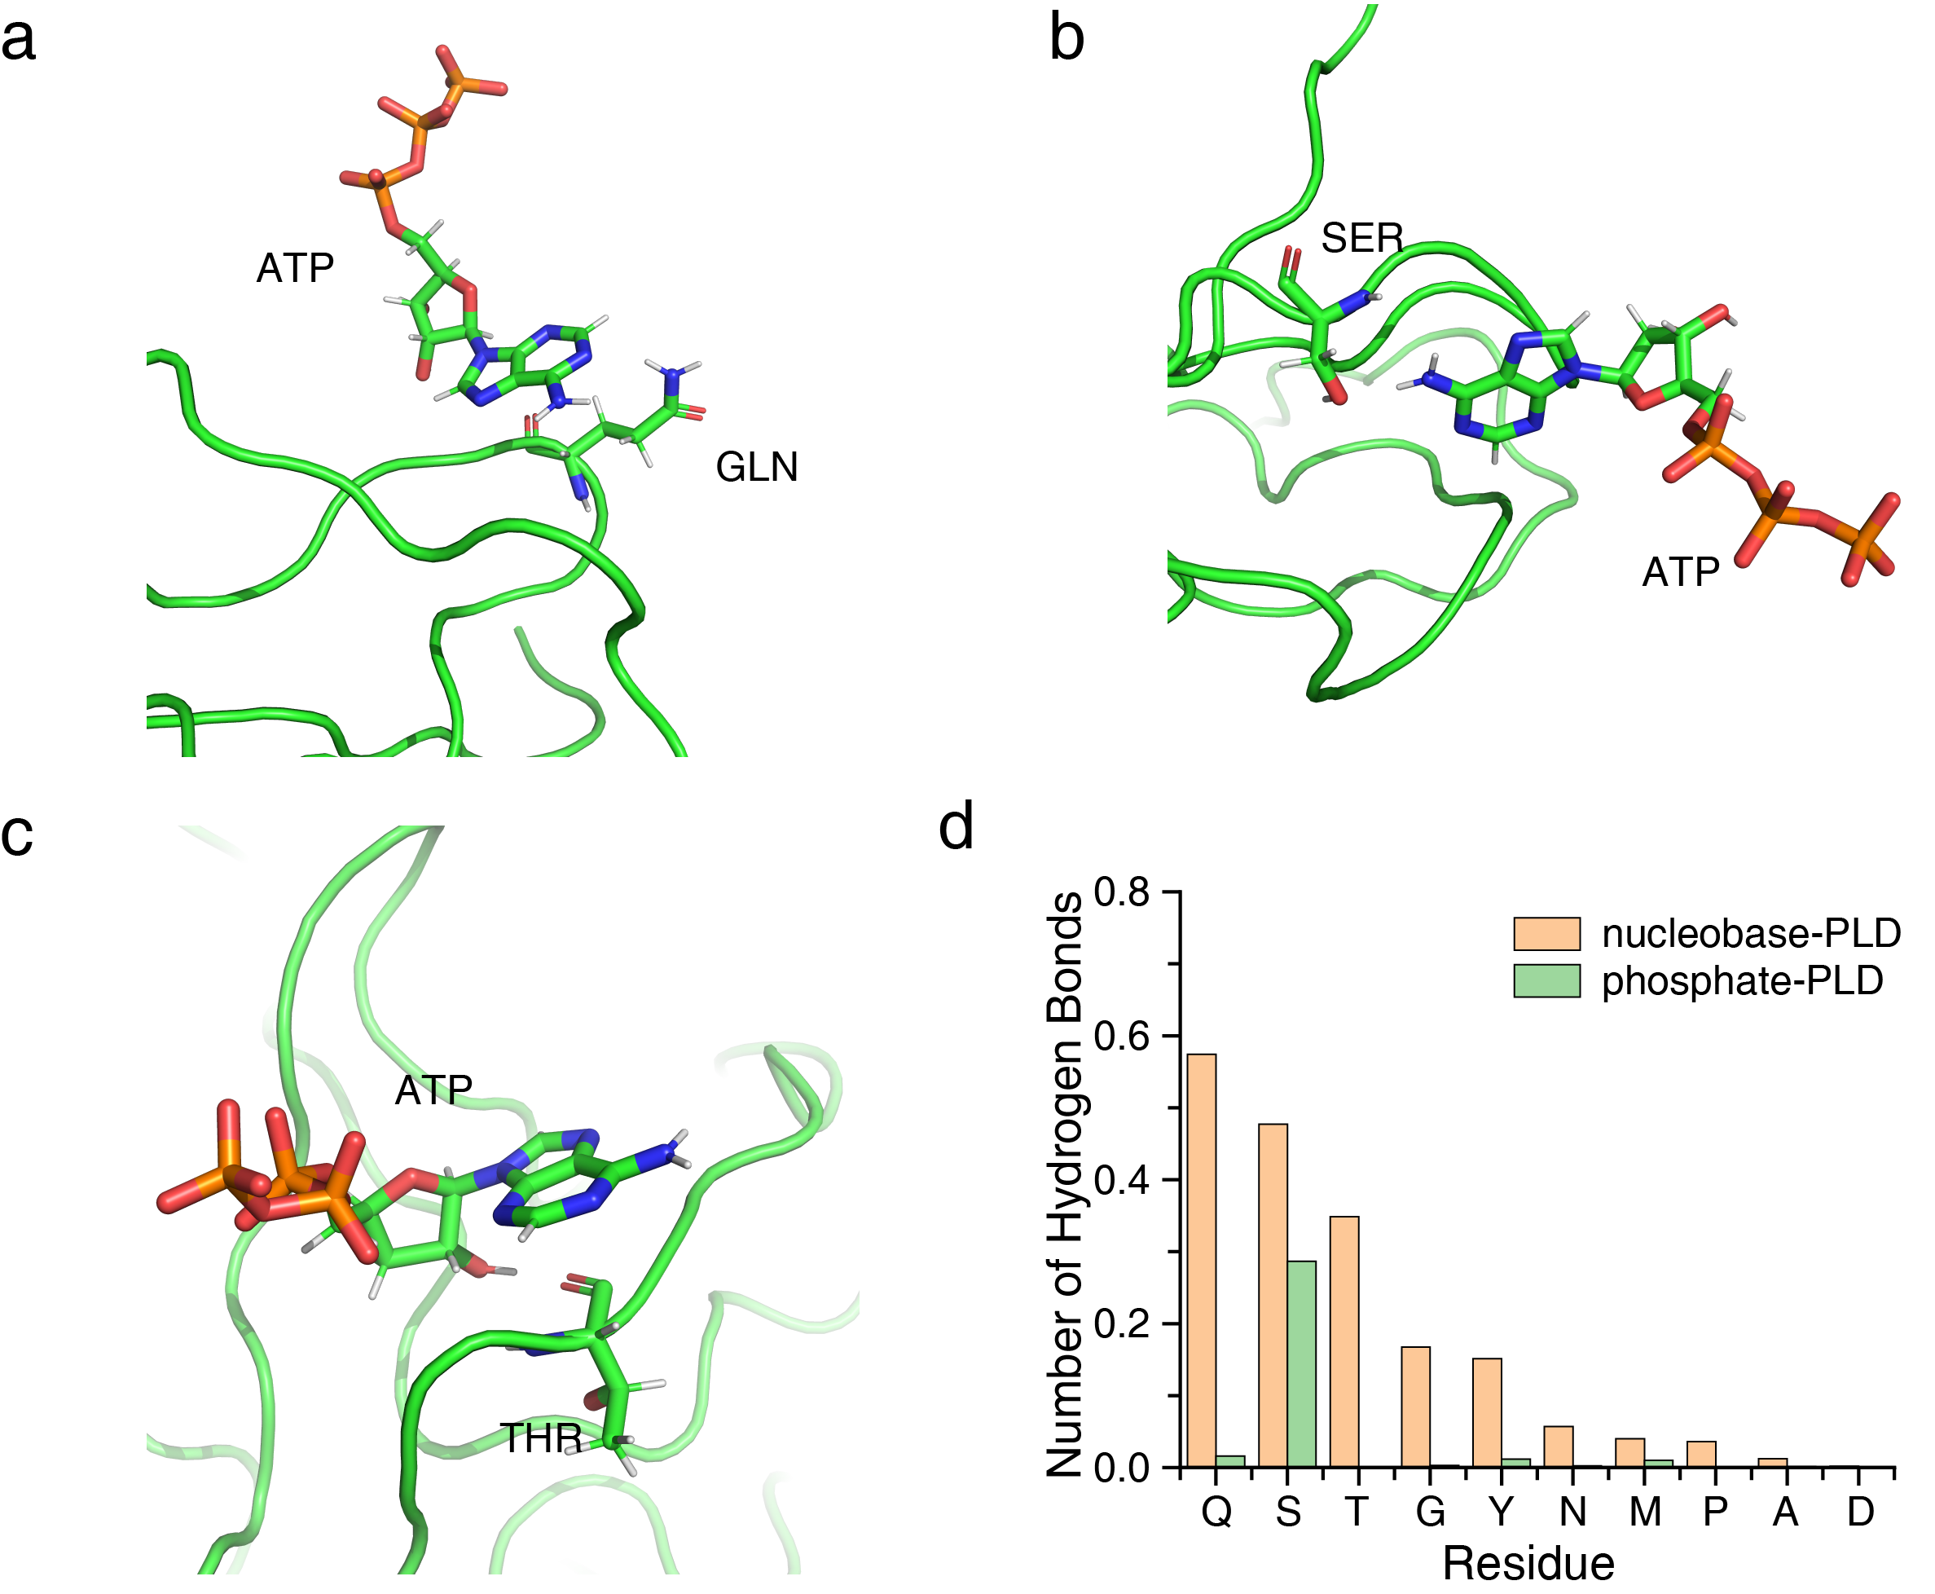
Supplementary Fig. 6 Structural models for the ATP-associated FUS-PLD
a-c Representative snapshots from MD simulation indicate that ATP phosphate group interacts with Gln, Ser and Thr sidechain, respectively. b Statistics of the number of the hydrogen bonds formed between ATP and different protein residues, with the phosphate and nucleobase groups tabulated separately.
1. Hwang, T. L., Mori, S., Shaka, A. J. & vanZijl, P. C. M. Application of phase-modulated CLEAN chemical EXchange spectroscopy (CLEANEX-PM) to detect water-protein proton exchange and intermolecular NOEs. J Am Chem Soc 119, 6203-6204 (1997).

