Additional File 3: Key results of sensitivity analysis using balanced data

Matthijs Blankers, Louk F. M. van der Post, Jack J. M. Dekker

Figure 1. Comparison of AUC scores for the ten machine learning based models
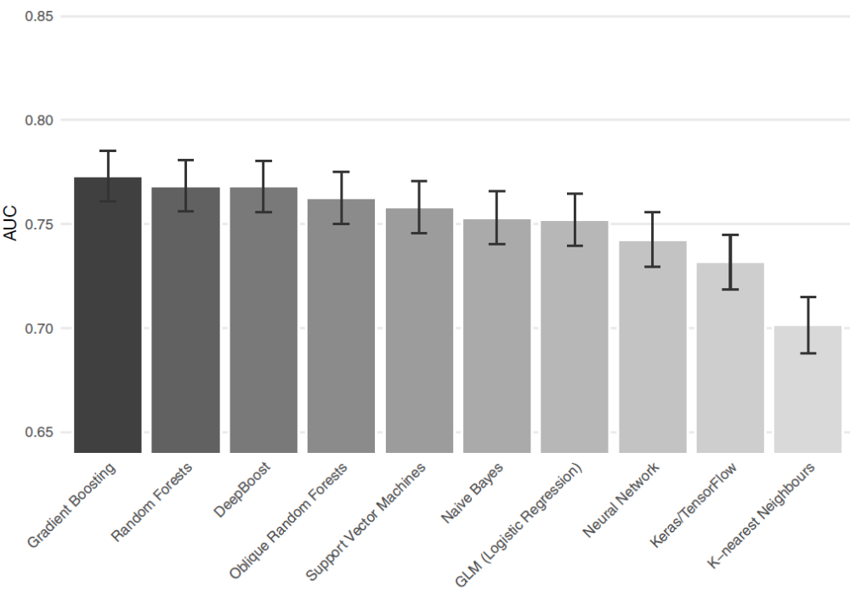
Note. AUC (or c-statistic) indicates the performance of the ten models based on the machine learning algorithms. The error bars indicate +/- 1 standard error intervals.

Figure 2: Overall variable importance plot for the machine learning based models
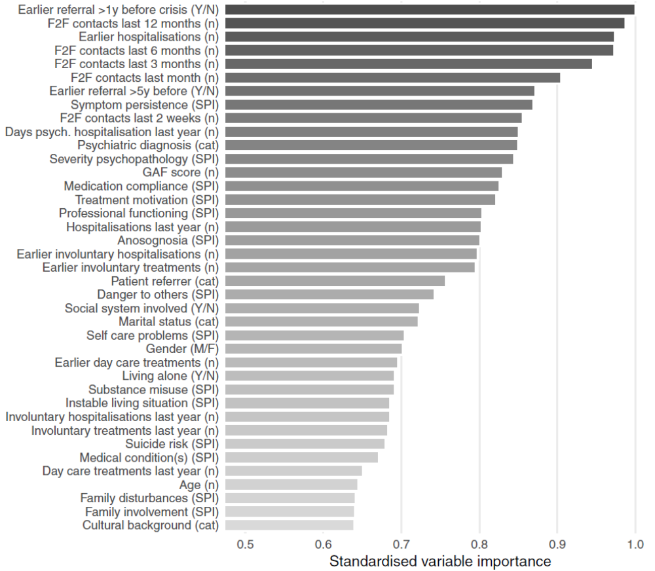
Note. This plot presents the 39 predictors (before dummy-recoding) in descending order of unique predictive value. (n) indicates a numeric variable, (cat) indicates the variable is categorical, (SPI) indicates the variable is part of the SPI instrument, (M/F) and (Y/N) variables are dichotomous. Psychiatric care register data have a 5-year time horizon unless otherwise indicated.
Net Reclassification Improvement Gradient Boosting vs. K-nearest Neighbors

## Proportions of Subjects with Improvement in Predicted Probability
##
## Number of events: 710 Number of non-events: 710
##
## Proportions of Positive and Negative Changes in Probabilities
##
## Proportion
## Increase for events (1) 0.1563
## Increase for non-events (2) 0.0986
## Decrease for events (3) 0.0915
## Decrease for non-events (4) 0.1521
##
##
## Net Reclassification Improvement
##
## Index SE Z 2P Lower 0.95 Upper 0.95
## NRI (1-3+4-2) 0.1183 0.0263 4.50 6.91e-06 0.0667 0.1699
## NRI events (1-3) 0.0648 0.0185 3.50 4.70e-04 0.0285 0.1011
## NRI non-events (4-2) 0.0535 0.0187 2.86 4.17e-03 0.0169 0.0901
##

Net Reclassification Improvement GLM/logistic regression vs. K-nearest Neighbors

## Proportions of Subjects with Improvement in Predicted Probability
##
## Number of events: 710 Number of non-events: 710
##
## Proportions of Positive and Negative Changes in Probabilities
##
## Proportion
## Increase for events (1) 0.1310
## Increase for non-events (2) 0.1028
## Decrease for events (3) 0.0958
## Decrease for non-events (4) 0.1338
##
##
## Net Reclassification Improvement
##
## Index SE Z 2P Lower 0.95 Upper 0.95
## NRI (1-3+4-2) 0.0662 0.0255 2.60 0.00939 0.01625 0.1161
## NRI events (1-3) 0.0352 0.0178 1.98 0.04819 0.00028 0.0701
## NRI non-events (4-2) 0.0310 0.0182 1.70 0.08898 -0.00472 0.0667
##

Net Reclassification Improvement Gradient Boosting vs. GLM/logistic regression

## Proportions of Subjects with Improvement in Predicted Probability
##
## Number of events: 710 Number of non-events: 710
##
## Proportions of Positive and Negative Changes in Probabilities
##
## Proportion
## Increase for events (1) 0.0704
## Increase for non-events (2) 0.0577
## Decrease for events (3) 0.0408
## Decrease for non-events (4) 0.0803
##
##
## Net Reclassification Improvement
##
## Index SE Z 2P Lower 0.95 Upper 0.95
## NRI (1-3+4-2) 0.0521 0.0187 2.79 0.00529 0.01549 0.0887
## NRI events (1-3) 0.0296 0.0125 2.37 0.01769 0.00514 0.0540
## NRI non-events (4-2) 0.0225 0.0139 1.62 0.10540 -0.00474 0.0498
##

