SUPPLEMENT FIGURES
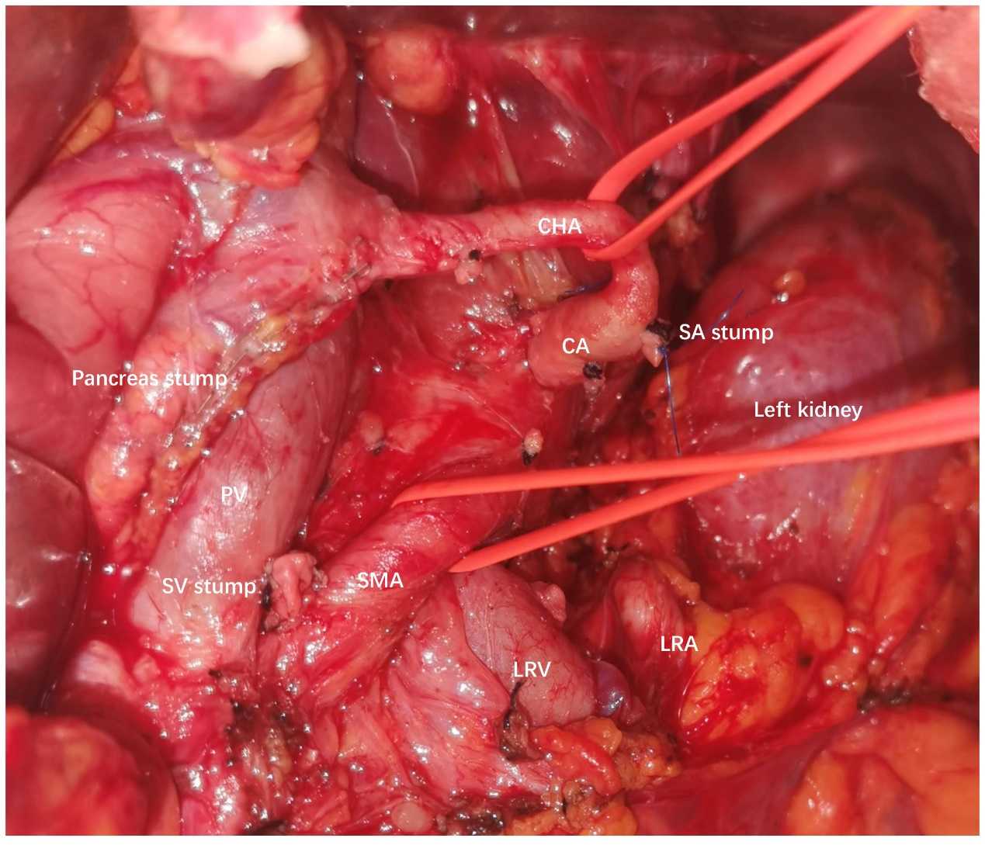
Supplement Figure 1. Picture of surgical field after posterior RAMPS. CA, celiac axis. SMA, superior mesenteric artery. CHA, common hepatic artery. SA, splenic artery. SV, splenic vein. LRA, left renal artery. LRV, left renal vein. PV, portal vein.
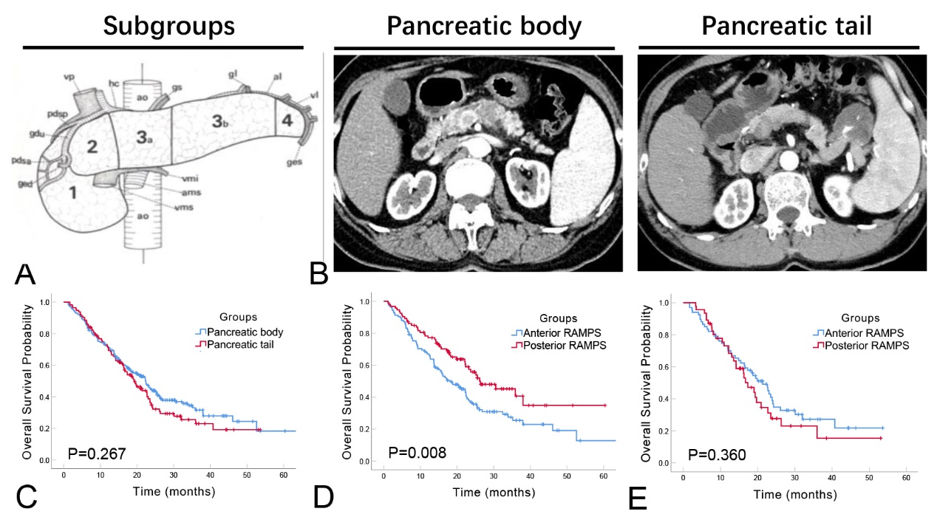
Supplement Figure 2. A) The sketch map of the sub-segment groups according to the study by Deki and Sato (‘3a’ and ‘3b’ for pancreatic body, ‘4’ for pancreatic tail). B) CT images of the pancreatic body and pancreatic tail subgroups. C) Comparison of OS among the pancreatic body and pancreatic tail subgroups. D) Comparison of OS between anterior and posterior RAMPS in pancreatic body subgrproup before PSM. E) Comparison of OS in pancreatic tail subgroup.
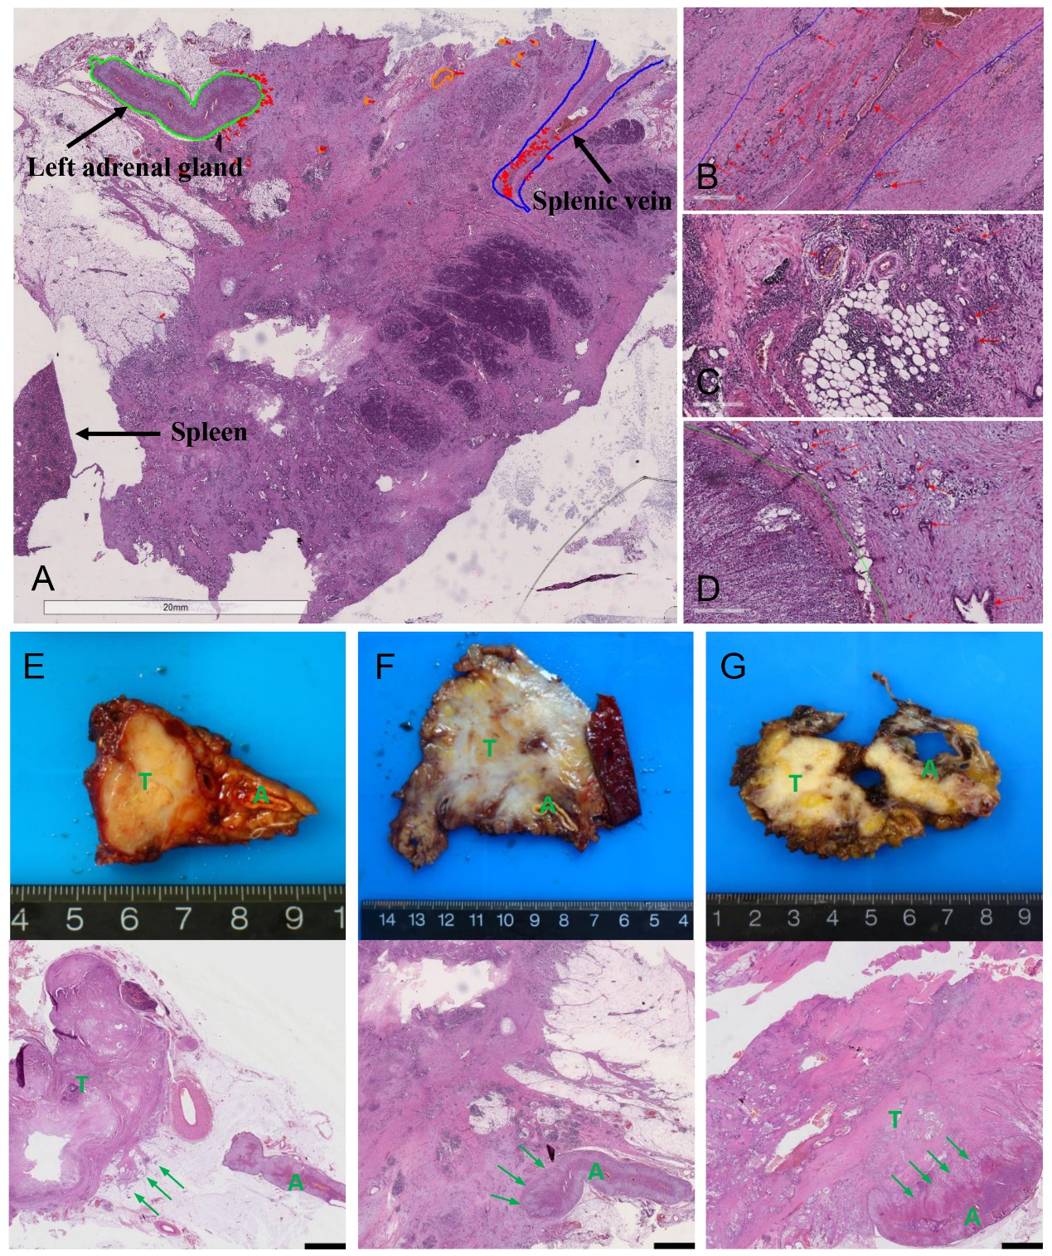
Supplemental Figure 3. A) Whole-slide pathological images of pancreatic body adenocarcinoma to show splenic vein invasion, peripancreatic nerve infiltration and left adrenal gland invasion. B, C, D) Enlarged pathogical images of splenic vein invasion, peripancreatic nerve infiltration and left adrenal gland invasion. The ‘red’ and ‘orange’ refer to cancer cells and peripancreatic nerves respectively. E) Whole-slide pathological images of pancreatic body adenocarcinoma which broke through the tumor capsule but not invaded the adrenal gland; F) which invaded the adrenal gland capsule; G) which invaded into the adrenal gland. Green arrows refer to cancer cells. The ‘A’, ‘S’, ‘T’ in green font refer to adrenal gland, spleen and pancreatic tumor. Scar bar, 20 mm for figure A, 500 μm for figure B, 300 μm for figures C and D, 3mm for figures E, F and G.

