SUPPORTING INFORMATION

Effects of chronic voluntary alcohol consumption on PDE10A availability: a longitudinal behavioural and [¹⁸F]JNJ42259152 PET study in rats
Bart de Laat PhD^{1*}, Yvonne E. Klingl MSc^{2,3*}, Gwen Schroyen MSc⁴, Maarten Ooms PhD⁵, Jacob M Hooker PhD⁶, Guy Bormans PhD⁵, Koen Van Laere MD PhD DSc^{1,7}, Jenny Ceccarini PhD¹

*both authors contributed equally to this work

Supplementary Figure 1. PDE10A BP_{ND} changes during the intermittent access to ethanol (IAE) animal model in function of the alcohol consumption

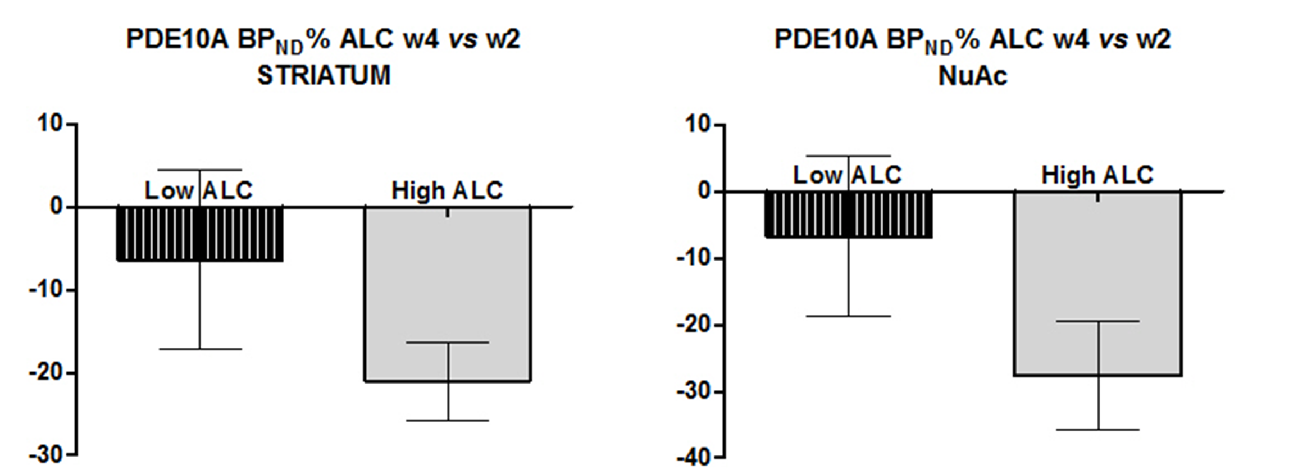

Percentage changes of PDE10A binding potential (BP_{ND}) at alcohol exposure week 4 of the intermittent access to ethanol (IAE) model, compared to week 2, in function of (left) alcohol consumption (mean ± SEM), and (right) OFT locomotor activity changes normalized to the baseline condition (BL). High ALC = rats who reported a higher alcohol consumption and preference above the mean during the first phase of the IAE model (w2 and w3, see Figure 2); NuAc = nucleus accumbens.

