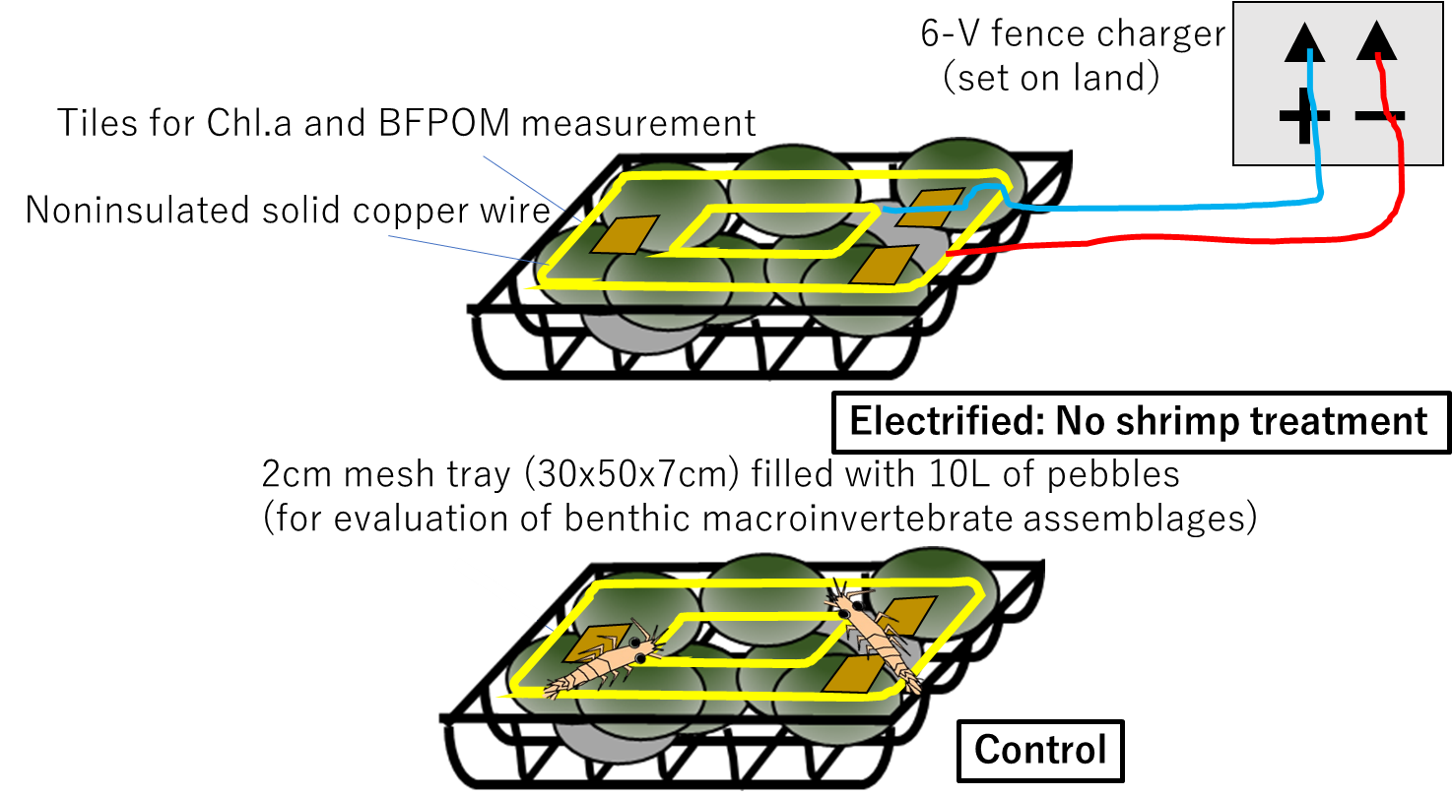

Figure S1: Design of the electroshock experiment used in this study.

Table S1: Environment and watershed characters of each sampling site for the field survey.

Table S2: (A) Correlation coefficient and (B) variance inflation factors (VIF) among all variables of the sampling site. There was a high degree of collinearity and VIF scores between the shrimp presence and the elevation and between the shrimp presence and shrimp density. Therefore, we excluded the shrimp presence from the analyses.

Table S3
Effect of shrimp presence
ANOVA table electroshock experiment lmer() block as random effect

Table S4. Top models with ΔAICc<4 and the confidence set used for model averaging. df is the
number of parameters in each model including the intercept and error terms, logLik is the log-likelihood, ΔAICc is the difference between the top model AICc value and subsequent model AICc values and weight is the model weight for each model.

