Brain multi-contrast, multi-atlas segmentation of diffusion tensor imaging and ensemble learning automatically diagnose late-life depression
Kostas Siarkos^{1*}, Efstratios Karavassilis^{2,3}, Georgios Velonakis³,
Charalabos Papageorgiou⁴, Nikolaos Smyrnis⁵, Nikolaos Kelekis³, Antonios Politis^{1,6}

¹Division of Geriatric Psychiatry, First Department of Psychiatry, National and Kapodistrian University of Athens, Athens, Greece.
²Medical School, Democritus University of Thrace, Alexandroupolis, Greece
³Second Department of Radiology, Attikon General University Hospital, School of Medicine, National and Kapodistrian University of Athens, Athens, Greece
⁴First Department of Psychiatry, School of Medicine, Eginition Hospital, National and Kapodistrian University of Athens, Athens, Greece
⁵Second Department of Psychiatry, Attikon General University Hospital, School of Medicine, National and Kapodistrian University of Athens, Athens, Greece
⁶Department of Psychiatry, Division of Geriatric Psychiatry and Neuropsychiatry, Johns Hopkins Medical School, Baltimore, USA

Supplemental Methods

DTI and data processing
Subjects were positioned in supine position lying comfortably in the scanner. Earphones were used to isolate the external noise and pads to immobilize the head. Echo planar imaging was acquired using a rotated frame of reference known as "Gradient Overplus'' (Philips Medical Systems) that results in greater gradient strength and shorter TE values. The raw DICOM files were downloaded and processed on a local PC running in Windows. Before the data were submitted for imaging analysis in MRIcloud, the DWI images were converted to a 4D raw image matrix format (*.raw) and an image data information parameter file (*.dpf) using the DwiDcm2DpfRaw.exe converter provided by MRIcloud.

Image quantification and feature extraction
Of the 168 parcels initially segmenting the whole brain, 22 regions were discarded- non-brain (CSF: 1 parcel; ventricle system: 11 parcels), data were not reported for all subjects (mammillary bodies: 2 parcels; two hypothalamic sub regions; the left and right red nuclei; the left and right superior fronto-occipital fasciculus, and the two optic tracts) and thus 146 ROIs were analyzed. Parallel and perpendicular to the principal diffusion direction - axial diffusivity (AD) and radial diffusivity (RD), respectively quantify the magnitude of diffusion and radial diffusivity (RD) is the average of the second, λ2, and third, λ3, diffusion eigenvalues.

Machine learning analysis
There was no missing data. We trained and tested the AdaBoost (Freund & Schapire 1997. Zhu et al., 2009) ensemble algorithm for its effectiveness in small, moderately unbalanced samples (Shahri et al., 2021) control on overfitting (especially when used with cross validation), practicality, relatively lower complexity, and interpretable feature evaluation.

Classifier
In Scikit-learn, the algorithm sequentially fits a series of weak learners (i.e., two terminal-node decision tree stumps with max depth = 1) on weighted versions of the data to produce a strong classifier. In this process, weights determined by the features’ importance in predicting the class in the last iteration are assigned to the stumps, so that weaker classifiers receive greater weights in the next iteration, thereby boosting their predictive ability. Initially, all weights are set to w_{i} = 1/N having the weak learner trained on all the original data. The predictions obtained from all iterations are combined through majority vote, to reveal the final prediction probability.
Given the small sample size, reserving separate data for independent tests may not be feasible. Thus, a 12-fold cross validation was used to train and test/evaluate the classifiers’ performance. Using a stratified 12-fold cross validation, 2 LLD and one HC were left out as test fold during each iteration. Combined with Adaboost, multiple performance estimates are made providing a mean estimate of the model’s performance on unseen data. In total, 1800 models (12x30, for each WM metric) have been developed and evaluated for our study.

Table S1 Regions with statistically significant differences between the groups in Mann-Whitney test and their significance level listed in descending order

Regions | Raw p-values
FA Volume
fornix-stria terminalis R | p=0.005
retro lenticular internal capsule L | p=0.005
inferior cerebellar peduncle L | p=0.011
cerebral peduncle L | p=0.012
corticospinal tract R | p=0.021
retro-lenticular internal capsule R | p=0.021
cerebellum branch A L | p=0.023
superior temporal gyrus R gm | p=0.025
corticospinal tract L | p=0.03
sagittal stratum R | p=0.03
cuneus R gm | p=0.03
cingulum R | p=0.033
posterior corona radiata L | p=0.033
cingulate gyrus L gm | p=0.045
inferior frontal gyrus L gm | p=0.045
reticular formation R | p=0.049
FA
medulla L | p=0.011
midbrain L | p=0.042
Trace
lingual gyrus R gm | p=0.028
cerebellum | p=0.03
medulla L | p=0.042
AD
cerebellum | p=0.03
RD
cerebellum | p=0.023
medulla L | p=0.033

Gm, grey matter; L, left; R, right.

Fig. S1 Schematic representation of the automatic image segmentation pipeline with a description for each step (1 to 8). Note: The “subject AD” map output, also generated at step 8, is not shown. AIR: Automated Image Registration. LDDMM: Large Deformation Diffeomorphic Metric Mapping

Fig. S2 Violin plots of the classification performances for each evaluation metric

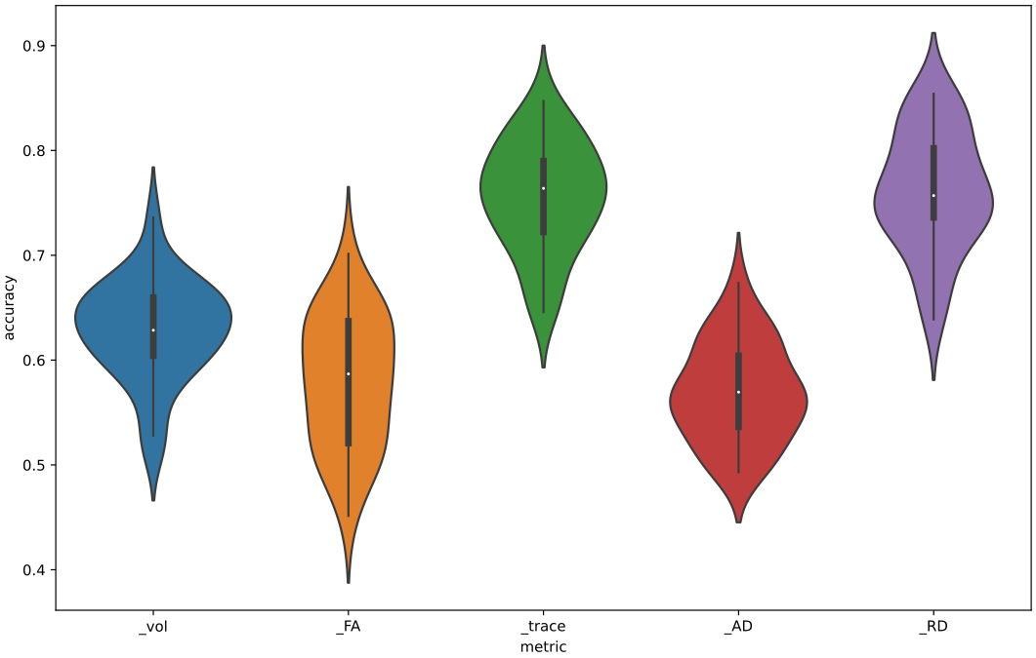
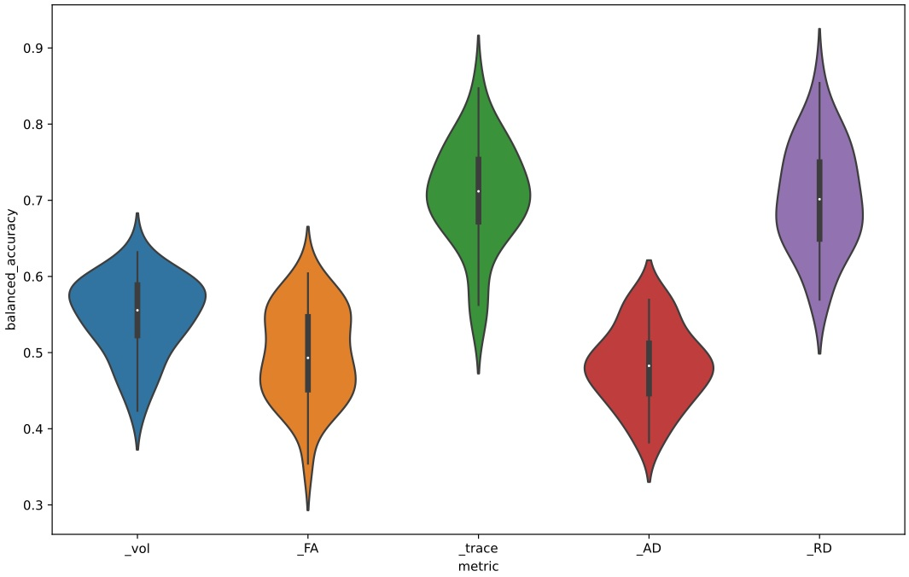
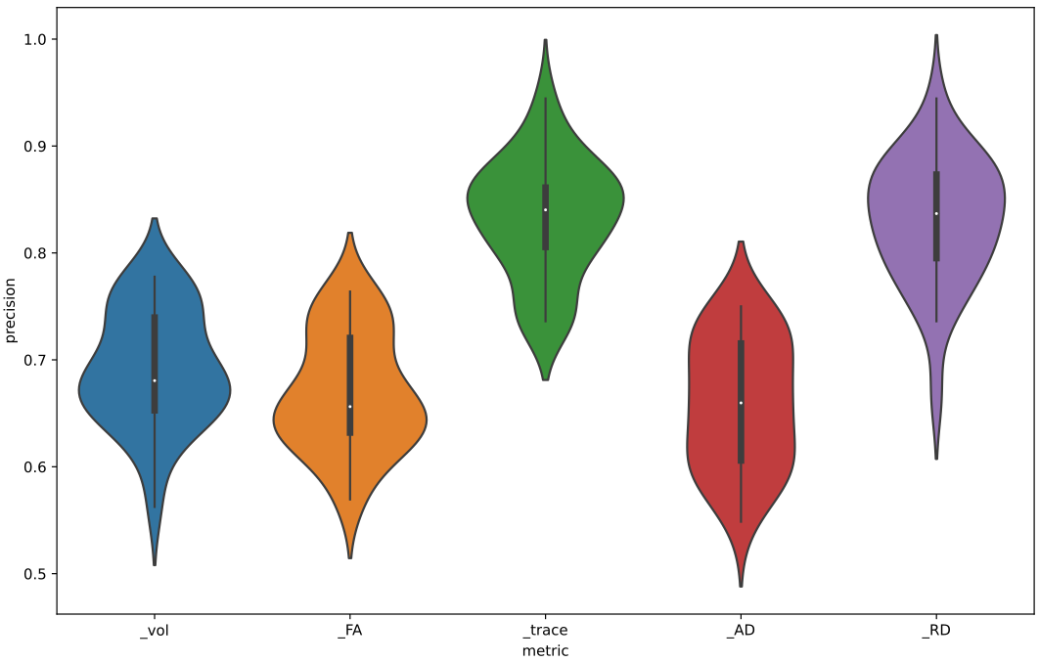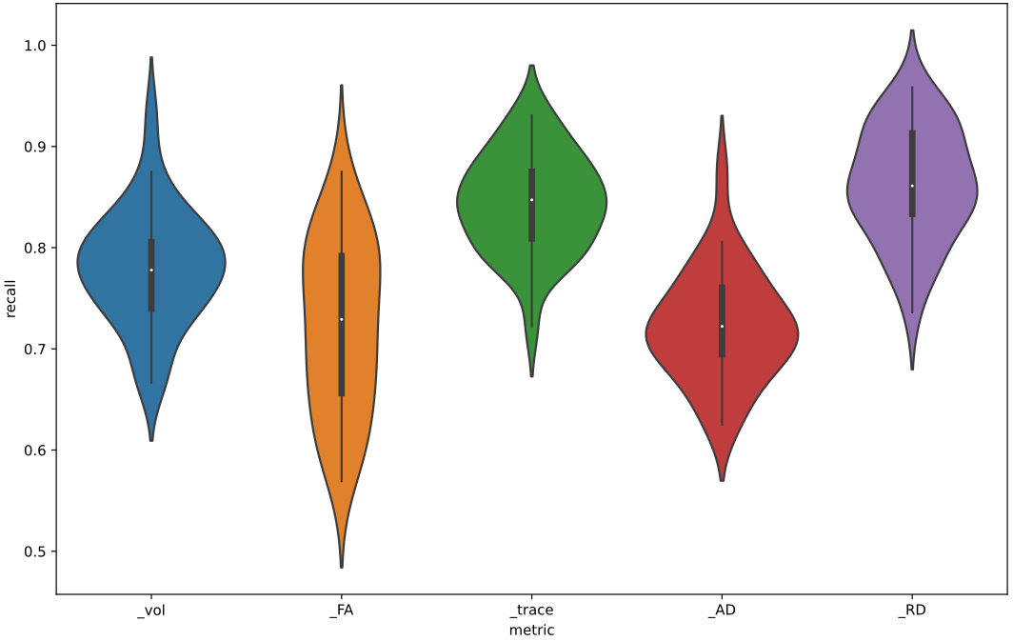

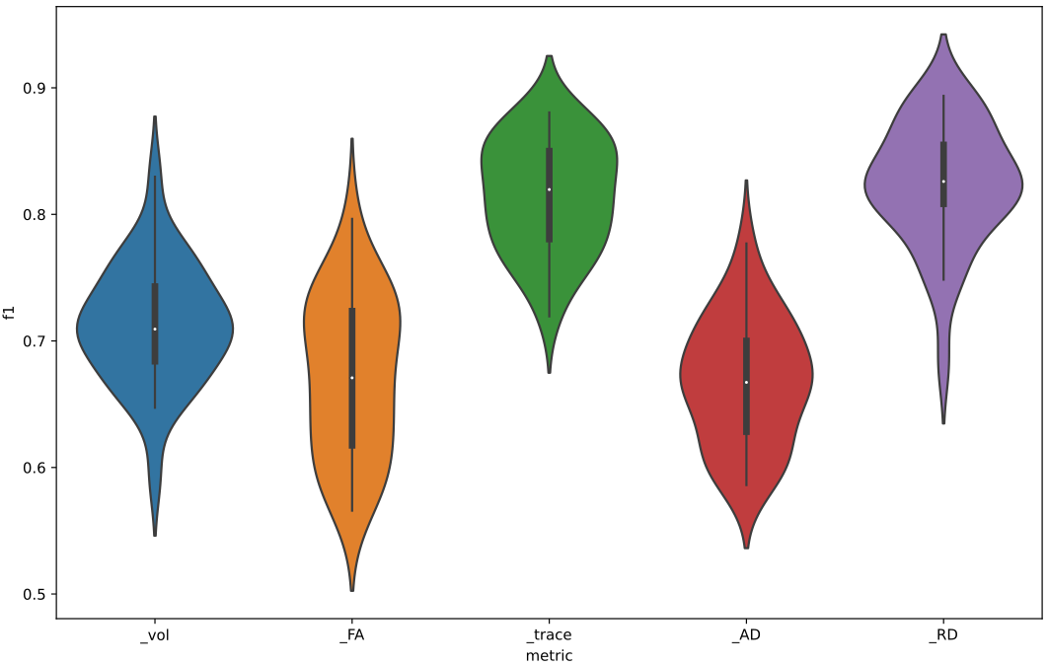
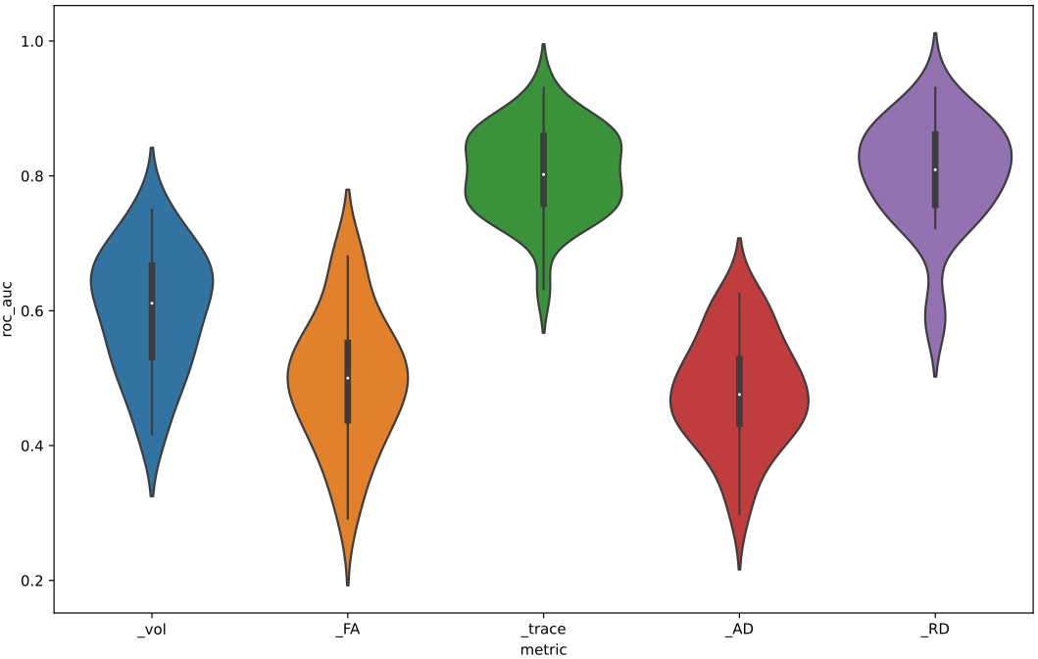

Appendix 1. All WM structures defined in the original parcellation maps currently featured in MRIcloud and used in the present study

Structure# | Structure Label
1 | SUPERIOR PARIETAL GYRUS left (gm)
2 | CINGULATE GYRUS left (gm)
3 | SUPERIOR FRONTAL GYRUS left (gm)
4 | MIDDLE FRONTAL GYRUS left (gm)
5 | INFERIOR FRONTAL GYRUS left (gm)
6 | PRECENTRAL GYRUS left (gm)
7 | POSTCENTRAL GYRUS left (gm)
8 | ANGULAR GYRUS left (gm)
9 | PRE-CUNEUS left (gm)
10 | CUNEUS left (gm)
11 | LINGUAL GYRUS left (gm)
12 | FUSIFORM GYRUS left (gm)
13 | PARAHIPPOCAMPAL GYRUS left (gm)
14 | SUPERIOR OCCIPITAL GYRUS left (gm)
15 | INFERIOR OCCIPITAL GYRUS left (gm)
16 | MIDDLE OCCIPITAL GYRUS left (gm)
17 | ENTORHINAL AREA left (gm)
18 | SUPERIOR TEMPORAL GYRUS left (gm)
19 | INFERIOR TEMPORAL GYRUS left (gm)
20 | MIDDLE TEMPORAL GYRUS left (gm)
21 | LATERAL FRONTO-ORBITAL GYRUS left (gm)
22 | MIDDLE FRONTO-ORBITAL GYRUS left (gm)
23 | SUPRAMARGINAL GYRUS left (gm)
24 | GYRUS RECTUS left (gm)
25 | INSULAR left (gm)
26 | AMYGDALA left
27 | HIPPOCAMPUS left
28 | CEREBELLUM left
29 | Corticospinal Tract left
30 | Inferior Cerebellar Peduncle left
31 | Medial Lemniscus left
32 | Superior Cerebellar Peduncle left
33 | Cerebral Peduncle left
34 | Anterior Limb of Internal Capsule left
35 | Posterior Limb of Internal Capsule left
36 | Posterior Thalamic Radiation left
37 | Anterior Corona Radiata left
38 | Superior Corona Radiata left
39 | Posterior Corona Radiata left
40 | Cingulum left
41 | Cingulum Hippocampal left
42 | Fornix Stria Terminalis left
43 | Superior Longitudinal Fasciculus left
44 | Superior Fronto-occipital Fasciculus left
45 | InferiorFronto-occipitalFasciculus left
46 | SagittalStratum left
47 | ExternalCapsule left
48 | UncinateFasciculus left
49 | PontineCrossingTract left
50 | MiddleCerebellarPeduncle left
51 | Fornix left
52 | Genu of Corpus Callosum left
53 | Body of Corpus Callosum left
54 | Splenium of Corpus Callosum left
55 | Retrolenticular Internal Capsule left
56 | Red Nucleus left
57 | Substantia Nigra left
58 | Tapetum left
59 | CAUDATE NUCLEUS left
60 | PUTAMEN left
61 | THALAMUS left
62 | GLOBUS PALLIDUS left
63 | MIDBRAIN left
64 | Reticular formation left
65 | MEDULLA left
66 | SUPERIOR PARIETAL GYRUS right (gm)
67 | CINGULATE GYRUS right (gm)
68 | SUPERIOR FRONTAL GYRUS right (gm)
69 | MIDDLE FRONTAL GYRUS right (gm)
70 | INFERIOR FRONTAL GYRUS right (gm)
71 | PRECENTRAL GYRUS right (gm)
72 | POSTCENTRAL GYRUS right (gm)
73 | ANGULAR GYRUS right (gm)
74 | PRECUNEUS right (gm)
75 | CUNEUS right (gm)
76 | LINGUAL GYRUS right (gm)
77 | FUSIFORM GYRUS right (gm)
78 | PARAHIPPOCAMPAL GYRUS right (gm)
79 | SUPERIOR OCCIPITAL GYRUS right (gm)
80 | INFERIOR OCCIPITAL GYRUS right (gm)
81 | MIDDLE OCCIPITAL GYRUS right (gm)
82 | ENTORHINAL AREA right (gm)
83 | SUPERIOR TEMPORAL GYRUS right (gm)
84 | INFERIOR TEMPORAL GYRUS right (gm)
85 | MIDDLE TEMPORAL GYRUS right (gm)
86 | LATERAL FRONTO-ORBITAL GYRUS right (gm)
87 | MIDDLE FRONTO-ORBITAL GYRUS right (gm)
88 | SUPRAMARGINAL GYRUS right (gm)
89 | GYRUS RECTUS right (gm)
90 | INSULAR right (gm)
91 | AMYGDALA right
92 | HIPPOCAMPUS right
93 | CEREBELLUM right
94 | Corticospinal Tract right
95 | Inferior Cerebellar Peduncle right
96 | Medial Lemniscus right
97 | Superior Cerebellar Peduncle right
98 | Cerebral Peduncle right
99 | Anterior Limb of Internal Capsule right
100 | Posterior Limb of Internal Capsule right
101 | Posterior Thalamic Radiation right
102 | Anterior Corona Radiata right
103 | Superior Corona Radiata right
104 | Posterior Corona Radiata right
105 | Cingulum right
106 | Cingulum Hippocampal right
107 | Fornix Stria Terminalis right
108 | Superior Longitudinal Fasciculus right
109 | Superior Fronto-occipital Fasciculus right
110 | Inferior Fronto-occipital Fasciculus right
111 | Sagittal Stratum right
112 | External Capsule right
113 | Uncinate Fasciculus right
114 | Pontine Crossing Tract right
115 | Middle Cerebellar Peduncle right
116 | Fornix right
117 | Genu of Corpus Callosum right
118 | Body of Corpus Callosum right
119 | Splenium of Corpus Callosum right
120 | Retrolenticular Internal Capsule right
121 | Red Nucleus right
122 | Substantia Nigra right
123 | Tapetum right
124 | CAUDATE NUCLEUS right
125 | PUTAMEN right
126 | THALAMUS right
127 | GLOBUS PALLIDUS right
128 | MIDBRAIN right
129 | Reticular formation right
130 | MEDULLA right
131 | Nucleus accumbens left
132 | Nucleus accumbens right
133 | Hypothalamus A left
134 | Hypothalamus A right
135 | OpticTract left
136 | OpticTract right
137 | Hypothalamus B left
138 | Hypothalamus B right
139 | Mammillary body right
140 | Mammillary body left
141 | Hypothalamus C left
142 | Hypothalamus C right
143 | Hypothalamus D left
144 | Hypothalamus D right
145 | Hypothalamus E left
146 | Hypothalamus E right
147 | Hypothalamus F left
148 | Hypothalamus F right
149 | LVL_frontal left
150 | LVL_frontal right
151 | LVL_body left
152 | LVL_body right
153 | LVL_atrium left
154 | LVL_atrium right
155 | LVL_occipital left
156 | LVL_occipital right
157 | LVL_temporal left
158 | LVL_temporal right
159 | III and IV ventricle
160 | Superior Longitudinal Fasciculus-t left
161 | Superior Longitudinal Fasciculus-t right
162 | ICP-cerebellum left
163 | ICP-cerebellum right
164 | Cerebellum Branch-A left
165 | Cerebellum Branch-A right
166 | Cerebellum Branch-B left
167 | Cerebellum Branch-B right
168 | CSF

