Supplementary Figures:

Supplementary Fig. 1 | Quality control of cross-tissue snRNA-seq data.
a, Boxplot showing the number of UMIs in 19 tissues. The horizontal line in the boxplots corresponds to the median, the box bounds indicate the 25th and 75th percentiles and the whiskers represent 1.5 times the interquartile range. Values outside the whiskers are displayed as points.
b, Boxplot showing the number of detected genes in 19 tissues.
c, Boxplot showing the proportion of mitochondria reads in 19 tissues.
d, Barplot showing the number of high-quality nuclei in 19 tissues after filtering.
Supplementary Fig. 2 | Spearman correlation of normalized expression levels for all protein-coding genes across seven common tissues between the two single-cell RNA-seq studies in pigs. We summarized the gene-wise expression of all high-quality cells by summing them up as the pseudo-bulk transcriptomic profiles of a tissue. The correlation coefficients are displayed in the top of each panel.

Supplementary Fig. 3 | Selected canonical marker genes for cell type annotation in pigs. Heatmap showing the expression levels of representative marker genes used to manually annotate all cell clusters in the present dataset.
Supplementary Fig. 4 | UMAP visualization and the proportion of cell clusters in 10 tissues. These tissues contain the adipose, cerebellum, cerebrum, colon, duodenum, heart, hypothalamus, ileum, jejunum, and kidney. The name and proportion of each cell population for every tissue are indicated, and definitions for abbreviations are provided in Supplementary Table 1.
Supplementary Fig. 5 | UMAP visualization and the proportion of cell clusters in nine tissues. These tissues contain the liver, lymph, muscle, ovary, pancreas, pituitary, spleen, testis, and uterus The name and proportion of each cell population for every tissue are indicated, and definitions for abbreviations are provided in Supplementary Table 1.
Supplementary Fig. 6 | Comparison of single-cell transcriptional patterns between our dataset and a public pig scRNA-seq study.
a, Single-cell transcriptional difference of the ADIPOQ gene in pig adipose tissue between two studies.
b, Single-cell transcriptional difference of the DOCK4 gene in pig heart tissue between two studies.
c, Single-cell transcriptional difference of the CD163 gene in pig liver tissue between two studies.
d-f, Single-cell transcriptional difference in the cerebellum (d), kidney (e), and spleen (f) between two studies.

Supplementary Fig. 7 | Inferred cell state for each major cell type. Cell types are ordered by the magnitude of the putative cell cycling index, with the most highly proliferative at the top and quiescent cells at the bottom of the list.

Supplementary Fig. 8 | Detailed characterization of type I and type II myofibers.
a-b, Functional annotation of differentially expressed genes between type I (a) and type II myofibers (b).
c, Correlation of genes with the largest fold changes between type I and type II myofibers in pigs and humans. The candidate gene list was retrieved from Rubenstein et al..

Supplementary Fig. 9 | The cell type annotation of epithelial cell clusters based on snRNA-seq data. UMAP visualization showing cell distribution according to cell types (left) and tissues (right).

Supplementary Fig. 10 | Differentiation trajectory inference for selected cell types from four intestinal segments.
a, Cell cycle indices for various cell types from four intestinal segments.
b, RNA velocity analysis demonstrating state transition for various cell types from four intestinal segments. The arrows represent a flow derived from the ratio of unspliced to spliced transcripts, which in turn predicts dynamic changes in cell identity. Heatmap on the right demonstrating stereotyped changes in gene expression trajectory.
c-f, Pseudotime analysis of selected cell types from colon (c), duodenum (d), ileum (e), and jejunum (f). The trajectory is colored by cell subtypes (left) or pseudotime (right) for each panel.
Supplementary Fig. 11 | Heatmap representation of genes showing cell-type-restricted expression patterns in the nine defined cell subtypes. The top 20 differentially expressed genes for each cell subtype were extracted as the representative. Color represents normalized expression levels.
Supplementary Fig. 12 | Heatmap showing the activity scores of transcription factors for each cell subtype from four intestinal segments. Each row represents one representative transcription factor, and each column represents one cell subtype.

Supplementary Fig. 13 | Dot plots depicting representative ligand-receptor interactions between various cell subtypes from four intestinal segments.

Supplementary Fig. 14 | Cell type annotation of immune cell clusters based on snRNA-seq data.
a, UMAP visualization showing cell distribution according to tissues.
b, The proportion of total immune cell types in each tissue.

Supplementary Fig. 15 | Diverse transcriptional profiles for each cell cluster in myeloid cell compartments.
a, Differentially expressed genes for each cell cluster in tissue-resident macrophages and monocytes.
b, UMAP and heatmap showing the pseudotime differentiation trajectories of monocyte and macrophage lineages.

Supplementary Fig. 16 | Diverse transcriptional profiles for each cell cluster in T cell compartments.
a, Cell cycle indices for various T cell types.
b, Differentially expressed genes for each cell cluster in T cell subpopulations.

Supplementary Fig. 17 | Correlation between known and deconvoluted cellular composition.
a, Stacked bar plots showing the known fraction of cell types in the pseudo-bulk liver samples simulated by the SCDC software.
b, Stacked bar plots showing the predicted fraction of cell types by deconvoluting the pseudo-bulk liver samples.
c, Scatter plot of known and predicted cell compositions. The Pearson correlation coefficients are displayed at the top of the panel.
d, Heatmap showing the Pearson correlation coefficients of all putative cell types with the proportion over zero.
e, Heatmap showing the Spearman correlation coefficients of 17 matching tissues between our snRNA-seq and PigGTEx samples.
f, Barplot comparing the number of cell types detected in our snRNA-seq data versus the number of those deconvoluted cell types for 17 PigGTEx tissues.

Supplementary Fig. 18 | Stacked bar plots showing the fraction of cell types estimated in PigGTEx RNA-seq samples based on our snRNA-seq reference matrix in 16 tissues. These tissues contain the adipose, cerebellum, cerebrum, colon, duodenum, heart, hypothalamus, ileum, jejunum, kidney, liver, lymph, ovary, pancreas, pituitary, spleen, testis, and uterus.
Supplementary Fig. 19 | Cell-type-specific effects of ieQTL on gene expression and complex traits.
a, Six examples showing cell-type-specific effects in different cell types. Each point represents an individual and is colored by three genotypes. Both gene expression levels and cell type enrichment values are inverse normal transformed across samples. The lines are fitted by a linear regression model using the geom_smooth function from ggplot2 (v3.3.2) in R (v4.0.2).
b, Aligned Manhattan plots of pig GWAS, ieQTL, and eQTL at the six representative loci for different traits. SNPs are colored according to the magnitude of linkage disequilibrium (r²) between adjacent SNPs pairs.

Supplementary Fig. 20 | Dot plots showing the significance of enrichment for four main trait categories. The exterior category was discarded due to the low sample size (n = 6). Each circle represents a cell type. The top 10 most highly associated cell types are labeled for each trait.

Supplementary Fig. 21 | Dot plots showing the significance of enrichment for nine trait subcategories. Each circle represents a cell type. The top 10 most highly associated cell types are labeled for each trait.

Supplementary Fig. 22 | Dot plots showing the significance of enrichment for seven representative traits. These traits contain average daily gain (ADG), backfat thickness (BFT), loin muscle area (LMA), loin muscle depth (LMDEP), total number born alive (NBA), number of stillborn pigs (NBS), and litter size (TNB). Each circle represents a cell type. The top 10 most highly associated cell types are labeled for each trait.
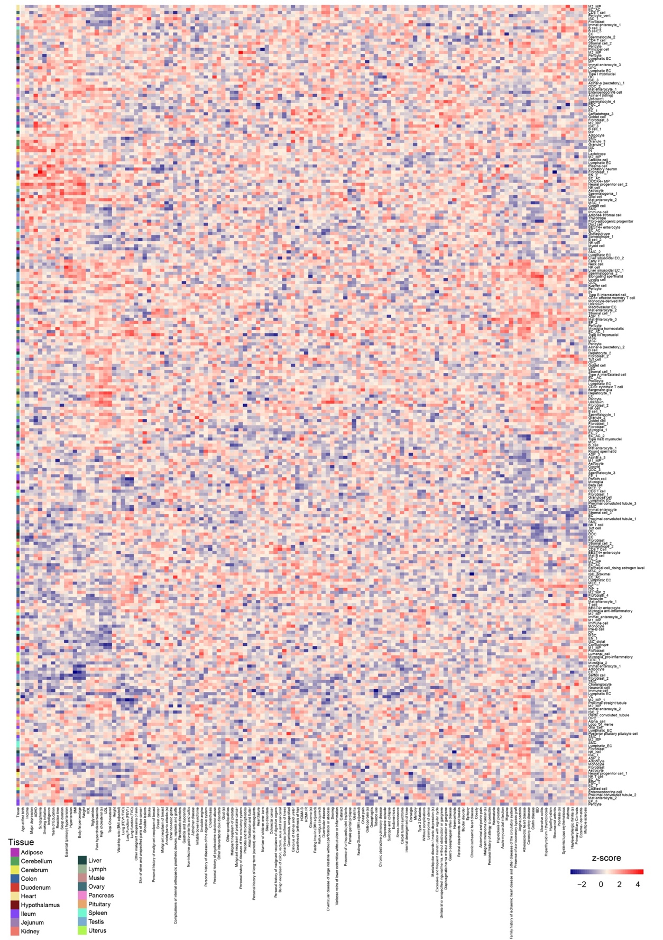
Supplementary Fig. 23 | Global cell-type-trait associations in humans. Heatmap showing enrichment of cell types associated with complex traits and diseases from genome-wide association studies in humans. Stratified linkage disequilibrium score regression (LDSC) analysis was performed using GWAS summary statistics for 137 phenotypes.

Supplementary Tables:

Supplementary Table 1: Significant genes for each cell cluster in 19 pig tissues.
Supplementary Table 2: Detailed information on 268 metaGWAS in pigs.
Supplementary Table 3: Coloc results of cell type ieQTL and eQTL with PP4 ≥ 0.50.
Supplementary Table 4: Summary of 137 GWAS in humans.
Supplementary Table 5: Association of GWAS traits and human genetic diseases with pig cell types.

