h_{BC} = 150 µm  Bond coat (NiCrAlY)  Conventional CSZ  h_{TC} = 350 µm  Substrate (IN738LC) | Bond coat (NiCrAlY)  Conventional CSZ  CSZ + (MAC) Al₂O₃ + MoSi₂  Substrate (IN738LC)  h_{BC} = 150 µm  h₁ = 200 µm  h₂ = 150 µm
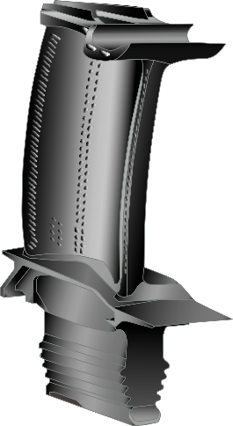
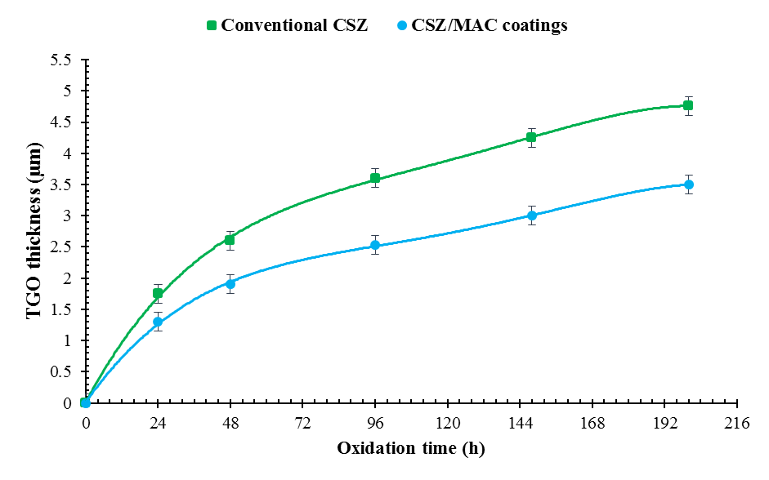
Graphical abstract

