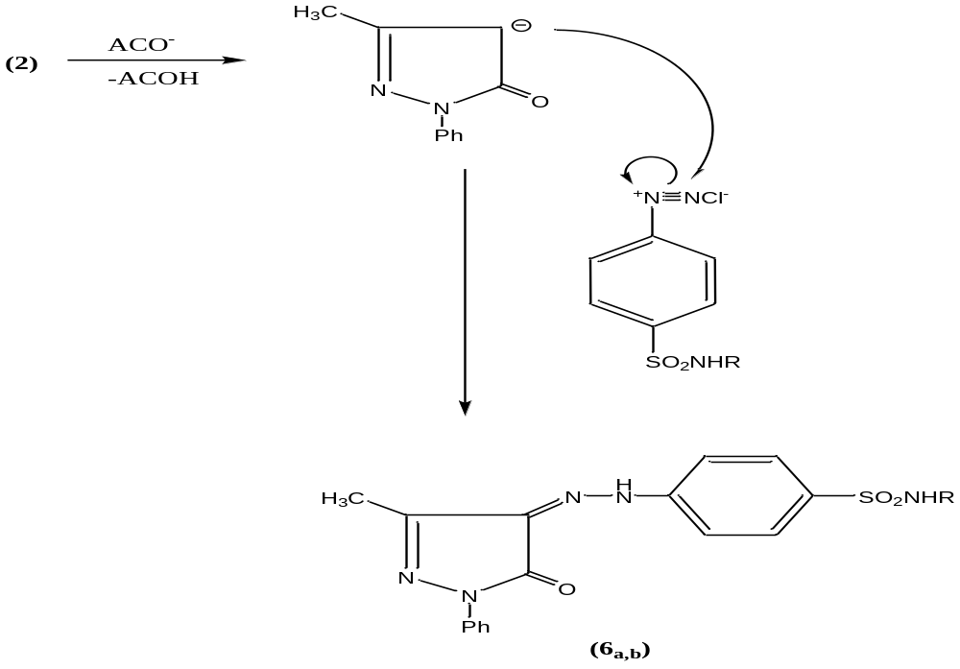
a

The following tautomeric isomers are possible for l-phenyl-3-methyl-5-pyrazolones:
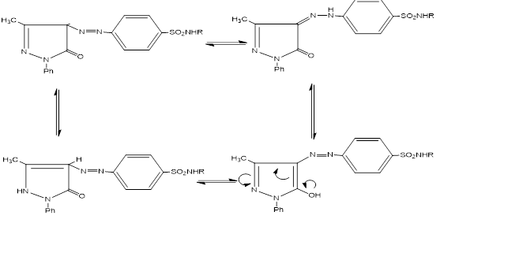
b
Figure S1. a) Proposed mechanism for synthesis of pyrazolone-sulfonamide hydrids6_{a,b.} b) Tautomeric forms of pyrazolone-sulfonamide hydrides 6_{a,b}

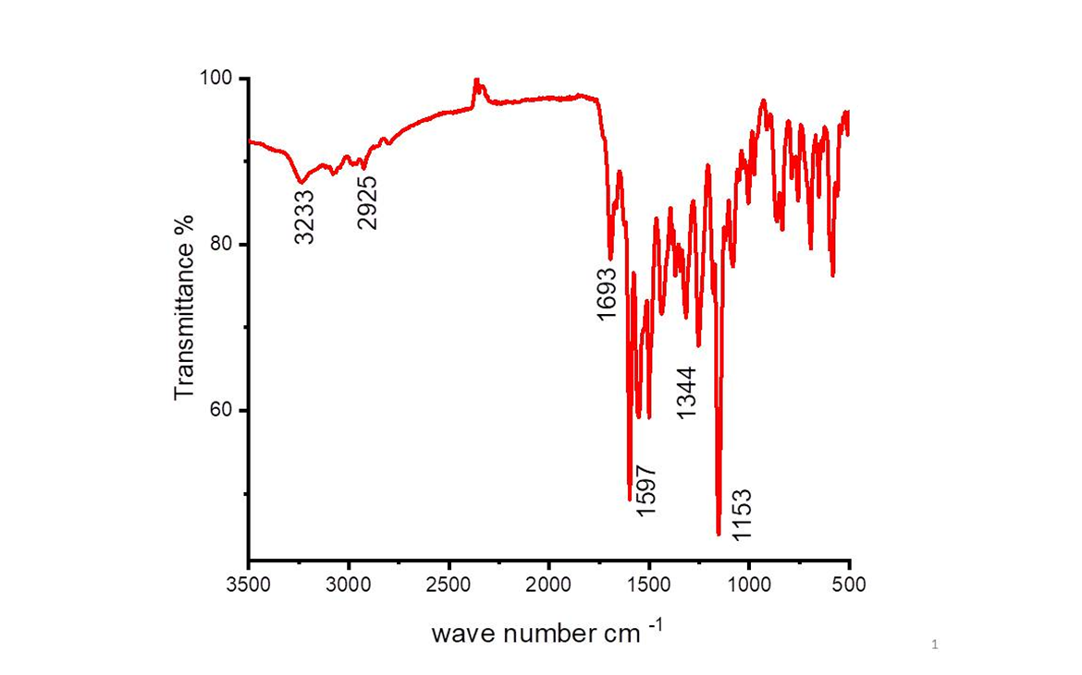
a
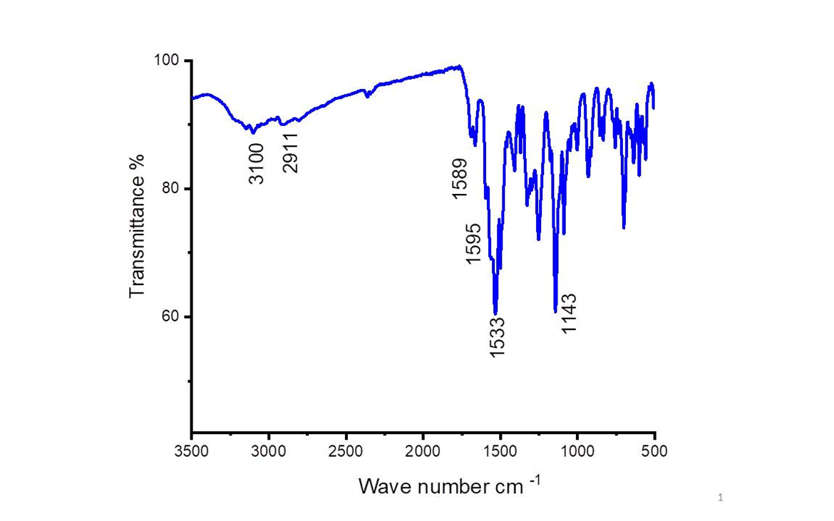 Figure S2. FTIR of the synthesized compound a)6a and b)6b
b

