Supplementary Figures

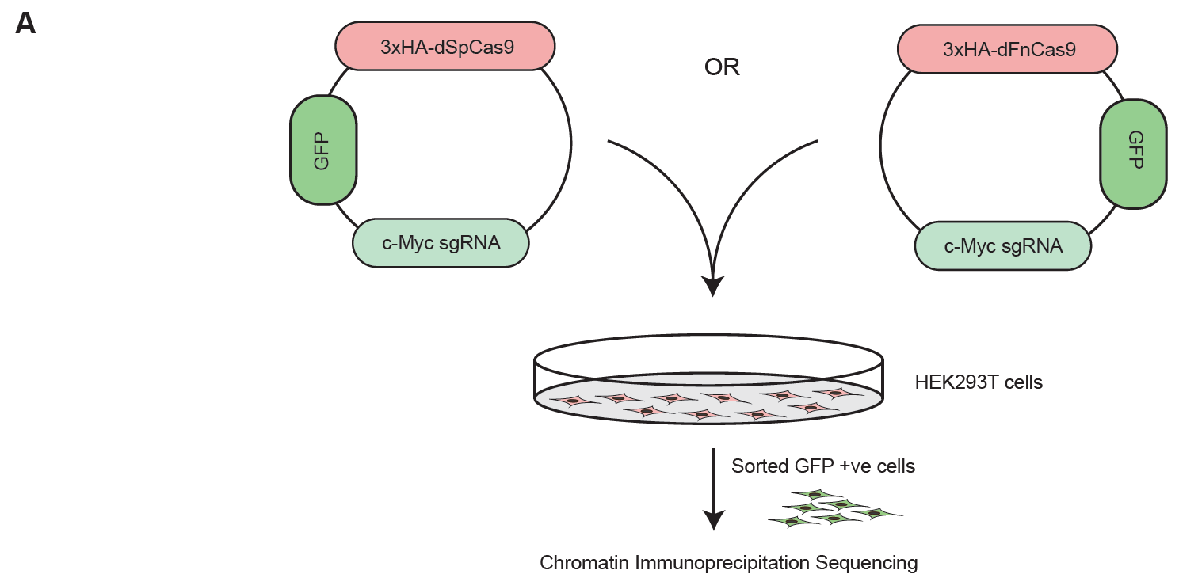
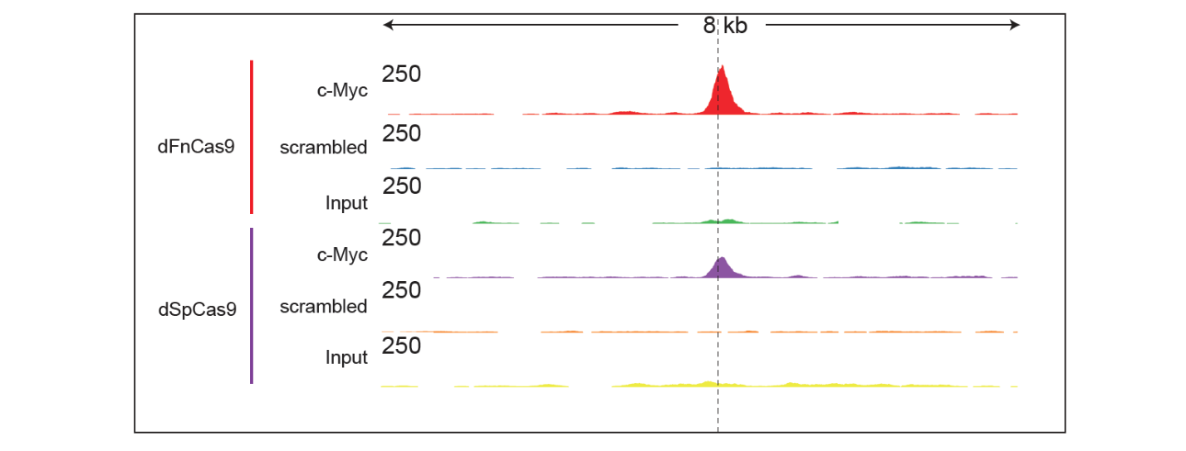
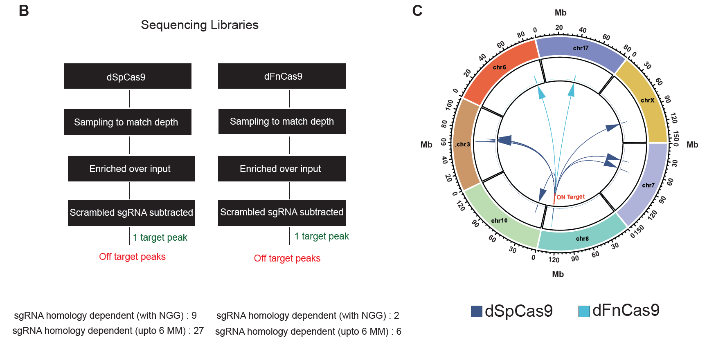
Supplementary Figure 1. Mapping genome-wide binding sites of dSpCas9 and dFnCas9 in c-MYC locus in HEK293T cells

Supplementary Figure 1:

A. Schematic showing the ChIP-Seq assay for targeting c-MYC locus by 3xHA-dSpCas9 and 3xHA-dFnCas9. ChIP-Seq signal intensity of dSpCas9 and dFnCas9 with respect to input sample and scrambled sgRNA transfection at the intended on-target region is shown.
B. Peak calling pipeline showing the off-target sites of 3xHA-dSpCas9 and 3xHA-dFnCas9 ChIP-Seq assay on c-MYC locus.
C. Circos plot showing the sgRNA homology dependent off-target peaks (calculated upto 6 mismatches, MM) with NGG PAM for dSpCas9 and dFnCas9. Chromosomes are arranged radially and shown in megabase (Mb) for which sequence reads were captured for both the dCas9s. On-target peaks for both the dCas9s are shown and marked in red.

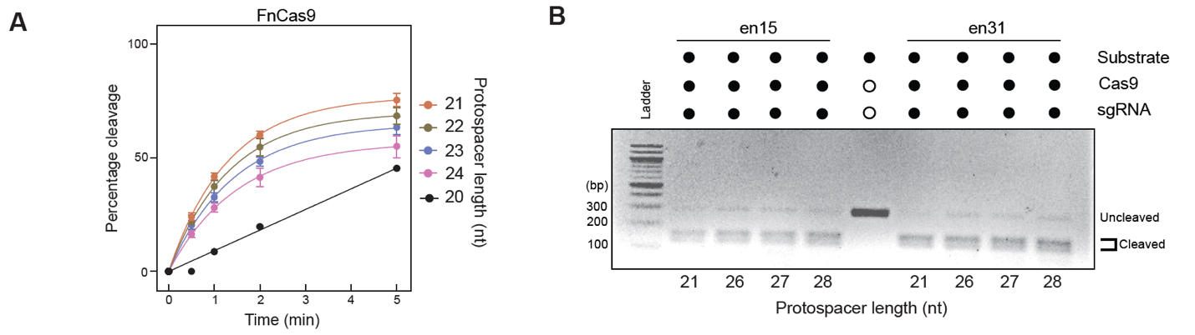
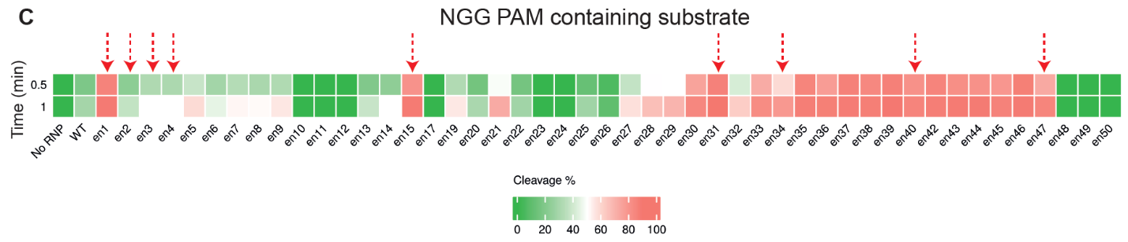
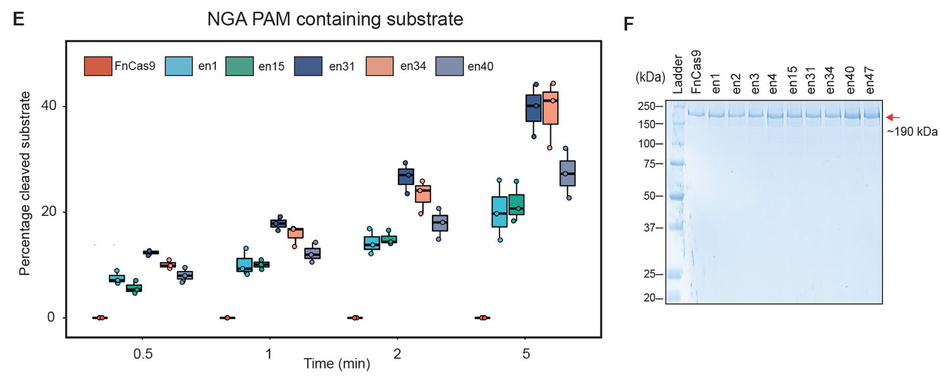
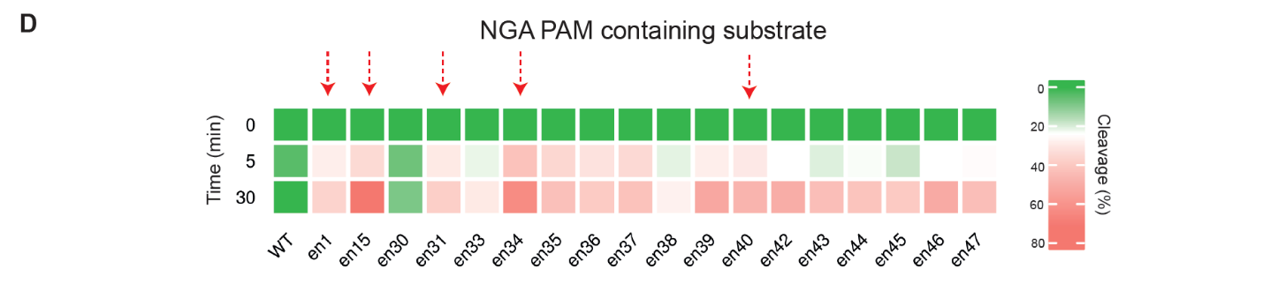
Supplementary Figure 2. In vitro assays for characterization of cleavage activity of enFnCas9 variants

Supplementary Figure 2:

A. Fitted line plot showing the rates of in vitro DNA cleavage of FnCas9 (expressed in percentage, Y-axis) as a function of time (expressed in minutes, on X-axis) upon programmed with variable length of sgRNAs having protospacer length ranging from 20 to 24 nucleotides (nt).
B. Agarose gel image of the in vitro cleavage assay showing the DNA cleavage efficiency of en15 and en31 upon programmed with variable length of sgRNAs having protospacer length ranging from 21, 26 to 28 nucleotides (nt). 25nM DNA substrate was incubated with 250nM RNP for 15 minutes. Reaction was quenched and treated with Proteinase K before running on 2% agarose gel. Solid dot and open dot represent the presence and absence of components in the assay respectively.
C. Heat map showing the in vitro cleavage screening assay of FnCas9 (WT) and enFnCas9 variants using GGG PAM containing DNA substrate expressed as cleavage percentage for 0.5 and 1 minutes. Red dotted arrows indicate the subset of nine enFnCas9 variants selected for studying enzymatic activity as a function of time.
D. Heat map showing the in vitro cleavage screening assay of a subset of FnCas9 (WT) and enFnCas9 variants using GGA PAM containing DNA substrate expressed as cleavage percentage for 5 and 30 minutes. Red dotted arrows indicate the subset of five enFnCas9 variants selected for studying enzymatic activity as a function of time.
E. Box plot showing in vitro cleavage assay using GGA PAM containing DNA substrate expressed as cleavage percentage (y-axis) as a function of time (x-axis). Error bars represent SD (three independent experiments).
F. Coomassie stained SDS-PAGE gel showing purified FnCas9 and enFnCas9 protein variants used in the study.

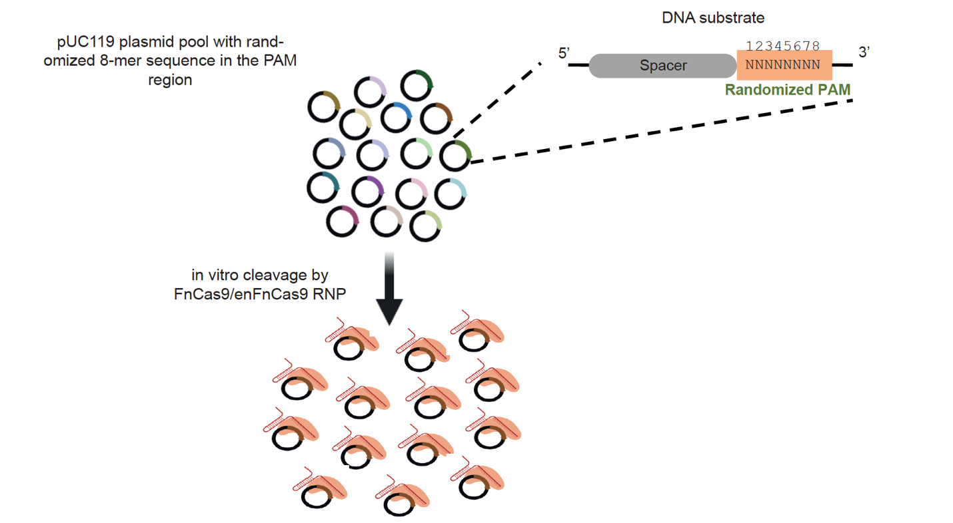
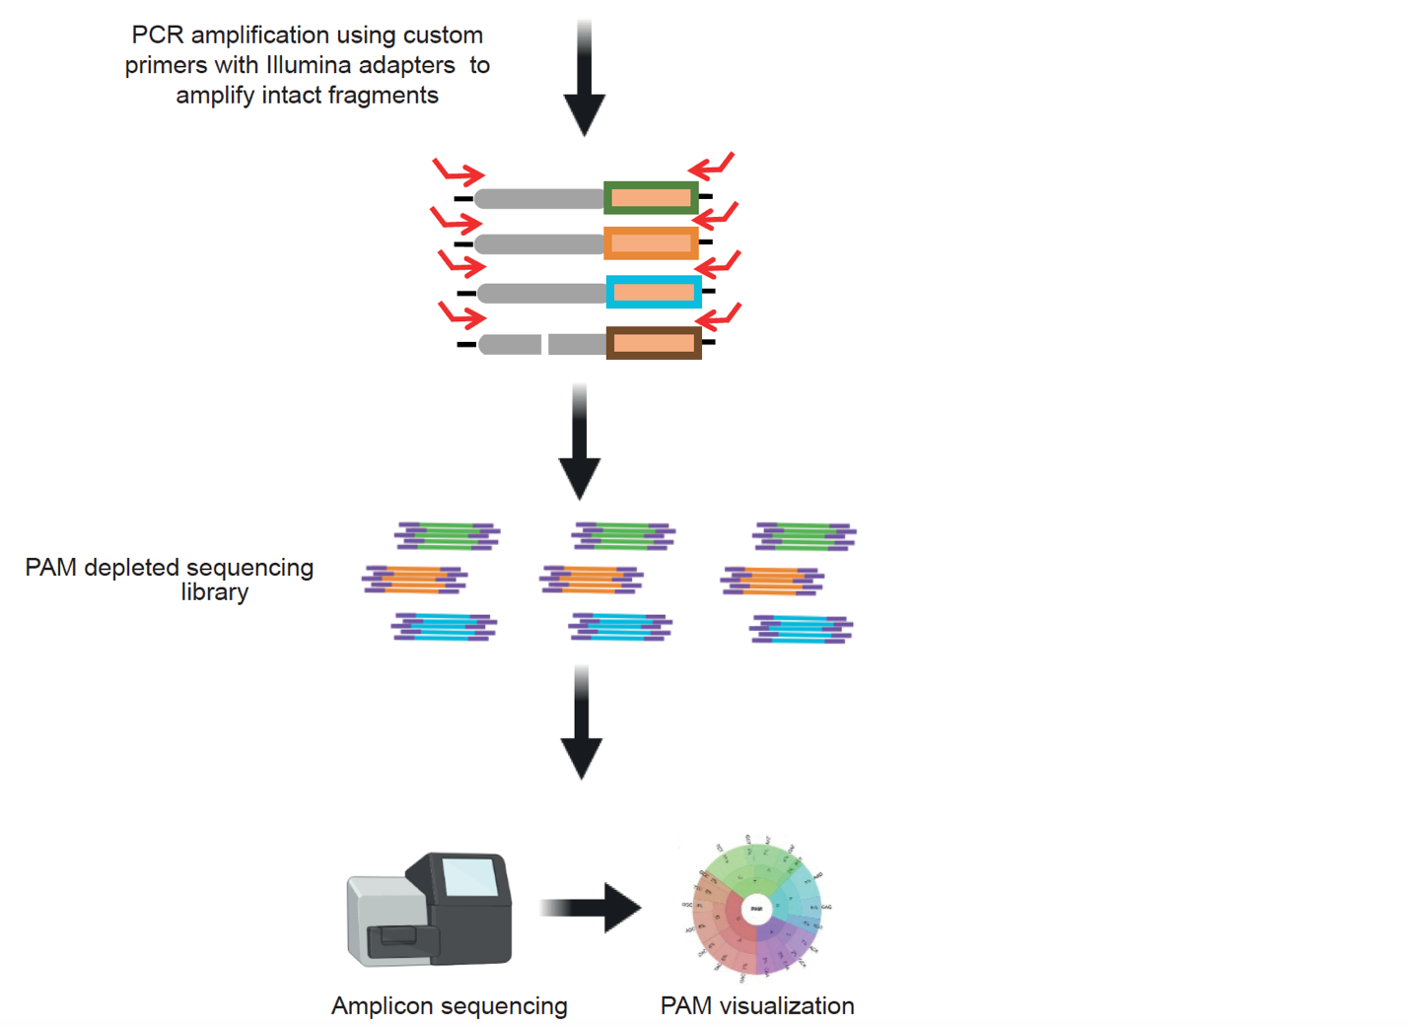
Supplementary Figure 3. Pipeline of PAM discovery assay to comprehensively characterize PAM preferences of enFnCas9 variants

Supplementary Figure 3:

Schematic representation showing the pipeline of PAM discovery assay. Main steps in the assay are highlighted.

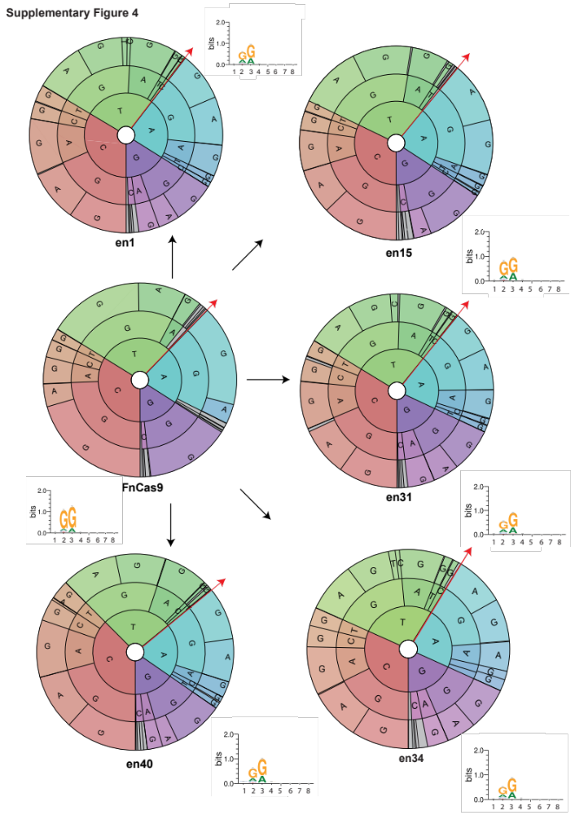
Supplementary Figure 4. Characterization of PAM preferences of enFnCas9 variants using PAM discovery assay

Supplementary Figure 4:
The PAM wheels and sequence logos showing the results obtained from PAM discovery assay for FnCas9, en1, en15, en31, en34 and en40. Individual sections of the pie charts in the PAM wheels with ≤ 2% depletion enrichment are shown in gray. Bases from the inner to the outer circle in the PAM wheels map the PAM reads away from the target region in the 5’ to 3’ direction as shown by red arrows.

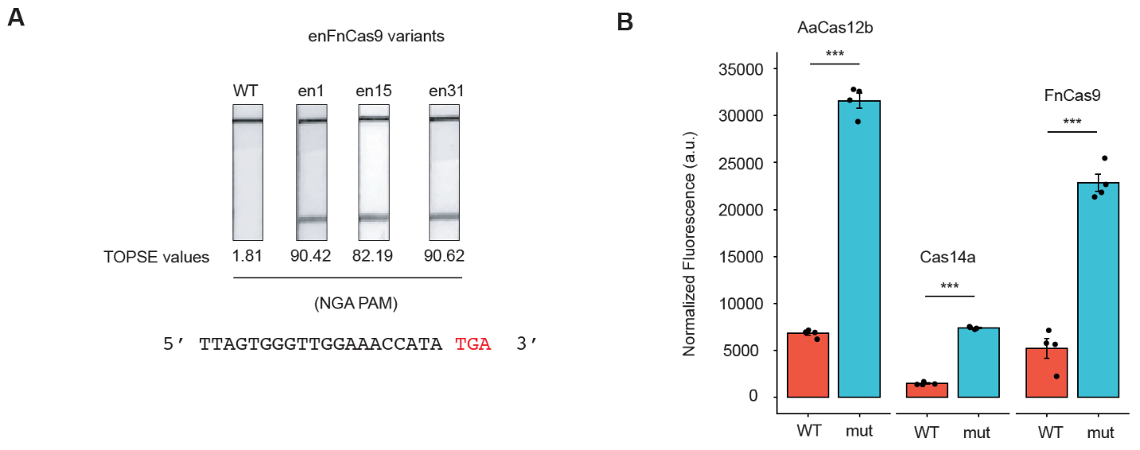
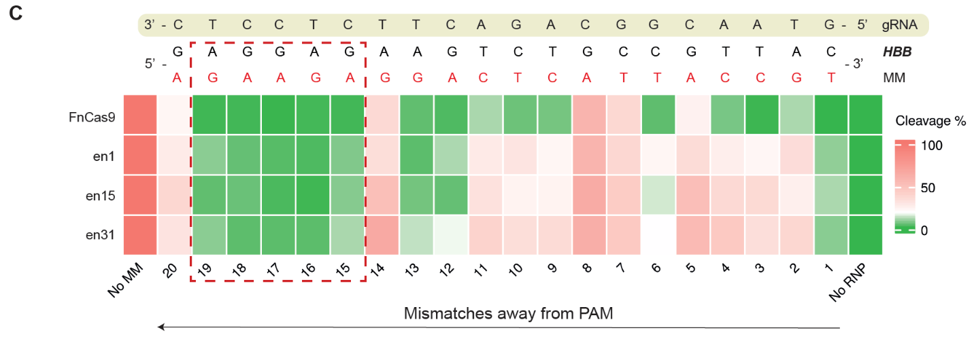
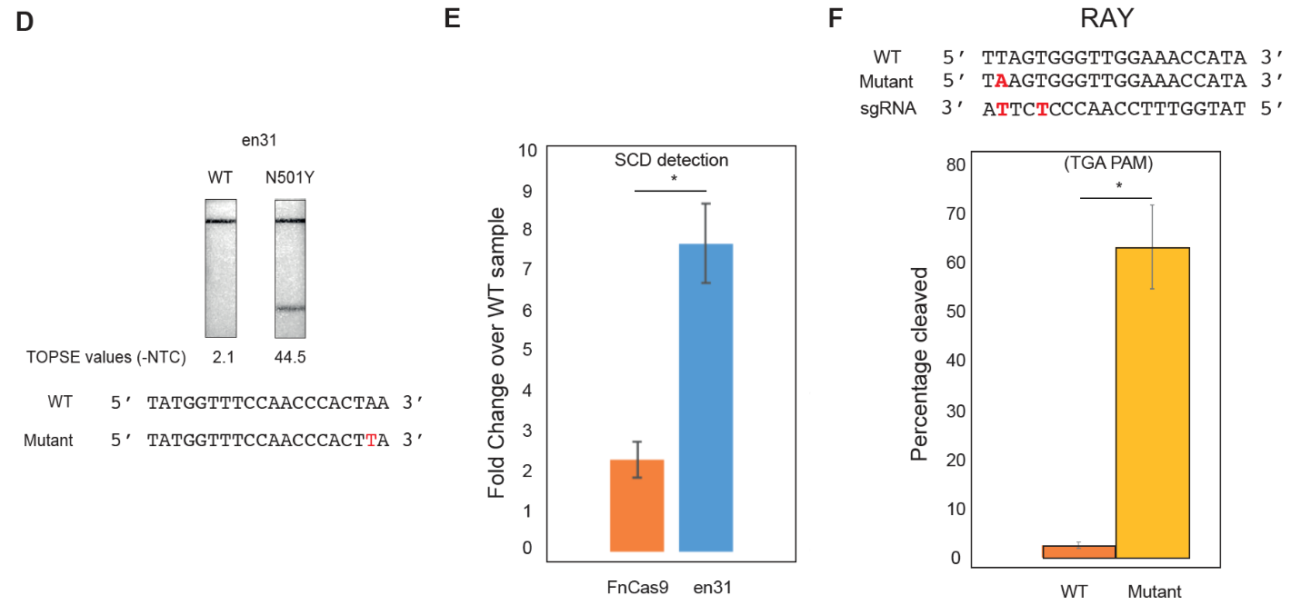
Supplementary Figure 5. In vitro characterization of enFnCas9 variants for mismatch sensitivity and its potential in CRISPRDx platforms

Supplementary Figure 5:

A. Outcome of lateral flow assay (LFA) on a TGA PAM containing substrate for WT, en1, en15 and en31. Corresponding TOPSE values are given at the bottom.
B. Bar plot showing the discrimination of a single mismatched substrate by dFnCas9, AaCas12b and Cas14a1 using fluorescence-based assays (affinity based for FnCas9 and trans-cleavage for AaCas12b and Cas14a1). Error bars represent SEM (n=3 independent experiments). Student’s unpaired t-test p-values are represented for *** <0.001.
C. Heat map showing the in vitro cleavage assay outcome (expressed in percentage of cleavage) of FnCas9, en1, en15 and en31 on HBB and its mutant substrates. Each substrate is harboring a single mutation (position is indicated by counting away from PAM) across the target length. Mismatch containing base is indicated in red while other unaltered bases are shown in black. 25nM of DNA substrates was incubated with respective 100nM RNPs for 15 min at 37°C. Reaction was quenched and treated with Proteinase K before running on 2% agarose gel. Dotted box shown in red represents PAM-distal sites showing minimum mismatch tolerance.
D. Outcome of lateral flow assay (LFA) for SARS-Cov2 N501Y (with a NGG PAM) mutation detection by en31 using RAY. WT and N501Y target sequences are shown. The N501Y mutation is represented in red. Corresponding TOPSE values are given at the bottom.
E. Bar plot showing the SCD mutation discrimination by en31 and FnCas9 using FELUDA. Data is shown as a fold enrichment over WT sample (n=3 independent experiments). Student’s unpaired t-test p-value is represented for * <0.05.
F. Bar plot showing outcome of in vitro cleavage based detection of N501Y (with an NGA PAM) by en31(n=3 independent experiments). WT and mutant substrate sequences are shown along with sequence of gRNA. Mismatches are indicated in red on the respective sequences. Student’s unpaired t-test p-value is represented for * <0.05.

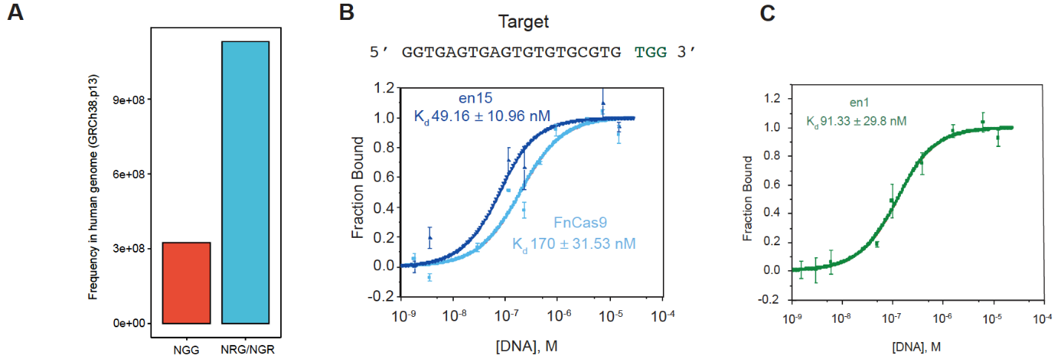
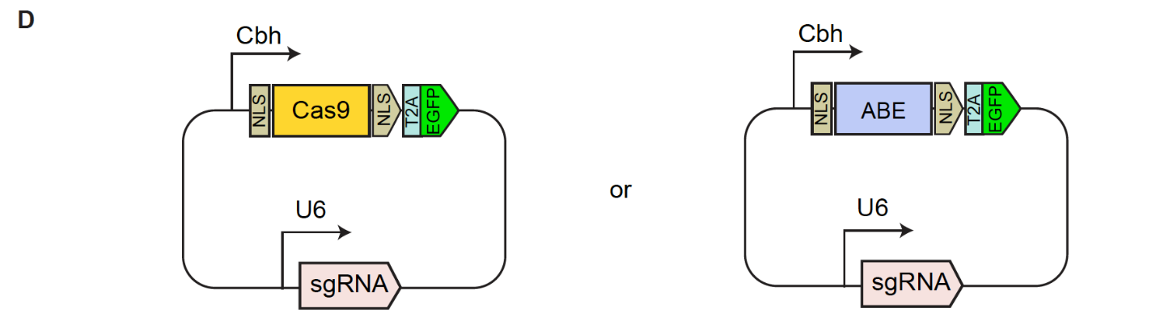
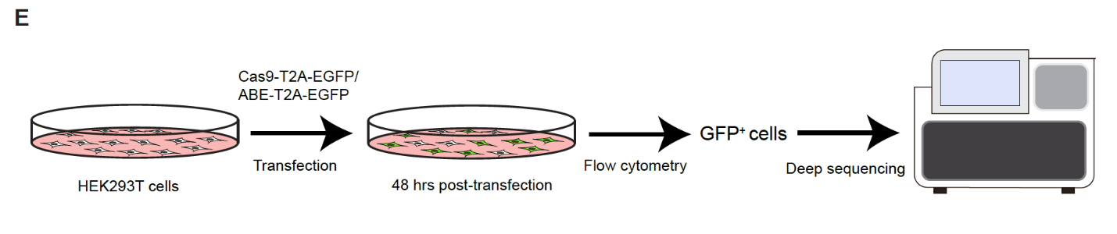
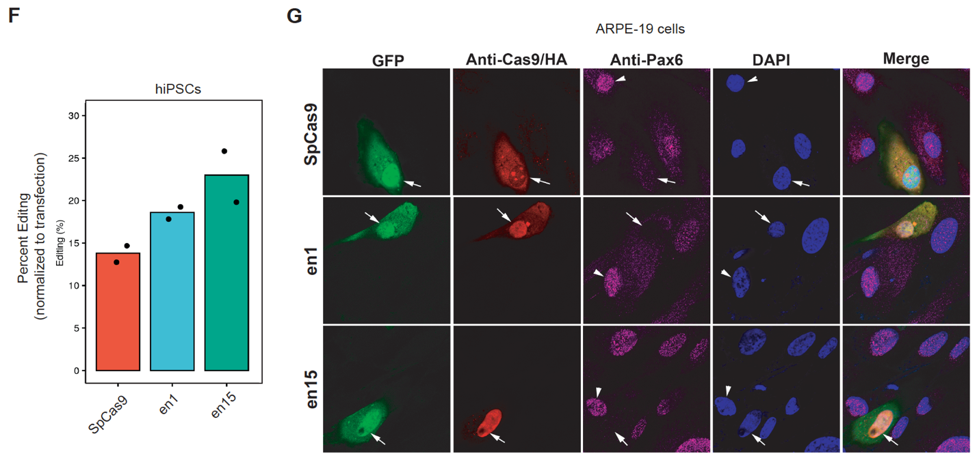
Supplementary Figure 6. Broad targeting range coupled with improved DNA binding underscore its utility in efficient targeting of human genome

Supplementary Figure 8:

A. Bar plot showing the calculated frequency of NGG PAM and NRG/NGR PAM in the human genome (GRCh38.p13).
B. MicroScale Thermophoresis (MST) result showing the comparative binding affinity between FnCas9 and en15 on VEGFA3 substrate DNA. Data is represented as a fraction bound RNP (y-axis) with respect to purified DNA substrate (Molar units M, x-axis). Error bars represent SD (3 independent experiments).
C. MST result showing the binding affinity of en1 on VEGFA3 substrate DNA. Data is represented as a fraction bound RNP (y-axis) with respect to purified DNA substrate (Molar units M, x-axis). Error bars represent SD (3 independent experiments).
D. Schematic showing the architecture of all-in-one plasmids expressing nucleases or base editors as T2A-EGFP fusion with gRNA cloning sites.
E. Schematic showing the experimental pipeline used for genome editing efficiency evaluation.
F. Bar plot showing the InDel percentage (editing) normalized to the transfection efficiency as obtained from T7E1 assay upon targeting PAX6 locus by SpCas9, en1 and en15 in hiPSC cells. Values represent the mean of n=2 independent biological replicates.
G. Immunofluorescence image showing the fixed cells stained with anti-HA/anti-Cas9 (red), anti-PAX6 (pink) and DAPI (blue) upon targeting PAX6 locus by SpCas9, en1 and en15 in ARPE cells. The GFP panel is showing Cas9 transfected cells. Merged panel depicts all the cells present in the field. Cas9 expressing cells are marked by arrows and cells without Cas9 expression are marked by arrowheads.

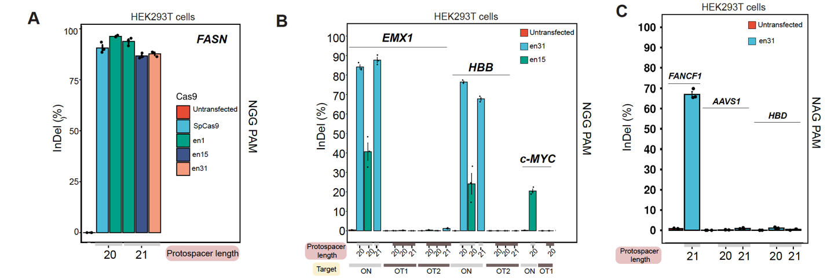
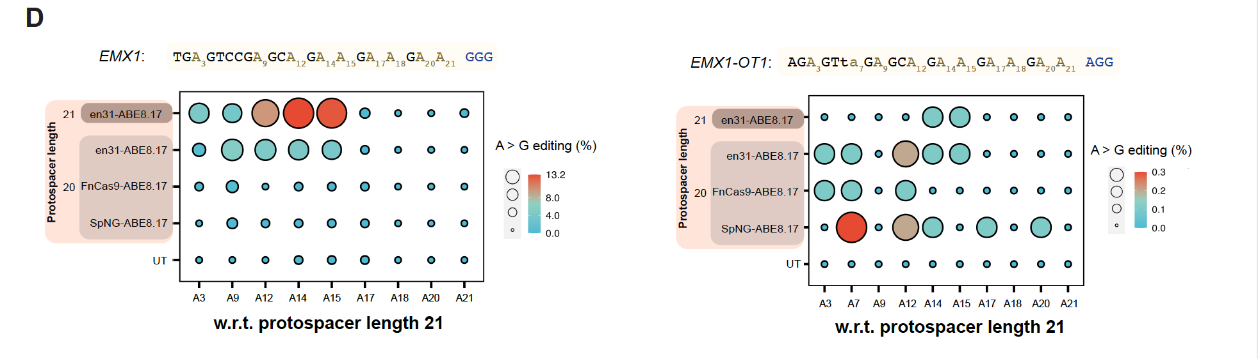
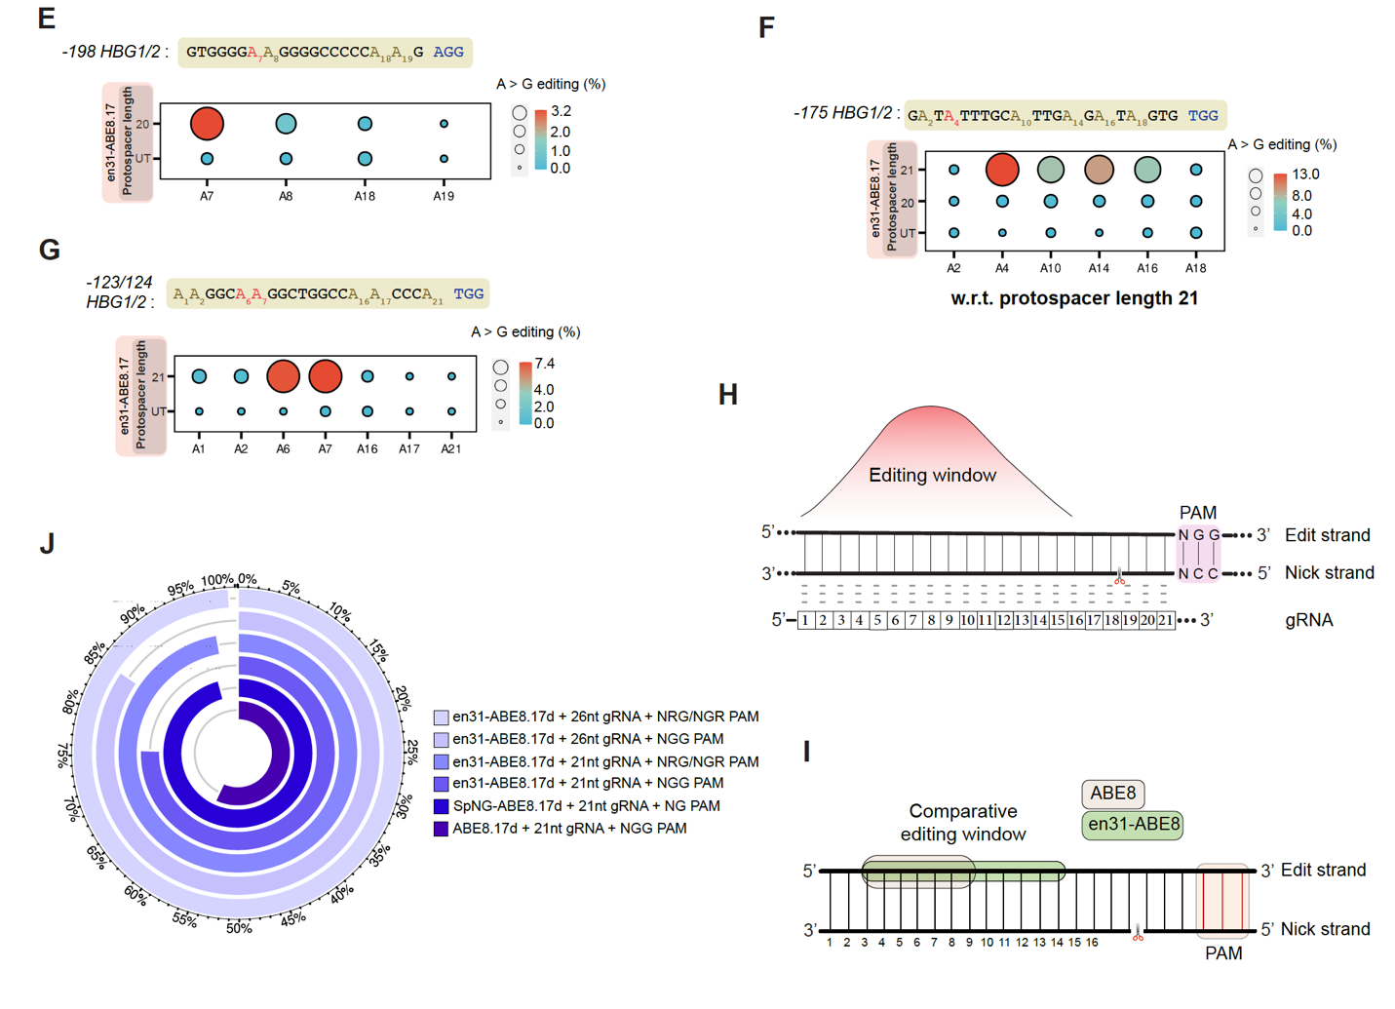
Supplementary Figure 7. Characterization of enFnCas9 variants as nucleases and base editors in human cells

Supplementary Figure 7:

A. Bar plot showing the InDel events (expressed in percentage) plotted on the Y-axis as obtained from amplicon sequencing upon targeting NGG PAM containing FASN locus by SpCas9, en1, en15 and en31 with either sgRNA containing 20-nt protospacer or sgRNA containing 21-nt protospacer in HEK293T cells. Untransfected cells were used as control. Error bars represent SEM of n=3 independent biological replicates with individual values shown as dots.
B. Bar plot showing the InDel events (expressed in percentage) plotted on the Y-axis as obtained from amplicon sequencing upon targeting NGG PAM containing EMX1, HBB and c-MYC loci by en31 and en15 with either sgRNA containing 20-nt protospacer (g20) or sgRNA containing 21-nt protospacer (g21) in HEK293T cells. Untransfected cells were used as control. Error bars represent SEM of n=3 independent biological replicates with individual values shown as dots.
C. Bar plot showing the InDel events (expressed in percentage) plotted on the Y-axis as obtained from amplicon sequencing upon targeting NAG PAM containing FANCF1 site2, AAVS1 and HBD loci by en31 with either sgRNA containing 20-nt protospacer (g20) or sgRNA containing 21-nt protospacer (g21) in HEK293T cells. Untransfected cells were used as control. Error bars represent SEM of n=3 independent biological replicates with individual values shown as dots.
D. (Left) Ballon plot showing the A to G editing events (expressed in percentage) as obtained from amplicon sequencing upon targeting EMX1 locus by FnCas9-ABE8.17d, en31ABE8.17d and SpNG-ABE8.17d with either sgRNA containing 20-nt protospacer (g20) or sgRNA containing 21-nt protospacer (g21) in HEK293T cells. Target bases (As) for adenine base editing are on the X-axis and numbered w.r.t. g21. The area of the dots is proportional to the magnitude of editing (numerical values). Values represent the mean of n=3 independent biological replicates. (Right) Ballon plot showing the A to G editing events (expressed in percentage) as obtained from amplicon sequencing for the validated off-target, EMX1-OT1 upon targeting EMX1 locus by FnCas9-ABE8.17d, en31ABE8.17d and SpNG-ABE8.17d with either sgRNA containing 20-nt protospacer (g20) or sgRNA containing 21-nt protospacer (g21) in HEK293T cells. Mismatches on the protospacer are shown in small caps. The area of the dots is proportional to the magnitude of editing (numerical values). Values represent the mean of n=3 independent biological replicates.
E. Ballon plot showing the A to G editing events (expressed in percentage) as obtained from amplicon sequencing upon targeting -198 site of HBG1/2 promoter by en31ABE8.17d in HEK293T cells. Target bases (As) for adenine base editing are numbered on the X-axis with target site (A7) indicated in red. The area of the dots is proportional to the magnitude of editing (numerical values). Values represent the mean of n=3 independent biological replicates.
F. Ballon plot showing the A to G editing events (expressed in percentage) as obtained from amplicon sequencing upon targeting -175 site of HBG1/2 promoter by en31ABE8.17d with either sgRNA containing 20-nt protospacer (g20) or sgRNA containing 21-nt protospacer (g21) in HEK293T cells. Target bases (As) for adenine base editing are numbered on the X-axis w.r.t. g21 with target site (A4) indicated in red. The area of the dots is proportional to the magnitude of editing (numerical values). Values represent the mean of n=3 independent biological replicates.
G. Ballon plot showing the A to G editing events (expressed in percentage as obtained from amplicon sequencing upon targeting -123/124 sites of HBG1/2 promoter by en31ABE8.17d in HEK293T cells. Target bases (As) for adenine base editing are numbered on the X-axis with target sites (A6-A7) indicated in red. The area of the dots is proportional to the magnitude of editing (numerical values). Values represent the mean of n=3 independent biological replicates.
H. Schematic showing the adenine base editing window of en31ABE8.17d. Apex of the bell curve indicates the optimal editing space. Numbers indicate the positions across the protospacer of the gRNA. The location of the nick by en31ABE8.17d (nD11A) is indicated by a scissor on the nick strand. PAM containing strand hosts the target bases for base editor and represented as edit strand.
I. Schematic showing the comparative base editing window between ABE8.17d (shaded in pink) and en31ABE8.17d (shaded in green). Numbers indicate the positions across the protospacer of the gRNA. The location of the nick by ABE8.17d (D10A) and en31ABE8.17d (nD11A) is indicated by a scissor on the nick strand. PAM containing strand hosts the target bases for base editor and represented as edit strand.
J. Circular bar plot showing the theoretically targetable pathogenic SNPs (expressed in percentage) as identified from the ClinVar for SpCas9ABE8.17d (NGG PAM), SpNG-ABE8.17d (NG PAM) and en31ABE8.17d (NGG/NRG/NGR PAMs) with respective gRNAs containing specified protospacer length.

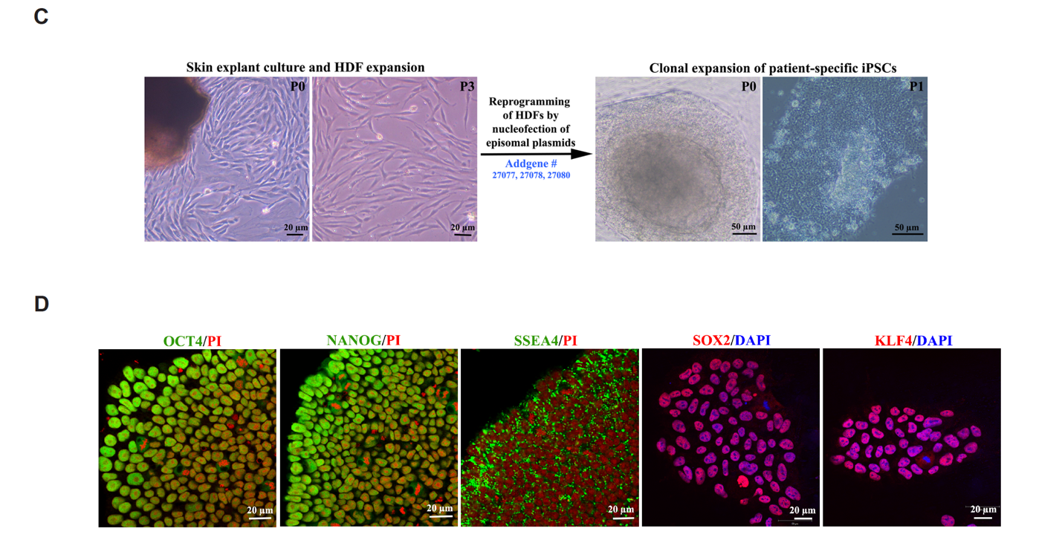
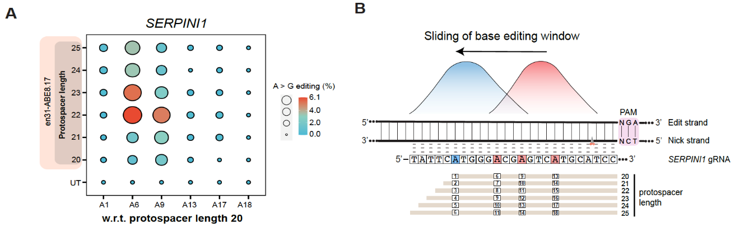
Supplementary Figure 8. Validation of pathogenic mutation correction by en31-base editor in patient-derived iPSC line

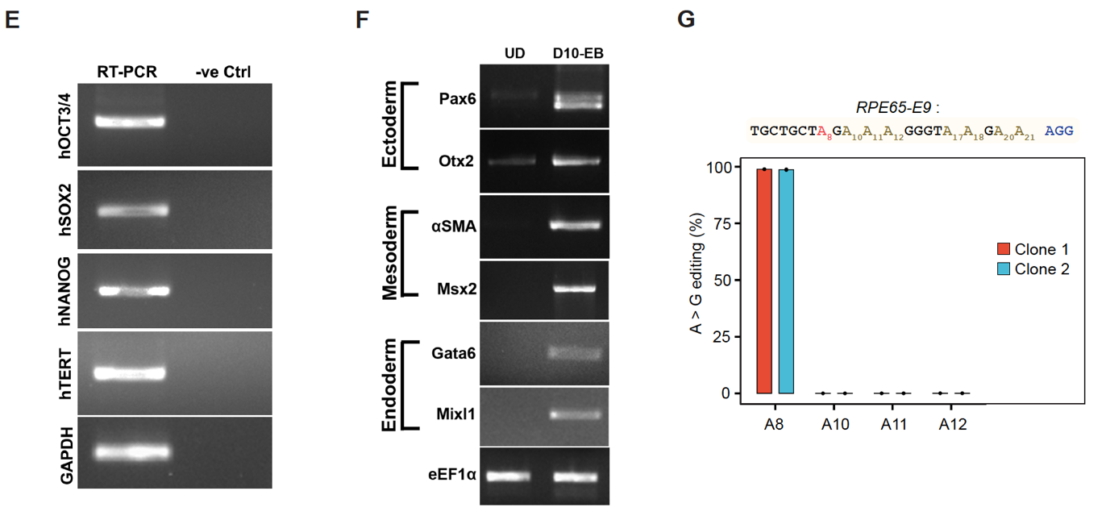

Supplementary Figure 8:

A. Ballon plot showing the modulation of base editing window by en31ABE8.17d expressed in percentage of A to G editing plotted on Y-axis using gRNAs with extended protospacers (g20 to g25) as obtained from amplicon sequencing upon targeting SERPINI1 locus against TGA PAM. Target bases (As) for adenine base editing are on the X-axis and numbered w.r.t. g20. Values represent the mean of n=3 independent biological replicates.
B. Schematic showing the sliding of the base editing window from primary window (shown in red) to secondary window (shown in blue) by extended gRNAs and indicated by higher efficiency of A to G editing on SERPINI1 locus with TGA PAM.
C. Images showing the skin explant culture and human dermal fibroblast (HDF) expansion (right) isolated from patient diagnosed with Leber congenital amaurosis (LCA) followed by reprogramming of HDFs into iPSC clones by episomal plasmids (left).
D. Image iPSC colony stained for pluripotency markers (Oct4, Nanog, Sox2 and Klf4) and merged with DAPI (in blue).
E. Agarose gel image showing the RT-PCR results for expression of stemness markers (hOCT4, hSOX2, hNANOG and hTERT) of patient-specific iPSC line. GAPDH was used as internal control.
F. Agarose gel image showing the RT-PCR results for expression of trilineage markers upon embryoid body (EB) formation from patient-specific iPSC line. Undifferentiated iPSCs (UD) were used as a control for trilineage markers. eEF1α was used as an internal control.
G. Bar plot showing the efficiency of A to G editing of en31ABE8.17d-treated patient-specific iPSC clones for correction of the disease mutation (in red). Target bases (As) were shown on the X-axis and base editing efficiency expressed as A to G editing percentage was plotted on the Y-axis as obtained from amplicon sequencing. A8 is the patient mutation and A10-A12 are bystander bases for the base editor across the protospacer. Error bars represent SEM of n=3 independent sequencing replicates with individual values shown as dots.

Supplementary Figure 9: Comparison between Superfi-Cas9 and enFnCas9 variant for evaluating cleavage activity and specificity of DNA interrogation
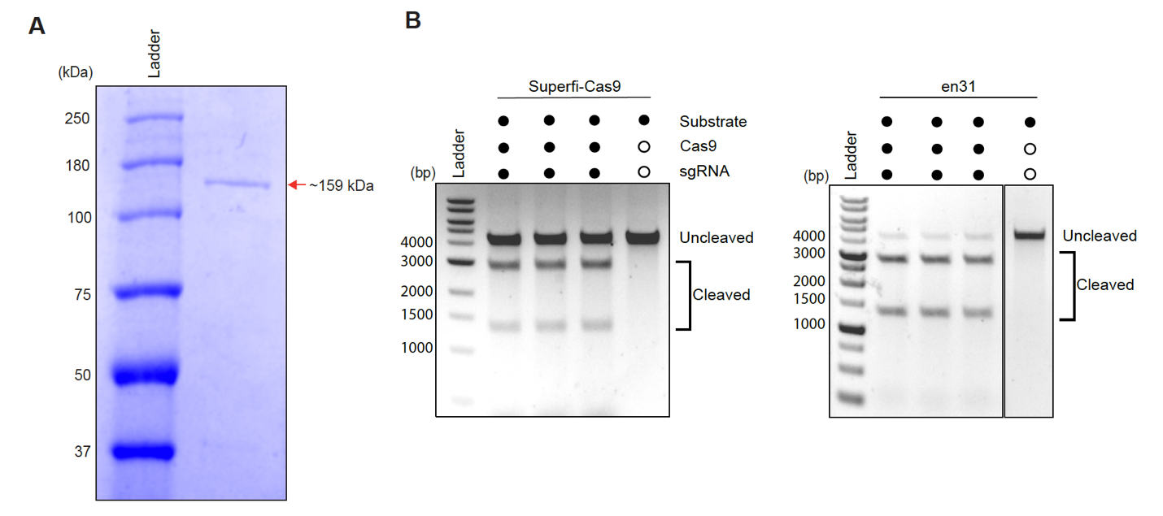
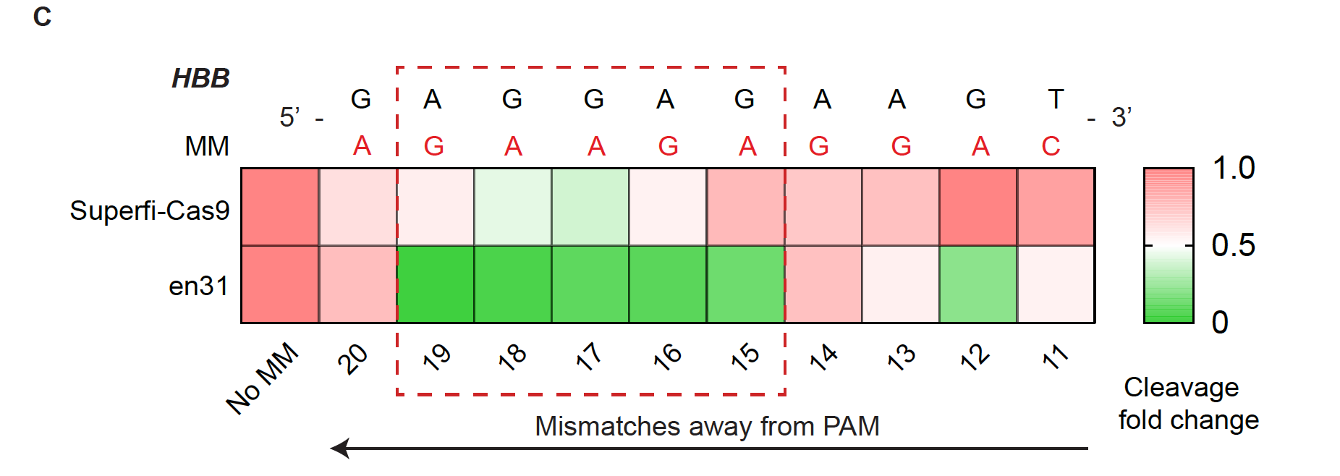

Supplementary Figure 9:

A. Coomassie stained SDS-PAGE gel image of purified Superfi-Cas9.
B. Agarose gel image of in vitro cleavage assay showing the efficiency of DNA cleavage as a function of time of Superfi-Cas9 and en31 on HBB substrate cloned in TOPO vector. 5nM linearized substrate (4200 bp) was incubated with respective 50nM ribonucleoproteins (RNPs) for 10 minutes. Reaction was quenched and treated with Proteinase K before running on 0.8% gel. Experiments were done in triplicates. Solid dot and open dot represent the presence and absence of components in the assay respectively.
C. Heat map showing the in vitro cleavage-based mismatch (MM) walking assay outcome between Superfi-Cas9 and en31 on HBB and its mutant substrates, each carrying a single mismatch. Reaction was quenched and treated with Proteinase K before running on 2% agarose gel. Mismatches are indicated in red and counted away from PAM as indicated on the x-axis. Dotted box shown in red represents PAM-distal sites showing minimum mismatch tolerance. Data is shown as cleavage fold change normalized to HBB substrate (No MM).

Supplementary Note 1

Details of structure-guided engineering

The crystal structure of FnCas9 showed that the PAM duplex is nestled in the FnCas9 WED-PI domain, and the major groove dG(2) and dG(3) of 5′-NGG-3′ PAM on the nontarget strand are recognized by R1585 and R1556 respectively through bidentate hydrogen bonds while dN(1) is free from any protein contacts. R1556 also recognizes dA(3) by a single hydrogen bond which signifies the very weak interaction with 5′-NGA3′ PAM by FnCas9. Towards developing a PAM-relaxed FnCas9-NG variant, earlier work reported that substituting R1556A abrogates the protein function and thus relaxing the PAM constraint to NG PAM cannot be done by this approach. Partial rescue of functional activity was achieved by incorporating base non-specific interactions E1369R and E1449H. This led to the creation of the RHA-FnCas9 variant with activity on YG PAM³. However, we observed that the RHA variant has very poor activity even on the canonical NGG PAM necessitating the development of alternate variants with improved activity (current manuscript) (Supplementary Note 1, Figure 1). In previous studies, the major groove adenine:glutamine contact had been reported^{2,85}. Substituting R1556Q (en49) completely destroyed the protein function in vitro, recapitulating the earlier observation seen with R1556A. Expectedly, R1556T(en17) substitution designed for 5′-NGT-3′ PAM recognition considering the preference of threonine for thymine base failed to show any protein activity. This confirms the interaction between R1556 with dG(3) of non-target strand of the PAM duplex is indispensable for FnCas9 functional activity. Interestingly, the incorporation of novel base non-specific interactions with the WED-PI domain of the protein created a subset of three variants (en1, en15 and en31) which showed enhanced enzymatic activity on both canonical NGG PAM and non-canonical NGA PAM. This subset also showed NGR/NRG PAM recognition which broadens the targeting scope in the genome. The crystal structure entails that the en1(E1369R) and en15(E1603H) variants create additional interactions with the backbone phosphate group between dC(-2) and dA(- 1) in the target DNA strand and between dG(2) and dT(1) in the non-target strand respectively. In the triple mutant (E1369R/E1449H/G1243T, en31), E1369R/E1449H makes hydrogen bonding interaction with phosphate backbone between dC(-2) and dA(-1) in the target DNA strand and the phosphate-lock loop (PLL) G1243T makes additional hydrogen bonding interaction with +1 phosphate in the target strand from where DNA unwinding ensues (Supplementary Note 1 Figure 2). Notably, amino acid substitutions of the protein with PAM-duplex base non-specific interactions which results in enhanced kinetic activity (en48, en50) failed to rescue the activity of R1556Q FnCas9. It is important to note that G1243T alone cannot enhance functional activity to a greater extent. However, G1243T in combination with E1369R and E1603H (en31) exhibited robust in vitro kinetic enhancement on both NGG and NGA PAM.

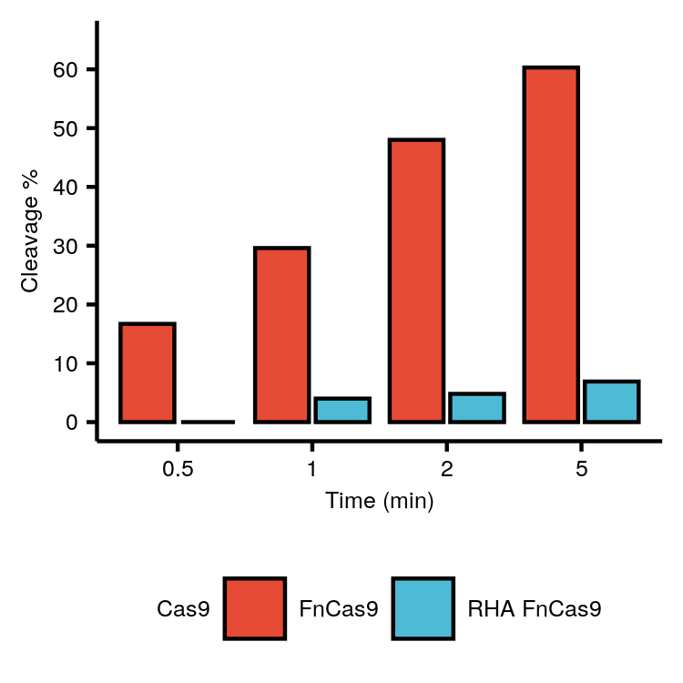

Supplementary Note 1, Figure 1: Comparative evaluation of in vitro cleavage activity between FnCas9 and RHA-FnCas9 on TGG PAM containing substrates represented by percentage cleavage (y-axis) at different time points (x-axis).

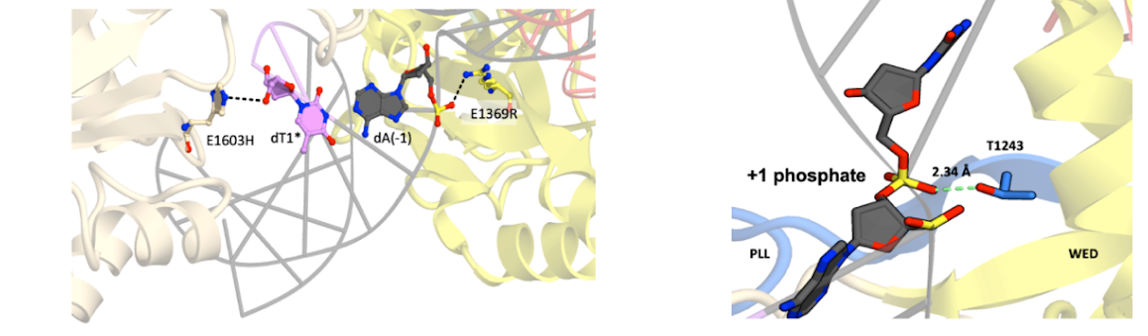
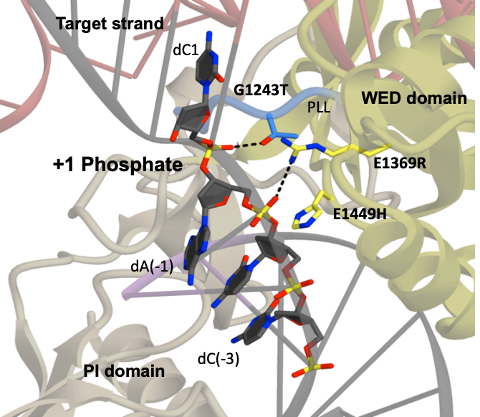

A. B

C

Supplementary Note 1, Figure 2: Structural models showing interaction between substituted amino acids and PAM duplex. A) Interactions of en1 (E1369R) and en15 (E1603H) are shown. B) Interaction of G1243T substitution on phosphate lock loop (PLL) (en4) with +1 Phosphate group. C) Interactions of en31 (E1369R/E1603H/G1243T) with PAM duplex and PLL loop.

