Title：
Effects of land use/cover changes on soil organic carbon stocks in Qinghai-Tibet Plateau: A comparative analysis of different ecological functional areas based on machine learning methods and soil carbon pool data
1.Figures Supplementary：
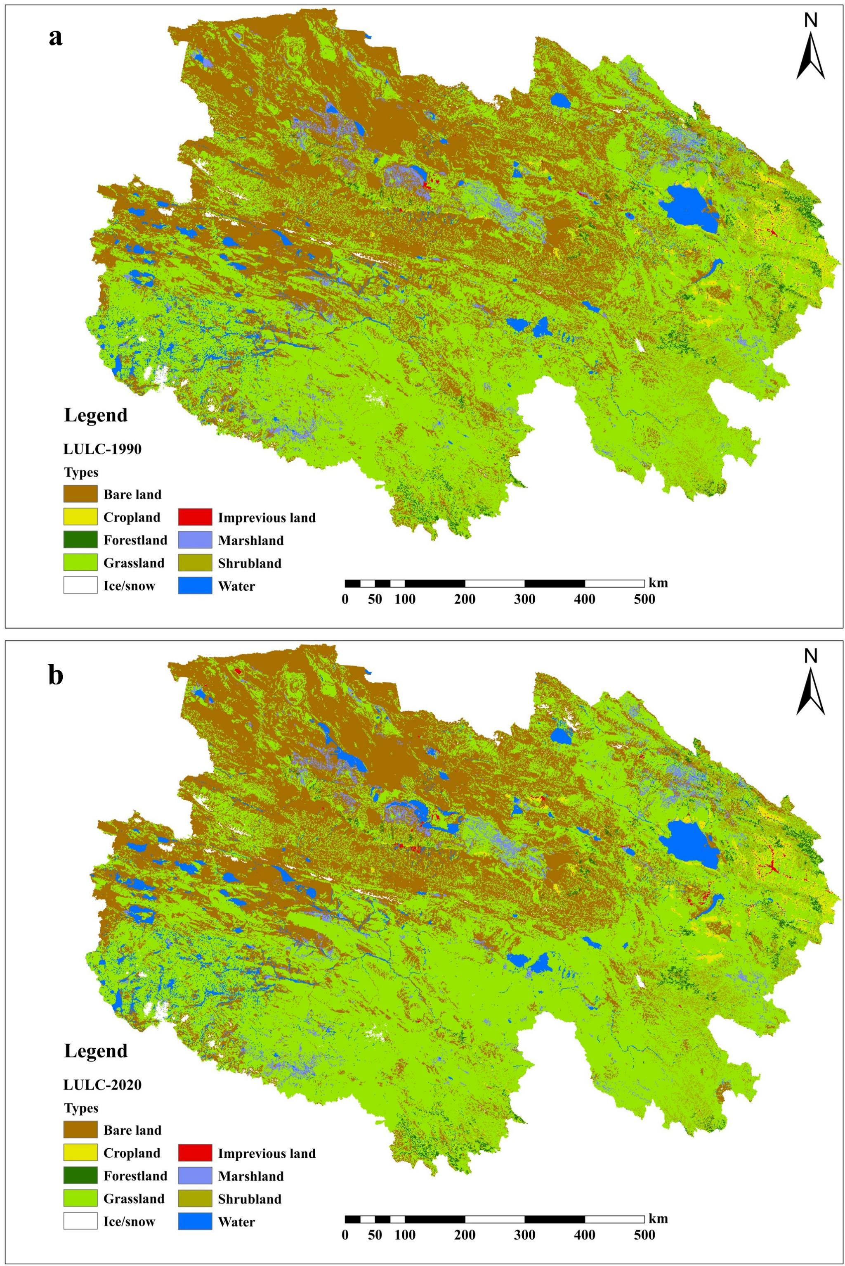
Fig.S1. Land use/cover types in 1990(a) and 2020(b) of Qinghai Province.
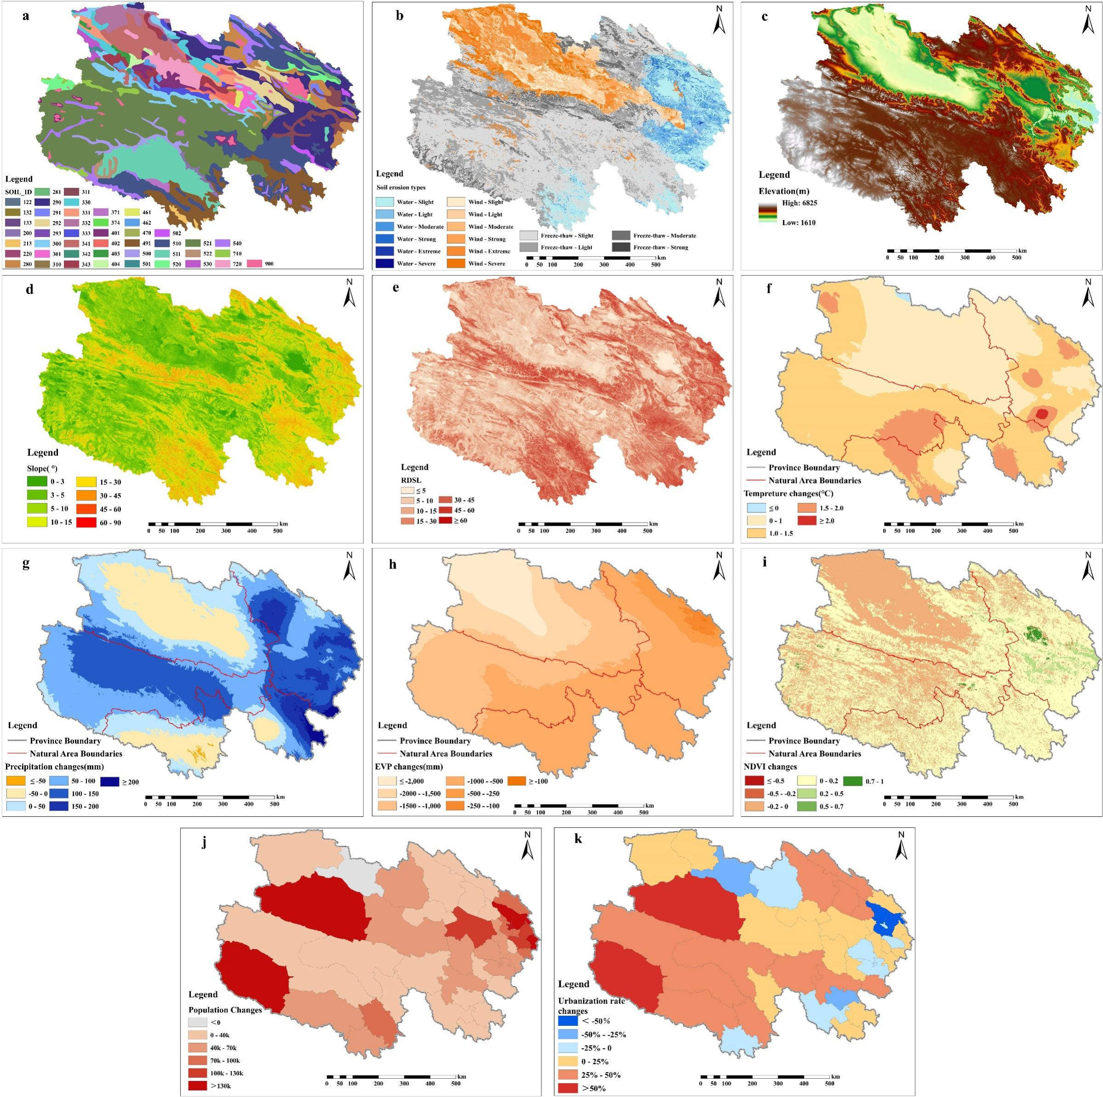
Fig.S2. Driving factors of LUCC in Qinghai Province. (a: Soil types; b: Soil erosion types; c: Elevation; d: Slope; e: RDSL; f: Tem-Change; g: Pre-Change; h: EVP Change; i: NDVI Change; j: Pop-Change; U-Change).

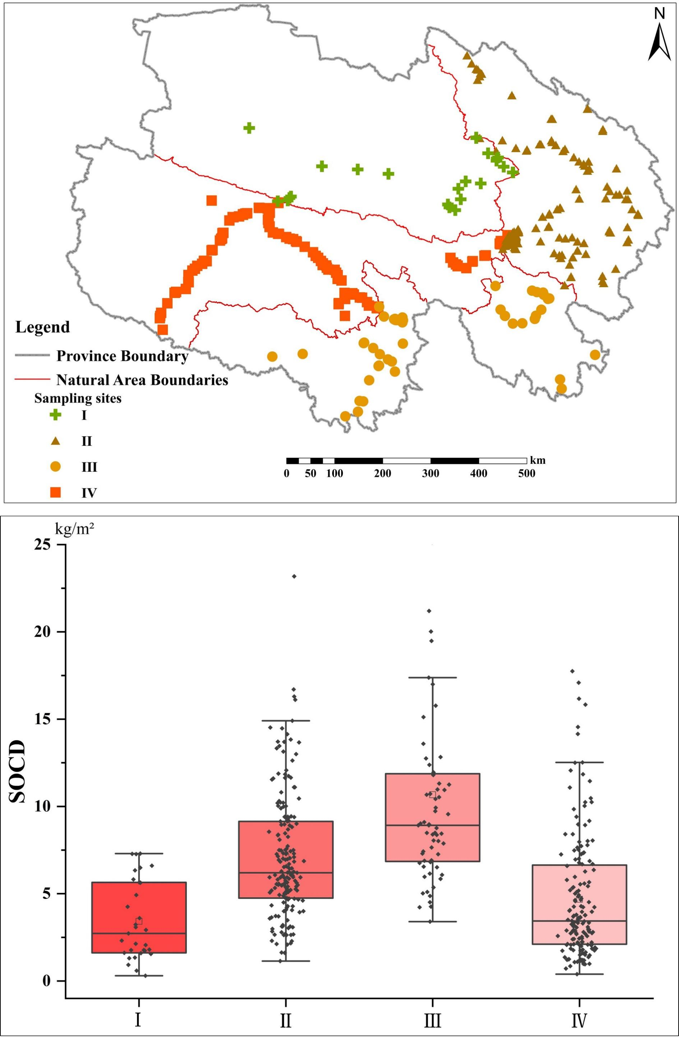
Fig.S3. Sampling sites in four natural areas(a) and the basic characteristic of SOCD(kg/m²)(b)(Note: Ⅰ: Desert and Gobi area, Ⅱ: Agricultural and Pastoral area, Ⅲ: Pastoral area and Ⅳ: Sanjiangyuan Nature Reserve).
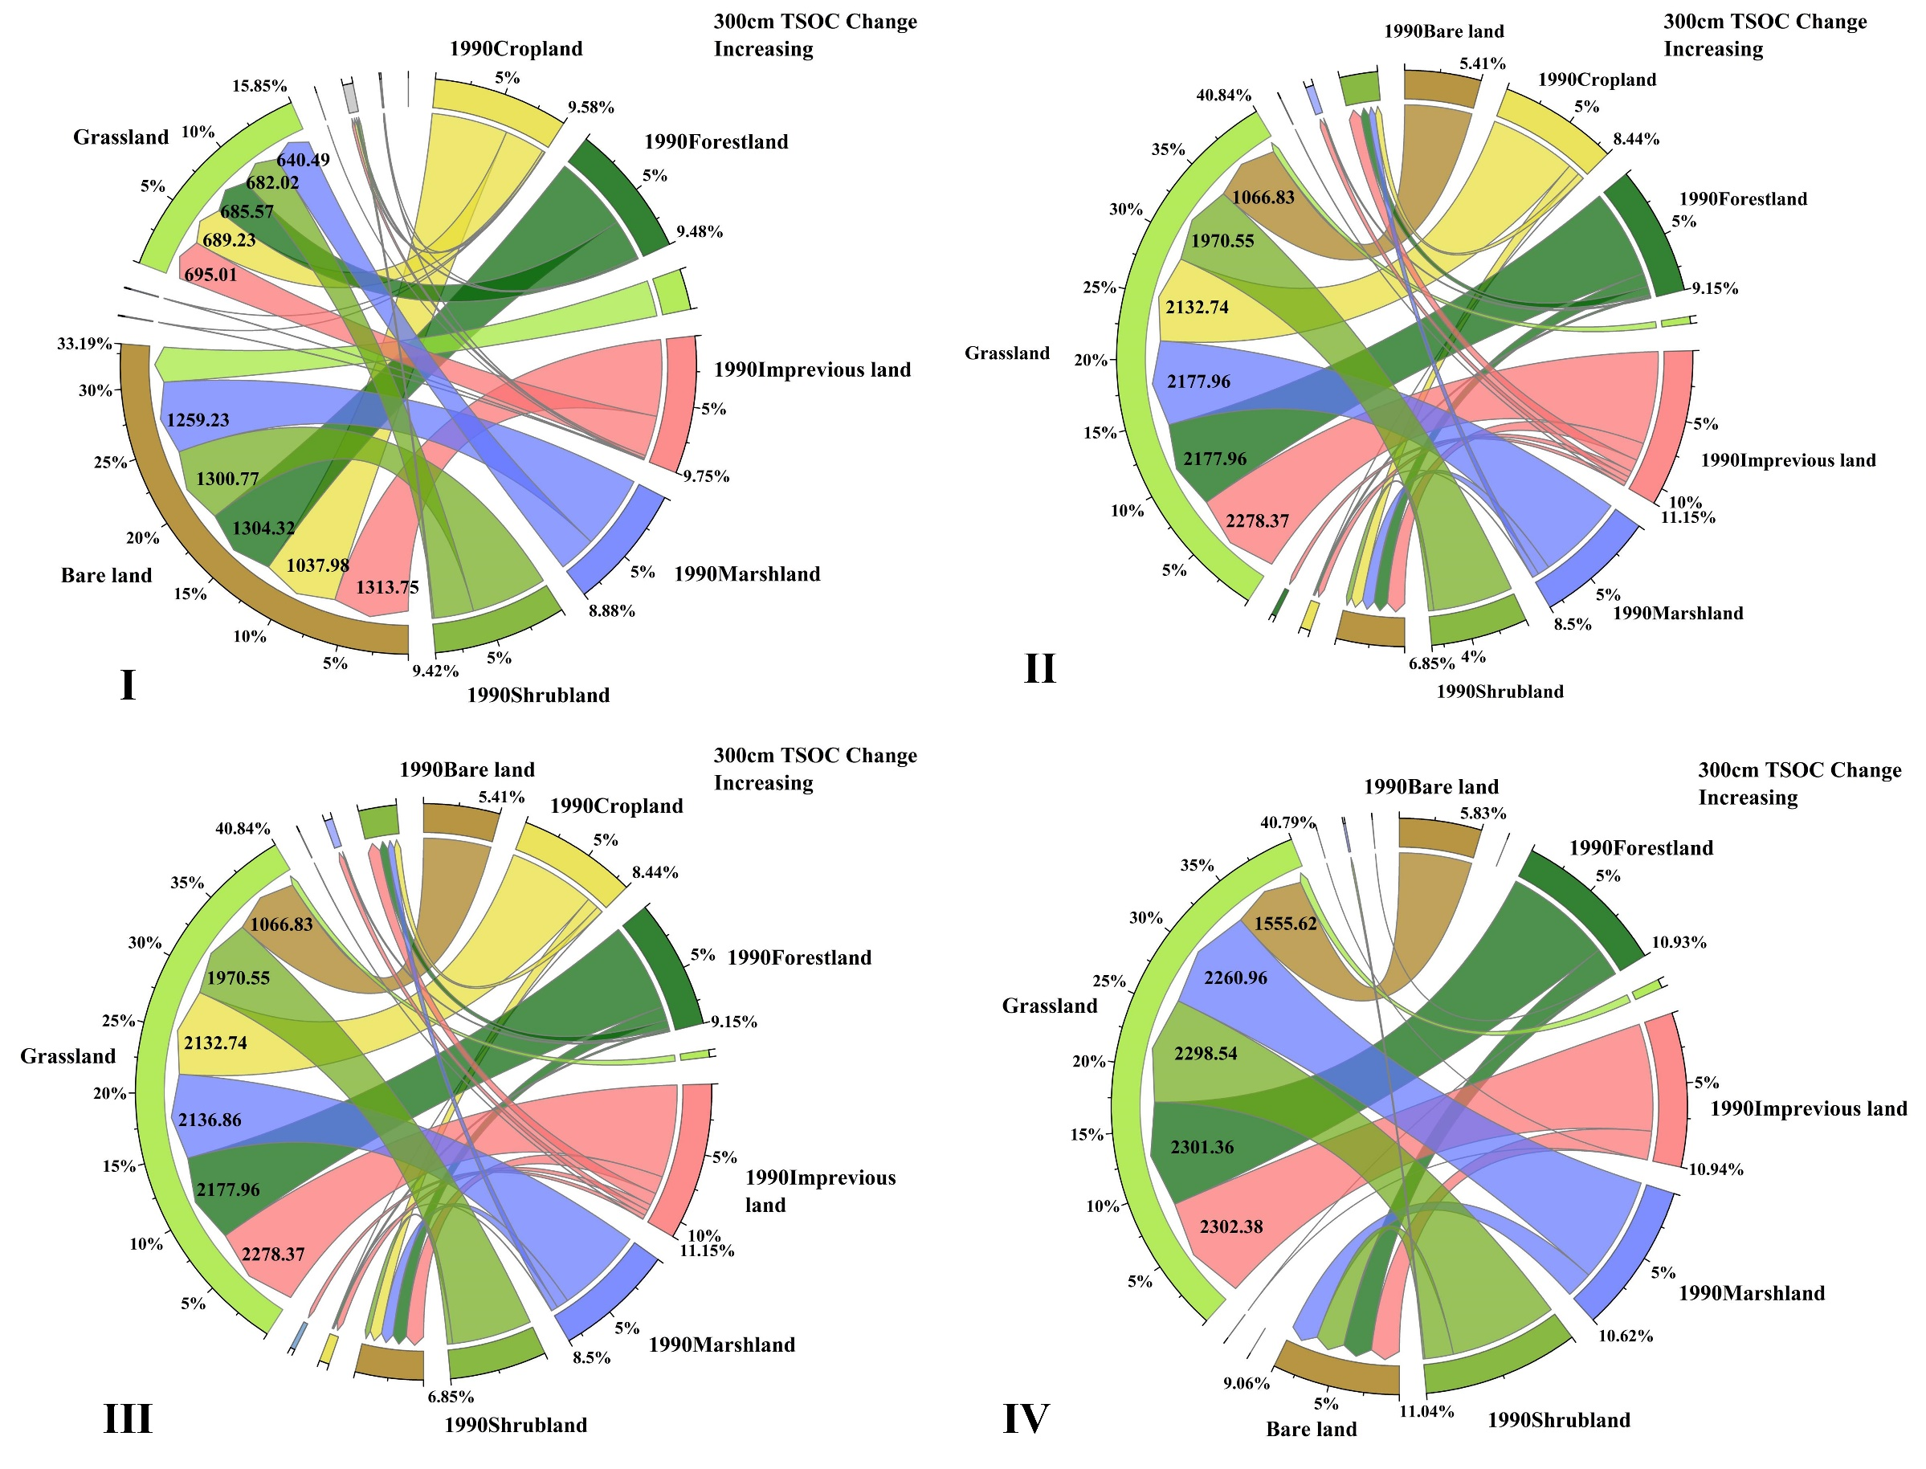
Fig.S4. Increasing in total soil organic carbon(TSOC) stocks under the influence of LUCC in 0-300cm layer(Tg C) (Note: Ⅰ: Desert and Gobi area, Ⅱ: Agricultural and Pastoral area, Ⅲ: Pastoral area and Ⅳ: Sanjiangyuan Nature Reserve).
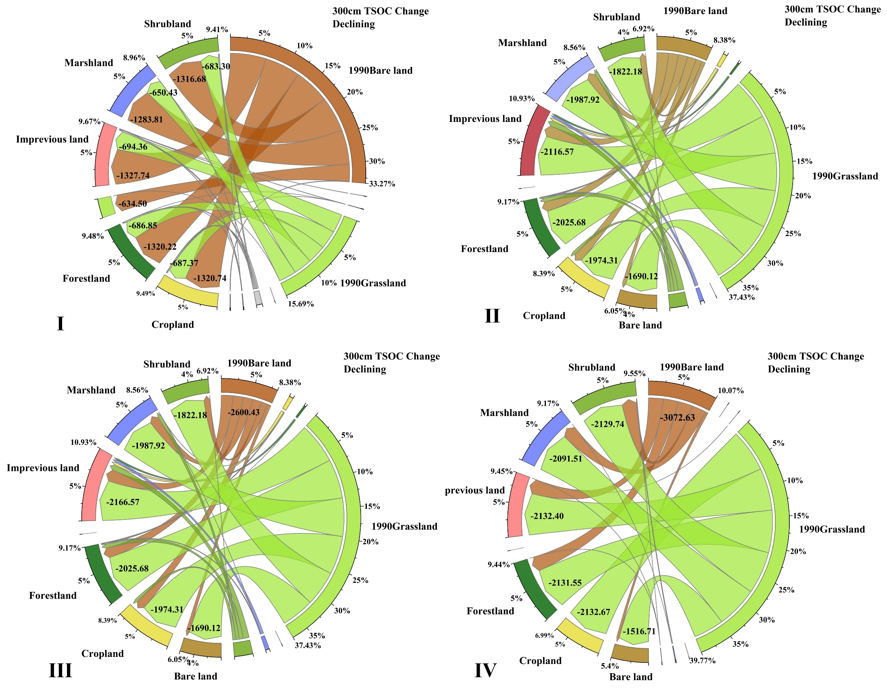
Fig.S5. Declining in total soil organic carbon (TSOC) stocks under the influence of LUCC in 0-300cm depth(Tg C) (Note: Ⅰ: Desert and Gobi area, Ⅱ: Agricultural and Pastoral area, Ⅲ: Pastoral area and Ⅳ: Sanjiangyuan Nature Reserve).
2.Tables Supplementary：

Table S1 Transfer Matrix of Qinghai Province between 1990-2020(Note: Ⅰ: Desert and Gobi area, Ⅱ: Agricultural and Pastoral area, Ⅲ: Pastoral area and Ⅳ: Sanjiangyuan Nature Reserve). (km²)
Areas | 1990  2020 | Bare land | Crop-  land | Forest-  land | Grass-  land | Ice/  snow | Impervious- land | Marsh  land | Shrub  land | Water | Sum 1990 | Transferred out
Qinghai total | Bare land | 180799.26 | 237.40 | 485.54 | 58938.42 | 1129.74 | 222.46 | 2328.47 | 786.57 | 4798.32 | 249726.18 | 68926.92
Qinghai total | Cropland | 121.69 | 4696.43 | 142.74 | 2223.40 | 0.00 | 402.64 | 7.66 | 113.05 | 170.45 | 7878.06 | 3181.63
Qinghai total | Forestland | 352.50 | 148.57 | 3848.34 | 2653.24 | 0.16 | 30.06 | 14.17 | 369.67 | 61.57 | 7478.29 | 3629.94
Qinghai total | Grassland | 38306.12 | 3071.17 | 2806.80 | 319630.46 | 400.72 | 594.08 | 5000.57 | 9760.47 | 6832.84 | 386403.22 | 66772.76
Qinghai total | Ice/snow | 728.47 | 0.00 | 0.34 | 344.26 | 3053.70 | 0.00 | 34.49 | 3.27 | 3.28 | 4167.81 | 1114.11
Qinghai total | Impervious land | 29.54 | 230.52 | 11.09 | 187.98 | 0.00 | 252.69 | 1.62 | 11.06 | 112.64 | 837.15 | 584.46
Qinghai total | Marshland | 2203.65 | 5.56 | 10.52 | 4286.19 | 25.23 | 78.45 | 8318.31 | 44.34 | 1237.40 | 16209.65 | 7891.34
Qinghai total | Shrubland | 594.45 | 168.87 | 403.95 | 8142.89 | 2.28 | 19.87 | 51.75 | 9354.38 | 169.75 | 18908.20 | 9553.82
Qinghai total | Water | 1859.99 | 122.52 | 59.31 | 4379.24 | 7.19 | 29.00 | 285.01 | 131.24 | 15784.05 | 22657.56 | 6873.51
Qinghai total | Sum 2020 | 224995.67 | 8681.03 | 7768.64 | 400786.09 | 4619.01 | 1629.24 | 16042.06 | 20574.04 | 29170.30 | 714266.10
Qinghai total | Transferred into | 44196.41 | 3984.60 | 3920.30 | 81155.63 | 1565.32 | 1376.56 | 7723.75 | 11219.67 | 13386.25
I | Bare land | 123135.04 | 170.20 | 298.94 | 22314.73 | 323.63 | 175.99 | 1424.68 | 332.47 | 1680.63 | 149856.32 | 26721.28
I | Cropland | 87.90 | 412.44 | 2.52 | 142.01 | 0.00 | 20.97 | 0.56 | 10.70 | 8.80 | 685.90 | 273.46
I | Forestland | 301.61 | 7.57 | 426.84 | 299.78 | 0.45 | 5.94 | 3.10 | 36.45 | 2.37 | 1084.12 | 657.28
I | Grassland | 21435.49 | 298.36 | 293.14 | 44645.62 | 96.96 | 129.90 | 1264.46 | 521.68 | 980.07 | 69665.68 | 25020.06
I | Ice/snow | 399.82 |  | 0.05 | 63.30 | 655.09 | 0.00 | 0.42 | 1.34 | 0.16 | 1120.18 | 465.09
I | Impervious land | 30.70 | 25.32 | 0.36 | 45.39 | 0.00 | 87.26 | 0.40 | 1.44 | 100.53 | 291.42 | 204.15
I | Marshland | 1677.01 | 2.07 | 6.53 | 1232.64 | 0.00 | 68.21 | 3192.54 | 21.62 | 860.67 | 7061.31 | 3868.77
I | Shrubland | 327.96 | 10.76 | 39.54 | 516.61 | 1.93 | 4.17 | 33.10 | 526.09 | 20.20 | 1480.37 | 954.27
I | Water | 684.40 | 6.63 | 2.98 | 256.32 | 0.04 | 4.29 | 51.03 | 14.67 | 1958.99 | 2979.35 | 1020.35
I | Sum 2020 | 148079.94 | 933.35 | 1070.89 | 69516.42 | 1078.09 | 496.73 | 5970.28 | 1466.49 | 5612.44 | 234224.64
I | Transferred into | 24944.90 | 520.91 | 644.05 | 24870.80 | 423.01 | 409.47 | 2777.74 | 940.40 | 3653.45
II | Bare land | 10786.70 | 134.19 | 157.19 | 11780.00 | 401.10 | 23.45 | 426.65 | 364.54 | 466.07 | 24539.88 | 13753.18
II | Cropland | 53.77 | 3789.99 | 141.33 | 2323.95 | 0.00 | 350.78 | 9.90 | 116.69 | 157.44 | 6943.87 | 3153.87
II | Forestland | 98.64 | 128.54 | 1906.97 | 1556.96 | 0.00 | 21.59 | 12.21 | 265.75 | 40.41 | 4031.08 | 2124.11
II | Grassland | 5407.74 | 2676.81 | 1455.09 | 67115.97 | 17.21 | 378.57 | 1565.36 | 4339.41 | 1032.30 | 83988.45 | 16872.48
II | Ice/snow | 92.80 | 0.00 | 0.34 | 15.56 | 58.34 | 0.00 | 0.90 | 1.60 | 0.00 | 169.54 | 111.20
II | Impervious land | 4.06 | 195.87 | 12.60 | 161.91 | 0.00 | 110.35 | 0.32 | 8.45 | 10.66 | 504.22 | 393.87
II | Marshland | 363.30 | 5.63 | 10.03 | 1679.51 | 0.00 | 2.36 | 1894.56 | 28.64 | 174.76 | 4158.78 | 2264.23
II | Shrubland | 266.39 | 136.95 | 271.74 | 4555.13 | 0.00 | 10.07 | 27.81 | 5211.65 | 109.71 | 10589.45 | 5377.80
II | Water | 119.25 | 108.35 | 37.95 | 813.00 | 0.00 | 24.21 | 105.81 | 103.41 | 4858.42 | 6170.41 | 1311.99
II | Sum 2020 | 17192.63 | 7176.34 | 3993.24 | 90002.00 | 476.66 | 921.37 | 4043.52 | 10440.15 | 6849.77 | 141095.68
II | Transferred into | 6405.94 | 3386.34 | 2086.27 | 22886.02 | 418.32 | 811.03 | 2148.97 | 5228.50 | 1991.35
III | Bare land | 3241.79 | 1.33 | 56.93 | 6246.31 | 96.60 | 4.25 | 152.78 | 125.63 | 105.50 | 10031.12 | 6789.33
III | Cropland | 0.00 | 38.41 | 20.51 | 144.12 |  | 6.80 | 0.00 | 13.63 | 11.42 | 234.89 | 196.48
III | Forestland | 21.42 | 21.61 | 966.93 | 1086.35 | 0.00 | 2.52 | 0.00 | 146.10 | 14.91 | 2259.85 | 1292.92
III | Grassland | 3196.24 | 152.80 | 1070.93 | 96569.05 | 71.61 | 54.03 | 1172.68 | 4120.45 | 562.06 | 106969.83 | 10400.79
III | Ice/snow | 85.87 | 0.00 | 0.00 | 82.93 | 263.09 | 0.00 | 0.53 | 0.32 | 0.09 | 432.83 | 169.74
III | Impervious land | 0.00 | 3.33 | 0.00 | 25.23 | 0.00 | 3.52 | 0.00 | 2.65 | 0.69 | 35.42 | 31.91
III | Marshland | 71.87 | 0.00 | 0.00 | 1238.26 | 5.32 | 0.22 | 1009.71 | 1.72 | 53.38 | 2380.48 | 1370.77
III | Shrubland | 109.12 | 36.46 | 169.46 | 4152.40 | 1.04 | 3.75 | 1.52 | 2091.70 | 32.94 | 6598.38 | 4506.68
III | Water | 20.18 | 13.11 | 18.98 | 435.96 | 1.38 | 1.26 | 36.20 | 28.00 | 172.07 | 727.14 | 555.07
III | Sum 2020 | 6746.48 | 267.06 | 2303.73 | 109980.60 | 439.03 | 76.35 | 2373.43 | 6530.21 | 953.05 | 129669.95
III | Transferred into | 3504.69 | 228.65 | 1336.80 | 13411.55 | 175.94 | 72.84 | 1363.71 | 4438.52 | 780.98
IV | Bare land | 40059.30 | 0.00 | 6.89 | 21288.99 | 199.41 | 5.72 | 412.03 | 8.94 | 2415.67 | 64396.94 | 24337.64
IV | Forestland | 2.37 | 0.00 | 23.64 | 26.00 | 0.00 | 0.60 | 0.00 | 0.03 | 2.40 | 55.05 | 31.41
IV | Grassland | 11113.90 | 3.27 | 23.66 | 108650.42 | 254.89 | 5.63 | 904.65 | 64.90 | 3635.48 | 124656.79 | 16006.37
IV | Ice/snow | 262.53 | 0.00 | 0.00 | 227.27 | 1920.10 | 0.00 | 26.80 | 0.00 | 4.83 | 2441.52 | 521.42
IV | Impervious land | 2.02 | 0.00 | 0.06 | 3.41 | 0.00 | 0.17 | 0.00 | 0.00 | 0.16 | 5.82 | 5.64
IV | Marshland | 409.57 | 0.00 | 0.00 | 844.40 | 25.91 | 0.00 | 1139.58 | 1.30 | 183.13 | 2603.90 | 1464.32
IV | Shrubland | 3.60 | 0.00 | 1.19 | 99.06 | 0.00 | 2.98 | 0.72 | 23.40 | 1.13 | 132.09 | 108.69
IV | Water | 1283.53 | 0.00 | 0.91 | 3468.24 | 5.33 | 1.74 | 101.46 | 0.31 | 7872.09 | 12733.62 | 4861.53
IV | Sum 2020 | 53136.84 | 3.27 | 56.36 | 134607.79 | 2405.64 | 16.84 | 2585.23 | 98.88 | 14114.87 | 207025.73
IV | Transferred into | 13077.54 | 3.27 | 32.72 | 25957.37 | 485.54 | 16.67 | 1445.65 | 75.48 | 6242.78

