Supplemental Information
Gut Microbiota Regulates the Metabolic Benefits of Resistance Exercise Intervention via BCAAs Biosynthesis

Kai Zhang¹, Siting Shen², Jueni Duan³, Meng Li², Haihua Yuan⁴, Yuan Huang⁴, Xuefeng Gao⁵#, Yunpeng Cai¹#
¹Research Center for Biomedical Information Technology, Shenzhen Institute of Advanced Technology, China Academy of Science, Shenzhen, Guangdong, China
²Central Laboratory, Shenzhen Key Laboratory of Precision Medicine for Hematological Malignancies, Shenzhen University General Hospital, Shenzhen, Guangdong, China
³Health Management Center, Shenzhen University General Hospital, Shenzhen University Clinical Medical Academy, Shenzhen, Guangdong, China
⁴Catic Wellness Group Co., ltd., Shenzhen, Guangdong, China
⁵Integrative Microecology Center, Department of Gastroenterology, Shenzhen Hospital, Southern Medical University, Shenzhen, Guangdong, Chin

#Address correspondence to Xuefeng Gao, xfgao@smu.edu.cn, Yunpeng Cai, yp.cai@siat.ac.cn.

This PDF file includes: Figure S1-S8

Figure S1. Flow chart illustrating the procedures for screening and selection of study participants.
Figure S2. The distribution of regression coefficients (slopes) in the regression analysis with GLMMLASSO between microbial beta diversity, clinical factors or physical activity and weight loss across individuals.
Figure S3. Linear models of enrichment microbial functional pathway in responders against non-responders with co-variate adjustment for BMI.
Figure S4.The metabolites originate discrimination analysis of serum metabolites. (A) Venn diagram shows the distribution of metabolites in host, microbiota and co-metabolism; (B) Number of metabolites from different sources.
Figure S5.FMT promotes distinct microbial shifts of alpha and beta diversity in responder and non-responder mice. (A) Boxplot displaying the Shannon index and (B) Chao 1 index; (C) Principal coordinate analysis of the beta-diversity index based on Bray-Curtis distance, colored by mice group; (D) NMDS plot of microbial community structure variation betwwen responders and non-responders based on Bray-Curtis distance. ANOSIM (analysis of similarities).
Figure S6. Faecal microbiota analysis showing FMT led to durable engraftment of human-associated microbiota into DIO mice. (A) Venn diagram showing the migration of predominant genera in donors, DIO mice and control mice after the FMT; (B) Boxplot showing the univariate analyses of relative abundance differences of predominant genera in donors, DIO mice and control mice. One-way ANOVA followed by Tukey post hoc test.
Figure S7.Body weight changes from baseline to 12 weeks versus baseline log10-transformed P/B ratio for participant. Linear regression line is depicted in red and respective confidence interval (95%) is drawn in gray.
Figure S8. The receiver operating characteristic (ROC) curves and area under curve (AUC) of the baseline BCAAs feature-based model for the discrimination between responders and non-responders in (A) gut BCAAs function gene model in discovery cohort; (B) serum BCAAs concentration model in discovery cohort and (C) gut BCAAs function gene model in validation cohort.

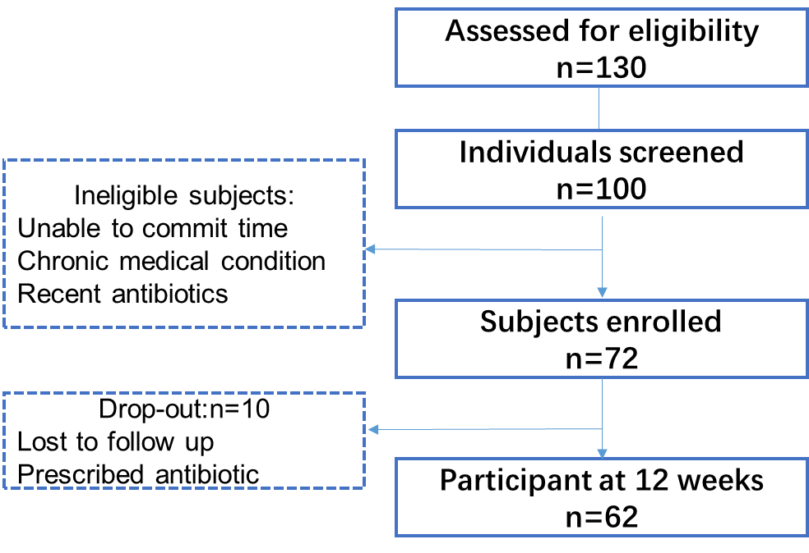
Figure S1.

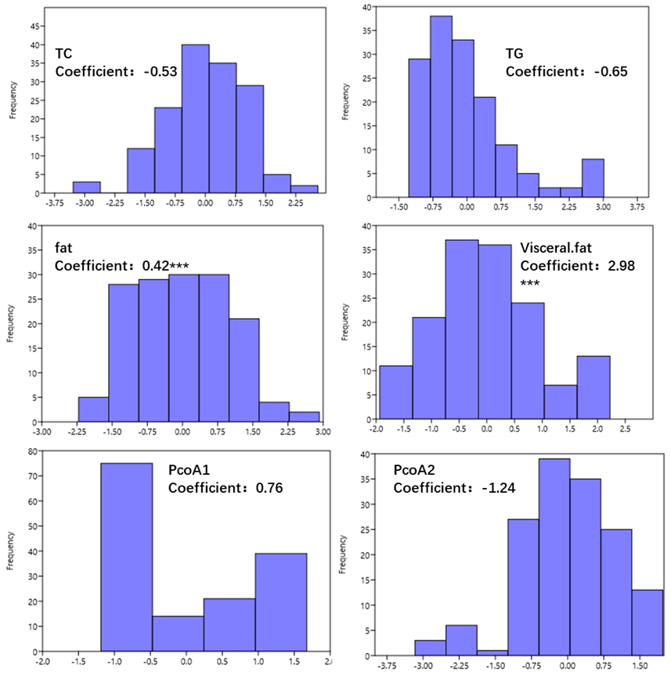
Figure S2
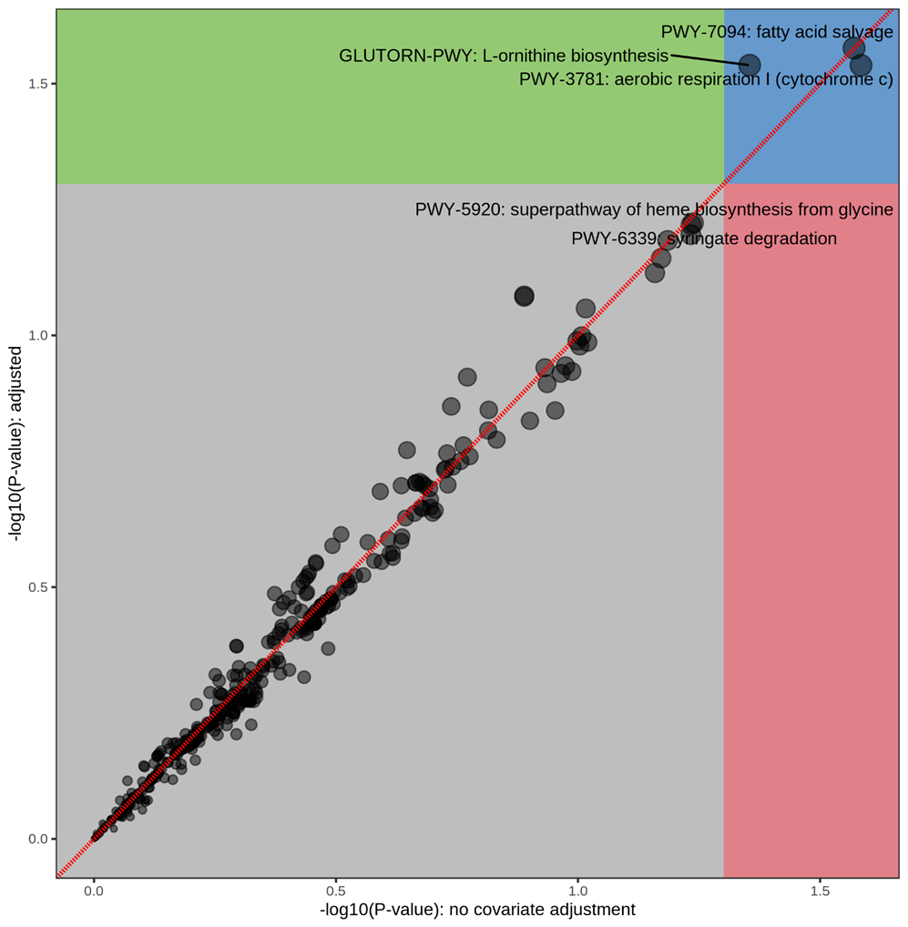
Figure S3

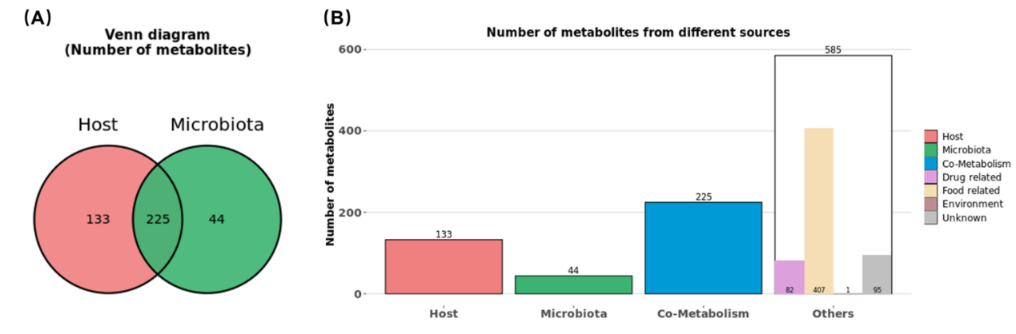
Figure S4.

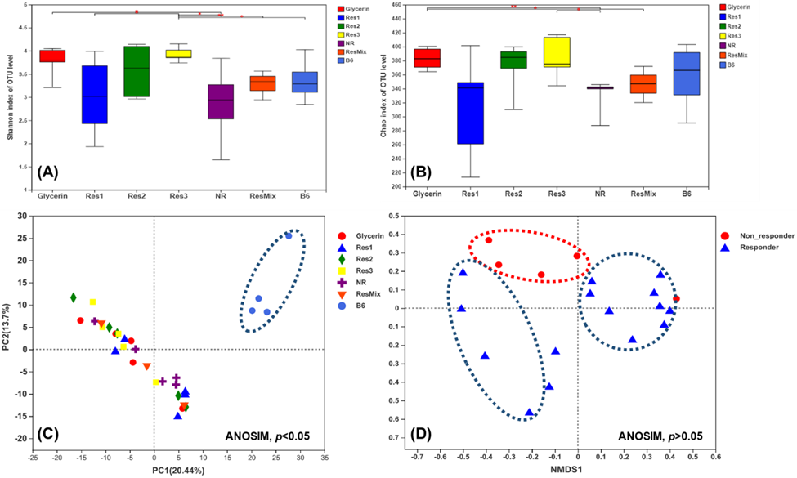
Figure S5.

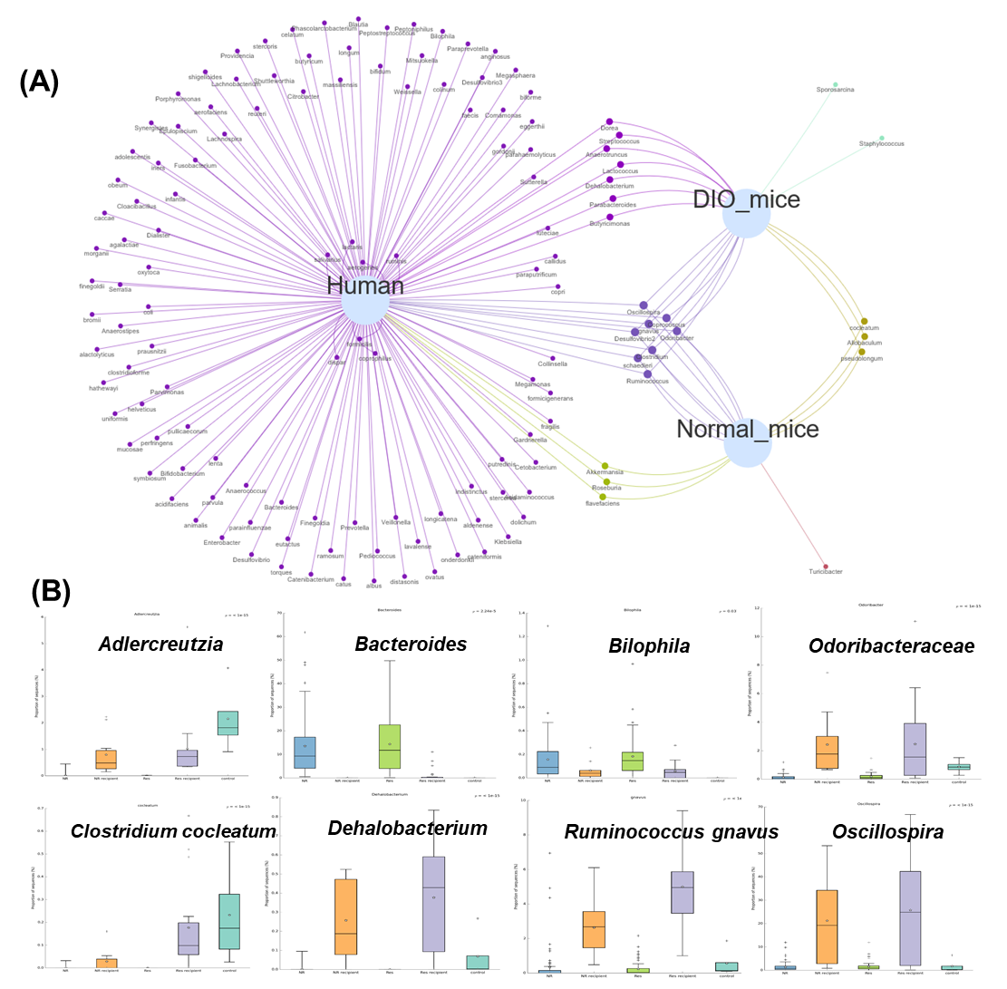
Figure S6.

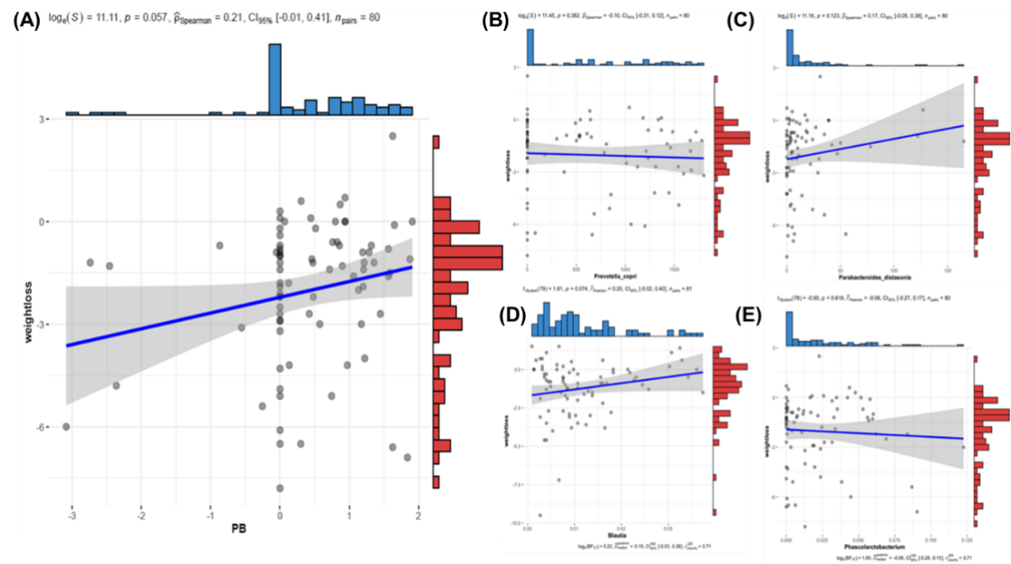

Figure S7.

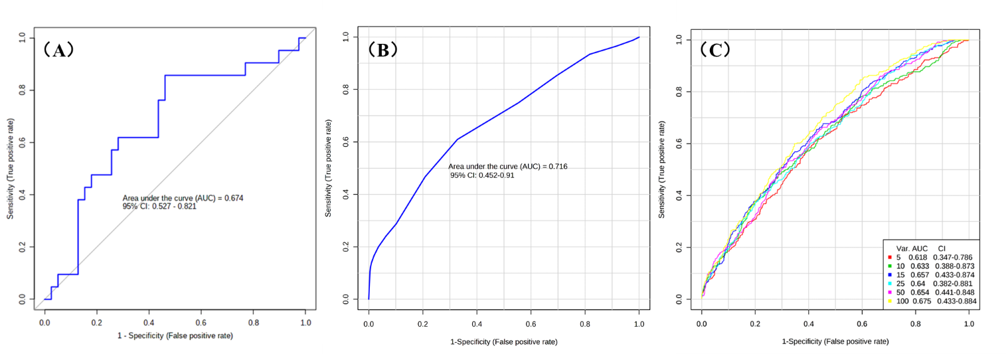
Figure S8.

