Supporting Information for
Polysaccharide-based hydrogels with self-healing, antibacterial, and antioxidant activity for S. aureus-infected wound healing
Que Bai, Siyuan Gou, Fangfang Hu, Qian Gao, Wenhui Zhang, Yanni Zhang, Tingli Lu*
Key Laboratory of Space Bioscience and Biotechnology, School of Life Sciences, Northwestern Polytechnical University, 127 West Youyi Road, Xi'an, Shaanxi, 710072, PR China
1. EXPERIMENTAL SECTION
1.1. Materials
Chitosan (100-200 mpa.s) was from Sigma-Aldrich (USA). 1-ethyl-3-(3-dimethyllaminopropyl) carbodiimide hydrochloride (EDC), N-hydroxysuccinimide (NHS), and curcumin were from Aladdin Reagent (Shanghai, China). Glycidyltrimethylammonium chloride (ca.80% in Water) (GTMAC) and 4-Carboxyphenylboronic acid (4-CPBA) were purchased from J&K Scientific (Beijing, China). 3-(4, 5-dimethyl-2-thiazolyl)-2, 5-diphenyl tetrazolium bromide (MTT) was obtained from Beijing Solarbio Science & Technology Co., Ltd. 2, 2-Diphenyl-1-picrylhydrazyl (DPPH) was from Shanghai Yuanye Bio-Technology Co., Ltd. Methanol and Dimethyl sulfoxide (DMSO) were obtained from HUSHI (Shanghai, China). Hydrogen peroxide 30% (H₂O₂) was purchased from DAMAO CHEMICAL REAGENT FACTORY (Tianjin, China). Triton X-100 was purchased from Amresco (USA). Hemostatic sponge was from Kuai Kang (Guangzhou, China). Calcein/PI cell viability assay kit and Reactive Oxygen Species assay kit were supplied by Beyotime (Shanghai, China). All cell culture-related reagents (Fetal Bovine Serum, High-DMEM, Trypsin, and Penicillin-Streptomycin solutin) were from Biological Industries (Israel).
1.2 Synthesis of PBA-QCS
2 g chitosan was dissolved in 72 mL 1% acetic acid solution, and 3.578 mg GTMAC was added for 24 h at 55℃, and the residual small molecule compounds were removed by dialysis for 3 days. 3 g of QCS was fully dissolved in 440 mL ddH₂O, and 1.9956 g EDC and 1.4796g NHS were sequentially added. After pH was adjusted to 5.5 and 3.09 g of 4-CPBA was added for 24 h, and lyophilized after 3 days of dialysis. The obtained products were confirmed by UV-Vis spectrophotometer (F-2300, HITACHI, Japan) and Fourier Transform Infrared Spectroscopy (FTIR, Nicolet iS50, Thermo Scientific, USA).
1.3 Swelling of the hydrogels in vitro
The freeze-dried hydrogel was soaked in 10 mL PBS and placed in a 120-rpm shaker at 37℃. The hydrogels were weighed (using filter paper to remove surface water) at a predetermined time until the weight of all hydrogel samples remained constant. The swelling ratio of hydrogels could be calculated by the equation:
Swelling ratio (%) = (W_{P}-W₀)/W₀ × 100%
Where W₀ and W_{P} referred to the weight of hydrogel at initial and predetermined time respectively.
1.4 Degradation of the hydrogels in vitro
To evaluate degradation of PBA-QCS1.5, PBA-QCS2, PBA-QCS2.5, and PBA-QCS2@Cur hydrogels in vitro, 600 μL hydrogels were weighed and incubated in 15 mL PBS on a rotary shaker (120 rpm) at 37℃. At predetermined time, the sample was weighed after wiping the surface water with filter paper, and the weight loss of the sample was calculated according to the formula:
Weight loss (%) = (W₀-W_{P})/W₀ × 100%
Where W₀ and W_{P} referred to the weight of hydrogel at initial and predetermined time respectively.
1.5 DPPH scavenging
The DPPH radical scavenging ability of hydrogels was determined by UV-vis spectrophotometer. Briefly, 200 μL hydrogel was ground into powder and soaked in DPPH-methanol (10 mΜ, 3 mL) solution. After incubation in darkness for 60 min, the absorbance value of supernatant at 517 nm was detected with a microplate reader (Synergy H1, BioTek, USA). DPPH scavenging was calculated with the equation:
DPPH scavenging (%) = (OD_{C}-OD_{H})/OD_{C} × 100%
Where OD_{C} and OD_{H} represent the absorbance values of DPPH-methanol and hydrogel + DPPH-methanol, respectively.
1.6 ROS staining
Fresh tissues were sectioned to 15 μm thick slices. The intracellular ROS levels were determined by staining the slides with dihydroethylenediamine (DHE, GDP1018, Servicebio). DHE could freely enter the cell through living cells and be oxidized by intracellular ROS to form ethidium oxide. Ethidium oxide could be incorporated into chromosome DNA to produce red fluorescence. The stained slides were photographed using a Digital Pathology Syestem (3DHISTECH).
1.7 Data analysis
All experimental data were obtained from at least triplicate replicates, all of which were mean ± standard deviation (SD). The data were analyzed using Origin 9 and GraphPad Prism 8. Differences between values were assessed using a one-way analysis of variance (ANOVA). The no significance (NS) indicated P > 0.05, and there is no significant difference in data. * P < 0.05, ** P < 0.01, *** P < 0.001, **** P < 0.0001 are statistically significant.
2 RESULTS
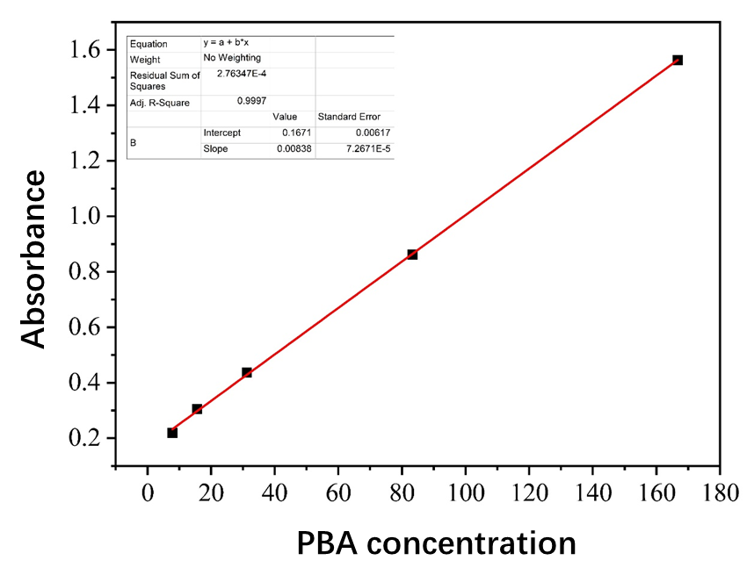
Figure S1. PBA standard curve (y = 0.00838x + 0.1671, R2 = 0.9997).
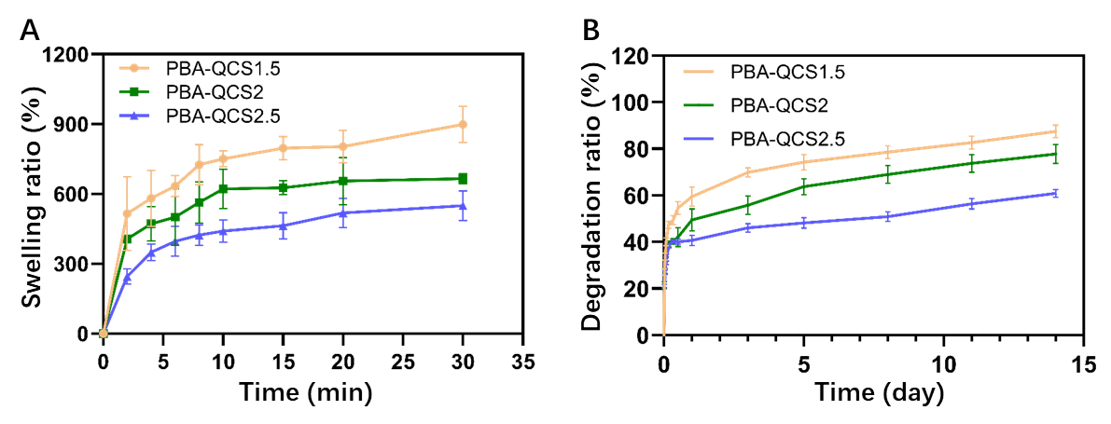
Figure S2. (A) Swelling ratio of PBA-QCS hydrogels. (B) The degradation ratio of PBA-QCS hydrogels. (n=5)
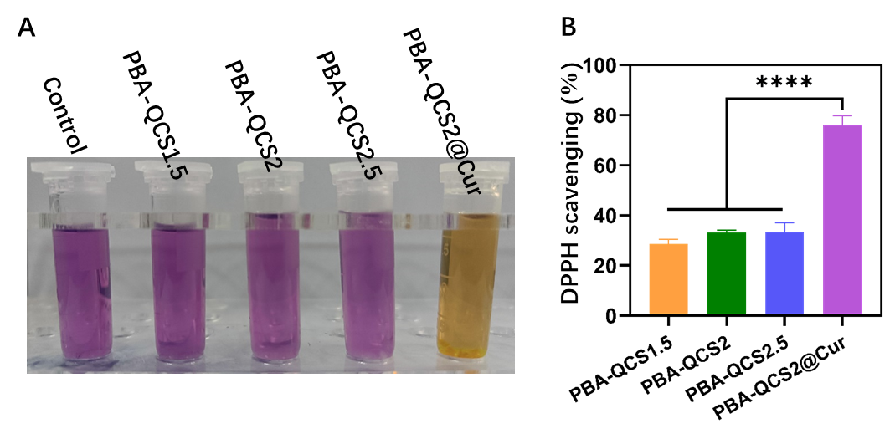
Figure S3. (A) Color change of hydrogel after incubation with DPPH solution. (B) DPPH scavenging.
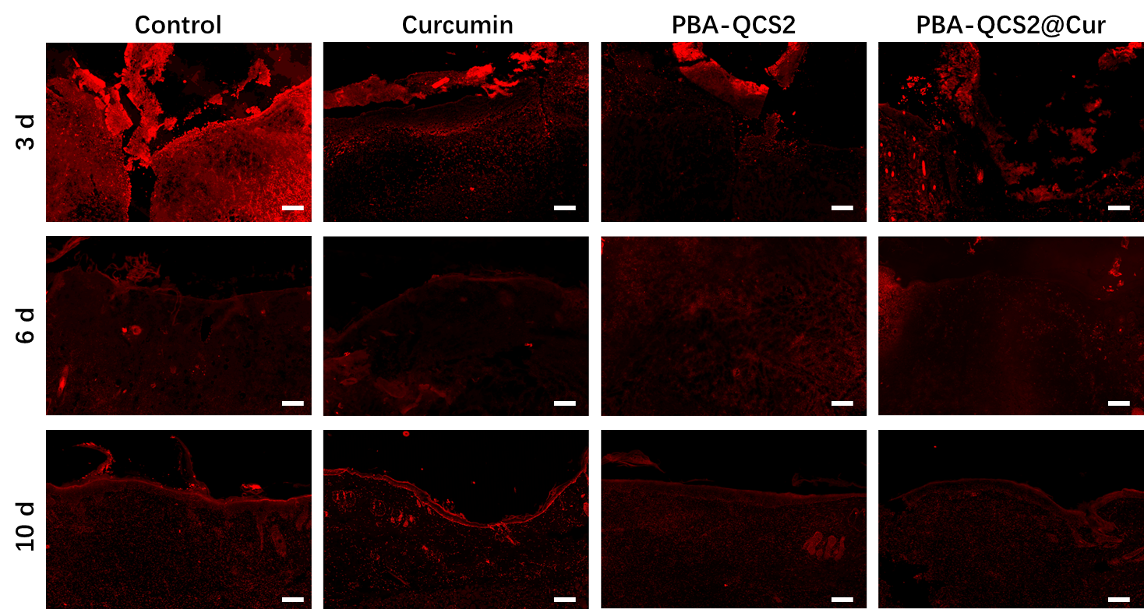
Figure S4. Immunofluorescence images of ROS (DHE). Scale bar = 200 μm.

