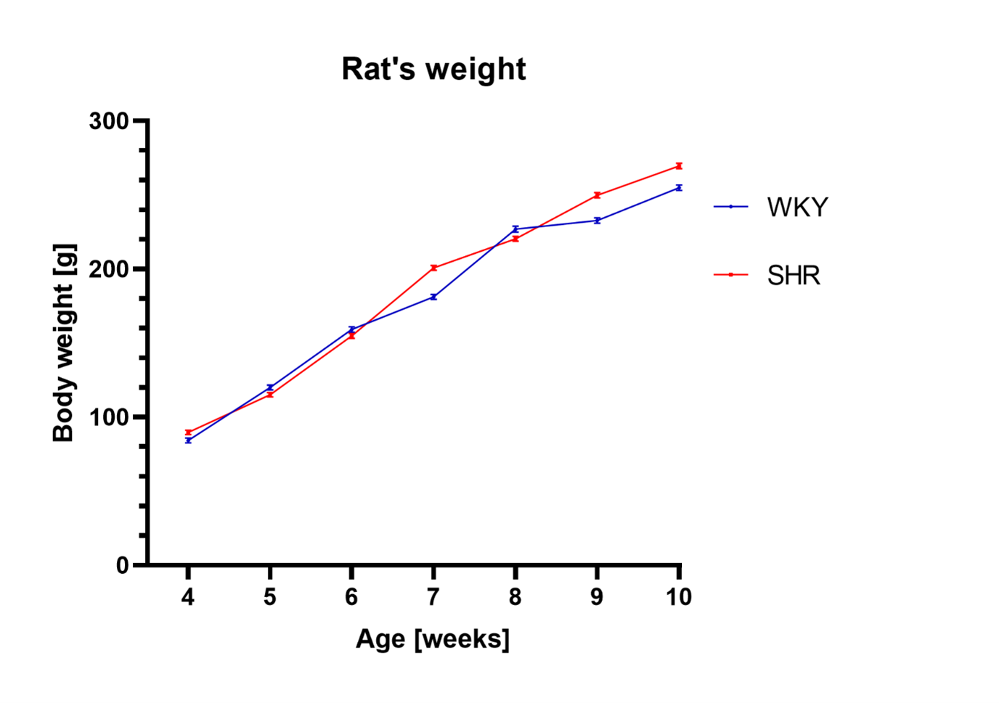
Figure S1. Rat body weight [g] during the experimental period (4-10 weeks). The one-way ANOVA analysis followed by Tukey’s post hoc t-test did not show significant statistical differences between strains in a one-way ANOVA test (n =5 or 6 rats per group; mean value ± SD).

