Theoretical and Applied Climatology

Supplementary Material for
Southern Hemisphere Continental Temperature Responses to Major Volcanic Eruptions since 1883 in CMIP5 Models
P. J. Harvey¹, S. W. Grab¹

¹School of Geography, Archaeology and Environmental Studies, University of the Witwatersrand, Johannesburg, South Africa

Corresponding author: Pamela Harvey (pamjharvey14@gmail.com)

Contents of this document
Figures S1 to S3

Introduction
This supplemental material provides three figures, each showing the Southern Hemisphere (SH) temperature response after the eruptions of Krakatau, Santa Maria, Agung and Pinatubo for the seasons DJF (Fig. S1), JJA (Fig. S2) and SON (Fig. S3).

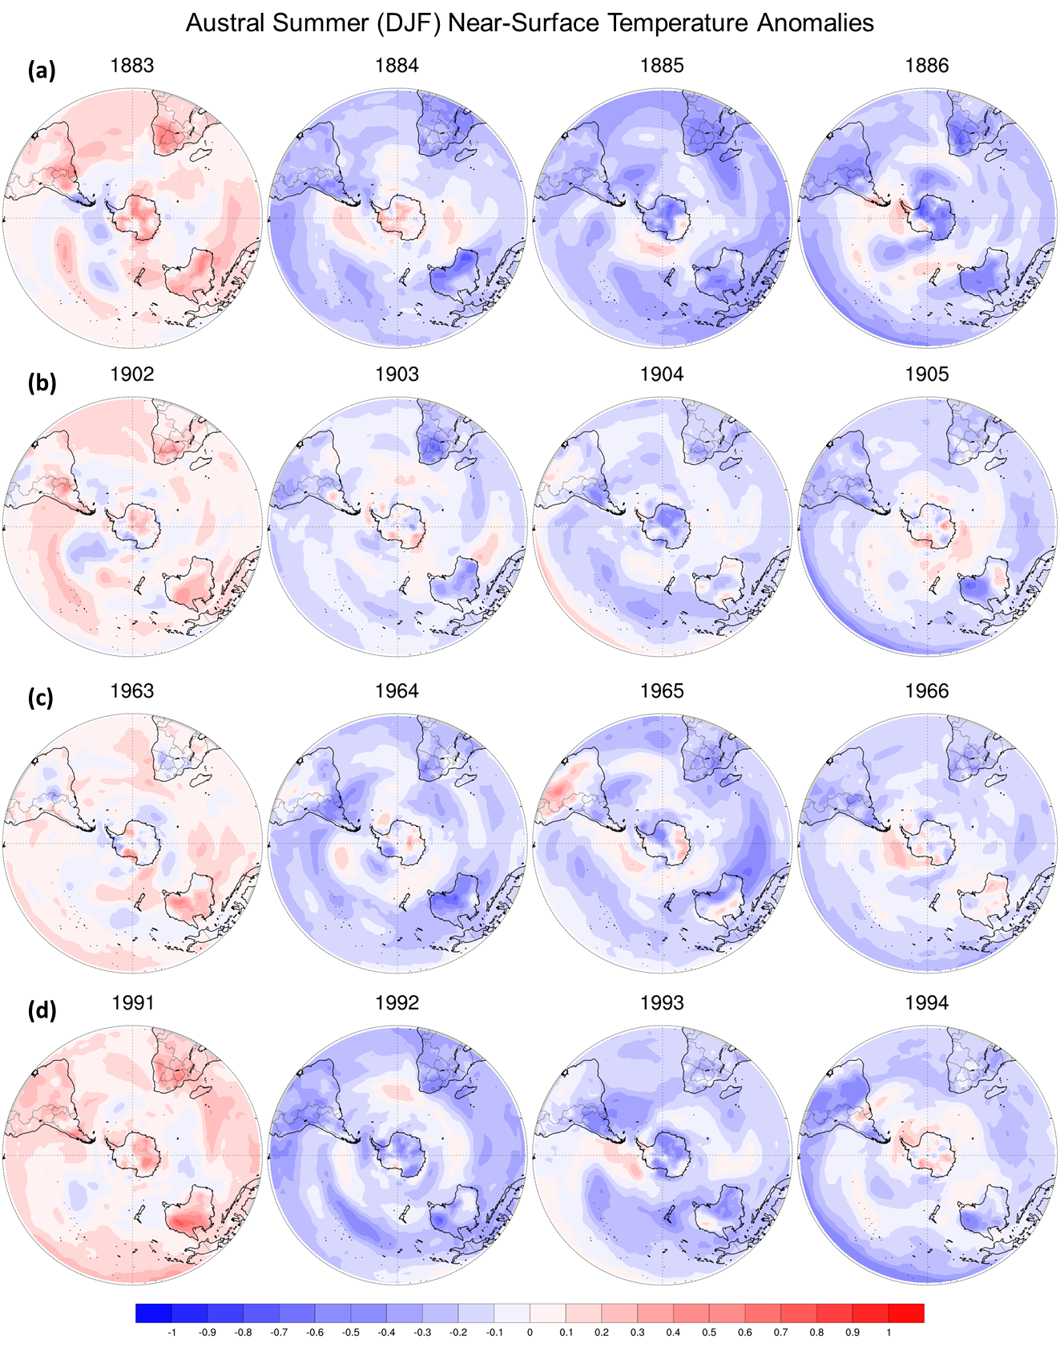
Fig. S1 Spatial maps of austral summer temperature anomalies over the Southern Hemisphere (SH) for the eruptions of (a) Krakatau, (b) Santa Maria, (c) Agung and (d) Pinatubo.
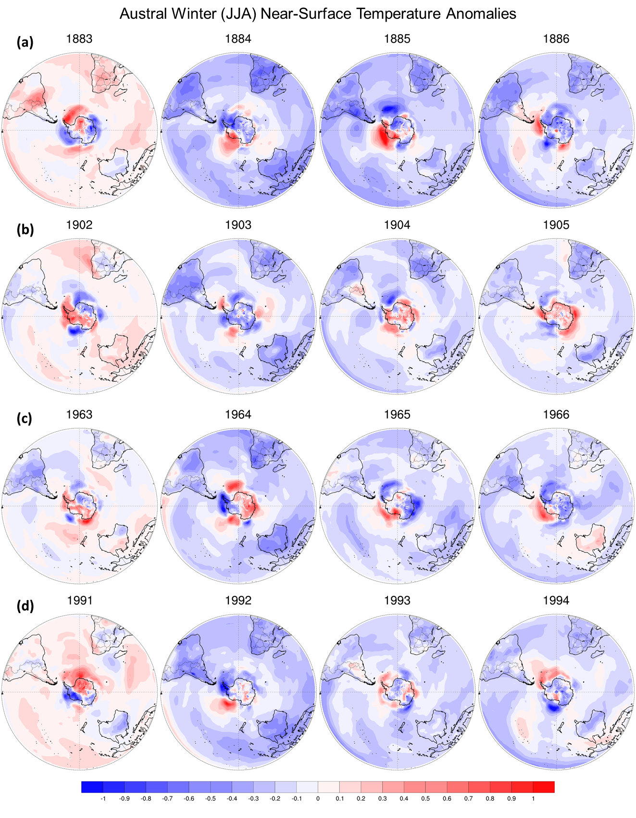
Fig. S2 Spatial maps of austral winter temperature anomalies over the SH for the eruptions of (a) Krakatau, (b) Santa Maria, (c) Agung and (d) Pinatubo.

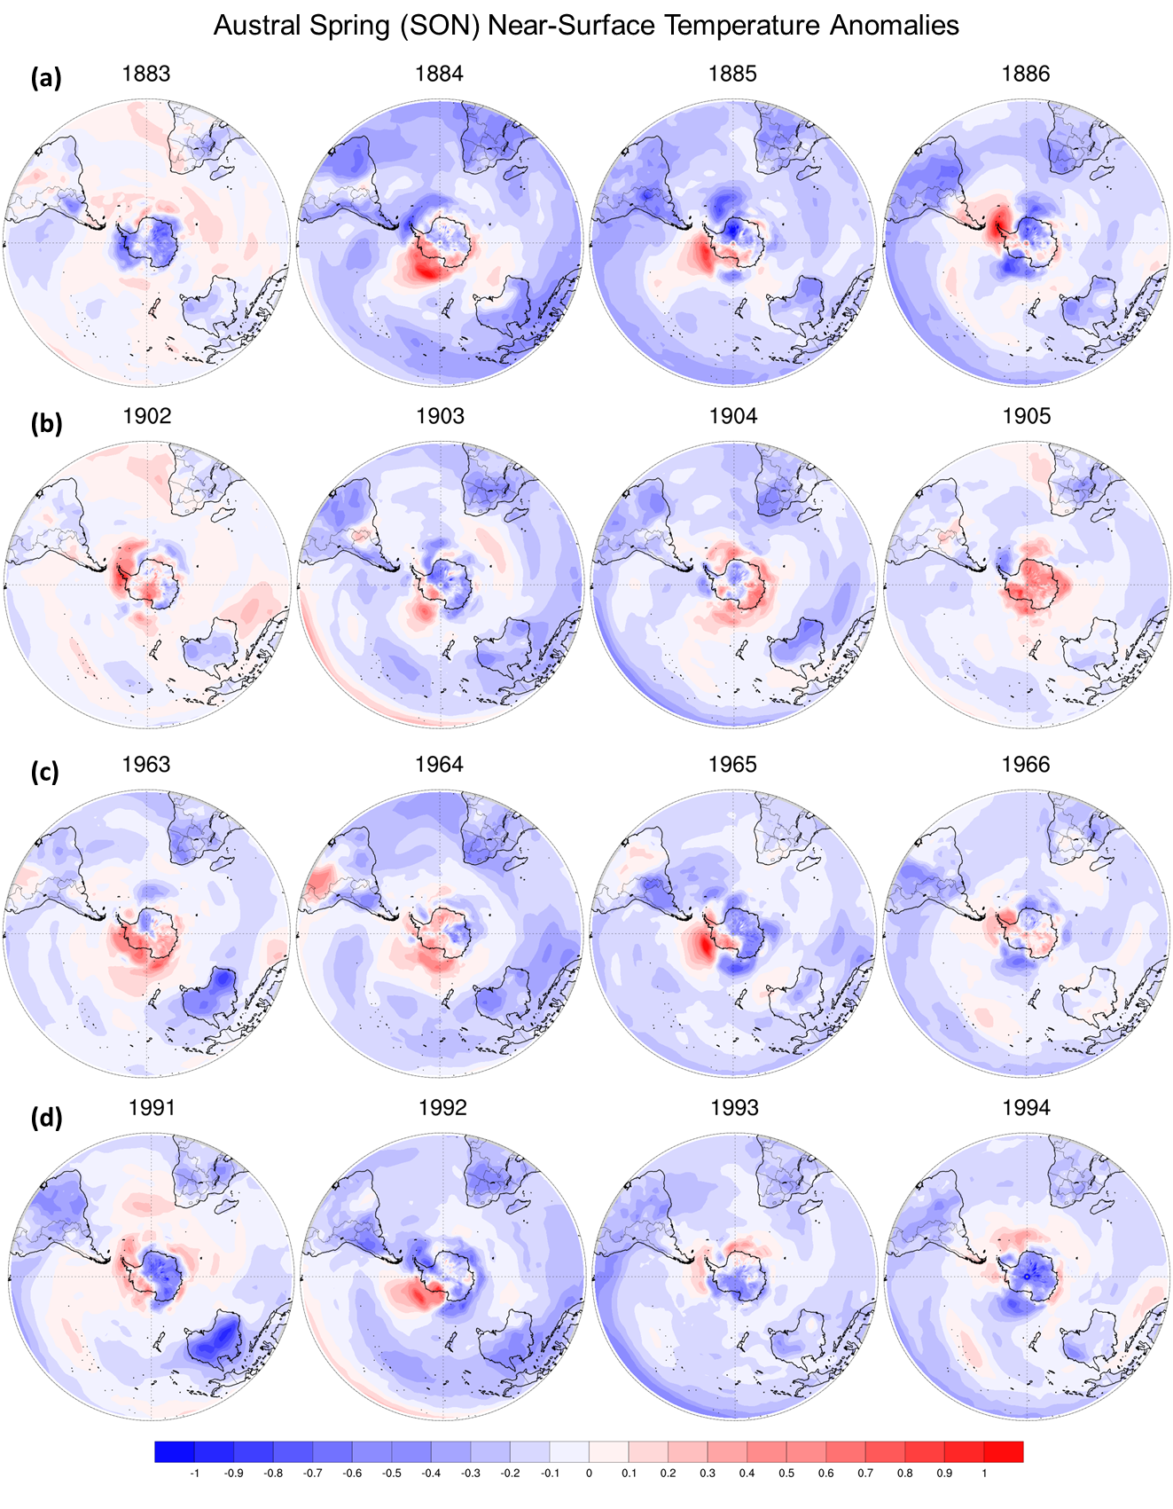
Fig. S3 Spatial maps of austral spring temperature anomalies over the SH for the eruptions of (a) Krakatau, (b) Santa Maria, (c) Agung and (d) Pinatubo.

