Extended Materials

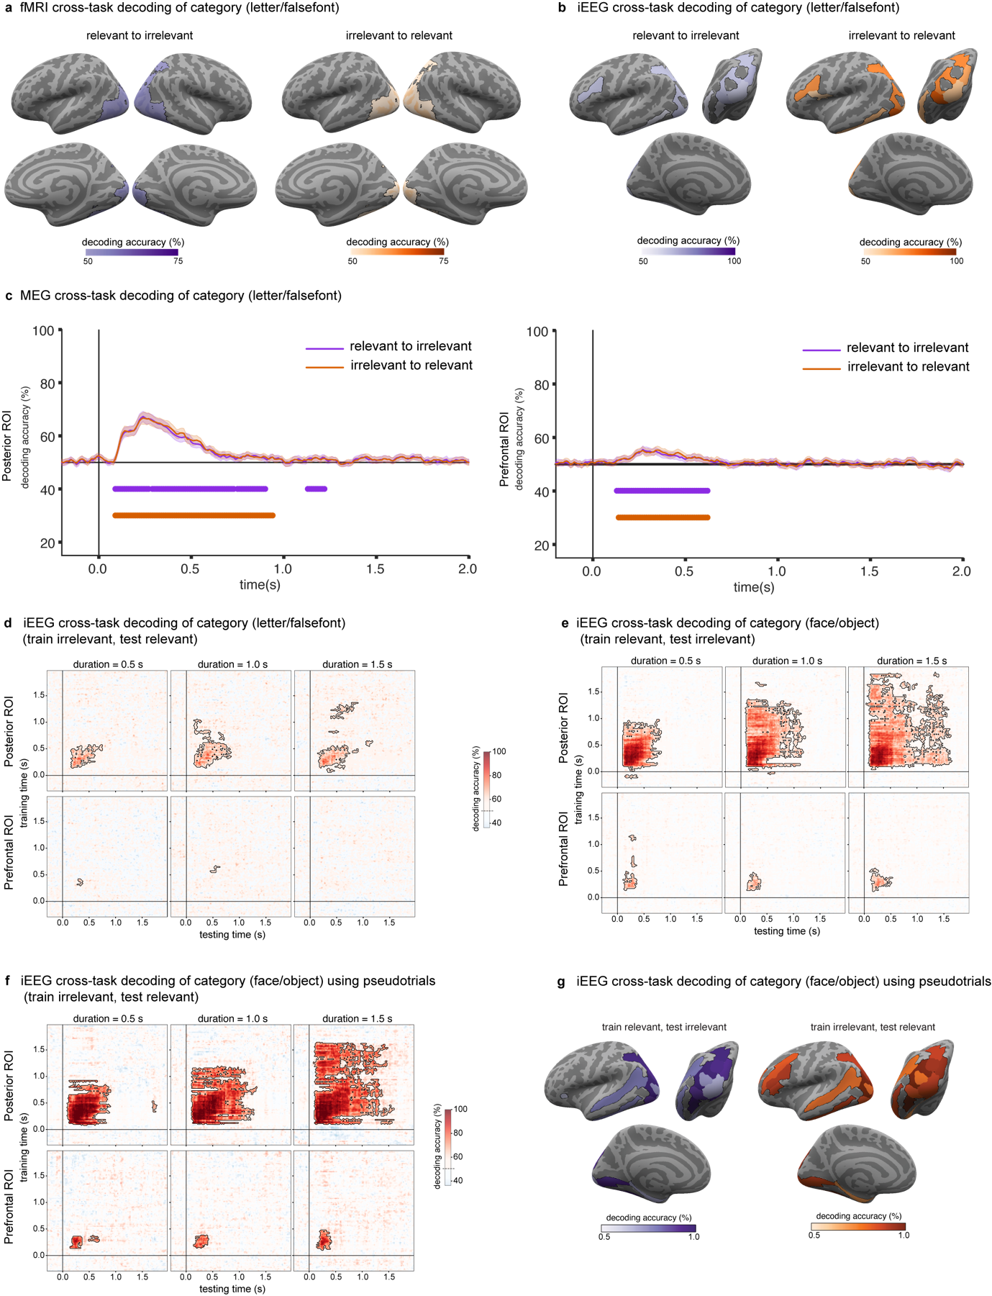

Extended Data Figure 1: Prediction#1 Decoding of conscious content for letters, false fonts, faces and objects
a. fMRI decoding accuracies (letters vs. false fonts) using a searchlight approach, collapsed across the three stimulus durations. Left: decoding for classifiers trained on task relevant and tested on task irrelevant stimuli (purple). Right: decoding for classifiers trained on task irrelevant and tested on task relevant stimuli (orange-red). Regions showing significantly above-chance (50%) decoding accuracies are indicated by the outlined colored regions on the inflated cortical surfaces (top: left/right lateral views; bottom: right/left medial views).
b. iEEG decoding accuracies (letters vs. false fonts) within the theory-relevant ROIs collapsed across stimulus duration. Left: decoding for classifiers trained on task relevant and tested on task irrelevant stimuli (purple). Right: decoding for classifiers trained on task irrelevant and tested on task relevant stimuli (orange-red). ROIs showing significantly above-chance (50%) decoding are displayed on inflated surface maps from a left lateral view (top left), posterior view (top right) and left medial view (bottom).
c. MEG cross-task decoding of category for letter vs false font. (orange-red: train on test irrelevant, test on task relevant; purple: train on task relevant, test on task irrelevant). Left: results in posterior ROIs. Right: results in prefrontal ROIs.
d. iEEG cross-task temporal generalization of category decoding (letters vs. false fonts) classifiers trained on task relevant stimuli and tested on task irrelevant stimuli. The three stimulus durations are plotted in columns (left: 0.5 s; center: 1.0 s; right: 1.5 s) and the two theory ROIs in rows (top: posterior ROIs; bottom: prefrontal ROIs). Significantly above-chance (50%) decoding is indicated by the outlined pink-red regions in the temporal generalization matrices.
e. iEEG cross-task temporal generalization of category decoding (faces vs. objects) in the opposite direction as in Figure 2b (classifiers trained on task relevant stimuli and tested on task irrelevant stimuli). Conventions as in c.
f. iEEG cross-task temporal generalization of category decoding (faces vs. objects), Classifiers are trained on task relevant and tested on task irrelevant stimuli. Pseudotrials are used to boost decoding accuracy. Conventions as in c.
g. iEEG decoding accuracies within the theory-relevant ROIs using pseudotrial aggregation to boost decoding accuracies, collapsed across stimulus duration. Conventions as in b.

Extended Data Table 2: Theory defined anatomical ROIs (Destrieux atlas)

Parcellation | Relevant for
Fronto-marginal gyrus (of Wernicke) and sulcus | IIT excluded
Inferior occipital gyrus (O3) and sulcus | IIT, FFA
Transverse frontopolar gyri and sulci | IIT excluded
Anterior part of the cingulate gyrus and sulcus (ACC) | GNWT, IIT excluded
Middle-anterior part of the cingulate gyrus and sulcus (aMCC) | GNWT, IIT excluded
Middle-posterior part of the cingulate gyrus and sulcus (pMCC) | GNWT
Cuneus (O6) | IIT
Opercular part of the inferior frontal gyrus | GNWT, IIT excluded
Orbital part of the inferior frontal gyrus | GNWT, IIT excluded
Triangular part of the inferior frontal gyrus | GNWT, IIT excluded
Middle frontal gyrus (F2) | GNWT, IIT excluded
Superior frontal gyrus (F1) | IIT excluded
Middle occipital gyrus (O2, lateral occipital gyrus) | IIT, LOC
Superior occipital gyrus (O1) | IIT
Lateral occipito-temporal gyrus (fusiform gyrus, O4-T4) | IIT, FFA
Lingual gyrus, ligual part of the medial occipito-temporal gyrus, (O5) | IIT
Parahippocampal gyrus, parahippocampal part of the medial occipito-temporal gyrus, (T5) | IIT
Orbital gyri | IIT extended
Angular gyrus | IIT extended
Supramarginal gyrus | IIT extended
Precentral gyrus | IIT extended
Straight gyrus, Gyrus rectus | IIT excluded
Subcallosal area, subcallosal gyrus | IIT excluded
Lateral aspect of the superior temporal gyrus | IIT extended
Planum temporale or temporal plane of the superior temporal gyrus | IIT extended
Inferior temporal gyrus (T3) | IIT
Middle temporal gyrus (T2) | IIT extended
Horizontal ramus of the anterior segment of the lateral sulcus (or fissure) | GNWT
Vertical ramus of the anterior segment of the lateral sulcus (or fissure) | GNWT
Occipital pole | IIT
Temporal pole | IIT
Calcarine sulcus | IIT
Inferior frontal sulcus | IIT extended, GNW
Middle frontal sulcus | GNW, IIT excluded
Superior frontal sulcus | GNW, IIT excluded
Sulcus intermedius primus (of Jensen) | IIT extended
Intraparietal sulcus (interparietal sulcus) and transverse parietal sulci | IIT
Middle occipital sulcus and lunatus sulcus | IIT, LOC
Superior occipital sulcus and transverse occipital sulcus | IIT
Anterior occipital sulcus and preoccipital notch (temporo-occipital incisure) | IIT extended
Lateral occipito-temporal sulcus | IIT extended
Lateral orbital sulcus | IIT excluded
Medial orbital sulcus (olfactory sulcus) | IIT excluded
Orbital sulci (H-shaped sulci) | IIT excluded
Inferior part of the precentral sulcus | IIT extended
Suborbital sulcus (sulcus rostrales, supraorbital sulcus) | IIT excluded
Inferior temporal sulcus | IIT extended
Superior temporal sulcus (parallel sulcus) | IIT

Anatomical regions-of-interest (ROIs) labelled in Destrieux et al. (2010) atlas used for testing theories predictions (unless otherwise specified). IIT and GNWT ROIs are the ROIs in posterior cortex and prefrontal cortex (PFC) relevant for IIT and GNWT predictions, respectively. IIT extended ROIs specify areas within PFC in which IIT considers that effects might be found, rendering them non-diagnostic for the evaluation of the theory. IIT excluded ROIs are regions within PFC where IIT does not predict any effect (i.e., no increase in decoding accuracy when these regions are added to posterior regions in the analysis). Thus, an effect found on those areas would pose a challenge for IIT. Additionally, ROIs used to define the Face Fusiform Area (FFA), and Lateral Occipital Complex (LOC), relevant for connectivity analyses are included.

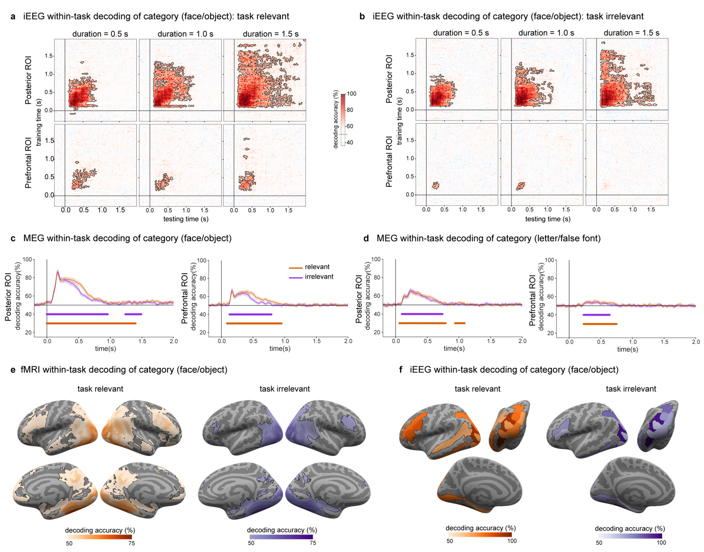

Extended Data Figure 3: Within-task temporal generalization of decoding of stimulus category (faces vs. objects).
a. iEEG decoding accuracies for pattern classifiers trained and tested on task relevant stimuli. As in Figure 2b, the three stimulus durations are plotted in columns (left: 0.5 s; center: 1.0 s; right: 1.5 s) and the two theory ROIs in rows (top: posterior ROIs; bottom: prefrontal ROIs). Significantly above-chance (50%) decoding is indicated by the outlined pink-red regions in the temporal generalization matrices.
b. iEEG decoding accuracies for pattern classifiers trained and tested on task irrelevant stimuli. Same plotting conventions as in panel a.
c. MEG within task decoding of category for faces vs objects (red-task relevant; purple-task irrelevant). Left: results in posterior ROIs. Right: results in prefrontal ROIs.
d. MEG within task decoding of category for letters vs false fonts (red-task relevant; purple-task irrelevant). Left: results in posterior ROIs. Right: results in prefrontal ROIs.
e. fMRI decoding using a searchlight approach, collapsed across the three stimulus durations. Left: decoding accuracies for pattern classifiers trained and tested on task relevant stimuli (orange-red). Right: decoding accuracies for pattern classifiers trained and tested on task irrelevant stimuli (purple). Regions showing significantly above-chance (50%) decoding accuracies are indicated by the outlined colored regions on the inflated cortical surfaces (top: left/right lateral views; bottom: right/left medial views).
f. iEEG decoding accuracies within the theory-relevant ROIs, collapsed across stimulus duration. Left: decoding for classifiers trained and tested on task relevant stimuli (orange-red). Right: decoding for classifiers trained and tested on task irrelevant stimuli (purple). ROIs showing significant above-chance (50%) decoding are displayed on inflated surface maps from a left lateral view (top left), posterior view (top right) and left medial view (bottom).
Extended Data Table 4: Decoding of faces vs. category in the theory-defined ROIs

Anatomical ROIs (Destrieux atlas) | Irrelevant-Relevant |  | Relevant-irrelevant |  | Irrelevant |  | Relevant
 | n voxels | % voxels | n voxels | % voxels | n voxels | % voxels | n voxels | % voxels
Posterior ROI
G_and_S_occipital_inf | 1868 | 93 | 1866 | 93 | 1868 | 93 | 1876 | 93
G_oc-temp_lat-fusifor | 2549 | 98 | 2550 | 98 | 2542 | 98 | 2561 | 99
G_occipital_middle | 1979 | 80 | 1952 | 79 | 1909 | 76 | 2096 | 85
S_oc_middle_and_Lunatus | 1009 | 100 | 1008 | 100 | 1000 | 100 | 1010 | 100
G_cuneus | 600 | 24 | 542 | 22 | 587 | 23 | 1233 | 49
G_occipital_sup | 1351 | 69 | 1295 | 66 | 1299 | 66 | 1302 | 66
G_oc-temp_med-Lingual | 1403 | 47 | 1374 | 46 | 1375 | 46 | 1499 | 50
G_oc-temp_med-Parahip | 430 | 30 | 408 | 29 | 432 | 31 | 521 | 37
G_temporal_inf | 686 | 47 | 692 | 47 | 756 | 52 | 859 | 59
Pole_occipital | 1952 | 80 | 1934 | 80 | 1870 | 77 | 1968 | 81
Pole_temporal | 0 | 0 | 0 | 0 | 0 | 0 | 15 | 2
S_calcarine | 448 | 18 | 427 | 18 | 395 | 16 | 657 | 27
S_intrapariet_and_P_trans | 261 | 7 | 287 | 8 | 799 | 21 | 1670 | 44
S_oc_sup_and_transversal | 1163 | 82 | 1166 | 82 | 1225 | 87 | 1230 | 87
S_temporal_sup | 1100 | 22 | 944 | 19 | 820 | 17 | 2264 | 46
PFC ROI
G_and_S_cingul-Mid-Post | 0 | 0 | 0 | 0 | 0 | 0 | 0 | 0
Lat_Fis-ant-Horizont | 0 | 0 | 0 | 0 | 0 | 0 | 1250 | 23
Lat_Fis-ant-Vertical | 6 | 1 | 1 | 0 | 3 | 1 | 36 | 8
G_and_S_cingul-Ant | 0 | 0 | 0 | 0 | 5 | 0 | 278 | 8
G_and_S_cingul-Mid-Ant | 0 | 0 | 0 | 0 | 0 | 0 | 200 | 1
G_front_inf-Opercular | 134 | 6 | 65 | 3 | 98 | 4 | 436 | 20
G_front_inf-Orbital | 0 | 0 | 0 | 0 | 0 | 0 | 34 | 5
G_front_inf-Triangul | 142 | 9 | 68 | 4 | 130 | 78 | 608 | 37
G_front_middle | 50 | 1 | 15 | 0 | 154 | 3 | 1301 | 21
S_front_middle | 0 | 0 | 4 | 0 | 29 | 1 | 86 | 4
S_front_sup | 0 | 0 | 0 | 0 | 0 | 0 | 300 | 8
S_front_inf | 164 | 8 | 89 | 4 | 184 | 9 | 1022 | 49

The table presents the number of voxels in each theory-defined ROI that were detected in the searchlight decoding of category (faces vs. objects). The results are presented separately for cross-task decoding (i.e., when classifiers are trained on the task irrelevant trials and tested on task relevant ones, or vice versa), as well as for within task decoding (irrelevant and relevant conditions).

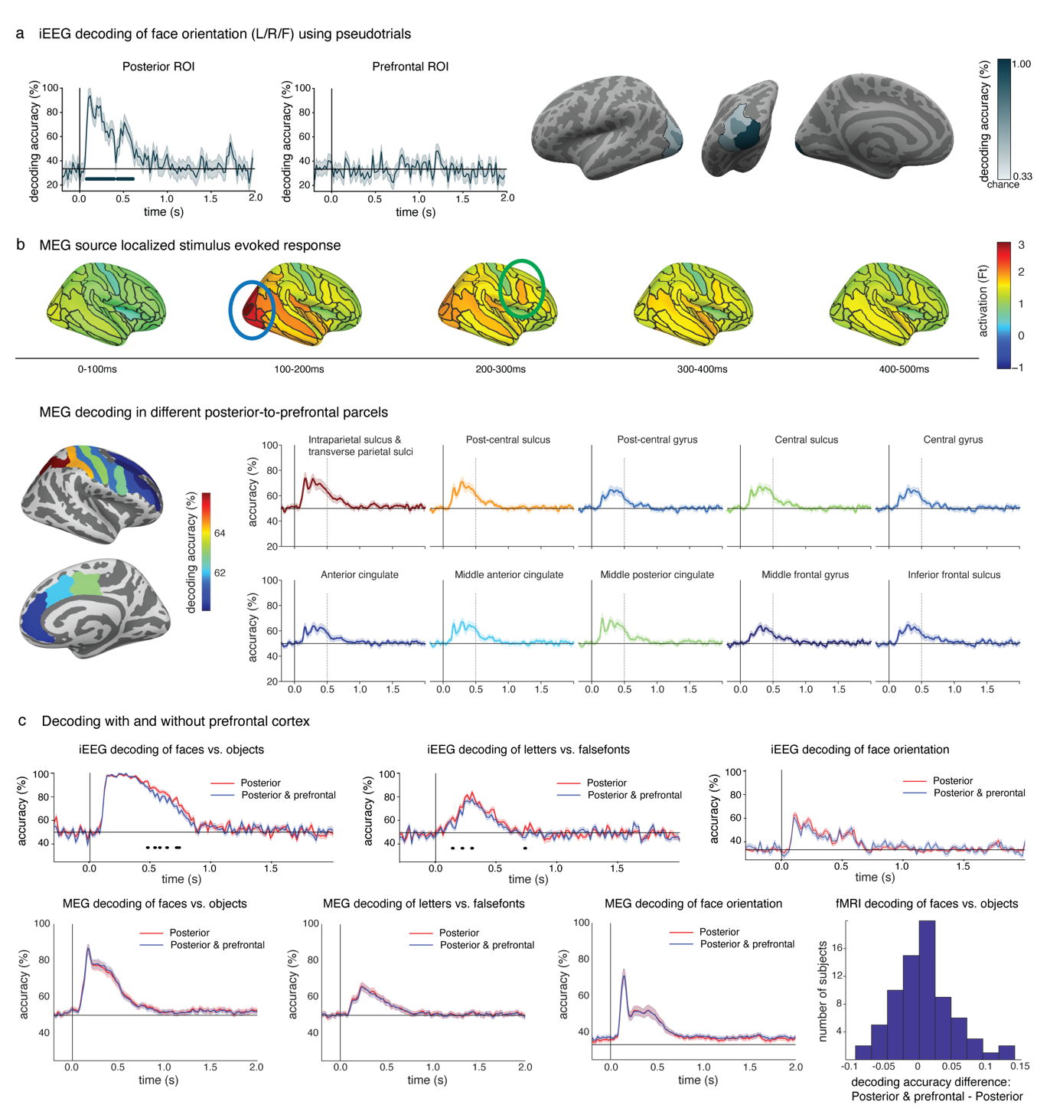

Extended Data Figure 5: Control analyses for the decoding prediction.
a. Left panel: iEEG decoding results of orientation (left vs. right vs. front view faces) within the theory ROIs over time as in Figure 2, using pseudotrials akin to the MEG analysis. Right panel: Regions with electrodes showing above-chance (33%) accuracies are indicated in outlined blue on the inflated surfaces (left: left lateral view; middle: posterior view; right: left medial view).
b. Two analyses were performed to evaluate potential leakage in the MEG decoding results. These analyses were conducted on independent data from the optimization phase (N=32). Top panel: Stimulus-evoked response in face task relevant trials combined across three stimulus durations were investigated at different latencies and projected on the inflated surfaces. Blue and green ellipses denote posterior and prefrontal areas, respectively. Activity in posterior areas showed the highest peak ~0.1-0.2 s while prefrontal areas showed the highest peak in a later time window ~0.2-0.3 s. These differential peak timings serve as evidence against the leakage interpretation. Bottom panels: Face vs. object decoding performance in task relevant trials combining trials across the three durations was investigated separately within parcels in parietal and PFC to evaluate the possibility of a posterior to anterior decoding gradient. Left panel: average face vs. object decoding accuracy in an early time window (0.25-0.5 s) projected on two differently inflated surfaces to better depict gyri and sulci in parietal and prefrontal areas. Right panel, time-resolved decoding performance in parietal and frontal parcels. Decoding performance is highest in posterior areas and lowest in anterior areas, with fairly similar time courses, consistent with the possibility of leakage in decoding from posterior to anterior areas. This effect is better appreciated when considering the high decoding of faces vs. objects in motor related areas, with a gradient from postcentral to precentral sulcus.
c. Decoding analysis including or excluding prefrontal areas alongside posterior areas to evaluate changes in decoding performance. IIT predicts that including PFC to posterior areas should have either no effect or decreased decoding performance (Posterior + Prefrontal: blue; posterior only: red). Top: iEEG decoding of faces vs. objects (left), letters vs. false fonts (middle) and face orientation (right). Lines underneath the decoding functions indicate time-periods showing significantly worse decoding accuracies when including PFC. Bottom: MEG decoding results, same order as iEEG. Right, fMRI decoding of faces vs. objects. Histogram shows the differences in classification including and excluding frontal areas. iEEG and MEG results consistently show similar (or worse) decoding performance when including prefrontal areas. fMRI accuracies of PFC + Posterior show slight increase of 1.2% on average compared to posterior accuracies, observed in 56% of the subjects. However, it is important to note that these increases are not considered robust due to several factors, including the small magnitude of the accuracy difference and the fact that this slight increase was observed only in the combined features analysis and not the combined models’ analysis (see Methods). The negative outcomes observed in iEEG and MEG data support our interpretation of the fMRI results.

Extended Data Table 6: Electrode locations found to be significant in the LMM analysis

Channel | x | y | z | Destrieux ROI | Wang ROI | Desikan ROI | Model
SE107-O2PH16 | -0.03618 | -0.08678 | 0.000733 | S_oc_middle_and_Lunatus | TO1 | ctx-lh-lateraloccipital | IIT x Cate
SE120-T3bOT10 | -0.05876 | -0.06964 | -0.02078 | G_oc-temp_lat-fusifor | Unknown | ctx-lh-fusiform | IIT x Cate
SE120-T3bOT9 | -0.05712 | -0.0689 | -0.02016 | G_oc-temp_lat-fusifor | Unknown | ctx-lh-fusiform | IIT x Cate
SF102-LO1 | -0.01976 | -0.10359 | 0.001174 | Pole_occipital | V2d | ctx-lh-lateraloccipital | IIT x Cate
SF102-LO2 | -0.02301 | -0.09792 | 0.005426 | Pole_occipital | V2d | ctx-lh-lateraloccipital | IIT x Cate
SF103-PIT1 | -0.04072 | -0.06213 | -0.02039 | G_oc-temp_lat-fusifor | Unknown | ctx-lh-fusiform | IIT x Cate
SF103-PIT2 | -0.04156 | -0.04393 | -0.02499 | G_oc-temp_lat-fusifor | Unknown | ctx-lh-fusiform | IIT x Cate
SF104-LO1 | -0.01396 | -0.10275 | 0.008659 | Pole_occipital | V2d | ctx-lh-lateraloccipital | IIT x Cate
SF104-LO2 | -0.01663 | -0.10338 | 0.005258 | Pole_occipital | V2d | ctx-lh-lateraloccipital | IIT x Cate
SF109-IO3 | 0.006178 | -0.07586 | -0.00279 | G_oc-temp_med-Lingual | V2v | ctx-rh-lingual | IIT x Cate
SF109-IO4 | 0.005093 | -0.07816 | -0.0047 | G_oc-temp_med-Lingual | V2v | ctx-rh-lingual | IIT x Cate
SF113-RIT1 | 0.038119 | -0.04974 | -0.02225 | G_oc-temp_lat-fusifor | Unknown | Cerebellum-Cortex | IIT x Cate
SF113-RIT2 | 0.040545 | -0.04845 | -0.02346 | G_oc-temp_lat-fusifor | Unknown | Cerebellum-Cortex | IIT x Cate
SE107-O1b3 | -0.01196 | -0.06305 | -0.00094 | G_oc-temp_med-Lingual | Unknown | ctx-lh-lingual | GNW
SE107-O2PH14 | -0.03383 | -0.08203 | 6.93E-05 | S_oc_middle_and_Lunatus | LO2 | ctx-lh-lateraloccipital | GNW
SE107-O2PH15 | -0.0354 | -0.08519 | 0.000512 | S_oc_middle_and_Lunatus | LO2 | ctx-lh-lateraloccipital | GNW
SE108-O2b14 | -0.0294 | -0.09064 | -0.00472 | S_oc_middle_and_Lunatus | LO1 | ctx-lh-lateraloccipital | GNW
SE120-O2*5 | -0.04225 | -0.09646 | -0.00451 | G_and_S_occipital_inf | Unknown | ctx-lh-lateraloccipital | GNW
SE120-O2*6 | -0.04354 | -0.09769 | -0.00357 | G_and_S_occipital_inf | Unknown | ctx-lh-lateraloccipital | GNW
SE120-T3c6 | -0.05264 | -0.08681 | 0.025426 | S_temporal_sup | Unknown | ctx-lh-inferiorparietal | GNW
SF104-LO3 | -0.02255 | -0.10253 | 0.000551 | Pole_occipital | V2d | ctx-lh-lateraloccipital | GNW
SF109-DL4 | 0.022039 | -0.07051 | 0.008421 | S_calcarine | Unknown | ctx-rh-pericalcarine | GNW
SF109-DL5 | 0.02433 | -0.07204 | 0.008081 | S_calcarine | Unknown | ctx-rh-pericalcarine | GNW
SF109-G45 | 0.04645 | -0.08224 | -0.00242 | G_occipital_middle | Unknown | ctx-rh-lateraloccipital | GNW
SE108-O2b13 | -0.02856 | -0.08853 | -0.00505 | G_and_S_occipital_inf | Unknown | ctx-lh-lateraloccipital | IIT
SE110-O2*10 | 0.036288 | -0.1042 | -0.00079 | G_and_S_occipital_inf | Unknown | ctx-rh-lateraloccipital | IIT
SE110-O2*7 | 0.031792 | -0.09698 | -0.00721 | S_oc-temp_lat | Unknown | ctx-rh-lateraloccipital | IIT
SE110-O2*8 | 0.03359 | -0.09987 | -0.00464 | G_and_S_occipital_inf | Unknown | ctx-rh-lateraloccipital | IIT
SE110-O2*9 | 0.035389 | -0.10276 | -0.00207 | G_and_S_occipital_inf | Unknown | ctx-rh-lateraloccipital | IIT
SE120-O1b10 | -0.02828 | -0.11893 | 0.004408 | Pole_occipital | V2d | ctx-lh-lateraloccipital | IIT
SF102-LO3 | -0.0356 | -0.08904 | -0.00424 | G_occipital_middle | LO2 | ctx-lh-lateraloccipital | IIT
SF107-O1 | 0.024693 | -0.10108 | -0.00812 | Pole_occipital | Unknown | ctx-rh-lateraloccipital | IIT
SF107-O2 | 0.027381 | -0.09982 | -0.00773 | Pole_occipital | Unknown | ctx-rh-lateraloccipital | IIT
SF107-O3 | 0.042207 | -0.08618 | -0.00419 | G_occipital_middle | Unknown | ctx-rh-lateraloccipital | IIT
SF113-RO1 | 0.034984 | -0.08617 | 0.010333 | G_occipital_middle | V3B | ctx-rh-lateraloccipital | IIT
SF113-RO2 | 0.040244 | -0.08034 | 0.011692 | G_occipital_middle | LO2 | ctx-rh-inferiorparietal | IIT
Electrodes location in MNI coordinates, as well as in the corresponding parcellations of the Destrieux Atlas, Wang Atlas and Desikan Atlas.

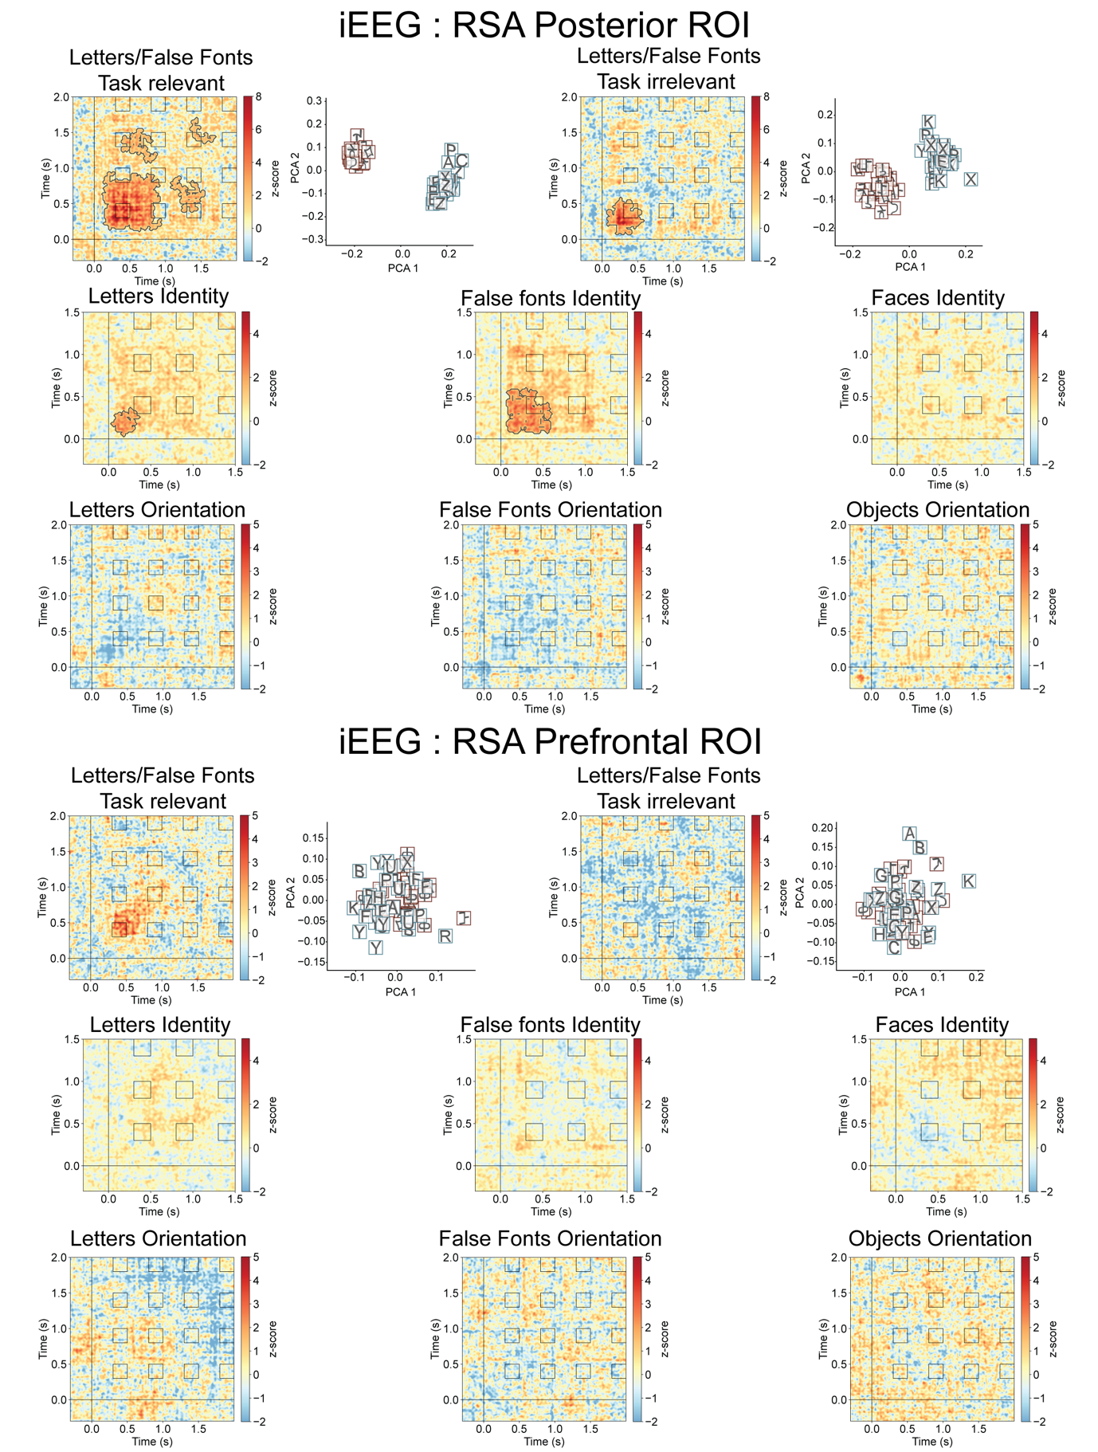

Extended Data Figure 7: Maintenance of conscious content over time for stimulus categories, identity and orientation. Cross temporal representational similarity matrices across all electrodes in posterior cortex for letters vs. false fonts (upper row), identity (middle) and orientation (bottom) for posterior (upper half) and PFC (lower half) ROI, respectively. Contours in the matrices represent statistical significance, established using cluster-based permutation tests (upper tail test at alpha=0.05). Clear separability between letters and false fonts in posterior cortex is illustrated using Principal Component Analysis at 0.3 s irrespective of the task (left – task relevant, right - task irrelevant). Separability was mostly sustained in the task relevant condition, but not from ~0.95 to 1.4 s. In the task irrelevant condition, however, separability was statistically significant for a brief period in the beginning. Identity information was statistically significant for letters and false fonts, but not faces. Identity information was not sustained for the entire stimulus duration (however, z-scores were elevated until 1 s, hinting at a limitation in statistical power). No statistically significant orientation information was evident for any of the categories. None of the contrasts yielded statistically significant results in the PFC ROI.

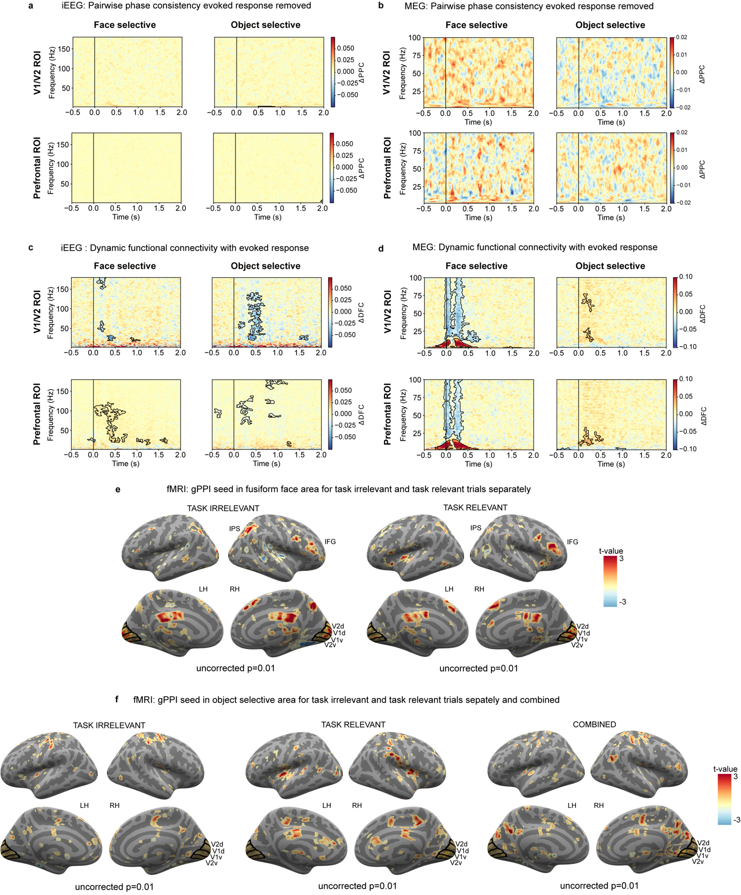

Extended Data Figure 8: Control analysis for the interareal communication prediction
a. iEEG Pairwise phase consistency (PPC) analysis of task irrelevant trials did not reveal any significant category-selective synchrony cluster neither in the posterior ROI nor in the PFC ROI after removing the evoked response. Colorbars represent the change in PPC (face-object trials) for each node (face-selective, object-selective). Positive values reflect stronger connectivity for faces. Negative values reflect stronger connectivity for objects.
b. MEG PPC analysis of task irrelevant trials did not reveal any significant category-selective synchrony cluster neither in the posterior ROI nor in the PFC ROI after removing the evoked response. The same conventions of Figure 8a are used here.
c. iEEG Dynamic functional connectivity (DFC) analysis of task irrelevant trials without removing the evoked response reveals significant content-selective connectivity between object-selective electrodes and V1/V2 electrodes (top-right), reflected as broadband (25-125 Hz) decrease in the change in DFC (e.g., faces < objects). Similar broadband content-selective changes in DFC (faces > objects) were observed for face-selective electrodes in PFC (bottom-left). Smaller, yet significant effects, were detected for connectivity between face-selective electrodes and V1/V2 electrodes (top-left) and for object-selective electrodes and PFC electrodes (bottom-right). Conventions as in Figure 8a.
d. MEG DFC analysis of task irrelevant trials without removing the evoked response reveal significant content-selective synchrony between the face-selective GED filter node and both V1/V2 (top-left) and PFC (bottom-left). This is reflected in an increase in low-frequency connectivity (<25 Hz) combined with a decrease in high-frequency connectivity (25-100 Hz). Smaller yet significant effects were detected for the object-selective GED filter (right). Conventions as in Figure 8a.
e. Generalized psychophysiological interactions (gPPI) task-related connectivity analysis of task irrelevant (left) and task relevant (right) conditions revealed weak clusters of content-selective connectivity when FFA is used as the analysis seed (p < 0.01, uncorrected). Common significant regions showing task related connectivity in task irrelevant, task relevant, and combined conditions (Figure 4) include V1/V2, right intraparietal sulcus (IPS), and right inferior frontal gyrus (IFG).
f. gPPI task-related connectivity analysis of task irrelevant (left), task relevant (middle), and combined conditions revealed weak clusters of content-selective connectivity when lateral occipital complex (LOC) is used as the analysis seed (p < 0.01, uncorrected). The results of the gPPI showed that there are no common significant regions showing task related connectivity in task irrelevant, task relevant, and combined conditions.

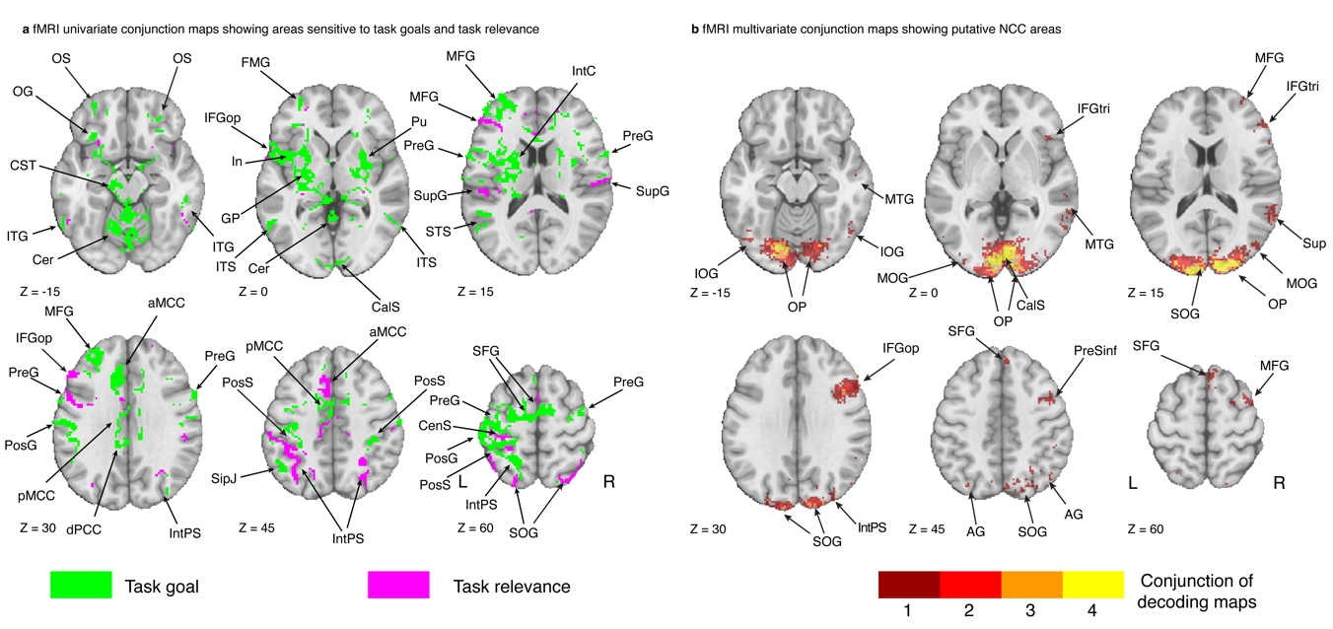

Extended Data Figure 9: fMRI maps of areas involved in Task goals, Task relevance and presumptive NCC
a. Results from the univariate fMRI (N=73) contrast-conjunction analysis identifying task goals (green) and task relevance (magenta) areas. Task goals areas were identified as follows: targets > bsl & task relevant = bsl & task irrelevant = bsl. Task relevance were identified as follows: targets > bsl & task relevant ≠ bsl & task irrelevant = bsl. Axial brain slices are displayed from inferior (top left) to superior (bottom right). Left and right hemisphere are displayed to the left and right, respectively. Neuroanatomical labels from the Destrieux atlas and additional subcortical regions as in Figure 5.
b. fMRI multivariate contrast-conjunction analysis (N=73) identifying areas showing consistent whole-brain searchlight decoding of stimulus vs. baseline using thresholded statistical maps obtained at the subject level after removing areas identified in a. Conjunction was defined as above chance decoding both for task relevant & task irrelevant stimuli for each stimulus category separately. Colorbar shows the number of stimulus categories passing the conjunction.

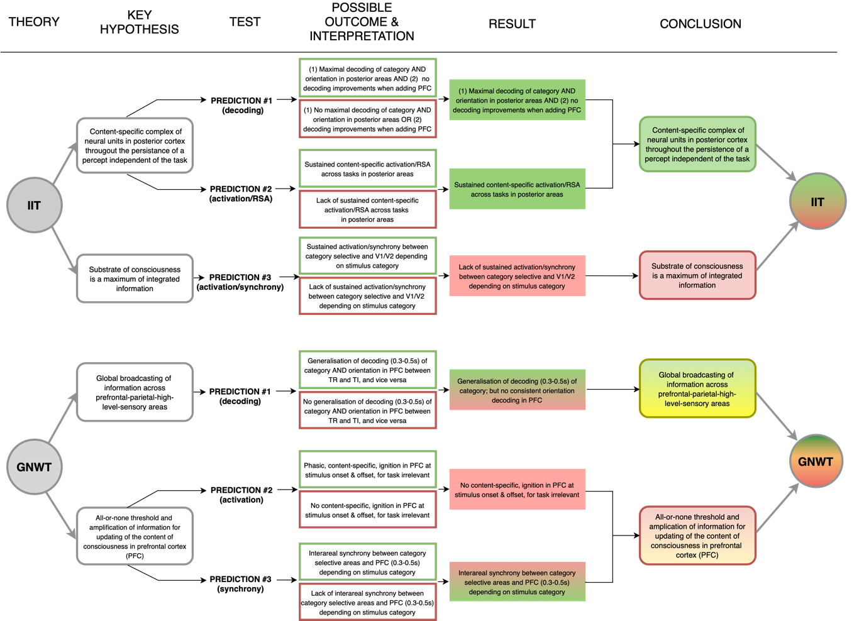
Extended Data Figure 10: An overview of theoretical predictions, experimental outcomes and interpretations.
On the left, the original predictions made by the IIT (top) and GNWT (bottom), preregistered here (see also ¹² ;Figure 1). The table describes the key hypotheses (second column, ‘Key hypotheses’) made by the theories (see also Figure 1a), and probed in three different test analyses (third column, ‘Test’; decoding (prediction #1; Figure 2), activation & RSA (prediction #2; Figure 3) and synchrony (prediction #3; Figure 4). Next, we describe the possible outcomes of each of these analyses, and how they would inform the theoretical predictions (fourth column, ‘Possible outcome and interpretation’). Outcomes that conform with the prediction are presented in a green frame (i.e., ‘pass’), while outcomes that contradict the prediction are presented in a red frame (i.e., ‘fail’). Thus, the left side of the table presents the a-priori predictions and expected outcomes, prior to conducting the experiment. The right side of the figure presents instead the actual findings of this experiment, integrating over the three modalities and multiple tests. We first describe the key findings with respect to each prediction (fifth column; ‘Result’). Green marks results that confirm the theories, red marks results that challenge them, the mixture of green/red marks cases in which the combination of results yielded a mixture of a pass and a fail. Finally, we integrate over these results to generate the final conclusion based on the key hypotheses: Here, green/red is used for pass/fail. Yellow marks cases in which we considered that the results did not allow a confident interpretation. Namely, for GNWT’s prediction #1, we found cross-task generalization of decoding of faces vs. objects, in line with the prediction. However, the only evidence for orientation decoding was found in the MEG data, where we could not conclusively rule out leakage from posterior areas. Thus, as passing this prediction requires both decoding of category and orientation to be found, we cannot determine with high confidence if this prediction should be counted as a pass or a fail. For GNWT’s prediction #3, we do find evidence supporting it, yet with an exploratory analysis (DFC), after the preregistered analysis failed to show support for the prediction. Thus, it cannot be regarded as a preregistered ‘pass’. Altogether: for IIT, a mixture of a passed prediction (of content-specific complex of neural units in posterior cortex, throughout the persistence of a percept, independent of the task) and a challenge prediction (of maximum integrated information), and for GNWT, two mixtures of partly challenged predictions (of global broadcasting of information in the PFC and an all-or-none threshold and amplification of information updating the content of consciousness in PFC).

