Supplementary materials

Actionable prediction of Klebsiella phage host tropism at the subspecies level
Dimitri Boeckaerts^{1,2}, Michiel Stock², Celia Ferriol-González³, Rafael Sanjuan³, Pilar Domingo-Calap³, Bernard De Baets², Yves Briers^{1,*}

Supplementary materials S1
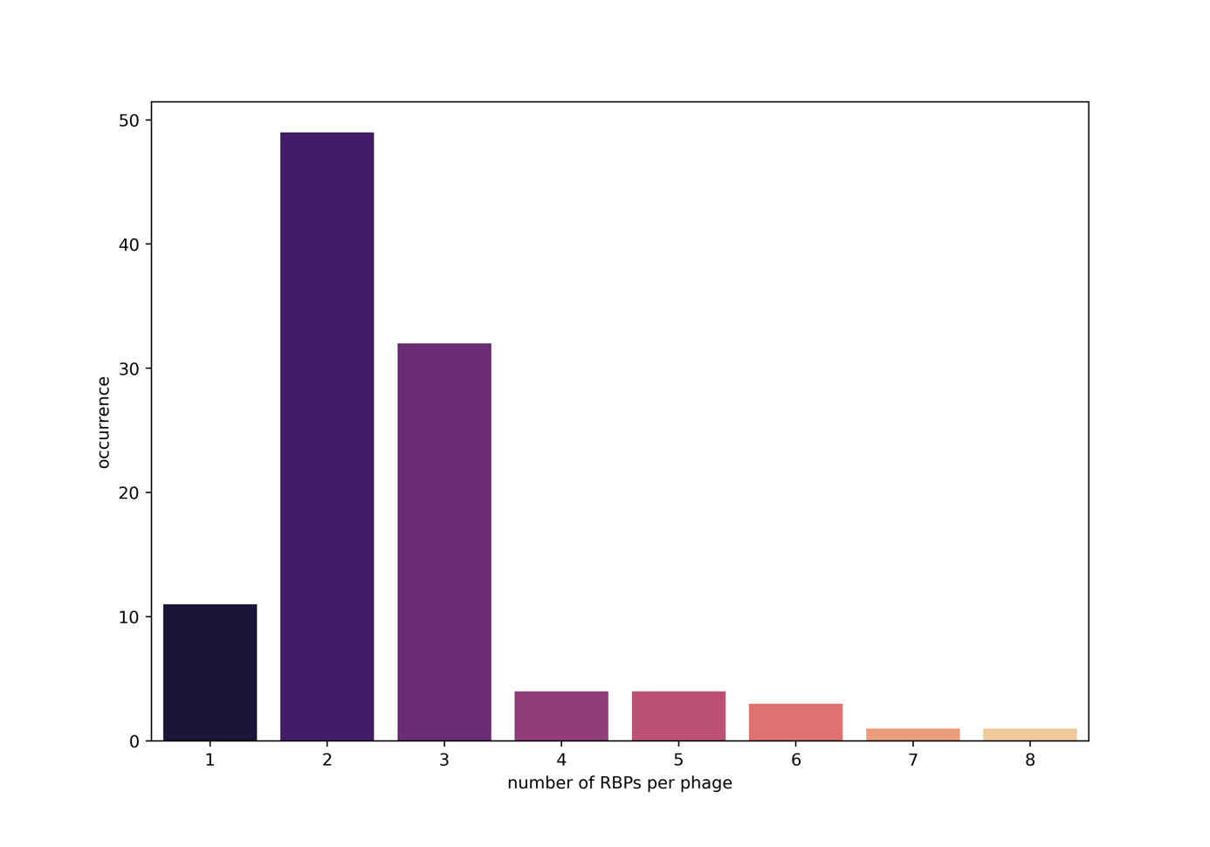
Figure S1: Count plot of the number of detected RBPs per phage across all the collected phage genomes.

Supplementary materials S2
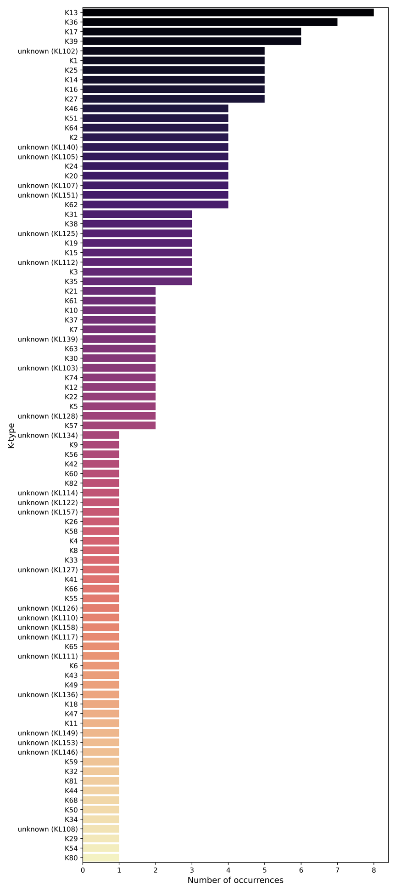
Figure S2: Count plot of the number of occurrences of each K-type across the 200 collected bacterial genomes.

