Supporting information

Eco-friendly and practical plastic food-packaging alternatives of all-biomass-derived nanocomposite films
Yuanyuan Ding*, Peng Zhang, Fenglong Zhang, Bocun Zhong, Tenglin Yang, Xiang Ding, Chenguang Liu*, Zhe Chi*

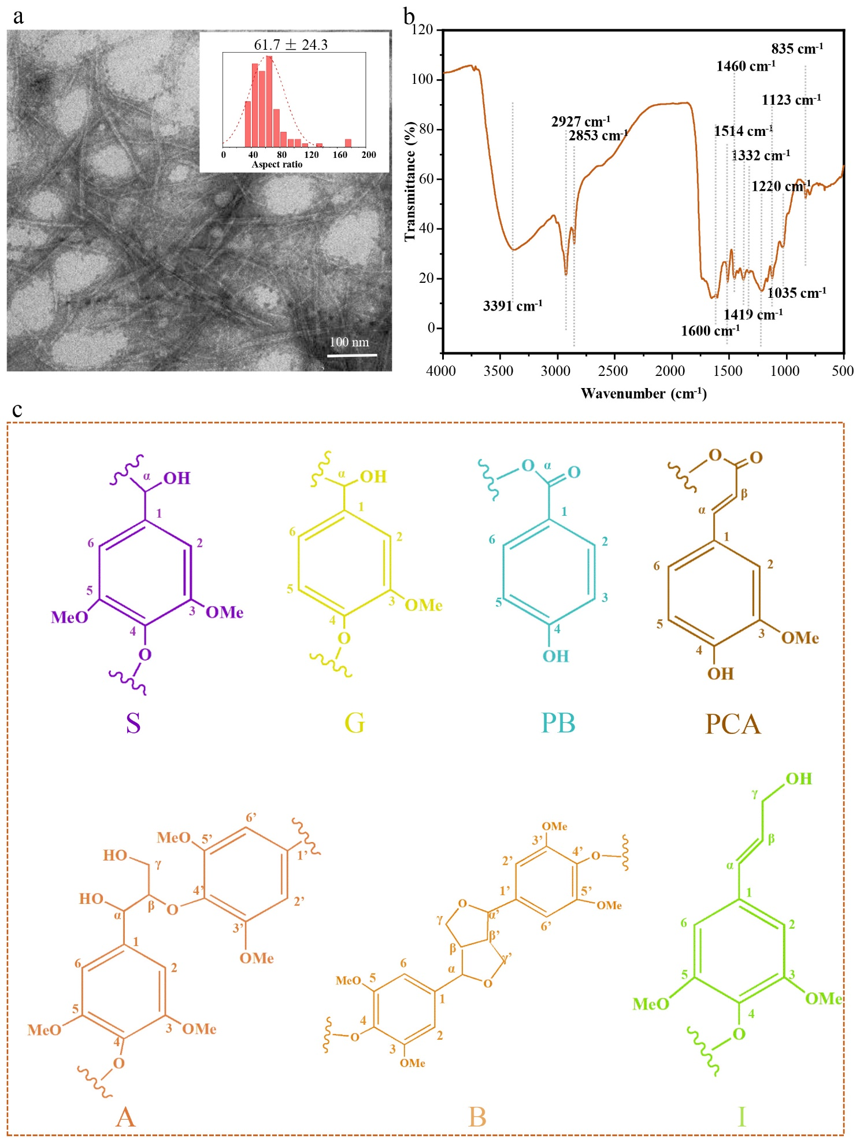
Figure S1. (a) Transmission electron microscope (TEM) images showing cellulose nanocrystals (CNCs) prepared from corn stalks (CS) using sulfuric acid hydrolysis. (b) Fourier transform infrared spectroscopy (FT-IR) spectrum of the brown powder obtained from DES_{LG} solution. (c) Substructures identified using 2D-HSQC NMR in the brown powder extracted from DES_{LG} solution. S, syringyl units; G, guaiacyl units; PB, p-benzoate; PCA, p-coumarate moieties; A, β-O-4' aryl ether linkages; B, resinol units (β-β'); and I, p-hydroxycinnamyl alcohol end-groups.

Figure S1a illustrates the aspect ratio of cellulose nanocrystals (CNCs) obtained through sulfuric acid hydrolysis of CSC, measuring 61.7 ± 24.3.
The FTIR spectrum (Figure S1b) of the brown powder obtained from the DES_{LG} solution was compared to that in a previous study. The peak observed at 3,391 cm⁻¹ corresponded to the stretching vibrations of aliphatic alcohol hydroxyl and phenolic hydroxyl groups.^{[1]} Additionally, the peaks at 2,927 cm⁻¹ and 2,853 cm⁻¹ were attributed to the asymmetric and symmetric C-H stretching vibrations of aliphatic alcohol hydroxyl and phenolic hydroxyl groups, respectively.^{[1]} Furthermore, characteristic peaks associated with the functional groups of lignin were detected. These included peaks at 1,600 cm⁻¹, 1,514 cm⁻¹, and 1,419 cm⁻¹, which originated from the aromatic ring skeleton of lignin phenylpropane. Peaks at 1,332 cm⁻¹, 1,220 cm⁻¹, and 1,123 cm⁻¹ could be attributed to syringyl (S) units, whereas the peak at 1,035 cm⁻¹ was ascribed to guaiacyl (G) units.^{[2]} The presence of these distinctive lignin peaks in the FTIR spectrum of indicates the brown powder extracted from the DES_{LG} solution is lignin^{[3-4]}. Moreover, the insolubility of this lignin confirms it is a hydrophobic lignin (HBL).
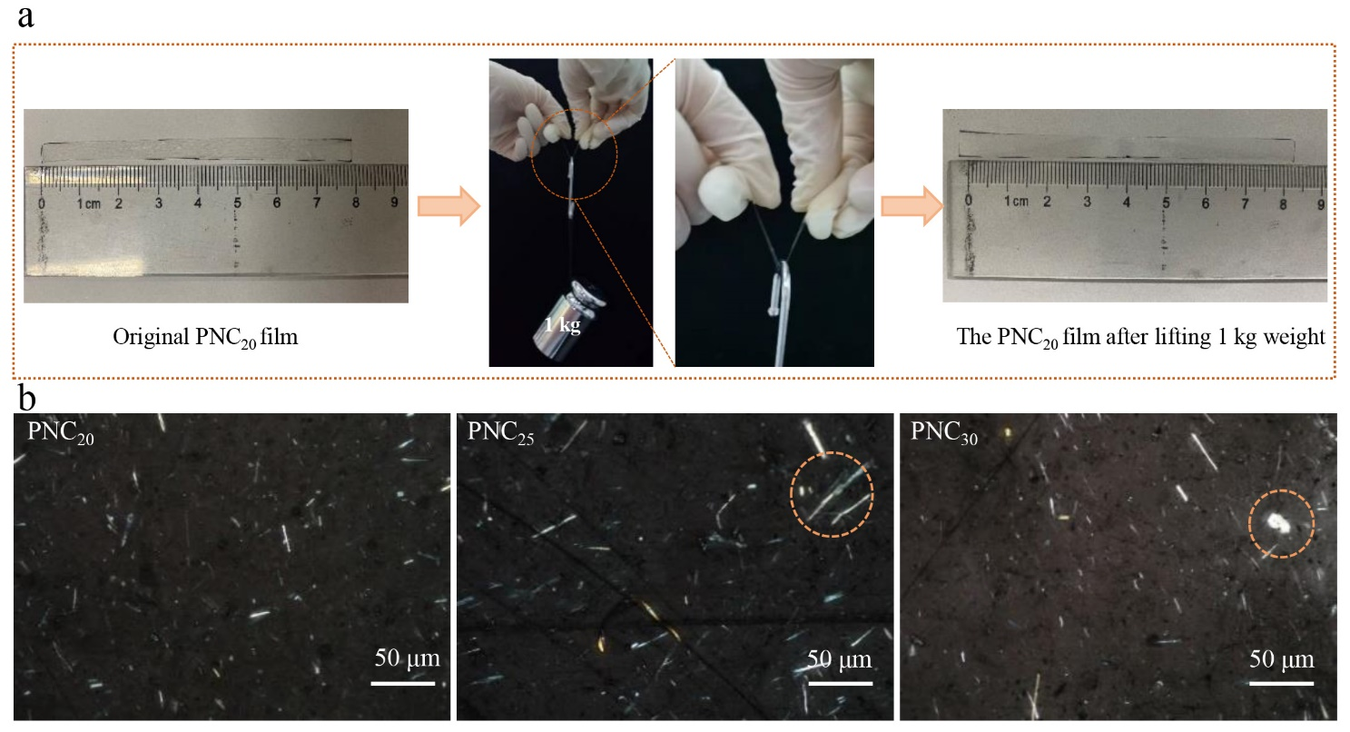
Figure S2. (a) Photographs illustrating the original PNC₂₀ film (dimensions: length 8 cm, width 0.5 cm, thickness 0.03 mm), the PNC₂₀ film supporting a 1 kg weight, and the PNC₂₀ film after supporting a 1 kg weight. (b) Polarized light microscopy (POM) images depicting the PNC₂₀, PNC₂₅, and PNC₃₀ films. Scale bar = 50 μm

Figure S2a illustrates that a 0.03 mm-thick PNC₂₀ film belt (length: 8 cm; width: 0.5 cm) is capable of effortlessly lifting 1 kg of weight without fracturing or displaying noticeable stretching. The distribution of NC in the PNC₂₀, PNC₂₅, and PNC₃₀ films was visualized using polarized light microscopy (POM) (Figure S2b). The POM images revealed that NC was uniformly dispersed throughout the PNC₂₀ film, whereas in the PNC₂₅ film, NC began to form small aggregates, and in the PNC₃₀ film, larger visible aggregates were observed. These findings indicate that NC can be evenly dispersed in the PNC₂₀ film, whereas aggregation initiates in the PNC₂₅ film.

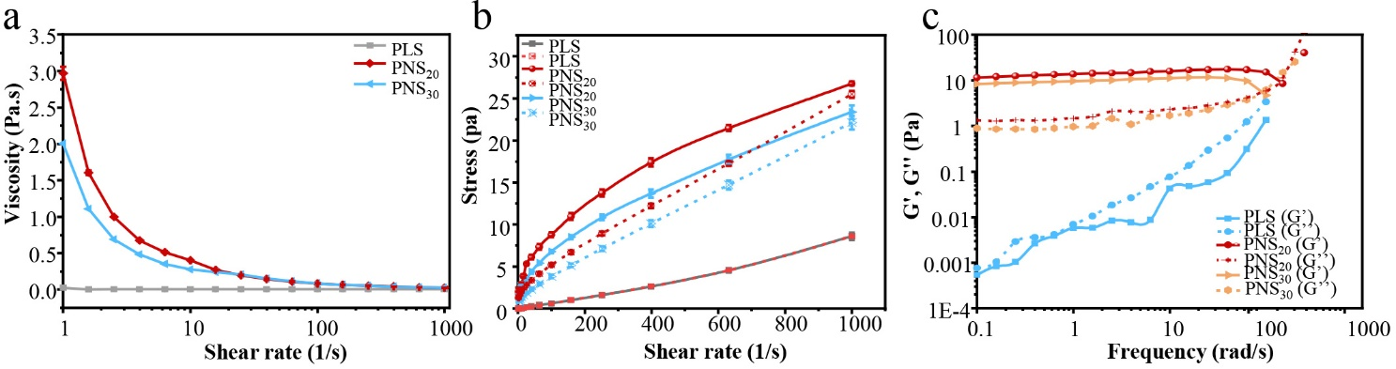
Figure S3. (a) Viscosity of pullulan solution (PLS) and pullulan-NC nanocomposite solution (PNS) as a function of shear rate. (b) Stress of PS and PNS as a function of shear rate. (c) Storage (G') and loss (G'') modulus of PS and PNS as a function of frequency. Data are presented as mean ± SD (n = 3). Data with different superscript letters indicate significant differences.

Figure S3 illustrates the distinct rheological behaviors of the pullulan solution (PLS) and the PNC solution (PNS). The PNS showed characteristic features of a non-Newtonian fluid with thixotropy, displaying shear rate-thinning behavior, whereas the PLS behaved as a sticky Newtonian fluid without thixotropy, characterized by a shear rate-independent viscosity.^{[5]} Comparing their viscosities at low shear rates, the PNSs demonstrated significantly higher viscosities than the PLS owing to the formation of entangled and disordered networks of NC and increased intermolecular interactions between NC and pullulan macromolecules within the PNSs (Figure S3a).^{[6]} Furthermore, the thixotropic ring, modulus, and shear stress of PNS₃₀ were considerably lower than those of PNS₂₀. This could be attributed to the weakened intermolecular interaction between pullulan and NC, as well as the disruption of the polymer chain entanglement network caused by the accumulation of NC in PNS at high concentrations (Figure S3a-c).^{[5]}

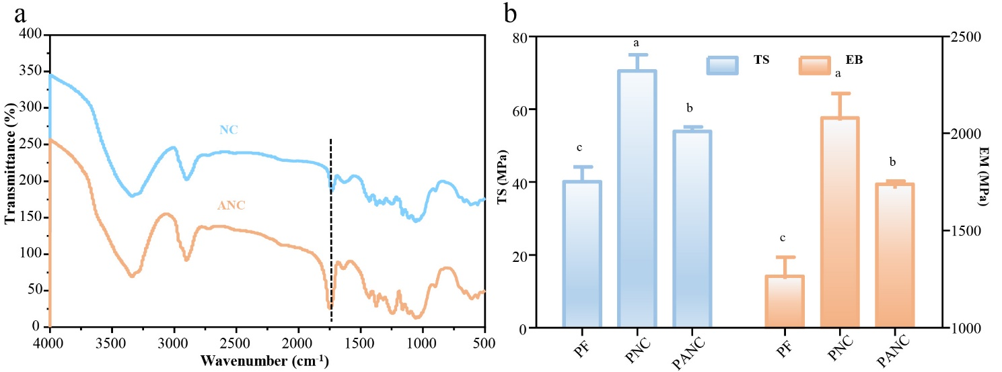
Figure S4. (a) FT-IR spectra of prepared NC and acetylated NC (ANC). (b) Tensile strength (TS) and elastic modulus (EM) of pullulan film (PF), pullulan-NC nanocomposite film (PNC), and pullulan-ANC composite film (PANC). Data are presented as mean ± SD (n = 3). Data with different superscript letters indicate significant differences.

Acetylated nanocellulose (ANC) was synthesized with a substitution degree of 0.49 to block the hydroxyl groups of NC. This was confirmed by the intensified peak at 1,750 cm⁻¹, which corresponded to the C=O stretching vibration in the FT-IR spectra of NC (Figure S4a). In comparison with unacetylated PNC, the PANC exhibited a weaker mechanical property, specifically tensile strength (TS) and elastic modulus (EM) (Figure S4b). This decrease could be attributed to the reduced hydrogen bonding between pullulan and NC.^{[7]} These findings reinforce the significant role of hydrogen bonds, primarily formed by the hydroxyl groups of pullulan and NC, in enhancing the mechanical properties of pullulan films.

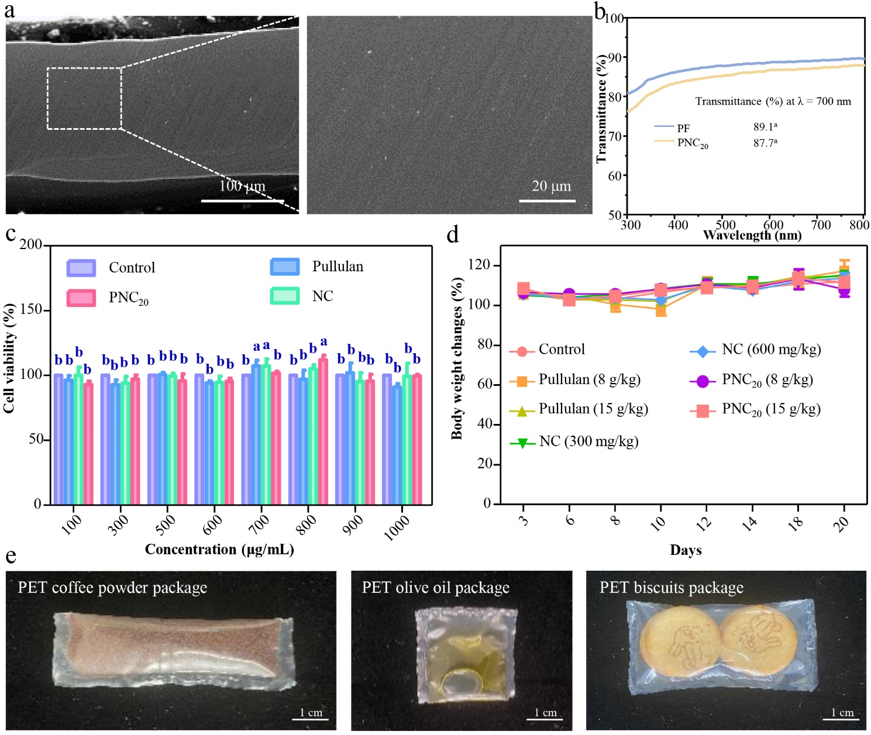
Figure S5. (a) Cross-sectional scanning electron microscope (SEM) images of a heat-sealed PNC₂₀ film. (b) Transmittance curves of PF and PNC₂₀ film ranging from 300 nm to 800 nm, along with their transmittance at 700 nm. (c) Cell viability assessed using MTT assay at various concentrations of pullulan, PNC₂₀ film, and NC. (d) Changes in body weight of mice after administration of pullulan, PNC₂₀, and NC at different doses. Data are presented as mean ± SD (n = 3). Superscript letters indicate significant differences between data points. (e) Photographs of PET packages containing coffee, olive oil, and biscuits.

The SEM images of the cross-section of the PNC₂₀ film, following heat sealing, revealed a smooth surface with no gaps between the adjacent layers of PNC₂₀ film. This observation highlights its exceptional thermal sealing performance (Figure S5a).
Figure S5b presents the transmittance curves of the PNC₂₀ and PF films across the wavelength range 300-800 nm. At a wavelength of 700 nm, the transmittances of the PF and PNC₂₀ films were 89.1% and 87.7%, respectively. These findings indicate that the PNC₂₀ film exhibits comparable transparency with the PF film.
The biosecurity of the pullulan, NC, and PNC₂₀ films was assessed, considering factors such as cytotoxicity and acute toxicity in mice, which are crucial for food-packaging materials. The cytotoxicity results demonstrated that the pullulan, NC, and PNC₂₀ films exhibited L929 cell viabilities above 80%, confirming their safety for L929 cells (Figure S5c). Furthermore, the mouse body weight gradually increased over a 20-day period after intragastric administration of pullulan at 15 g/kg, PNC₂₀ film at 15 g/kg, and NC at 600 mg/kg for 1 day, respectively. This finding indicates the absence of toxicity and suggests that these materials can be safely employed as food-packaging materials (Figure S5d).

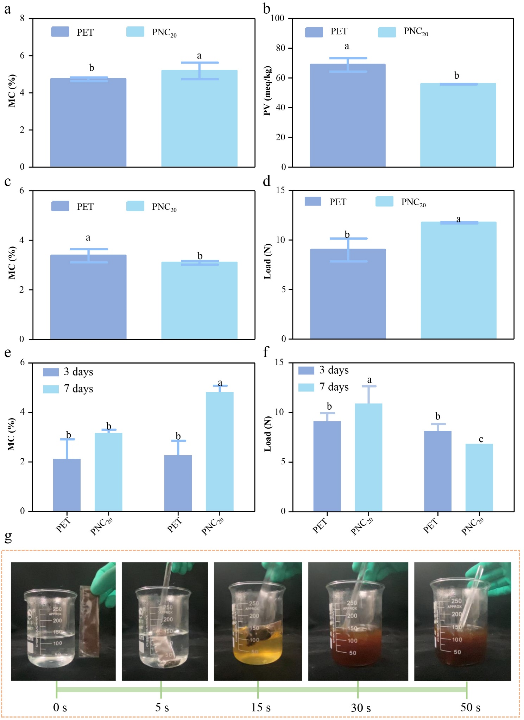
Figure S6. (a) Moisture content (MC) of coffee stored in a packaging combination consisting of PNC₂₀ bags as inner packages and kraft paper wraps as outer packages, compared with that of PET packages, after 12 months at 53% relative humidity. (b) Peroxide value (PV) of olive oil stored in the same packaging combination and PET packages, after 12 months at 53% relative humidity. (c) MC and (d) load of biscuits stored in the packaging combination and PET packages, after 12 months at 53% relative humidity. Data are presented as mean ± SD (n = 3). Data with different superscript letters indicate significant differences. (e) Photographs showing the dissolution test of coffee contained in PNC₂₀ food inner packages in hot water (95 ± 2℃).

The food-preserving effect of the PNC₂₀ inner-packaging bag was assessed by analyzing the moisture content (MC) of coffee and crisp biscuits, as well as the peroxide value (PV) of olive oil. These samples were sealed in a packaging combination consisting of a PNC₂₀ bag as the inner packaging and a kraft paper wrap as the outer packaging. The storage period was 12 months at 53% relative humidity (RH). Figure S6a illustrates that the MC of the coffee sealed in the PNC₂₀/kraft paper packaging pair was higher than that sealed in PET bags, yet it remained below 6%, thus not affecting the quality of the coffee. Furthermore, Figure S6b presents the PV of the olive oil packaged in the PNC₂₀/kraft paper packaging pair, which was notably lower than that of the oil packaged in PET packages. This reduction can be attributed to the synergistic effect of the exceptional oxygen-blocking ability of PNC₂₀ packages in conjunction with the kraft paper wrap. The MC of the biscuits sealed in the PNC₂₀/kraft paper packaging pair was considerably lower than that of the biscuits packaged in PET packages, (Figure S6c). Subsequently, the crispness of the biscuits was evaluated by measuring the force required to puncture them, as shown in Figure S6d. The results indicated that the biscuits packaged in PNC₂₀/kraft paper packaging pairs and stored for 12 months at 53% RH exhibited higher load values than those packaged in PET bags. This improvement could be attributed to the migration of water from the biscuits to the PNC₂₀ inner packages. These findings demonstrate that the PNC₂₀/kraft paper packaging pair effectively preserves these food items, ensuring an extended shelf life. In addition to its outstanding mechanical properties, heat-sealing ability, and barrier-blocking capacity, this PNC₂₀/kraft paper packaging pair offers a promising alternative to plastic food packaging material owing to its biodegradability when compared with that of PET bags.

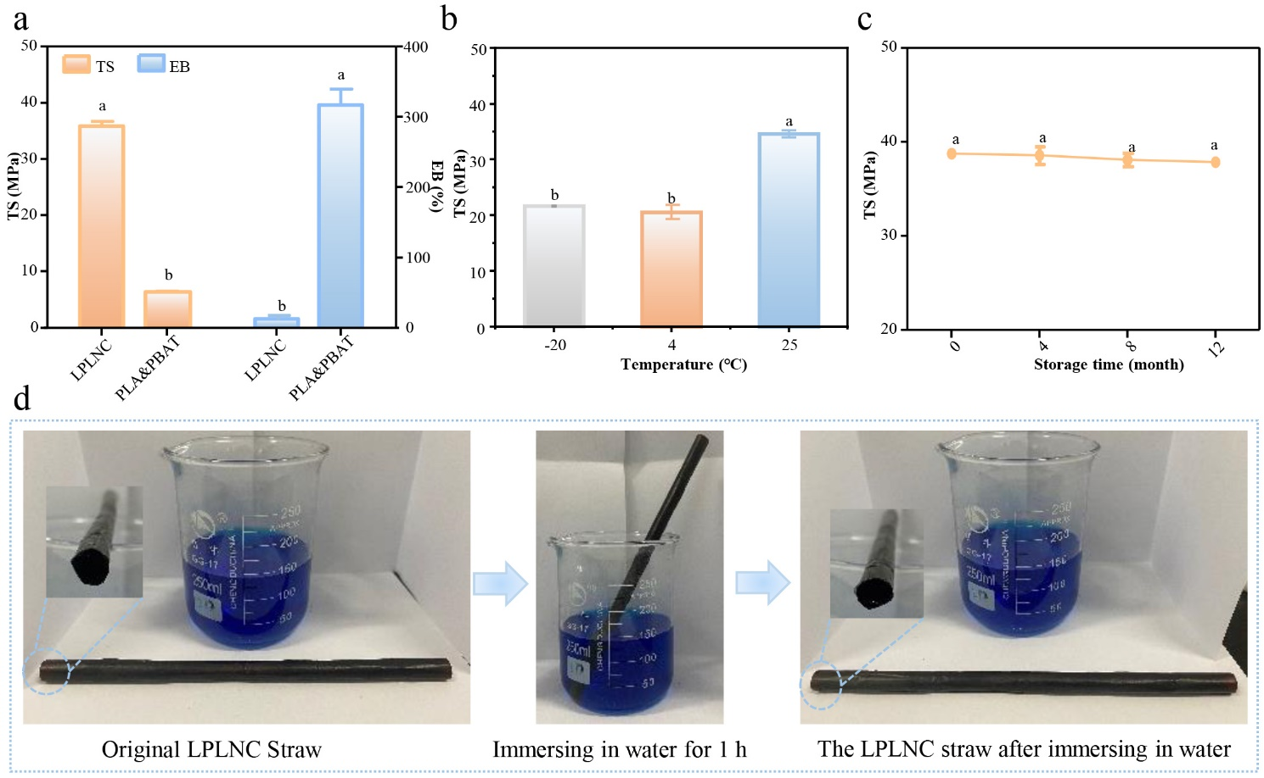
Figure S7. (a) Comparison of tensile strength (TS) and elongation at break (EB) values between LPLNC film and commercial PLA-PBAT bag. (b) Effect of temperature on TS of LPLNC film after 24 h of storage. (c) Changes of TS for LPLNC film after storing at 25℃ and 53% relative humidity for 12 months. Data are presented as mean ± SD (n = 3). Data with different superscript letters indicate significant differences. (d) Visual comparison of the LPLNC-M straw before and after immersing in water for 1 h.
Table S1. Changes in cellulose yield, lignin yield, and cellulose purity obtained from corn stalks (CS) using recycled DES_{LG} pretreatment.
DES_{LG} recycle times | DES_{LG} recovery rate (%) | Cellulose yield (%) | Lignin yield (%) | Cellulose purity (%)
1 | 74.5 ± 2.3ª | 23.1 ± 0.9^{b} | 14.1 ± 0.7ª | 101.2 ± 1.7ª
2 | 72.0 ± 3.1ª | 22.6 ± 1.2^{b} | 12.6 ± 1.3ª | 100.8 ± 0.9ª
3 | 74.2 ± 3.3ª | 23.2 ± 0.4^{b} | 13.6 ± 0.5ª | 98.6 ± 2.6ª
4 | 71.6 ± 4.2ª | 22.2 ± 0.1^{b} | 13.5 ± 0.8ª | 98.1 ± 1.9ª
5 | 73.3 ± 2.8ª | 34.8 ± 1.5ª | 9.8 ± 1.2^{b} | 94.7 ± 1.1^{b}
Data are presented as mean ± SD (n = 3). Values with different superscripts are significantly different.

The effective recycling of DES_{LG} was evaluated by assessing changes in cellulose yield, lignin yield, and cellulose purity. Table S1 illustrates no significant differences in cellulose yield, lignin yield, or cellulose purity when pretreated with recycled DES_{LG} for 1-4 cycles. However, the cellulose yield from CS, pretreated with recycled DES_{LG} for five cycles, exhibited a significant increase owing to the higher weight of impurities. Conversely, the lignin yield showed dramatic decrease as the recycled DES_{LG} failed to effectively dissolve the lignin in CS. Consequently, cellulose purity also significantly decreased owing to the increased presence of impurities. These findings indicate that DES_{LG} could be recycled up to four times while maintaining consistent pretreatment efficacy.
Table S2. Tensile strength (TS) and elongation at break (EB) of PNC₂₀ and PNC₂₅ films compared with those of previously reported materials.
Types of materials | Materials | TS (Mpa) | EB (%)
Natural polymer materials | 1 DNA plastics ^{[8]} | 2.5 | 16.0
Natural polymer materials | 2 Soy protein isolate (SPI) film ^{[9]} | 15.6 | 10.0
Natural polymer materials | 3 Thermoplastic Starch-Nanocellulose Composites ^{[10]} | 27.1 | 4.0
Natural polymer materials | 4 Pullulan-carboxylated cellulose nanocrystal composites ^{[11]} | 39.0 | 6.2
Natural polymer materials | 5 Hemicelluloses-chitosan-based edible films ^{[12]} | 65.2 | 4.3
Natural polymer materials | 6 Cellulose nanocrystals-cellulose nanofibril composites ^{[13]} | 72.3 | 8.3
Bio-based plastics | 7 PHA ^{[14]} | 40.0 | 4.0
Bio-based plastics | 8 PLA ^{[15]} | 45.0 | 5.0
Bio-based plastics | 9 PBAT ^{[14]} | 15.0 | 800.0
Conventional fossil-based plastics | 10 PS ^{[14]} | 60.0 | 4.5
Conventional fossil-based plastics | 11 PET ^{[14]} | 78.0 | 200.0
Conventional fossil-based plastics | 12 LDPE ^{[14]} | 12.0 | 500.0
Conventional fossil-based plastics | 13 PP ^{[14]} | 25.0 | 600.0
Recycled synthetic materials | 14 Poly (γ-butyrolactone) (PγBL) - poly (trans-hexahydrophthalide) (PT6HP) composites ^{[16]} | 13.3 | 149.0
This work | 15 Prepared PNC₂₀ and PNC₂₅ film | 75.6 | 7.3
Table S3. Mechanical properties of the PNC₂₀ and PNC₂₅ films with varying thickness.
Films | Thickness (mm) | Tensile strength (MPa) | Elongation at break (%) | Maximum force at break (N)
PNC₂₀ | 0.0282 ± 0.0008 | 81.7 ± 0.9ª | 16.1 ± 0.7ª | 34.4 ± 1.5^{f}
PNC₂₀ | 0.0449 ± 0.0006 | 79.0 ± 0.7ª | 16.0 ± 0.6ª | 48.7 ± 0.7e
PNC₂₀ | 0.0675 ± 0.0009 | 79.2 ± 1.6ª | 16.5 ± 0.4ª | 81.1 ± 0.7^{d}
PNC₂₀ | 0.0912 ± 0.0028 | 79.3 ± 0.6ª | 16.5 ± 0.9ª | 107.7 ± 1.7^{c}
PNC₂₀ | 0.1108 ± 0.0018 | 78.7 ± 1.6ª | 16.9 ± 1.2ª | 129.7 ± 1.6^{b}
PNC₂₀ | 0.1264 ± 0.0027 | 81.6 ± 1.0ª | 16.5 ± 1.0ª | 162.3 ± 2.5ª
PNC₂₅ | 0.0286 ± 0.0009 | 81.0 ± 1.0ª | 16.4 ± 0.8ª | 35.2 ± 0.9^{f}
PNC₂₅ | 0.0445 ± 0.0009 | 80.5 ± 1.1ª | 15.9 ± 0.3ª | 49.4 ± 0.7e
PNC₂₅ | 0.0681 ± 0.0004 | 80.5 ± 0.6ª | 16.2 ± 0.7ª | 80.4 ±1.4^{d}
PNC₂₅ | 0.0900 ± 0.0017 | 80.7 ± 1.0ª | 16.8 ± 0.9ª | 108.8 ± 1.3^{c}
PNC₂₅ | 0.1129 ± 0.0045 | 79.7 ± 0.8ª | 16.8 ± 1.4ª | 128.8 ± 0.8^{b}
PNC₂₅ | 0.1285 ± 0.00072 | 80.9 ± 1.1ª | 16.1 ± 1.1ª | 164.9 ± 1.7ª
Data are presented as mean ± SD (n = 3); Values with different superscripts are significantly different.

Table S4. Location and fraction of curve-fitting peaks for O-H absorption in the FTIR spectra of pure pullulan film (PF) and its nanocomposites.
Samples | Peak Ⅰ ª |  | Peak Ⅱ ª
Samples | Location (cm⁻¹) | Fraction (%) | Location (cm⁻¹) | Fraction (%)
PF | 3517.2 ± 2.5 | 31.9 | 3340.8 ± 1.7 | 68.1
PNC₂₀ | 3517.3 ± 1.4 | 33.7 | 3336.7 ± 3.6 | 66.3
PNC₃₀ | 3524.2 ± 2.1 | 33.7 | 3345.7 ± 1.5 | 66.3
ªPeak Ⅰ: Free OH; Peak Ⅱ: Hydrogen bonded OH.

Table S5. Degradation rate of PNC₂₀ and PLA-PBAT films after 10 days of burying in soil.
Materials | Degradation (%)
PNC₂₀ film | 83.4 ± 1.1ª
PLA&PBAT film | 1.1 ± 0.3^{b}
Data are presented as mean ± SD (n = 3); Values with different superscripts are significantly different.

Table S6. Thickness, tensile strength (TS), and maximum force at break (MF) of LPLNC-M film with multiple layers.
Layer numbers | Thickness (mm) | TS (Mpa) | MF (N)
3 | 0.065 ± 0.002ª | 34.5 ± 0.5ª | 26.6 ± 0.3ª
5 | 0.118 ± 0.004^{b} | 34.9 ± 0.4ª | 34.8 ± 1.1^{b}
7 | 0.160 ± 0.007^{c} | 34.3 ± 0.5ª | 49.9 ± 1.7^{c}
15 | 0.284 ± 0.004^{d} | 35.7 ± 0.4ª | 100.0 ± 1.1^{d}
21 | 0.394 ± 0.003e | 35.7 ± 0.7ª | 138.0 ± 3.1e
25 | 0.495 ± 0.009^{f} | 35.5 ± 0.7ª | 159.8 ± 4.5^{f}
Data are presented as mean ± SD (n = 3); Values with different superscripts are significantly different.

Experimental Section
Preparation and Characterization of NC and HBL from CS Using DES: A DES comprising glycine (hydrogen bond acceptor) and lactic acid (hydrogen bond donor) (both from Maclin Biochemical Technology Co., Ltd, Shanghai) was prepared with a molar ratio of 1:9. The two components were mixed in a water bath at 60 °C until a transparent and homogeneous solution was obtained.^{[17-18]} CS powder with a particle size of 100 - 200 μm was then added to the DES at a mass ratio of 1:20. The reaction was performed in an oil bath at 130 °C under continuous magnetic stirring for 3 h. To terminate the reaction, the solid residue (CS sample) and liquid solution (DES) were separated using vacuum suction filtration. The solid residue was washed with distilled water to achieve a neutral pH, followed by three cycles of bleaching treatment. The bleaching agent comprised an equal volume of sodium chlorite solution (Sigma, America) [1.7 wt% NaClO₂ in water] and acetate buffer solution [27 g NaOH (Sigma, America) and 75 mL glacial acetic acid (Sigma, America), diluted to 1 L with distilled water]. This process yielded pure white-colored cellulose fibers derived from CS (CSC).^{[19]} Subsequently, the CSC was transformed into NC through high-pressure homogenization (HPH) using a high-pressure homogenizer (AH-PILOT 2018, ATS, Canada) at 500 bar for 30 cycles. The resulting liquid solution was used to extract hydrophobic lignin (HBL), and the DES was recovered. The liquid solution was mixed with distilled water at a volume ratio of 1:3 and refrigerated at 4 °C overnight. The cooled mixture was then separated using suction filtration to obtain the solid residue from the liquid solution. The solid residue was washed with 10% ethanol to achieve a neutral pH, followed by drying at 50 °C for 2 h to obtain the HBL product. The DES was recovered from the aforementioned liquid solution using rotary evaporation at 80 °C; it can be utilized in the subsequent pretreatment process.^{[20]}
NC yield was calculated using Equation (1):
NC yield (%) = mass of obtained NC (g)/ mass of CS (g) × 100% (1)
HBL yield was calculated using Equation (2):
HBL yield (%) = mass of obtained HBL (g)/ mass of CS (g) ×100% (2)
The purity of the CSC was assessed using a previously reported method.^{[21]}
The chemical structure of CS after various pretreatments was characterized using several analytical techniques: FT-IR (PerkinElmer Spectrum 100, Perkin Elmer, USA),^{[22]} solid-state NMR carbon spectroscopy (¹³C SS NMR) (AVANCE II 400M, Bruker BioSpin AG, Switzerland),^{[23]} and XPS (K-Alpha X, Thermo Scientific, US).^{[24]}
The morphology of the NC was examined using TEM (JEM-2100, JEOL, Japan),^{[22]} and their length and diameter were measured using the Nano Measure 1.2 software.
The chemical structure of HBL was analyzed using FT-IR (PerkinElmer Spectrum 100, Perkin Elmer, USA) and 2D-HSQC NMR (AVANCE II 400M, Bruker BioSpin AG, Switzerland).^{[25]}
To extract NC from CS, alkali treatment and sulfuric acid hydrolysis were employed as control methods, following a previously reported procedure^{[26]} with some modifications. The CS were initially pulverized into a powder, which was then dispersed in a 4% (w/v) NaOH solution. This mixture was subjected to continuous stirring and reacted at 80 ℃ for 2 h. The alkali treatment was repeated three times. To halt the reaction, the resulting solid residue and the liquid solution (NaOH solution) were separated using vacuum suction filtration. The obtained solid residues underwent a bleaching process using a bleaching agent, which was repeated three times to yield pure white cellulose fibers. Subsequently, the cellulose was hydrolyzed using a 64 wt% sulfuric acid solution at 45 ℃ for 30 min, followed by HPH at 300 bar for 30 cycles, resulting in the production of NC. The appearance of the NC was examined using TEM (JEM-2100, JEOL, Japan),^{[22]} and the length and diameter of the NC were measured using the Nano Measure 1.2 software. The liquid solution obtained from the process was utilized to precipitate the lignin, employing a previously reported method.^{[27]} The yields of NC and lignin were calculated using the equation described above.
Environmental factor (E-factor) of NC and lignin was calculated using Equation (3):^{[28]}
E-factor = waste (kg)/ product (kg) (3)

Preparation and Characterization of PNC Film: PNC composite films were fabricated using a straightforward solution casting method. Firstly, PNSs were prepared by blending pullulan (M_{W} = 3 × 10⁵) into an NC suspension (0.29 wt%) at various mass ratios: 0 mg/g pullulan (PS), 5 mg/g pullulan (PNS₅), 10 mg/g pullulan (PNS₁₀), 20 mg/g pullulan (PNS₂₀), 25 mg/g pullulan (PNS₂₅), and 30 mg/g pullulan (PNS₃₀). The blending process involved subjecting the mixture to HPH at 300 bar for 20 cycles. Subsequently, the PNSs were poured into PS plates (10 × 10 cm²), and the excess water was evaporated at 25 °C for 24 h. These resulting films, namely PF, PNC₅, PNC₁₀, PNC₂₀, PNC₂₅, and PNC₃₀, respectively, were stored at 25 ℃ and 53% RH until their properties were tested.
The rheological properties of the PS and PNS films were investigated using a stress-controlled rheometer (HAAKE MARS40, Thermo Fisher Scientific, USA) equipped with a cone and plate system (40 mm diameter, 1 mm gap) at 25°C, following a previous study^{[29-30]} with some modifications. Steady-state viscosity, strain sweep, and frequency sweep were analyzed. To determine the steady-state viscosity, measurements were taken over a shear rate range of 1 s⁻¹ to 1,000 s⁻¹. Prior to each frequency sweep, a strain sweep was performed to identify the linear viscoelastic region. The strain sweep measurements covered a range of 0.01% to 100% at a fixed frequency of 1 Hz. Subsequently, frequency sweep measurements were conducted within the linear viscoelastic region, spanning an angular frequency range of 0.1 to 1,000 rad/s, with the strain maintained within the linear viscoelastic region. All experiments were conducted at 25 °C, and a 5 min equilibration time was observed before each measurement. Each sample was analyzed in triplicate.
Furthermore, the TS, EB, and vapor and oxygen barrier properties of the PF and PNC films were determined using methods outlined in previous studies.^{[30-33]}
To assess the interfacial compatibility between NC and pullulan in the PNC films, XRD analysis was performed at room temperature using a Thermo ARL XTRA X-ray diffractometer with Cu Ka (1.5418 Å) radiation (40 kV, 40 mA) with steps of 3° min⁻¹.
The surface morphologies of the PF and PNC films were observed using a Nanoscope IV Multimode Atomic Force Microscope (Veeco, Santa Barbara, CA, USA) equipped with an E scanner and NSC11/AIBS cantilevers.
The dispersion of NC in the pullulan matrix within the PNC films was observed using an optical microscope (Olympus BX51, Olympus Corporation, Japan) equipped with two polarizers.
The FT-IR spectra of the PF and PNC films were acquired using a spectrometer (iS50, Thermo Fisher Scientific, USA) equipped with an attenuated total reflection (ATR) accessory. The measurements were conducted at room temperature with 32 scans and a spectral resolution of 4 cm⁻¹, covering the wavenumber range from 4,000 cm⁻¹ to 550 cm⁻¹. To determine the fraction of hydrogen bonding in the hydroxyl groups (F_{H-OH}), the infrared spectra of the hydroxyl groups were curve-fitted using the Gauss/Lorentz spectra function within the range of 3,000 cm⁻¹ to 3,700 cm⁻¹. F_{H-OH} was then calculated using Equation (4):^{[34-35]}
F_{H-OH}=A_{H}/r_{H/a}/(A_{H}/r_{H/a}+A_{a}) (4)
Where A_{a} and A_{H} represent the peak areas of the free and hydrogen-bonded components, respectively, and rH/a denotes the specific absorbance ratio of the two bands.
The TS of PNC₂₀ films, both with and without kraft paper, was measured under different RH conditions of 33%, 53%, and 83%. The PNC₂₀ films were first cut into rectangular pieces measuring 1.5 × 6 cm². These films were then divided into two parts. One part was subjected to storage at RH 33%, 53%, and 83% for 3 and 7 days. The other part was sealed in a kraft paper package and stored under the same RH conditions for 3 and 7 days. Subsequently, the TS values of the films were determined.
The TS ratio of the PNC₂₀ film was tested by comparing the values after and before repeated folding (δ/δ₀).^{[33]} Rectangular pieces of PNC₂₀ films measuring 1.5 × 6 cm² were subjected to repeated folding for different durations, and the TS of the resulting PNC₂₀ film was measured. TS ratio after repeated folding (δ/δ₀) was calculated using Equation (5):
δ/δ₀ = TS_{n}/TS₀ × 100% (5)
Where TS_{n} and TS₀ are TS values of the PNC₂₀ film after being repeatedly folded for various durations and TS value of the PNC₂₀ film without any repeated folding, respectively.
Furthermore, the heat-sealing strength of the PNC₂₀ film was assessed using the Instron 2340 testing equipment (Instron Ltd., High Wycombe, UK) under standard conditions of room temperature and 53% RH. Two pieces of the PNC₂₀ film (length, 4 cm; width, 1.5 cm) were stacked together and heat-sealed using a heat-sealing machine (HST-H6, Labthink Instruments Co. Ltd., China) for a dwell time of 3 s and at 130 ± 1°C. The heat-sealing pressure applied was 300 kPa, and the heat-sealing area was 20 × 10 mm². Subsequently, the specimens were stored at RH 53% and 25°C for 48 h. Each leg of the heat-sealed PF and PNC₂₀ film was securely clamped to the machine and peeled apart at an angle of 180°. The stretching speed was set at 1 mm/s. The heat-sealing strength was calculated using Equation (6):
Heat-sealing strength (kN/m) = maximal force to cause seal failure (kN) /seal width (m) (6)
The crossover surface morphology of the heat-sealed PNC₂₀ film was examined using a field-emission scanning electron microscope (FE-SEM) (VLTRA-55, Carl Zeiss) operating at 1.0 kV. Prior to observation, the films were frozen in liquid nitrogen and fractured.
The optical properties of both the PF and PNC₂₀ films were evaluated using a UV-Vis spectrophotometer (Hitachi U-2900, Japan). Each spectrum was recorded within the wavelength range 300 - 800 nm.
The cytotoxicity and acute toxicity of NC, pullulan, and the PF and PNC₂₀ films were assessed using a method previously described.^{[36-37]} The cytotoxicity experiment was conducted as follows: L929 cells, with a cell density of 1 × 10⁴, were seeded in a 96-well plate that was then incubated at 37°C with 5% CO₂ for 24 h. The sample concentrations were then diluted to 100, 300, 500, 600, 700, 800, 900, and 1,000 μg/mL in DMEM. DMEM without fetal bovine serum was used as a negative control. These samples were applied to the cells in five replicates, which were then incubated for an additional 24 h at 37 °C with 5% CO₂. The cytotoxicity of the samples was evaluated using MTT (3-(4,5-dimethylthiazolyl-2)-2,5-diphenyltetrazolium bromide). To assess acute toxicity in mice, the following experimental procedure was employed: 56 C57BL/6N mice, with an equal number of males and females, were adaptively fed for 1 week. The mice were then divided into seven groups: control, pullulan (8 g/kg), pullulan (15 g/kg), NC (300 mg/kg), NC (600 mg/kg), PNC₂₀ film (8 g/kg), and PNC₂₀ film (15 g/kg). The groups receiving samples were administered the specified doses for 1 day, followed by continued feeding for 20 days while monitoring their body weights. The control group received an equivalent volume of water.

Preparation and Characterization of Acetylated NC (ANC) and Pullulan-Acetylated NC Composite Film: ANC was fabricated using a previously reported method^{[7]} with some modifications. Five grams of the prepared NC was dispersed in 100 mL of anhydrous pyridine using a high-intensity ultrasonic processor (Cole-Parmer Model VCX 750, Sonics & Materials Inc., USA) for 15 min in an ice bath to prevent overheating. The ultrasonic parameters were set as follows: duration time = 2 s per cycle, interval time = 2 s, total cycles = 100, and power = 40 W. Subsequently, a composite solution of acetic anhydride and pyridine in a volume ratio of 5:4 was added dropwise to the NC-pyridine suspension. The resulting mixture was stirred continuously and reacted at 80 °C for 5 h. The reaction was terminated, and the NC was precipitated by adding distilled water. The precipitate was washed four times with acetone to remove any impurities, followed by washing with distilled water to eliminate residual acetone. The resulting ANC was then dispersed in water and dialyzed for 12 h. Finally, the ANC suspension was freeze-dried to obtain ANC powder. The FT-IR spectra of NC and ANC were obtained using a PerkinElmer Spectrum 100 spectrometer (Perkin Elmer, USA). To prepare pullulan-ANC composite films (PANC), the ANC powder was dispersed in distilled water by sonication using the same high-intensity ultrasonic processor for 15 min. Subsequently, pullulan was dissolved in the ANC suspension, and the resulting mixture was subjected to HPH at 300 bar for 20 cycles. The PANC film was obtained by pouring the homogenized solution into PS plates (10×10 cm²) and allowing free water to evaporate at room temperature for 24 h. The PANC film was stored at 25 °C and 53% RH until further testing. TS and EM were measured using previously described methods.^{[38]}

Fabrication and Evaluation of Preserving Effect of PNC₂₀ Food Inner-Packaging Bags: PNC₂₀ and PET films were cut into rectangular pieces measuring 4 × 8 cm² and 8 × 8 cm², respectively. Each piece was then folded in half along both the short and length edges. Three sides of the resulting bags were heat-sealed at 130°C for 3 s. Subsequently, coffee powder was manually transferred into bags measuring 2 × 8 cm², whereas olive oil was manually transferred into bags measuring 4 × 4 cm². Biscuits were also manually placed in bags measuring 4 × 8 cm² and swiftly heat-sealed. The PNC₂₀ packages containing coffee powder, olive oil, or biscuits were then enclosed in sealed kraft paper wraps. These wraps were stored at 25 °C and RH 53% for 12 months. The MC of the coffee powder and biscuits was determined using methods previously described.^{[30, 39-40]} The crispiness of the biscuits was assessed through texture profile analysis (TPA) using an Instron 3343 dynamometer (Instron Ltd.™, High Wycombe, UK) equipped with a 500 N load cell. The cylindrical probe moved at a constant speed of 1 mm/s. The PV of the olive oil was measured in accordance with the Chinese national standard (GB 5009.227-2016).^{[30, 41]}

Biodegradation Tests of PNC₂₀ Food Inner-Packaging Bags: The biodegradability of the PNC₂₀ film and commercial PLA-PBAT bags was assessed through a laboratory-scale trial, following the ASTM D5988 standard with certain modifications.^{[42-43]} In this trial, the PNC₂₀ film, as well as the PLA and PLA-PBAT bags, were cut into 3 × 3 cm² squares, weighed, and placed in a sealed 1 L bottle containing 100 g of soil comprising a mixture of 1/3 agricultural field, 1/3 meadow, and 1/3 forest. To maintain moisture, the soil was sprayed with water twice daily. After burying the samples for 4 and 10 days, the film morphology was observed, and the amount of CO₂ released into the sealed bottle was measured. The degradation rate of the polymer was calculated based on the amount of CO₂ produced as a result of the polymer decomposition by soil microorganisms.

Preparation and Characterization of LPLNC Sandwich Composite Film: Sandwich-like LPLNC films were fabricated by sequentially stacking PNC₂₀ films and LNC film layers in a sandwich-like structure. The LNC served as the bifacial outer layers, and the stacking was achieved via hot-pressing at 2.5 MPa and 140 °C for 10 s. PNC₂₀ films were prepared with varying glycerol contents of 100, 200, 250, 300, and 350 mg/g pullulan. The LNC films were fabricated using the solvent casting method with L/C ratios of 1:1, 2:3, 1:2, 1:3, and 1:6. To prepare the LNC, lignin was blended into an NC DMF suspension, followed by addition of HPH at 300 bar for 15 cycles. The resulting mixtures were poured onto a 30 × 30 cm² stainless-steel plate, and excess DMF was removed by spraying in a fume hood at room temperature. Subsequently, LPLNC films were prepared by combining PNC₂₀ films with various glycerol contents and LNC films with an L/C ratio of 1:2. Additionally, LPLNC films were prepared using PNC₂₀ films with a glycerol content of 300 mg/g pullulan (PNC₂₀-G300) and LNC films with L/C ratios of 1:1, 2:3, 1:2, 1:3, and 1:6. For increased thickness, a new LPLNC-M film was fabricated by hot-pressing multiple layers of LNC-2 and PNC₂₀-G300 films, with each layer alternatively overlaid on top of the other, while maintaining the LNC film as the outermost layer on both sides. All prepared films were stored at 25 °C and 53% RH until testing. The film thickness was determined using an electronic spiral micrometer (GL23-242, Shenzhen Xindeya Precision Instrument Co., Ltd, China). The TS, EB, and MF of the LPLNC films were measured using the Instron 2340 testing equipment (Instron Ltd., High Wycombe, UK). The folding endurance and the ratio of TS after and before folding (δ/δ₀) of the LPLNC film were determined following a previously reported method.^{[33]} Water absorption of the LPLNC films was measured with some modifications to a previously reported method.^{[44]} A square section of LPLNC film measuring 2 × 2 cm² was cut and dried at 105 °C for 2 h. The dry weight of the LPLNC film (W₀) was recorded. The LPLNC films were then immersed in water for varying durations, and the wet weights of the films at each time point (Wa) were recorded. The water absorption capacity of the LPLNC films was calculated using Equation (7):
Water absorption (%) = Wa/W₀ (7)
The water contact angles of the LPLNC films were determined using a DSA 100 instrument (Hamburg, Germany), following a previously published method.^{[44]}
To measure the TS of the LPLNC films, two types of films were prepared: LNC-2 film and PNC₂₀-G300 film. These films were subsequently stored at different temperatures (-20℃, 4℃, and 25℃) for 48 h, after which their TS values were determined.

Fabrication and Characterization of LPLNC-M Food Outer-Packaging Materials and Expendables: LPLNC-M films of various thicknesses were utilized to create food-preserving shopping bags (3 layers) and disposable cups (21 layers) and straws (25 layers). Initially, the LPLNC-M films with three layers were cut into rectangular pieces measuring 30 cm in length and 15 cm in width. These rectangles were then folded in half along the longer side, and the two sides were sealed using food-grade silicone glue, resulting in the formation of LPLNC-M food-preserving bags. To test their effectiveness, 200 g of beef was placed in an LPLNC-M food-preserving bag and stored in a -20℃ refrigerator for 3 months. Next, the LPLNC-M film with three layers was employed to create shopping bags. The LPLNC-M films were cut into squares measuring 30×30 cm², and two rectangular pieces measuring 15 cm in length and 8 cm in width were obtained. The square was folded in half to serve as the main body of the shopping bag, whereas the rectangular pieces were utilized as side connection sections. All these components were assembled using food-grade silicone glue. In addition, an LPLNC-M film with 21 layers was used to fabricate disposable cups. The LPLNC-M film was cut into a rectangular piece measuring 20 cm in length and 5 cm in width to form the body of the cup. An orbicular piece with a diameter of 5 cm was cut to serve as the cup bottom. All connections were securely sealed with food-grade silicone glue. To assess the cup functionality, boiled water was poured into an LPLNC-M cup that was then left overnight. Finally, LPLNC-M films with 25 layers was transformed into a straw. The practicality of the resulting LPLNC-M straw was evaluated by testing the water-sucking capability and immersing it in water for 1 h.

Biodegradation Tests of LPLNC-M Film: We assessed the biodegradability of the LPLNC-M film, consisting of 25 layers, and compared it with that of commercial PLA-PBAT bags. To conduct the evaluation, we buried these materials in a 10 cm-deep soil layer within a garden setting. Both the LPLNC-M film and commercial PLA-PBAT bags were cut into 2 × 2 cm² squares before being buried. Subsequently, we observed the appearance of these samples at intervals of 1 day, 1 week, 3 weeks, and 5 weeks after burial in the soil.

Statistical Analysis: The experiments were conducted in triplicate (n = 3) or sextuplicate (n = 6), as necessary. The results are presented as the mean ± standard deviation. Comparative analysis of means was conducted using one-way ANOVA, with statistical significance set at p < 0.05.

References
[1] H. Ji, P. Lv, Green Chem 2020, 22, 1378.
[2] M. Z. Xiao, W. J. Chen, S. Hong, B. Pang, X. F. Cao, Y. Y. Wang, T. Q. Yuan, R. C. Sun, Int. J. Biol. Macromol. 2019, 138, 519.
[3] H. R. Ji, P. L. Lv, Green Chemistry 2020, 22, 1378.
[4] M. Z. Xiao, W. J. Chen, S. Hong, B. Pang, R. C. Sun, International Journal of Biological Macromolecules 2019, 138.
[5] Y. C. Ching, M. E. Ali, L. C. Abdullah, K. W. Choo, Y. C. Kuan, S. J. Julaihi, C. H. Chuah, N. S. Liou, Cellulose 2016, 23, 1011.
[6] K. Abdelouahdi, A. Barakat, M. Zahouily, A. Fihri, A. Solhy, M. E. Achaby, Carbohydr. Polym. 2015, 129, 156.
[7] L. Cheng, D. L. Zhang, Z. B. Gu, Z. F. Li, Y. Hong, C. M. Li, Int. J. Biol. Macromol. 2018, 111, 959.
[8] J. Han, Y. Guo, H. Wang, K. Zhang, D. Yang, J. Am. Chem. Soc. 2021, 143, 19486.
[9] A. Kamada, M. Rodriguez-Garcia, F. S. Ruggeri, Y. Shen, T. P. J. Knowles, Nat. Commun. 2021, 12, 3529.
[10] E. Csiszar, D. Kun, E. Fekete, Polymers (Basel) 2021, 13, 3186.
[11] F. Chen, C. Chi, Int. J. Biol. Macromol. 2021, 186, 405.
[12] J. Xu, R. Xia, L. Zheng, T. Yuan, R. Sun, Carbohydr. Polym. 2019, 224, 115164.
[13] J. Fernandez-Santos, C. Valls, O. Cusola, M. B. Roncero, Int. J. Biol. Macromol. 2022, 211, 218.
[14] M. B. Fournet, Polymers 2021, 13, 2155.
[15] O. Olejnik, A. Masek, J. Zawadzio, Materials 2021, 14, 898.
[16] A. Sangroniz, J. B. Zhu, X. Tang, A. Etxeberria, E. Y. Chen, H. Sardon, Nat. Commun. 2019, 10, 3559.
[17] D. Tian, Y. Guo, J. Hu, G. Yang, F. Shen, Int. J. Biol. Macromol. 2019, 142, 288.
[18] J. A. Sirviö, M. Visanko, H. Liimatainen, Green Chem. 2015, 17, 3401.
[19] H. A. Silvério, W. P. Flauzino Neto, N. O. Dantas, D. Pasquini, Ind. Crops Prod. 2013, 44, 427.
[20] G. Yan, Y. Zhou, L. Zhao, W. Wang, Y. Yang, X. Zhao, Y. Chen, X. Yao, Ind. Crops Prod. 2022, 183.
[21] C. H. He, H. Li, J. L. Hong, H. J. Xiong, H. Ni, M. J. Zheng, Polymers 2022, 14, 518.
[22] S. Lu, T. Ma, X. Hu, J. Zhao, X. Liao, Y. Song, X. Hu, J. Sci. Food. Agric. 2022, 102, 312.
[23] A. Modica, S. Roselli, G. Catinella, F. Sottile, M. Bruno, Carbohydr. Polym. 2020, 240, 116290.
[24] N. Maaloul, P. Oulego, M. Rendueles, A. Ghorbal, M. Díaz, J. Environ, Chem. Eng. 2021, 9, 105139.
[25] Y. Su, C. X. Huang, C. H. Lai, Q. Yong, Bioresour. Technol. 2021, 321, 124471.
[26] J. Xu, E. F. Krietemeyer, V. M. Boddu, S. X. Liu, W. C. Liu, Carbohydr. Polym. 2018, 192, 202.
[27] F. Bello, A. Chimphango, Int. J. Biol. Macromol. 2020, 167, 1379.
[28] A. C. Bédard, A. R. Longstreet, J. Britton, Y. Wang, H. Moriguchi, R. W. Hicklin, W. H. Green, T. F. Jamison, Bioorg. Med. Chem. 2017, 25, 6233.
[29] M. C. Li, Q. Wu, K. Song, ACS Sustainable Chem. Eng. 2015, 3, 821.
[30] S. F. Kang, Y. Q. Xiao, X. Y. Guo, A. Y. Huang, H. D. Xu, Food Chem. 2021, 350, 129199.
[31] S. Kashani Rahimi, R. Aeinehvand, K. Kim, J. U. Otaigbe, Biomacromolecules 2017, 18, 2179.
[32] Z. L. Yu, F. K. Alsammarraie, F. X. Nayigiziki, W. Wang, B. Vardhanabhuti, A. Mustapha, M. S. Lin, Food Res. Int. 2017, 99, 166.
[33] Y. J. Wang, S. Xia, H. Li, J. F. Wang, Adv. Funct. Mat. 2019, 29, 1903876.
[34] H.-Y. Yu, J.-M. Yao, Compos. Sci. Technol. 2016, 136, 53.
[35] Y. H. Y., Z. H., S. M. Li., e. al., ACS Appl. Mater. Interfaces 2017, 9, 43920.
[36] V. H. Ingole, T. Vuherer, U. Maver, A. Vinchurkar, A. V. Ghule, V. Kokol, Nanomaterials 2019, 10, 25.
[37] J. Fawell, R. Mitchell, R. Hill, D. Everett, Hum. Exp. TToxicol Toxicol. 1999, 18, 168.
[38] S. Kang, Y. Xiao, X. Guo, A. Huang, H. Xu, Food Chem. 2021, 350, 129199.
[39] H. M. Yong, J. Liu, Food Packag. Shelf Life 2020, 26.
[40] A. Pluta-Kubica, E. Jamróz, A. Kawecka, L. Juszczak, P. Krzyściak, Int. J. Biol. Macromol. 2020, 155, 1307.
[41] G. 5009.227-2016, Vol. GB 5009.227-2016, 2016.
[42] S. Singha, M. Mahmutovic, C. Zamalloa, L. Stragier, M. S. Hedenqvist, ACS Sustainable Chem. Eng. 2021, 9, 6337.
[43] S. Yeasmin, J. H. Yeum, S. B. Yang, Carbohydr. Polym. 2020, 240, 116307.
[44] J. L. Wang, W. Chen, T. T. Dong, H. Q. Wang, S. R. Si, X. S. Li, Green Chem. 2021, 23, 10062.

