Supplementary data
Table S1 Origin and substrate specificities of GH29 enzymes functionally characterised in SSN clusters

 | GenBank No. | Organism | Protein Name | Reported substrates hydrolyzed
Cluster 1  (GH29-B) | AAD10477.1 | Streptomyces sp. 142 | SsFuc | LNFP-II-PA, LNFP-III-PA, Fucα1,2-LNFP-II-PA (Sano et al., 1992)
Cluster 1  (GH29-B) | - | Bifidobacterium pseudocatenulatum MP80 | Ga0224696_111927 | 2’FL, LNFP-II, LNFP-I, LNFP-III (Shani et al., 2022)
Cluster 1  (GH29-B) | EEG94253.1 | Roseburia inulinivorans DSM 16841 | RiFuc29 | LeA (Pichler et al., 2020)
Cluster 1  (GH29-B) | ACU93704.1 | Capnocytophaga ochracea | H06 | Lewis epitope from human N glycans and glycoproteins (Grootaert et al., 2020)
Cluster 1  (GH29-B) | UUB87425.1 | Breast-fed infant faecal microbiome | Fuc39 | LeA, LeB, LeX, LeY, 3FL (Moya-Gonzálvez et al., 2022)
Cluster 1  (GH29-B) | UUB87420.1 | Breast-fed infant faecal microbiome | Fuc18 | LeA, LeB, LeX, LeY, 3FL, 2’FL (Moya-Gonzálvez et al., 2022)
Cluster 1  (GH29-B) | ADZ77236.1 | Sphingobacterium sp. | F11 | Lewis epitope from human N glycans (Grootaert et al., 2020)
Cluster 1  (GH29-B) | AFK02389.1 | Emticicia oligotrophica DSM 17448 | Eo0918 | mono-sialyaed A1F (Liu et al., 2016)
Cluster 1  (GH29-B) | WP_243035407.1 | Ruminococcus gnavus E1 | E1_10125 | pNP-Fuc, 3FL, LeA, LeX, sLeA, sLeX, human plasma N glycan, PDB: 6TR4 (Wu et al., 2021)
Cluster 1  (GH29-B) | ADK97204 | Prevotella melaninogenica | E07 | pNP-Fuc, Lewis epitope from human N glycans (Grootaert et al., 2020)
Cluster 1  (GH29-B) | CCG57154.1 | Brachyspira pilosicoli | E01 | Lewis epitope from human N glycans and glycoproteins (Grootaert et al., 2020)
Cluster 1  (GH29-B) | ACJ53394.1 | Bifidobacterium longum subsp. infantis ATCC 15697 | Blon_2336 | 3’FL, PDB: 3MO4 (Sela et al., 2012); 3FL, transfucosylation (Saumonneau et al., 2015); LeX epitope from human N-glycans (Grootaert et al., 2020)
Cluster 1  (GH29-B) | AAO79241.1 | Bacteroides thetaiotaomicron VPI-5482 | BT4136 | pNP-Fuc, α-l-fucopyranosyl fluoride (Shaikh et al., 2013)
Cluster 1  (GH29-B) | AAO77299.1 | Bacteroides thetaiotaomicron VPI-5482 | BT2192 | LeX, LeA, 3FL, LeY, LeB, 2’FL, pNP-Fuc (Sakurama et al., 2012); PDB: 3EYP (to be published)
Cluster 1  (GH29-B) | AAO76732.1 | Bacteroides thetaiotaomicron VPI-5482 | BT1625 | pNP-Fuc (Shaikh et al., 2013); LeX, LeY, LeA, 3FL, LeB (Briliūtė et al., 2019)
Cluster 1  (GH29-B) | - | Bifidobacterium longum subsp. longum SC596 | BLNG_01263 | α(1–3/4) Fuc linkages (Garrido et al., 2016)
Cluster 1  (GH29-B) | BAH80310.1 | Bifidobacterium bifidum JCM 1254 | BbAfcB | LNFP-II, LeA, LeX, LNFP-III, LeY, 3FL, LeB (Ashida et al., 2009), transfucosylation (Zeuner et al., 2018)
Cluster 1  (GH29-B) | ABG83106.1 | Clostridium perfringens ATCC 13124 | CpAfc2 | LeX, LeA, PGM (Fan et al., 2016), transfucosylation (Zeuner et al., 2018)
Cluster 1  (GH29-B) | AAK76203.1 | Streptococcus pneumoniae TIGR4 | SpGH29 | LeY, LeX, LeA, LeB, 3FL, PDB: 6ORG (Hobbs et al., 2019)
Cluster 1  (GH29-B) | ALJ46339.1 | Bacteroides ovatus ATCC 8483 | Bovatus_01698 | PDB: 4ZRX (to be published)
Cluster 1  (GH29-B) | NP_180377.2 | Arabidopsis thaliana | AtFUC1 | 3FL-AB, LNFP-II-AB, LeA glycan-PA (Zeleny et al., 2006)
Cluster 2  (GH29-A) | AAK43160.1+AAK43159.1 | Sulfolobus solfataricus P2 | Ssα-fuc | pNP-Fuc, Fucα1-3Fucα-O-pNP, transfucosylation (Cobucci-Ponzano et al., 2003); XyG (Curci et al., 2021)
Cluster 2  (GH29-A) | AFR68935.1 | Fusarium graminearum PH-1 | FgFCO1 | Fucα1-2Galβ1-2Xyl (Cao et al., 2014; Zeuner et al., 2018);  2’-FL (Schopohl et al., 1992; Zeuner et al., 2018), Fucα1-2Gal (Schopohl et al., 1992); transglycosylation (Zeuner et al., 2018, 2020; Biel-Nielsen et al., 2022), PDB: 4NI3 (Cao et al., 2014)
Cluster 2  (GH29-A) | AAM42160.1 | Xanthomonas campestris pv.campestris str. ATCC 33913 | NixE | pNP-Fuc, core1,3fucose in plan N glycan (Dupoiron et al., 2015);  2'-FL, XyG nonasaccharide (XXFG) extracted from apple, XyG-rich fraction extracted from citrus peel (Zeuner et al., 2018)
Cluster 2  (GH29-A) | UUB87428.1 | Breast-fed infant faecal microbiome | Fuc2358 | LeA, BgH-II, LeX, LeY, 2’FL, 6FN, 3FL, BgH-I, LeB, BgA, BgB (Moya-Gonzálvez et al., 2022)
Cluster 2  (GH29-A) | EDY95436.1 | Bacteroides plebeius DSM 17135 | BpGH29 | pNP-Gal, PDB: 7LJJ (Robb et al., 2022)
Cluster 3  (GH29-A) | CBM40947.1 | Paenibacillus thiaminolyticus | aLfuk1 | pNP-Fuc, transglycosylation (Benešová et al., 2013), PDB: 6GN6 (Kovaľová et al., 2019)
Cluster 3  (GH29-A) | AEX22740.1 | Vibrio sp.strain EJY3 | VejFCD | pNP-Fuc, pNP-α-d-Glc, pNP-α-d-Gal, pNP-β-d-Gal, lactose, maltose, PDB: 7DB5 (Hong et al., 2021)
Cluster 3  (GH29-A) | QEX52072.1 | Paenibacillus sp.3179 | PsFuc | pNP-Fuc, transfucosylate to produce 2'FL (Thøgersen et al., 2020)
Cluster 3  (GH29-A) | MW767957 | Flavobacterium algicola | OUC-Jdch16 | pNP-Fuc, transfucosylate to produce 2'FL (Zhou et al., 2021)
Cluster 3  (GH29-A) | A0A068B4M2 | soil metagenome | Mfuc7 | 2'FL, XyG, 3FL (Lezyk et al., 2016)
Cluster 3  (GH29-A) | KJ626340 | soil metagenome | Mfuc5 | XyG, 2'FL, 3FL (Lezyk et al., 2016)
Cluster 3  (GH29-A) | KJ626339 | soil metagenome | Mfuc4 | XyG, 2'FL, 3FL (Lezyk et al., 2016)
Cluster 3  (GH29-A) | A0A068B4L8 | soil metagenome | Mfuc2 | XyG, 2'FL, 3FL (Lezyk et al., 2016)
Cluster 3  (GH29-A) | A0A068B780 | soil metagenome | Mfuc1 | XyG, 2'FL, 3FL (Lezyk et al., 2016)
Cluster 3  (GH29-A) | ANW96113.1 | Wenyingzhuangia fucanilytica CZ1127^{T} | FucWf2 | pNP-Fuc, α-1,3/4-linked terminal l-fucose in sulfated fucooligosaccharides (Silchenko et al., 2022)
Cluster 3  (GH29-A) | ANW96121.1 | Wenyingzhuangia fucanilytica CZ1127^{T} | FucWf1 | pNP-Fuc, α-1,3/4-linked terminal l-fucose in sulfated fucooligosaccharides (Silchenko et al., 2022)
Cluster 3  (GH29-A) | UUB87423.1 | Breast-fed infant faecal microbiome | Fuc35A | LeX, 2’FL, LeY, 6FN, LeA, 3FL, LeB (Moya-Gonzálvez et al., 2022)
Cluster 3  (GH29-A) | UUB87426.1 | Breast-fed infant faecal microbiome | Fuc193 | LeX, LeY, 6FN, LeA, 2’FL, 3FL (Moya-Gonzálvez et al., 2022)
Cluster 3  (GH29-A) | MW623633.1 | Paraglaciecola sp. | Fp251 | CNP-Fuc (Schultz-Johansen et al., 2022)
Cluster 3  (GH29-A) | MW623631.1 | Paraglaciecola sp. | Fp239 | CNP-Fuc, 2’FL, LeY, 3FL (Schultz-Johansen et al., 2022)
Cluster 3  (GH29-A) | MW623630.1 | Paraglaciecola sp. | Fp231 | CNP-Fuc, 4FN (Schultz-Johansen et al., 2022)
Cluster 3  (GH29-A) | ACD03857.1 | Akkermansia muciniphila Muc^{T} (ATCC BAA-835) | Amuc_0010 | pNP-Fuc, 2’FL (Kostopoulos et al., 2020), 3FN (Shuoker et al., 2023)
Cluster 3  (GH29-A) | ANW96380.1 | Wenyingzhuangia fucanilytica CZ1127^{T} | Alf1_Wf | pNP-Fuc, LeA, α1,3 linkage in the fucoidan fragment (Dong et al., 2017)
Cluster 3  (GH29-A) | WP_004844769.1 | Ruminococcus gnavus ATCC 29149 | ATCC_03833 | pNP-Fuc, 2’FL, 3FL, LeA, sLeA, FA2G2 (Wu et al., 2021)
Cluster 4  (GH29-A) | ACZ87343.1 | Streptosporangium roseum | SrFucNaFLD | 4-Methylumbelliferyl-α-l-fucopyranoside, 2'FL, BgH-II, LeA (Bishnoi et al., 2018)
Cluster 4  (GH29-A) | KXK31601.1 | Omnitrophica bacterium OLB16 | Fucosidase O | 2'FL, NA2F, M3N2F, NGA2F, M3N2XF, LNFP-II; xylosylated NGA2F (Vainauskas et al., 2018)
Cluster 4  (GH29-A) | AFK04462.1 | Emticicia oligotrophica DSM 17448 | Eo3066 | 3'-FL, LNFP-III, LNDFH-I, LNDFH-II (Liu et al., 2016)
Cluster 4  (GH29-A) | AAA52481.1 | Homo sapiens | HsFucA1 | 4MU-Fuc, Fucα1-2Gal-, pNP-Fuc, 2’FL,LNFP-II, LNFP-III, α1-2Fuc-dekasaccharide, 6FN (Dawson and Tsay, 1977); PDB: 7PLS (Armstrong et al., 2022)
Cluster 4  (GH29-A) | AAM50292.1 | Drosophila melanogaster | DmFuca | 4MU-Fuc (Intra et al., 2015)
Cluster 4  (GH29-A) | AFR68934.1 | Fusarium oxysporum 0685 | FoFCO1 | pNP-Fuc (Paper et al., 2013);  fucoidan, PGM (Yamamoto et al., 1986)
Cluster 4  (GH29-A) | BBG92283.1 | Patiria pectinifera | Pap-Alf | pNP-Fuc, pNP-2-sulfo-α-Fuc, fucosyl-α-lactosides (Fuc-α1,2/3/6-Galβ1→4Glc-β-pNP) (Ono et al., 2019)
Cluster 4  (GH29-A) | CAA34268.1 | Rattus norvegicus | RnFucA1 | pNP-Fuc, α1-2/3/4 fucosyl linkages (Opheim and Touster, 1978)
Cluster 4  (GH29-A) | CAA63362.1 | Canis lupus familiaris | ClfFucA1 | 4MU-Fuc (Bielicki et al., 2000)
Cluster 4  (GH29-A) | CAB53746.1 | Homo sapiens | HsFucA2 | 2’FL, Fucα1-2Gal/Glc/Xyl, 3FN, 4FN, 6FN, Fucα1-6Gal (Dicioccio et al., 1982)
Cluster 4  (GH29-A) | AAO51149.1 | Dictyostelium discoideum | DdFucA | 6FN, 2’-Fucosyllactitol, 3-Fucosyllactitol, LNFP-I (Schopohl et al., 1992)
Cluster 4  (GH29-A) | BCX80342.1 | Bombyx mori | BmFucA | 2’FL, GlcNAcβ(1-4)[Fucα(1-6)]GlcNAc, 3FL, GlcNAcβ(1-4)[Fucα(1-3)]GlcNAc (Nakamura et al., 2020)
Cluster 5  (GH29-A) | AKH95075.1 | Elizabethkingia meningoseptica FMS-007 | cFase I | pNP-Fuc, 3'-FL, LeX, PLA2, HRP (Li et al., 2018)
Cluster 5  (GH29-A) | ADB37178.1 | Spirosoma linguale DSM74 | SlFuc29 | pNP-Fuc (Pozzo et al., 2018)
Cluster 5  (GH29-A) | UUB87421.1 | Breast-fed infant faecal microbiome | Fuc19A | LeA, LeB, LeX, LeY, 3FL (Moya-Gonzálvez et al., 2022)
Cluster 5  (GH29-A) | AFK05193.1 | Emticicia oligotrophica DSM 17448 | Eo3812 | 3'-FL, LNFP III (Liu et al., 2016)
Cluster 5  (GH29-A) | CAH09273.1 | Bateroides fragilis NCTC 9343 | BF3591 | LeX, 3FN, pNP-Fuc, Fucα1,2Gal, LeA, 6FN, 4FN (Liu et al., 2020)
Cluster 6  (GH29-A) | UUB87429.1 | Breast-fed infant faecal microbiome | Fuc5372 | 2'FL, BgH-II, BgB, BgA, 6FN, 3FL, BgH-I (Moya-Gonzálvez et al., 2022)
Cluster 6  (GH29-A) | CAH06554.1 | Bacteroides fragilis NCTC 9343 | BF0810 | pNP-Fuc (Liu et al., 2020)
Cluster 7  (GH29-A) | AAD35394.1 | Thermotoga maritima MSB8 | TmαFuc | pNP-Fuc, transglycosylation (Osanjo et al., 2007);  2’FL, XXFG, XyG (Lezyk et al., 2016; Zeuner et al., 2018); PDB: 1HL8 (Sulzenbacher et al., 2004)
Cluster 7  (GH29-A) | ACJ51546.1 | Bifidobacterium longum subsp. infantis TCC 15697 | Blon_0426 | CNP-Fuc, LNFP III (Sela et al., 2012); 2’FL, 6FN, Fucα1-2Gal (Ashida et al., 2020)
Cluster 7  (GH29-A) | ACJ51376.1 | Bifidobacterium longum subsp. infantis ATCC 15697 | Blon_0248 | CNP-Fuc, LNFP III (Sela et al., 2012); 6FN, Fucα1-2Gal (Ashida et al., 2020)
Cluster 8  (GH29-A) | AEW21393.1 | Tannerella forsythia ATCC 43037 | TfFuc1 (TT1386) | pNP-Fuc, 2’FL (Megson et al., 2015; Zeuner et al., 2018), BgH-I, 6FN (Megson et al., 2015), XyG (Zeuner et al., 2018)
Cluster 8  (GH29-A) | QKE45427.1 | Pedobacter sp. CAU209 | PbFuc | pNP-Fuc, 3'FL,2'FL, transfucosylate to produce 2'FL/3’FL (Shi et al., 2020)
Cluster 8  (GH29-A) | CAH08937.1 | Bateroides fragilis NCTC 9343 | BF3242 | pNP-Fuc, 3FN, 6FN, Fucα1-2Gal, 4FN, LeA, LeX, transfucosylate to produce 3FN/6FN (Liu et al., 2020)
Cluster 9  (GH29-A) | UUB87427.1 | Breast-fed infant faecal microbiome | Fuc1584 | LeX, 6FN, LeY, 3FL, LeA, LeB, LNF-II (Moya-Gonzálvez et al., 2022)
Cluster 10  (GH29-A) | AAO78076.1 | Bacteroides thetaiotaomicron VPI-5482 | BT2970 | pNP-Fuc, 3FN, 4FN (Sakurama et al., 2012); PDB: 2WVV (Bueren et al., 2010)
Cluster 10  (GH29-A) | CAH05807.1 | Bateroides fragilis NCTC 9343 | BF0028 | pNP-Fuc, LeA, Fucα1-2Gal, 3FN (Liu et al., 2020)
Cluster 11  (GH29*) | UUB87422.1 | Breast-fed infant faecal microbiome | Fuc30 | 6FN (Moya-Gonzálvez et al., 2022)
Cluster 13  (GH29-B) | UUB87424.1 | Breast-fed infant faecal microbiome | Fuc35B | LeA, 3FL, LeX, LeB, LeY, LNF-II (Moya-Gonzálvez et al., 2022)
Cluster 13  (GH29-B) | NP_812709.1 | Bacteroides thetaiotaomicron VPI-5482 | BT3798 | pNP-Fuc (Grootaert et al., 2020),PDB: 3GZA (Bueren et al., 2010)
Cluster 16  (GH29-A) | CAQ67877.1 | Lactobacillus casei BL23 | AlfB | 3FN, Fucα1-2Gal, 2’FL, BgH-II, 4FN (Rodríguez-Díaz et al., 2011)
Cluster 18  (GH29-A) | AIC77303.1 | soil metagenome | Mfuc6 | XyG, 2'FL, transfucosylation (Lezyk et al., 2016)
Cluster 20  (GH29-A) | ANW97462.1 | Wenyingzhuangia fucanilytica CZ1127^{T} | FucWf6 | Failed to express in soluble fraction (Silchenko et al., 2022)
Cluster 21  (GH29-A) | QTJ01949.1 | Paraglaciecola sp. | Fp240 | CNP-Fuc (Schultz-Johansen et al., 2022)
Cluster 23  (GH29-A) | AEW80941.1 | Propionibacterium acnes | C11 | pNP-Fuc, lewis epitope from human N glycans (Grootaert et al., 2020)
Cluster 26  (GH29-A) | CAQ67984.1 | Lactobacillus casei BL23 | AlfC | 6FN, 4FN, Fucα1-2Gal, 3FN(Rodríguez-Díaz et al., 2011), transglycosylate to produce 6FN/6FN-Asn (Rodríguez-Díaz et al., 2013; Becerra et al., 2020), PDB: 6O18 (Klontz et al., 2020)
Cluster 34  (GH29-A) | QTJ01951.1 | Paraglaciecola sp. | Fp284 | CNP-Fuc, 2’FL, 6FN (Schultz-Johansen et al., 2022)
Cluster 41  (GH29-A) | CAQ67115.1 | Lactobacillus casei BL23 | AlfA | pNP-Fuc, 6FN (Rodríguez-Díaz et al., 2011)
Cluster 45  (GH29-B) | ABG82807.1 | Clostridium perfringens ATCC 13124 | Afc1 (TT4199) | n.a. (Fan et al., 2016)
Cluster 47  (GH29-A) | ANW96108.1 | Wenyingzhuangia fucanilytica CZ1127^{T} | FucWf3 | pNP-Fuc, α-1,2/3/4-linked terminal l-fucose in sulfated fucooligosaccharides (Silchenko et al., 2022)
Non-clustered | ANW96106.1 | Wenyingzhuangia fucanilytica CZ1127^{T} | FucWf4 | α-1,3/4-linked terminal l-fucose in sulfated fucooligosaccharides (Silchenko et al., 2022)
Substrates in bold are the most preferred ones among listed. n.a., not active; -, not available; *, new GH29 subfamily; 4MU-Fuc, 4 methy-lumbelliferyl-α-l-fucopyranoside; -AB, 2-aminobenzammide-labelled; -PA, 2-aminopyridin-labelled; pNP-Fuc, p-nitrophenyl-α-l- fucopyranoside; pNP-Gal, p- nitrophenyl-α-l-galactopyranoside; PGM, porcine gastric mucin; PA, 2-aminopyridine, XyG, xyloglucan, 3FN, Fucα1-3GlcNAc; 4FN, Fucα1-4GlcNAc; 6FN, fucosyl-a-1,6-N-acetylglucosamine; BgH, blood group H; BgA, blood group A; BgB, blood group B
References:
Armstrong, Z., Meek, R. W., Wu, L., Blaza, J. N., and Davies, G. J. (2022). Cryo-EM structures of human fucosidase FucA1 reveal insight into substrate recognition and catalysis. Structure 30, 1443-1451.e5. doi: 10.1016/j.str.2022.07.001.
Ashida, H., Fujimoto, T., Kurihara, S., Nakamura, M., Komeno, M., Huang, Y., et al. (2020). 1,6-α-L-Fucosidases from Bifidobacterium longum subsp. infantis ATCC 15697 Involved in the Degradation of Core-fucosylated N-Glycan. J. Appl. Glycosci. 67, 23–29. doi: 10.5458/jag.jag.jag-2019_0016.
Ashida, H., Miyake, A., Kiyohara, M., Wada, J., Yoshida, E., Kumagai, H., et al. (2009). Two distinct α-L-fucosidases from Bifidobacterium bifidum are essential for the utilization of fucosylated milk oligosaccharides and glycoconjugates. Glycobiology 19, 1010–1017. doi: 10.1093/glycob/cwp082.
Becerra, J. E., Rodríguez-Díaz, J., Gozalbo-Rovira, R., Palomino-Schätzlein, M., Zúñiga, M., Monedero, V., et al. (2020). Unique microbial catabolic pathway for the human core n-glycan constituent fucosyl-α-1,6-N-acetylglucosamine-asparagine. MBio 11, 1–18. doi: 10.1128/mBio.02804-19.
Benešová, E., Lipovová, P., Dvořáková, H., and Králová, B. (2013). α-L-fucosidase from paenibacillus thiaminolyticus: Its hydrolytic and transglycosylation abilities. Glycobiology 23, 1052–1065. doi: 10.1093/glycob/cwt041.
Biel-Nielsen, T. L., Li, K., Sørensen, S. O., Sejberg, J. J. P., Meyer, A. S., and Holck, J. (2022). Utilization of industrial citrus pectin side streams for enzymatic production of human milk oligosaccharides. Carbohydr. Res. 519, 108627. doi: 10.1016/j.carres.2022.108627.
Bielicki, J., Muller, V., Fuller, M., Hopwood, J. J., and Anson, D. S. (2000). Recombinant canine α-L-fucosidase: Expression, purification, and characterization. Mol. Genet. Metab. 69, 24–32. doi: 10.1006/mgme.1999.2947.
Bishnoi, R., Mahajan, S., and Ramya, T. N. C. (2018). An F-type lectin domain directs the activity of Streptosporangium roseum alpha-L-fucosidase. Glycobiology 28, 860–875. doi: 10.1093/glycob/cwy079.
Briliūtė, J., Urbanowicz, P. A., Luis, A. S., Baslé, A., Paterson, N., Rebello, O., et al. (2019). Complex N-glycan breakdown by gut Bacteroides involves an extensive enzymatic apparatus encoded by multiple co-regulated genetic loci. Nat. Microbiol. 4, 1571–1581. doi: 10.1038/s41564-019-0466-x.
Bueren, A. L. Van, Arde, A., Fayers-Kerr, J., Luo, B., Zhang, Y., Sollogoub, M., et al. (2010). Analysis of the reaction coordinate of alpha-L-fucosidases: a combined structural and quantum mechanical approach. J. Am. Chem. Soc. 132, 1804–6. doi: 10.1021/ja908908q.
Cao, H., Walton, J. D., Brumm, P., and Phillips, G. N. (2014). Structure and substrate specificity of a eukaryotic fucosidase from fusarium graminearum. J. Biol. Chem. 289, 25624–25638. doi: 10.1074/jbc.M114.583286.
Cobucci-Ponzano, B., Trincone, A., Giordano, A., Rossi, M., and Moracci, M. (2003). Identification of an archaeal α-L-fucosidase encoded by an interrupted gene: Production of a functional enzyme by mutations mimicking programmed -1 frameshifting. J. Biol. Chem. 278, 14622–14631. doi: 10.1074/jbc.M211834200.
Curci, N., Strazzulli, A., Iacono, R., De Lise, F., Maurelli, L., Di Fenza, M., et al. (2021). Xyloglucan oligosaccharides hydrolysis by exo‐acting glycoside hydrolases from hyperthermophilic microorganism saccharolobus solfataricus. Int. J. Mol. Sci. 22. doi: 10.3390/ijms22073325.
Dawson, G., and Tsay, G. (1977). Substrate Specificity of Human α-L-Fucosidase. Arch. Biochem. Biophys. 184, 12–23.
Dicioccio, R. A., Barlow, J. J., and Khushi, L. (1982). Substrate Specificity and Other Properties of a-L-Fucosidase from Human Serum. J. Biol. Chem. 257, 714–718. Available at: http://www.jbc.org/content/257/2/714.full.pdf.
Dong, S., Chang, Y., Shen, J., Xue, C., and Chen, F. (2017). Purification, expression and characterization of a novel α-L-fucosidase from a marine bacteria Wenyingzhuangia fucanilytica. Protein Expr. Purif. 129, 9–17. doi: 10.1016/j.pep.2016.08.016.
Dupoiron, S., Zischek, C., Ligat, L., Carbonne, J., Boulanger, A., Dugé De Bernonville, T., et al. (2015). The N-Glycan cluster from Xanthomonas campestris pv. campestris: A toolbox for sequential plant N-Glycan processing a toolbox for sequential plant N-Glycan processing. J. Biol. Chem. 290, 6022–6036. doi: 10.1074/jbc.M114.624593.
Fan, S., Zhang, H., Chen, X., Lu, L., Xu, L., and Xiao, M. (2016). Cloning, characterization, and production of three α- L -fucosidases from Clostridium perfringens ATCC 13124. J. Basic Microbiol. 56, 347–357. doi: 10.1002/jobm.201500582.
Garrido, D., Ruiz-Moyano, S., Kirmiz, N., Davis, J. C., Totten, S. M., Lemay, D. G., et al. (2016). A novel gene cluster allows preferential utilization of fucosylated milk oligosaccharides in Bifidobacterium longum subsp. longum SC596. Sci. Rep. 6, 35045. doi: 10.1038/srep35045.
Grootaert, H., van Landuyt, L., Hulpiau, P., and Callewaert, N. (2020). Functional exploration of the GH29 fucosidase family. Glycobiology 00, 1–11. doi: 10.1093/glycob/cwaa023.
Hobbs, J. K., Pluvinage, B., Robb, M., Smith, S. P., and Boraston, A. B. (2019). Two complementary α-fucosidases from Streptococcus pneumoniae promote complete degradation of host-derived carbohydrate antigens. J. Biol. Chem. 294, 12670–12682. doi: 10.1074/jbc.RA119.009368.
Hong, H., Kim, D. H., Seo, H., Kim, K. J. K. H. K. J., and Kim, K. J. K. H. K. J. (2021). Dual α-1,4- and β-1,4-Glycosidase Activities by the Novel Carbohydrate-Binding Module in α- l -Fucosidase from Vibrio sp. Strain EJY3. J. Agric. Food Chem. 69, 3380–3389. doi: 10.1021/acs.jafc.0c08199.
Intra, J., Concetta, V., Daniela, D. C., Perotti, M. E., and Pasini, M. E. (2015). Drosophila sperm surface alpha-l-fucosidase interacts with the egg coats through its core fucose residues. Insect Biochem. Mol. Biol. 63, 133–143. doi: 10.1016/j.ibmb.2015.06.011.
Klontz, E. H., Li, C., Kihn, K., Fields, J. K., Beckett, D., Snyder, G. A., et al. (2020). Structure and dynamics of an α-fucosidase reveal a mechanism for highly efficient IgG transfucosylation. Nat. Commun. 11, 1–14. doi: 10.1038/s41467-020-20044-z.
Kostopoulos, I., Elzinga, J., Ottman, N., Klievink, J. T., Blijenberg, B., Aalvink, S., et al. (2020). Akkermansia muciniphila uses human milk oligosaccharides to thrive in the early life conditions in vitro. Sci. Rep. 10, 1–17. doi: 10.1038/s41598-020-71113-8.
Kovaľová, T., Bene, E., Lipovová, P., and Dohnálek, J. (2019). Active site complementation and hexameric arrangement in the GH family 29 ; a structure – function study of α - L -fucosidase isoenzyme 1 from Paenibacillus thiaminolyticus. Glycobiology 29, 59–73. doi: 10.1093/glycob/cwy078.
Lezyk, M., Jers, C., Kjaerulff, L., Gotfredsen, C. H., Mikkelsen, M. D., and Mikkelsen, J. D. (2016). Novel α-L-fucosidases from a soil metagenome for production of fucosylated human milk oligosaccharides. PLoS One 11, 1–18. doi: 10.1371/journal.pone.0147438.
Li, T., Li, M., Hou, L., Guo, Y., Wang, L., Sun, G., et al. (2018). Identification and characterization of a core fucosidase from the bacterium Elizabethkingia meningoseptica. J. Biol. Chem. 293, 1243–1258. doi: 10.1074/jbc.M117.804252s.
Liu, P., Zhang, H., Wang, Y., Chen, X., Jin, L., Xu, L., et al. (2020). Screening and characterization of an α-L-fucosidase from Bacteroides fragilis NCTC9343 for synthesis of fucosyl-N-acetylglucosamine disaccharides. Appl. Microbiol. Biotechnol. 104, 7827–7840. doi: 10.1007/s00253-020-10759-w.
Liu, S., Kulinich, A., Cai, Z. P., Ma, H. Y., Du, Y. M., Lv, Y. M., et al. (2016). The fucosidase-pool of Emticicia oligotrophica: Biochemical characterization and transfucosylation potential. Glycobiology 26, 871–879. doi: 10.1093/glycob/cww030.
Megson, Z. A., Koerdt, A., Schuster, H., Ludwig, R., Janesch, B., Frey, A., et al. (2015). Characterization of an α-L-fucosidase from the periodontal pathogen Tannerella forsythia. Virulence 6, 282–292. doi: 10.1080/21505594.2015.1010982.
Moya-Gonzálvez, E. M., Peña-Gil, N., Rubio-del-Campo, A., Coll-Marqués, J. M., Gozalbo-Rovira, R., Monedero, V., et al. (2022). Infant Gut Microbial Metagenome Mining of α- L -Fucosidases with Activity on Fucosylated Human Milk Oligosaccharides and Glycoconjugates. Microbiol. Spectr. 10. doi: 10.1128/spectrum.01775-22.
Nakamura, S., Miyazaki, T., and Park, E. Y. (2020). α-L-Fucosidase from Bombyx mori has broad substrate specificity and hydrolyzes core fucosylated N-glycans. Insect Biochem. Mol. Biol. 124, 103427. doi: 10.1016/j.ibmb.2020.103427.
Ono, A., Suzuki, T., Gotoh, S., Kono, H., Matsui, M., Aoki, D., et al. (2019). Structural investigation of α-L-fucosidase from the pancreas of Patiria pectinifera, based on molecular cloning. Carbohydr. Res. 475, 27–33. doi: 10.1016/j.carres.2019.02.001.
Opheim, D. J., and Touster, O. (1978). α-L-Fucosidase from Rat Liver Lysosomes. Methods Enzymol. 50, 505–510. doi: 10.1016/0076-6879(78)50053-0.
Osanjo, G., Dion, M., Drone, J., Solleux, C., Tran, V., Rabiller, C., et al. (2007). Directed evolution of the α-L-fucosidase from Thermotoga maritima into an α-L-transfucosidase. Biochemistry 46, 1022–1033. doi: 10.1021/bi061444w.
Paper, J. M., Scott-Craig, J. S., Cavalier, D., Faik, A., Wiemels, R. E., Borrusch, M. S., et al. (2013). α-Fucosidases with different substrate specificities from two species of Fusarium. Appl. Microbiol. Biotechnol. 97, 5371–5380. doi: 10.1007/s00253-012-4423-3.
Pichler, M. J., Yamada, C., Shuoker, B., Alvarez-Silva, C., Gotoh, A., Leth, M. L., et al. (2020). Butyrate producing colonic Clostridiales metabolise human milk oligosaccharides and cross feed on mucin via conserved pathways. Nat. Commun. 11. doi: 10.1038/s41467-020-17075-x.
Pozzo, T., Higdon, S. M., Pattathil, S., Hahn, M. G., and Bennett, A. B. (2018). Characterization of novel glycosyl hydrolases discovered by cell wall glycan directed monoclonal antibody screening and metagenome analysis of maize aerial root mucilage. PLoS One 13, 1–19. doi: 10.1371/journal.pone.0204525.
Robb, C. S., Hobbs, J. K., Pluvinage, B., Reintjes, G., Klassen, L., Monteith, S., et al. (2022). Metabolism of a hybrid algal galactan by members of the human gut microbiome. Nat. Chem. Biol. 18, 501–510. doi: 10.1038/s41589-022-00983-y.
Rodríguez-Díaz, J., Carbajo, R. J., Pineda-Lucena, A., Monedero, V., and Yebra, M. J. (2013). Synthesis of fucosyl-N-Acetylglucosamine disaccharides by transfucosylation using α-L-Fucosidases from Lactobacillus casei. Appl. Environ. Microbiol. 79, 3847–3850. doi: 10.1128/AEM.00229-13.
Rodríguez-Díaz, J., Monedero, V., and Yebra, M. J. (2011). Utilization of natural fucosylated oligosaccharides by three novel α-L-fucosidases from a probiotic lactobacillus casei strain. Appl. Environ. Microbiol. 77, 703–705. doi: 10.1128/AEM.01906-10.
Sakurama, H., Tsutsumi, E., Ashida, H., Katayama, T., Yamamoto, K., and Kumagai, H. (2012). Differences in the Substrate Specificities and Active-Site Structures of Two α- L -Fucosidases (Glycoside Hydrolase Family 29) from Bacteroides thetaiotaomicron. Biosci. Biotechnol. Biochem. 76, 1022–1024. doi: 10.1271/bbb.111004.
Sano, M., Hayakawa, K., and Kato, I. (1992). Purification and characterization of alpha-L-fucosidase from Streptomyces species. J. Biol. Chem. 267, 1522–7. Available at: http://www.ncbi.nlm.nih.gov/pubmed/1730698.
Saumonneau, A., Champion, E., Peltier-Pain, P., Molnar-Gabor, D., Hendrickx, J., Tran, V., et al. (2015). Design of an α-L-transfucosidase for the synthesis of fucosylated HMOs. Glycobiology 26, 261–269. doi: 10.1093/glycob/cwv099.
Schopohl, D., Muller-Taubenberger, A., Orthen, B., Hess, H., Reutter, W., Müller-Taubenberger, a, et al. (1992). Purification and properties of a secreted and developmentally regulated α-L-fucosidase from Dictyostelium discoideum. J. Biol. Chem. 267, 2400–2405. doi: 10.1016/s0021-9258(18)45893-0.
Schultz-Johansen, M., Stougaard, P., Svensson, B., and Teze, D. (2022). Characterization of five marine family 29 glycoside hydrolases reveals an α-L-fucosidase targeting specifically Fuc(α1,4)GlcNAc. Glycobiology 32, 529–539. doi: 10.1093/glycob/cwab132.
Sela, D. A., Garrido, D., Lerno, L., Wu, S., Tan, K., Eom, H. J., et al. (2012). Bifidobacterium longum subsp. infantis ATCC 15697 α-fucosidases are active on fucosylated human milk oligosaccharides. Appl. Environ. Microbiol. 78, 795–803. doi: 10.1128/AEM.06762-11.
Shaikh, F. A., Lammerts Van Bueren, A., Davies, G. J., and Withers, S. G. (2013). Identifying the catalytic acid/base in GH29 α-L-fucosidase subfamilies. Biochemistry 52, 5857–5864. doi: 10.1021/bi400183q.
Shani, G., Hoeflinger, J. L., Heiss, B. E., Masarweh, C. F., Larke, J. A., Jensen, N. M., et al. (2022). Fucosylated Human Milk Oligosaccharide Foraging within the Species Bifidobacterium pseudocatenulatum Is Driven by Glycosyl Hydrolase Content and Specificity. Appl. Environ. Microbiol. 88. doi: 10.1128/AEM.01707-21.
Shi, R., Ma, J., Yan, Q., Yang, S., Fan, Z., and Jiang, Z. (2020). Biochemical characterization of a novel α-L-fucosidase from Pedobacter sp. and its application in synthesis of 3′-fucosyllactose and 2′-fucosyllactose. Appl. Microbiol. Biotechnol. 104, 5813–5826. doi: 10.1007/s00253-020-10630-y.
Shuoker, B., Pichler, M. J., Jin, C., Sakanaka, H., Wu, H., Gascueña, A. M., et al. (2023). Sialidases and fucosidases of Akkermansia muciniphila are crucial for growth on mucin and nutrient sharing with mucus-associated gut bacteria. Nat. Commun. 14, 1833. doi: 10.1038/s41467-023-37533-6.
Silchenko, A. S., Rubtsov, N. K., Zueva, A. O., Kusaykin, M. I., Rasin, A. B., and Ermakova, S. P. (2022). Fucoidan-active α-L-fucosidases of the GH29 and GH95 families from a fucoidan degrading cluster of the marine bacterium Wenyingzhuangia fucanilytica. Arch. Biochem. Biophys. 728, 109373. doi: 10.1016/j.abb.2022.109373.
Sulzenbacher, G., Bignon, C., Nishimura, T., Tarling, C. A., Withers, S. G., Henrissat, B., et al. (2004). Crystal structure of Thermotoga maritima α-L-fucosidase: Insights into the catalytic mechanism and the molecular basis for fucosidosis. J. Biol. Chem. 279, 13119–13128. doi: 10.1074/jbc.M313783200.
Thøgersen, M. S., Christensen, S. J., Jepsen, M., Pedersen, L. H., and Stougaard, P. (2020). Transglycosylating β-d-galactosidase and α-l-fucosidase from Paenibacillus sp. 3179 from a hot spring in East Greenland. Microbiologyopen 9, 1–15. doi: 10.1002/mbo3.980.
Vainauskas, S., Kirk, C. H., Petralia, L., Guthrie, E. P., McLeod, E., Bielik, A., et al. (2018). A novel broad specificity fucosidase capable of core α1-6 fucose release from N-glycans labeled with urea-linked fluorescent dyes. Sci. Rep. 8, 9504. doi: 10.1038/s41598-018-27797-0.
Wu, H., Rebello, O., Crost, E. H., Owen, C. D., Walpole, S., Bennati-Granier, C., et al. (2021). Fucosidases from the human gut symbiont Ruminococcus gnavus. Cell. Mol. Life Sci. 78, 675–693. doi: 10.1007/s00018-020-03514-x.
Yamamoto, K., Tsuji, Y., Kumagai, H., and Tochikura, T. (1986). Induction and purification of a-L-fucosidase from fusarium oxysporum. Agric. Biol. Chem. 50, 1689–1695. doi: 10.1080/00021369.1986.10867654.
Zeleny, R., Leonard, R., Dorfner, G., Dalik, T., Kolarich, D., and Altmann, F. (2006). Molecular cloning and characterization of a plant α1,3/4-fucosidase based on sequence tags from almond fucosidase I. Phytochemistry 67, 641–648. doi: 10.1016/j.phytochem.2006.01.021.
Zeuner, B., Muschiol, J., Holck, J., Lezyk, M., Gedde, M. R., Jers, C., et al. (2018). Substrate specificity and transfucosylation activity of GH29 α-L-fucosidases for enzymatic production of human milk oligosaccharides. N. Biotechnol. 41, 34–45. doi: 10.1016/j.nbt.2017.12.002.
Zeuner, B., Vuillemin, M., Holck, J., Muschiol, J., and Meyer, A. S. (2020). Improved transglycosylation by a xyloglucan-active α-L-fucosidase from fusarium graminearum. J. Fungi 6, 1–19. doi: 10.3390/jof6040295.
Zhou, W., Jiang, H., Liang, X., Qiu, Y., Wang, L., and Mao, X. (2021). Discovery and characterization of a novel α-L-fucosidase from the marine-derived Flavobacterium algicola and its application in 2′-fucosyllactose production. Food Chem. 369, 130942. doi: 10.1016/j.foodchem.2021.130942.

Table S2 List of new GH29 fucosidase targets

No. | Fucosidases | Genbank No. | Uniprot No. | Source_Phylum | Source_Strain | Cluster
1 | TT1377 | BAG34209.1 | B2RLG4 | Bacteroidetes | Porphyromonas gingivalis (strain ATCC 33277) | 1
2 | TT1379 | CBL09437.1 | D4KRD5 | Firmicutes | Roseburia intestinalis M50/1 | 2
3 | TT1380 | CBJ23255.1 | D3HBK5 | Firmicutes | Streptococcus mitis (strain B6) | 1
4 | TT1385(SsFuc) | AAD10477.1 | Q9Z4I9 | Actinobacteria | Streptomyces sp. | 1
5 | TT1386(TfFuc1) | AEW21393.1 | G8UMQ6 | Bacteroidetes | Tannerella forsythia (strain ATCC 43037) (Bacteroides forsythus) | 8
6 | TT1817 | WP_169795686.1 | UPI0007202582 | Proteobacteria | Lysobacter antibioticus | 3
7 | TT1819 | KJY49568.1 | A0A0F4KU40 | Actinobacteria | Bifidobacterium asteroides | 26
8 | TT1820 | CDD22838.1 | R6XGR0 | Firmicutes | Firmicutes bacterium CAG:345 | 26
9 | TT4187 | EMI43122.1 | M5T1J4 | Planctomycetes | Rhodopirellula sp. SWK7 | 3
10 | TT4199(Afc1) | ABG82807.1 | A0A0H2YQY6 | Firmicutes | Clostridium perfringens (strain ATCC 13124) | 45
11 | TT4197 | ADY12241.1 | F0RXW4 | Spirochaetota | Sphaerochaeta globosa (strain ATCC BAA-1886) (Spirochaeta sp. (strain Buddy)) | 9
12 | TT4202 | KPL16698.1 | A0A0S8K4Z7 | Bacteroidetes | Bacteroides sp. SM23_62 | 44
13 | TT4206 | SMQ76172.1 | A0A1Y6FTG1 | Proteobacteria | Sphingopyxis terrae subsp. Ummariensis | Non-clustered
14 | TT4225 | OQP40061.1 | A0A1V9E1W8 | Bacteroidetes | Niastella yeongjuensis | 4

Figure S1. SDS-PAGE of recombinant GH29 fucosidases. Lanes 1-7/9-15 correspond to the purified recombinant GH29 fucosidases. Lane 8 corresponds to the molecular weight marker (PageRuler™ Prestained Protein Ladder, 10 to 180 kDa). The gel was stained with InstantBlue Coomassie Protein Stain.
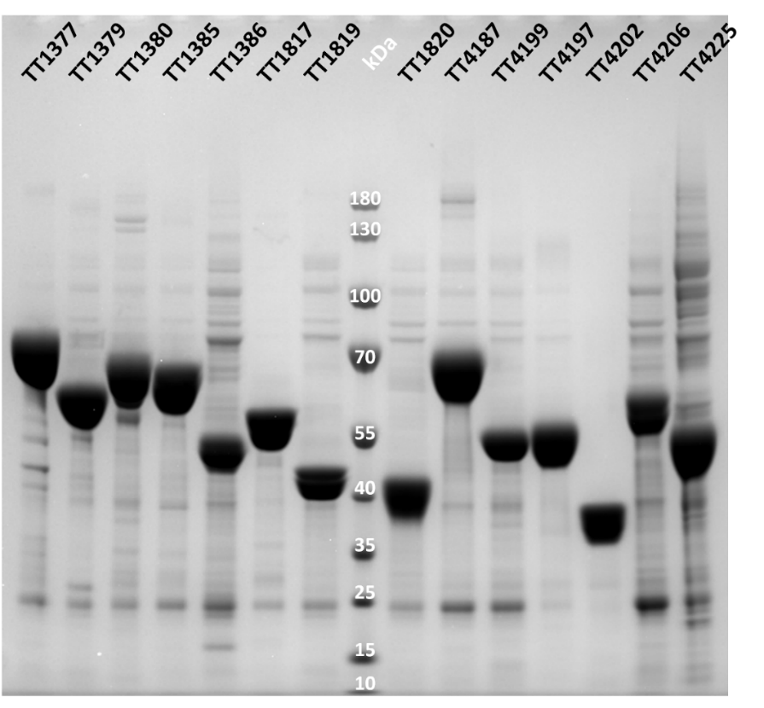

Figure S2. HPAEC-PAD analysis of GH29 fucosidases reaction products with different fucosylated substrates. The data were analysed with Prism. Standards: Fuc (red), fucosylated glycans (green for the substrates used; blue for the potential reaction products). The traces corresponding to the enzymatic reaction with GH29 enzymes in the presence of different substrates or in buffer control are shown in black.

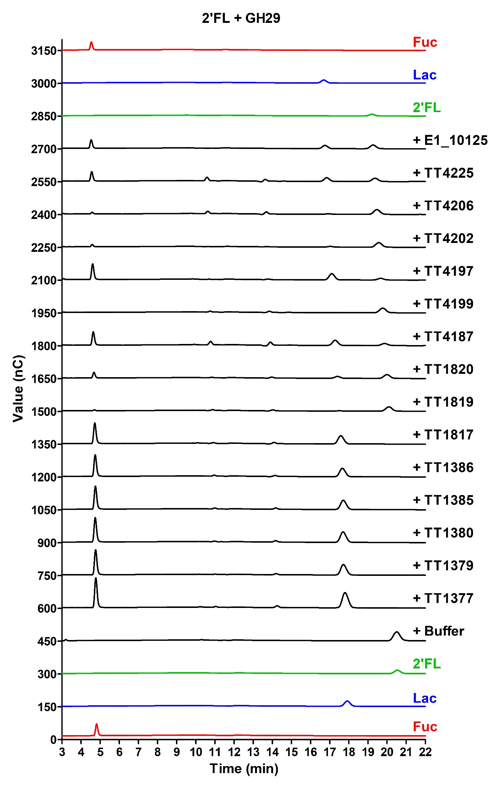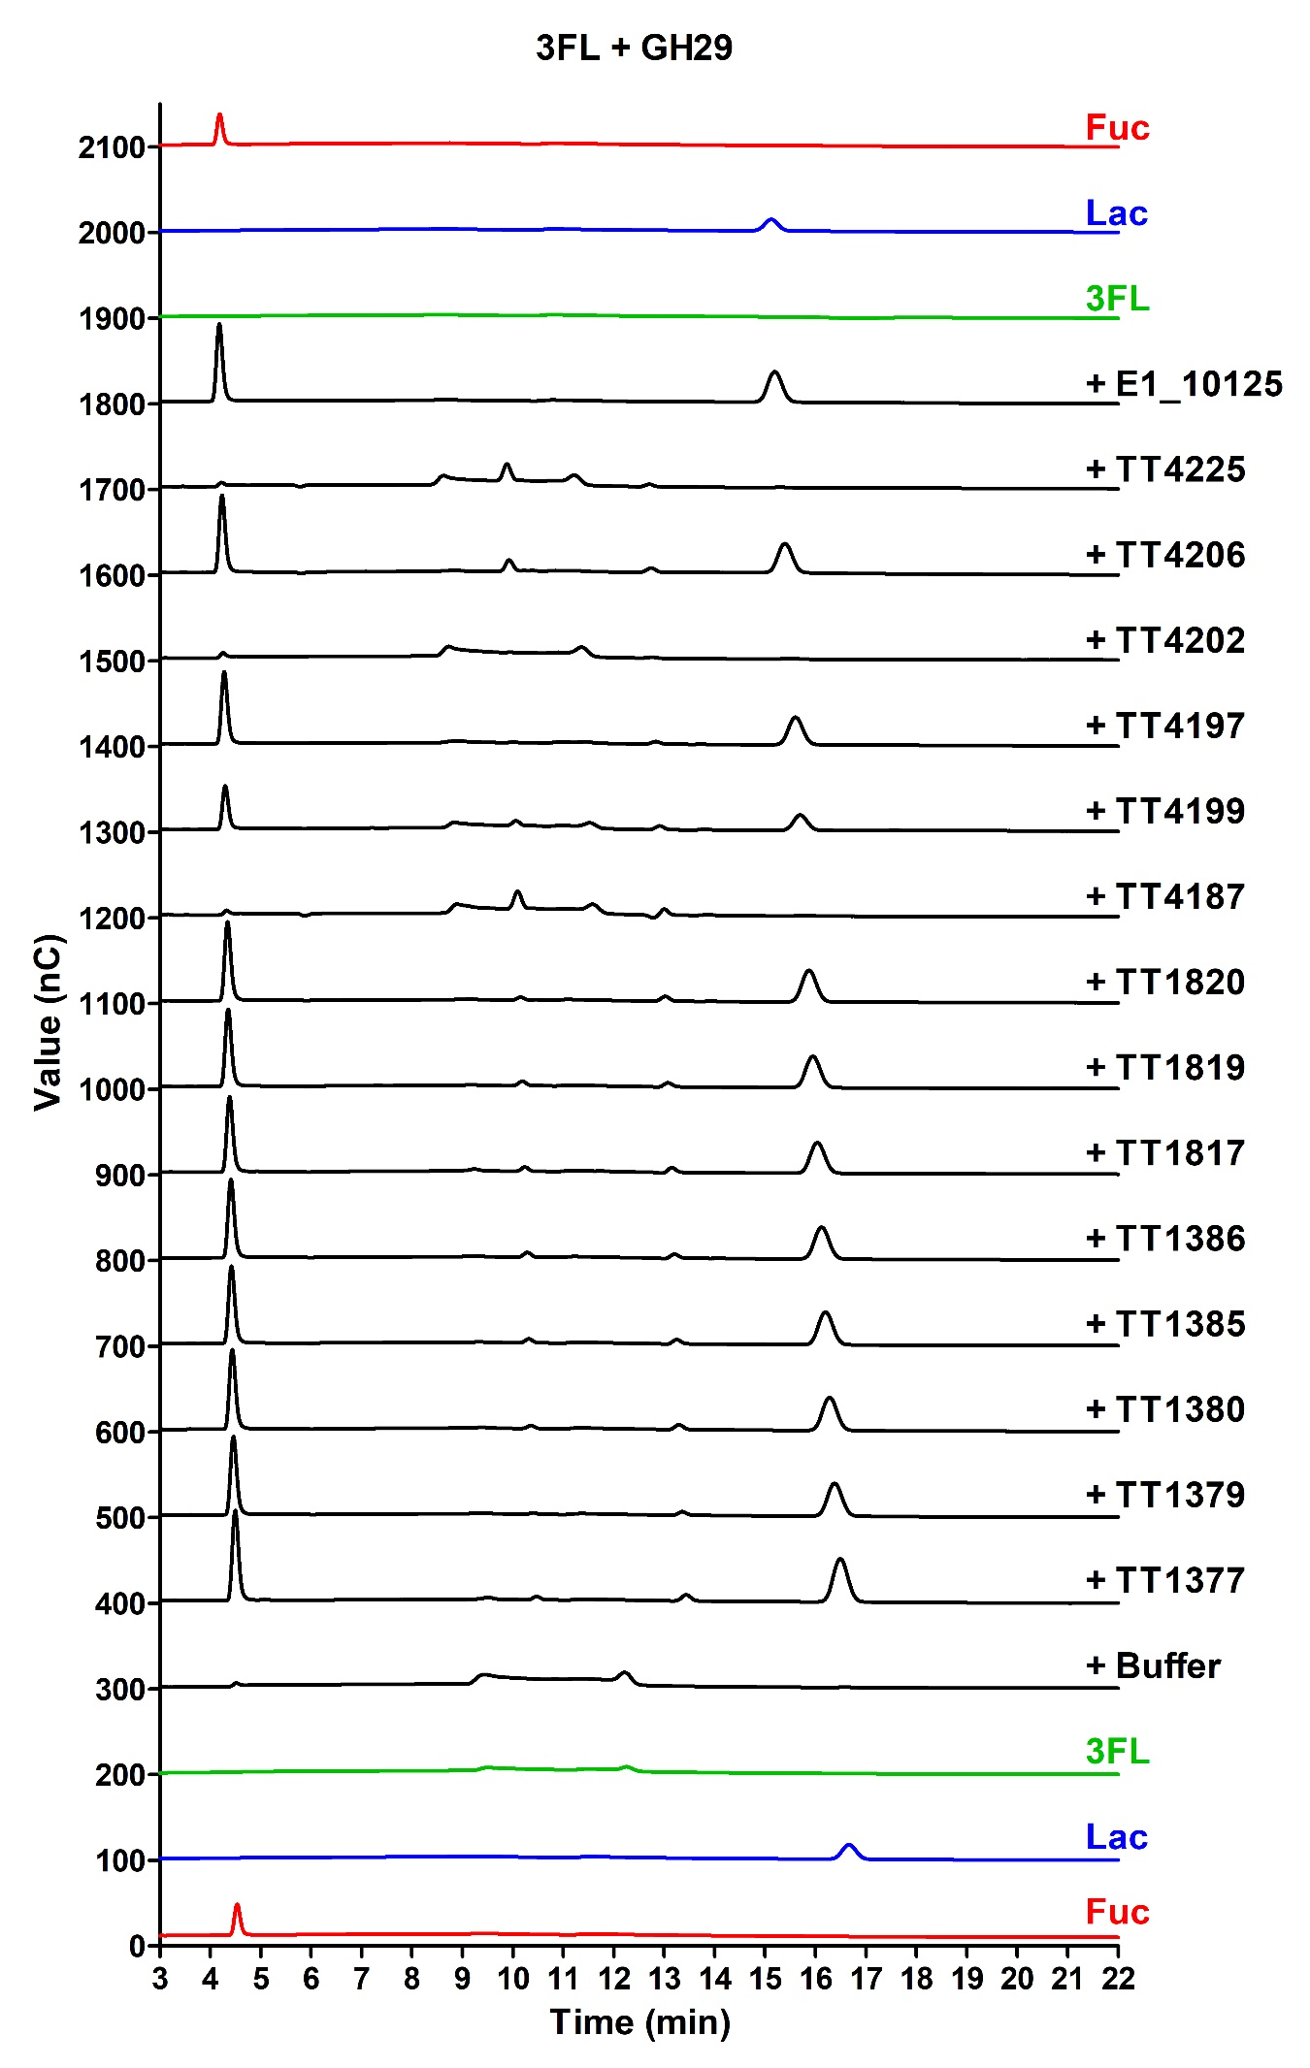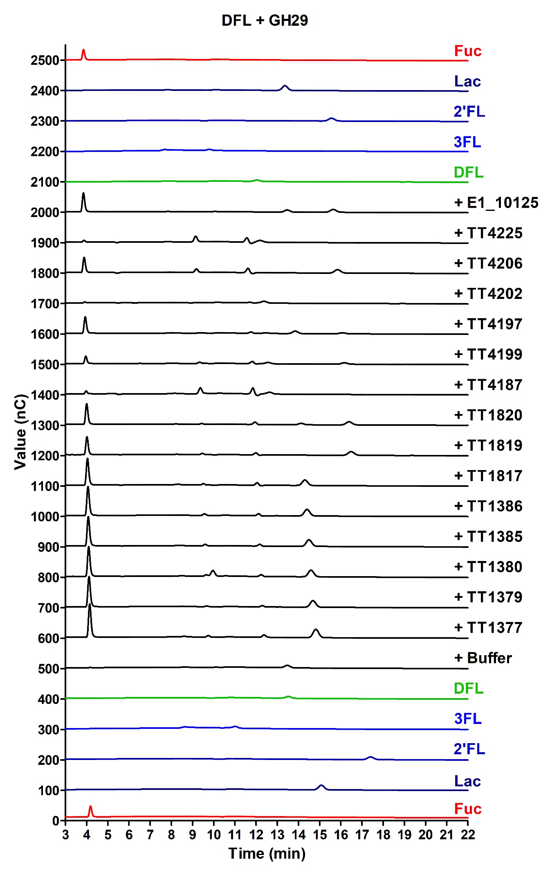
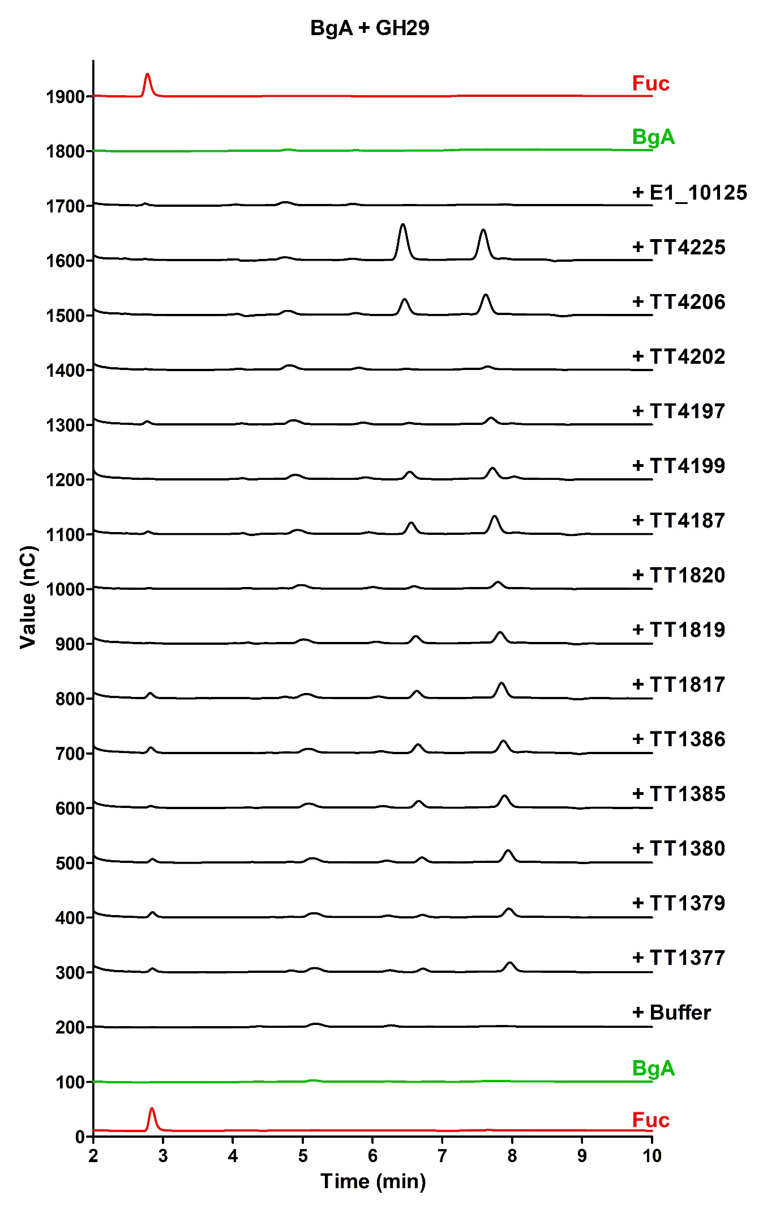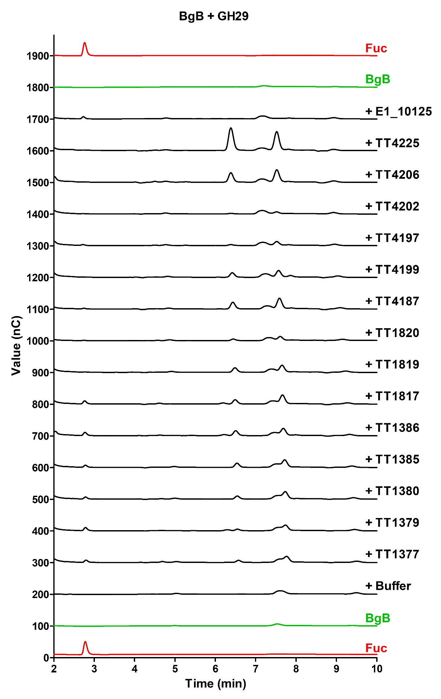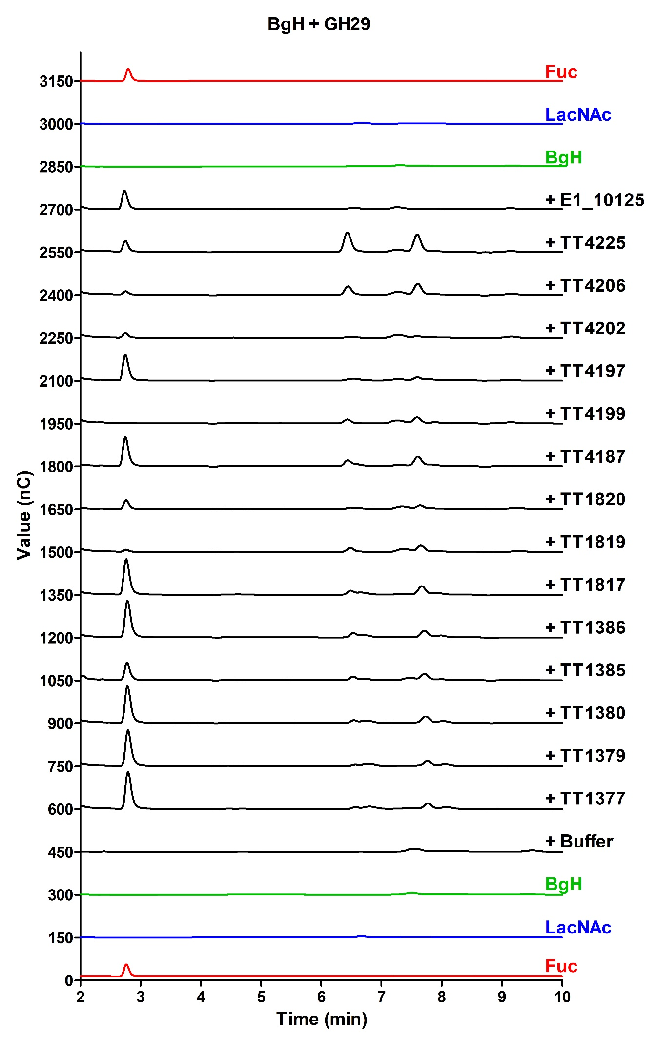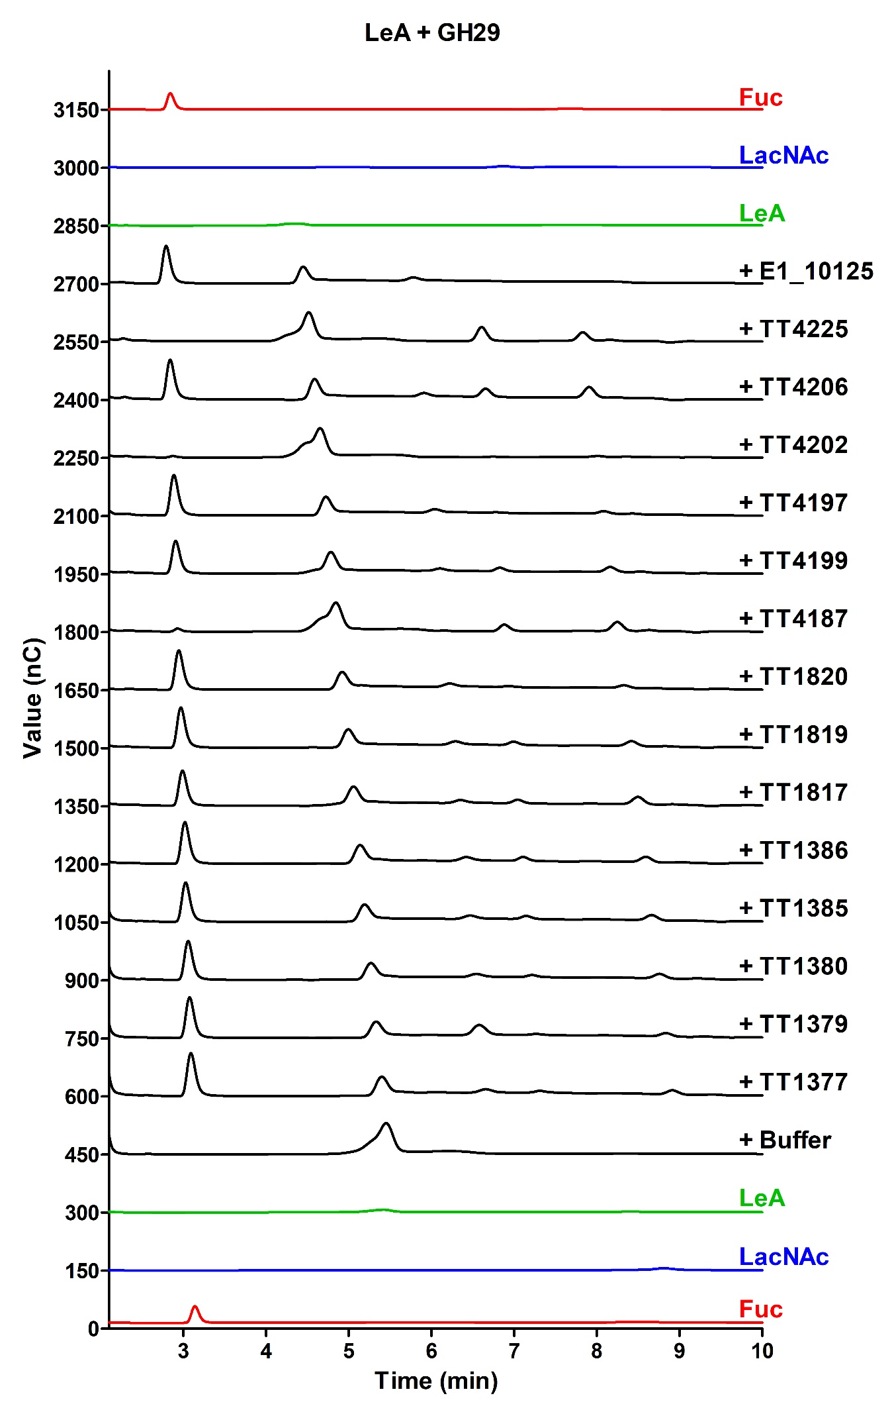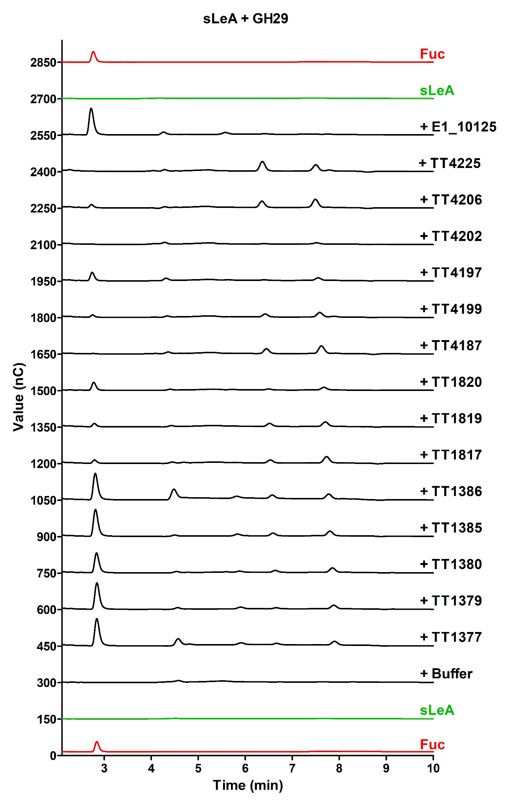
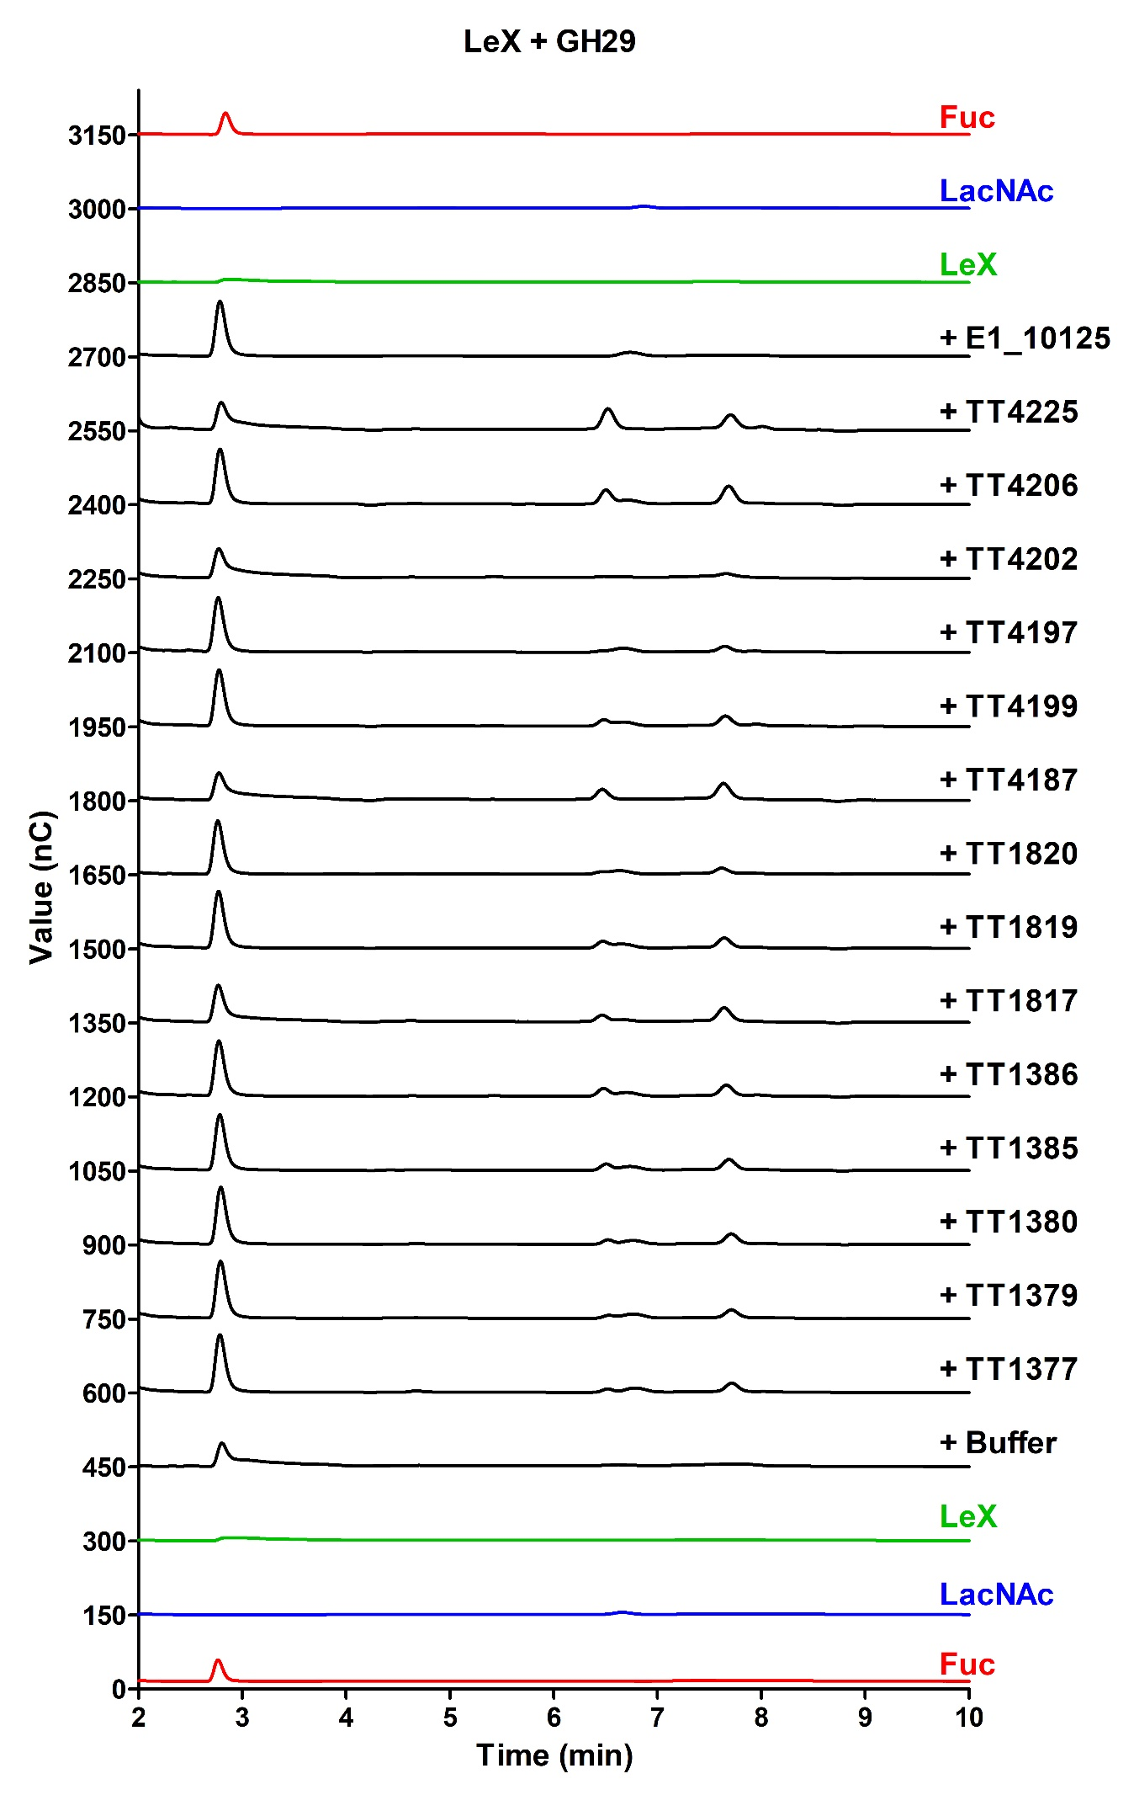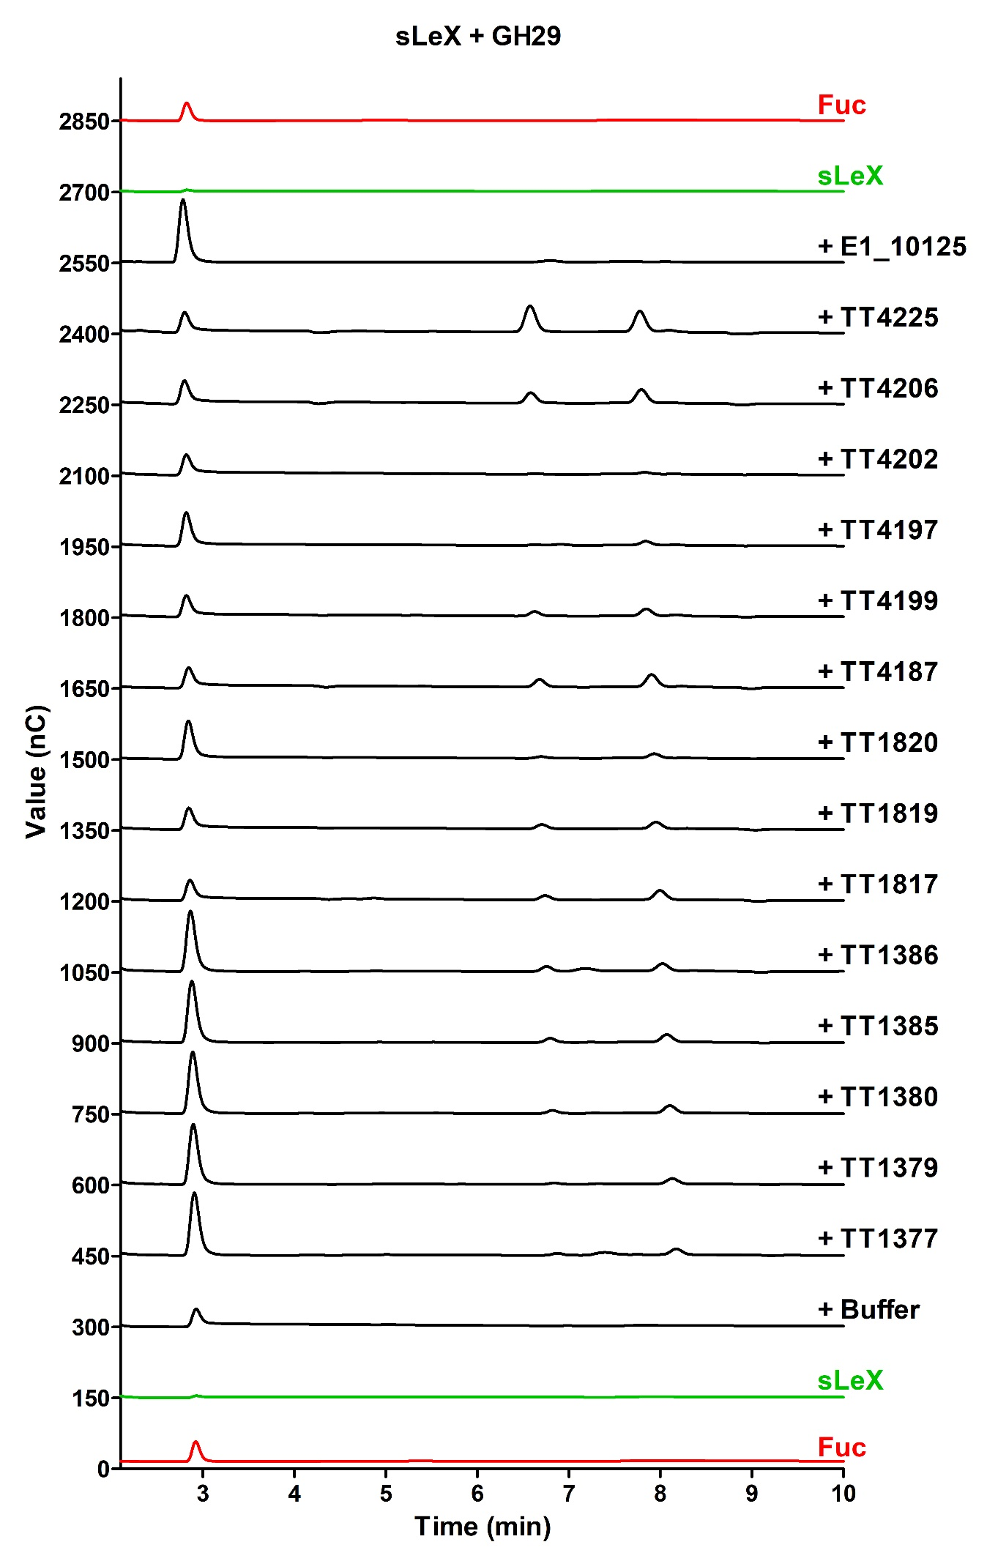
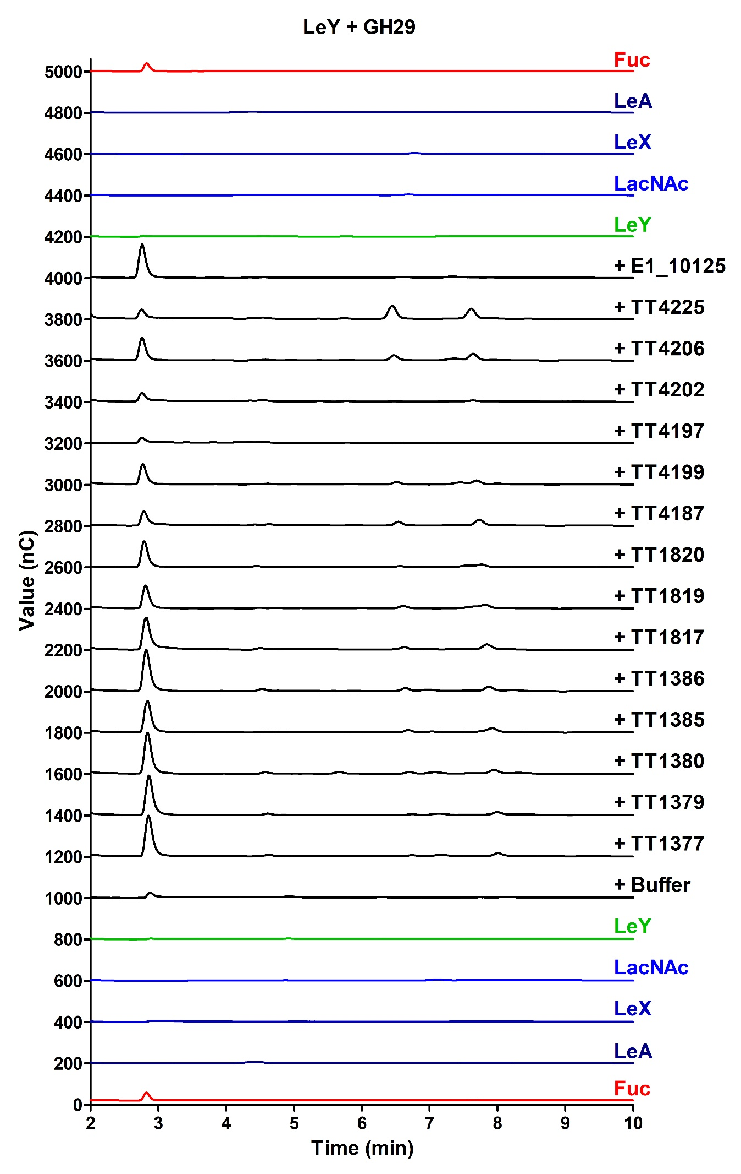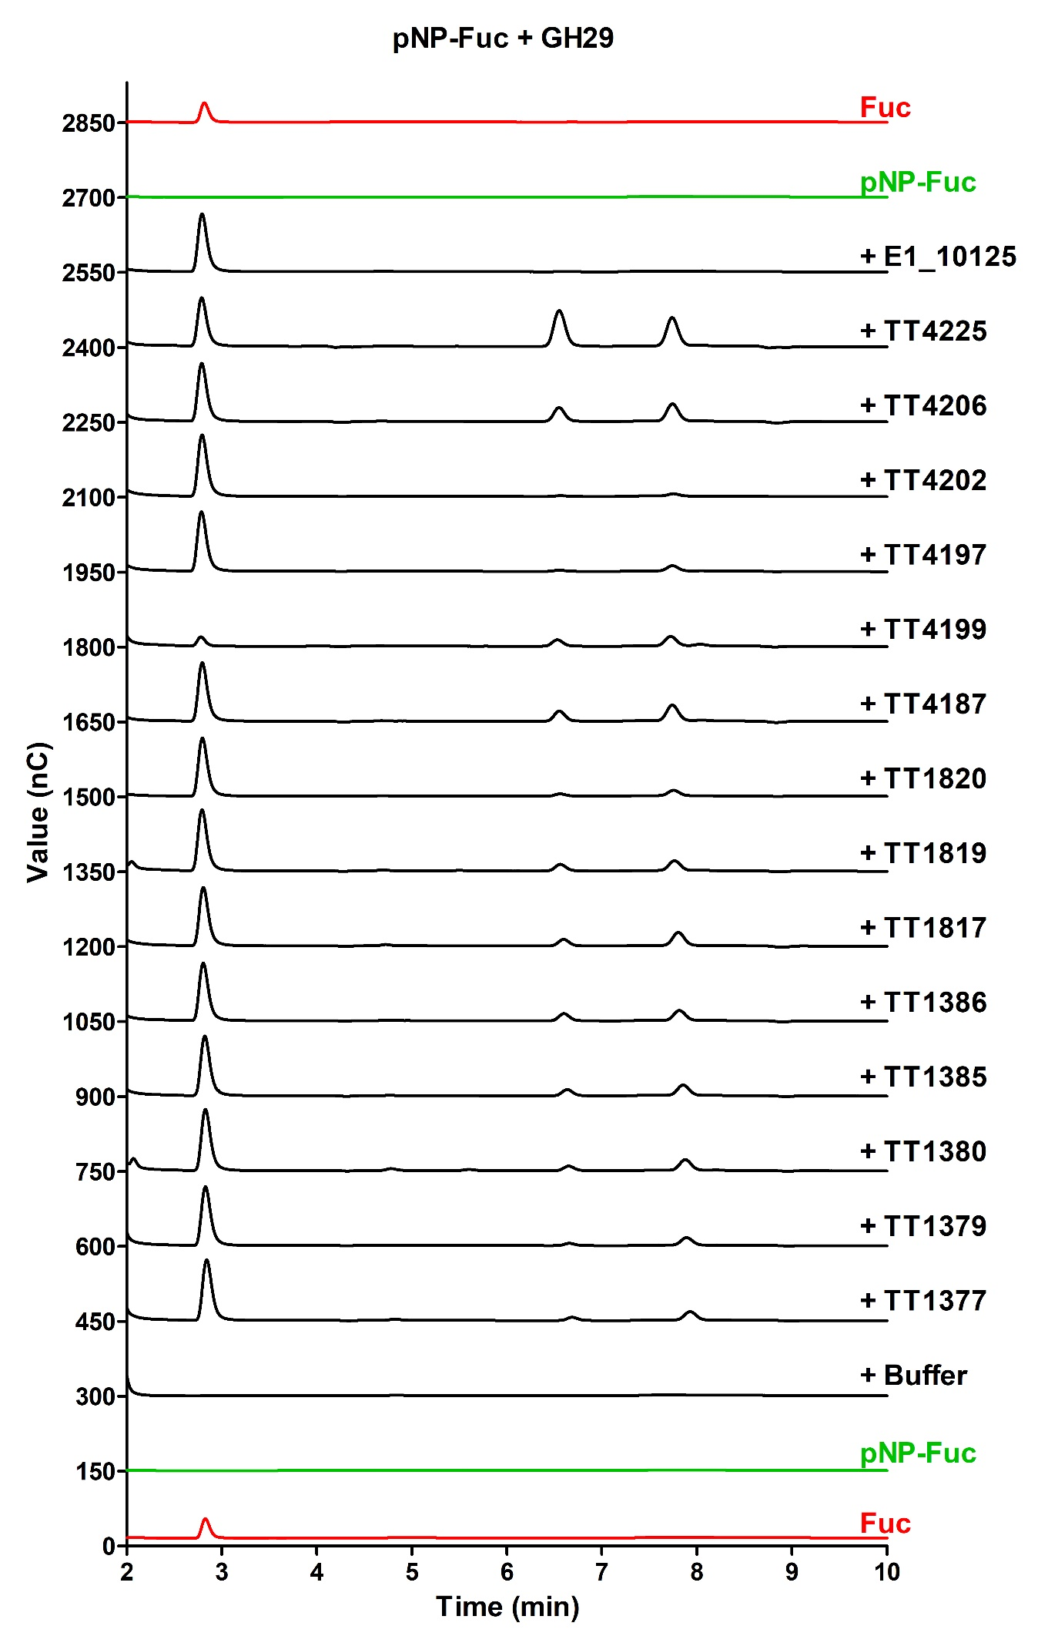
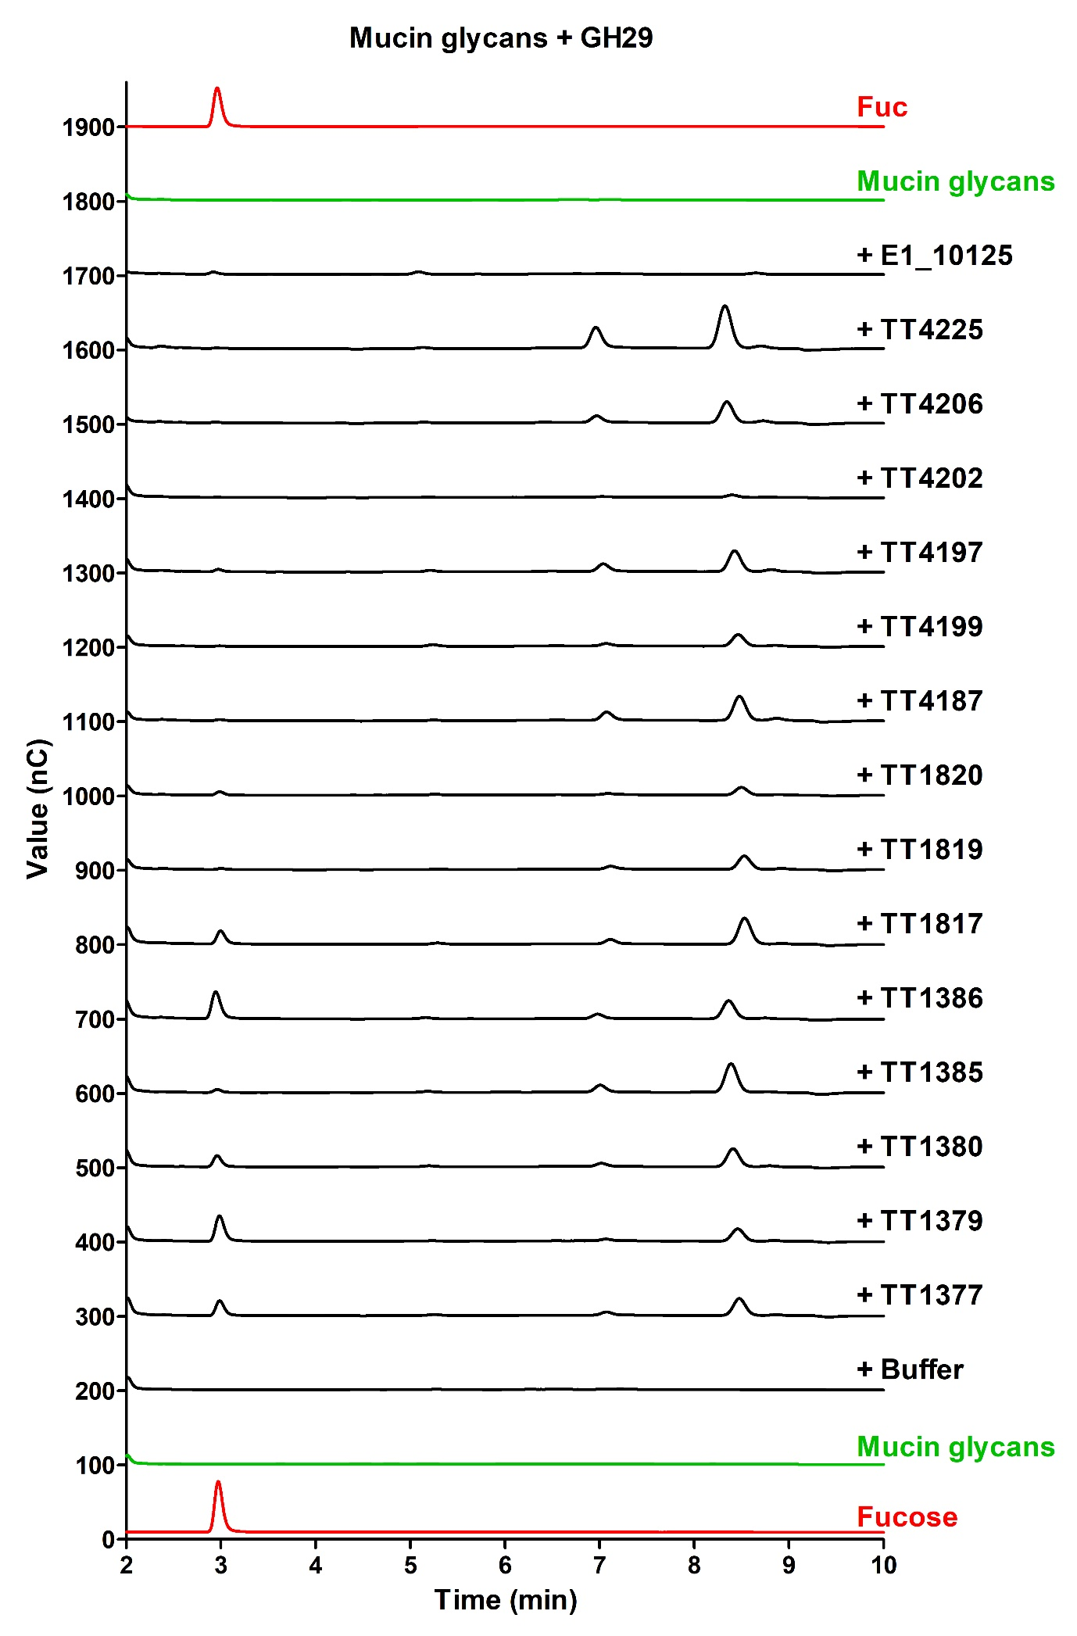
Figure S3. LC-FD-MS/MS analysis of the product profile of GH29 fucosidase reaction ons complex glycans. Enzymatic reactions with IgG glycoprotein (A), IgG N-glycans (B), PLA2 glycoprotein (C), and PLA2 N-glycans (D). Control samples were without enzymes. Glycan products are annotated next to peaks on the chromatograms.

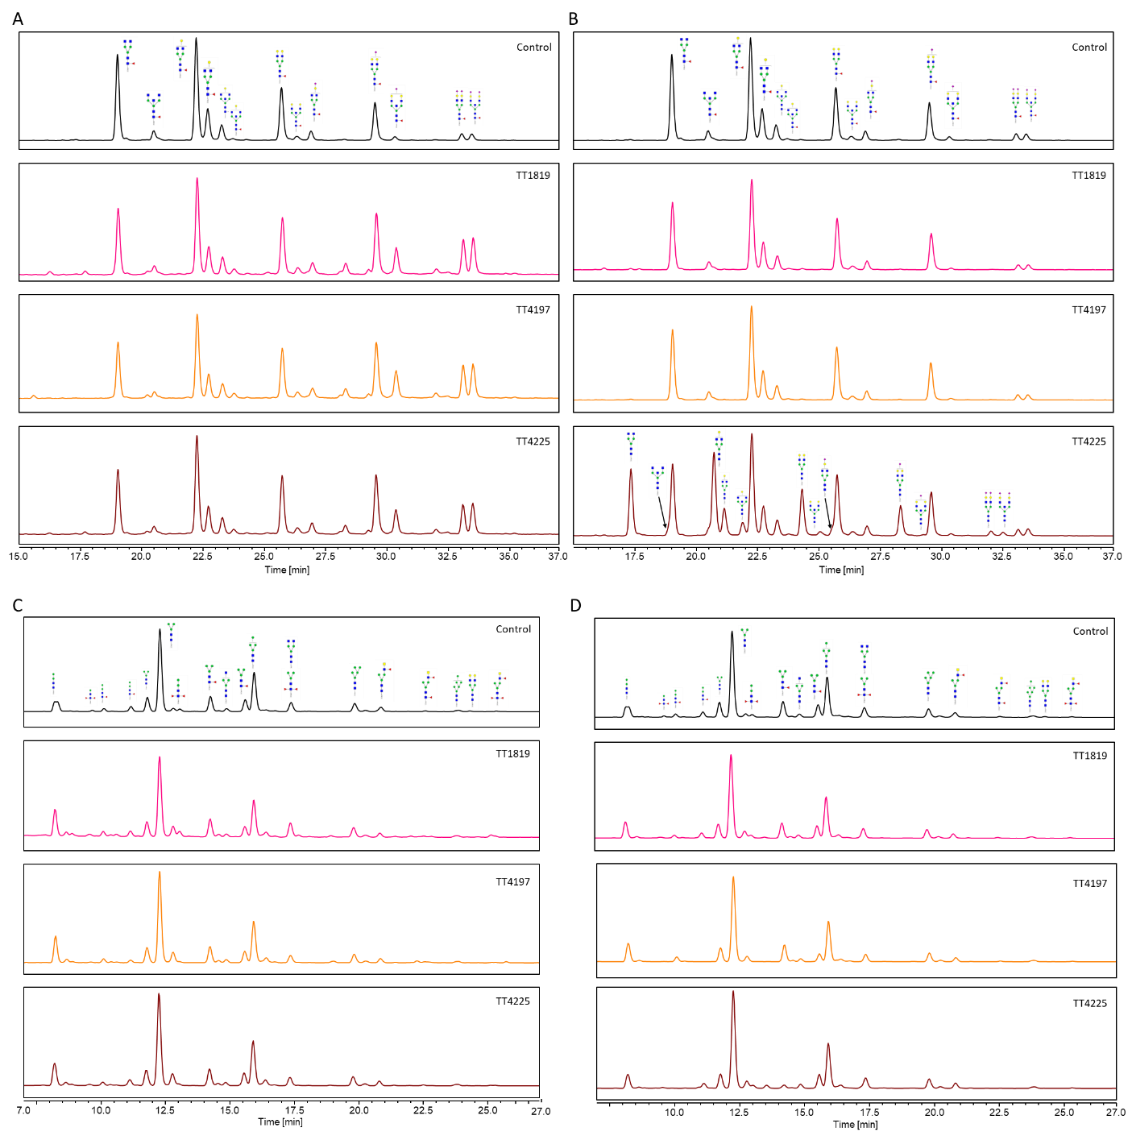

Figure S4 Transfucosylation activity of GH29 fucosidases. A) TLC and TLC-ESI-MS analysis of ATCC_03833 transfucosylation reactions with GlcNAc, Fuc1,3GlcNAc or Fuc1,6GlcNAc as acceptors and pNP-Fuc as donor. Lanes 1 to 5 and 9 are standards: Fuc (lane 1), pNP-Fuc (lane 2), GlcNAc (lane 3), Fuc1,4GlcNAc (lane 4), Fuc1,3GlcNAc (lane 5) and Fuc1,6GlcNAc (lane 9). Lanes 6 to 8 are ATCC_03833 transfucosylation reactions with GlcNAc (lane 6), Fuc1,3GlcNAc (lane 7) and Fuc1,6GlcNAc (lane 8). B) TLC analysis of TT1379, TT1817 and TT1820 transfucosylation reactions with GlcNAc as acceptor and pNP-Fuc as donor. Lanes 1 to 4 are standards: GlcNAc (lane 1), Fuc1,4GlcNAc (lane 2), Fuc1,3GlcNAc (lane 3) Fuc1,6GlcNAc (lane 4). Lanes 5 to 7 are transfucosylation reactions with GlcNAc using TT1379 (lane 5), TT1817 (lane 6) and TT1820 (lane 9). C) H¹ NMR analysis of ATCC 03833 , TT1379, TT1817 and TT1120 reactions. Peaks were assigned by using the appropriate sugar standards. The mid field region allows the distinctive detection of signals of Fuc1,6GlcNAc and Fuc1,3GlcNAc in ATCC 03833, Fuc1,3GlcNAc and Fuc1,4GlcNAc in TT1379, Fuc1,3GlcNAc and Fuc1,6GlcNAc in TT1817 and Fuc1,6GlcNAc in TT1820.

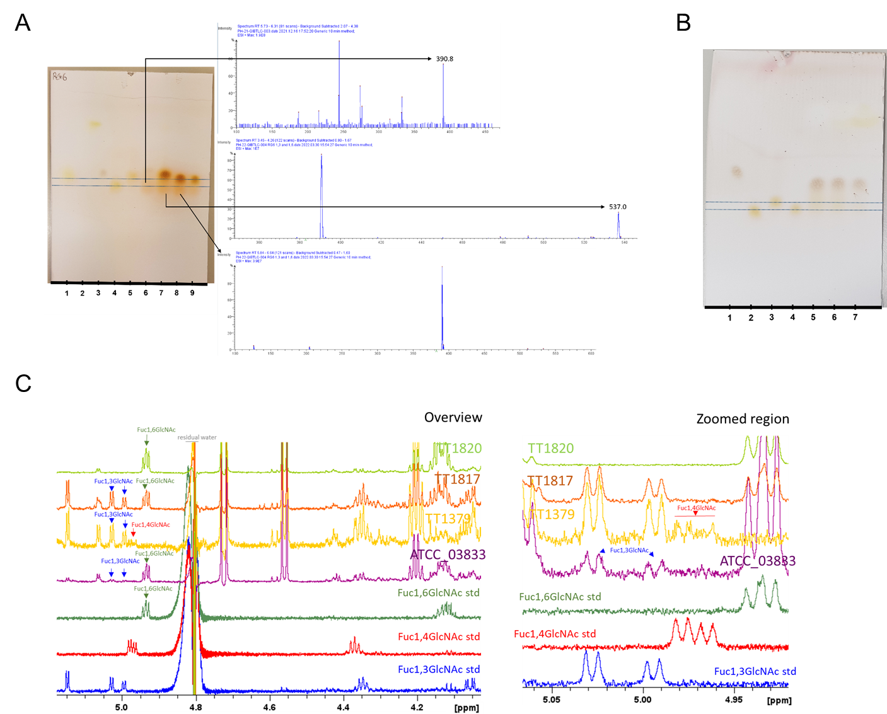

Figure S5 Close-up of TT18149 active site. A) Fo-Fc difference map at 3σ (grey) and 5σ (grey) for fucose bound in the TT1819 active site. B) Potential for plasticity in the TT1819 active site highlighted by scaling and coloring the protein according to B factor. C) TT1819 (light blue) comparison with E1_10125 GH29 (brown, PDB 6TR3). Residue numbering of TT1819 or E1_10125. D) TT1819 (light blue) comparison with α1,3/4 GH29 Blon_2336 from B. longum subsp. infantis (orange, D172A/E217A mutant in complex with lacto-N-fucopentaose II, PDB 3UET; yellow, WT PDB 3MO4). Residue numbering of TT1819 or Blon_2336. The hydrogen bond between Blon_2336 E237 and the ligand fucose residue is indicated.
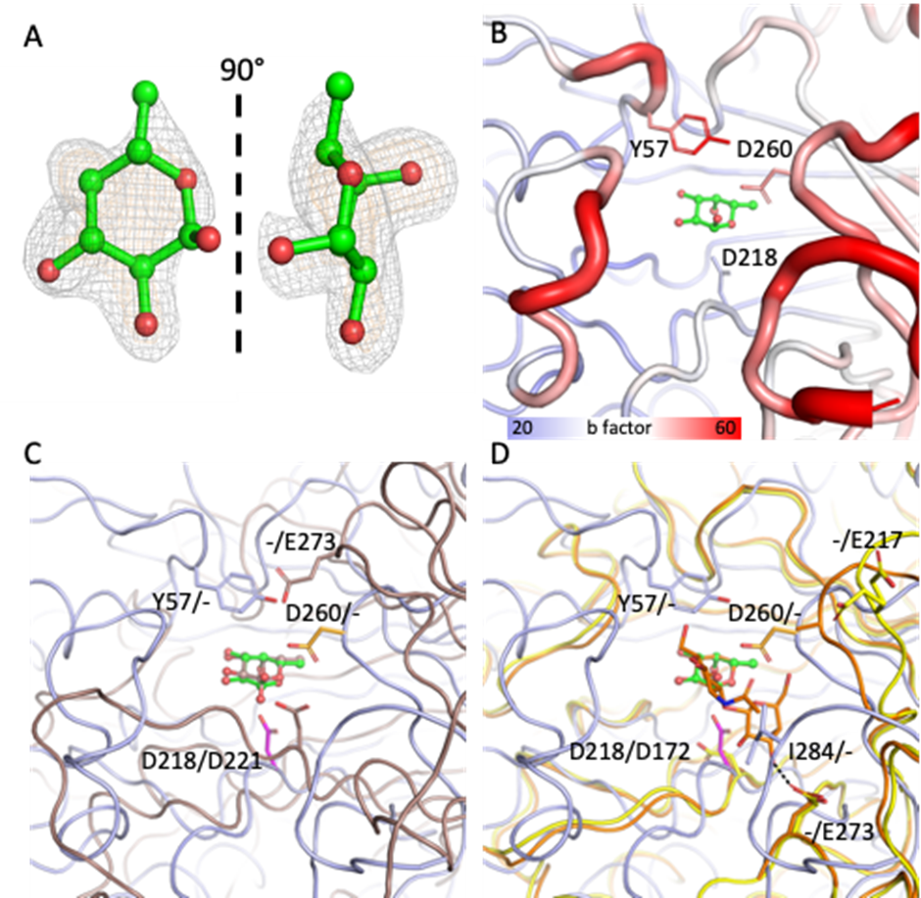

Figure S6 STD NMR full build-up curve analysis of the binding of FA2G2 to TT1819. A) Experimental STD NMR build-up curves for the sample containing the FA2G2/TT1819 complex. B) STD initial slopes values for the analysed protons, with contact intensities colouring scheme.

