Appendix 3. Overall survival (OS) outcome: Sensitivity analyses and meta-analyses (continuous, 6, 12 and 18-months)
OS sensitivity analysis (excluding study with high risk of bias –Ford 2014–)
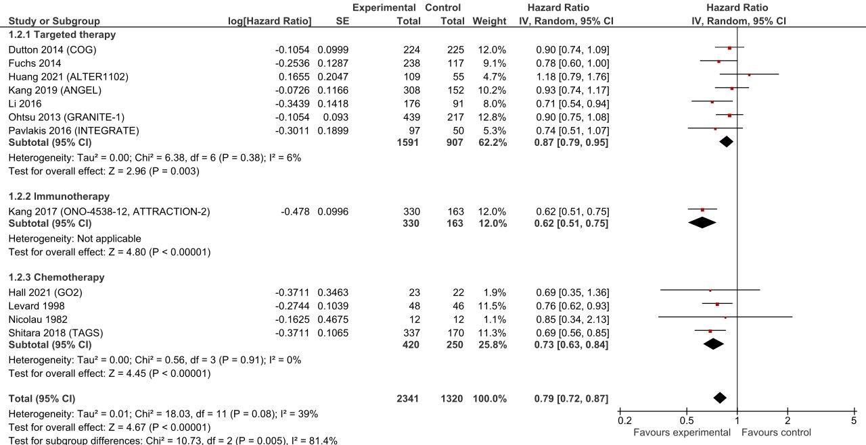

OS sensitivity analysis (excluding studies considering gastric cancer)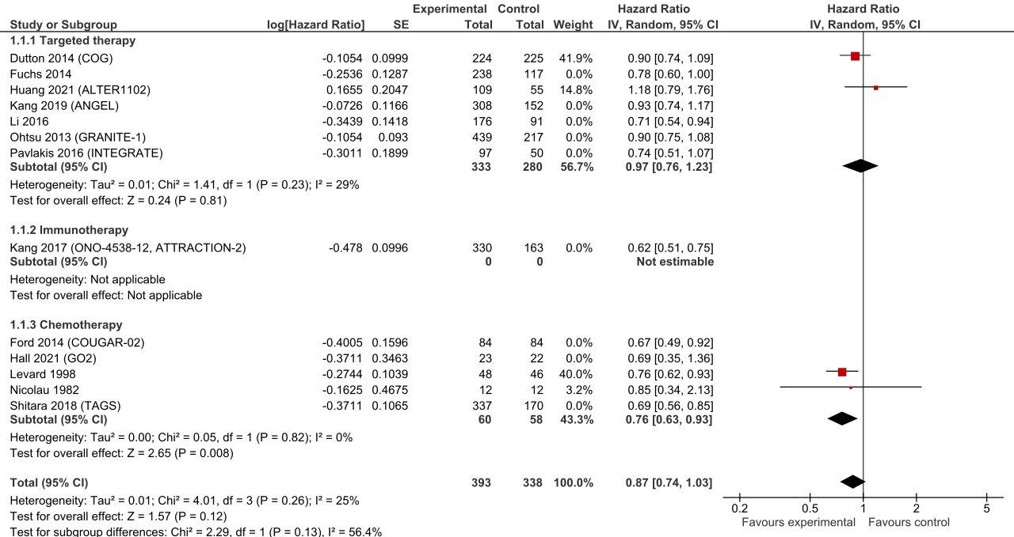

OS as continuous outcome
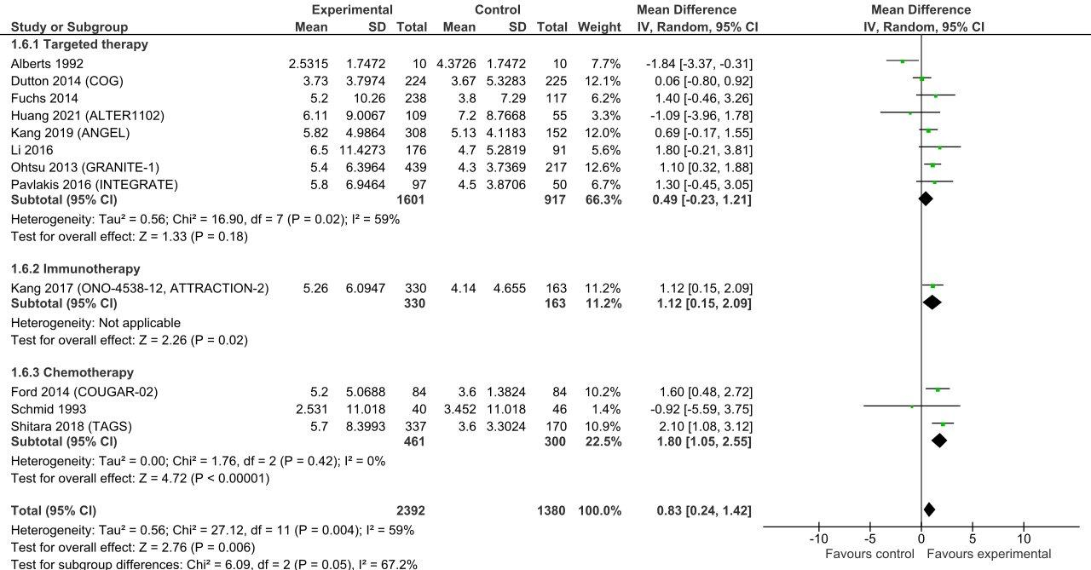
OS follow-up 6 months
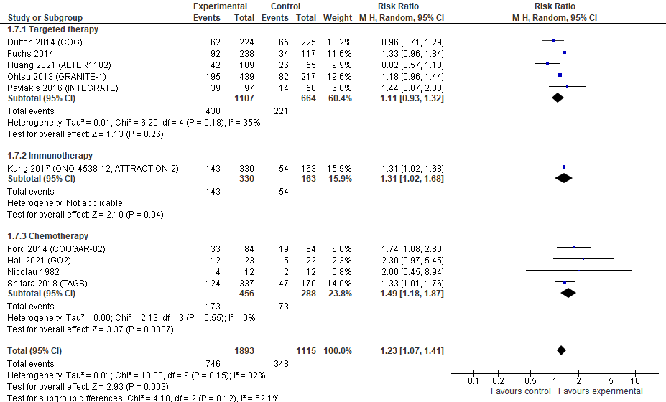

OS follow-up 12 months
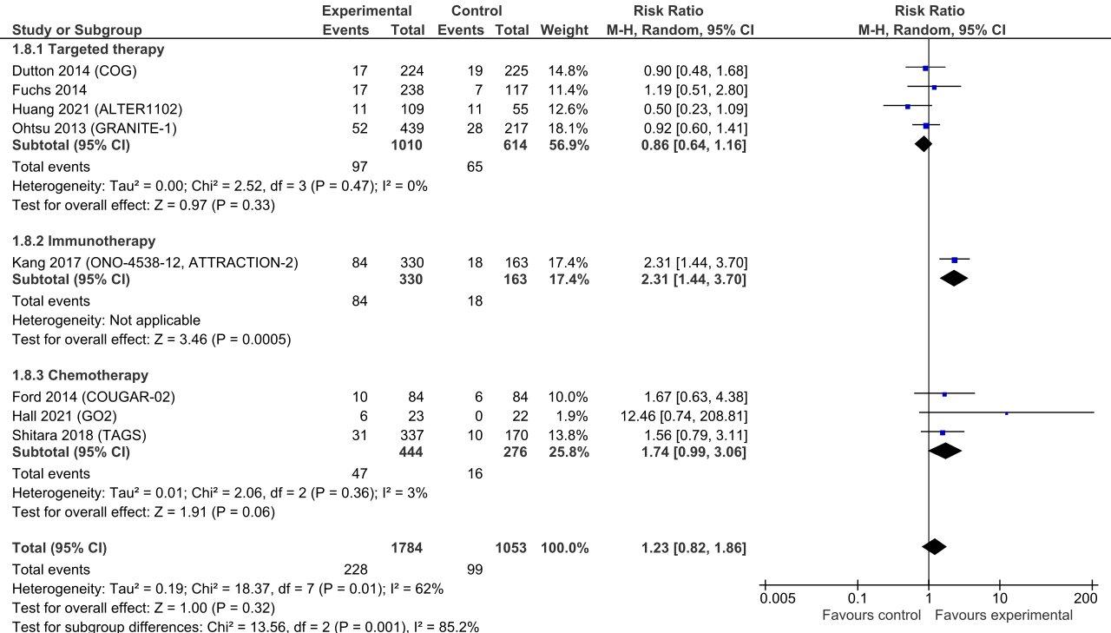
OS follow-up 18 months
