ELECTRONIC SUPPLEMENTARY MATERIAL

Electronic supplementary material 1. Course of study for the objectives
Course of study for primary and secondary objectives
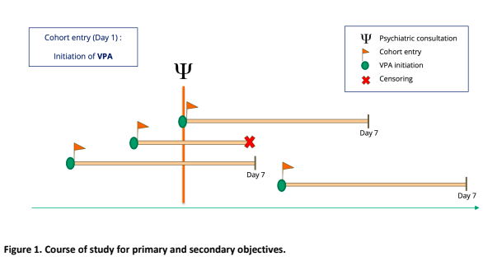
Time
Patient A
Patient B
Patient C
Patient D
Course of study for tertiary objective
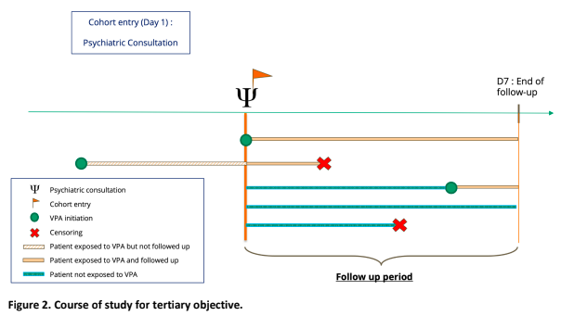
Time
Patient A
Patient B
Patient D
Patient E
Patient F

Electronic supplementary material 2. Modified Gagnon algorithm for counterverifying nursing notes and RASS
