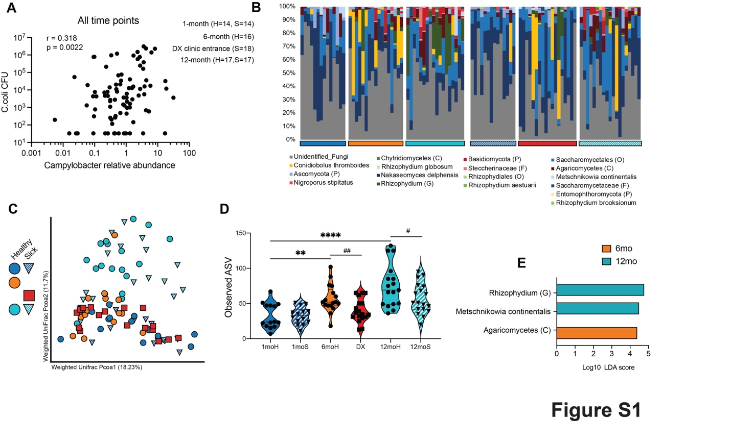
Figure S1: Development of the infant mycobiome and impact of diarrhea. (A) correlation between relative abundance and colony forming units equivalent measured by qPCR. (B) Stacked bar plot of fungal ITS taxonomy organized by time-point. Each vertical bar represents a single sample. (C) Principal coordinate analysis (PCoA) of fecal mycobiome weighted UniFrac distance (ITS amplicon) colored by host status and timepoint. (D) Violin plot of observed amplicon sequencing variants at each time point. (E) Differentially abundant taxa between healthy and sick samples at 6 and 12 months (LEfSe, Log₁₀ LDA score > 2).

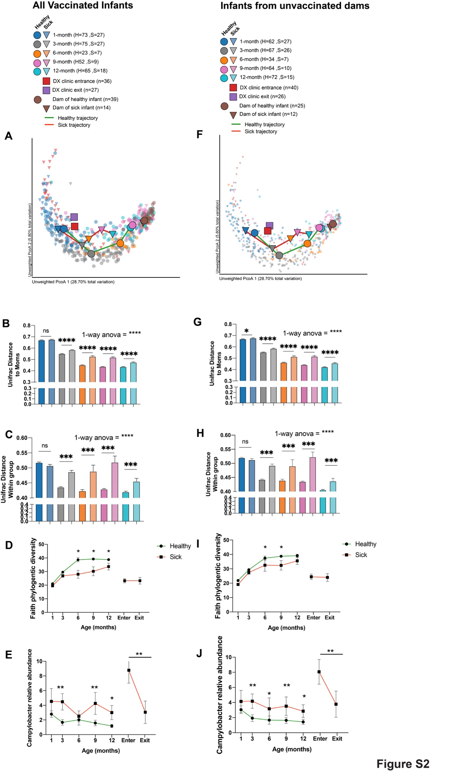
Figure S2: Vaccination against C. coli does not impact microbiome maturation or mitigate impact of breakthrough diarrhea. Panels A-E show data from infants that received a C. Coli vaccine to show that vaccination alone did not drive the overall trends observed. Panels F-J show data from all infants, both vaccinated and unvaccinated, whose dams were not vaccinated, to illustrate that maternal vaccination had no impact on the observed trends. (A) Principal coordinate analysis (PCoA) of fecal microbiome unweighted UniFrac distance (16S amplicon), colored by host status and timepoint. Small points represent individual samples while larger points represent the centroid for a given timepoint/host status. Solid lines connecting centroids illustrate the developmental trajectory of both healthy and sick infants. (B) Bar plot of unifrac distance between dams and each infant timepoint/health status. (C) Bar plot of within group unifrac distance for each infant group. (D) Longitudinal measurements of Faith’s phylogenetic diversity, in healthy and sick infants connecting lines colored by host status. (E) Longitudinal measurements of Campylobacter relative abundance, in healthy and sick infants connecting lines colored by host status. (F) Principal coordinate analysis (PcoA) of fecal microbiome unweighted UniFrac distance (16S amplicon), colored by host status and timepoint. Small points represent individual samples while larger points represent the centroid for a given timepoint/host status. Solid lines connecting centroids illustrate the developmental trajectory of both healthy and sick infants. (G) Bar plot of unifrac distance between dams and each infant timepoint/health status. (H) Bar plot of within group unifrac distance for each infant group. (I) Longitudinal measurements of Faith’s phylogenetic diversity, in healthy and sick infants connecting lines colored by host status. (J) Longitudinal measurements of Campylobacter relative abundance, in healthy and sick infants connecting lines colored by host status. Significance for B, C, G, and H was determined using 1-way ANOVA **** p < 0.0001, with Holm-Sidak’s multiple comparison test, **** p < 0.0001, error bars = SEM. Significance for D, E, I and J was determined using unpaired T-test at each time-point, *p <0.05, **p < 0.01, ***p < 0.001, error bars = SEM.

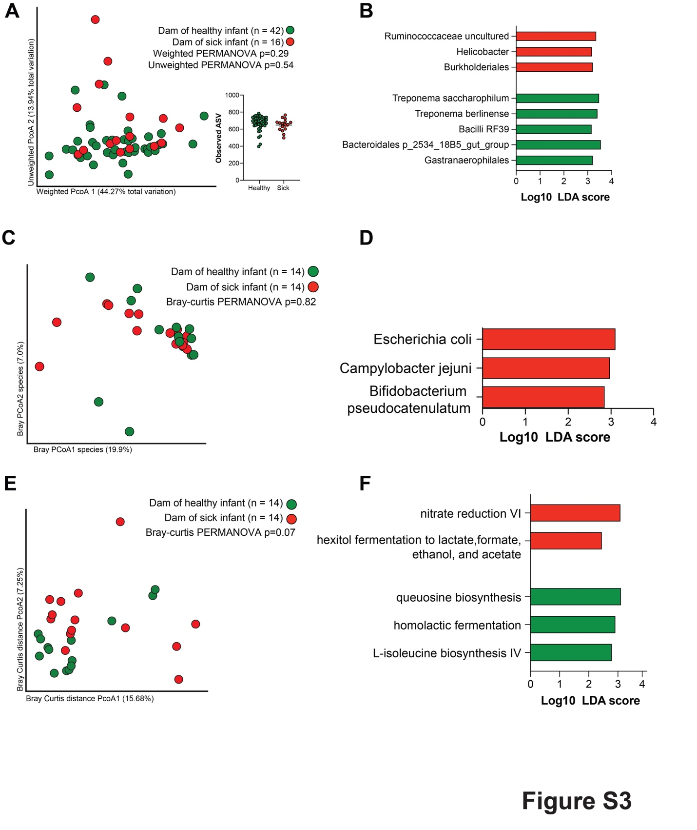
Figure S3: The maternal microbiome as a predictor of infant diarrhea. (A) Principal coordinate analysis (PCoA) of fecal microbiome weighted UniFrac dissimilarity (16S amplicon) from maternal samples collected at infant age 1-month, colored by infant status. (B) Differentially abundant taxa (16S amplicon) between mothers of healthy and sick infants (LEfSe, Log₁₀ LDA score > 2). (C) PcoA of Bray-Curtis dissimilarity built on the species level taxonomy generated using MetaPhlAn and colored by infant status. (D) Differentially abundant species (MetaPhlAn) between mothers of healthy and sick infants (LEfSe, Log₁₀ LDA score > 2). (E) PCoA of Bray-Curtis dissimilarity built on the abundance of all functional genes annotated using HUMAnN3 and the Uniref90 database colored colored by infant status. (F) Differentially abundant MetaCyc pathways between mothers of healthy and sick infants (LEfSe, Log₁₀ LDA score > 2).

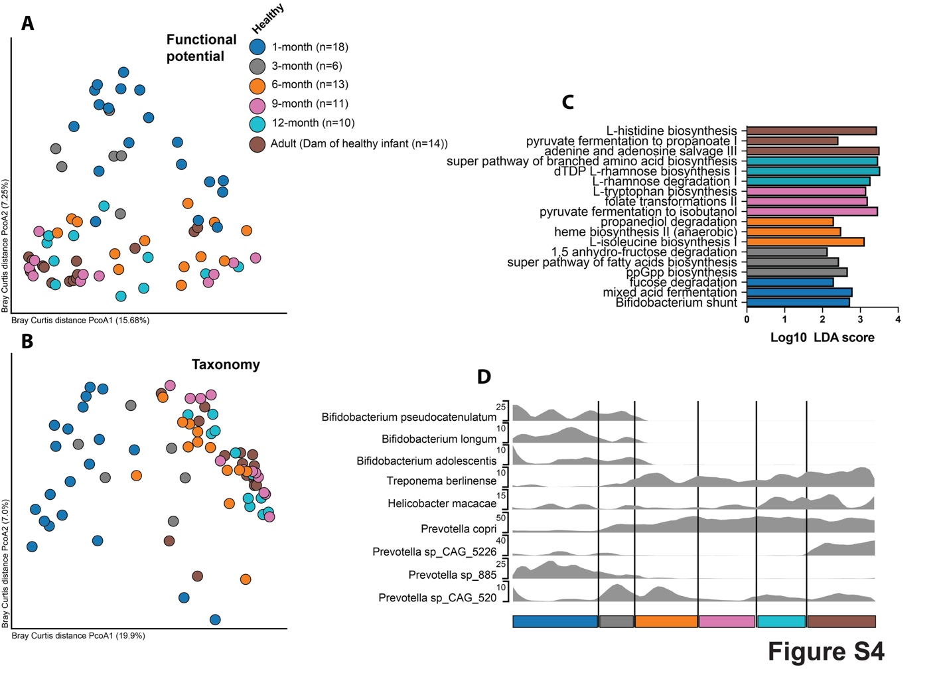
Figure S4: Functional and taxonomic development of the healthy infant microbiome. (A) PCoA of Bray-Curtis dissimilarity built on the abundance of all functional genes annotated using HUMAnN3 and the Uniref90 database colored by and timepoint including only healthy infants and dams. (B) Differentially abundant MetaCyc pathway between time-points including only healthy animals (LEfSe, Log₁₀ LDA score > 2). (C) PCoA of Bray-Curtis dissimilarity built on the species level taxonomy generated using MetaPhlAn and colored by timepoint including only healthy infants. (D) Longitudinal average plot of key bacterial species across time-points in healthy infants.

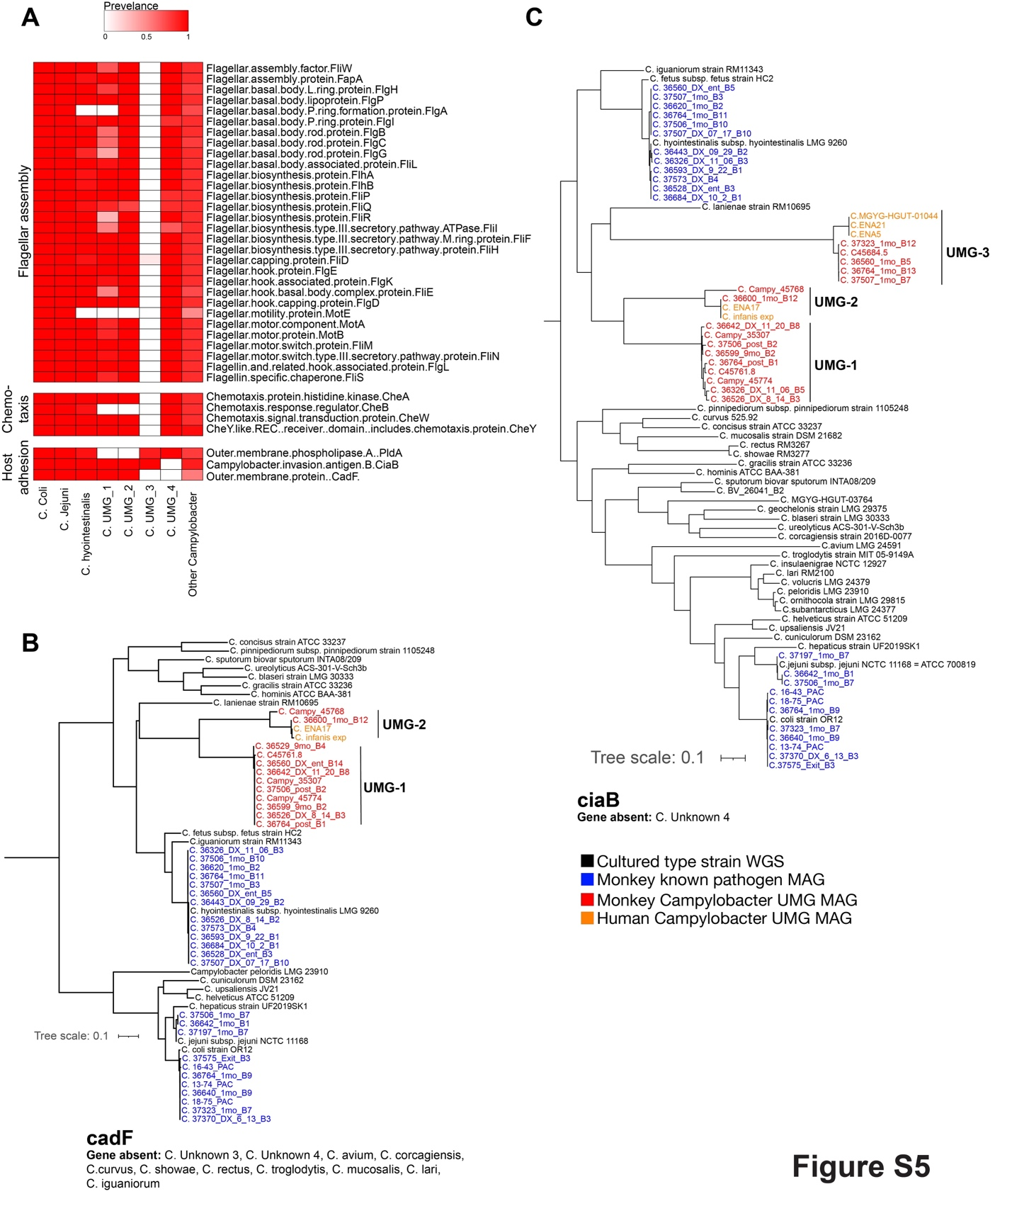
Figure S5: UMG-3 lacks motility genes and adhesion/invasion genes are conserved within but not between species. (A) Prevalence heatmap of genes associated with flagellar assembly, chemotaxis, and host adhesion. (B, C) Phylogeny built on the amino acid alignment of the adhesion gene cadF (B) and the Campylobacter invasion antigen gene ciaB (C).

