Supporting Information
Benzothiazole-Derived Covalent Organic Framework for Multimedia Iodine Uptake
Ritika Jaryal¹, Sadhika Khullar¹*, Rakesh Kumar¹*
¹Dr. B. R. Ambedkar National Institute of Technology Jalandhar, Jalandhar, Punjab, India (144027)
Corresponding author emails: *khullars@nitj.ac.in, *rakeshkumar@nitj.ac.in

Contents Page Number
1. ¹H NMR spectra of the monomers
Fig. S1-S-3 ¹H NMR spectra of the synthesized monomers S3-S4
2. Schematic for the synthesis of COFs S4
3. Characterization of the synthesized COFs
¹³C CP-MAS solid-state NMR spectra of COFs S5
HR-TEM images of COFs S6
TGA scans of COFs S6
XPS spectra of COFs S7

- 1H NMR spectra of the monomers
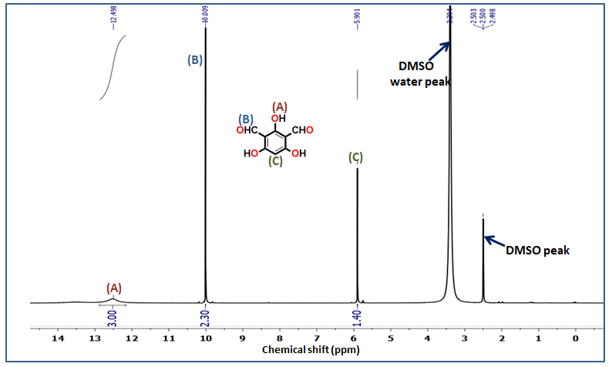
Fig. S1. ¹H NMR spectrum of 2,4,-diformylphloroglucinol.
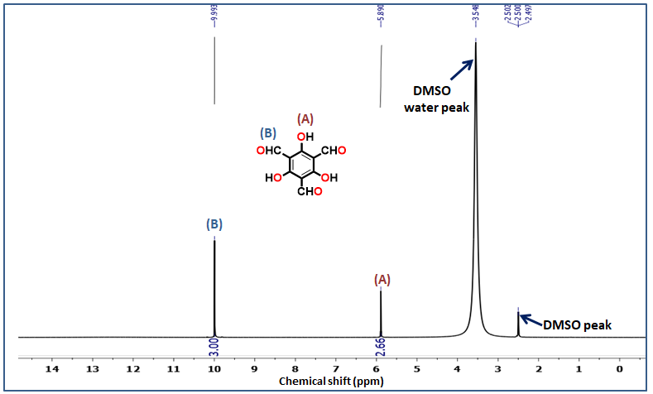
Fig. S2. ¹H NMR spectrum of 2,4,6-triformylphloroglucinol.
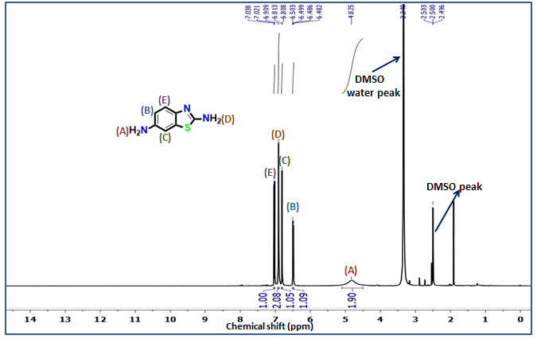
Fig. S3. ¹H NMR spectrum of 2,6-diaminobenzothiazole.
- Synthetic for the synthesis of COFs
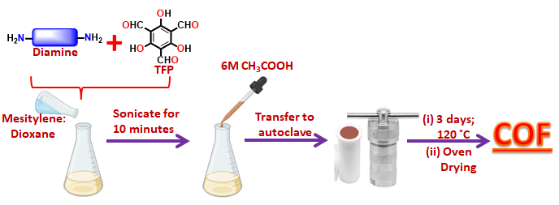
Scheme S1. Schematic representation for the synthesis of COF-3 and COF-4.

- Characterization of synthesized COFs
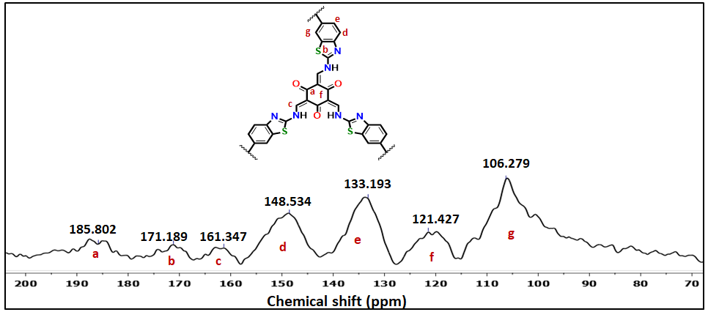
Fig. S4. ¹³C CP-MAS solid-state NMR spectrum of COF-3.
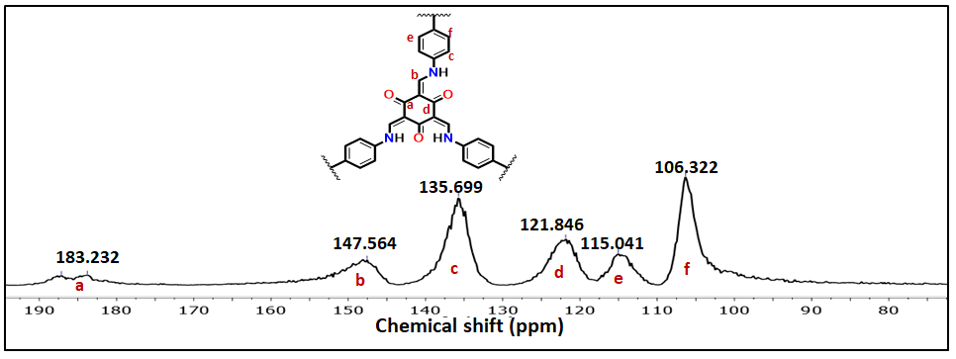
Fig. S5. ¹³C CP-MAS solid-state NMR spectrum of COF-4.
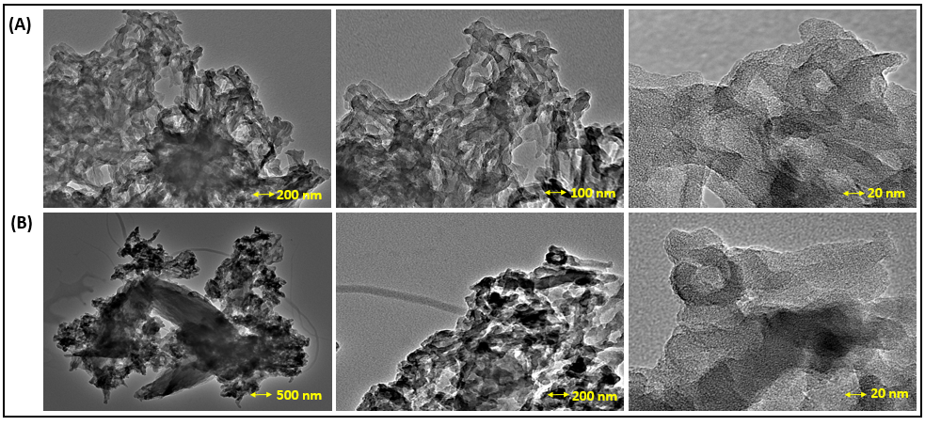
Fig. S6. HR-TEM images of COF-3 (A); and COF-4 (B).
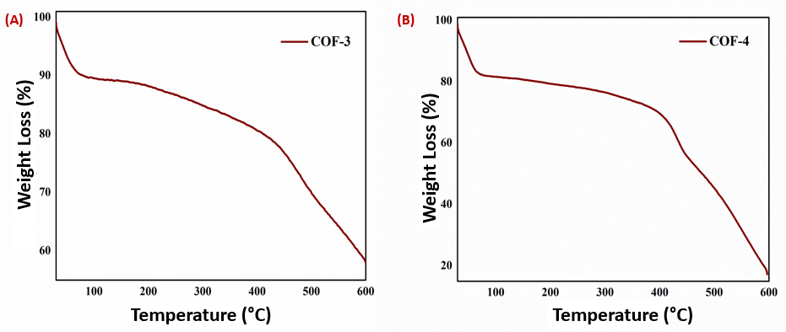
Fig. S7. TGA scans of COF-3 (A); and COF-4 (B).

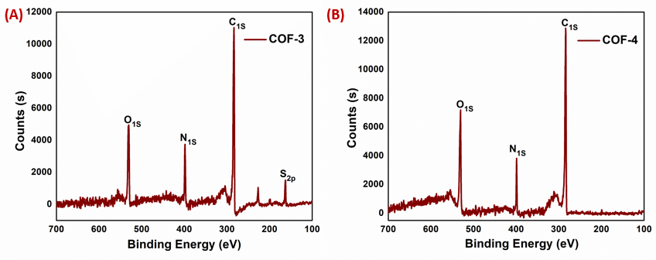
Fig. S8. XPS spectra of COF-3 (A); and COF-4 (B).

