SUPPLEMENTARY MATERIAL

Supplementary Material 1: The figures below describe in detail the AOO 1985 and 2019 results obtained for all other species studied.
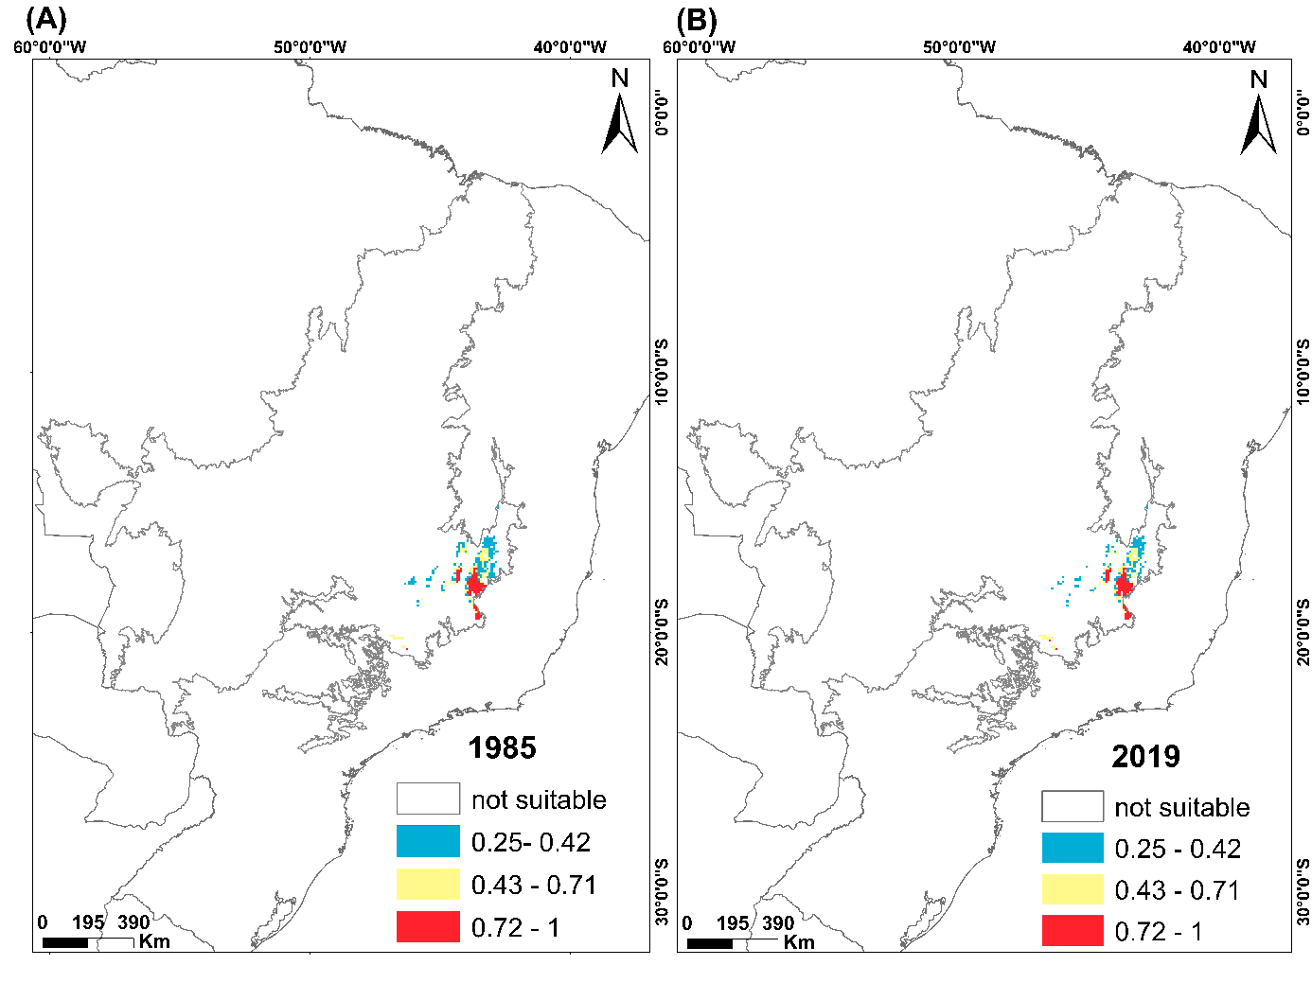
Figure S1.1. Areas of occupancy for 1985 (A) and 2019 (B) for the species Asthenes luizae. Blank areas are environments that had suitability values below the presence/absence threshold or were excluded by spatial restriction. To represent the classes, we divided them according to the natural breaks method, and it was as follows: the areas in blue (0.25-0.42) are considered areas with low environmental suitability values; in yellow (0.43-0.71) intermediate and in red (0.72 –1) high environmental suitability.

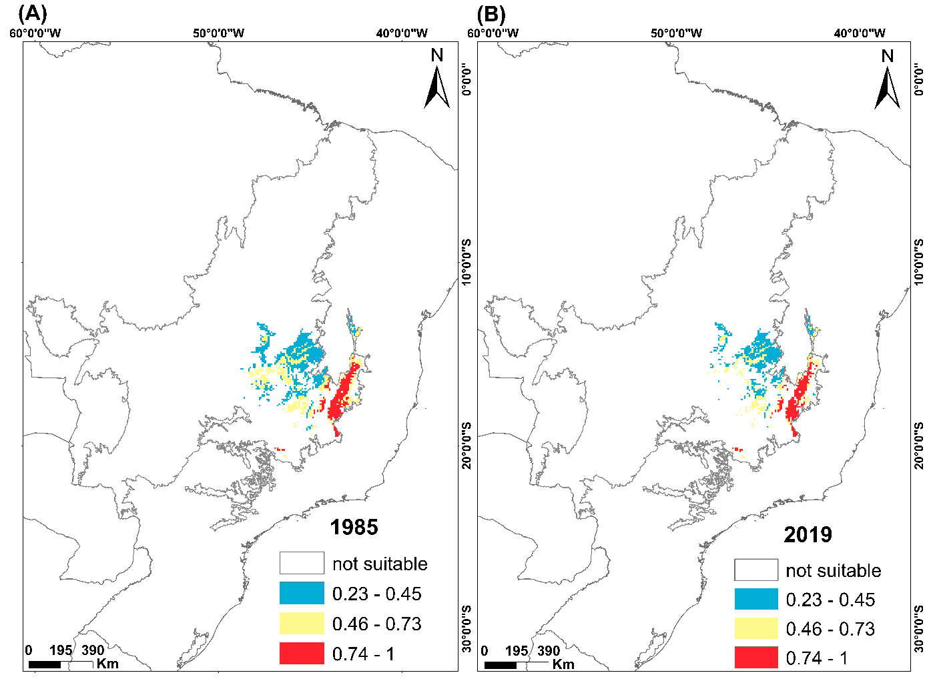
Figure S1.2. Areas of occupancy for 1985 (A) and 2019 (B) for the species Augastes scutatus. Blank areas are environments that had suitability values below the presence/absence threshold or were excluded by spatial restriction. To represent the classes, we divided them according to the natural breaks method, and it was as follows: the areas in blue (0.23-0.45) are considered areas with low environmental suitability values; in yellow (0.46-0.73) intermediate and in red (0.74–1) high environmental suitability.

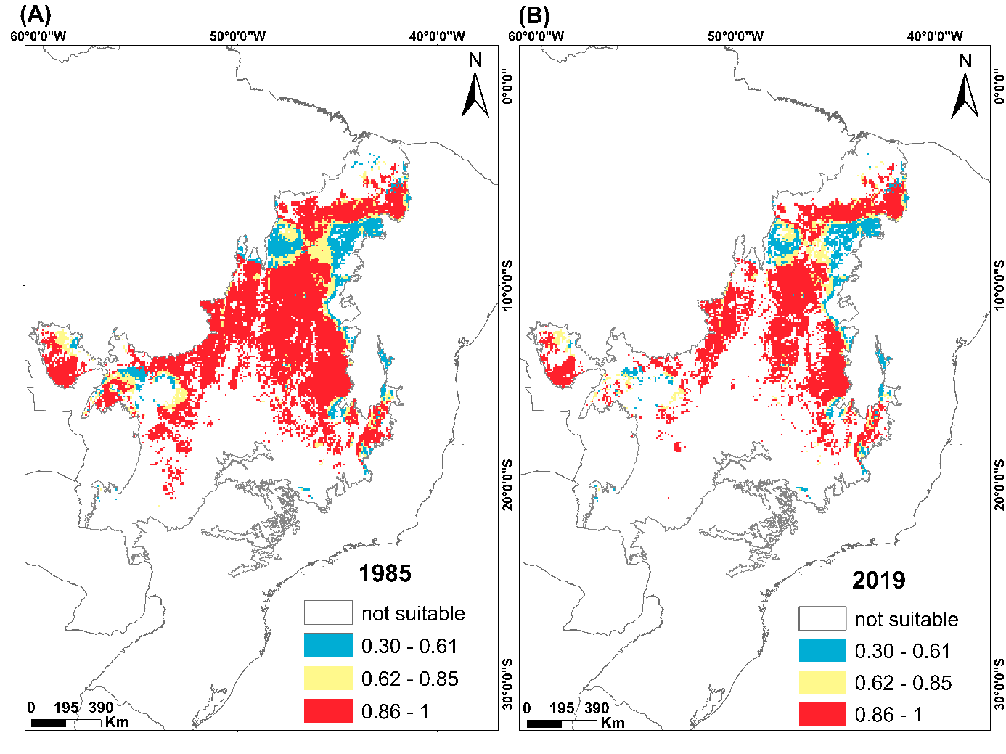
Figure S1.3. Areas of occupancy for 1985 (A) and 2019 (B) for the species Charitospiza eucosma. Blank areas are environments that had suitability values below the presence/absence threshold or were excluded by spatial restriction. To represent the classes, we divided them according to the natural breaks method, and it was as follows: the areas in blue (0.30-0.61) are considered areas with low environmental suitability values; in yellow (0.61-0.85) intermediate and in red (0.86–1) high environmental suitability.
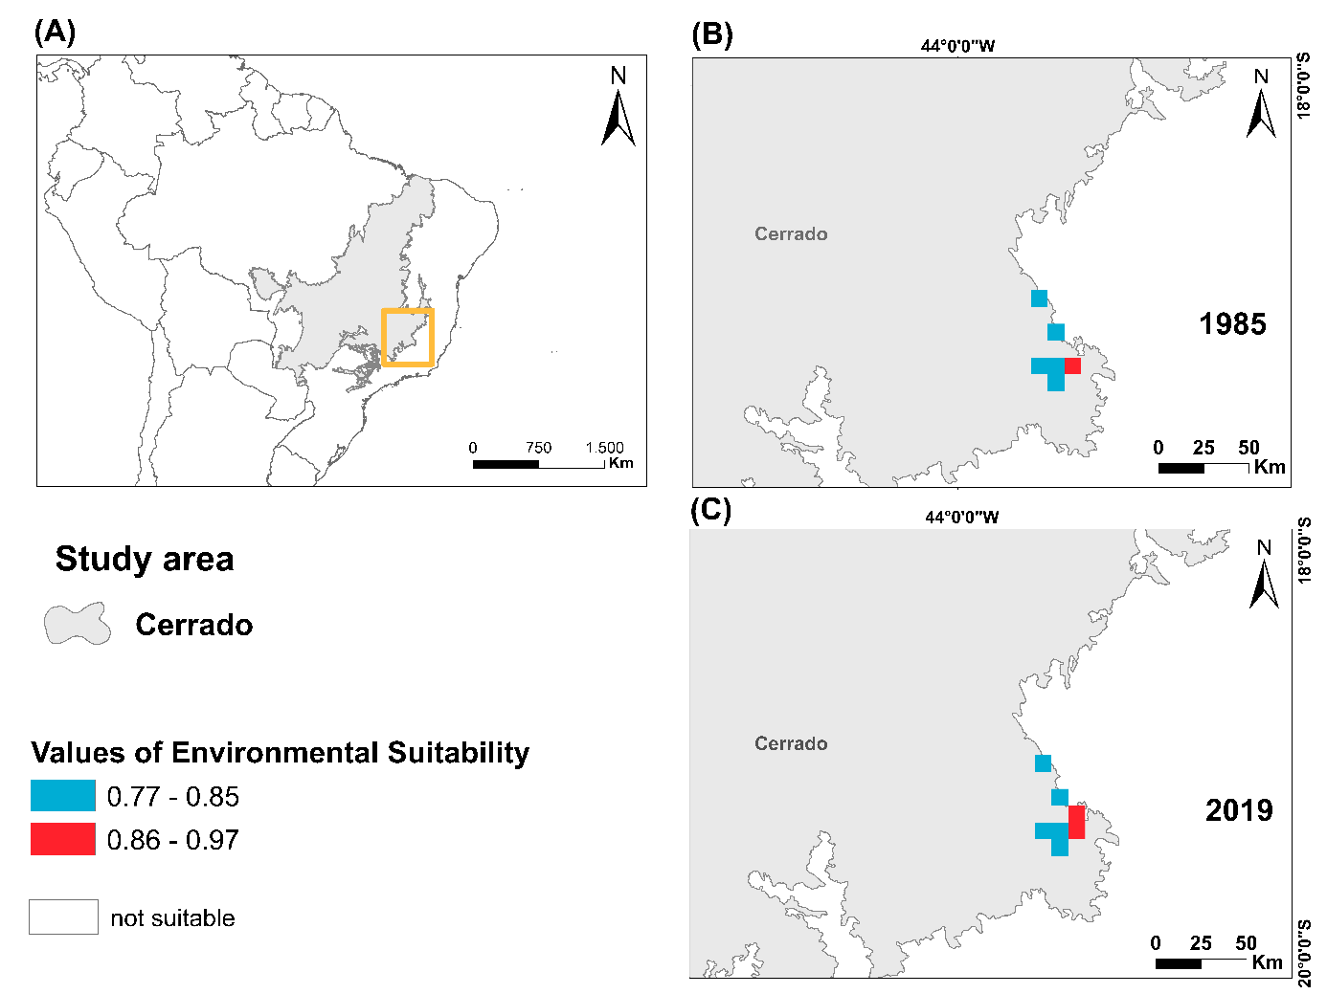
Figure S1.4. Areas of occupancy for 1985 (A) and 2019 (B) for the species Cinclodes espinacensis. Blank areas are environments that had suitability values below the presence/absence threshold or were excluded by spatial restriction. To represent the classes, we divided them according to the method of natural breaks, as follows: blue (0.77-0.85) and red (0.86-1).

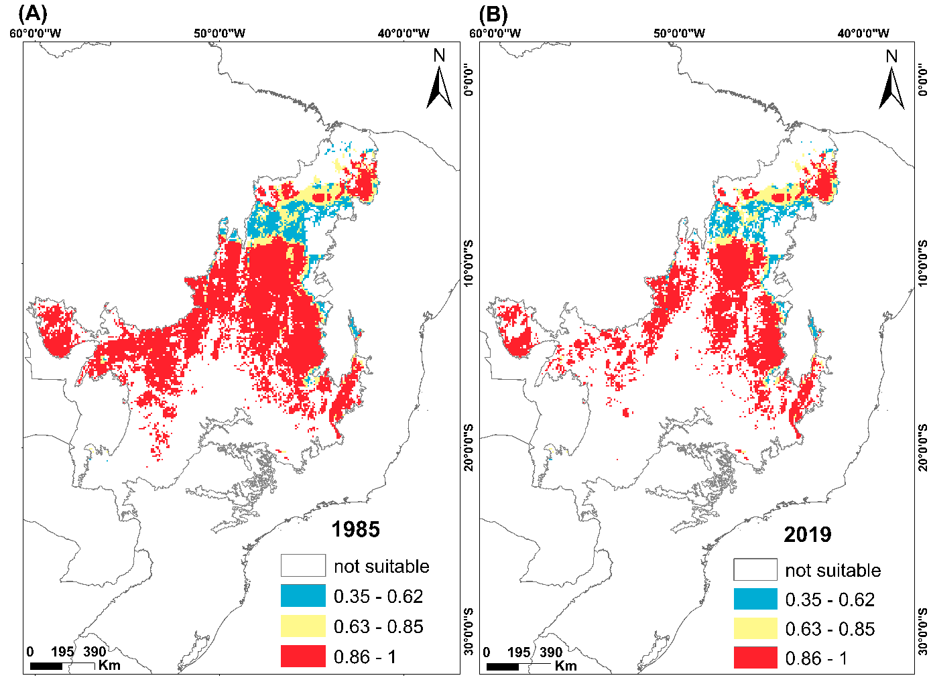
Figure S1.5. Areas of occupancy for 1985 (A) and 2019 (B) for the species Cyanocorax cristatellus. Blank areas are environments that had suitability values below the presence/absence threshold or were excluded by spatial restriction. To represent the classes, we divided them according to the natural breaks method, and it was as follows: the areas in blue (0.35-0.62) are considered areas with low environmental suitability values; in yellow (0.63-0.84) intermediate and in red (0.86–1) high environmental suitability.

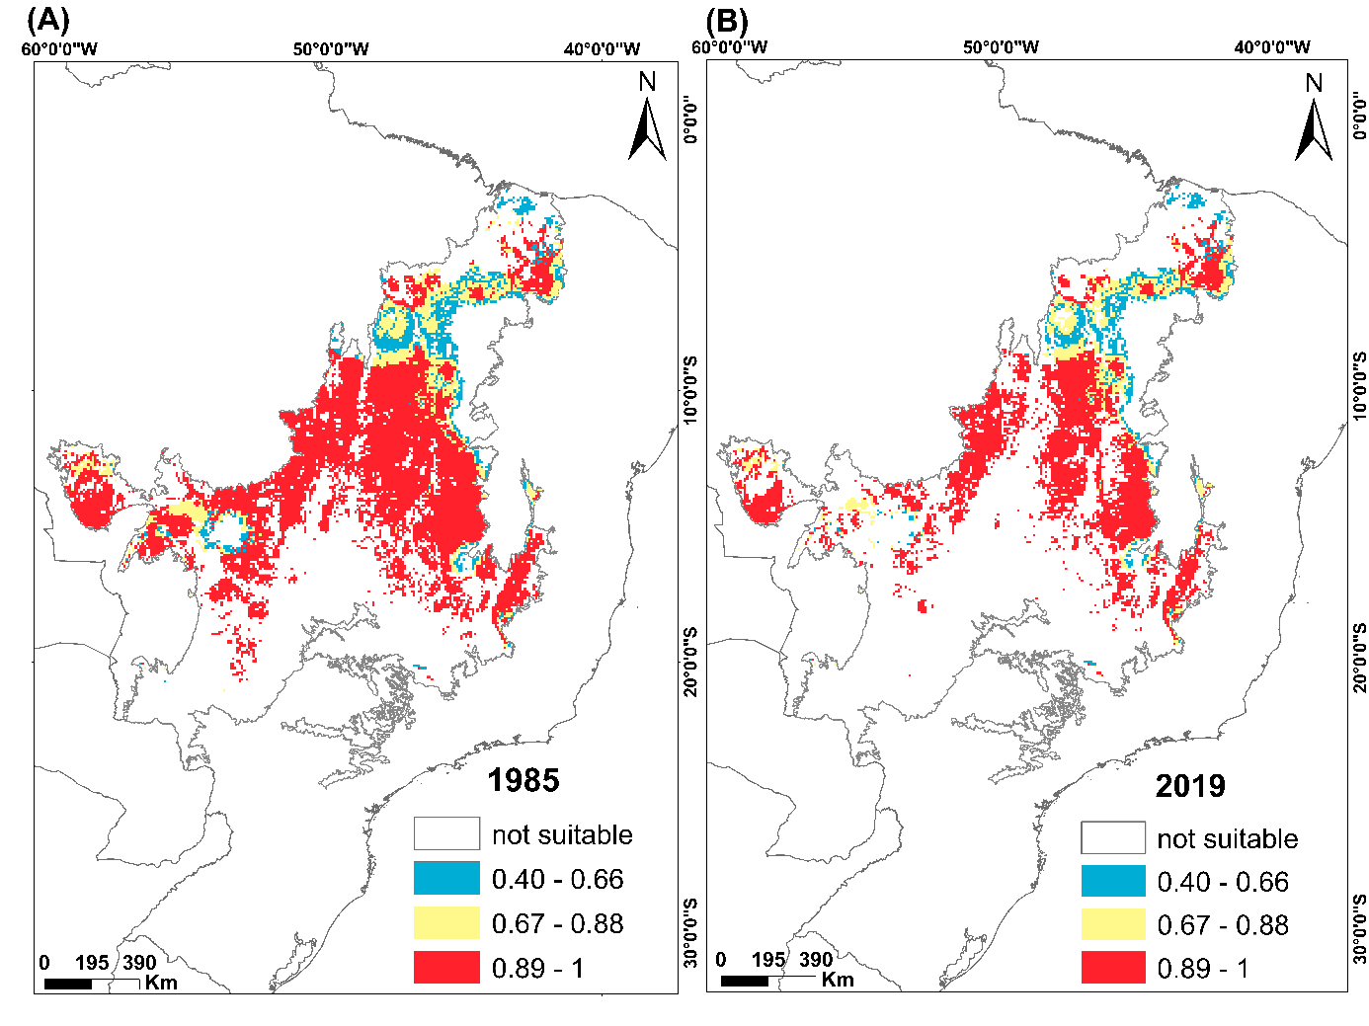
Figure S1.6. Areas of occupancy for 1985 (A) and 2019 (B) for the species Cypsnagra hirundinacea. Blank areas are environments that had suitability values below the presence/absence threshold or were excluded by spatial restriction. To represent the classes, we divided them according to the natural breaks method, and it was as follows: the areas in blue (0.40-0.66) are considered areas with low environmental suitability values; in yellow (0.67-0.88) intermediate and in red (0.89–1) high environmental suitability

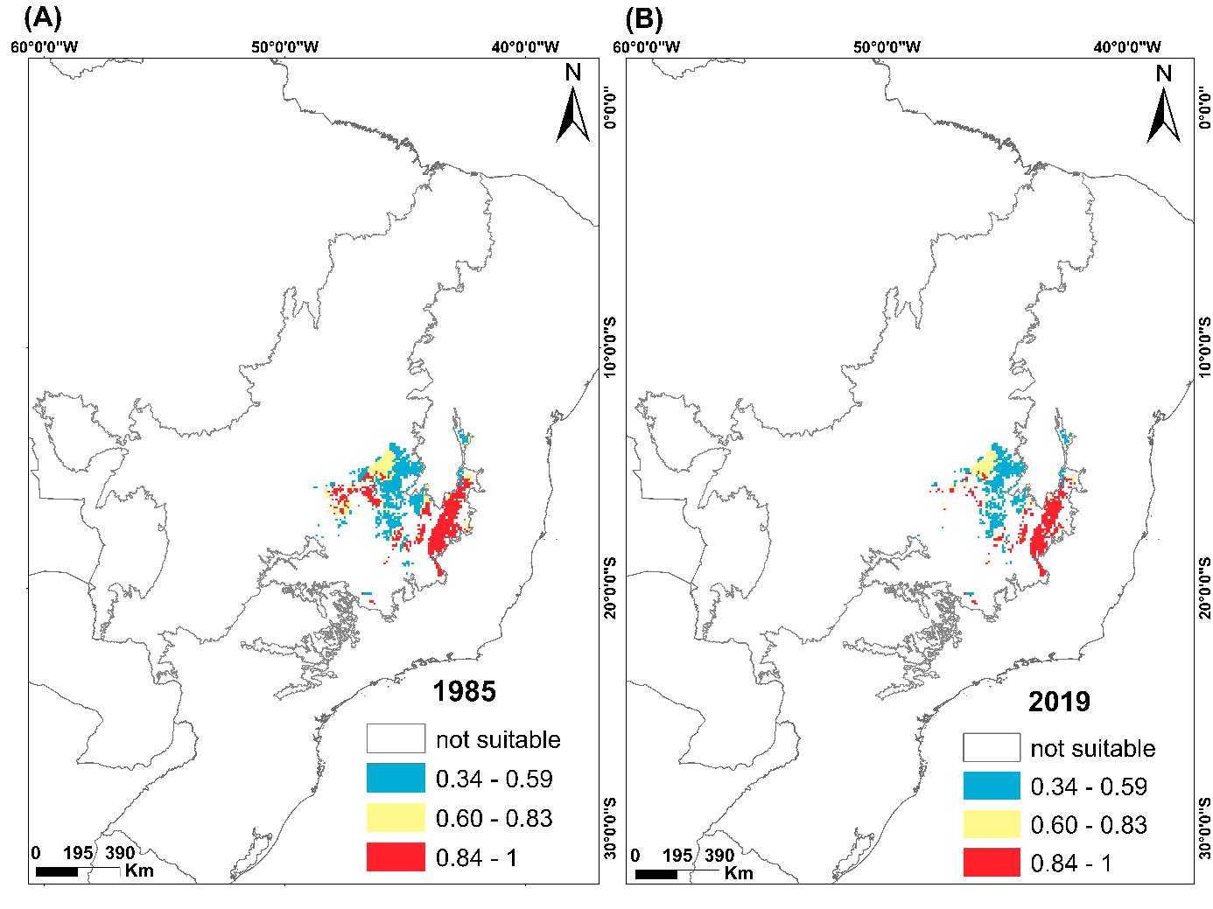
Figure S1.7. Areas of occupancy for 1985 (A) and 2019 (B) for the species Embernagra longicauda. Blank areas are environments that had suitability values below the presence/absence threshold or were excluded by spatial restriction. To represent the classes, we divided them according to the natural breaks method, and it was as follows: the areas in blue (0.34-0.59) are considered areas with low environmental suitability values; in yellow (0.60-0.83) intermediate and in red (0.84–1) high environmental suitability.
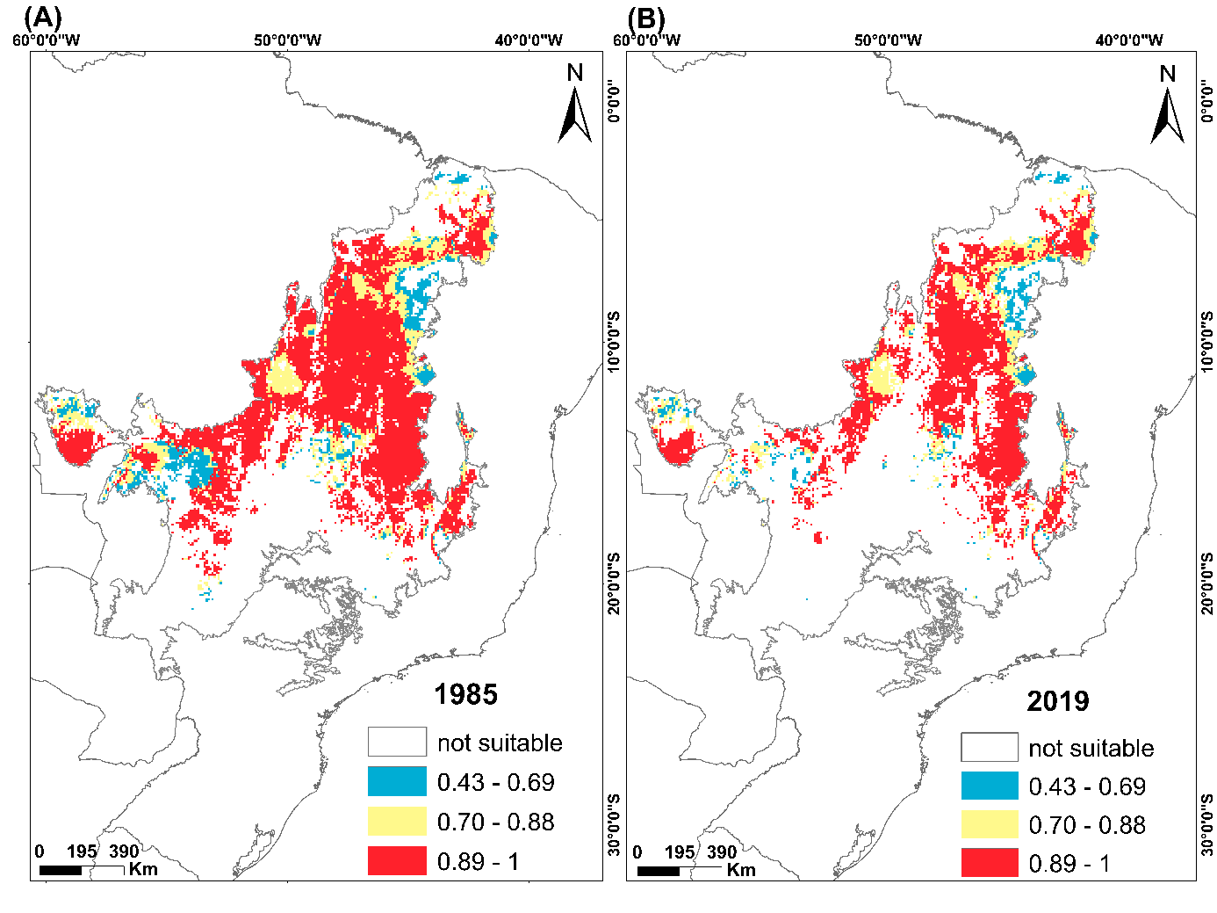
Figure S1.8. Areas of occupancy for 1985 (A) and 2019 (B) for the species Euscarthmus rufomarginatus. Blank areas are environments that had suitability values below the presence/absence threshold or were excluded by spatial restriction. To represent the classes, we divided them according to the natural breaks method, and it was as follows: the areas in blue (0.34-0.59) are considered areas with low environmental suitability values; in yellow (0.60-0.83) intermediate and in red (0.84–1) high environmental suitability.

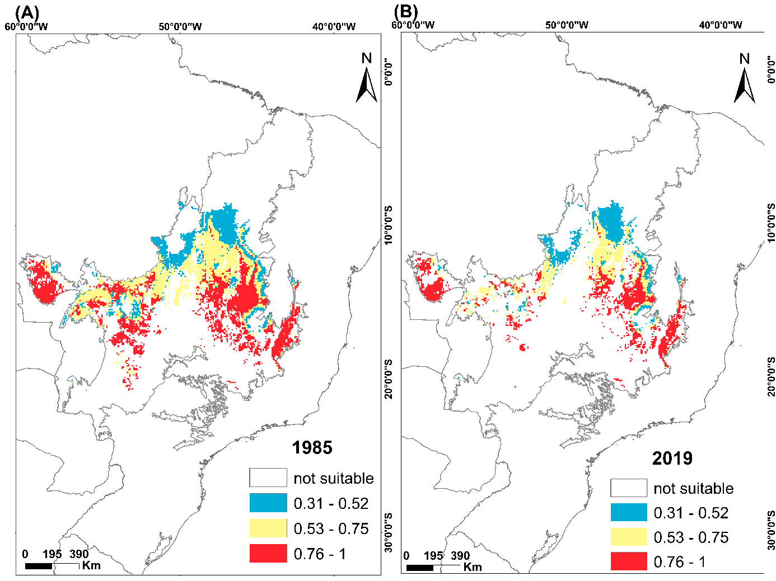
Figure S1.9. Areas of occupancy for 1985 (A) and 2019 (B) for the species Geositta poeciloptera. Blank areas are environments that had suitability values below the presence/absence threshold or were excluded by spatial restriction. To represent the classes, we divided them according to the natural breaks method, and it was as follows: the areas in blue (0.31-0.52) are considered areas with low environmental suitability values; in yellow (0.53-0.75) intermediate and in red (0.76–1) high environmental suitability.

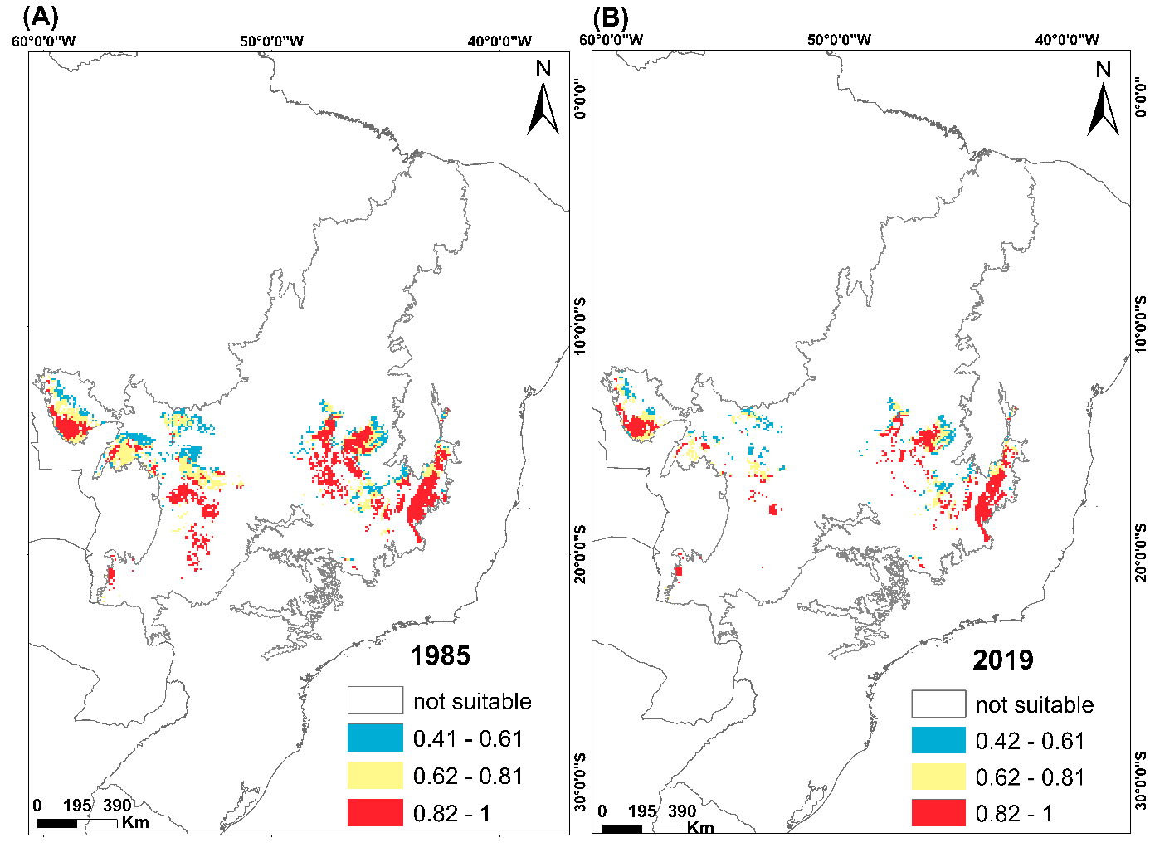
Figure S1.10. Areas of occupancy for 1985 (A) and 2019 (B) for the species Gubernetes yetapa. Blank areas are environments that had suitability values below the presence/absence threshold or were excluded by spatial restriction. To represent the classes, we divided them according to the natural breaks method, and it was as follows: the areas in blue (0.41-0.61) are considered areas with low environmental suitability values; in yellow (0.62-0.81) intermediate and in red (0.82–1) high environmental suitability.
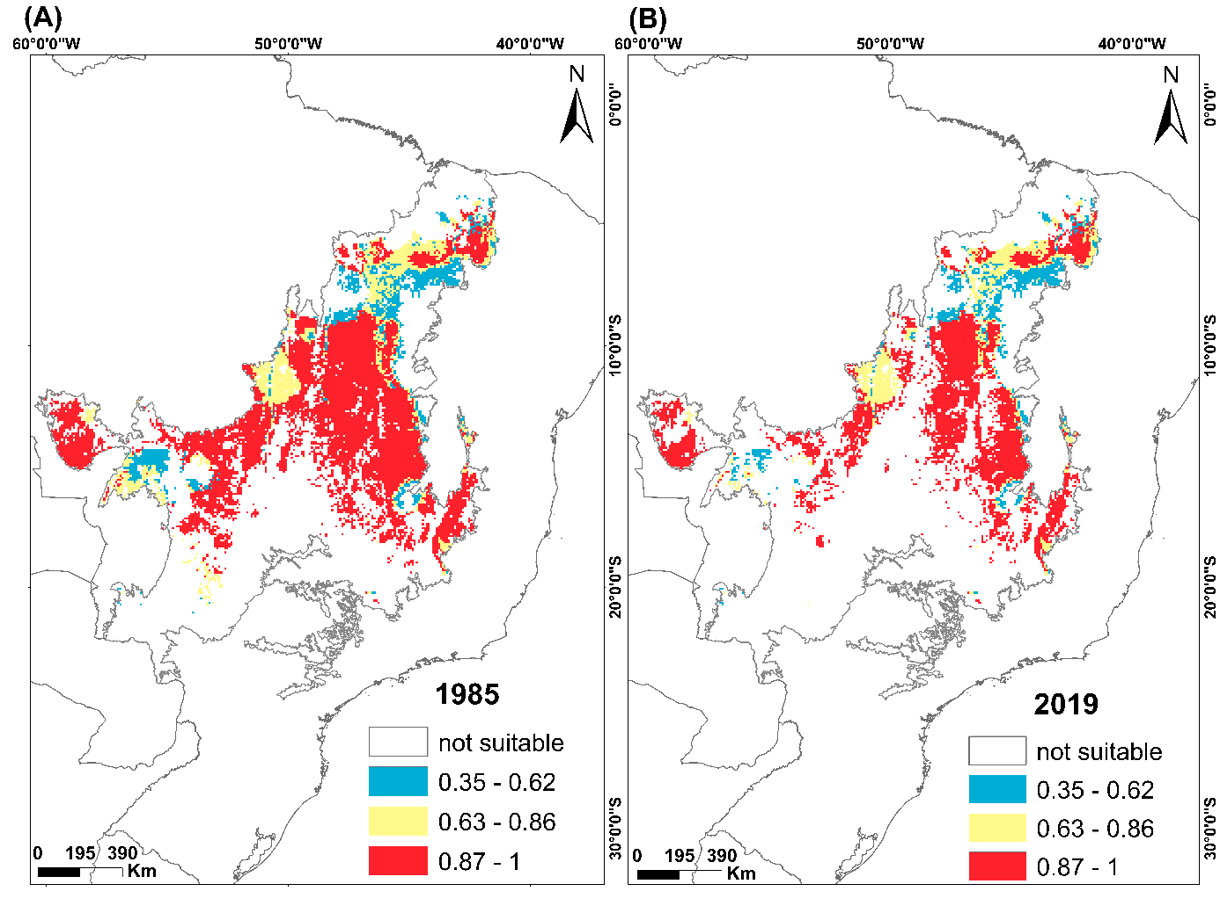
Figure S1.11. Areas of occupancy for 1985 (A) and 2019 (B) for the species Melanopareia torquata. Blank areas are environments that had suitability values below the presence/absence threshold or were excluded by spatial restriction. To represent the classes, we divided them according to the natural breaks method, and it was as follows: the areas in blue (0.35-0.62) are considered areas with low environmental suitability values; in yellow (0.63-0.86) intermediate and in red (0.87–1) high environmental suitability.
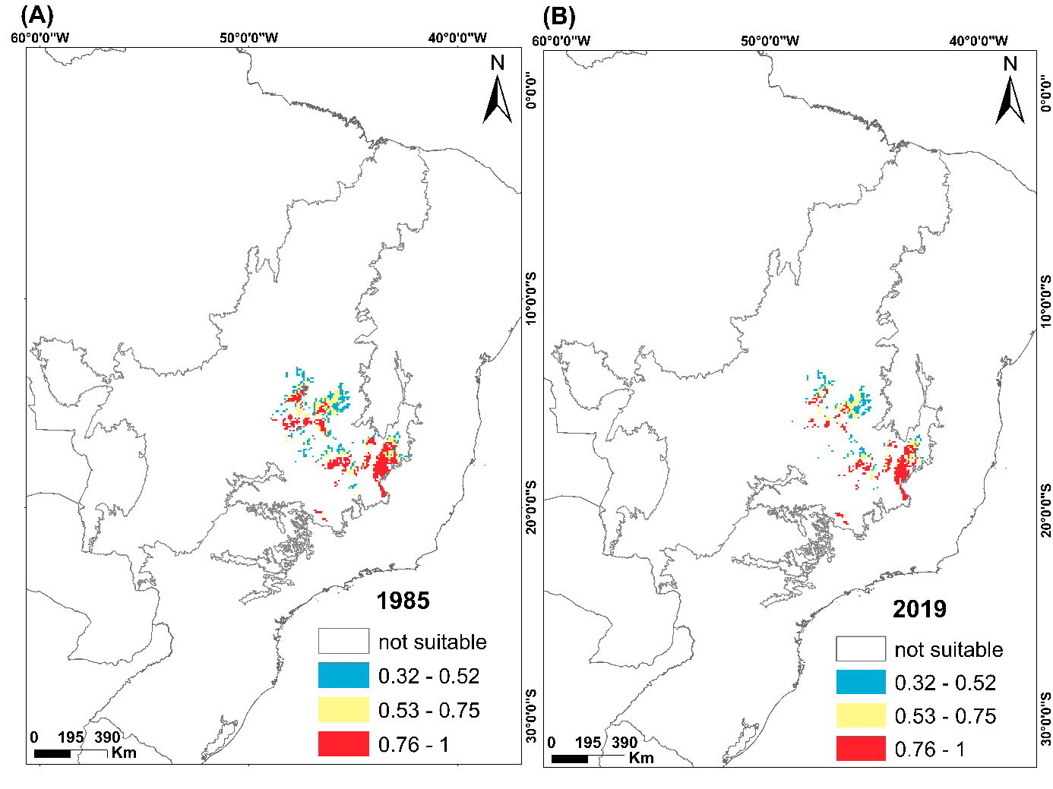
Figure S1.12. Areas of occupancy for 1985 (A) and 2019 (B) for the species Microspingus cinereus. Blank areas are environments that had suitability values below the presence/absence threshold or were excluded by spatial restriction. To represent the classes, we divided them according to the natural breaks method, and it was as follows: the areas in blue (0.32-0.52) are considered areas with low environmental suitability values; in yellow (0.53-0.75) intermediate and in red (0.76–1) high environmental suitability.
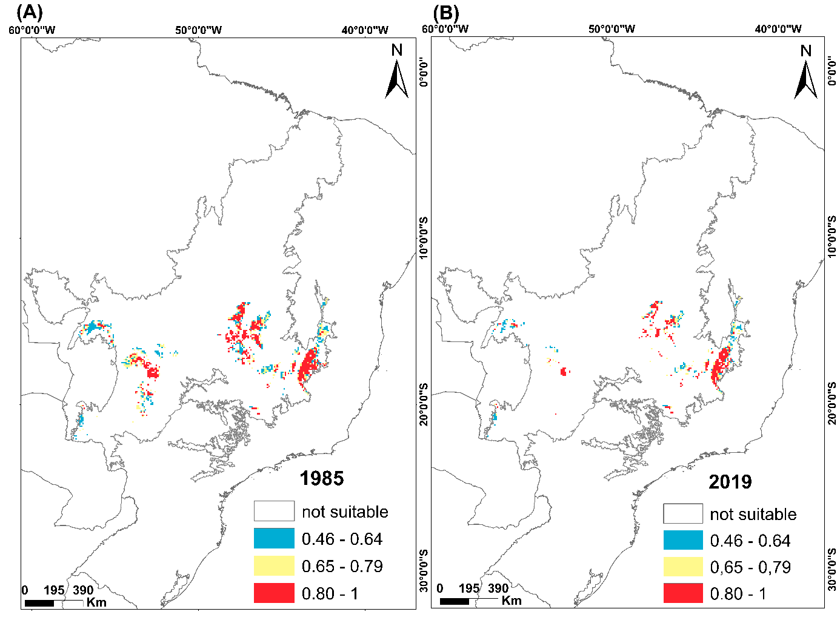
Figure S1.13. Areas of occupancy for 1985 (A) and 2019 (B) for the species Nothura minor. Blank areas are environments that had suitability values below the presence/absence threshold or were excluded by spatial restriction. To represent the classes, we divided them according to the natural breaks method, and it was as follows: the areas in blue (0.46-0.64) are considered areas with low environmental suitability values; in yellow (0.65-0.79) intermediate and in red (0.80–1) high environmental suitability.
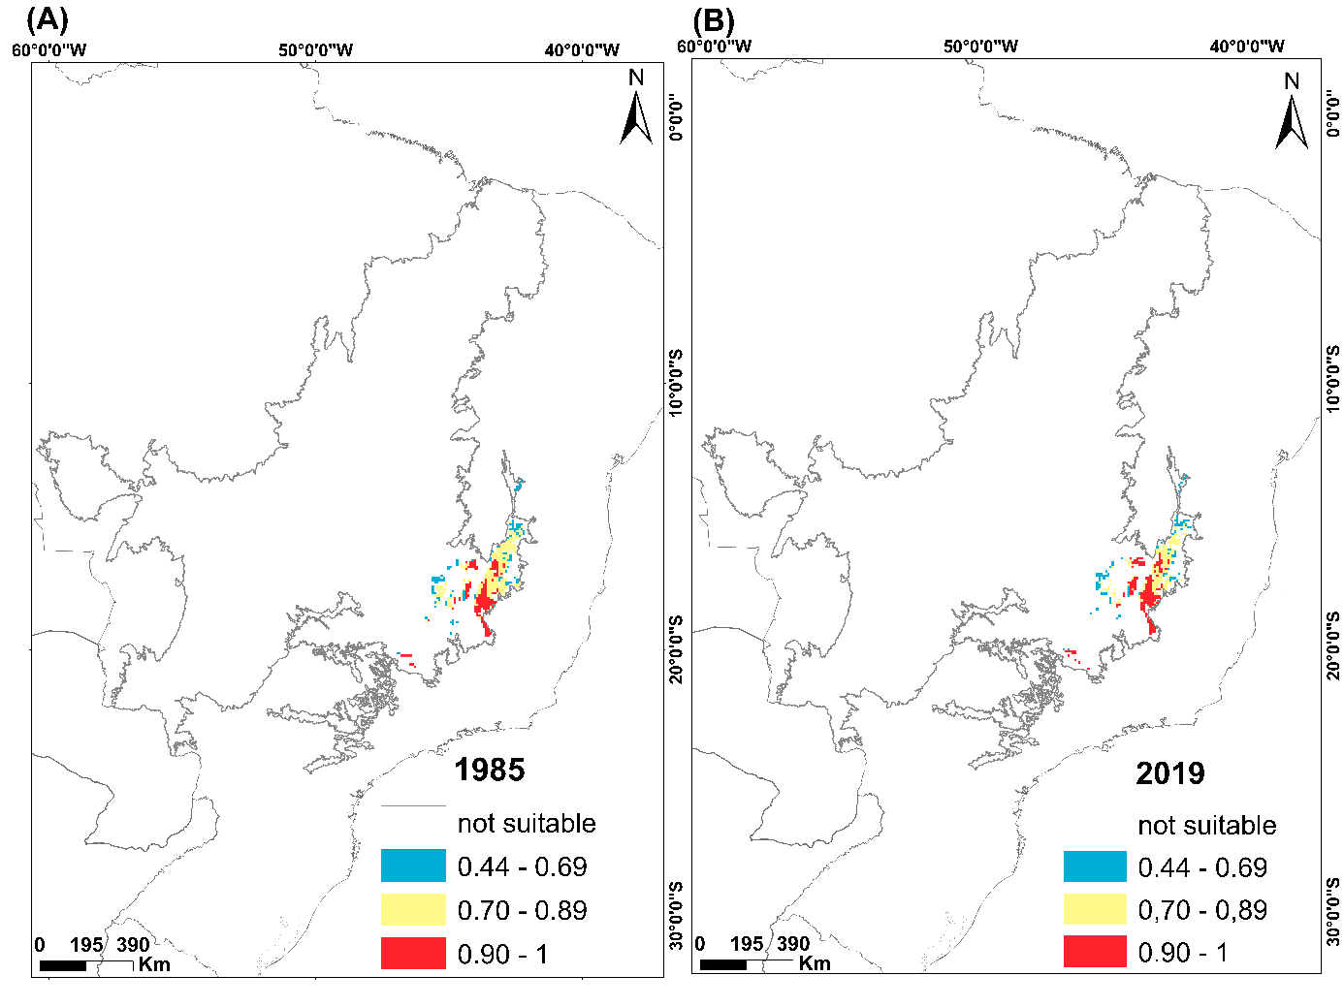
Figure S1.14. Areas of occupancy for 1985 (A) and 2019 (B) for the species Polystictus superciliaris. Blank areas are environments that had suitability values below the presence/absence threshold or were excluded by spatial restriction. To represent the classes, we divided them according to the natural breaks method, and it was as follows: the areas in blue (0.44-0.69) are considered areas with low environmental suitability values; in yellow (0.70-0.89) intermediate and in red (0.90–1) high environmental suitability.
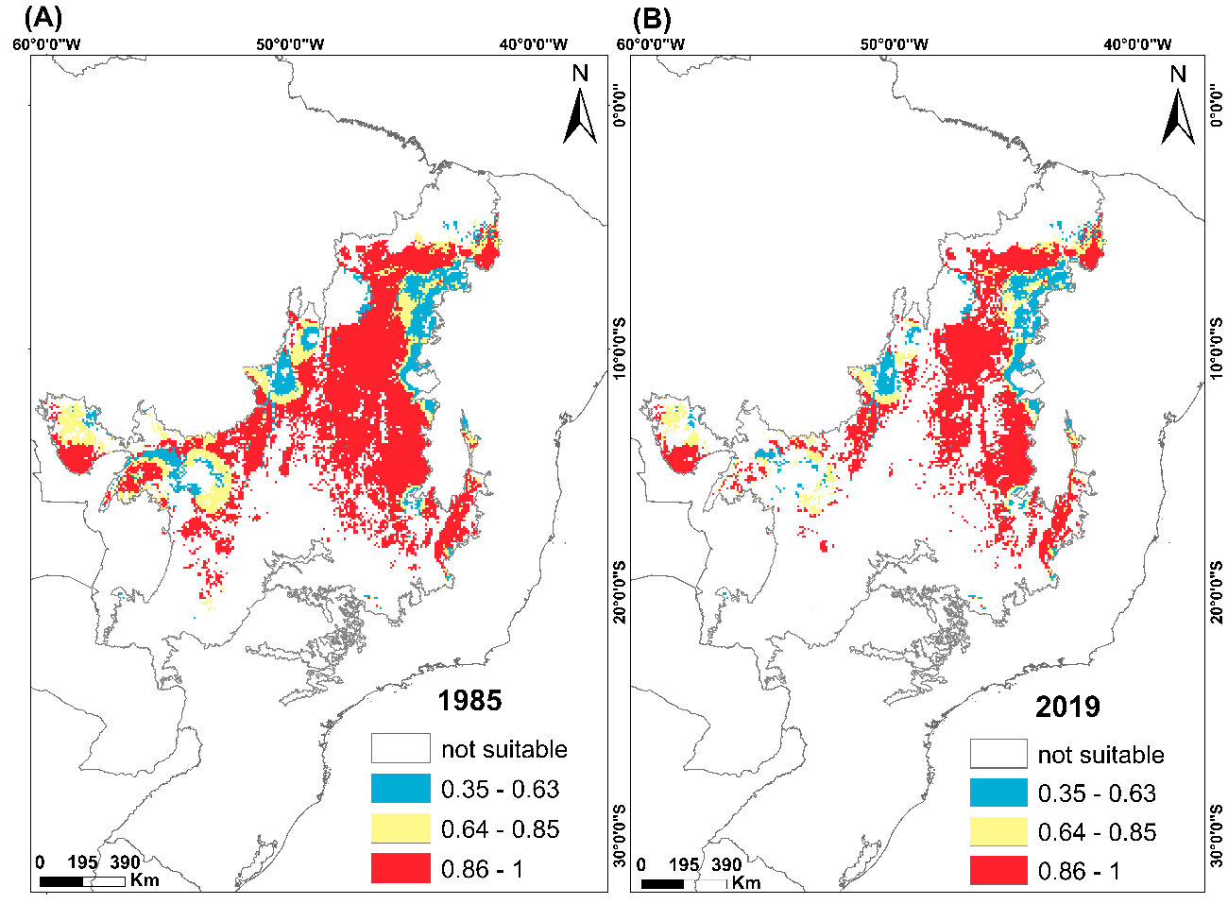
Figure S1.15. Areas of occupancy for 1985 (A) and 2019 (B) for the species Porphyrospiza caerulescens. Blank areas are environments that had suitability values below the presence/absence threshold or were excluded by spatial restriction. To represent the classes, we divided them according to the natural breaks method, and it was as follows: the areas in blue (0.35-0.63) are considered areas with low environmental suitability values; in yellow (0.64-0.85) intermediate and in red (0.86–1) high environmental suitability.
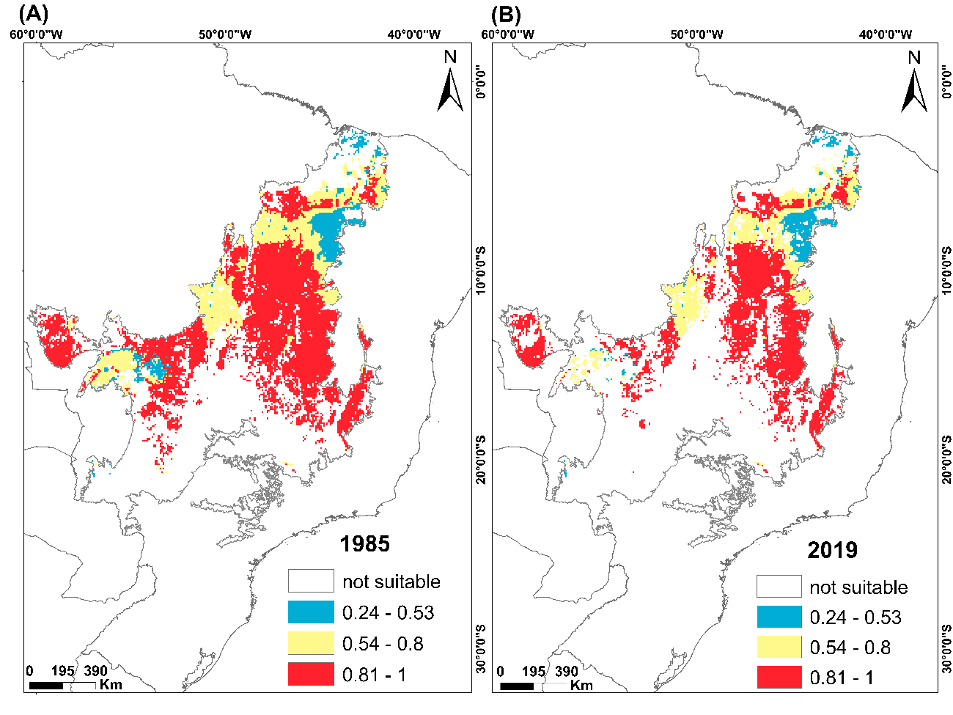
Figure S1.16. Areas of occupancy for 1985 (A) and 2019 (B) for the species Sicalis citrina species. Blank areas are environments that had suitability values below the presence/absence threshold or were excluded by spatial restriction. To represent the classes, we divided them according to the natural breaks method, and it was as follows: the areas in blue (0.24-0.53) are considered areas with low environmental suitability values; in yellow (0.54-0.8) intermediate and in red (0.81–1) high environmental suitability.

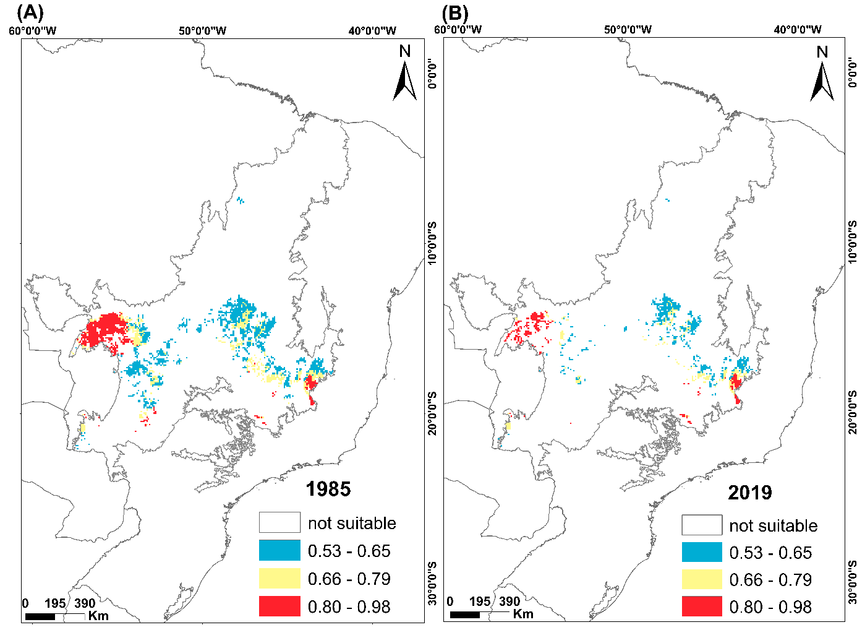
Figure S1.17. Areas of occupancy for 1985 (A) and 2019 (B) for the species Sporophila hypochroma. Blank areas are environments that had suitability values below the presence/absence threshold or were excluded by spatial restriction. To represent the classes, we divided them according to the natural breaks method, and it was as follows: the areas in blue (0,53-0,65) are considered areas with low environmental suitability values; in yellow (0.66-0.79) intermediate and in red (0.80 – 0,98) high environmental suitability.

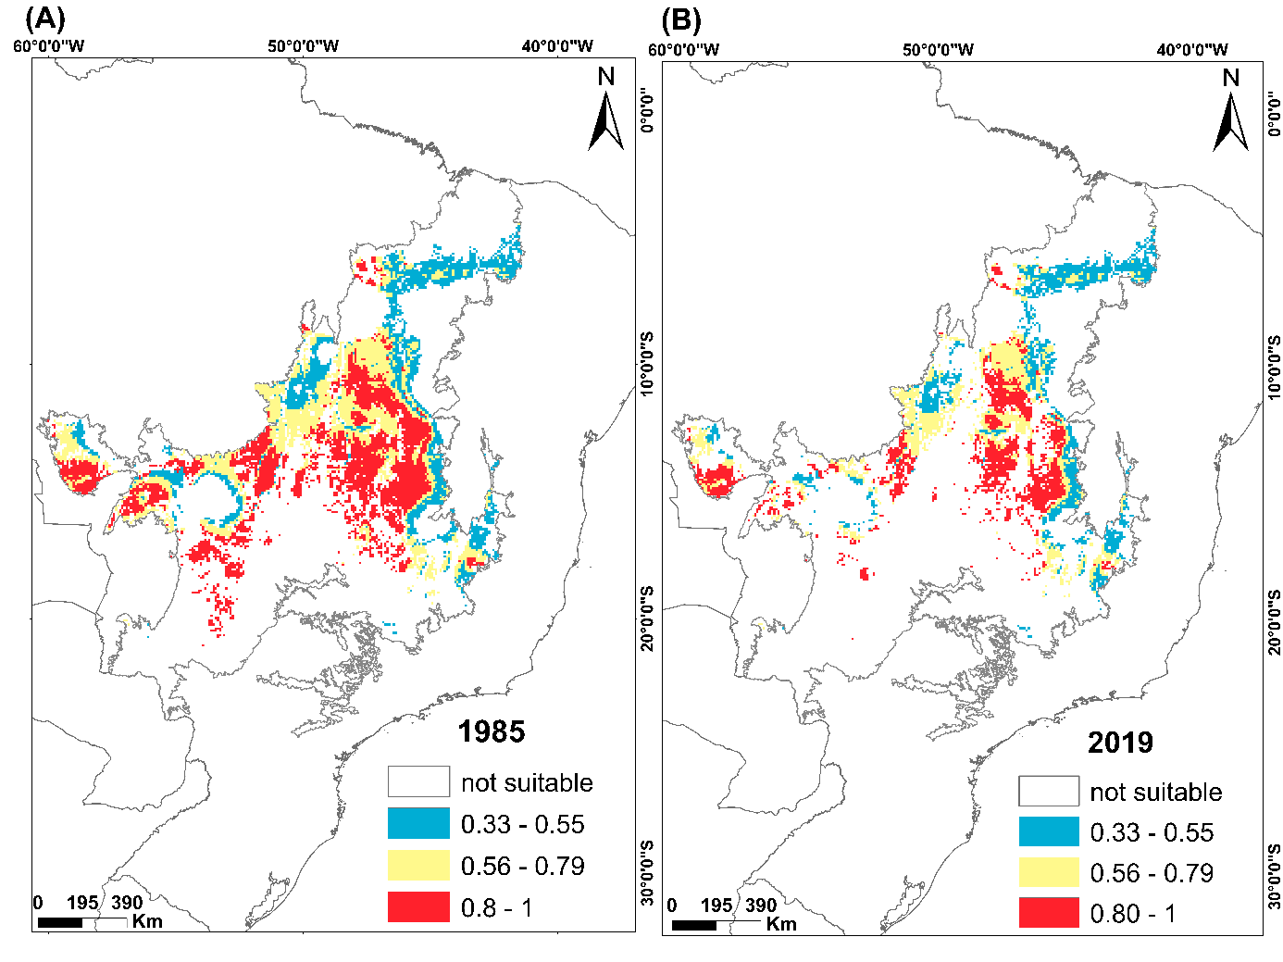
Figure S1.18. Areas of occupancy for 1985 (A) and 2019 (B) for the species Guyramemua affine. Blank areas are environments that had suitability values below the presence/absence threshold or were excluded by spatial restriction. To represent the classes, we divided them according to the natural breaks method, and it was as follows: the areas in blue (0.53-0.65) are considered areas with low environmental suitability values; in yellow (0.66-0.79) intermediate and in red (0.80–1) high environmental suitability.
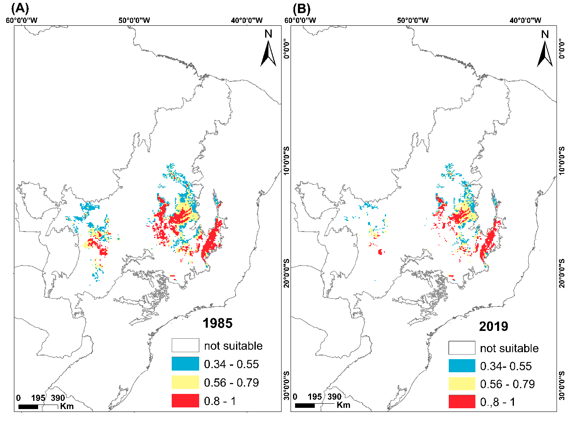
Figure S1.19. Areas of occupancy for 1985 (A) and 2019 (B) for the species Taoniscus nanus. Blank areas are environments that had suitability values below the presence/absence threshold or were excluded by spatial restriction. To represent the classes, we divided them according to the natural breaks method, and it was as follows: the areas in blue (0.34-0.55) are considered areas with low environmental suitability values; in yellow (0.56-0.79) intermediate and in red (0.8 –1) high environmental suitability.
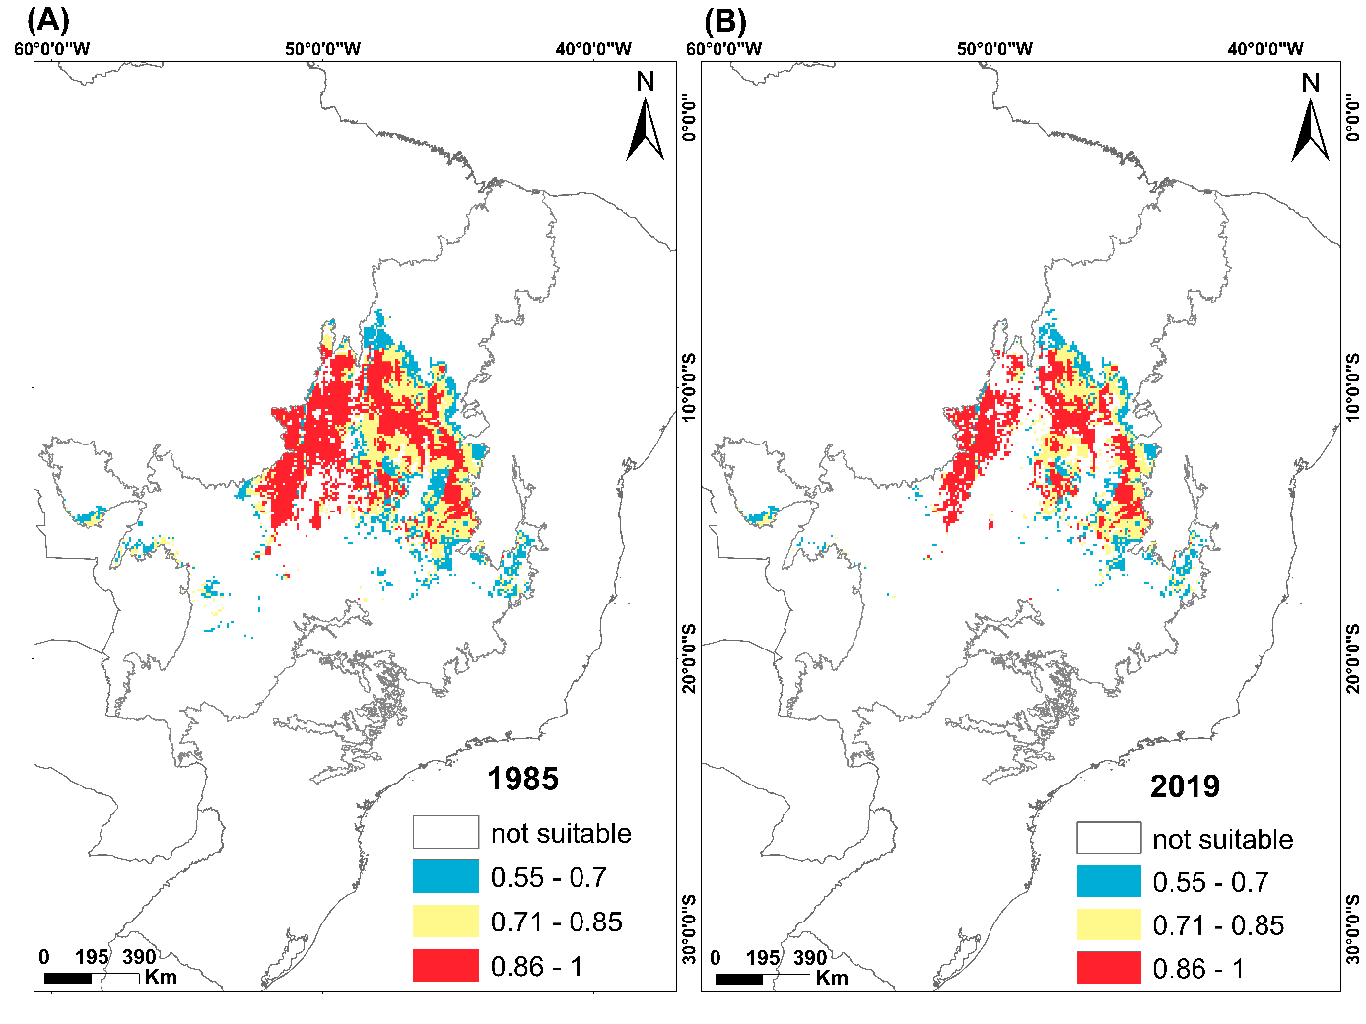
Figure S1.20. Areas of occupancy for 1985 (A) and 2019 (B) for the species Uropelia campestris. Blank areas are environments that had suitability values below the presence/absence threshold or were excluded by spatial restriction. To represent the classes, we divided them according to the natural breaks method, and it was as follows: the areas in blue (0.34-0.55) are considered areas with low environmental suitability values; in yellow (0.56-0.79) intermediate and in red (0.8–1) high environmental suitability.
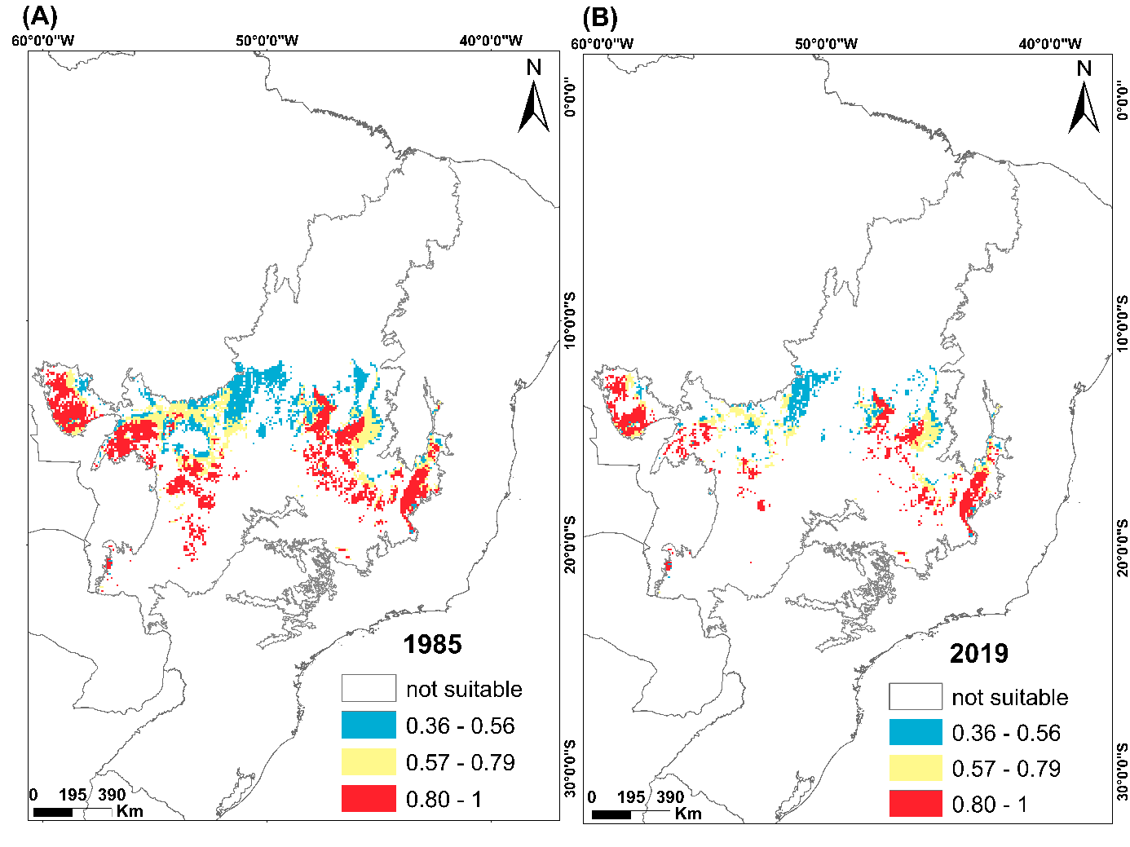
Figure S1.21. Areas of occupancy for 1985 (A) and 2019 (B) for the species Alectrurus tricolor. Blank areas are environments that had suitability values below the presence/absence threshold or were excluded by spatial restriction. To represent the classes, we divided them according to the natural breaks method, and it was as follows: the areas in blue (0.36-0.56) are considered areas with low environmental suitability values; in yellow (0.57-0.79) intermediate and in red (0.8 –1) high environmental suitability.
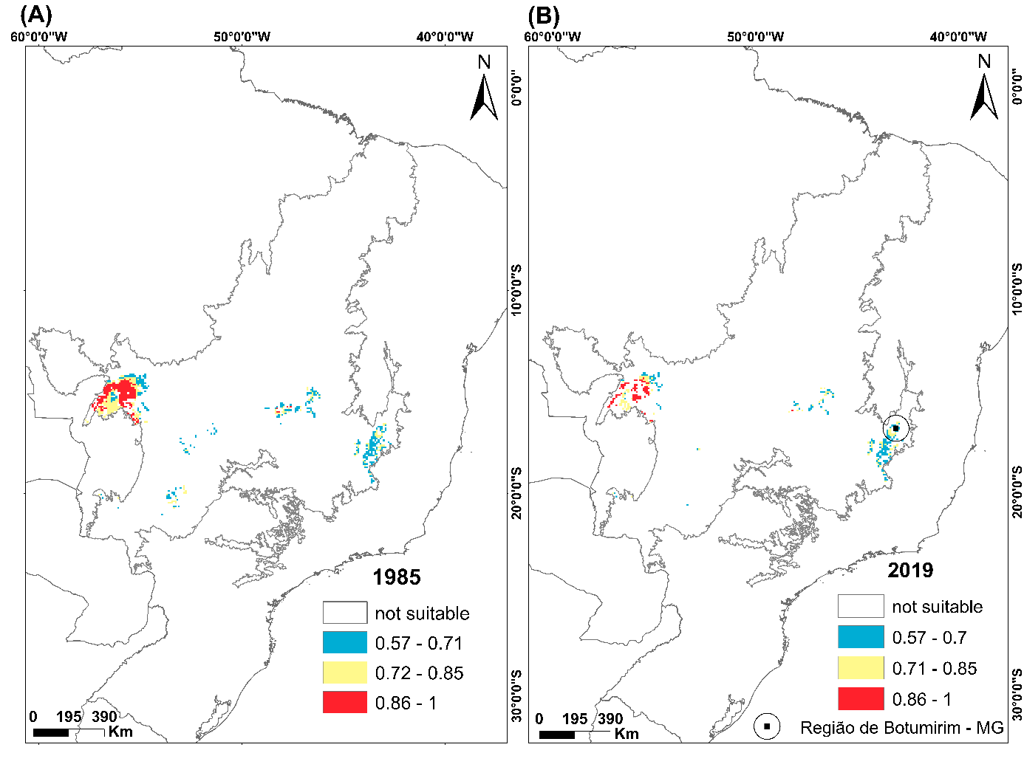
Figure S1.22. Areas of occupancy for 1985 (A) and 2019 (B) for the species Columbina cyanopis. Blank areas are environments that had suitability values below the presence/absence threshold or were excluded by spatial restriction. To represent the classes, we divided them according to the natural breaks method, and it was as follows: the areas in blue (0.57-0.71) are considered areas with low environmental suitability values; in yellow (0.72-0.85) intermediate and in red (0.86–1) high environmental suitability. Highlighting the region of Botumirim where the species is currently found.
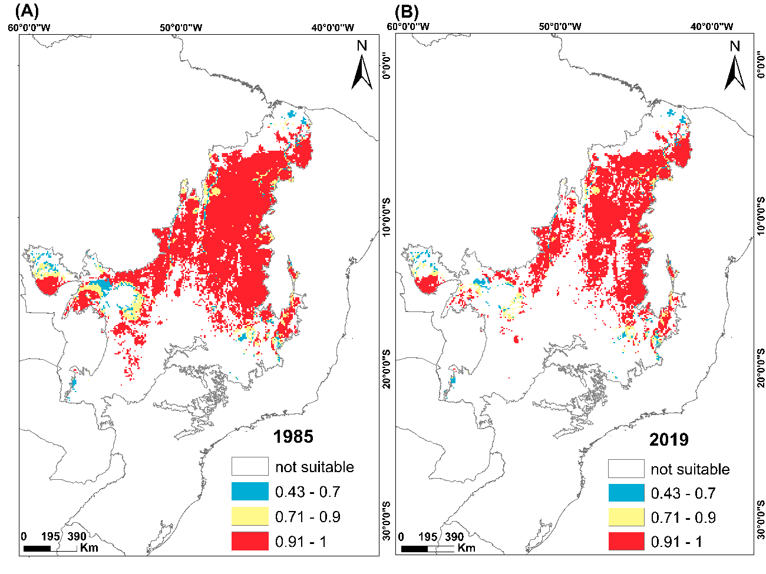

Figure S1.23. Areas of occupancy for 1985 (A) and 2019 (B) for the species Saltator atricollis. Blank areas are environments that had suitability values below the presence/absence threshold or were excluded by spatial restriction. To represent the classes, we divided them according to the natural breaks method, and it was as follows: the areas in blue (0.43-0.7) are considered areas with low environmental suitability values; in yellow (0.71-0.9) intermediate and in red (0.91–1) high environmental suitability.

Supplementary Material 2 - Occurrence dataset of species extracted from databases and the total number of unique records filtered

Table S1.2. Data Occurrence. These data are organized by the databases SpeciesLink, PortalBio and ICMBio and grouped by species.
Species | Number of records by Database |  |  | Total | Total unique records
 | PortalBio | SpeciesLink | ICMBio |  | Total unique records
Asthenes luizae Vielliard, 1990 | 75 | 0 | 0 | 75 | 24
Augastes scutatus (Temminck, 1824) | 85 | 5 | 0 | 90 | 54
Charitospiza eucosma Oberholser, 1905 | 103 | 5 | 0 | 108 | 89
Cinclodes espinhacensis Freitas, Chaves, Costa, Santos & Rodrigues, 2012 | 10 | 0 | 1 | 11 | 6
Columbina cyanopis (Pelzeln, 1870) | 12 | 0 | 5 | 17 | 13
Microspingus cinereus Bonaparte, 1850 | 416 | 1 | 0 | 417 | 54
Nothura minor (Spix, 1825) | 57 | 2 | 31 | 90 | 63
Porphyrospiza caerulescens (Wied, 1830) | 106 | 0 | 1 | 107 | 73
Sporophila hypochroma Todd, 1915 | 10 | 0 | 0 | 10 | 8
Guyramemua affine Zimmer, Whittaker & Oren, 2001 | 454 | 8 | 0 | 462 | 68
Taoniscus nanus (Temminck, 1815) | 46 | 3 | 32 | 81 | 53
Alectrurus tricolor (Vieillot, 1816) | 94 | 7 | 94 | 195 | 102
Cypsnagra hirundinacea (Lesson, 1831) | 177 | 6 | 0 | 183 | 122
Embernagra longicauda Strickland, 1844 | 125 | 5 | 0 | 130 | 92
Euscarthmus rufomarginatus (Pelzeln, 1868) | 56 | 5 | 0 | 61 | 42
Geositta poeciloptera (Wied, 1830) | 41 | 3 | 50 | 94 | 74
Polystictus superciliaris (Wied, 1831) | 92 | 3 | 0 | 95 | 68
Saltatricula atricollis (Vieillot, 1817) | 232 | 8 | 0 | 240 | 167
Sicalis citrina Pelzeln, 1870 | 90 | 6 | 0 | 96 | 66
Uropelia campestris (Spix, 1825) | 68 | 3 | 0 | 71 | 53
Melanopareia torquata (Wied, 1831) | 171 | 8 | 0 | 179 | 120
Cyanocorax cristatellus (Temminck, 1823) | 299 | 14 | 0 | 313 | 180
Gubernetes yetapa (Vieillot, 1818) | 85 | 16 | 0 | 101 | 84

Supplementary Material 3 – Climatic and topographic variables that were used to estimate the geographic distribution of species

Table S1.3. Set of environmental variables. There are 19 climatic variables extracted from WorldClim and two topographical variables extracted from GTOPPO30.

Abbreviation | Environmental Variables
BIO1 | Average annual temperature
BIO2 | Average diurnal variation
BIO3 | Isothermally
BIO4 | Seasonal temperature
BIO5 | Maximum temperature of the hottest month
BIO6 | Minimum temperature of the coldest month
BIO7 | Annual temperature interval
BIO8 | Temperature of the wettest quarter
BIO9 | Temperature of the driest quarter
BIO10 | Warmest quarter temperature
BIO11 | Coldest quarter temperature
BIO12 | Annual precipitation
BIO13 | Rainy month precipitation
BIO14 | Dry month precipitation
BIO15 | Seasonality of precipitation
BIO16 | Precipitation in the rainy quarter
BIO17 | Precipitation in dry quarter
BIO 18 | Precipitation in the warm quarter
BIO19 | Precipitation in the cold quarter
FLOW | Watercourse
SLOPE | Slope

Supplementary Material 4 – Environmental variables transformed after principal component analysis (PCA)

Table S1.4. Values of the eight principal components (PCs) generated from the 19 climatic variables. It also contains the proportion of individual and cumulative explanations and the explanation of eigenvalues.

Environmental Variables | Principal Component (PCs)
Environmental Variables | PC1 | PC2 | PC3 | PC4 | PC5 | PC6 | PC7 | PC8
Average annual temperature | 0,269 | 0,256 | 0,096 | -0,04 | 0,004 | 0,041 | -0,081 | 0,009
Average diurnal variation | -0,204 | 0,206 | 0,058 | 0,428 | -0,098 | -0,189 | 0,085 | 0,477
Isothermally | 0,242 | -0,004 | -0,335 | 0,079 | 0,028 | 0,029 | -0,105 | 0,492
Seasonal temperature | -0,245 | 0,033 | 0,394 | 0,034 | 0,007 | 0,012 | 0,171 | -0,096
Maximum temperature of the hottest month | 0,136 | 0,37 | 0,341 | 0,063 | 0,005 | 0,044 | 0,087 | 0,035
Minimum temperature of the coldest month | 0,301 | 0,12 | -0,063 | -0,138 | 0,04 | 0,097 | -0,095 | -0,018
Annual temperature interval | -0,254 | 0,119 | 0,312 | 0,205 | -0,042 | -0,082 | 0,171 | 0,045
Temperature of the wettest quarter | 0,206 | 0,306 | 0,183 | 0,037 | -0,056 | -0,075 | -0,18 | 0,055
Temperature of the driest quarter | 0,269 | 0,178 | 0,017 | -0,094 | 0,058 | 0,15 | 0,072 | 0,036
Warmest quarter temperature | 0,189 | 0,318 | 0,327 | -0,037 | 0,016 | 0,069 | 0,015 | -0,037
Coldest quarter temperature | 0,292 | 0,183 | -0,065 | -0,047 | 0,004 | 0,034 | -0,113 | 0,042
Annual precipitation | 0,275 | -0,2 | 0,076 | 0,165 | -0,055 | -0,099 | 0,159 | -0,096
Rainy month precipitation | 0,279 | -0,077 | -0,066 | 0,218 | -0,091 | -0,171 | 0,292 | -0,264
Dry month precipitation | 0,151 | -0,355 | 0,285 | 0,035 | 0,006 | 0,036 | -0,132 | 0,353
Seasonality of precipitation | -0,039 | 0,293 | -0,387 | 0,248 | -0,128 | -0,243 | 0,171 | 0,166
Precipitation in the rainy quarter | 0,28 | -0,086 | -0,062 | 0,22 | -0,086 | -0,165 | 0,284 | -0,254
Precipitation in dry quarter | 0,162 | -0,353 | 0,283 | 0,038 | 0,004 | 0,035 | -0,102 | 0,318
Precipitation in the warm quarter | 0,174 | -0,185 | 0,148 | 0,294 | -0,269 | -0,407 | -0,44 | -0,191
Precipitation in the cold quarter | 0,211 | -0,204 | 0,063 | 0,011 | 0,126 | 0,178 | 0,6 | 0,194
Watercourse | 0,024 | 0,012 | 0,011 | 0,166 | 0,92 | -0,336 | -0,092 | -0,057
Slope | -0,024 | -0,011 | -0,082 | 0,654 | 0,101 | 0,687 | -0,199 | -0,191
Eigenvalue | 9,863 | 3,861 | 2,281 | 1,209 | 1,011 | 0,856 | 0,74 | 0,45
Explanation (%) | 46,966 | 18,385 | 10,862 | 5,756 | 4,816 | 4,078 | 3,523 | 2,142
Cumulative proportion | 46,966 | 65,351 | 76,213 | 81,969 | 86,785 | 90,862 | 94,386 | 96,528
Supplementary Material 4 - Ensemble results

Here, we use the Sorensen similarity index as the evaluation metric and threshold for binary maps (THR). The ensemble maps were created from the average of the best algorithms, i.e., those with SORENSEN above average (SUP method). The presence-absence limit (THR_VALUE) was generated from the maximum limit of the Sorensen index. The sensitivity or true positive rate (TPR) and the specificity or true negative rate (TNR), extracted from the confusion matrix, indicate the accuracy of the model.

Table S1.5. Evaluation of Species models. Here are indicated the ensemble methods, the value of the presence-absence threshold (THR_VALUE), the general evaluation index (SORENSE), and the accuracy components of the models (True Positive Rate - TPR and True Negative Rate -TNR).
Species | Ensemble methods | THR | THR_VALUE | TPR | TNR
Alectrurus tricolor | SUP | SORENSEN | 0.357 | 0.980 | 0.971
Asthenes luizae | SUP | SORENSEN | 0.332 | 1.000 | 0.958
Augastes scutatus | SUP | SORENSEN | 0.231 | 1.000 | 0.981
Charitospiza eucosma | SUP | SORENSEN | 0.304 | 0.989 | 0.944
Cinclodes espinhacensis | SUP | SORENSEN | 0.730 | 1.000 | 1.000
Columbina cyanopis | SUP | SORENSEN | 0.574 | 0.933 | 0.933
Cyanocorax cristatellus | SUP | SORENSEN | 0.347 | 0.983 | 0.994
Cypsnagra hirundinacea | SUP | SORENSEN | 0.402 | 0.967 | 0.992
Embernagra longicauda | SUP | SORENSEN | 0.338 | 0.989 | 0.978
Euscarthmus rufomarginatus | SUP | SORENSEN | 0.433 | 0.976 | 0.952
Geositta poeciloptera | SUP | SORENSEN | 0.306 | 0.986 | 0.973
Gubernetes yetapa | SUP | SORENSEN | 0.411 | 0.964 | 0.964
Guyramemua affine | SUP | SORENSEN | 0.335 | 0.956 | 0.956
Melanopareia torquata | SUP | SORENSEN | 0.346 | 0.992 | 0.975
Microspingus cinereus | SUP | SORENSEN | 0.319 | 1.000 | 0.907
Nothura minor | SUP | SORENSEN | 0.460 | 0.968 | 0.952
Polystictus superciliaris | SUP | SORENSEN | 0.432 | 0.985 | 0.985
Porphyrospiza caerulescens | SUP | SORENSEN | 0.352 | 0.945 | 0.932
Saltatricula atricollis | SUP | SORENSEN | 0.427 | 0.976 | 1.000
Sicalis citrina | SUP | SORENSEN | 0.239 | 0.985 | 0.894
Sporophila hypochroma | SUP | SORENSEN | 0.528 | 1 | 0.875
Taoniscus nanus | SUP | SORENSEN | 0.340 | 1.000 | 0.962
Uropelia campestris | SUP | SORENSEN | 0.553 | 0.906 | 0.981

Supplementary Material 5 - Ensemble results

Table S1.6. contains in detail the raw results for each component analyzed in this work, which are the EOO, the AOO of 1985 and 2019, and the AOO of 2019 inserted in protected areas.

Table S1.6. Environmentally suitable area data for each species, without analyzing each component of its distribution, are the extent of occurrence (EOO), area of occupancy (AOO), and area of occupancy within protected areas (AOOPA).

Species | EOO  (km²) | AOO 1985 (km²) | AOO 2019 (km²) | AOOPA 2019 (km²)
Alectrurus tricolor | 1.221.936 | 399.011 | 207.354 | 63.914
Asthenes luizae | 124.561 | 27.714 | 23.954 | 4.051
Augastes scutatus | 360.622 | 134.585 | 97.627 | 19.841
Charitospiza eucosma | 1.838.080 | 940.252 | 634.005 | 139.185
Cinclodes espinhacensis | 1.453 | 485 | 565 | 565
Columbina cyanopis | 212.420 | 64.839 | 31.615 | 7.903
Cyanocorax cristatellus | 1.842.553 | 931.230 | 613.217 | 140.578
Cypsnagra hirundinacea | 1.809.721 | 899.137 | 585.718 | 140.561
Embernagra longicauda | 248.316 | 117.637 | 84.796 | 14.875
Euscarthmus rufomarginatus | 1.794.793 | 965.936 | 635.815 | 142.365
Geositta poeciloptera | 1.442.714 | 639.510 | 374.527 | 98.017
Gubernetes yetapa | 910.284 | 245.825 | 132.161 | 35.064
Guyramemua affine | 1.433.659 | 733.057 | 454.968 | 118.138
Melanopareia torquata | 1.743.749 | 874.228 | 572.520 | 132.844
Microspingus cinereus | 284.751 | 86.403 | 58.141 | 10.751
Nothura minor | 536.320 | 109.786 | 54.059 | 12.777,33
Polystictus superciliaris | 132.915 | 42.883 | 36.171 | 4.707
Porphyrospiza caerulescens | 1.717.177 | 923.720 | 613.120 | 134.518
Saltatricula atricollis | 1.855.208 | 972.046 | 710.661 | 140.966
Sicalis citrina | 1.959.647 | 1.001.823 | 723.939 | 150.885
Sporophila hypochroma | 856.602 | 201.275 | 88.356 | 23.036
Taoniscus nanus | 809.883 | 256.711 | 151.667 | 37.986
Uropelia campestris | 833.888 | 517.162 | 342.642 | 89.727

